Name: - AMAN PANT Roll No: - R171219042 Sap Id: - 500077611



# BUILD RELEASE AND MANAGEMENT LAB FILE

# Submitted By-

**Name-** AMAN PANT **Roll. No-**R171219042 **SAP ID-** 500077611

**Branch-** B. Tech CSE DevOps (2019-2023)

##### SEMESTER-IV

**Submitted to-**



#### **Dr. Hitesh Kumar Sharma**

#### Associate Professor

B.Sc. (PCM), Gurukul Kangri University Haridwar. M.Sc. (Physics), Gurukul Kangri University Haridwar. MTech (Software Engr - CSE), ITM, Gurgaon, Ph.D. (CSE ), Banas thali University, Banas thali, Rajasthan. GATE Qualified (2012)

pg. 1

# AIM

BUILD AND RELEASE MANAGEMENT LAB FILE

**Experiment 5**

1.To create a Maven project and create a Java class in it. 2.Write a simple program in Java class.

1. Edit ‘pom.xml’ file to include Maven site plugin.
2. Run install command and then site command in the Maven project.

# SOLUTION :

* + Create a Maven project.

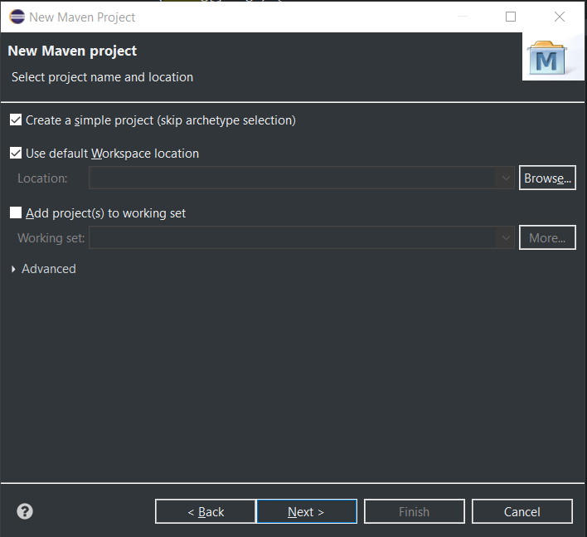

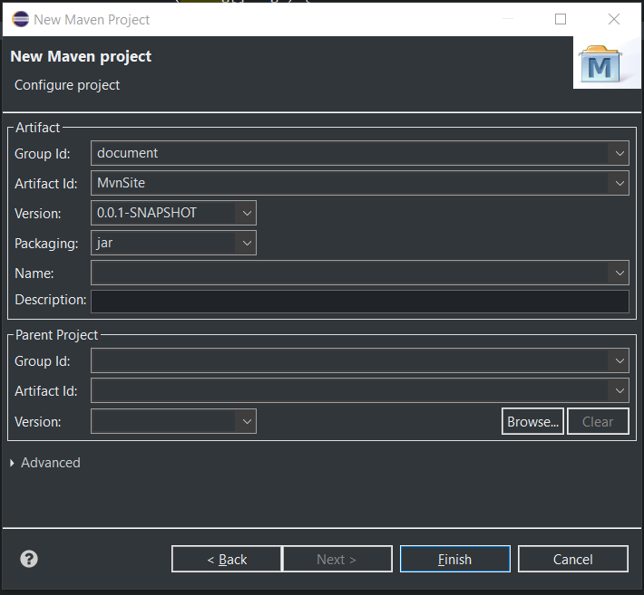

* + Create a Java class in it.

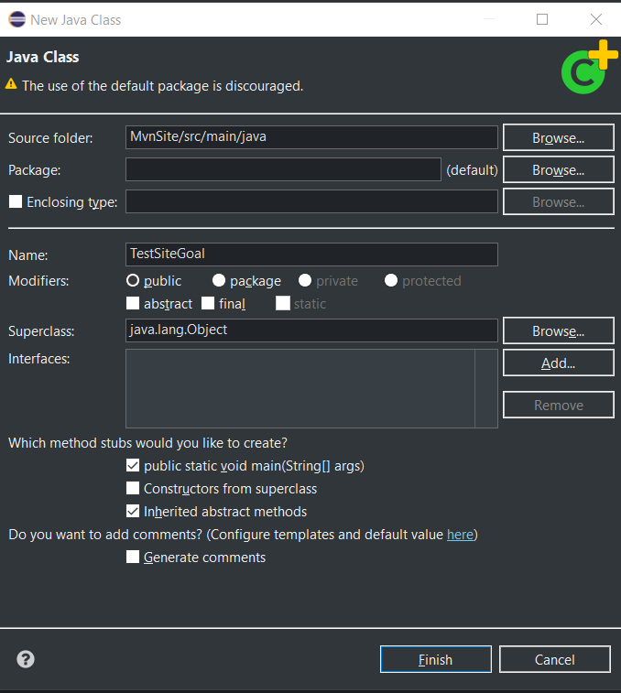

* + Program in Java class with output.

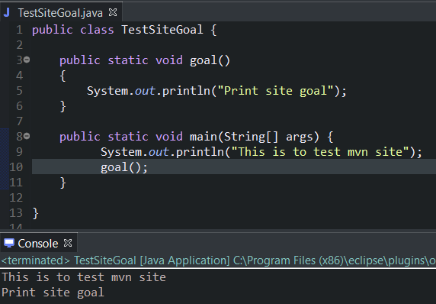

* + Editing ‘pom.xml’ to add Maven site plugin.

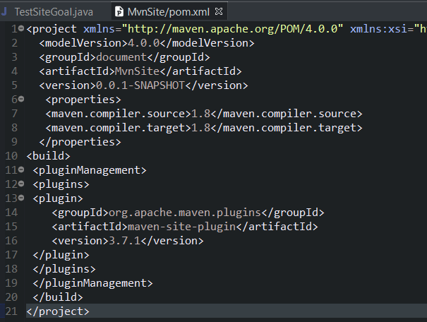

* + Running the **install** command for the Maven project.

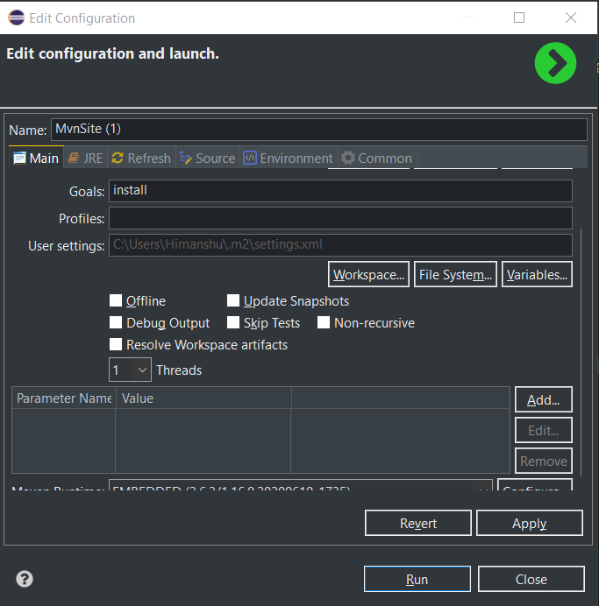

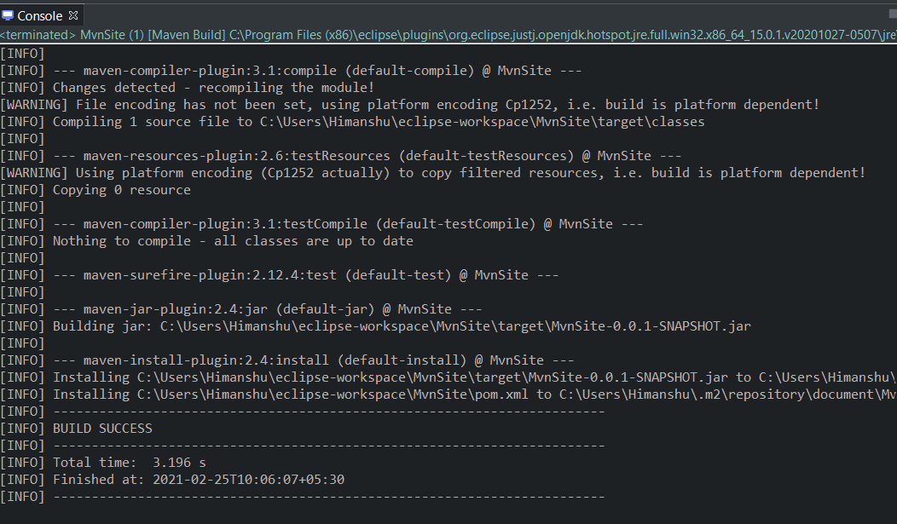

* + Running the **site** command for the Maven project.

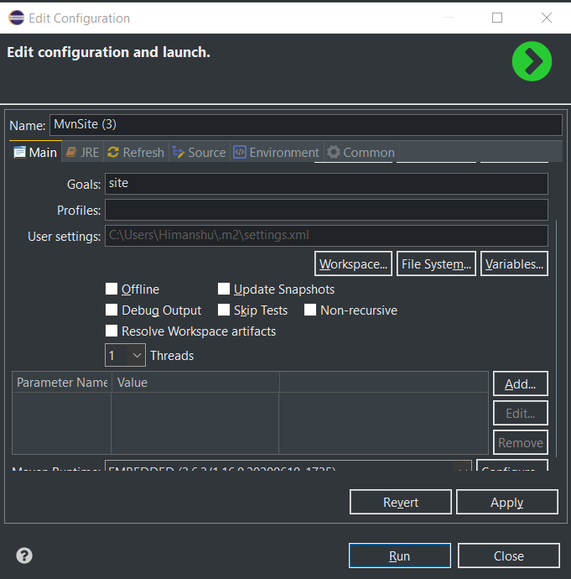

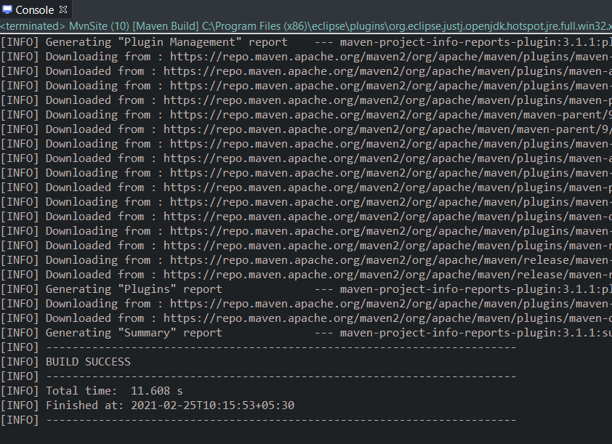

* + The **.html** files generated in site folder.

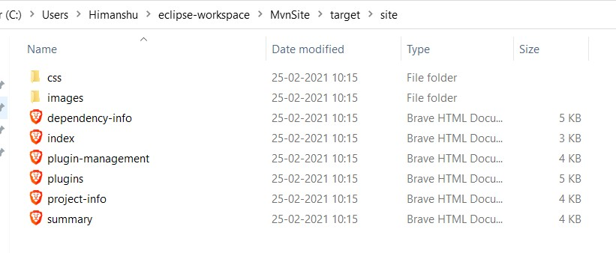

* + The webpage generated in **.html** files.

Last Pubisled' t02I47 2$ | Yesi n, 0.0.j-$ttAP$H0T

Project Documenttti0n ,

' Project Build Plugins



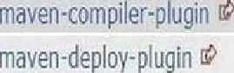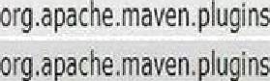og.aaeme /s



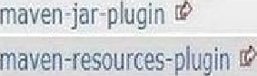org.apa‹Le.waxed.pIu its org.apa‹ke,naven.pl ins

org.apa‹fe.mave .plc ins  org.apa‹Le.iaaven.plc ins 

Project Report Plugins

a 9.apa‹Le.maven.plagirs 

MvnSite

Last Publisned: 2021-02-25 | Version O.O. 1-SNAPSHOT

fi roject Doc u mentation

Dependency Dependency Information

 Apache Nlaven



depend en cy›

<artifactId>EtvnSite‹/artifactld›

<vensior>0.0.1—SNAP5HOT‹/version›

</dependency>

Apache Buildr



Apache Ivy



2.4

2.6

3.7 1

2.12.4



<dependency org=“documert" name=’ñ1vnSite" rev="0.0.1—SNA°SHO*">

<a rtifact name=")1vnSite" type=”jar“ />

</dependercy>

Groovy Grape

JG r a b ( gr on p = ' bo c ume n t ’ , mob u ie= hlv n Sit e ’ , v e o s i o n = ' 8 . B . - SNAP S HDT ' )

MvnSite



Project Documentation

* Pt uj eat I nrut matic n Defend en cy

It fc r - ati at

Aburi:

PI tic i Nla lageil-ien:

PI tic i



Project Information

Summary



Field

Val ue

Name Description Homepage

NvnSite



Project Organization

This project does not belong to an organization.



Build Information

1.8

Field

Val ue