Name: - AMAN PANT Roll No: - R171219042 Sap Id: - 500077611



# BUILD RELEASE AND MANAGEMENT LAB FILE

# Submitted By-

**Name-** AMAN PANT **Roll. No-**R171219042 **SAP ID-** 500077611

**Branch-** B. Tech CSE DevOps (2019-2023)

##### SEMESTER-IV

**Submitted to-**



#### **Dr. Hitesh Kumar Sharma**

#### Associate Professor

B.Sc. (PCM), Gurukul Kangri University Haridwar. M.Sc. (Physics), Gurukul Kangri University Haridwar. MTech (Software Engr - CSE), ITM, Gurgaon, Ph.D. (CSE ), Banas thali University, Banas thali, Rajasthan. GATE Qualified (2012)

pg. 1

**LAB 6:**

**Aim**: Create a simple maven project using CLI. Procedure:

1. To check the mvn version use the command

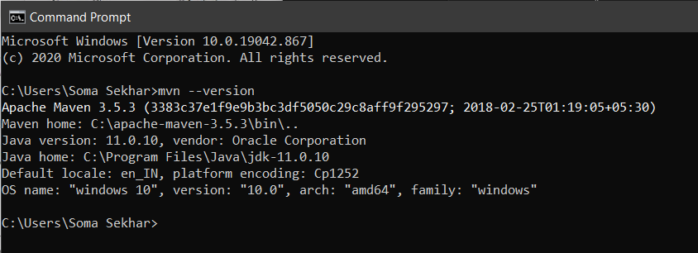“mvn –version”

1. Go into the workspace, and run the command

“ mvn archetype:generate -DgroupId=com.mycompany.app - DartifactId=BRM_LAB6_CLI -DarchetypeArtifactId=maven- archetype-quickstart -DarchetypeVersion=1.4 - DinteractiveMode=false “

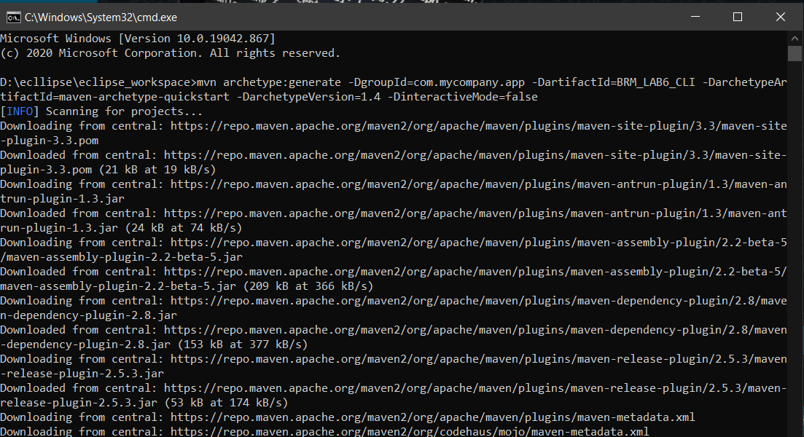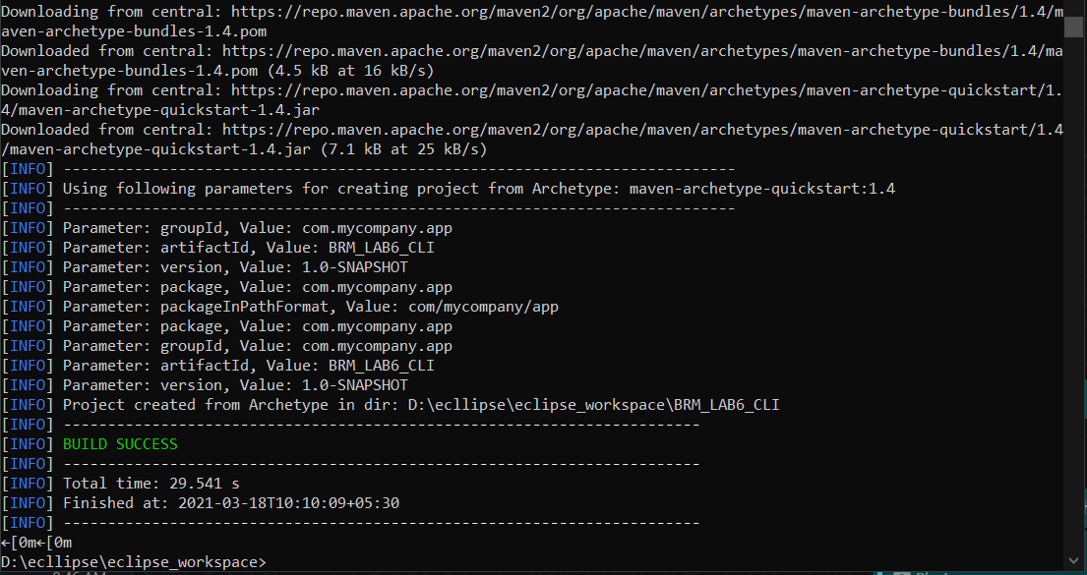

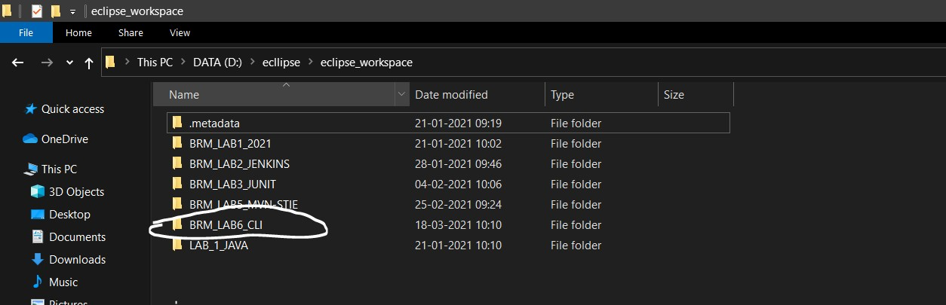

1. Now to build the project we can use the command “mvn package”

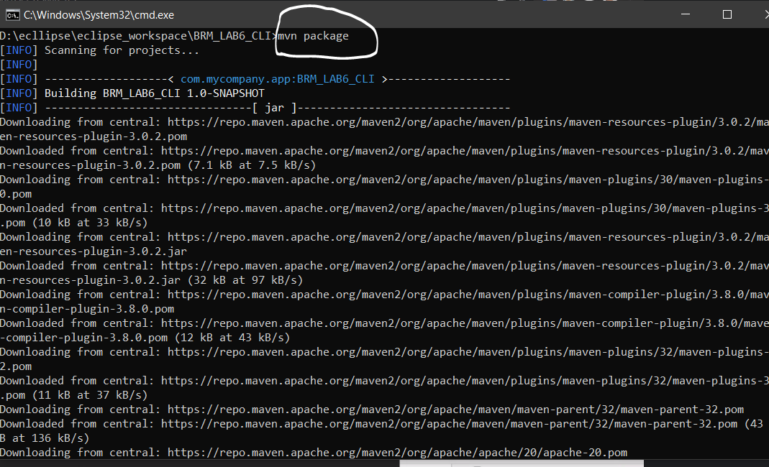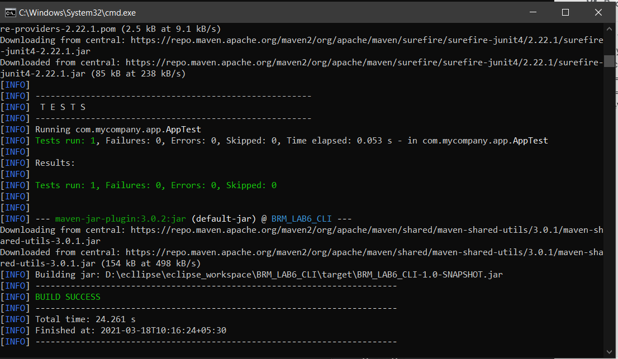

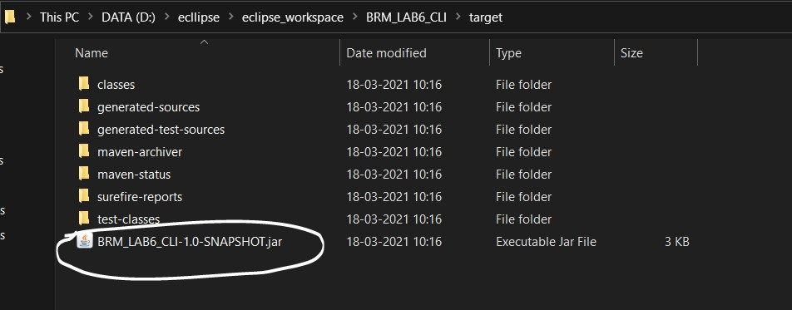

1. Running the java code from the project

“java -cp target/BRM_LAB6_CLI-1.0-SNAPSHOT.jar com.mycompany.app.App”



RESULT:

Thus, successfully, created a maven project through CLI.