Name: - AMAN PANT Roll No: - R171219042 Sap Id: - 500077611



# BUILD RELEASE AND MANAGEMENT LAB FILE

# Submitted By-

**Name-** AMAN PANT **Roll. No-**R171219042 **SAP ID-** 500077611

**Branch-** B. Tech CSE DevOps (2019-2023)

##### SEMESTER-IV

**Submitted to-**



#### **Dr. Hitesh Kumar Sharma**

#### Associate Professor

B.Sc. (PCM), Gurukul Kangri University Haridwar. M.Sc. (Physics), Gurukul Kangri University Haridwar. MTech (Software Engr - CSE), ITM, Gurgaon, Ph.D. (CSE ), Banas thali University, Banas thali, Rajasthan. GATE Qualified (2012)

pg. 1

BUILD AND RELEASE MANAGEMENT LAB FILE

**Experiment 8**

# AIM :

Create Build profile using Maven in both project and user type.

# SOLUTION :

* 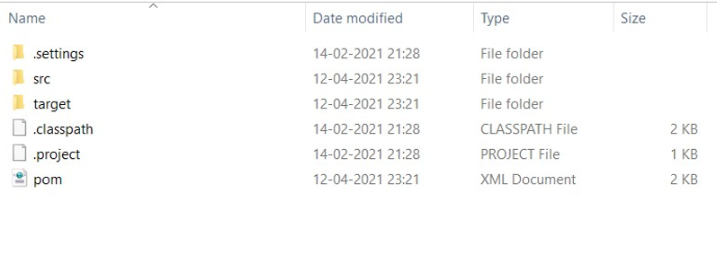Project overview.
* Creating ‘hello.txt’ in ‘src/main/resources’ folder.

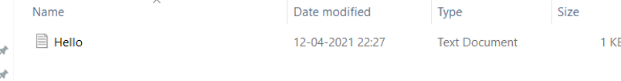

* Modifying ‘POM.xml’ by creating ‘Himanshu’ build profile.In which task is to copy ‘Hello.txt’ from ‘src/main/resources/Hello.txt’ to ‘src/CopiedHello.txt’ and print ‘Copying file’ message.

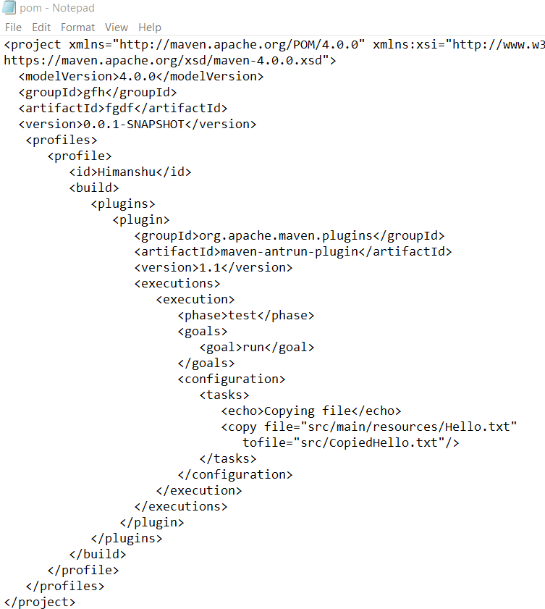

* The ‘src’ folder before running the ‘mvn test -PHimanshu’ command.

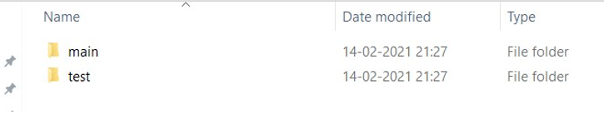

* Running the ‘mvn test -PHimanshu’ in command prompt with path set to project.

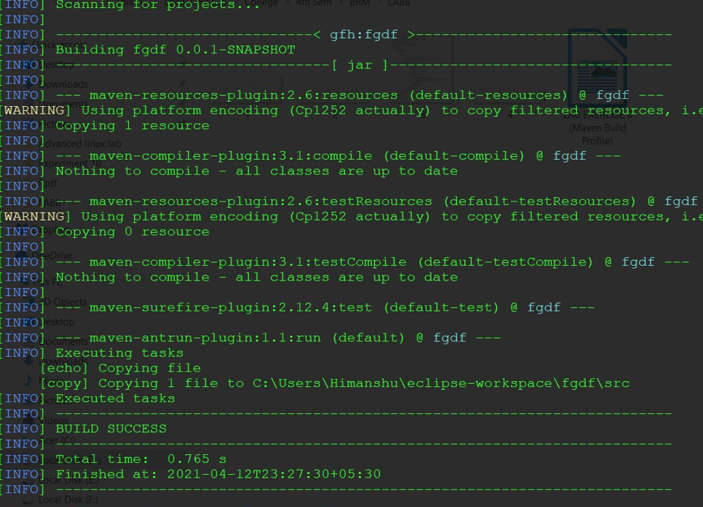

* The ‘src’ folder after running the ‘mvn test -PHimanshu’ command.

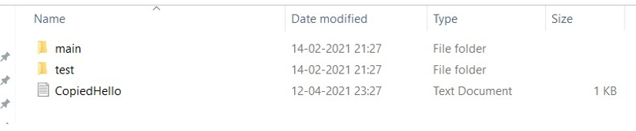

* The .m2 folder containing ‘settings.xml’ file.

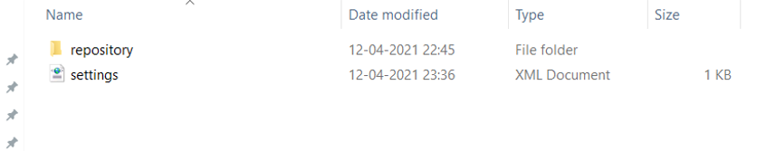

* Modifying ‘settings.xml’ file to create active build profiles ‘Himanshu’ and ‘Ragnar’. ‘Ragnar’ profile is not defined in the ‘POM.xml’ file of the project.

sett nos - Note had

File Edit Format View Help

I « gropIdorg m ycomypugins/gropId›

|  |  |  |
| --- | --- | --- |
| I | ‹artifactId›myplugin‹/artifactId› |  |
| I | ‹configuration› |
| I | ‹tomcatLocation›$(tomcatPath}‹/tomcatLocation› |
| I | ‹/configuration› |
| I | NOTE: If you just wanted to inject this configuration | whenev+ |
| I | anything, you could just leave off the ‹value/› | inside |



‹/plugin›



‹profile›

‹1d›env- dev‹/1d›

‹activation›

‹property›

‹name›target-env‹/name›

‹value›dev‹/value›

‹/property›

‹/activation›

‹properties›

‹tomcatPath›/path/to/tomcat/instances/tomcatPath›

‹/properties›

‹/profile›

‹/profiles›

‹!-- activeProfiles

I List of profiles that are active for all builds.

‹activeProfiles›

‹activeProfile›alwaysActiveProfile‹/activeProfile›

‹activeProfile›anotherAlwaysActiveProfile‹/activeProfile›

‹/activeProfiles›

‹activeProfiles›

‹activeProfile›AMAN‹/activeProfile›

‹activeProfile›Ragnar‹/activeProfile›

‹/activeProfiles›

‹/settings›

* Running ‘mvn test’ in command prompt with path set to project.Notice,we don’t need to use

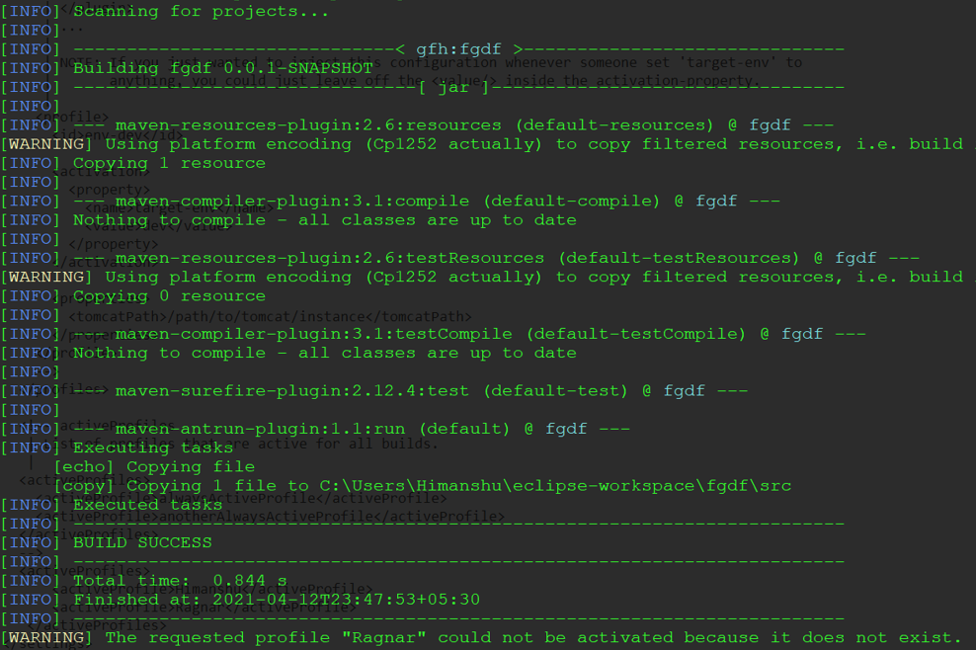*-P<profile>* option for running the build profile and also the warning message of ‘Ragnar’ profile.