

BRM_LAB_1



INTRODUCTION

NAME: AMAN PANT

BRANCH: DevOps

ROLL NUMBER: R171219042

SAP Id: 500077611

SEMESTER: IV

SUBJECT: BRM LAB

SUBMITTED TO:

HITESH KUMAR

Date OF Submission:

14\02\2021

**LAB 1**

* Create a Simple Maven project and make a class inside it .

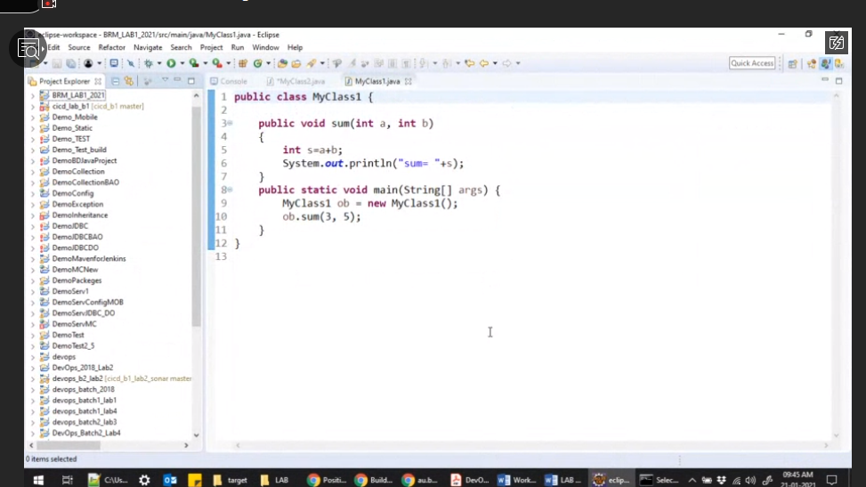

* Run the following maven goals:
* Clean🡪

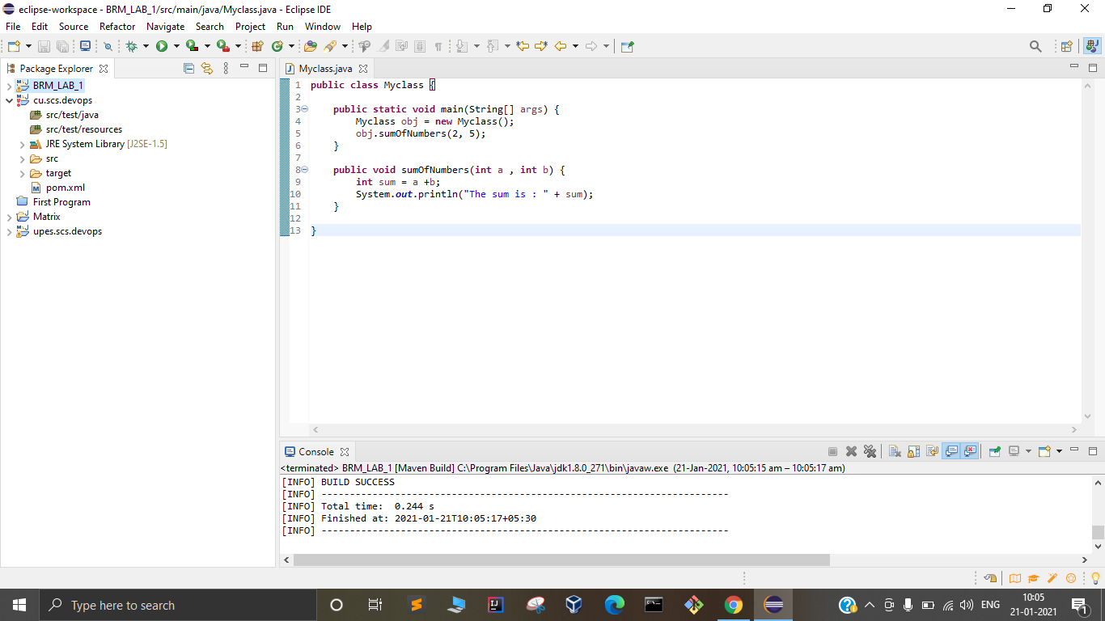

* Compile🡪

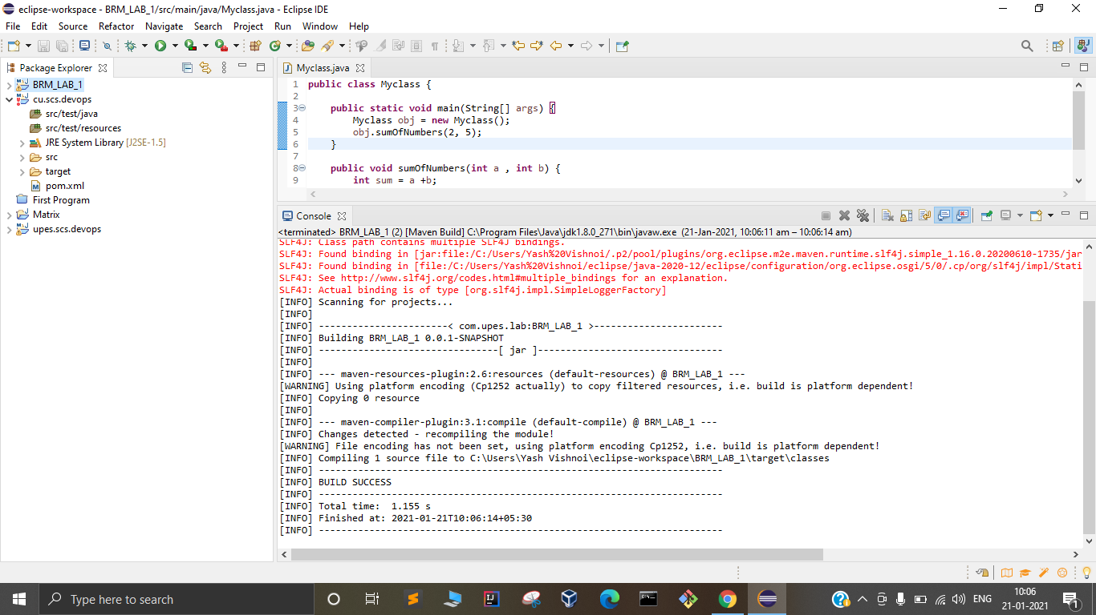

* Install🡪

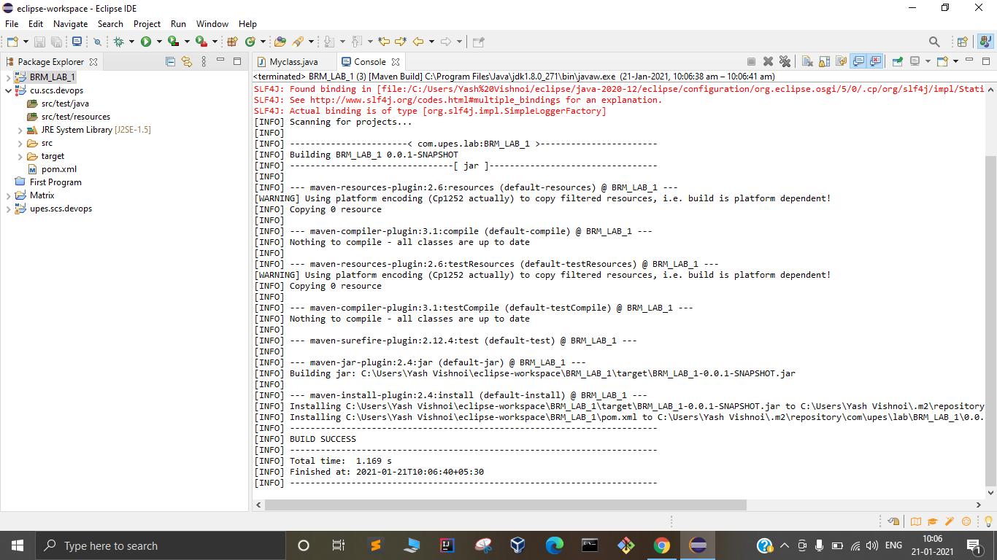

* Use jar file in other java Projects🡪

