

BRM_LAB_2



INTRODUCTION

NAME: AMAN PANT

BRANCH: DevOps

ROLL NUMBER: R171219042

SAP Id: 500077611

SEMESTER: IV

SUBJECT: BRM LAB

SUBMITTED TO:

HITESH KUMAR

Date OF Submission:

14\02\2021

LAB 2

* Create a Simple maven Project and then create a class:

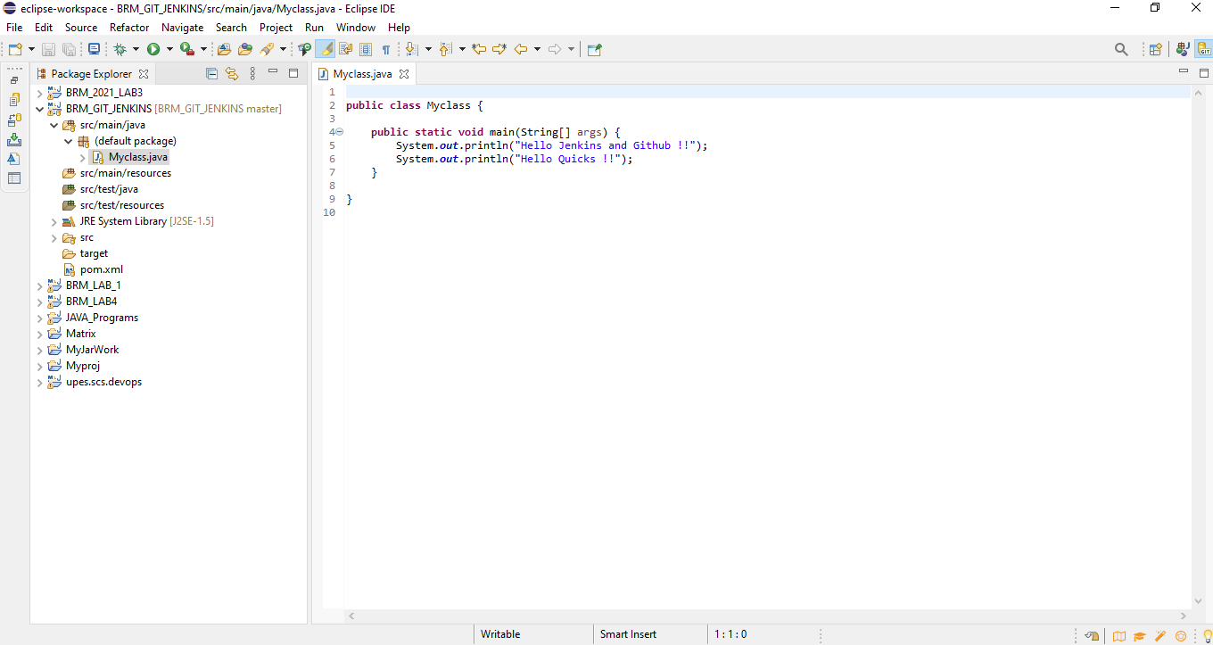

* Commit and Push into Github 🡪

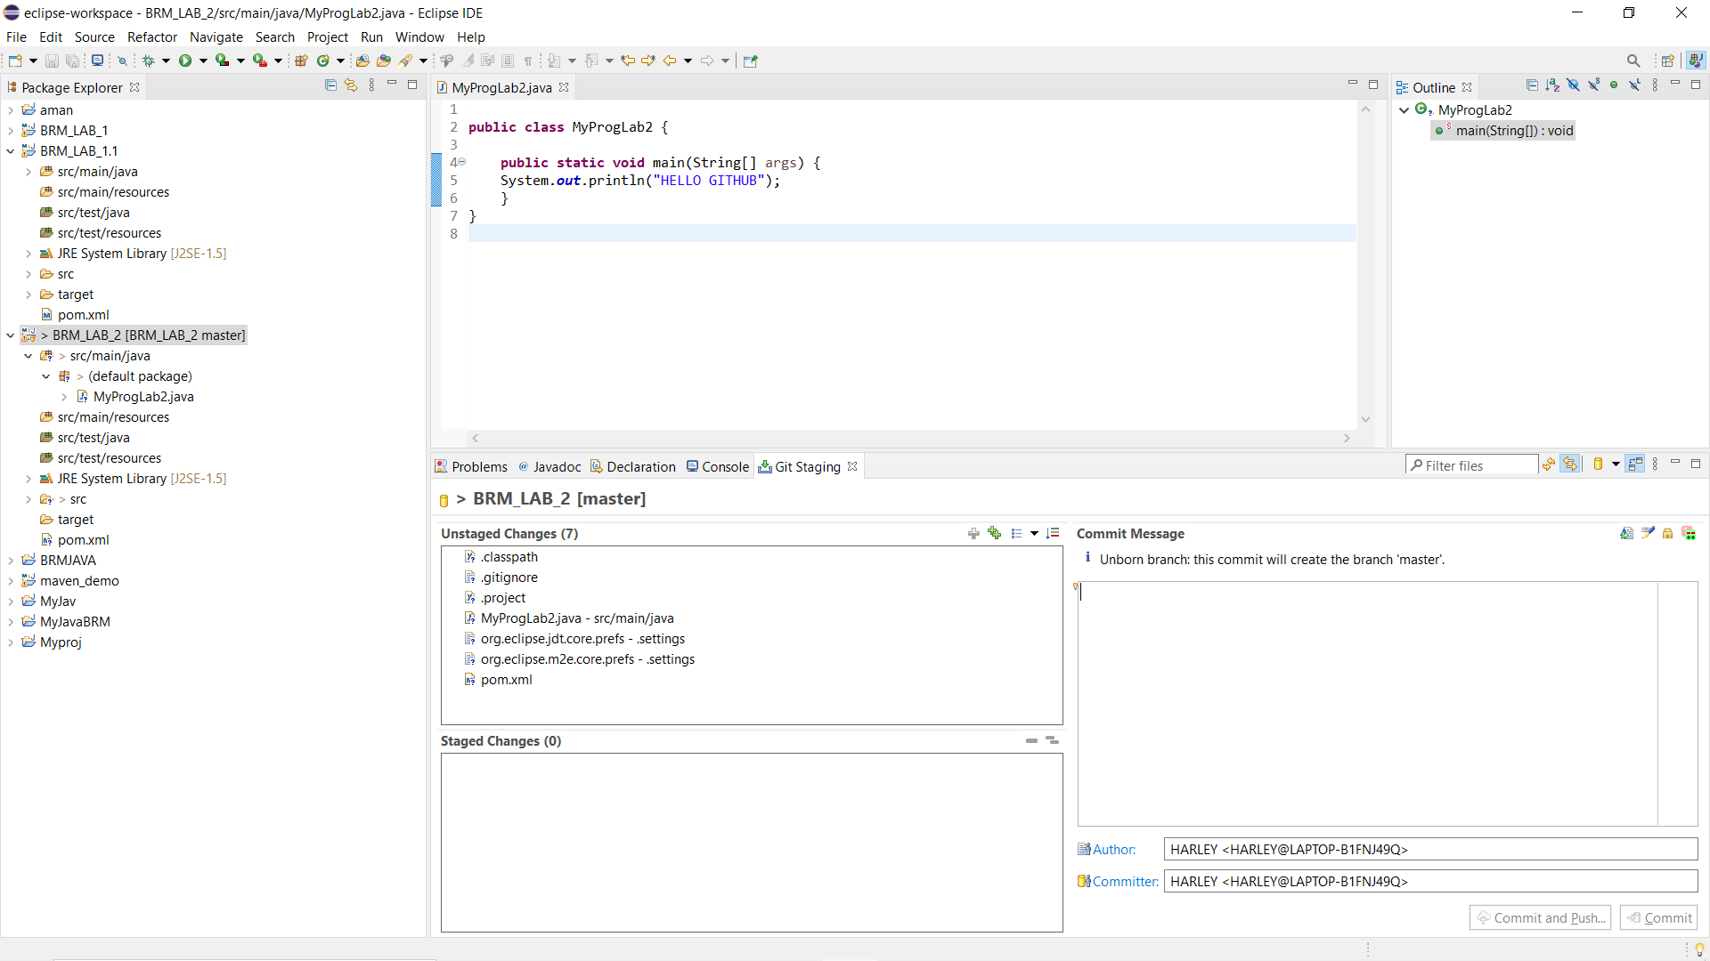

* 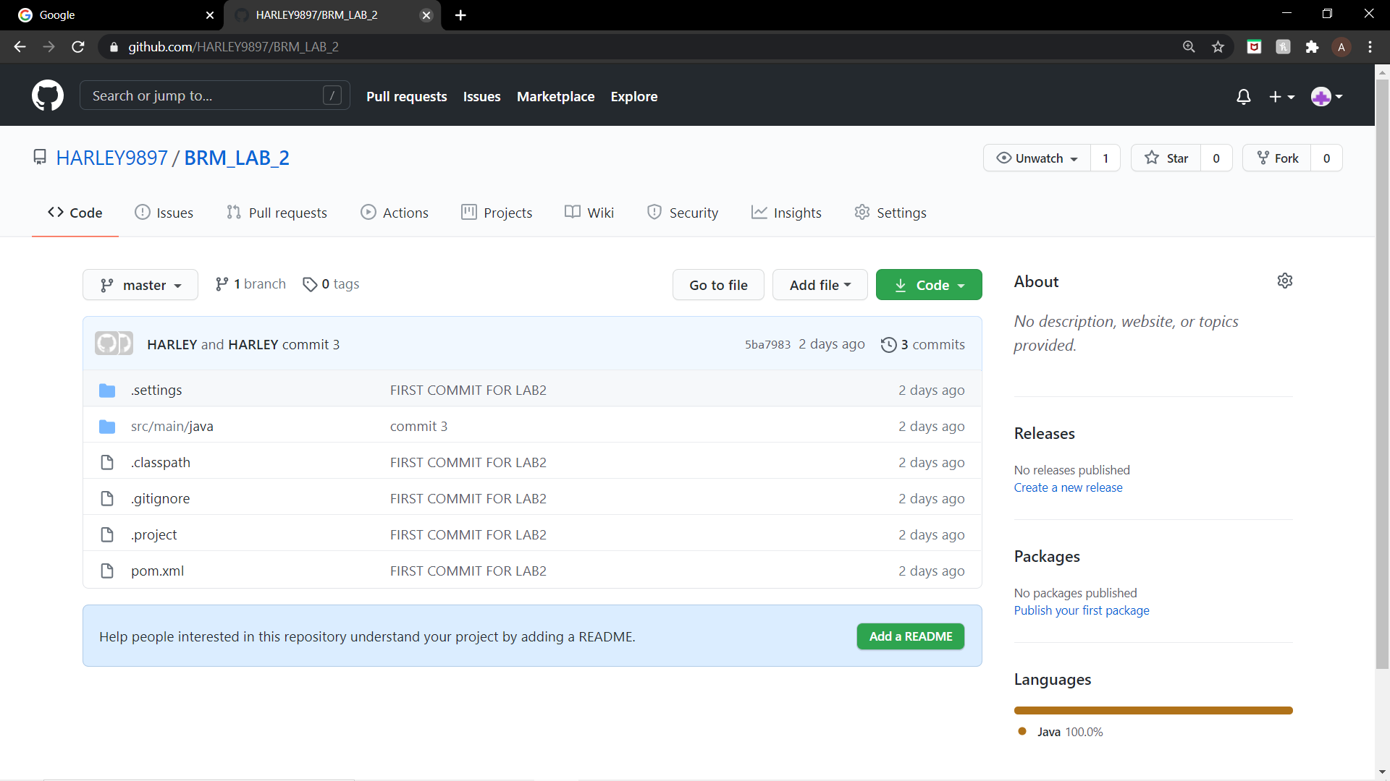

* Open Jenkins and run goals:

* Clean🡪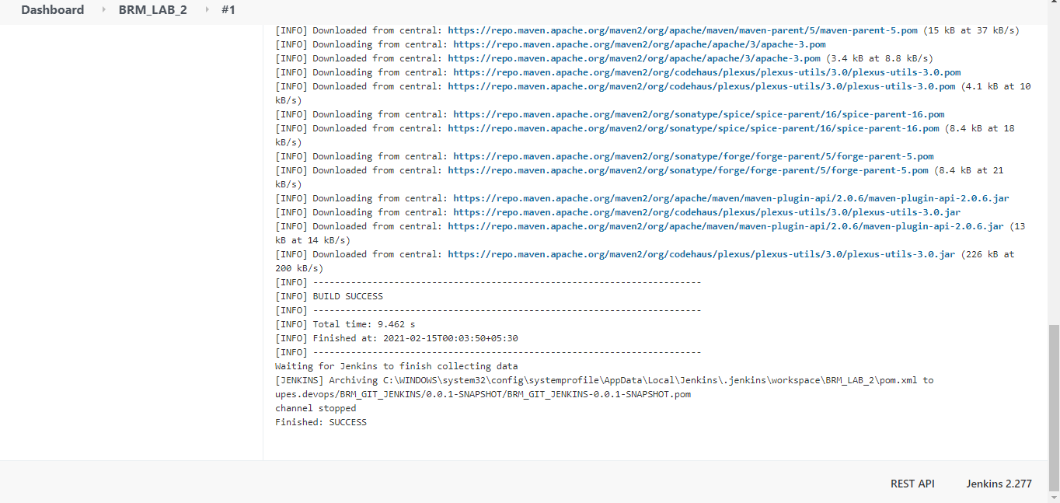

* Install🡪

