

BRM_LAB_3



INTRODUCTION

NAME: AMAN PANT

BRANCH: DevOps

ROLL NUMBER: R171219042

SAP Id: 500077611

SEMESTER: IV

SUBJECT: BRM LAB

SUBMITTED TO:

HITESH KUMAR

Date OF Submission:

14\02\2021

LAB 3

* Make a class in Maven Project🡪

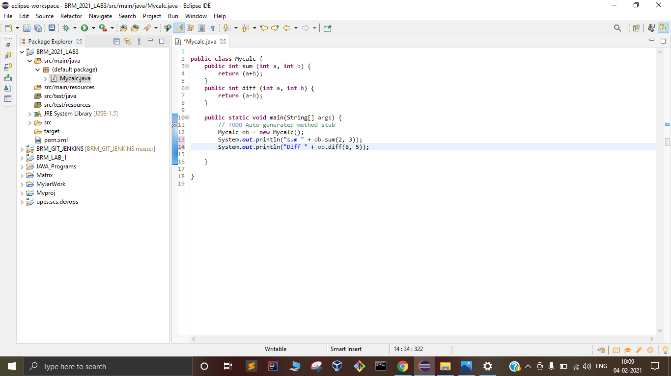

* Create a Junit test case in the project 🡪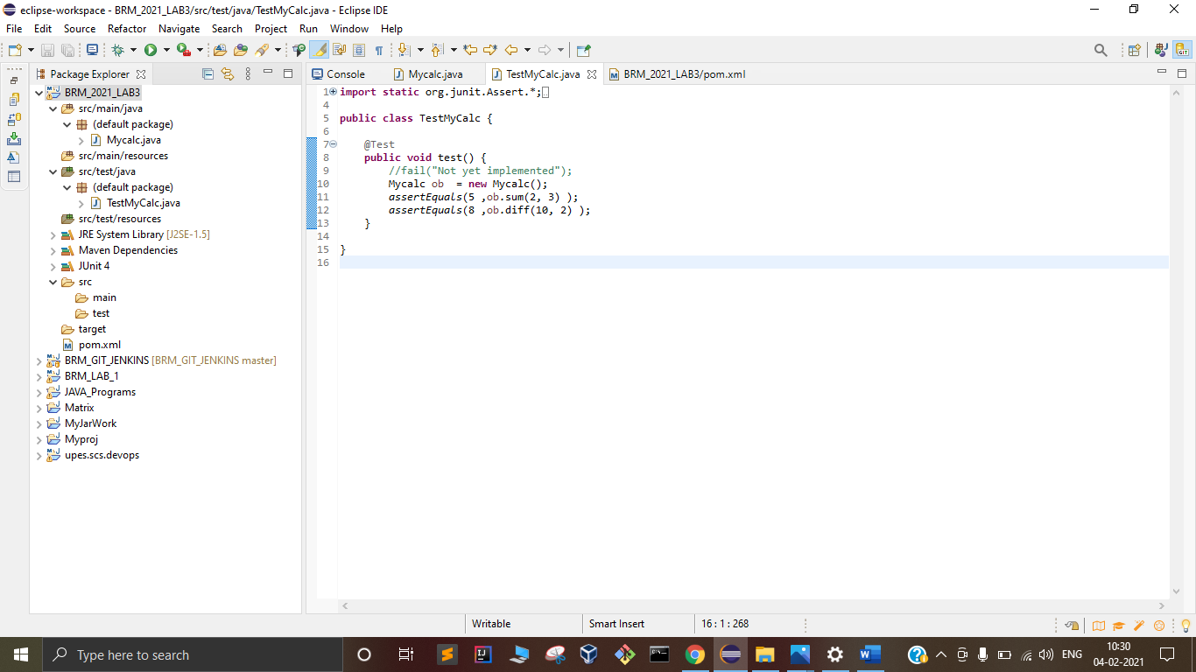

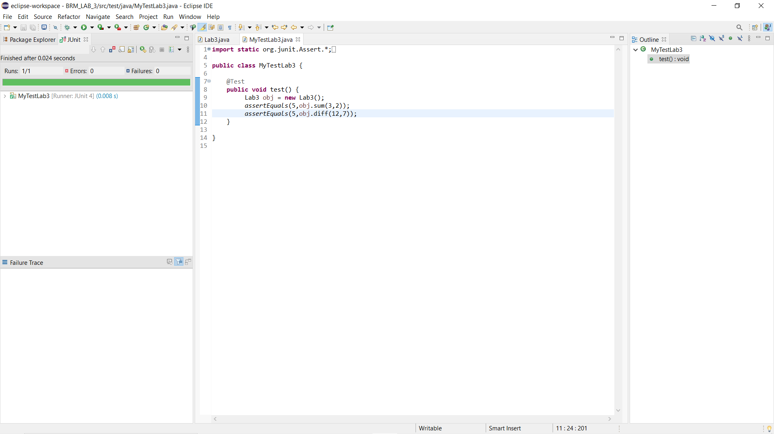

* Edit the porm.xml file 🡪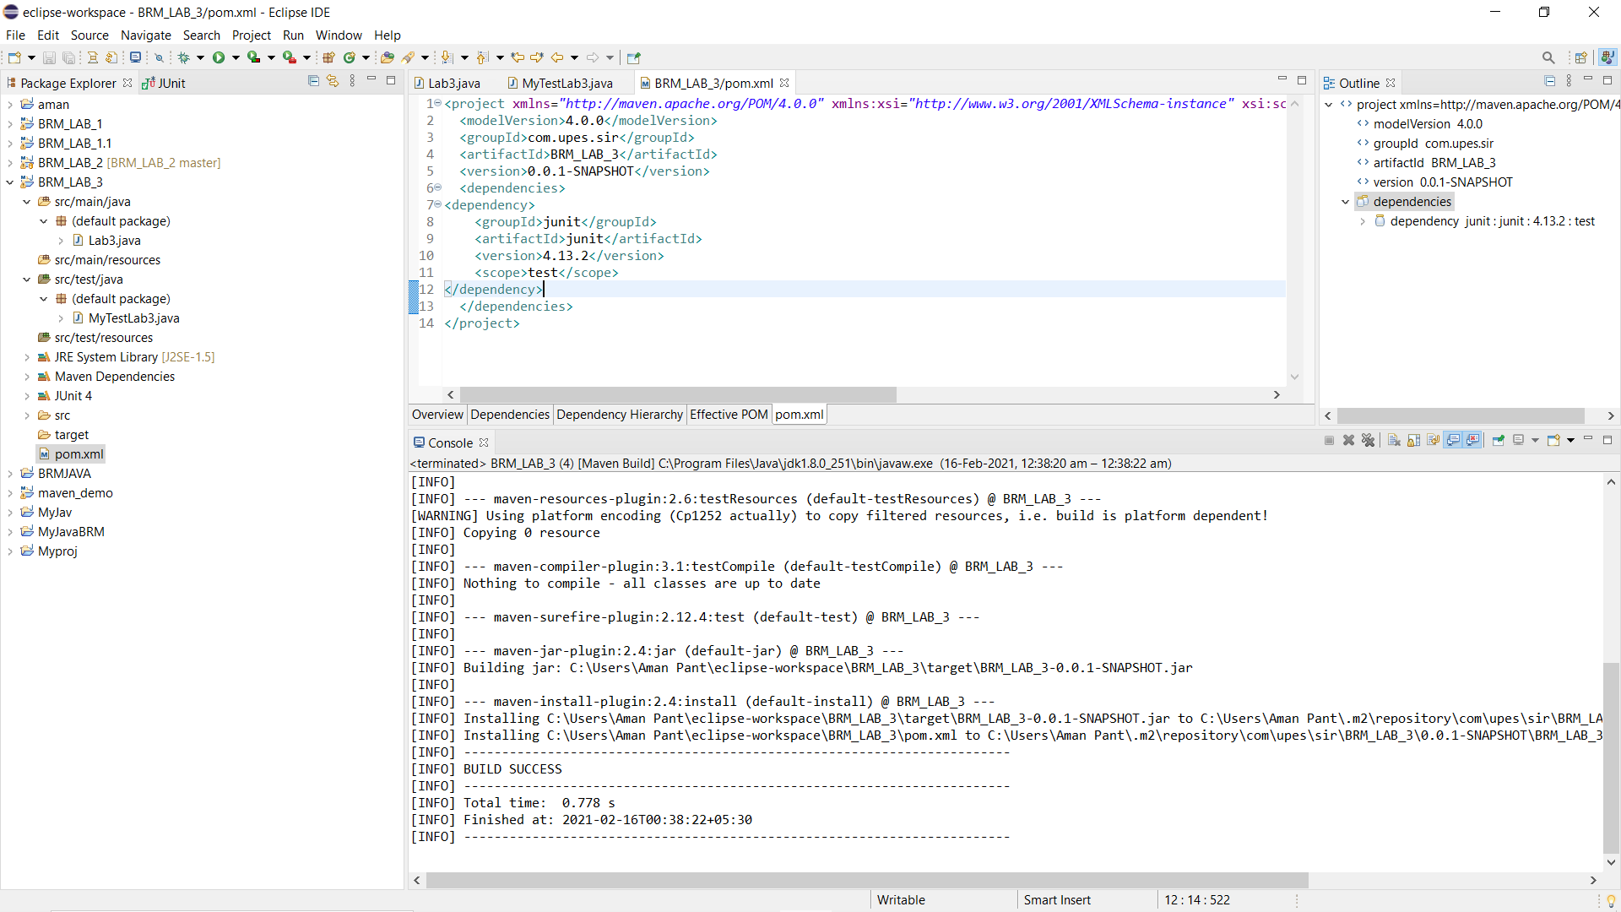

* Run the following maven goals 🡪

* Install: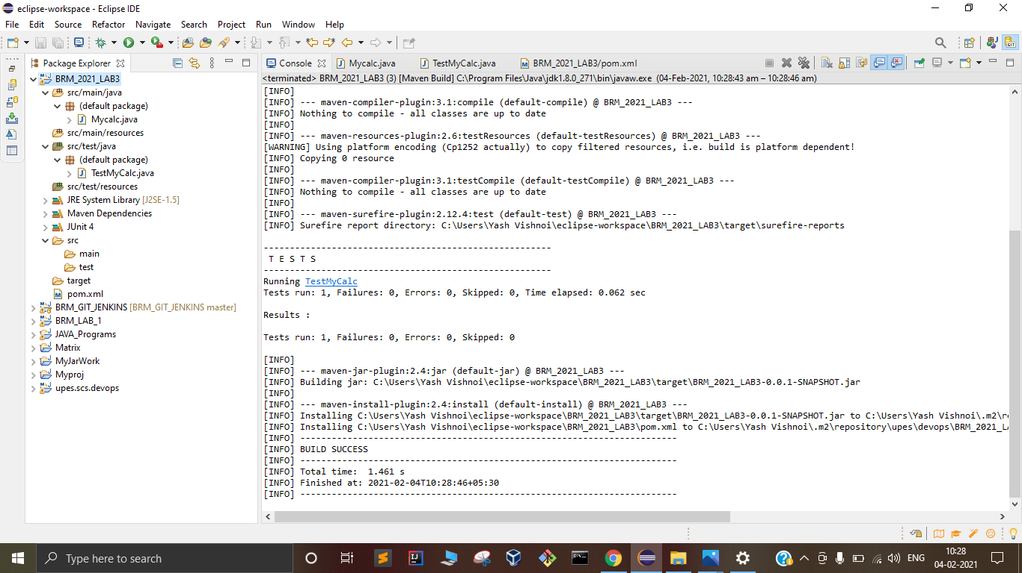

* Test:

