

BRM_LAB_4



INTRODUCTION

NAME: AMAN PANT

BRANCH: DevOps

ROLL NUMBER: R171219042

SAP Id: 500077611

SEMESTER: IV

SUBJECT: BRM LAB

SUBMITTED TO:

HITESH KUMAR

Date OF Submission:

14\02\2021

LAB 4

* Create a Simple Maven project and create a simple class in it:

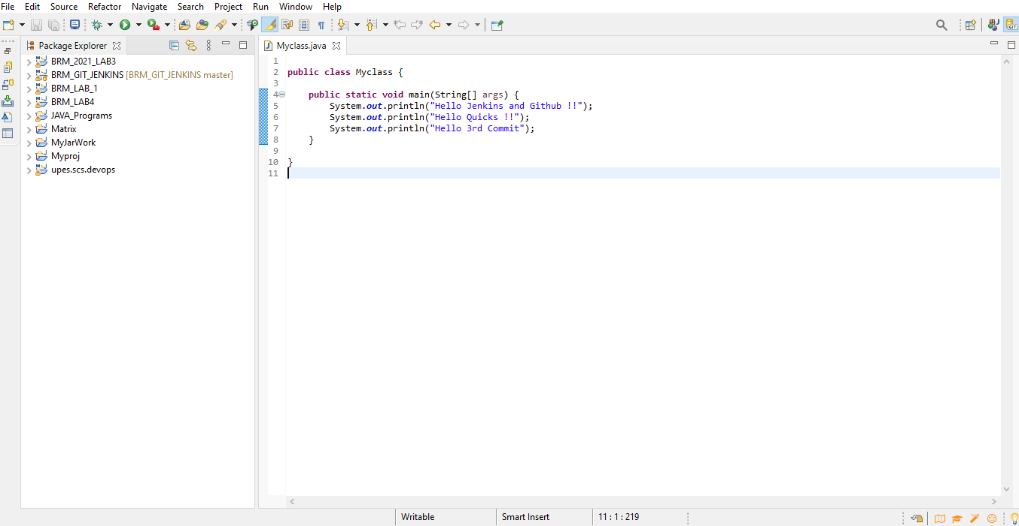

* Commit and push the code on Github:

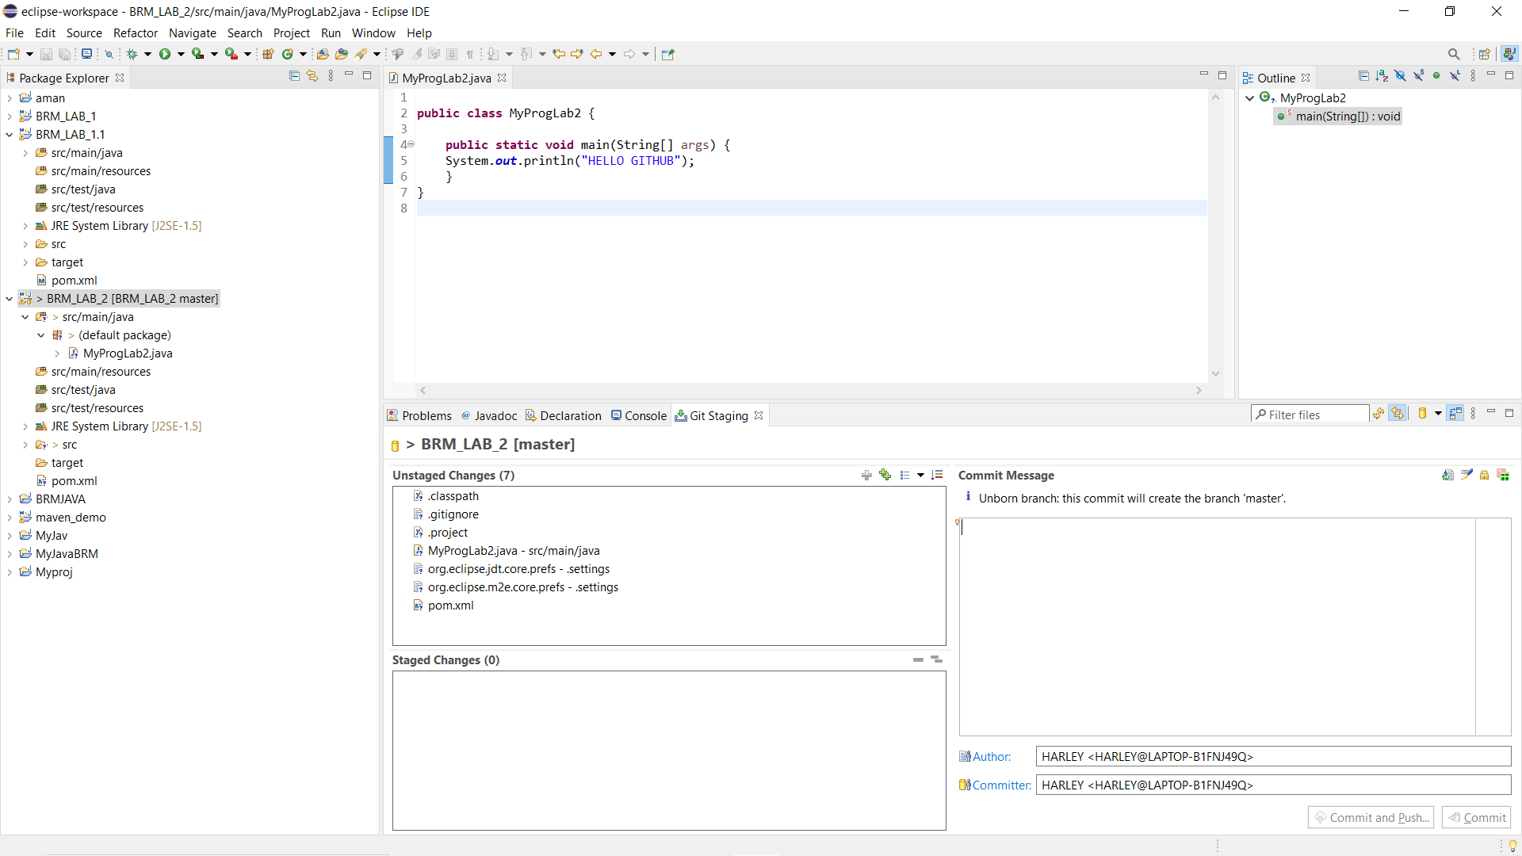

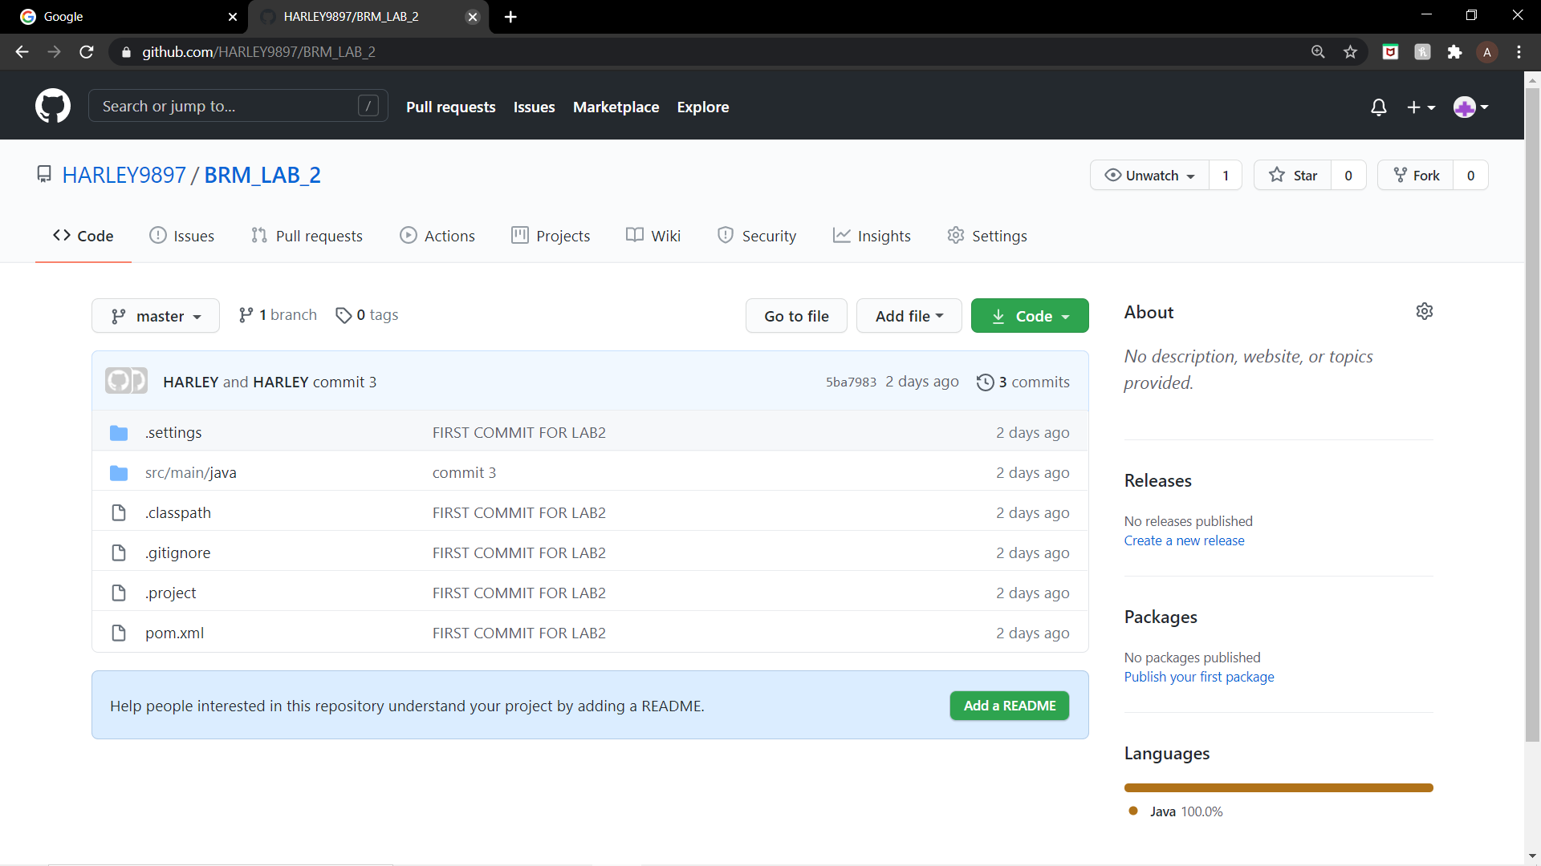

* Open Jenkins and run Goal as Clean:

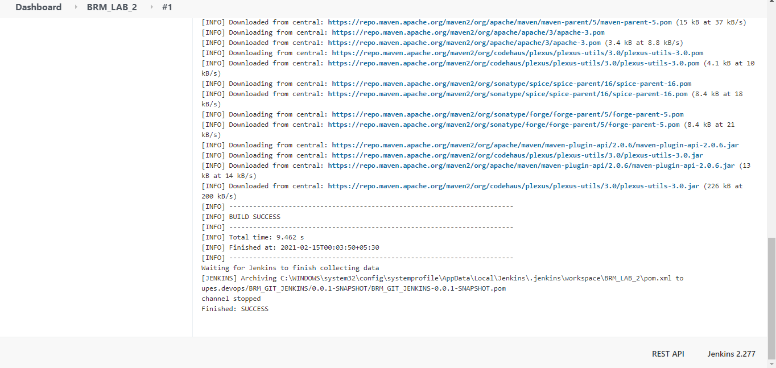

* Automate the build process through the configure option and push changes to Github to ensure:

