Aim: Create a simple Maven Project using CLI
First, download Maven and follow the installation instructions. After that, type the following in a
terminal or in a command prompt:
1. mvn --version

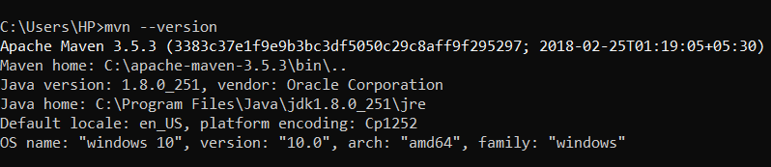

Creating a Project
You will need somewhere for your project to reside, create a directory somewhere and start a shell in that directory. On your command line, execute the following Maven goal:

1. mvn archetype:generate -DgroupId=com.mycompany.app -DartifactId=my-app -DarchetypeArtifactId=maven-archetype-quickstart -DarchetypeVersion=1.4 -DinteractiveMode=false

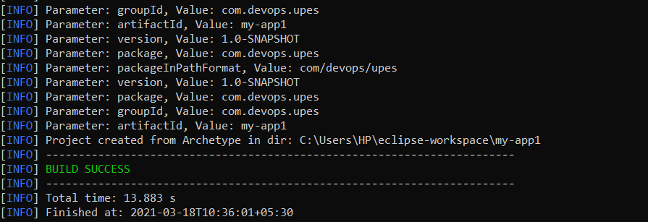

You will notice that the generate goal created a directory with the same name given as the artifactId. Change into that directory.

- cd my-app
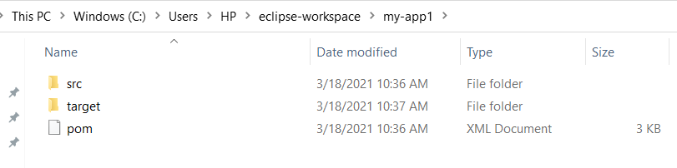

The POM

The pom.xml file is the core of a project's configuration in Maven. It is a single configuration file that contains the majority of information required to build a project in just the way you want. The POM is huge and can be daunting in its complexity, but it is not necessary to understand all of the intricacies just yet to use it effectively. This project's POM is:
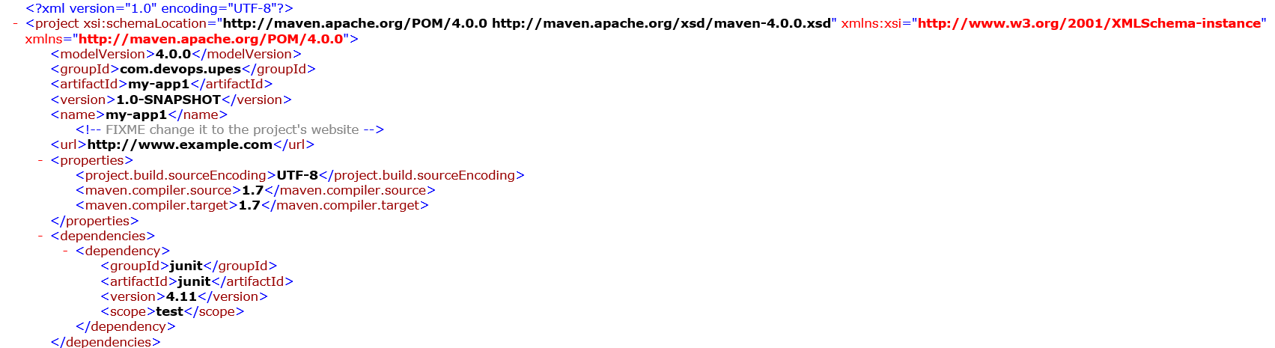
Build the Project
1. mvn package
The command line will print out various actions, and end with the following:

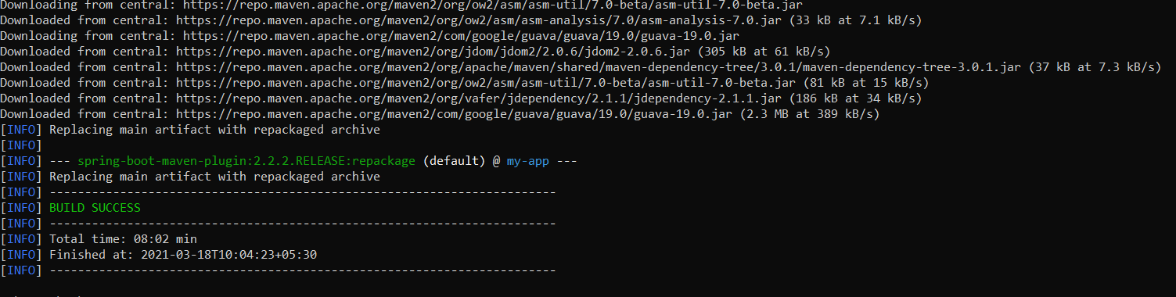

Unlike the first command executed (archetype:generate) you may notice the second is simply a
single word - package. Rather than a goal, this is a phase. A phase is a step in the build lifecycle,
which is an ordered sequence of phases. When a phase is given, Maven will execute every phase
in the sequence up to and including the one defined. For example, if we execute
the compile phase, the phases that actually get executed are:
1. validate
2. generate-sources
3. process-sourcesBuild and Release Management Lab
Prepared by: Dr. Hitesh Kumar Sharma Page 4
4. generate-resources
5. process-resources
6. compile
You may test the newly compiled and packaged JAR with the following command:
1. java -cp target/my-app-1.0-SNAPSHOT.jar com.mycompany.app.App
Which will print the quintessential:

