LAB EXERCISE 1

Aim:
- Create a Java Project using Maven.
- Run the following maven goals on this project
- Clean
- Compile
- Test-Compile
- Install

Project created by : Saubhagya Dixit
R171218089
500067088
Devops: Build and Release Management Lab

Create a Java Project using Maven

1) Open your eclipse and Go to File > New > Others.
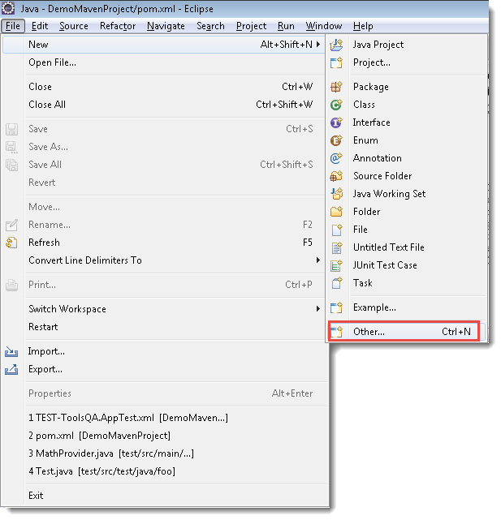

2) Select Maven Project and click on Next.
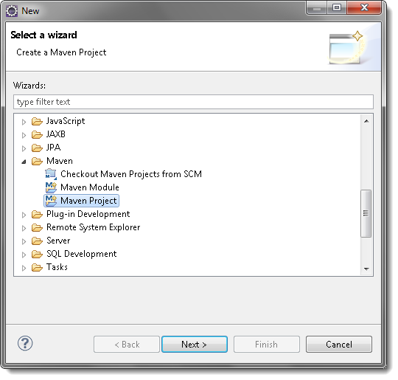

3) Un-check the ‘Use default Workspace location‘ and with the help of the Browse button choose your workspace where you would like to set up your Maven project.
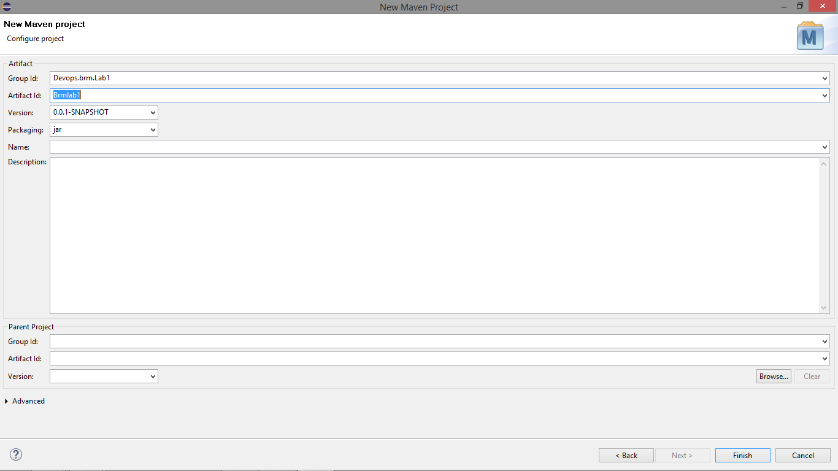

4) Select the archetype, for now just select the ‘maven-aechetype-quickstart‘ and click on Next.
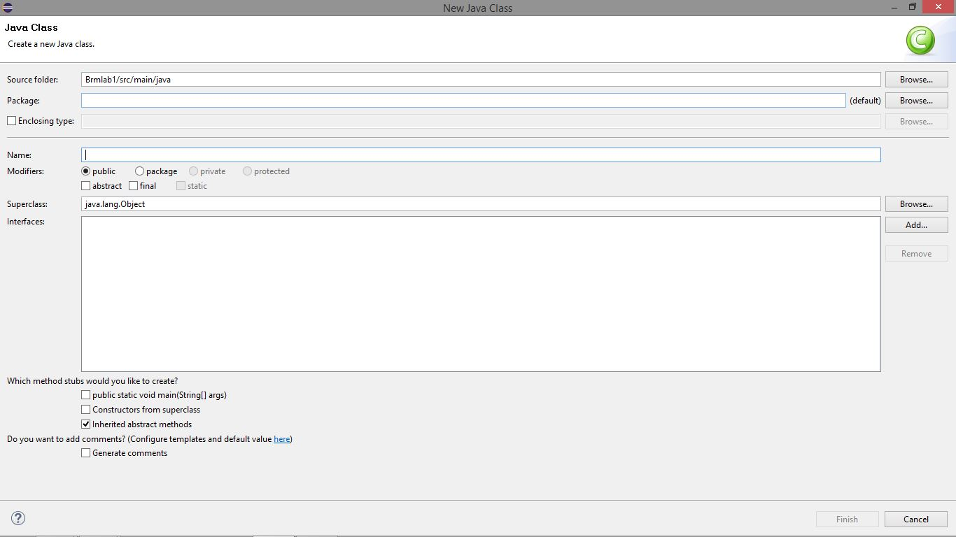

Run the following maven goals on this project
- Clean
Step1: Set goal as clean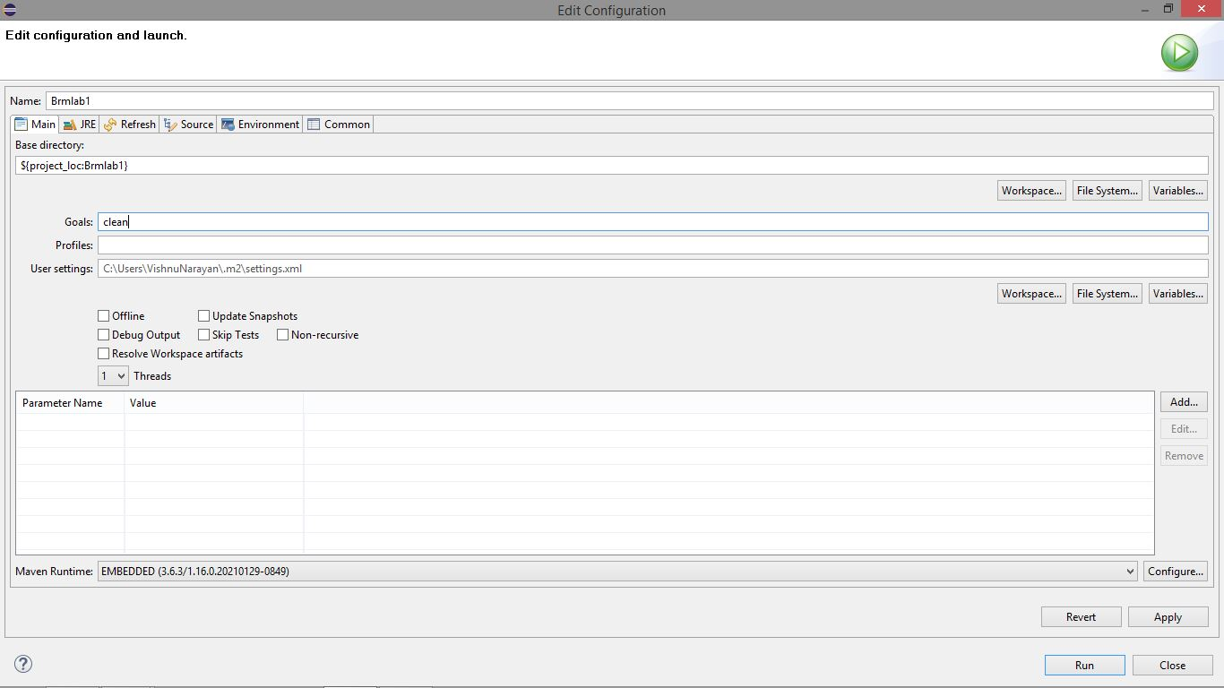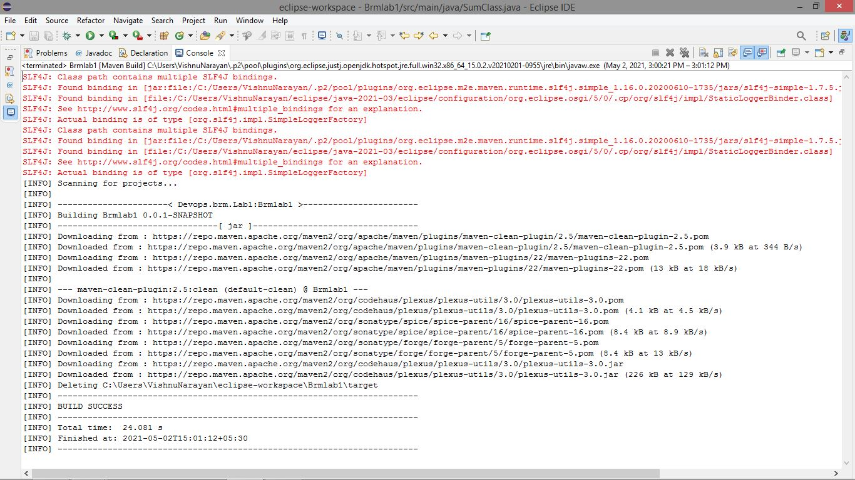

Compile
Step2 : Set goal as compile.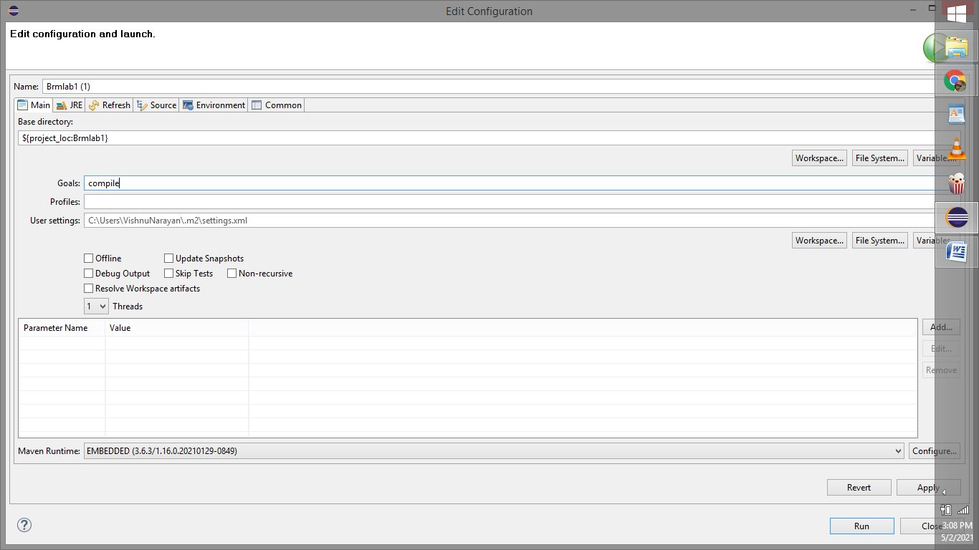

Step3: Set goal as install
