

**UNIVERSITY OF PETROLEUM & ENERGY STUDIES**

**Dehradun**

**CONTINOUS INTEGRATION**

**AND**

**CONTINOUS DELIVERY**

**ASSIGNMENT-2**

**Name: Aakarshit Agarwal**

**Course: B. TECH CSE DevOps (2018-22)**

**Roll no.: R171218001**

**Sapid: 500067782**

**ASSIGNMENT-2**

**1.Create a Maven Project**

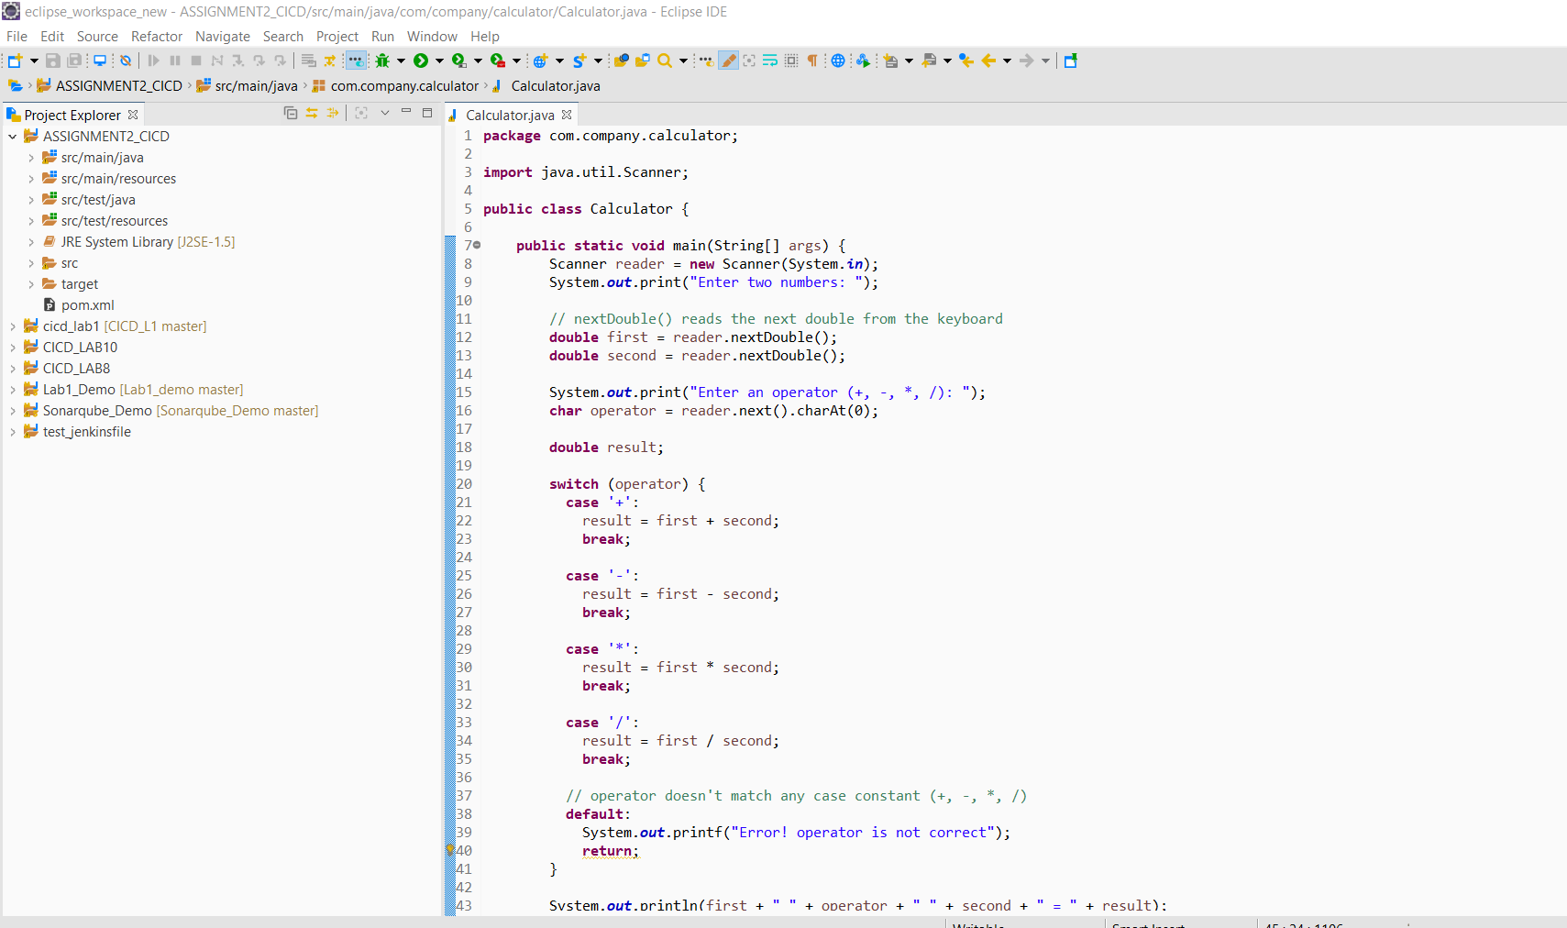

**Step 2: Create a Github Repository**

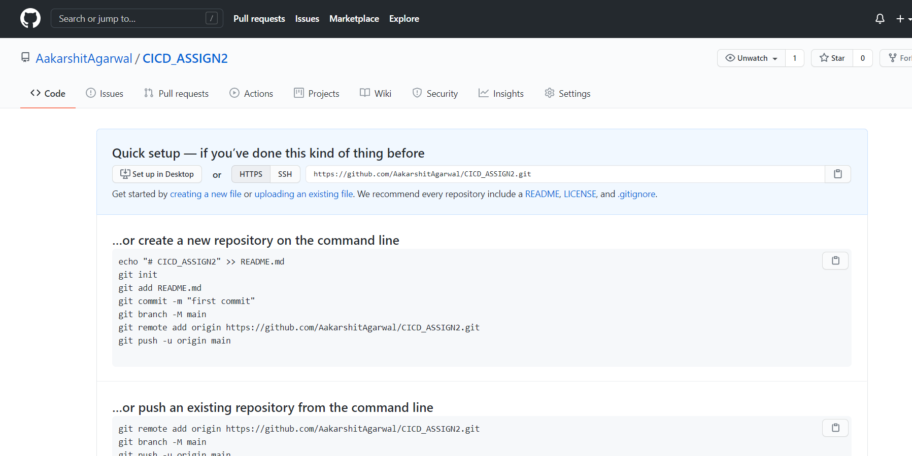

**Step 3: Push the Project on Github**

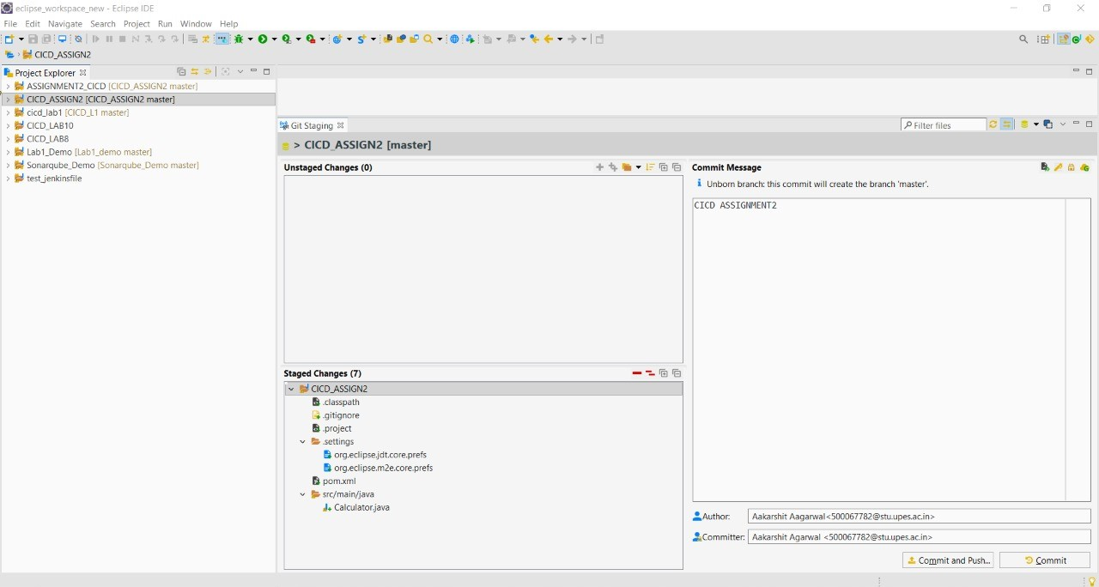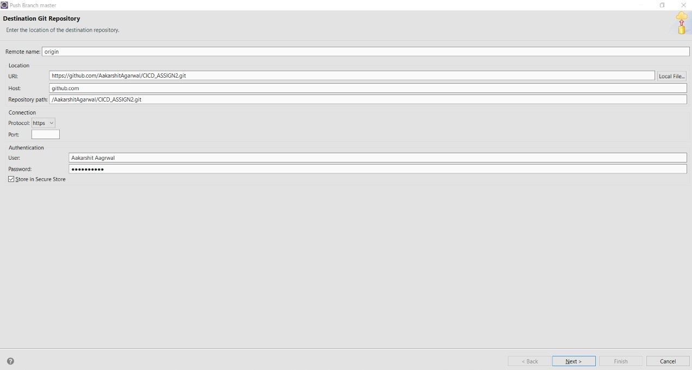

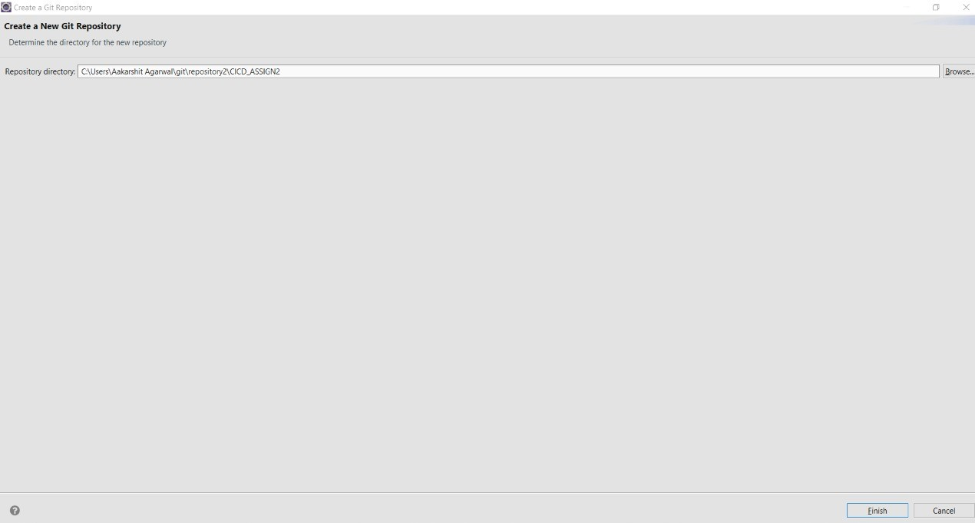

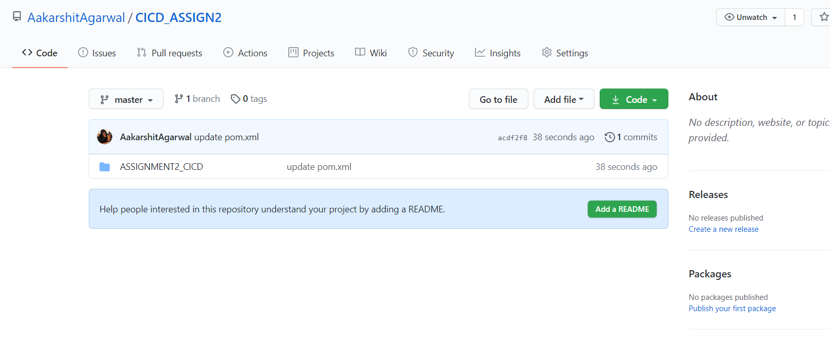

**Step 4: Create a Jenkins file inside the Repository**

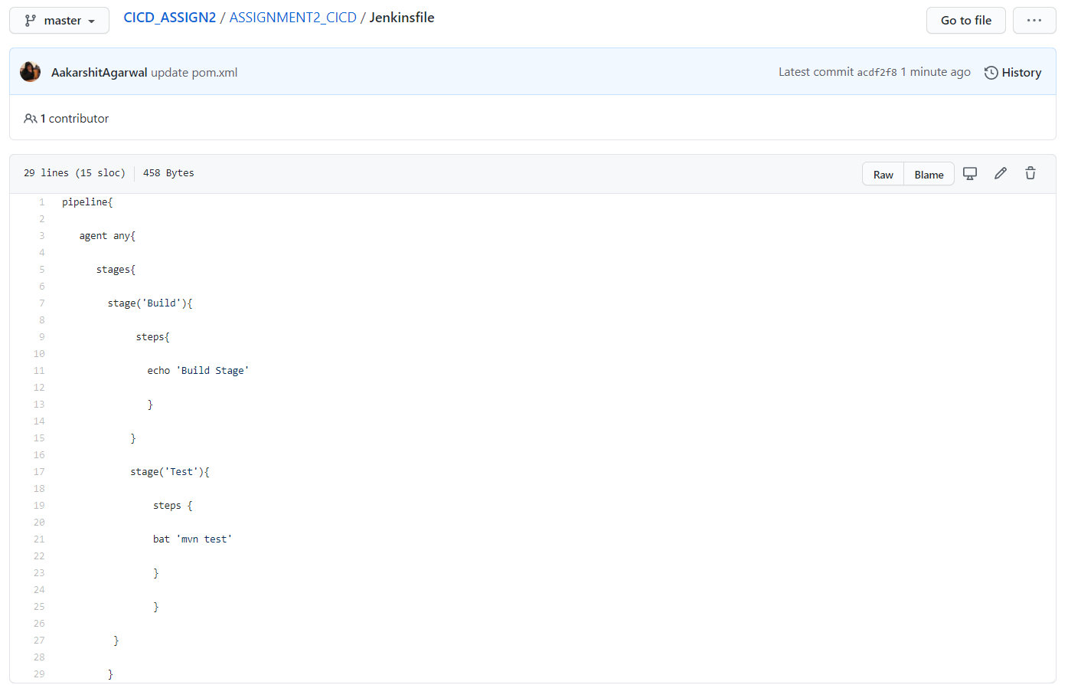

**Step 5:Go to Jenkins and Create a Pipeline for the Project**

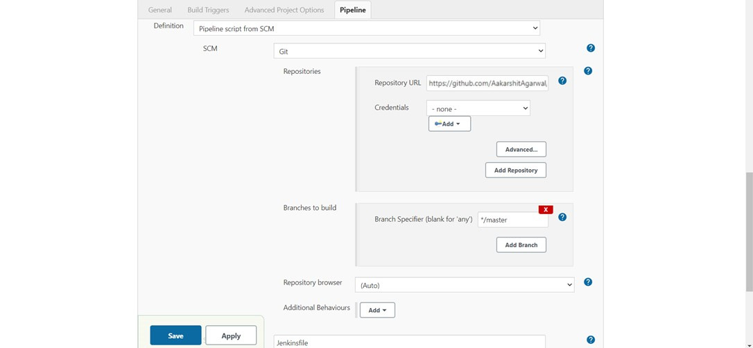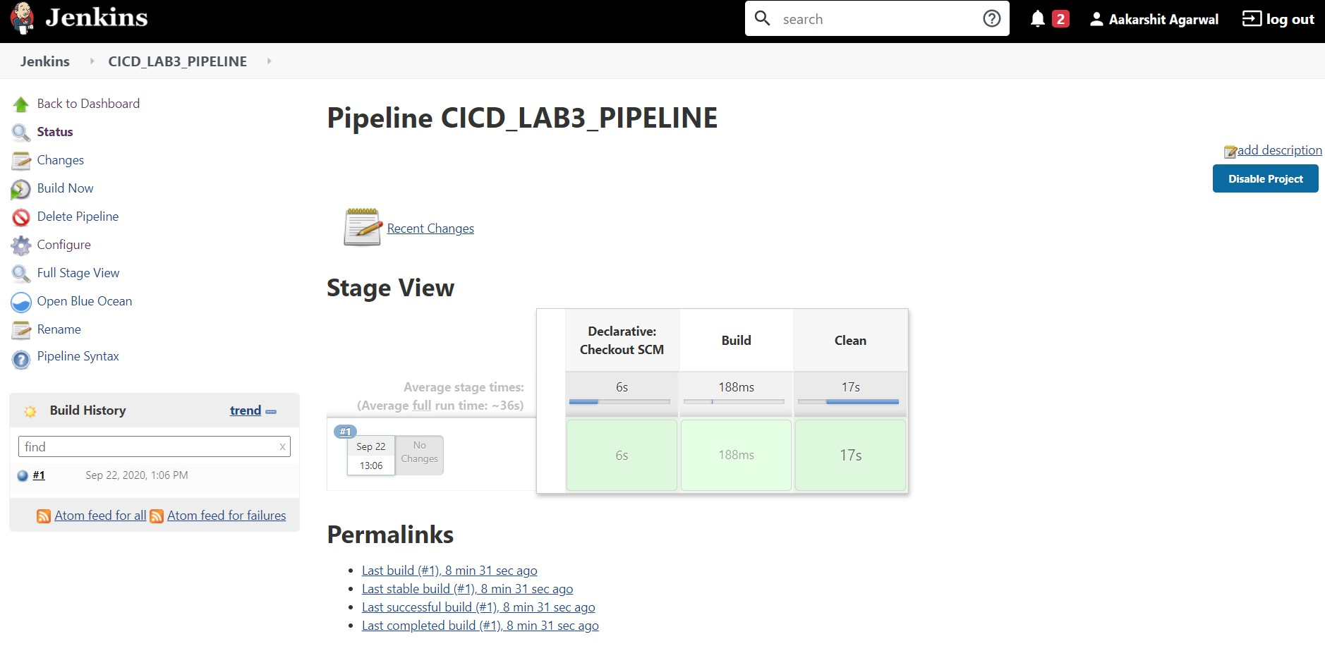

**Step 6: Run the nexus Server Using the Command nexus.exe/run**

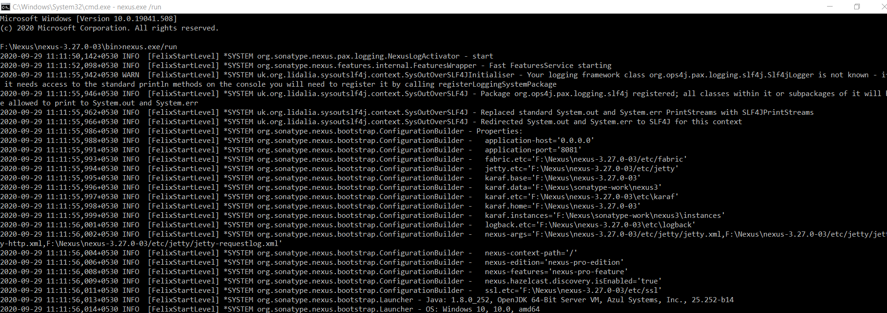

**Step 7: Create a Nexus Repository**

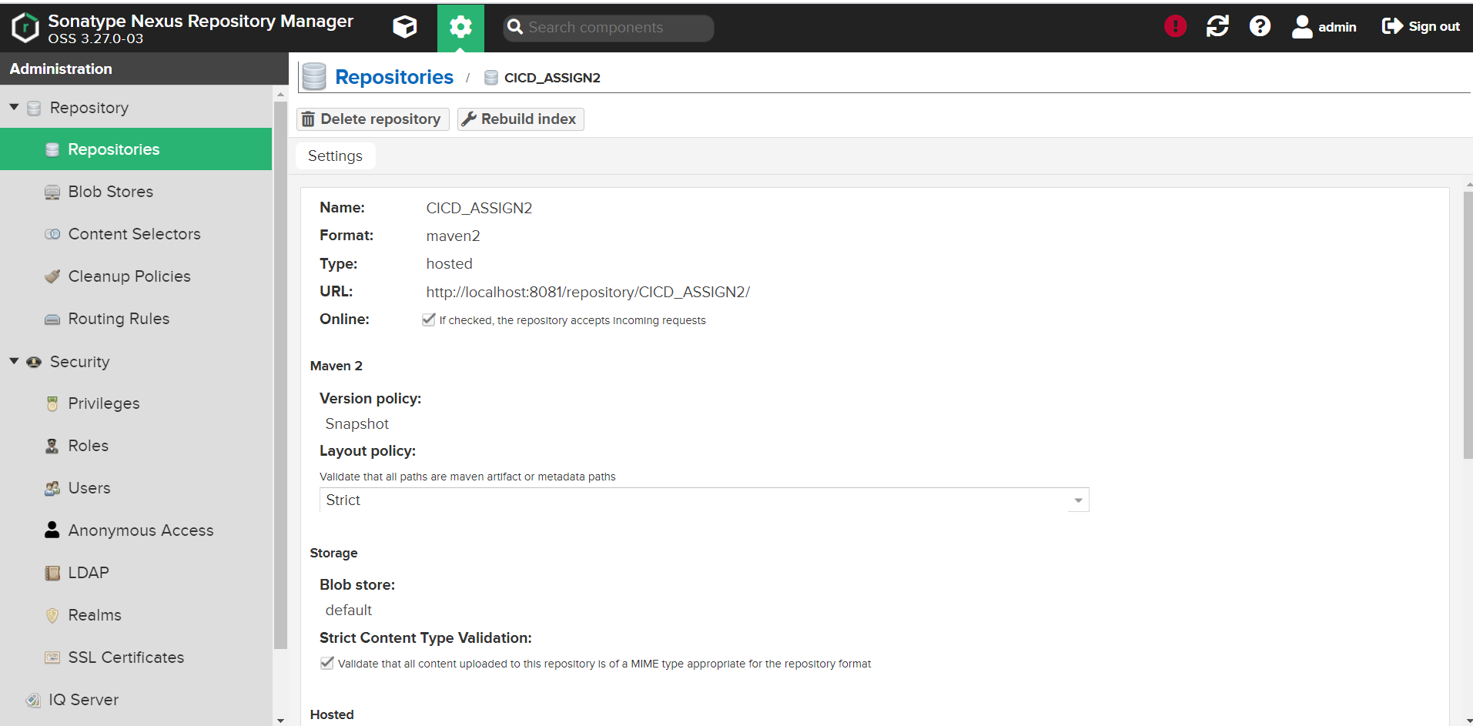

**Step 8.Configure the apache-maven config>settings.xml file**

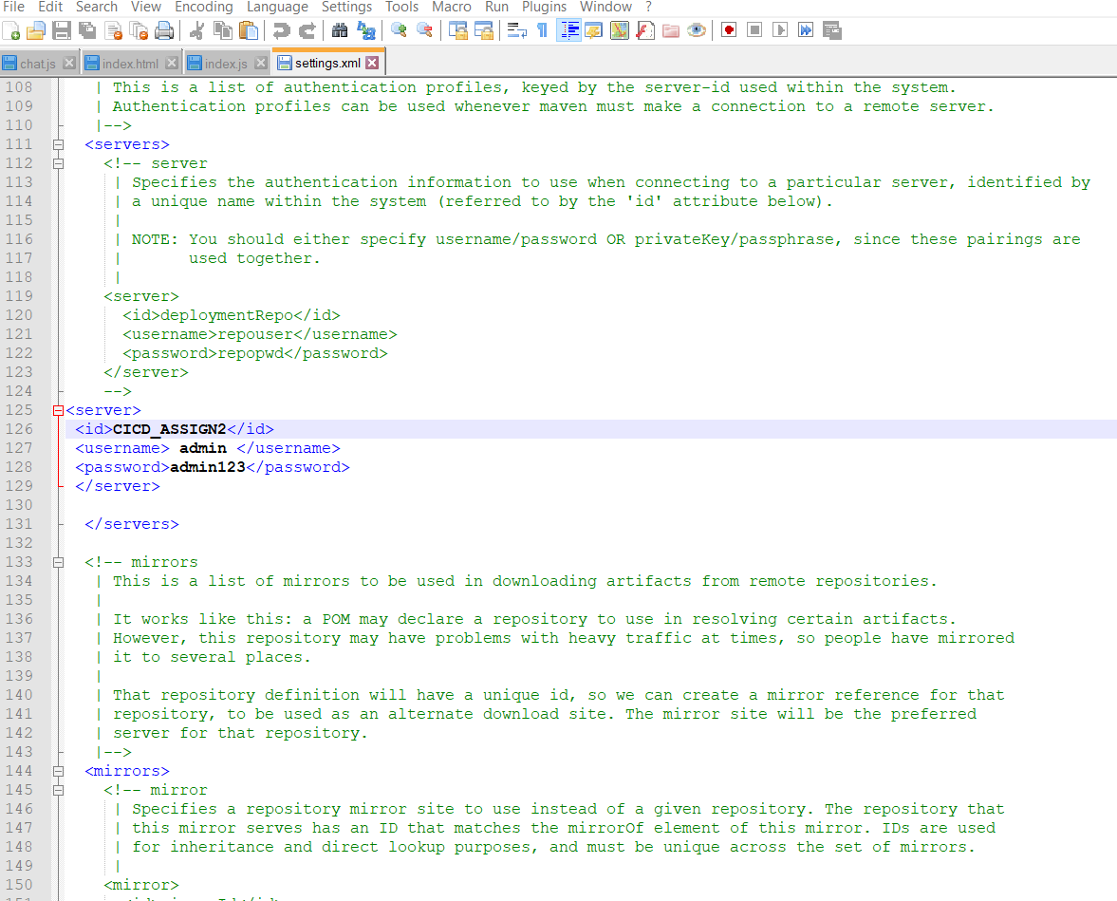

**Step 9: Configure the Pom.xml**

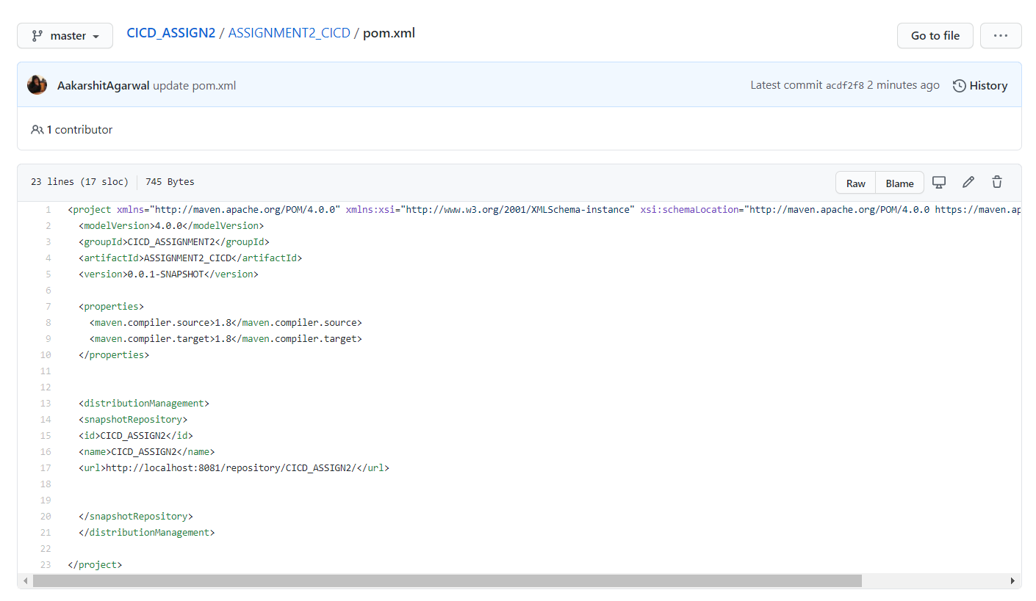

**Step 10:Run the following Maven Commands**

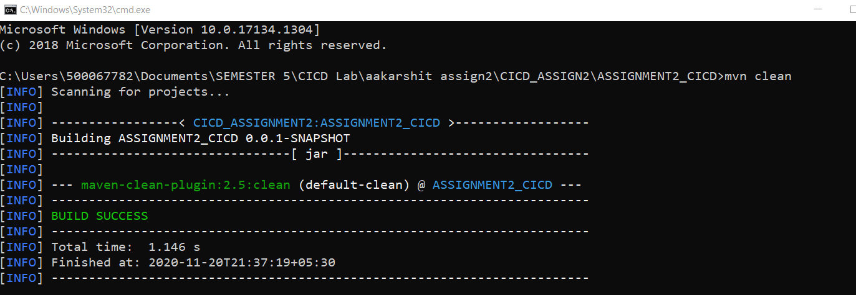

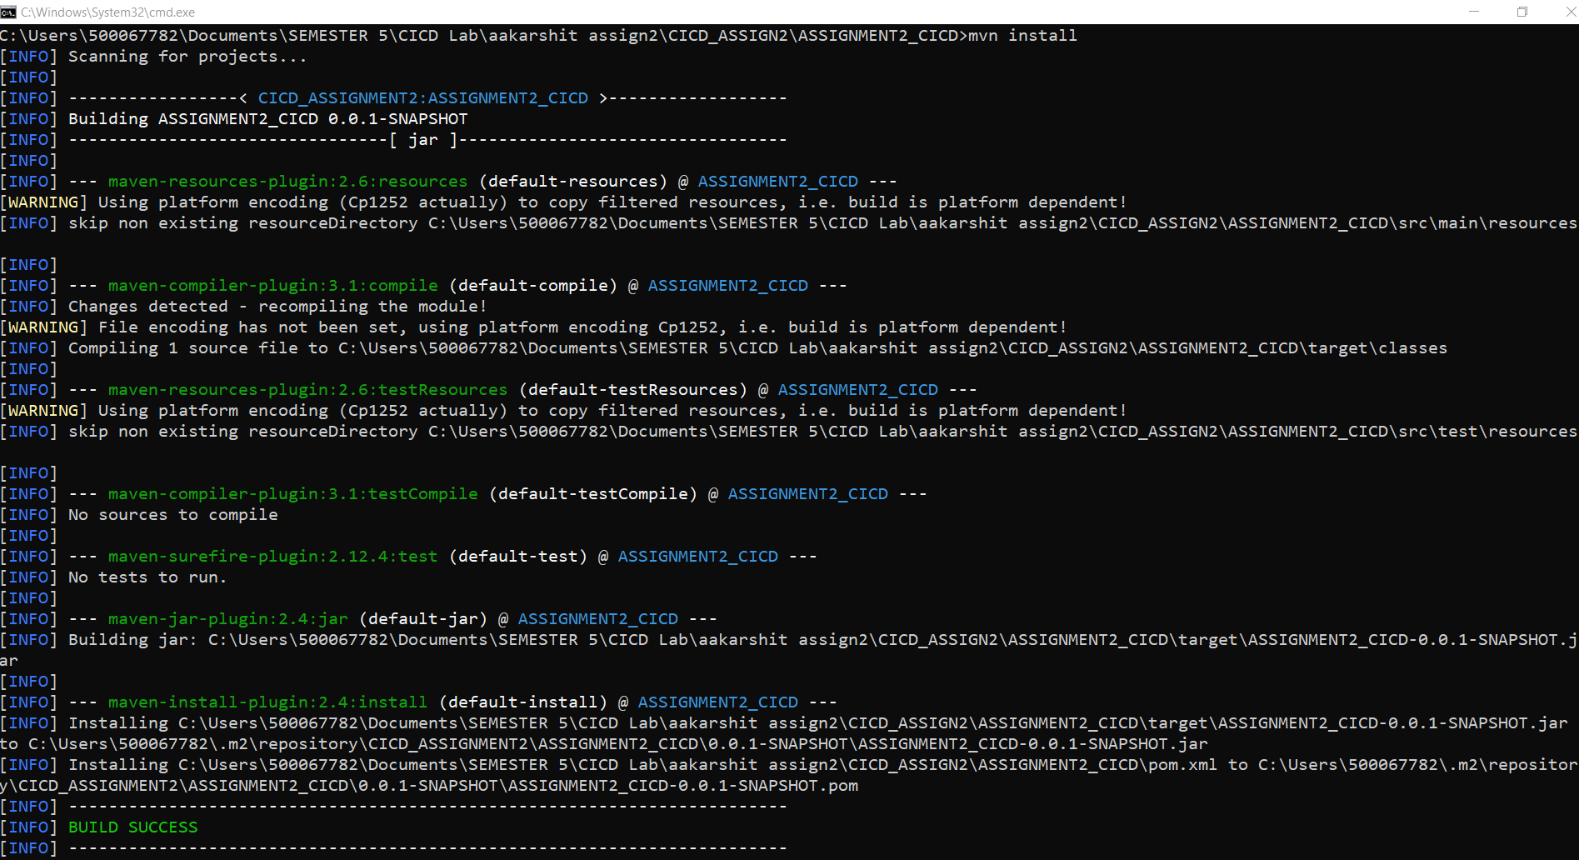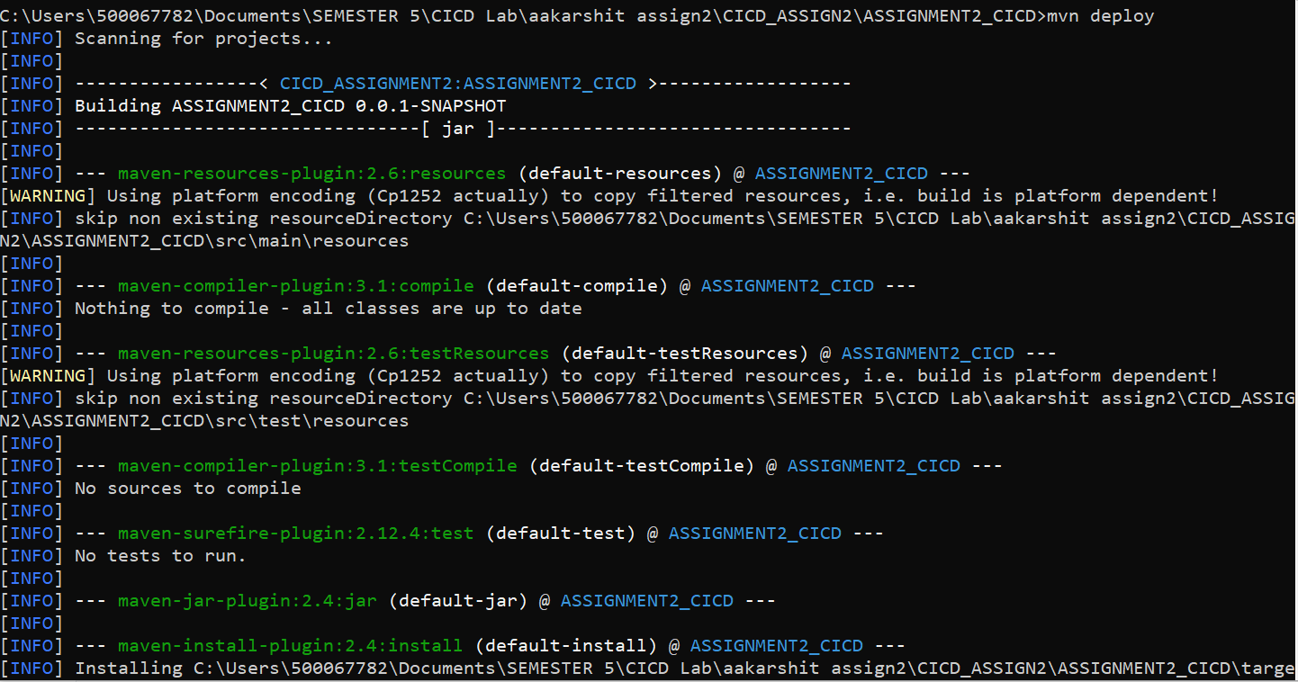

**Step 11: Go To Nexus Repository and Browse the Repository**

