**ASSIGNMENT**

**Aim:** Perform following steps using Git, Jenkins, Maven and Nexus and create a pdf  file including step by step screenshots.

**Step 1:** Create a Maven project using Eclipse/IDE.

Create a project a code editor.

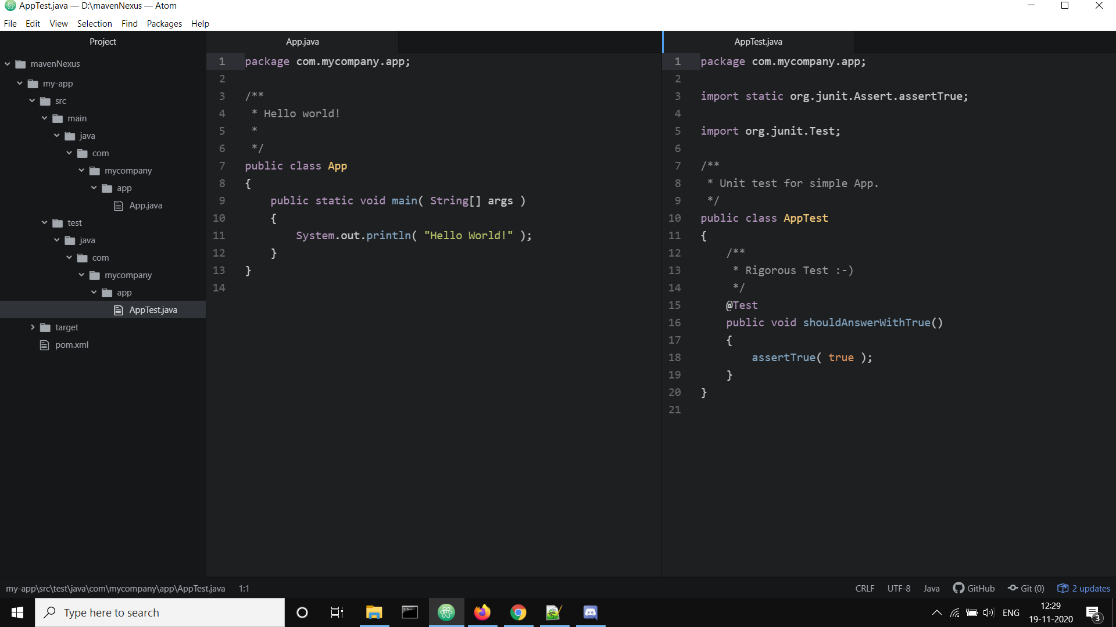

**Step 2:** Push the same running project on GitHub.

Pushing the code to github in the following way: 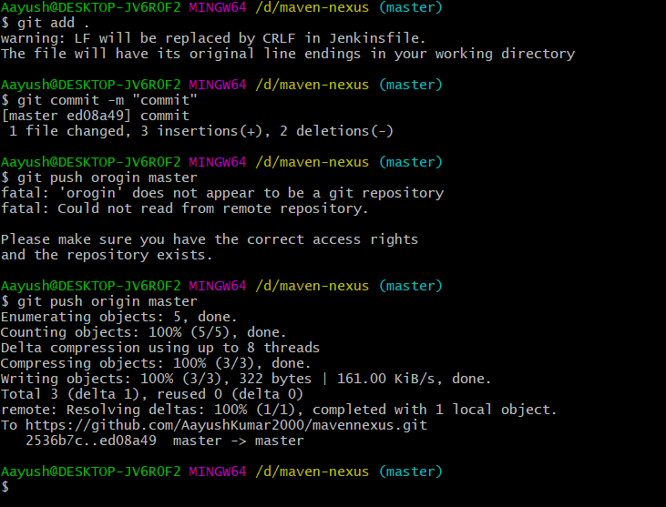

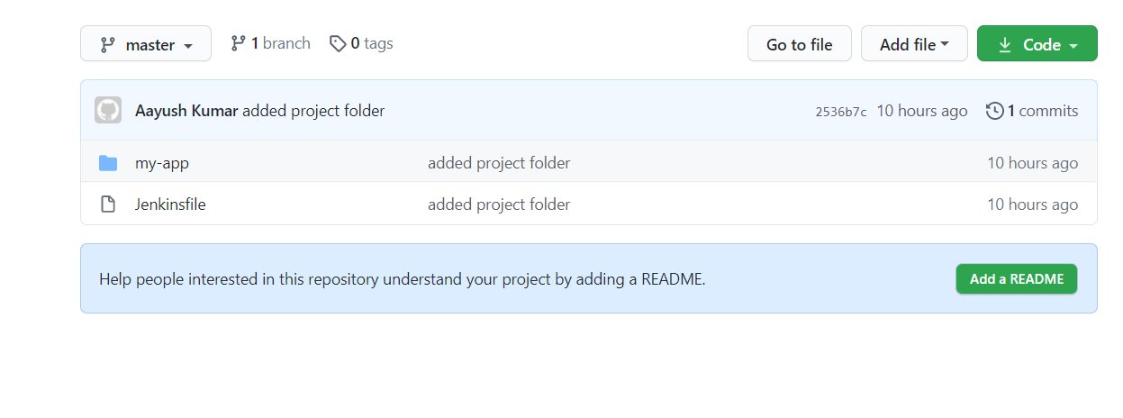

**Step 3:** Create a Jenkins Pipeline to generate build Jenkinsfile code and pushing the code on github

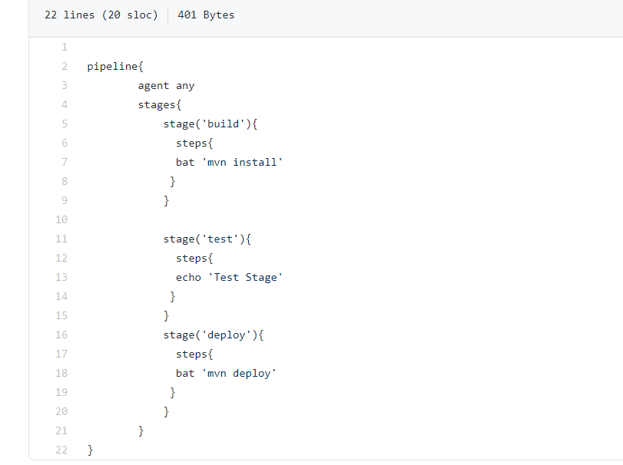

**Step 4:** Push the generated build on Nexus Server using Jenkinsfile in GitHub.

Configuring a Jenkins job that fill fetch the jenkinsfile from github and then run it and upload the code on the nexus server.

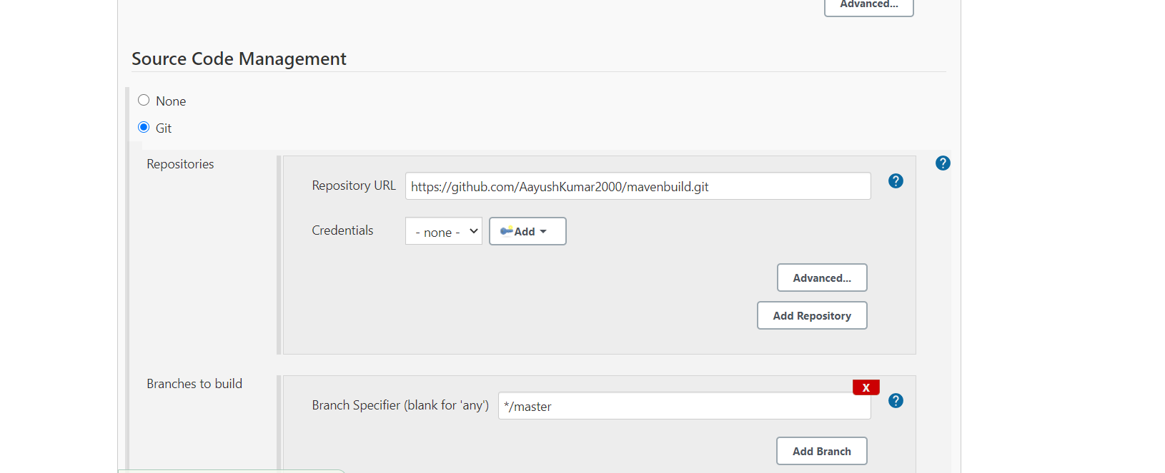

Click on build now to run the job and upload the code on the nexus server.

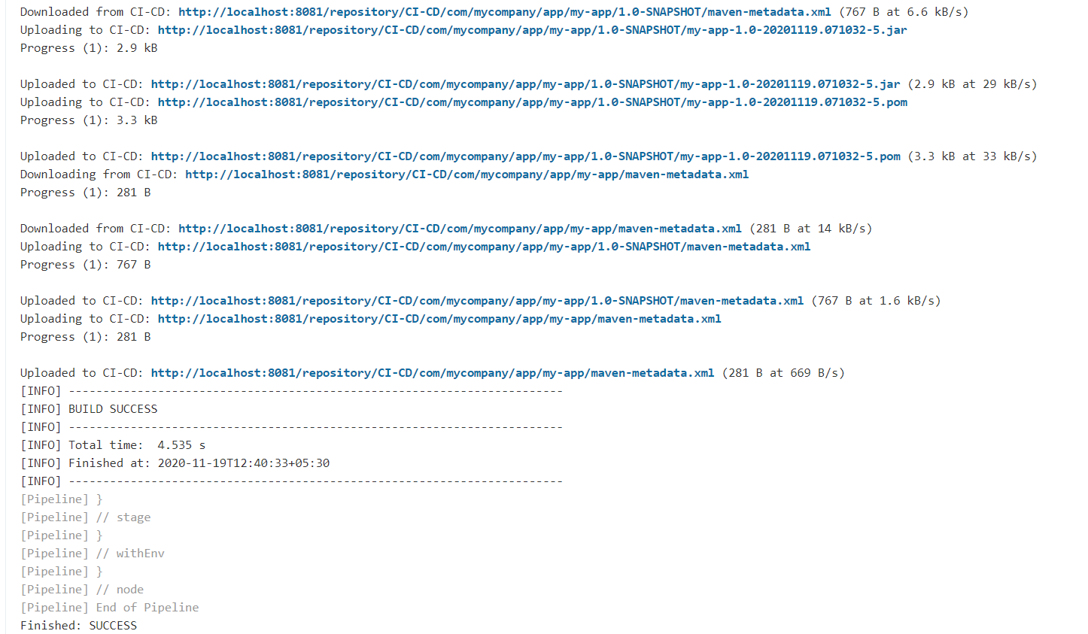

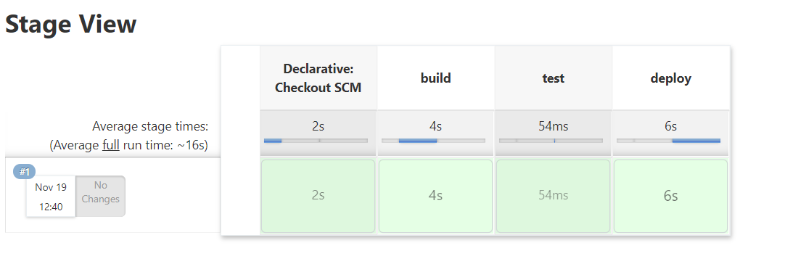

Output on the nexus dashboard:

