Name – Anubhav Deshwal

Roll no – R171218024

Sapid - 500069112

Assignment – 2

Step 1-Open Eclipse IDE and create a new maven project by choosing maven project option and filling the general configuration of the project. Assign an group ID and artifact ID to the project.

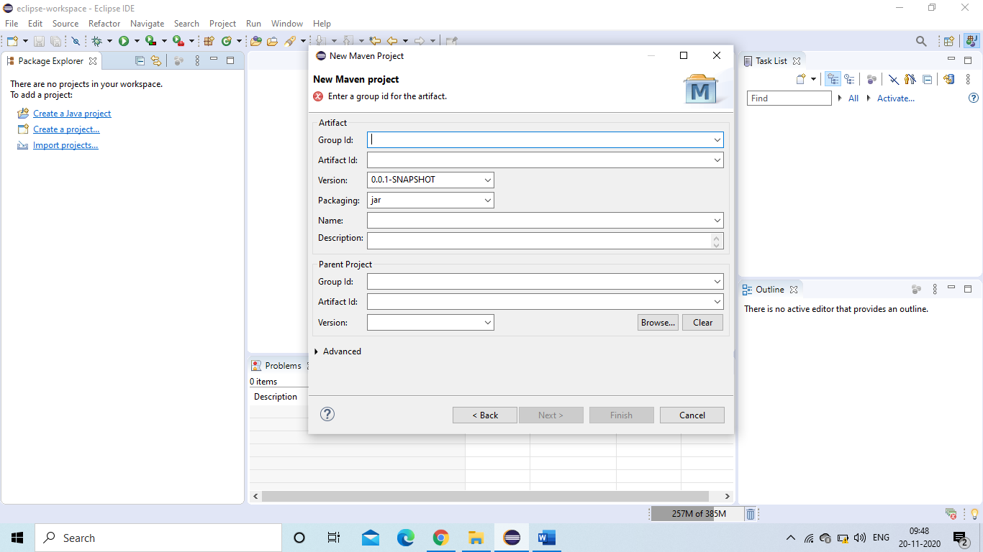

Step2 -Click Finish to successfully create the project, now right click on the project and select new and then a Java class for the source code.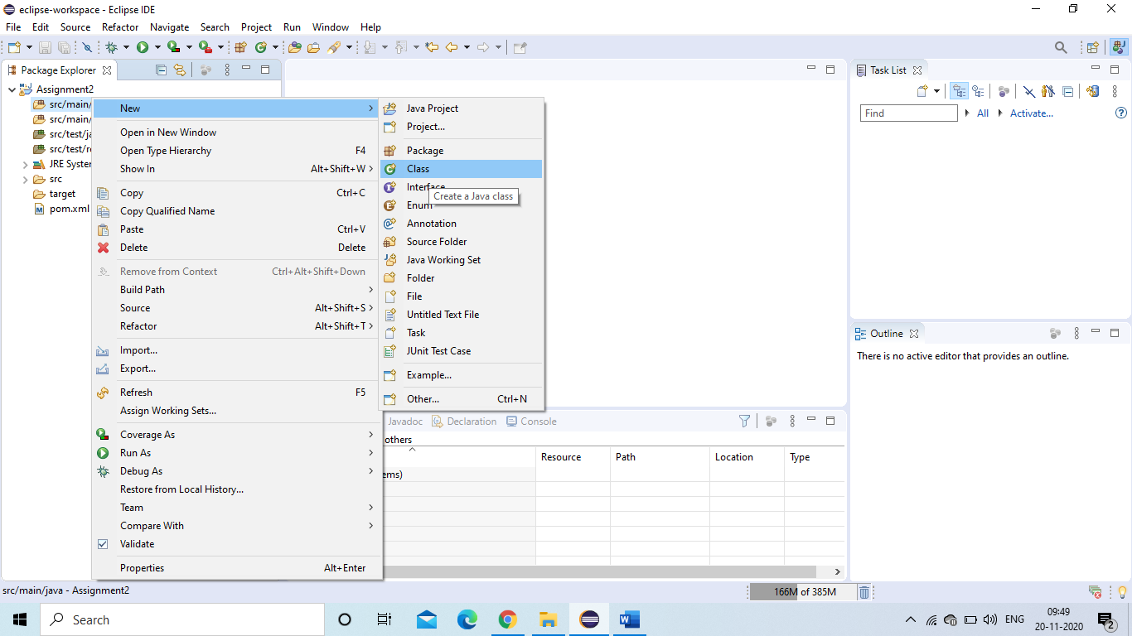

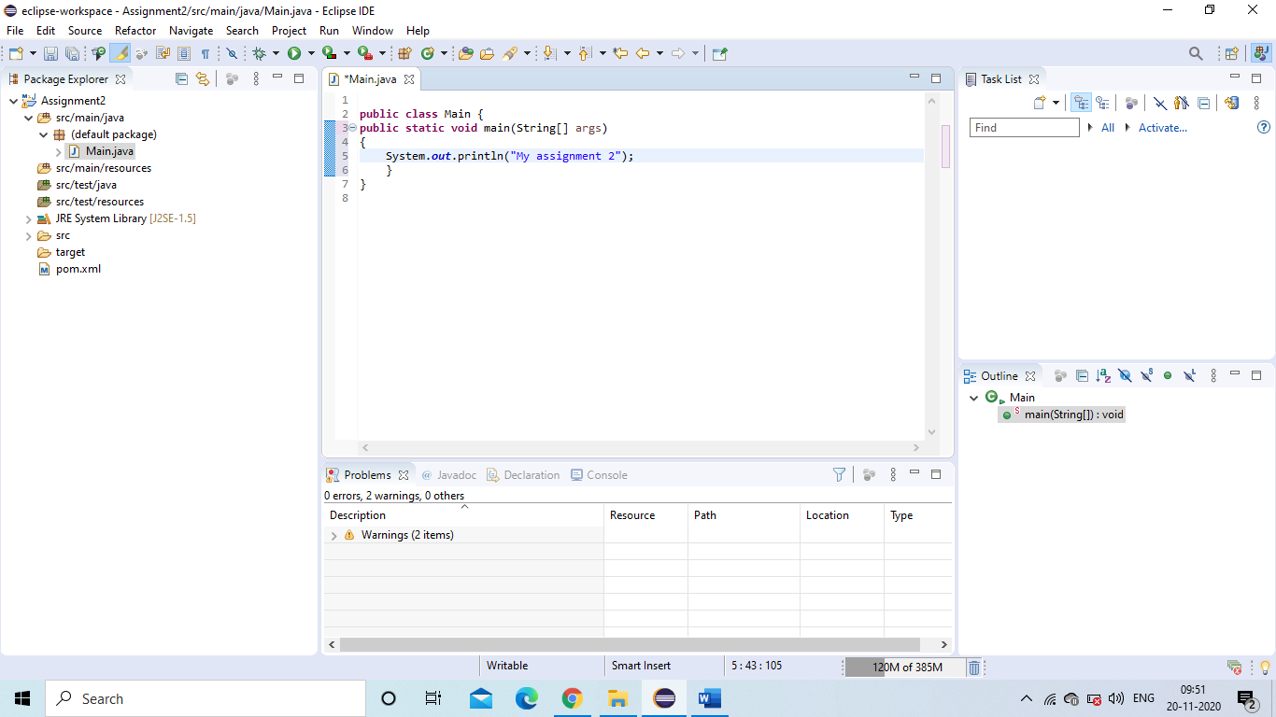

Step 3- we have to make a GitHub repository and connect it to eclipse so that we can push the project to GitHub.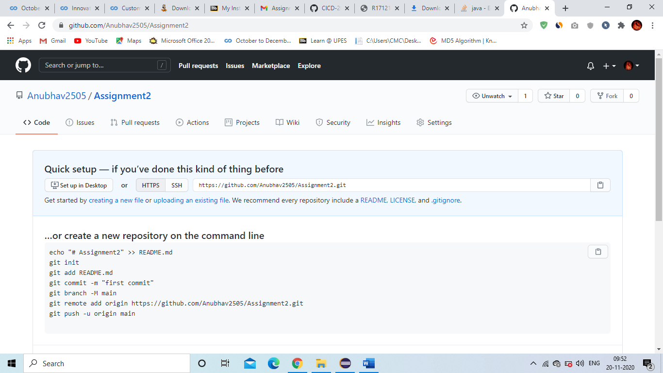

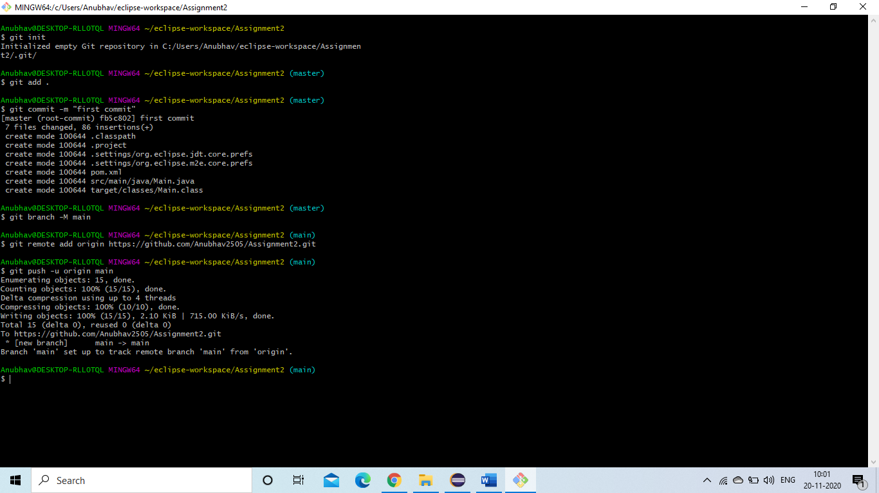

The project is available now on the git repository.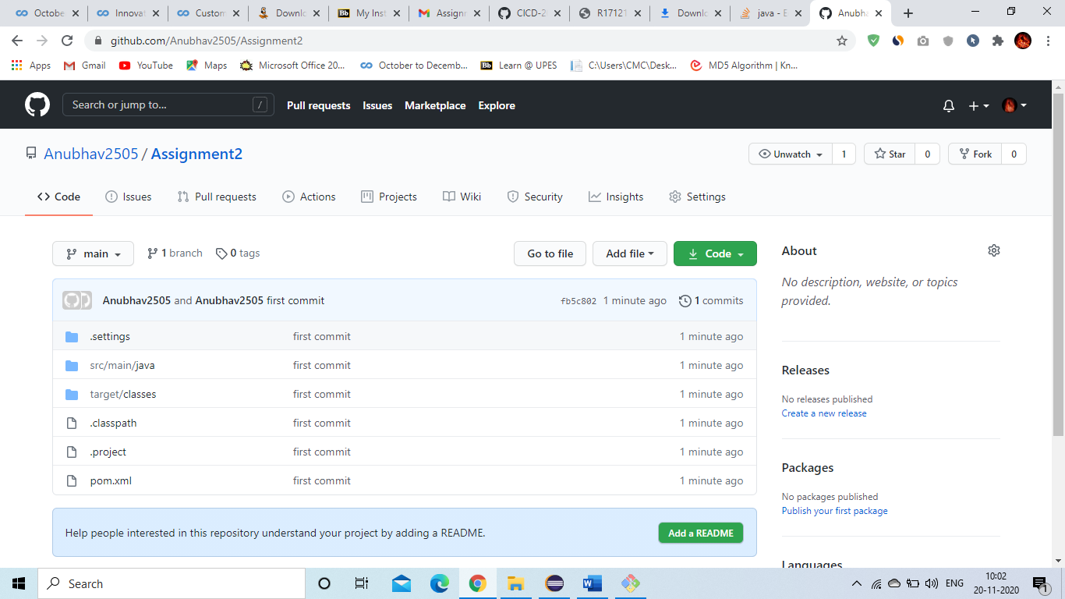

Step 4-Login to the Jenkins dashboard by using cmd and command ‘java -jar Jenkins.war’.

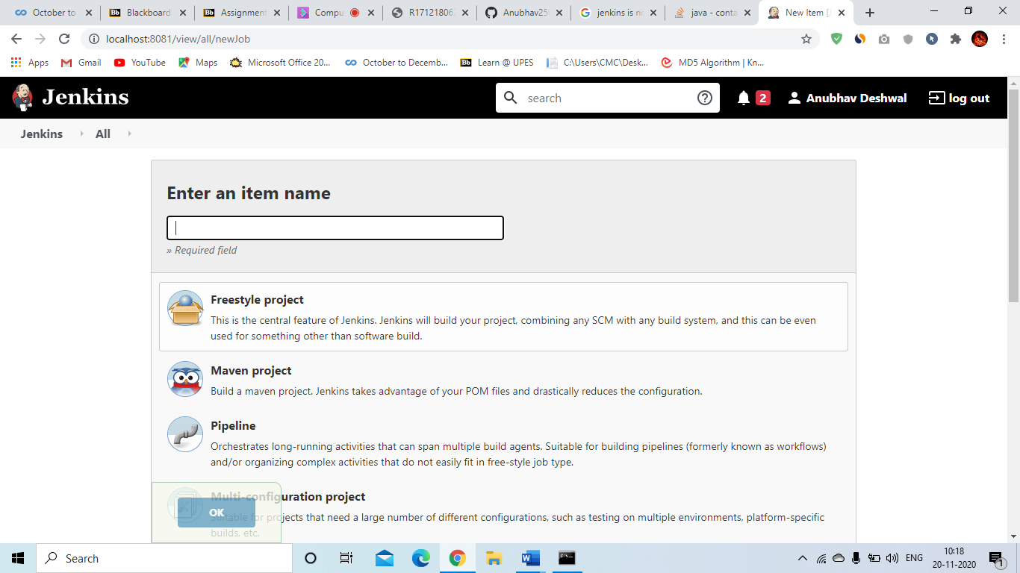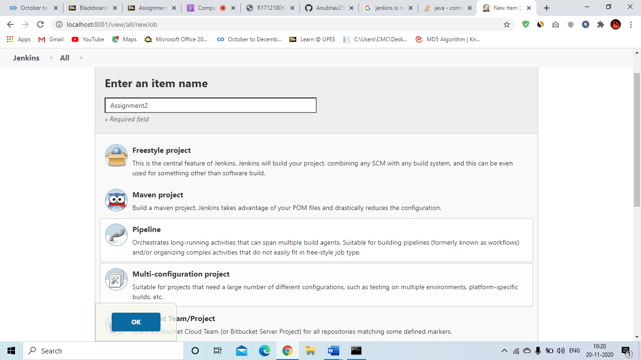

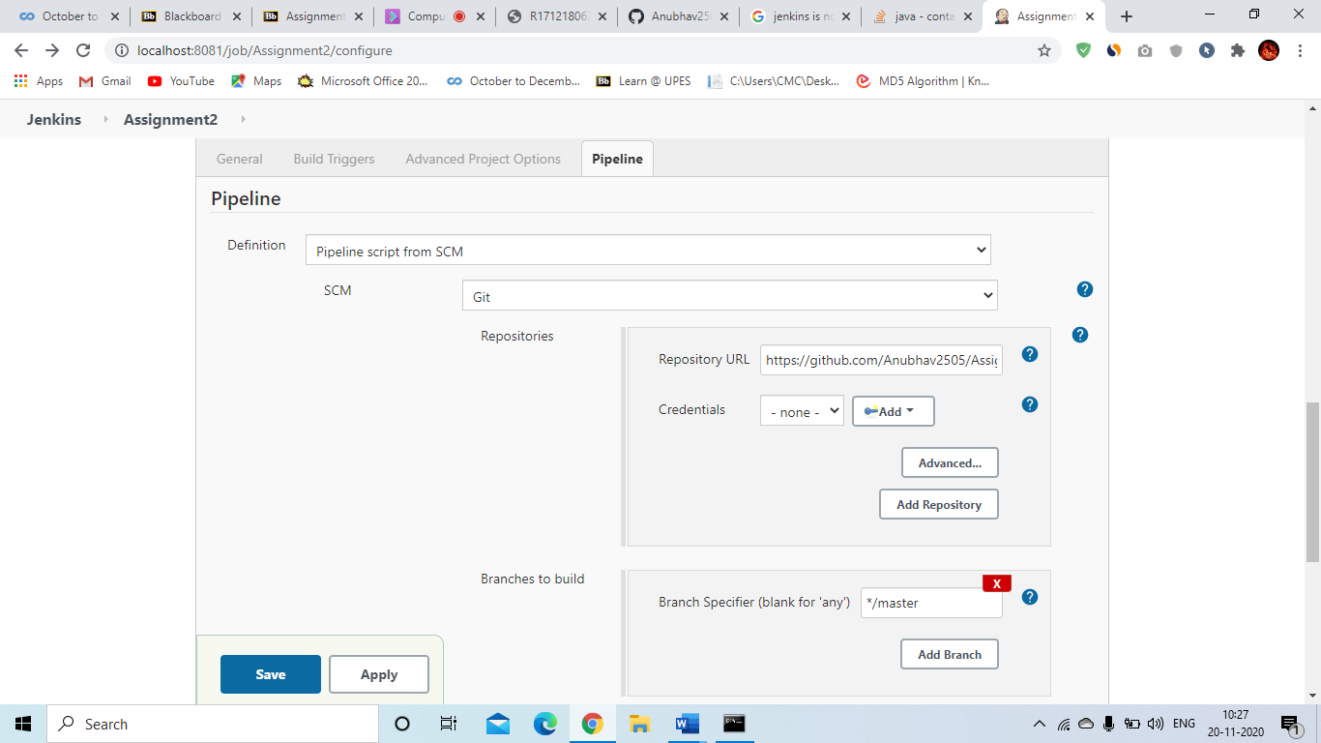

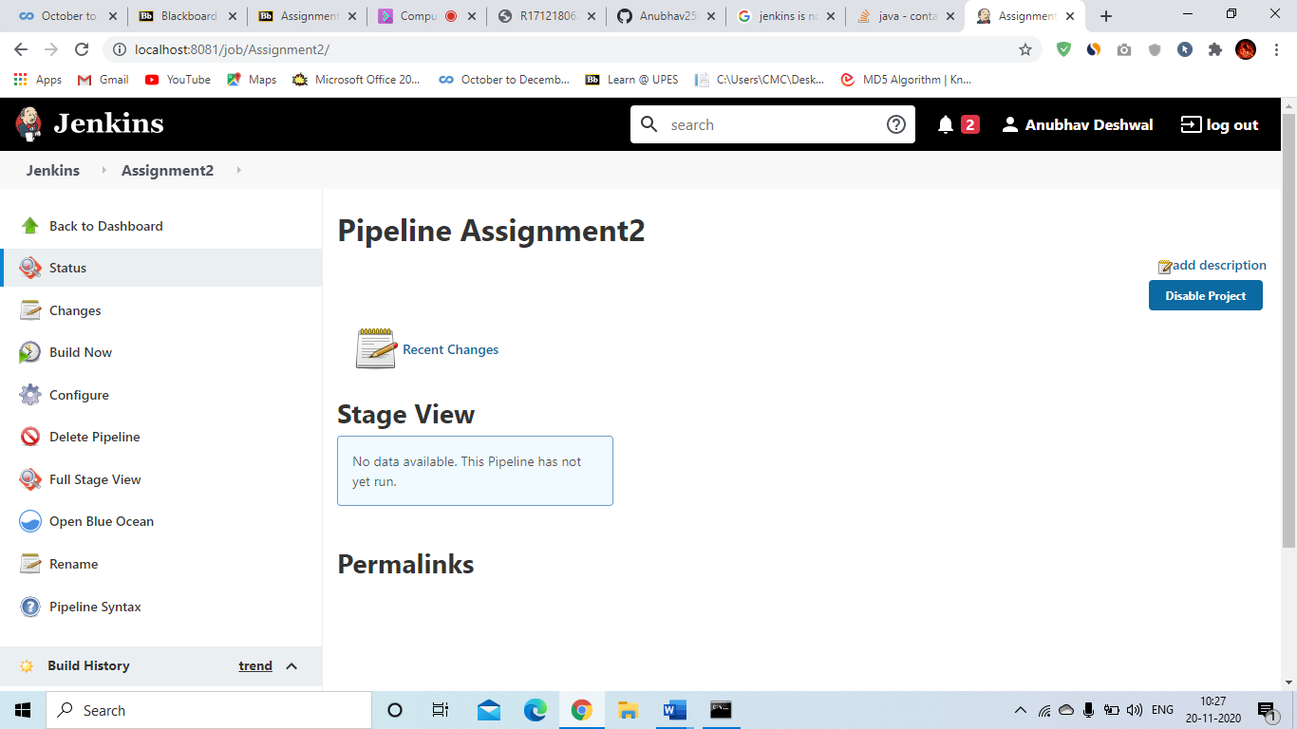

Step 5-Start nexus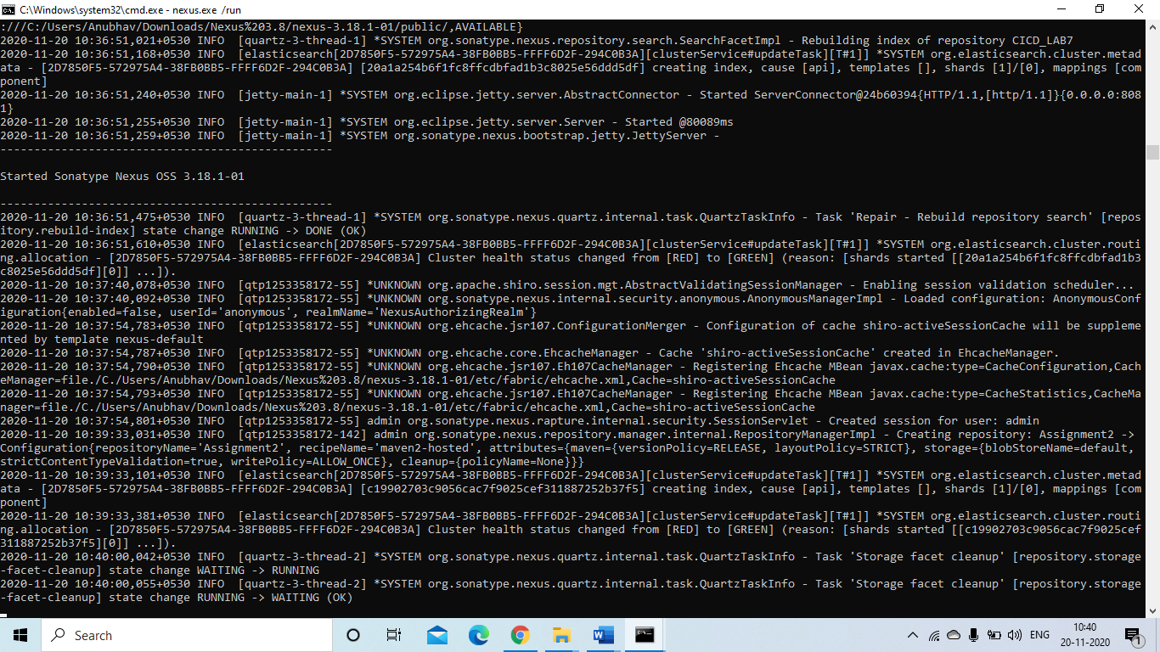

Step 5 – Make a new repository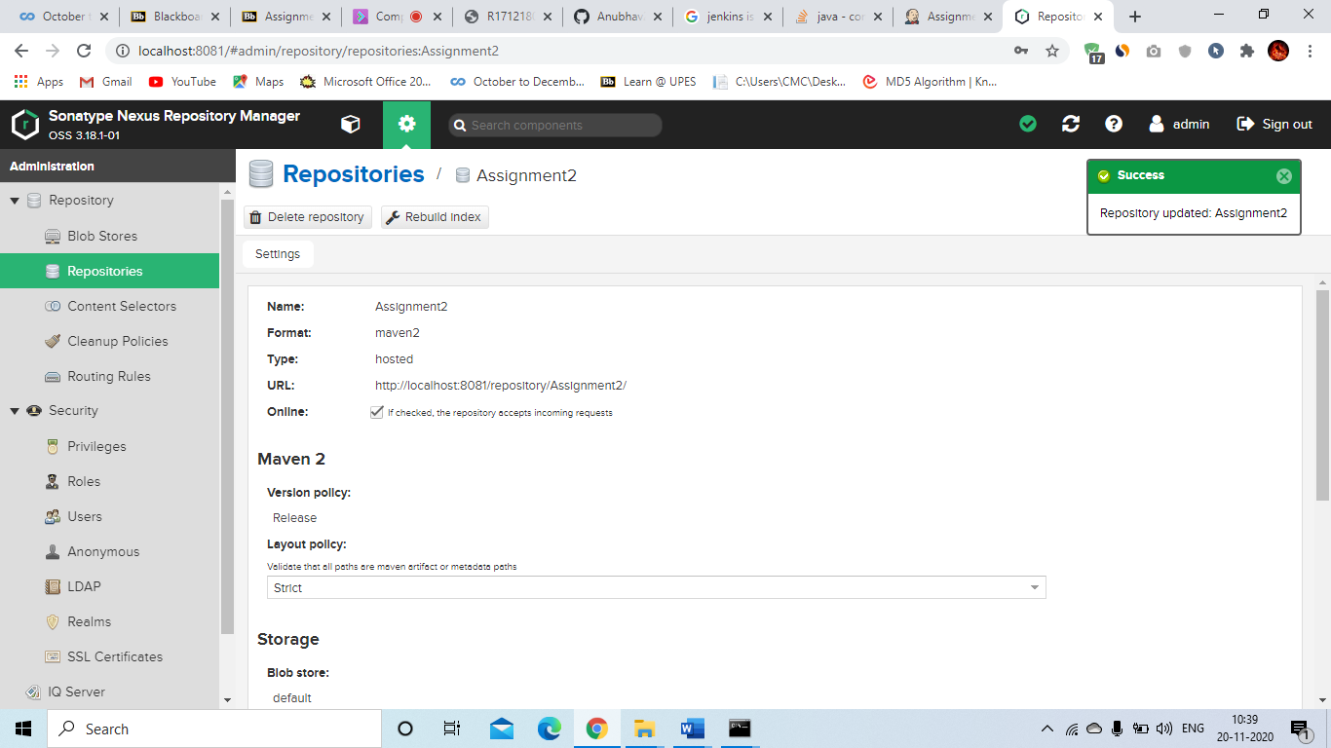

Step 6-

