# Food labels: Do consumers perceive what semiotics want to convey?

<http://dx.doi.org/10.1016/j.foodqual.2011.05.006>

Ares, G., Piqueras-Fiszman, B., Varela, P., Marco, R.M., López, A.M., Fiszman, S., 2011. Food labels: Do consumers perceive what semiotics want to convey? Food Quality and Preference 22, 689–698.

1. Introduction

A product’s package is the container that holds, protects, preserves and identifies the product, and which also facilitates its handling, storage and commercialization . Consumers usually actively scan packages before purchase (Ulrich & Malkewitz, 2008) and therefore packaging also plays a major role in attracting their attention and largely influence their purchase decisions . Consumers have to trade several sensory and non-sensory factors when making their everyday food choices . For this reason, in many companies great debates exist on whether a product’s performance in the marketplace is due to its sensory characteristics or to its associated imagery . Consumers draw important information about the product and its attributes from the package’s aesthetic and graphic design . Packaging is also a source of product recognition and serves as an extrinsic quality cue and provides consumers with information about brand image and lifestyle .

## 2.3. Design of the model labels

Five simulated yogurt label were designed by an expert industrial designer engineer from the Departamento de Proyectos de Ingeniería of the Universitat Politècnica de València. The designs were based on the previous semiotic analysis, specifically, by combining some representative elements of the main messages present in the commercial yogurts of the four surveyed markets. The objective was to create five labels capable of conveying very distinct messages.

The labels comprised different combination of non-verbal elements; the only text included was “Plain Yogurt” (Yogur Natural in Spanish), in different typographies and colors depending on the message and taking into account the semiotic analysis. The five designed model labels are displayed in Fig. 1. The labels were used as stimuli for a consumer survey.

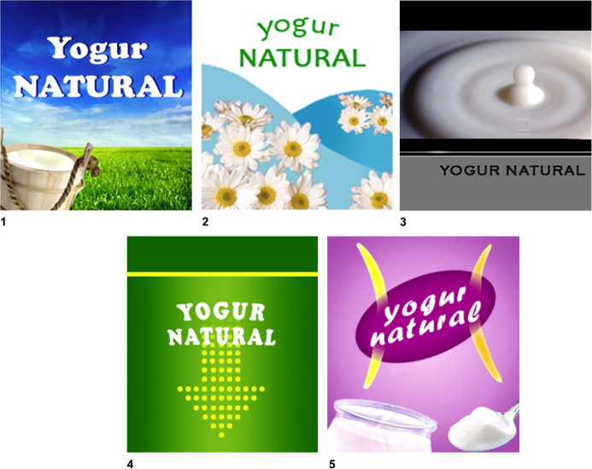

**Figure 1.** Model labels of plain yogurt used in the study. (1) Yogurt 1; (2) Yogurt 2; (3) Yogurt 3; (4) Yogurt 4 and (5) Yogurt 5.

## 3.1. Semiotic analysis

There are four main aspects of a label which can generate associations, and expectations in consumers’ mind: drawings (including the background and its texture), visual structure (relative positioning of the elements), colors and typography. According to considering that consumers’ purchase decisions are based on emotional aspects rather than on rational considerations, the symbolic meaning of images play a key role in determining consumers’ associations of a food label.

Table 2. Summary of results from semiotic analysis of the five yogurt labels considered.

|  |  |  |
| --- | --- | --- |
| Yogurt | Main message | Product characteristics, feelings and emotions conveyed by the label |
| Yogurt 1 | Natural, artisanal product | Freshness, naturalness, calm, relaxation, peace and purity |
| Yogurt 2 | Natural, ecological or organic product | Light or low-calorie, freshness, calm and relaxation |
| Yogurt 3 | Premium, high quality product | Exclusive, authentic and elegant |
| Yogurt 4 | Natural, positive effect on gastrointestinal health | Dynamism, joy, naturalness and optimism |
| Yogurt 5 | High quality product, positive effect on weight control | Feminine, weight control, authentic, dynamism and joy |

## 5. Conclusions

The results obtained in the word association task indicated that the main messages conveyed by the model labels were well understood in Spain and Uruguay.

However, some cultural differences were noted between the two countries.

In particular, the use of flowers in a yogurt label to convey “organic” was not successful in none of the countries, probably due to a low exposure to this sign because of the low penetration of organic yogurts. In addition, the use of black color to convey the meaning of high quality, premium or exclusive was successfully understood in both, even if this color is not used in yogurt labels in none of the countries. However this concept was rejected by some Uruguayan consumers, probably because of the absence of these colors in milk product packaging in their country, leading to an incongruence of meaning.

## References