Asian University ML Camp in Jeju

**July 22 ~ August 7, 2018**

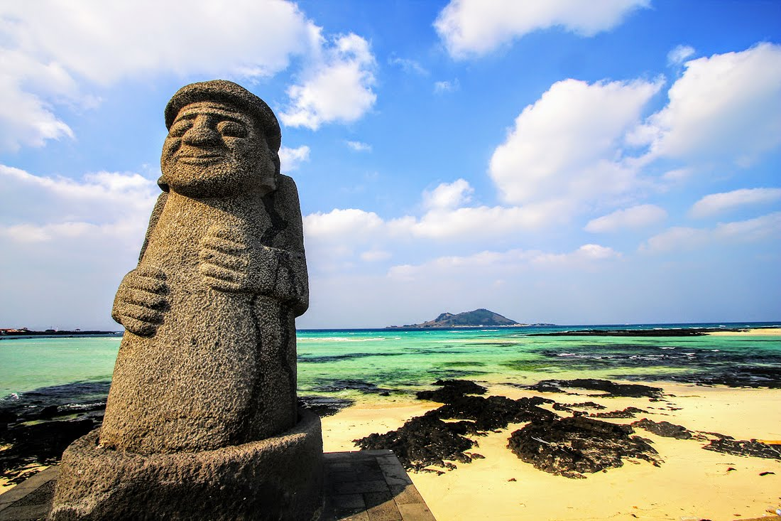

If you have interests in machine learning/deep learning and TensorFlow, you should want to have a chance to implement non-trivial and decent applications for learning machine learning deeply. Here is a good news. We invite you to join the 17-day long Asian University Machine Learning Camp in Jeju 2018, where you can do that and have a fun and unforgettable memory with your friends from other universities.

For the period, we will design and train a deep learning model for a specific application using TensorFlow from start-to-finish with your mentor. We might have access to some more mentors/experts to help you to implement your idea. We hope you get the benefit of this wonderful opportunity.

All of you guys selected as attendees(mentors and mentees) will be provided with rooms and meals during the camp at Jeju National University. Round-trip airfare to Jeju Island (South Korea) will be covered fully for the mentors and up to 500USD will be supported to each mentee for flights. In addition to these benefits, participants will get valuable and practical experiences in the field of machine learning/deep learning. We look forward to your application!

(Information regarding schedule, program, and benefits are subject to change)

Camp Overview

* Date: July 22 through August 7, 2018 (17 days, check-in date: July 22)
* Up to 15 mentees and some mentors will be invited.
* Venue: Campus of Jeju National University, Jeju, South Korea
* Host: Jeju National Univ.
* Supporter: Jeju Development Center, IIST (Subject to change)
* Contacts: Prof. Dr. Yung-Cheol Byun [ycb@jejunu.ac.kr](mailto:ycb@jejunu.ac.kr)
* Contacts (for Indonesian candidates for application): Prof. Dr. Kiyota Hashimoto (hash@kyhash.info)

Qualification

* Asian Universities
* No nationality, gender, age, and etc.
* Undergraduate and/or graduate students --> For Indonesian candidates: graduate students only
* Must stay in Jeju Island from July 22 to August 7 (17 days).
* Weekday camp programs from 10 AM to 6 PM and free time during the weekend
* Understanding of machine learning frameworks including TensorFlow or others, and the ability for implementation using programming languages
* Basic communication skills in English (All programs will be in English)
* Clear personal project description on what they would develop in the camp
* Produce practical applications of machine learning and/or research results in, for example, Image classification, Chatbots, Auto Q&A, Spam detection, and etc.
* 30% or more design/implementation of your project should be done before joining the camp to make it during the short camp period
* Project results will be shared together
* For Indonesian candidates: when chosen, students must join a couple of online (or offline) meetings that are planned *before* the camp.

Pre-Application for Indonesian Students

* 1 or 2 graduate students will be chosen
* Mentor will be Prof. Dr. Kiyota Hashimoto (PSU, Thailand), or another professor
* Deadline: 15-June
* Send *Pre-Application of Asian University ML Camp in Jeju for applications from Thailand*  to Prof. Dr. Kiyota Hashimoto ([hash@kyhash.info](mailto:hash@kyhash.info))
* Your planned project must be of the topics of deep learning. (It is possible to pick up some parts of your current research at your graduate school, but be sure that your planned project for this camp can be finished by the end of the camp

Application --> After pre-application selection

* Your proposal for Asian University Machine Learning Camp Jeju 2018 Project
* Please use the application form for Asian University ML Camp and describe information as in detail as possible.
* CV that showcases your experience about deep learning, Python, and TensorFlow
* Other supporting materials to show your expertise

Organizing Committee

* Yungcheol Byun, Jeju National University, Korea
* Lap Nguyen Trung, Hoasen University, Vietnam
* Bobby D. Gerardo, West Visayas State University, Philippines
* Tokuro Matsuo, Advanced Institute of Industrial Technology, Japan
* Debnath Bhattacharyya, Vignan’s Institute of Information Technology, India
* Chan Yeob Yeun, Khalifa University, UAE
* Kiyota Hashimoto, Prince of Songkla University, Thailand
* Chi-Man Pun, University of Macau, China
* Satoshi Takahashi, The University of Electronic-Communications, Japan

Hosted by

* Jeju National University
* Institute of Information Science & Technology

Supported by

* Jeju Development Center (JDC)
* Jeju Special Province
* Camp Teams
* 5~10 local & remote mentors: daily on/off-line meetings
* 15 attendees from Asian countries
* A few number of speakers (subject to change)

Venue (Jeju Island, Korea)

Located just off the coast of the Korean peninsula, Jeju Island is the largest volcanic island in Korea. Also known as Asia's Hawaii, the island is rife with beautiful sceneries and getaway resorts. Jeju boasts several natural treasures including Mount Halla, the country's highest peak, Trail Olle that winds around the rocky coastline, and Sunrise Peak, a dormant volcano ideal for catching sunrises and sunsets. You will be able to fully experience the island's charm for as long as a month stay without a visa. For more information, please visit at: http://www.visitjeju.net/en/index.jto.

Timeline

* June 23: attendee’s application due
* July 1: Selecting candidate(s) of participants by mentors (checking the quality of project and possibility of implementation)
* July 4: Announcement of final attendees by committee
* July 15: Mentee-mentor meeting(online/offline) and fix 2-week schedule before joining
* July 22: Check-in
* July 23: Camp starts with the intensive implementation
* August 6: Final presentation
* August 7: Check-out

Camp Schedule

|  |  |  |  |  |  |  |
| --- | --- | --- | --- | --- | --- | --- |
| Sun | Monday | Tuesday | Wednesday | Thursday | Friday | Saturday |
| 7/22 | 7/23 | 7/24 | 7/25 | 7/26 | 7/27 | 7/28 |
| check-in  (dormitory) | .orientation and setting  .10 minute speech: self/project introduction | .10am-10:30, 1min speech (what to do today)  .10:30~12pm, project  .12pm~1pm, lunch 1pm~5pm, project  .5pm-6pm, 5min speech(what I’ve done and challenges)  .6pm-7pm, dinner  .7pm-8pm, mentoring | .10am-10:30, 1min speech (what to do today)  .10:30~12pm, project  .12pm~1pm, lunch 1pm~5pm, project  .5pm-6pm, 5min speech(what I’ve done and challenges)  .6pm-7pm, dinner  .7pm-8pm, mentoring | .10am-10:30, 1min speech (what to do today)  .10:30~12pm, project  .12pm~1pm, lunch 1pm~5pm, project  .5pm-6pm, 5min speech(what I’ve done and challenges)  .6pm-7pm, dinner  .7pm-8pm, mentoring | .10am-10:30, 1min speech (what to do today)  .10:30~12pm, project  .12pm~1pm, lunch 1pm~5pm, project  .5pm-6pm, 5min speech(what I’ve done and challenges)  .6pm-7pm, dinner  .7pm-8pm, mentoring | Excursion/party and getting together |
| 7/29 | 7/30 | 7/31 | 8/1 | 8/2 | 8/3 | 8/4 |
| Free time | .10:00~12pm, project  .12pm~1pm, lunch 1pm~5pm, project  .5pm-6pm, 5min speech(what I’ve done and challenges)  .6pm-7pm, dinner  .7pm-8pm, mentoring | .10:00~12pm, project  .12pm~1pm, lunch 1pm~5pm, project  .5pm-6pm, 5min speech(what I’ve done and challenges)  .6pm-7pm, dinner  .7pm-8pm, mentoring | .10:00~12pm, project  .12pm~1pm, lunch 1pm~5pm, project  .5pm-6pm, 5min speech(what I’ve done and challenges)  .6pm-7pm, dinner  .7pm-8pm, mentoring | .10:00~12pm, project  .12pm~1pm, lunch 1pm~5pm, project  .5pm-6pm, 5min speech(what I’ve done and challenges)  .6pm-7pm, dinner  .7pm-8pm, mentoring | .10:00~12pm, project  .12pm~1pm, lunch 1pm~5pm, project  .5pm-6pm, 5min speech(what I’ve done and challenges)  .6pm-7pm, dinner  .7pm-8pm, mentoring | Excursion/party and getting together |
| 8/5 | 8/6 | 8/7 |  |  |  |  |
| Free time | .10:00~12pm, Final presentation  .12pm~2pm, Pizza time and let’s share our feelings! | .check-out |  |  |  |  |

Benefits for students

* Enjoy Jeju Island during the summer season
* Meet our friends from various Asian Universities
* Find the chance to enhance your skill in TF/DL
* Implement some practical applications/results using machine learning frameworks
* Live in Jeju for 17 days (accommodation and meals are supported) + various activities on weekends as you like
* The flight fare will be covered for each student (up to 500USD).

Co-Events

* Global Deep Learning Camp will be held in the same place for 1 month.
* You all might join some open seminar of the global camp(TBA).
* Sharing knowledge with the guys attending the global DL camp
* Visiting local places & having fun together

Potential Collaborations with Locals (subject to change)

* Invite students from Jeju National University
* Meetings with Jeju Science High school
* Other IT-related companies