How to install and run the dashboard on Windows OS

# Set up a webserver

1. Download and install XAMPP: <https://www.apachefriends.org/de/index.html>
2. Make sure that the host PC is part of the internal network and determine it’s IP address: Win+R -> cmd -> ipconfig

1. Open the XAMPP control panel
2. Click on Apache -> Config -> Apache (httpd.conf)

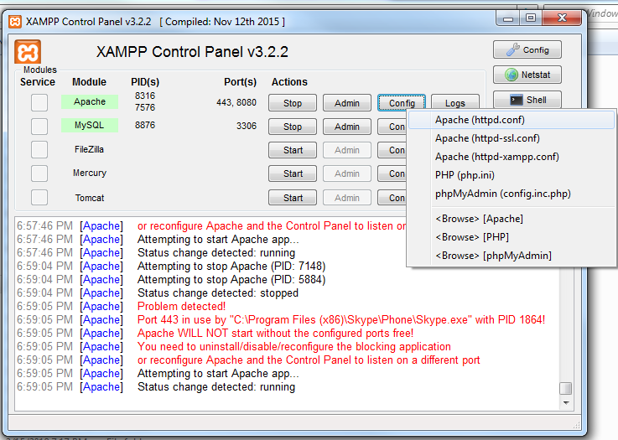

1. Search for “# Listen” and replace the two lines with the IP address (in this case: 192.168.195.58) and a port number different from “80” and “8080” (in this case: 81):

and change its server name:



1. Save and close the editor
2. Click on Apache -> Config -> Apache (httpd-xampp.conf)

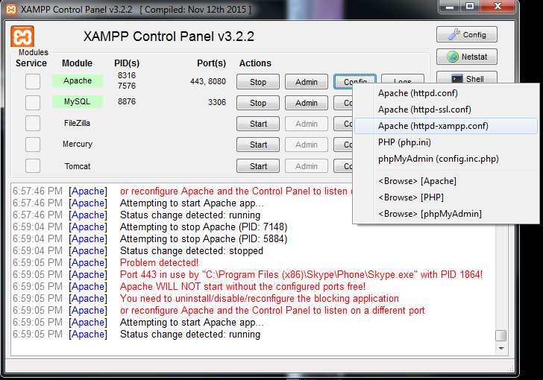

1. Replace

with

1. Save and close the editor
2. Allow XAMPP through the Windows firewall: Search for security -> Windows Security -> Firewall & network security -> Allow and app through firewall option -> Change settings -> Make sure that Apache HTTP Server has a left tick and one on “private” or “public” -> OK -> Close



1. Click on Apache -> Start and MySQL -> Start to start the server

# Install the application

1. Place the configured solution folder in C:\xampp\htdocs and rename the folder to “FOLDER_NAME”
2. Create the database table by running <http://192.168.195.58:81/FOLDER_NAME/index.php>

# Run the website

1. If a device is part of the same network, run the website: Open a browser -> <http://192.168.195.58:81/FOLDER_NAME/index.php>

Note: only the host PC is able to manually view and edit the database via <http://192.168.195.58:81/phpmyadmin>

# DEPRECATED:

# Create a database table for the user logins

1. Open a web browser and enter the URL: “<http://localhost/phpmyadmin/>“
2. Create a new database: “quality_management“ with “utf8_general_ci“
3. Create a new table: “users“ with “5“ fields
4. Fields: “id“, “username“, “password“, “last_login“, “admin_rights“
   1. id: index PRIMARY, A_I (auto increment)
   2. username: type VARCHAR, length 30
   3. password: type VARCHAR, length 30
   4. last_login: type VARCHAR, length 100
   5. admin_rights: type BOOLEAN
5. Save the table
6. Insert one new users (value admin, value admin, value 2000-01-01T00:00, value 1) and click “Go“

# Create a table for the projects

1. Open a web browser and enter the URL: “<http://localhost/phpmyadmin/>“
2. Create a new table “projects“ with “7“ fields for the database “quality_management“
3. Fields: “id“, “project_name“, “project_description“, “project_manager“, “design_team“, “site_manager“, “site_crew“
   1. id: index PRIMARY, A_I (auto increment)
   2. project_name: type VARCHAR, length 30
   3. project_description: type VARCHAR, length 300
   4. project_manager: type VARCHAR, length 30
   5. design_team: type VARCHAR, length 30
   6. site_manager: type VARCHAR, length 30
   7. site_crew: type VARCHAR, length 30
4. Save the table

# Run the website

1. Move the development folder to C:\\xampp\\htdocs
2. Run the script: “<http://localhost/Quality_Management/login.php>“

Hint: in Chrome, use the development tool to debug and disable the cache (while the development tool ist open) to ensure that all files are fetched properly.

# Update

- Image uploads and downloads via the database

- People column as a drop down menu (only one person can be selected & only people who are assigned to the project are available selection options)

- Person who is assigned to an issue has edit rights

- New column headers: “Issue Resolved” 🡺 “Completed” & “Effects” 🡺 “Issues”

- A new column “Solution” next to the people column