Name:

Answer each question.

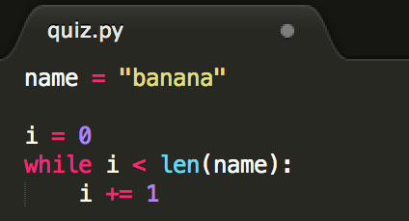

What does *i* equal after the while loop has run? Answer: i=6

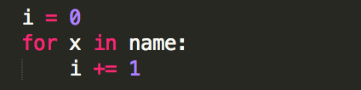

What does *i* equal after the for loop has run? Answer: i=6

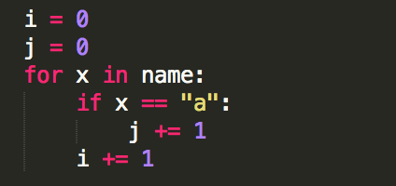

What do *i* and *j* equal after the for loop has run? Answer: i=6, j=3

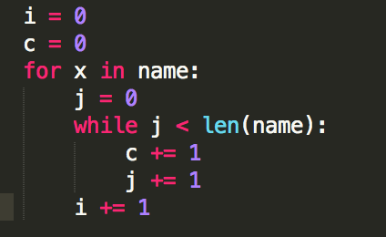

What do *i* and *c* equal after the for and while loops have run? Answer: i=6, j=6, c=36