Donald Tucker
donald@dtucker.xyz | LinkedIn
Industrial Engineer with manufacturing experience harnessing data analysis and lean principles to drive process improvements initiatives. Skilled in data visualizations, data mining, and statistical analysis to communicate insights to cross functional teams. Enabling data informed decisions.
Skills
Exploratory Data Analysis, Regression, Machine Learning, Process Improvement, Capacity analysis, Data Viz
Experience

Lockheed martin

9/2025 – present

Industrial Engineer Sr Staff, Lockheed martin - Aero Core IE

IE 1LMX Functional Architect, bridging IE and software development to lead cross business area teams in assessing current processes and defining a 2029 technical roadmap.

11/2022 – 9/2025

Industrial Engineer Mgr, Lockheed martin - Aero F35
Led a team of 17-20 Industrial Engineers to develop and implement metrics and data analytics processes, improving resource allocation efficiency and mitigating constraints.
- Implemented AI/ML Project to forecast prod spans, reduced forecasting error from 2 months to 2 days using XGBoost
- Implemented a ML RandomForest prediction on aircraft percent complete visualized in Tableau
- Led multiple Cost and Schedule Impact analysis

10/2019 – 11/2022

Industrial Engineer Asc Mgr, Lockheed martin - Aero F35
IE Asc Manager leading team of 8-12 production floor Industrial Engineers to develop metrics, data analytics, process improvement opportunities, resources allocation, and constraint mitigation plans.

9/2012 – 10/2019

Industrial Engineer Asc - Industrial Engineer Stf, Lockheed martin - Aero F35
Technical Lead Industrial Engineer role leading the integration of functional IE solutions by analyzing and developing production plans and monitoring production health metrics.
Education

5/2012
MS Industrial Engineering, New Mexico State University

12/2008
BS Industrial Engineering, University of texas at el Paso

Certifications
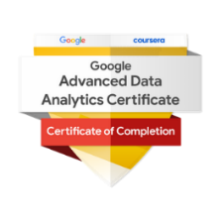
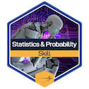
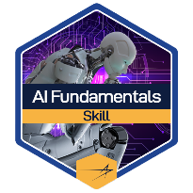
- LM AI/ML Skills Badge and Practitioner Badge, Apprenticeship
- Google Advanced Data Analytics Certificate
- LM Statistics and Probability for Python - Skills Badge
- AI for Predictive Maint anomaly detection Certificate
Software
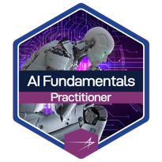
Python, Tableau (Portfolio), SQL, Business Objects, Power BI, Power Query, SAP, ECM, MAP, CAPP, ETS, MATLAB, Minitab, Process Simulator, Pro/Engineer, Solidworks, IntelliCad, DraftSight, Qlikview, HTML, CSS

