Open to portal.azure.com and authenticate with your company credentials.
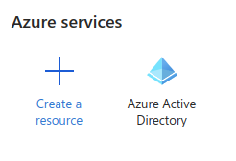

Select Azure Active Directory
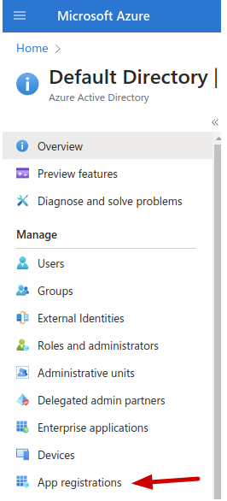

Scroll down and Select “App Registrations”

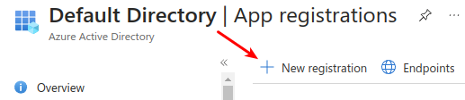

Select New Registration

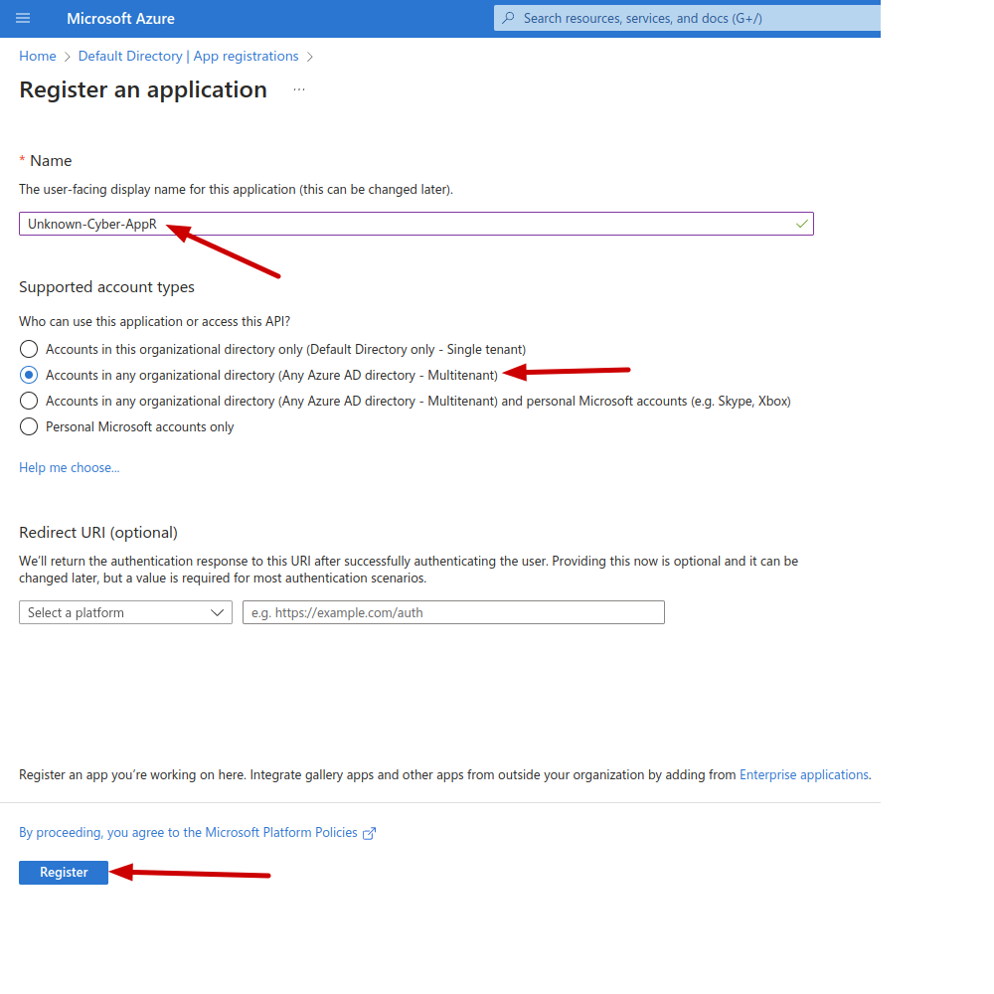

- We recommend the naming convention “Unknown-Cyber-AppR-CustomerName”
- Set for Multi-Tenant
- Click Register

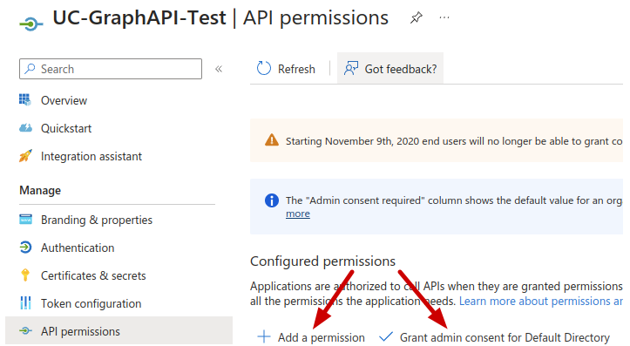

- Open the Newly Created App Registration.
- Ensure that “Grant admin consent for Default Directory” has a check mark, if not click the + Next to Grant and go through the wizard.
- Click on Add a Permission

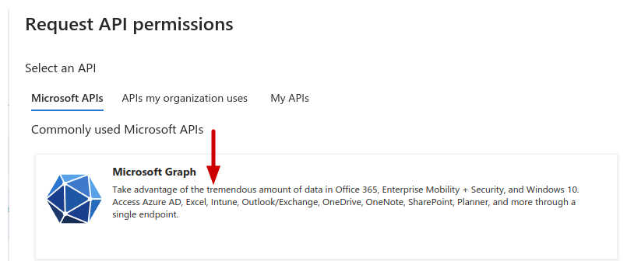
- Select Microsoft Graph

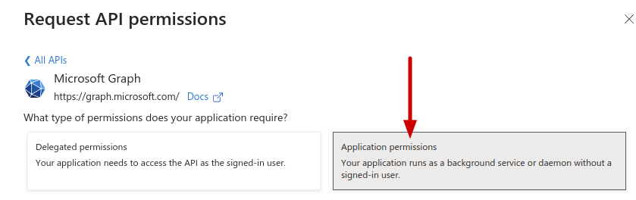
- Set to Application Permissions

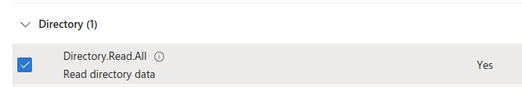
- Select Directory.Read.All
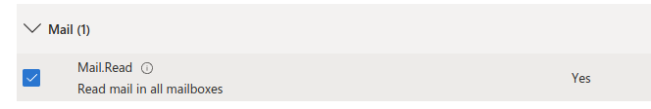
- Select “Mail → Mail.Read”
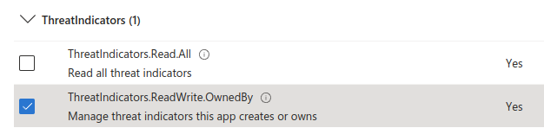
- Select “ThreatIndicators → ThreatIndicators.ReadWrite.OwnedBy”
- Click “Add permissions” at the bottom of the screen.

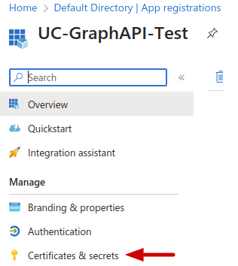

- Select “Certificates and secrets”
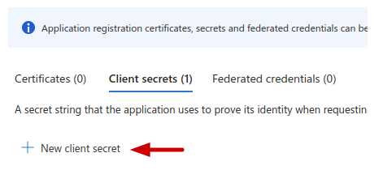

- Click “New client secret”

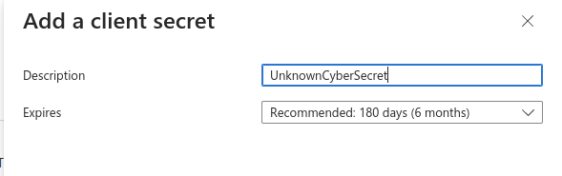
- Description “UnknownCyberSecret” is recommended
- Click Add

- Click the Copy Icon in the “Value” Column and store that value securely.

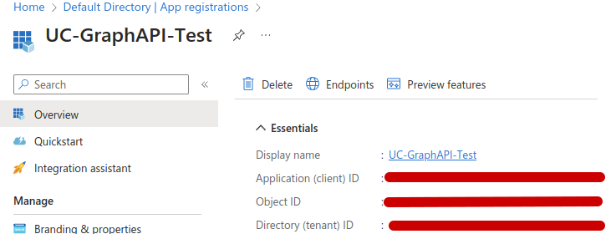
- Copy the “Application (client) ID
- Copy the “Directory (tenant) ID
- Contact Unknown Cyber and have the:
  - Application ID
  - Tenant ID
  - Secret Value

RECOMMENDED (Optional) – Enable Microsoft Sentinel

- Open “Microsoft Sentinel” from your Azure Portal.

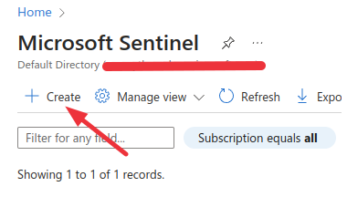

- Click “Create”
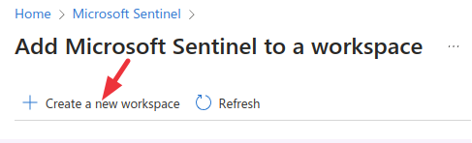

- Click “Create a new workspace”

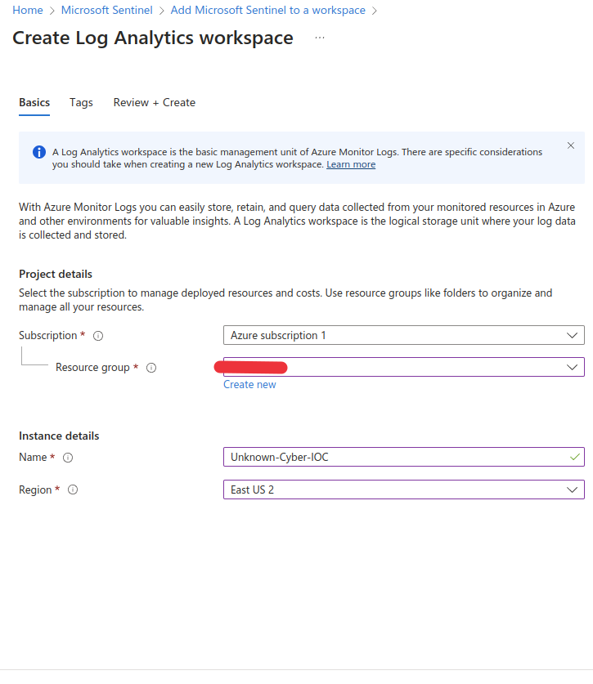
- Fill out the details in the Screen then click “Review + Create” wait for the validation to show green. Then click Create.
- Open your newly created Microsoft Sentinel Workspace and navigate to “Access Control (IAM) using the lefthand column.
- Click on “Add - > Add Role Assignment”
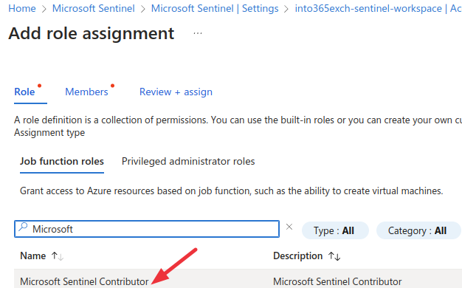

- Select “Microsoft Sentinel Contributor” for the Role
- For the Member, choose the App Reg you created earlier in this document.
- Move to Review and Assign, then click on “Review + assign”

