Open to portal.azure.com and authenticate with your company credentials.
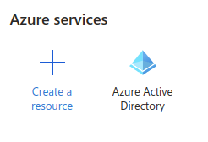

Select Azure Active Directory
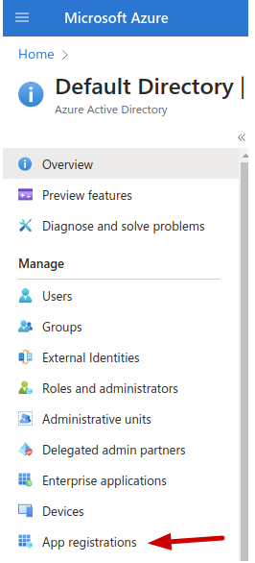

Scroll down and Select “App Registrations”

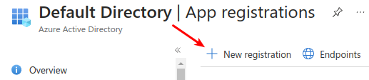

Select New Registration

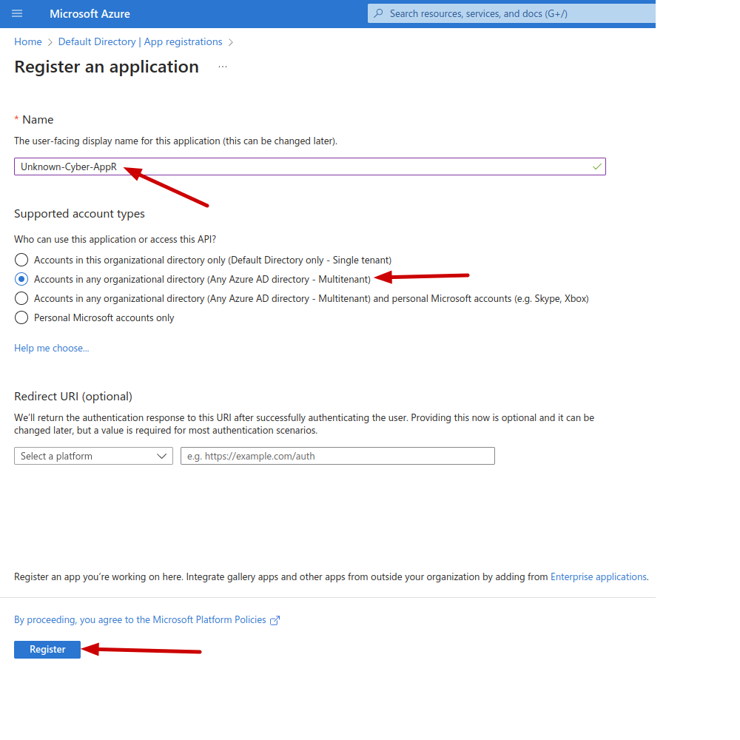

- We recommend the naming convention “Unknown-Cyber-AppR-CustomerName”
- Set for Multi-Tenant
- Click Register

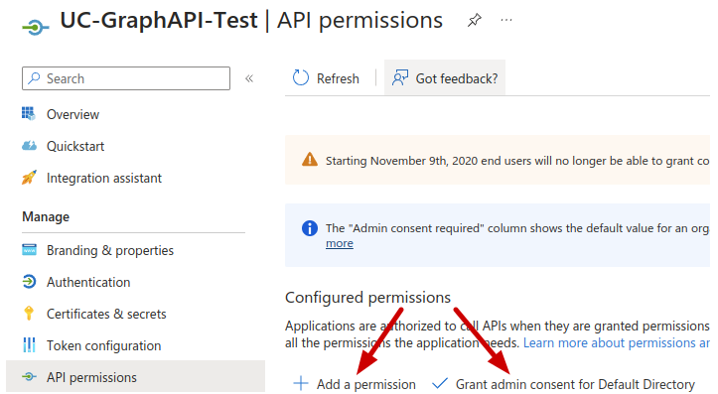

- Open the Newly Created App Registration.
- Ensure that “Grant admin consent for Default Directory” has a check mark, if not click the + Next to Grant and go through the wizard.
- Click on Add a Permission

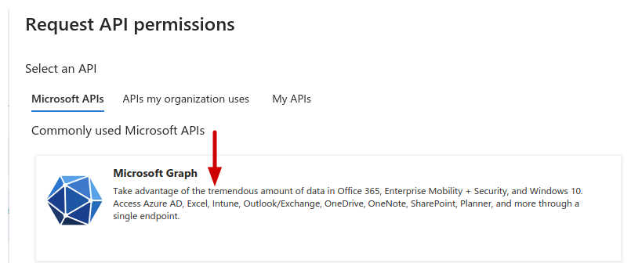
- Select Microsoft Graph

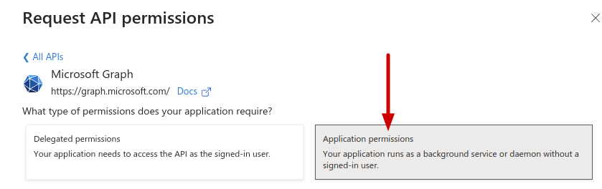
- Set to Application Permissions

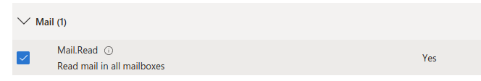
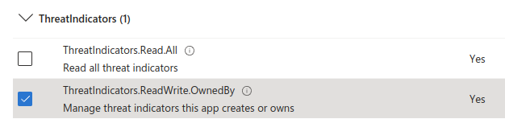
- Select “Mail → Mail.Read”
- Select “ThreatIndicators → ThreatIndicators.ReadWrite.OwnedBy”
- Click “Add permissions” at the bottom of the screen.

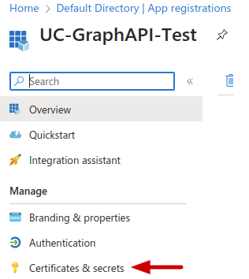

- Select “Certificates and secrets”
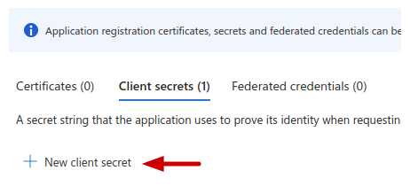

- Click “New client secret”

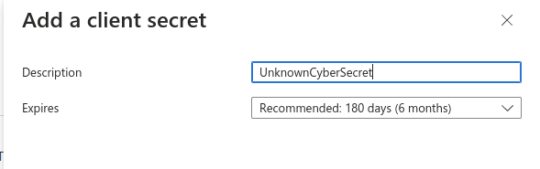
- Description “UnknownCyberSecret” is recommended
- Click Add

- Click the Copy Icon in the “Value” Column and store that value securely.

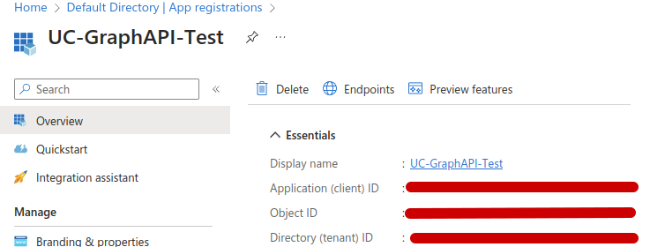
- Copy the “Application (client) ID
- Copy the “Directory (tenant) ID
- Contact Unknown Cyber and have the:
  - Application ID
  - Tenant ID
  - Secret Value

