### **Software Requirement**

**MySql:**

mysql Ver 8.0.37-0ubuntu0.22.04.3 for Linux on x86_64 ((Ubuntu))

**Java:**

openjdk 17.0.11 2024-04-16 LTS

OpenJDK Runtime Environment Corretto-17.0.11.9.1 (build 17.0.11+9-LTS)

OpenJDK 64-Bit Server VM Corretto-17.0.11.9.1 (build 17.0.11+9-LTS, mixed mode, sharing)h

### 

### **PreRequisite [Important]**

Create Database

**SQL Command:**

1. Create dataBase
   1. create database test_db;
2. Add you Access Key and Secret Key in Constants.java FIle here

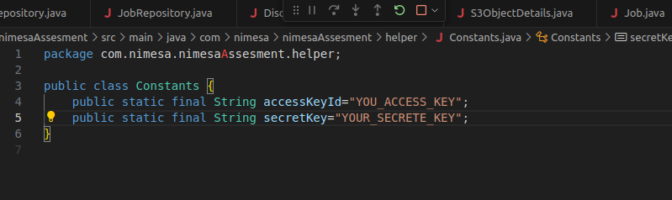

### **Output**

##### **1. DiscoverServices**

Url : localhost:8080/api/discovery/discoverServices

Input: [

"EC2",

"S3"

]

Output:

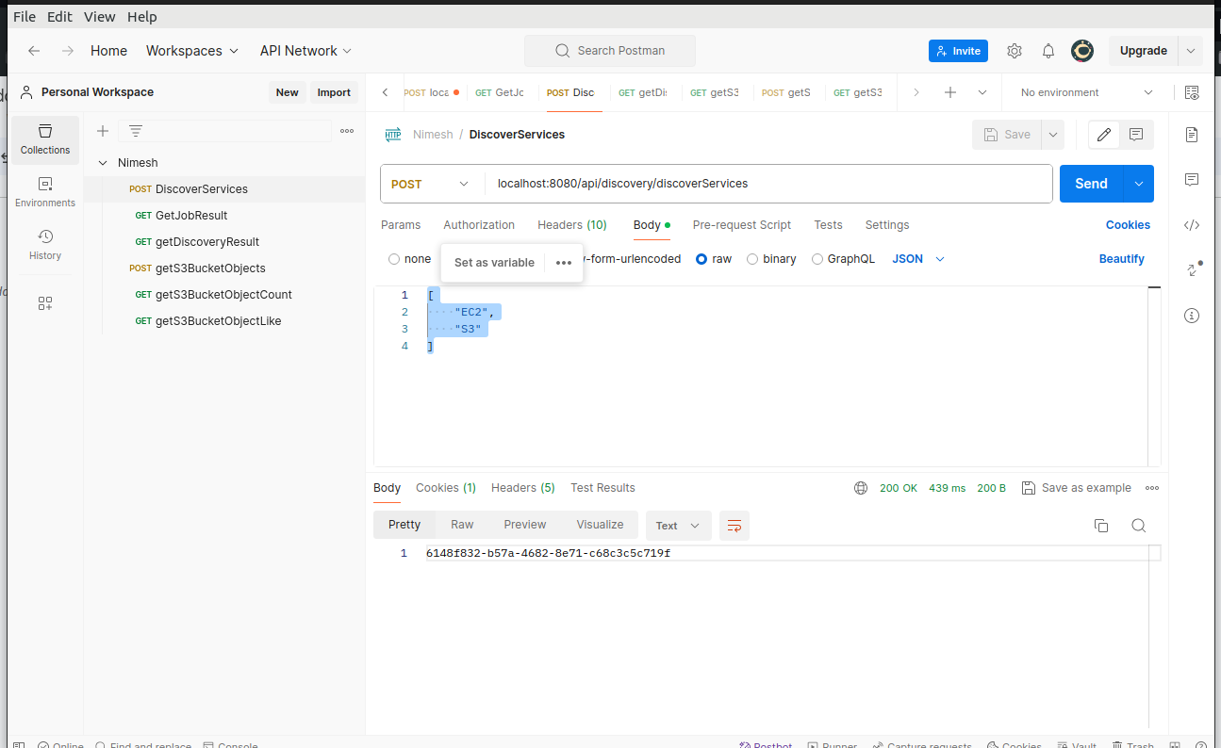

##### **2. GetJobResult**

Url: localhost:8080/api/discovery/getJobResult/6148f832-b57a-4682-8e71-c68c3c5c719f

Output:

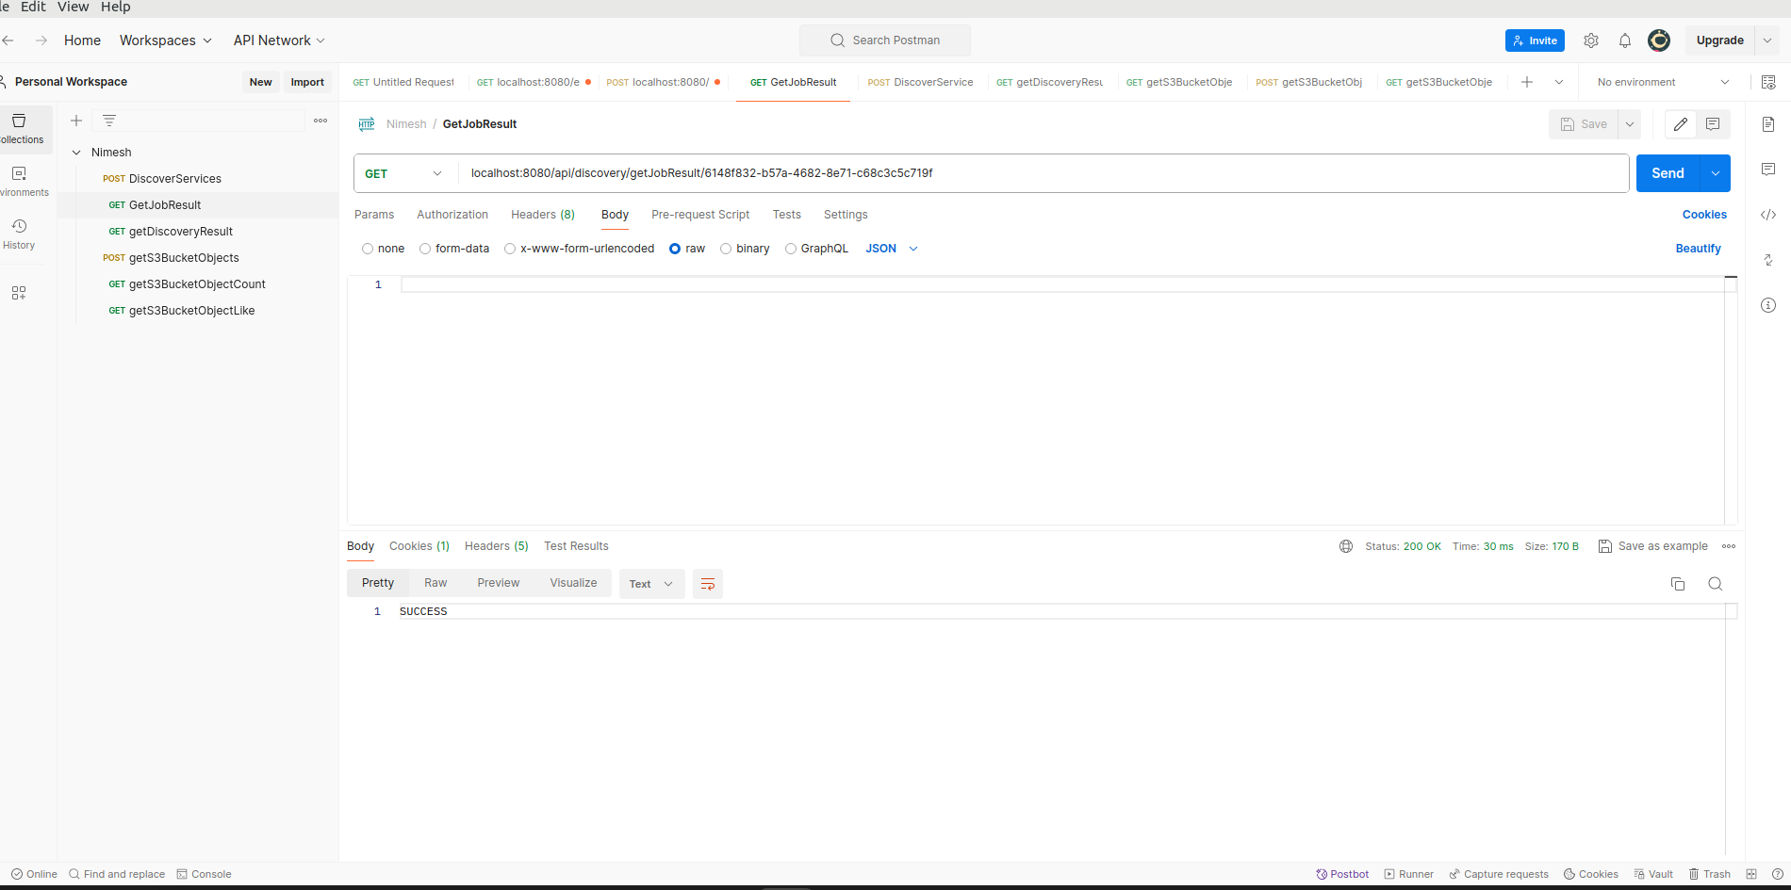

##### **3. getDiscoveryResult**

Url : localhost:8080/api/discovery/getDiscoveryResult/S3

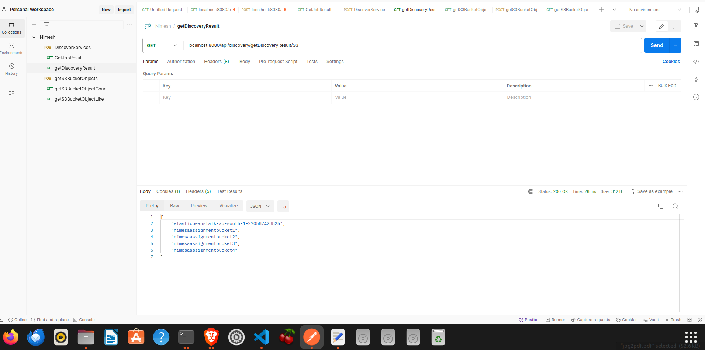

##### **4. getS3BucketObjects**

Url: localhost:8080/api/discovery/getS3BucketObjects

Input : nimesaassignmentbucket1

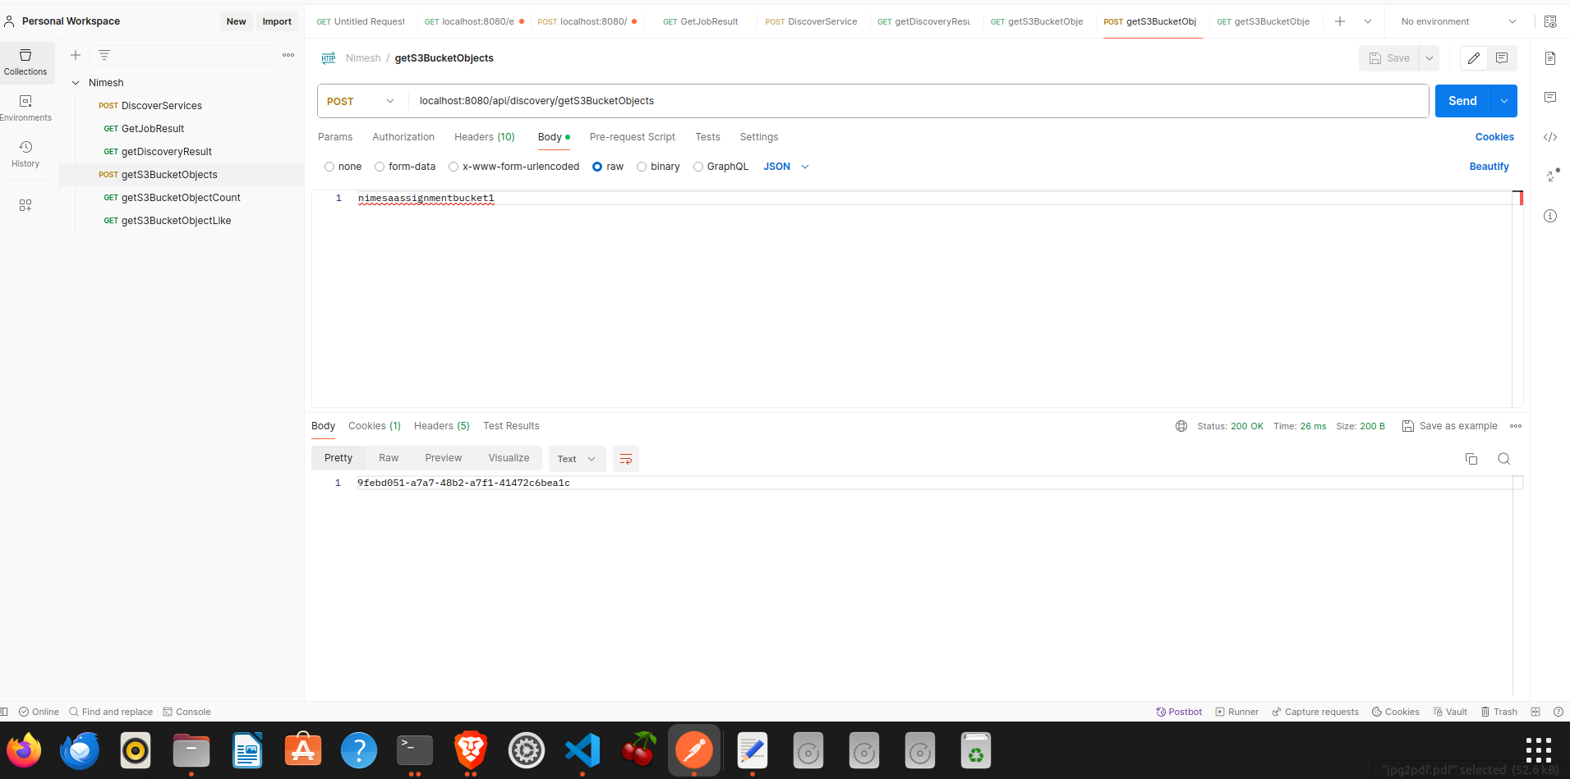

##### 

##### 

##### 

##### 

##### 

##### 

##### 

##### 

##### **5. getS3BucketObjectCount**

Url: localhost:8080/api/discovery/getS3BucketObjectCount/nimesaassignmentbucket1

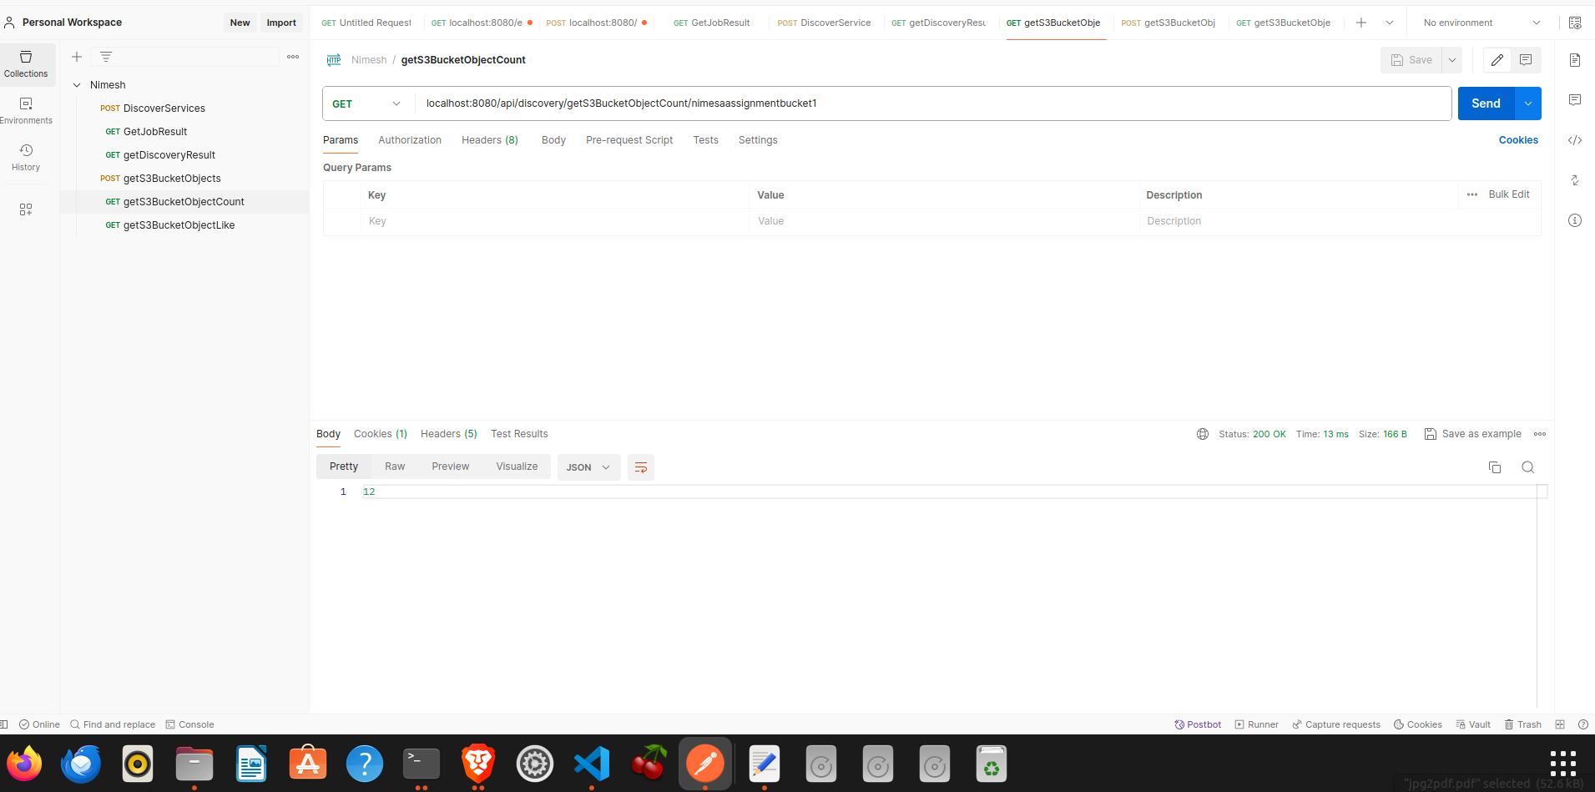

##### **6. getS3BucketObjectLike**

Url: localhost:8080/api/discovery/getS3BucketObjectLike?bucketName=nimesaassignmentbucket1&pattern=Test-File

