A Multi-Classifier System for Early Autism Spectrum Disorder Detection using Machine Learning

Brijit Adak, Saurabh Sushant, Roshan Sisodia, Aastha Anand, Antra Amrit
Computer Science and Engineering
Kalinga Institute of Industrial Technology deemed to be university
Bhubaneshwar, India

Abstract—Developing a precise and efficient diagnostic system for Autism Spectrum Disorder (ASD) is challenging due to the spectrum nature of the condition, where symptoms and thresholds vary widely among individuals. Furthermore, the process of generating detailed behavioral assessments by healthcare specialists is both time-consuming and labor-intensive. Early detection and intervention are crucial for improving the quality of life for individuals with ASD. Machine Learning (ML) algorithms offer a promising solution to identify and evaluate the presence of ASD more effectively. This study focuses on creating a prediction model utilizing multiple classifiers to enhance the accuracy and precision of ASD diagnosis.
Keywords—ANN, Autism Sprectrum Disorder (ASD), Classification Algorithm, Decision Tree, KNN, Logistic Regression, Machine Learning, Naive Bayes, Prediction Model, Randoom Forest, SVM.

Introduction

Autism Spectrum Disorder (ASD) is a complex neurodevelopmental condition marked by ongoing difficulties in social interaction, communication, and the presence of restricted or repetitive behaviors. Initially identified by Leo Kanner and Hans Asperger in the early 20th century, ASD has gained significant attention in recent years due to its prevalence and the substantial impact it has on individuals and families globally.
While the exact causes of ASD remain elusive, it is widely understood to be a combination of genetic and environmental factors. Research suggests that certain genetic mutations and prenatal factors may contribute to the development of ASD, though the specific mechanisms are still under investigation.
The spectrum nature of Autism Spectrum Disorder (ASD) means that individuals can exhibit a wide range of symptoms and levels of impairment. Some may experience relatively mild symptoms and function highly, while others may need substantial support for daily living. This variability highlights the importance of early diagnosis and personalized interventions to meet each individual's unique needs.
Despite the challenges associated with ASD, many individuals with the condition possess unique strengths and talents. With appropriate support and accommodations, they can lead fulfilling lives and make valuable contributions to their communities.

Objective
With the exponential increase in the rate of autism spectrum disorder (ASD) in children globally, the need for early detection has become more pressing. Early and accurate diagnosis of ASD requires expert intervention and is highly sought after to improve outcomes.
In this paper, we will delve into the various aspects of Autism Spectrum Disorder, including its diagnostic criteria, algorithms, limitations, comparisons among the algorithms to find the best one, prevalence, potential causes, and available interventions. By developing a deeper understanding of autism spectrum disorder (ASD), we can enhance awareness, acceptance, and support for individuals on the spectrum.
The motive of this research work is to efficiently catagorize patients in affected by ASD or notusing multi classifier based recommender system.

Literature Review

Machine Learning Algorithms in Autism
The application of machine learning (ML) algorithms in autism spectrum disorder (ASD) research has gained substantial attention over recent years. These algorithms have been instrumental in early diagnosis, behavioral analysis, and personalized intervention strategies.
Early and accurate diagnosis of ASD is critical for timely intervention. Traditional diagnostic methods are often subjective and time-consuming. Machine learning offers a promising alternative by analyzing patterns in genetic, neuroimaging, and behavioral data. Studies like Duda et al. (2016) utilized Support Vector Machines (SVM) and achieved significant accuracy in identifying ASD from brain imaging data. Similarly, Convolutional Neural Networks (CNNs) have shown promise in distinguishing between ASD and neurotypical development using facial recognition and eye-tracking data (Liu et al., 2016).
ML algorithms also contribute to understanding and predicting behaviors in individuals with ASD. For instance, Kanne et al. (2011) applied Random Forests to behavioral data to predict aggression and self-injurious behaviors. Natural Language Processing (NLP) techniques, including Long Short-Term Memory (LSTM) networks, are employed to analyze communication patterns, aiding in the assessment of social interaction deficits typical of ASD (Fusaroli et al., 2017).
Personalized intervention is another area where ML is making significant strides. Reinforcement Learning algorithms, particularly Q-learning, can tailor educational and therapeutic programs to individual needs. For example, Koegel et al. (2020) developed an adaptive learning system using Q-learning that adjusts its teaching strategies based on real-time feedback from the child's performance, improving engagement and learning outcomes.
Despite these advancements, several challenges remain. One major issue is the heterogeneity of ASD, which complicates the development of universal ML models. Additionally, there are concerns about the ethical implications of using ML in sensitive areas like ASD, particularly regarding data privacy and the potential for bias.
Future research should focus on developing more robust, generalizable models and addressing ethical concerns. Integrating multimodal data and utilizing advanced techniques like Explainable AI (XAI) could enhance the interpretability and reliability of ML applications in ASD.
In conclusion, machine learning algorithms such as Support Vector Machines, Convolutional Neural Networks, Random Forests, Long Short-Term Memory networks, and Q-learning hold significant potential for transforming the landscape of ASD diagnosis, behavior analysis, and intervention. Continued interdisciplinary collaboration and ethical considerations will be key to realizing the full benefits of these technologies.
Here we are using ANN, Decision Tree, Randoom Forest, SVM, Logistic Regression, Naive Bayes and KNN Machine Learning Algorithms to classify the patient among Autism affected or not.

Severity Stages of ASD
There are three severity diagnostic criteria stages.
- Stage 1: The patient exhibits repetitive and limited behaviors.
- Stage 2: The patient experiences significant challenges with social interaction and communication, requiring substantial assistance.
- Stage 3: This is the most severe stage, necessitating the most extensive support.

ASD screening approaches
The application of various screening tools has significantly enhanced the early detection and diagnosis of autism spectrum disorder (ASD). These tools provide structured frameworks for assessing and identifying characteristics of ASD, aiding clinicians and researchers in making more accurate diagnoses.
The Autism Behavior Checklist (ABC) is a comprehensive tool that evaluates a range of behaviors associated with ASD. It includes 57 items that cover five areas: sensory, relating, body and object use, language, and social and self-help skills. Designed to be used by parents or caregivers, the ABC provides a quantitative measure to support diagnostic assessments.
The Social Communication Questionnaire (SCQ) is a screening tool that evaluates communication skills and social functioning in children over four years old. The SCQ has two versions: a Lifetime version that assesses developmental history and a Current version that evaluates behavior over the past three months. The assessment comprises 40 yes-or-no questions designed to identify children who may require a thorough evaluation for Autism Spectrum Disorder (ASD).
The Autism Spectrum Quotient (AQ) is a self-report questionnaire utilized to gauge the level of autistic traits in adults. Comprising 50 questions, it encompasses five domains: social skills, attention switching, attention to detail, communication, and imagination. The AQ serves as a valuable tool for identifying individuals potentially harboring undiagnosed ASD and for research endeavors exploring the broader autism phenotype.
The Childhood Autism Rating Scale, Second Edition (CARS-2), is a behavior rating scale that helps to identify children with ASD and differentiate them from children with other developmental disorders. CARS-2 assesses behaviors in 15 areas, including imitation, verbal communication, non-verbal communication, and relationship to people. It provides a quantitative score that indicates the likelihood of ASD and the severity of symptoms.
Furthermore, the Modified Checklist for Autism in Toddlers (M-CHAT) is extensively employed for early screening in children aged 16 to 30 months. This questionnaire comprises 20 questions directed at parents, centering on early indicators of ASD, including eye contact, gestures, and responses to name.
Combining these standardized tools with clinical observations and interviews provides a robust framework for the early identification and diagnosis of ASD. Each tool contributes unique insights into different aspects of behavior and development, making them invaluable in the comprehensive assessment of autism spectrum disorder. Continued research and refinement of these methods are essential to improving the accuracy and reliability of ASD screening.

Treatment Therapies in Autism
Therapy sessions are meetings with patients with a goal to improve some aspects of their life.Initiating it early may help to improve skills and resolve their symptoms.
Some of them are mentioned below:
- Socially Assistive Robotics (SAR):
It refers to the robotics that focuses on developing robots designed to interact with humans in emotionally intelligent manner.
They teach and demonstrate socially beneficial behaviors. This tool assists children in expressing themselves in a better way.

- Nutrition therapy:
It is typically conducted by registered dietitians.Getting enough vitamins, minerals, and healthy fats from food is really important. A good diet can help manage some of the symptoms of autism and keep them under control.

- Speech Therapy:
Sign language and image-based communication aid children in overcoming speech challenges, offering alternative avenues to convey thoughts and emotions. These methods foster smoother interactions and social engagement. Moreover, they enhance sound clarity, contributing to effective communication for individuals with speech impairments.

- Occupational Therapy:
The primary goal of occupational therapy is to enable individuals to participate in activities that are meaningful to them.It helps them get better at everyday tasks. In therapy, they focus on what each person needs and what they want to achieve.

Technology used in Autism
Technology is helpful for people with autism. It helps them learn and communicate better. For example, if Autistic people have very little focus duration, then they can use pictures and sounds to keep them focused. Some of them are as follows:
- Gaming: Utilizing games to aid in vocabulary learning.
- Virtual Reality: Recreating and presenting real-world scenarios to autistic patients using Virtual Reality.
- Augmented Reality: Detecting symptoms through the analysis of facial expressions.
- Social Robots: Therapists employ social robots to assist autistic children in communication with minimal direct involvement.

Machine Learning Models Used
Various machine learning algorithms have been extensively applied to different aspects of detecting and investigating autism spectrum disorder. Data sources like the Autism Spectrum Quotient and the Childhood Autism Rating Scale, which cater to different age groups, can be utilized to classify various aspects of autism.
Following classification machine learning algos we have tried for ASD:

Support Vector Machine (SVM)
The Support Vector Machine (SVM) stands out as a potent supervised learning algorithm utilized for classification and regression tasks. Its effectiveness lies in identifying the hyperplane that maximizes the margin between classes, with support vectors delineating this boundary. SVM demonstrates adaptability in handling non-linear data through kernel tricks. Nonetheless, its sensitivity to outliers necessitates careful parameter tuning for optimal performance.

Random Forest(RF)
Random Forest is a flexible ensemble learning technique that functions by generating numerous decision trees during the training process. It excels in both classification and regression tasks, leveraging the wisdom of crowds to make predictions. By averaging or voting on the outputs of multiple trees, it reduces overfitting and enhances generalization performance. Random Forest is robust to noisy data and missing values, and it automatically evaluates feature importance, making it widely applicable in various domains without extensive preprocessing. Random Forest works as follows:
  - From the training dataset choose N data samples at random
  - Using chosen N data samples construct the decision tree
  - Select the number of decision trees to be built.
  - Incoming data samples are classified based on majority votes from constructed trees, ensuring accurate predictions.

Naive Bayes (NB)
Naive Bayes is a probabilistic classifier based on Bayes' theorem, assuming strong independence between features. The algorithm calculates the probability of each class based on a given feature set and selects the class with the highest probability. Despite its simplicity, Naive Bayes performs well on various tasks, especially text classification and spam detection. Its key strengths are efficiency, scalability, and robustness to irrelevant features. However, it assumes feature independence, which may not hold in real-world data, potentially impacting accuracy. Nonetheless, its ease of implementation and interpretability make it a popular choice for initial model building and quick insights.
Naive Bayes models are robust to irrelevant features and can handle missing data gracefully, making them widely used in various machine learning applications.P (A|B) = P (B|A) ∗ P (A)/p (B).

Logistic Regression (LR)
Logistic Regression serves as a commonly employed statistical technique for binary classification, estimating the probability of a binary outcome by considering predictor variables. It utilizes the logistic function to map predictions to probabilities, offering simplicity, interpretability, and efficiency in modeling tasks. Despite its linear nature, it's versatile and extends to multiclass classification with suitable techniques.

Decision tree (DT)
A Decision Tree serves as a supervised machine learning algorithm employed for classification and regression assignments. It depicts decisions and their potential outcomes in a tree-like structure, wherein internal nodes signify feature tests, branches represent potential outcomes, and leaf nodes denote classes or regression values. The construction of the tree involves recursively dividing the data based on feature values to maximize information gain. While Decision Trees are easily interpretable and visualizable, they may encounter overfitting, particularly with complex structures. Pruning methods are frequently utilized to address overfitting and improve generalization.

Artificial Neural Network (ANN)
Artificial Neural Networks (ANNs) are versatile machine learning models inspired by the human brain's structure. Comprising interconnected nodes organized in layers, ANNs excel in learning complex patterns from data through forward and backward propagation. They're widely used for tasks like image recognition and natural language processing due to their flexibility and scalability.

K-Nearrest Neighbour (KNN)
The k-Nearest Neighbors (k-NN) algorithm is a simple, non-parametric, instance-based learning approach utilized for both classification and regression tasks. It operates by identifying the 'k' nearest data points in the feature space to a specified query point and making predictions based on the majority class (for classification) or the average value (for regression) of these neighboring points. The choice of distance metric, often Euclidean, determines the proximity of points. k-NN is intuitive and straightforward to implement, but it can be computationally intensive with large datasets and sensitive to the selection of 'k' and the distance metric. Proper data scaling and preprocessing are essential for optimal performance.

Dataset

Dataset Properties
- We are utilizing the UCI Machine Learning Repository provided by Fadi Fayez Thabtah.
- The child dataset consists of 292 records, with 141 classified as ASD and 151 as non-ASD.
- The adolescent dataset contains 104 records, with 63 classified as ASD and 41 as non-ASD.
- The adult dataset comprises 704 records, with 189 classified as ASD and 515 as non-ASD.
- Overall, there are 21 features, including 10 questions related to behavioral information (A1-A10), 10 demographic attributes, and one class label indicating ASD prediction.
- Here we used
i) A1_Score to A10_Score: Scores derived from the Autism Spectrum Quotient (AQ) 10-item screening tool.
ii) age: Patient's age in years.
iii) gender: Patient's gender.
iv) ethnicity: Patient's ethnic background.
v) jaundice: Indicates whether the patient had jaundice at birth.
vi) autism: Indicates whether an immediate family member has been diagnosed with autism.
vii) country_of_res: Patient's country of residence.
viii) used_app_before: Indicates whether the patient has previously undergone a screening test.
ix) result: Score obtained from the AQ1-10 screening test.
x) age_desc: Description of the patient's age.
xi) Class/ASD: Classified result represented as 0 (No) or 1 (Yes). This column serves as the target variable, and values should be submitted as 0 or 1 only during submission.

Dataset Visualization

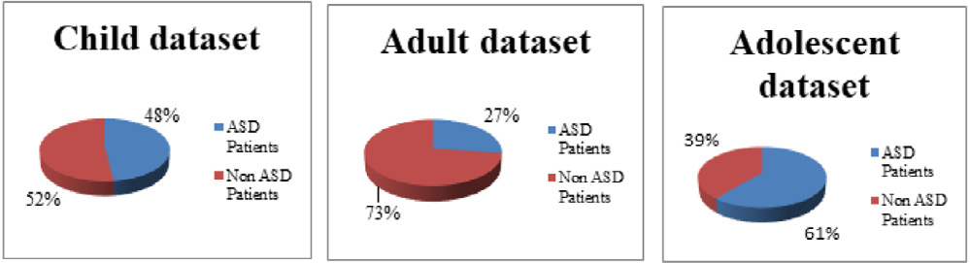
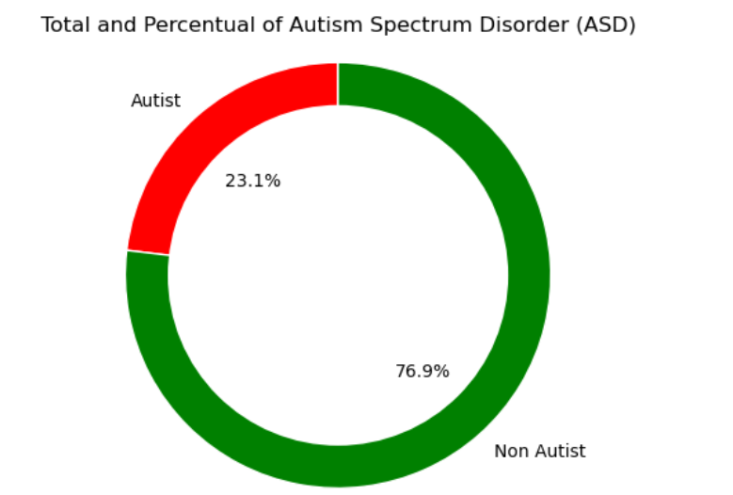

Questions in Dataset
- Demonstrates sensitivity to sounds not perceived by others.
- Displays a preference for holistic perception rather than detailed observation.
- Engages actively in group discussions within the community.
- Demonstrates proficiency in switching between available actions or tasks.
- Not able to make casual conversation with peers.
- Manages everyday small talk adequately.
- Finds it difficult to interpret emotional cues while reading or in social contexts.
- Shows a fondness for participating in role-playing activities, particularly in educational settings.
- Observe their experience by recognizing facial expressions.
- Exhibits challenges in initiating and maintaining friendships.
- Ethnicity recorded as 'White-European', 'South Asian', 'Asian', 'Middle Eastern', 'Pasifika', 'Hispanic', 'Turkish', 'Latino', 'Black', 'Others', or 'Unknown'.
- Indicates whether the individual was born with jaundice ('yes' or 'no')
- ndicates whether there's a family history of Pervasive Developmental Disorders (PDD) ('yes' or 'no').
- Captures the individual's country of residence.
- Records if the individual is acquainted with the screening application ('yes' or 'no').
- Records Score
- Describes the age of the individual.
- Specifies who administered the test.
- Indicates the individual's classification as per the autism spectrum disorder (ASD) screening results.

System Architecture
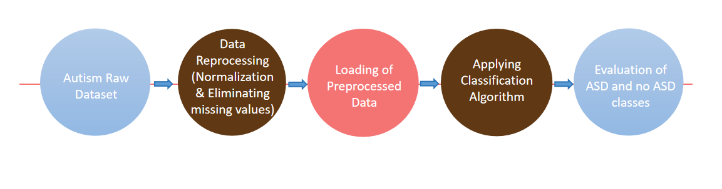

Comparison Studies

Metrices Equations
i. Accuracy = (True Positives + True Negatives) / (True Positives + True Negatives + False Positives + False Negatives)
ii. Precision = True Positives / (True Positives + False Positives)
iii. Recall = True Positives / (True Positives + False Negatives)
iv. F1-Score = 2 * (Recall * Precision) / (Recall + Precision)

Comparison in different ML algos
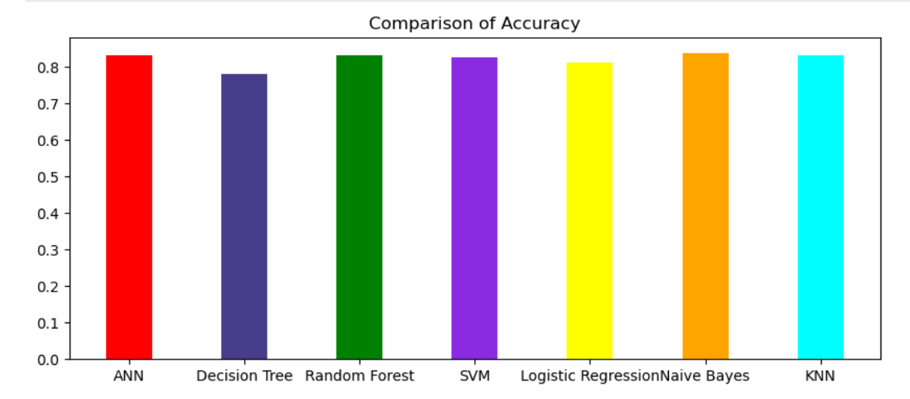
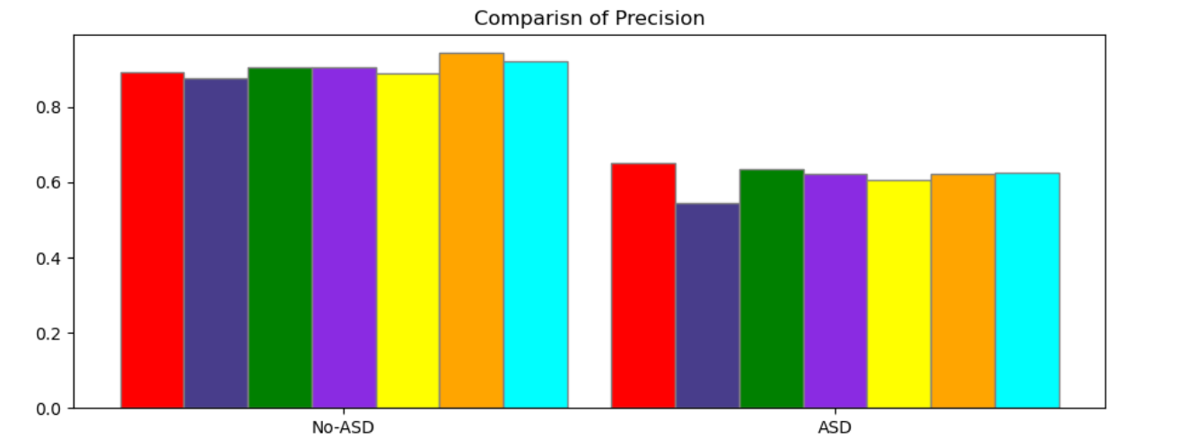

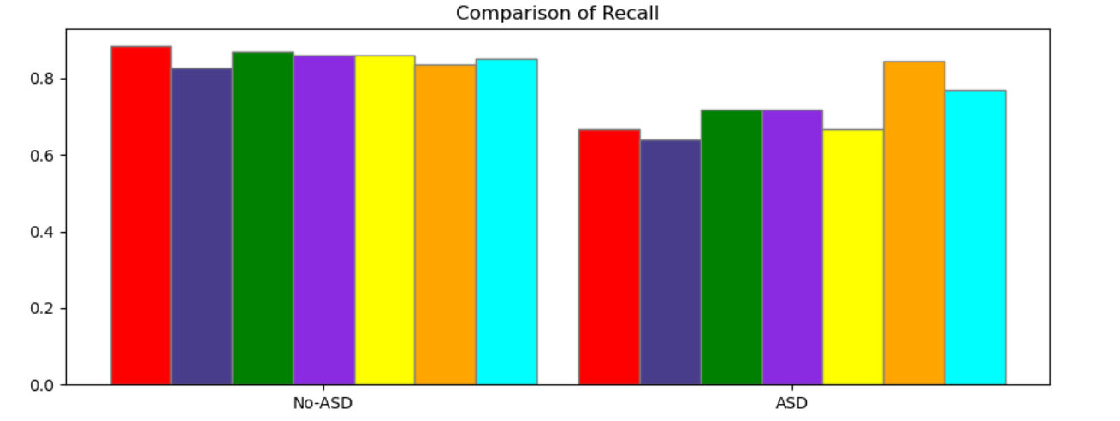
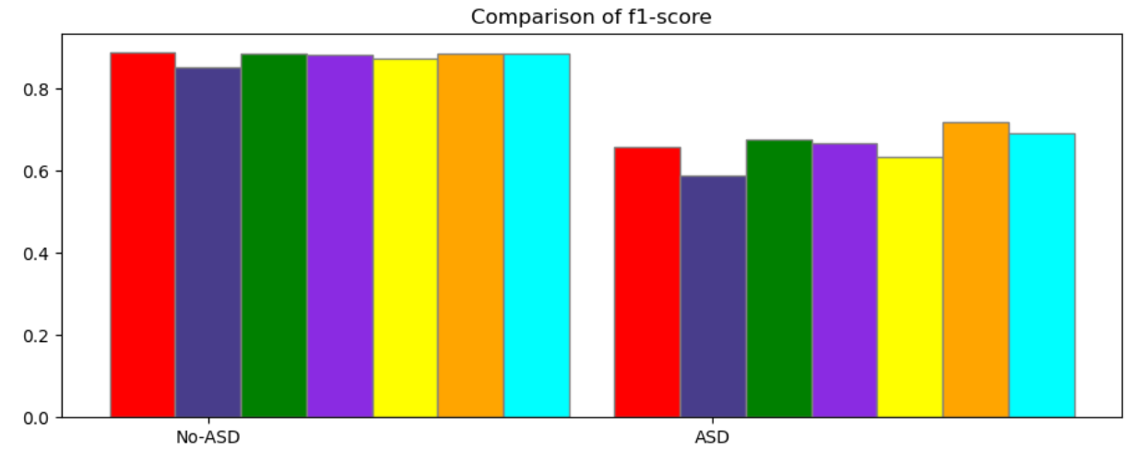
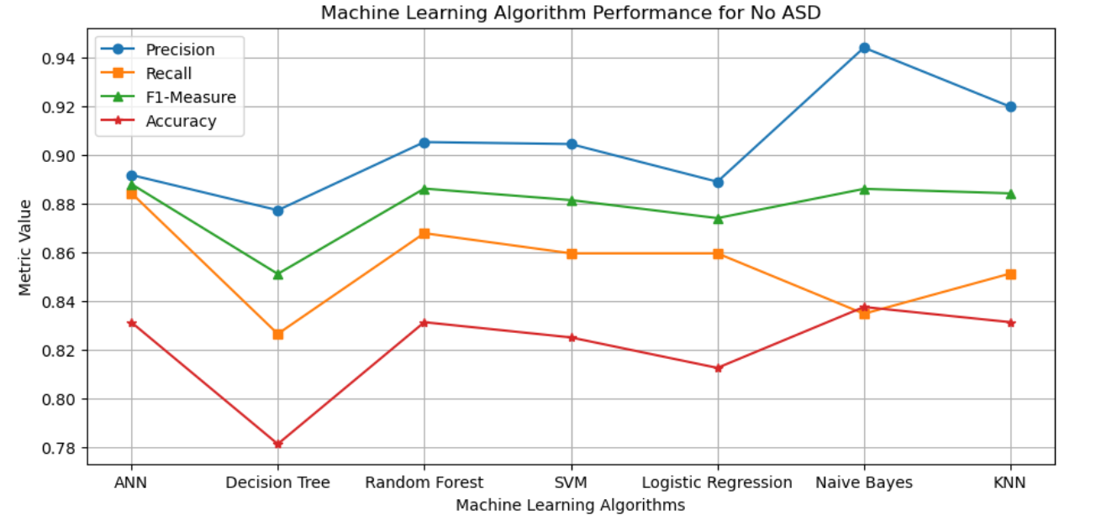
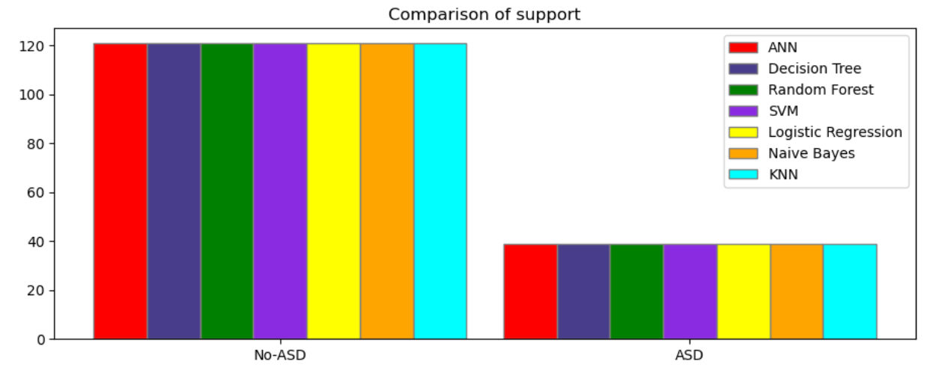

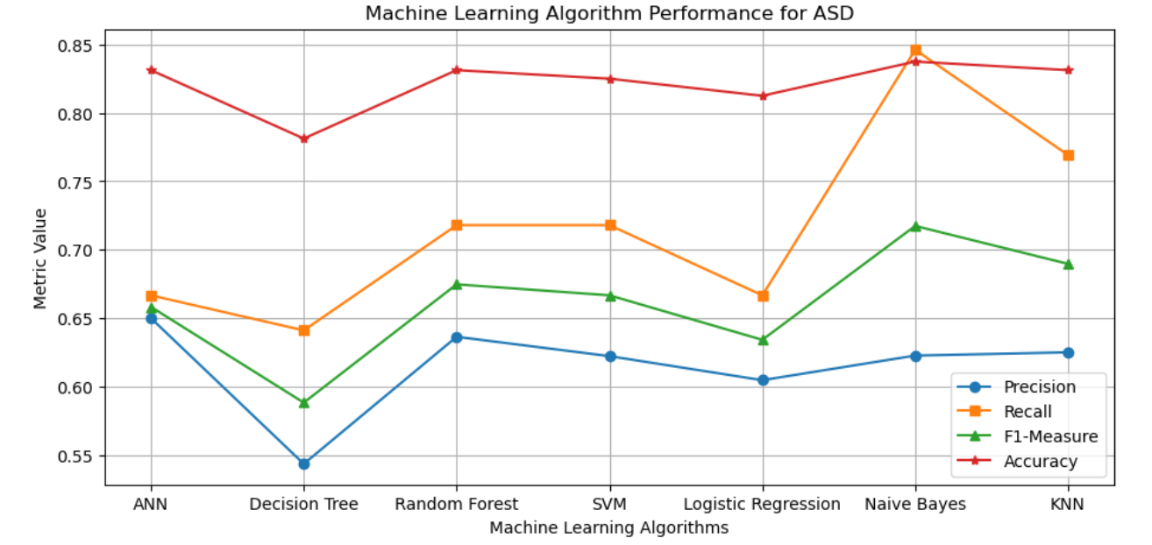

Experimental Results

ANN
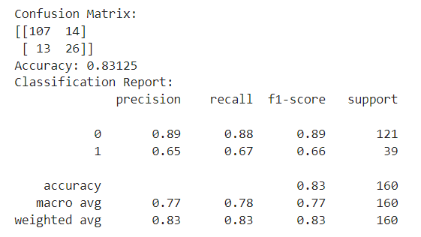

Decision Tree
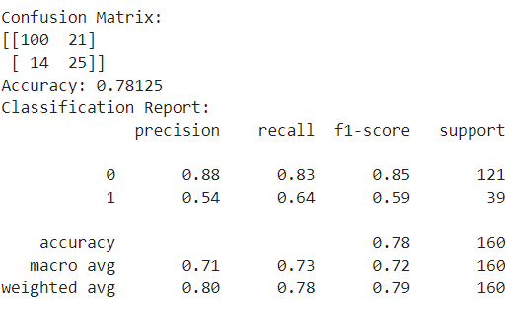

Random Forest
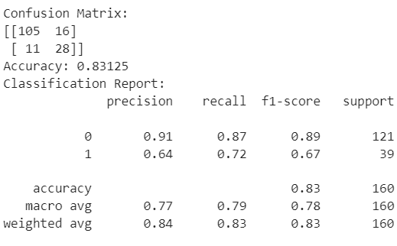

SVM
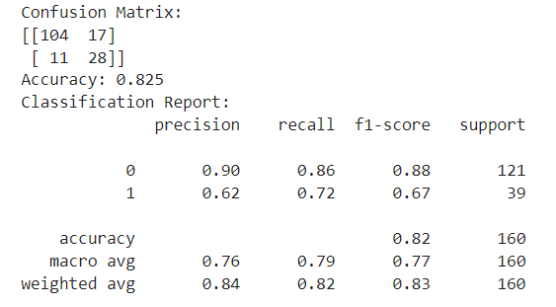

Logistic Regression
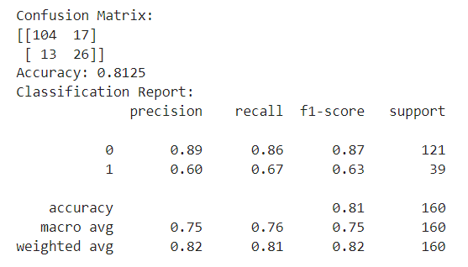

Naive Bayes
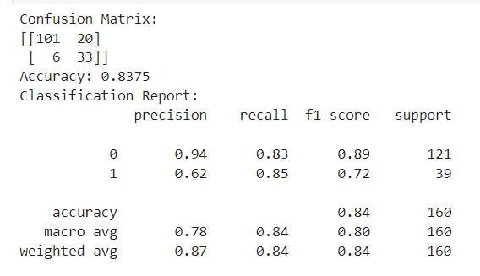

KNN
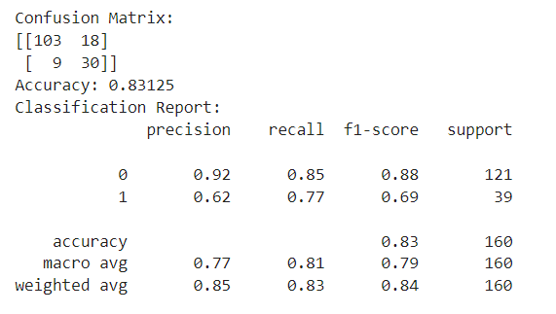

Tables
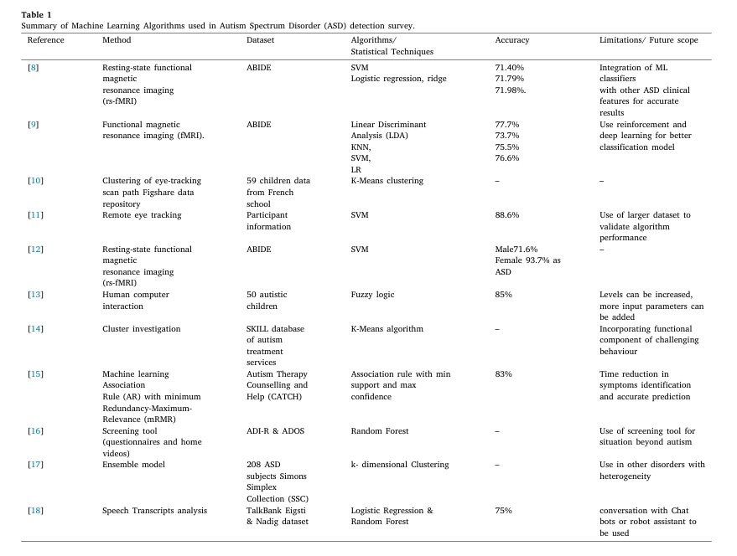
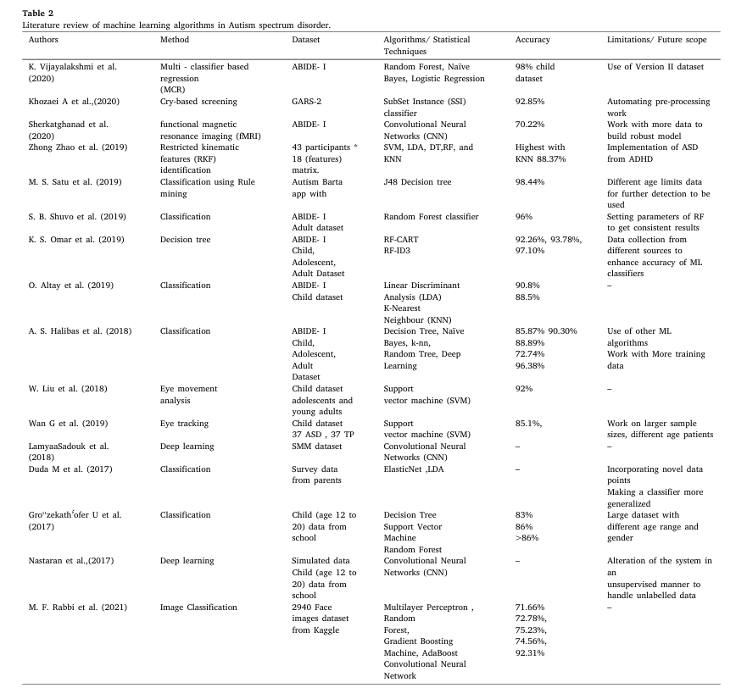

Limitations
As we move forward, the future holds promising developments in the understanding, diagnosis, and treatment of the autism spectrum disorder (ASD). Here are some areas of future scope in the field:

Early Detection and Intervention
Advances in neuroimaging, genetic testing, and behavioral assessments may lead to earlier detection of autism, allowing for timely intervention and improved outcomes. Research into early intervention strategies, such as targeted therapies and parent training programs, shows promise in maximizing developmental potential.

Personalized Medicine
The shift towards personalized medicine may revolutionize autism treatment by tailoring interventions to the individual's unique genetic, biological, and behavioral profile. Precision medicine approaches, including pharmacogenomics and targeted therapies, hold potential for optimizing treatment efficacy and minimizing side effects.

Neuroscience and Brain-Computer Interfaces
Continued research into the neurobiology of autism may uncover novel insights into the underlying neural mechanisms of the disorder. Neuroimaging advancements, such as fMRI and EEG, can revolutionize augmentative communication through BCIs. fMRI illuminates language processing, while EEG offers real-time brain monitoring. BCIs decode neural signals, empowering those with communication impairments to express themselves effectively and interact with their environment directly.

Artificial Intelligence and Data Analytics
The fusion of artificial intelligence (AI) and machine learning algorithms may enhance our ability to analyze large-scale datasets, identify patterns, and predict outcomes in autism research. AI-powered tools for early screening, diagnostic decision support, and personalized treatment planning have the potential to revolutionize clinical practice and improve patient care.

Digital Health Solutions
The proliferation of mobile health technologies and wearable devices presents opportunities for remote monitoring, real-time data collection, and personalized intervention delivery in autism management. Virtual reality (VR) and augmented reality (AR) applications may also offer innovative approaches for social skills training, sensory integration therapy, and behavior modification.

Community Support and Advocacy
The growing emphasis on community-based support services, inclusive education practices, and employment opportunities for individuals with autism reflects a broader societal shift towards promoting neurodiversity and social inclusion. Advocacy efforts aimed at raising awareness, reducing stigma, and fostering acceptance are essential for creating a more inclusive society.
By fostering interdisciplinary collaboration, harnessing technological advancements, and centering the needs and perspectives of individuals with autism and their families, we can strive towards a future where every person on the autism spectrum is empowered to flourish and achieve their full potential.

Coclusion
In conclusion, autism spectrum disorder (ASD) presents as a multifaceted neurodevelopmental condition impacting individuals in various manners. Throughout this presentation, we've delved into its defining traits, diagnostic benchmarks, prevalence rates, and plausible origins. It's imperative to acknowledge the individuality of each person with autism, as they possess their distinct strengths and confront unique challenges.
While there is still much to learn about autism, increased awareness, acceptance, and support are essential for improving the lives of individuals on the spectrum. Early intervention and personalized therapies can significantly enhance outcomes and help individuals with autism reach their full potential.
As our comprehension of autism grows, let's aim for a society that celebrates neurodiversity, champions inclusivity, and guarantees equal opportunities for individuals of all abilities. Through collaborative efforts, we can cultivate a more compassionate and supportive global community that empowers and uplifts everyone, including individuals with autism.

References

- Chen, C. P., Keown, C. L., Jahedi, A., Nair, A., Pflieger, M. E., Bailey, B. A., & Müller, R. A. (2015). Diagnostic classification of intrinsic functional connectivity highlights somatosensory, default mode, and visual regions in autism. NeuroImage. Clinical, 8, 238–245.
- Duda, M., Ma, R., Haber, N., & Wall, D. P. (2016). Use of machine learning for behavioral distinction of autism and ADHD. Translational psychiatry, 6(2), e732.
- Sherkatghanad, Z., Akhondzadeh, M., Salari, S., Zomorodi-Moghadam, M., Abdar, M., Acharya, U. R., Khosrowabadi, R., & Salari, V. (2020). Automated Detection of Autism Spectrum Disorder Using a Convolutional Neural Network. Frontiers in neuroscience, 13, 1325.
- Kosmicki, J. A., Sochat, V., Duda, M., & Wall, D. P. (2015). Searching for a minimal set of behaviors for autism detection through feature selection-based machine learning. Translational psychiatry, 5(2), e514.
- Kothe, C. A., & Makeig, S. (2013). BCILAB: a platform for brain-computer interface development. Journal of neural engineering, 10(5), 056014.
- Nunes, A. S., Peatfield, N., Vakorin, V., & Doesburg, S. M. (2019). Idiosyncratic organization of cortical networks in autism spectrum disorder. NeuroImage, 190, 182–190.
- Oberman, L. M., Rotenberg, A., & Pascual-Leone, A. (2015). Use of transcranial magnetic stimulation in autism spectrum disorders. Journal of autism and developmental disorders, 45(2), 524–536.
- Thabtah, F. (2017). Autism spectrum disorder screening: Machine learning adaptation and DSM-5 fulfillment. Proceedings of the 1st International Conference on Medical and Health Informatics 2017, 1-6.
- Santosh P. J. (2000). Neuroimaging in child and adolescent psychiatric disorders. Archives of disease in childhood, 82(5), 412–419.
- Zablotsky, B., Black, L. I., Maenner, M. J., Schieve, L. A., & Blumberg, S. J. (2015). Estimated Prevalence of Autism and Other Developmental Disabilities Following Questionnaire Changes in the 2014 National Health Interview Survey. National health statistics reports, (87), 1–20.

