A PROJECT REPORT

on

“AUTISM SPRECTRUM DISORDER”

Submitted to

KIIT Deemed to be University

In Partial Fulfillment of the Requirement for the Award of

BACHELOR’S DEGREE IN

COMPUTER SCIENCE & ENGINEERING

BY

BRIJIT ADAK
SAURABH SUSHANT
DIPTENDRA MAITY
ARIJIT MISTRY

21052410
21051335
21051562
21051721

UNDER THE GUIDANCE OF

PROF. ABHAYA KUMAR SAHOO



SCHOOL OF COMPUTER ENGINEERING

KALINGA INSTITUTE OF INDUSTRIAL TECHNOLOGY

BHUBANESWAR, ODISHA - 751024
Nov 2024

A PROJECT REPORT

on

“AUTISM SPRECTRUM DISORDER”

Submitted to

KIIT Deemed to be University

In Partial Fulfillment of the Requirement for the Award of

BACHELOR’S DEGREE IN INFORMATION TECHNOLOGY

BY

BRIJIT ADAK
SAURABH SUSHANT
DIPTENDRA MAITY
ARIJIT MISTRY

21052410
21051335
21051562
21051721

UNDER THE GUIDANCE OF

PROF. ABHAYA KUMAR SAHOO

SCHOOL OF COMPUTER ENGINEERING

KALINGA INSTITUTE OF INDUSTRIAL TECHNOLOGY

BHUBANESWAR, ODISHA -751024

Nov 2024

KIIT Deemed to be University

School of Computer Engineering
Bhubaneswar, ODISHA 751024

CERTIFICATE

This is certify that the project entitled

“AUTISM SPRECTRUM DISORDER”

submitted by

BRIJIT ADAK
SAURABH SUSHANT
DIPTENDRA MAITY
ARIJIT MISTRY

21052410
21051335
21051562
21051721

is a record of bonafide work carried out by them, in the partial fulfillment of the requirement for the award of Degree of Bachelor of Engineering (Computer Science & Engineering OR Information Technology) at KIIT Deemed to be university, Bhubaneswar. This work is done during year 2024-2025, under our guidance.

Date: 04/11 /2024

(PROF. ABHAYA KUMAR SAHOO)
Project Guide

Acknowledgments

We are profoundly grateful to PROF. ABHAYA KUMAR SAHOO
of Affiliation for his expert guidance and continuous encouragement throughout to see that this project rights its target since its commencement to its completion. .....................

BRIJIT ADAK
SAURABH SUSHANT
DIPTENDRA MAITY
ARIJIT MISTRY

ABSTRACT

This documentation provides a comprehensive overview of Autism Spectrum Disorder (ASD), covering its characteristic, diagnosis, and treatment options . Gain a deeper understanding of this complex neurodevelopmental condition.
Autism Spectrum Disorder (ASD) represents a multifaceted neurodevelopmental condition characterized by difficulties in social communication, interaction, and repetitive behaviors. This paper comprehensively reviews the current understanding of ASD, encompassing its epidemiology, potential etiological factors, and available interventions. Recognizing the heterogeneous nature of ASD presentations, emphasis is placed on the significance of early detection and individualized support strategies tailored to the unique needs of each affected individual. Moreover, the discussion advocates for increased awareness and acceptance within society to foster inclusive environments that promote the well-being and integration of individuals with ASD into various social and educational settings.

Contents

1 | Introduction |  | 1
2 | Basic Concepts or Literature Review |  | 2
 | 2.1 | What is ASD | 2
 | 2.2 | Causes of Autism | 3
 | 2.3 | Educational strategies | 3
3 | Treatment Therapies for Autism |  | 4
4 | Technology Used in Autism |  | 4
5 | Machine Learning Algorithms used in detection survey |  | 5
6 | Overview of Machine Learning and Deep Learning Algorithms |  | 6
7 | Data Processing Framework |  | 8
8 | Finally Selected Model |  | 9
9 | Diagrams |  | 10
10 | Result comparison with different algos |  | 11
11 | Standards |  | 12
 | 11.1 | Design | 12
 | 11.2 | Coding | 12
 | 11.3 | Testing | 13
12 | Conclusion and Future Scope |  | 14
References |  |  | 16
Individual Contribution |  |  | 17

List of Figures

Autism Spectrum Disorder

Chapter 1

Introduction:

This presentation provides a comprehensive overview of Autism Spectrum Disorder (ASD), covering its characteristic, diagnosis, and treatment options . Gain a deeper understanding of this complex neurodevelopmental condition.

Autism Spectrum Disorder (ASD) is a complex neurodevelopmental condition characterized by persistent challenges in social interaction, communication, and restricted or repetitive behaviors. First identified by Leo Kanner and Hans Asperger in the early 20th century, ASD has garnered increasing attention in recent decades due to its prevalence and impact on individuals and families worldwide.

While the exact causes of ASD remain elusive, it is widely understood to be a combination of genetic and environmental factors. Research suggests that certain genetic mutations and prenatal factors may contribute to the development of ASD, though the specific mechanisms are still under investigation.

The spectrum nature of ASD means that individuals can experience a wide range of symptoms and levels of impairment. Some may have relatively mild symptoms and be highly functional, while others may require significant support for daily living. This variability underscores the importance of early diagnosis and tailored interventions to address the unique needs of each individual.

Despite the challenges associated with ASD, many individuals with the condition possess unique strengths and talents. With appropriate support and accommodations, they can lead fulfilling lives and make valuable contributions to their communities.

In this paper, we will delve into the various aspects of Autism Spectrum Disorder, including its diagnostic criteria, prevalence, potential causes, and available interventions. By gaining a deeper understanding of ASD, we can work towards promoting greater awareness, acceptance, and support for individuals on the autism spectrum.

School of Computer Engineering, KIIT, BBSR 1

Autism Spectrum Disorder

Chapter 2

Basic Concepts/ Literature Review

This section contains the basic concepts about the related tools and techniques used in this project. For research work, present the literature review in this section.

2.1 What is ASD?

Autism Spectrum Disorder (ASD) is a complex neurodevelopmental condition characterized by challenges with social communication and repetitive behaviors.It is a spectrum disorder, meaning its impact varies widely from person to person.

Diagnosis of ASD involves assessment of social communication, repetitive behaviors, and sensory issues. The evaluation is conducted by a multidisciplinary team, including psychologists, speech therapists, and pediatricians.

Autism was described first by Kanner in 1943. It is a developmental disorder commencing in early childhood. Boys are 4 times more likely than girls to be affected.

Individuals with ASD may exhibit challenges in social interactions, restricted interests, and sensory sensitivities. Understanding these characteristics is crucial for providing appropriate support and interventions.

2.2 CAUSE OF AUTISM?

The cause of autism is unknown and no one particular anatomical, biochemical or genetic disorder has been found in those who suffer from it. The problem appears to lie in that part of the brain responsible for the development of language.

School of Computer Engineering, KIIT, BBSR 2

Autism Spectrum Disorder

2.3 Educational Strategies

Educators play a crucial role in supporting students with ASD. Implementing visual supports, structured routines, and individualized learning plans can create an inclusive and supportive learning environment.

Family Support
Families of individuals with ASD benefit from educational resources, support groups, and access to specialized services. Building a strong support network is essential for navigating the challenges of ASD.

Medical Interventions Medical Interventions
In some cases, medical interventions such as medication for co-occurring conditions and genetic testing may be recommended. These interventions should be carefully considered and tailored to the individual's needs.

Transition to Adulthood Transition to Adulthood
Supporting individuals with ASD during the transition to adulthood involves vocational training, independent living skills, and access to community resources. This phase requires a holistic approach to ensure long-term success.

Advocacy and Awareness Advocacy and Awareness
Advocacy efforts are crucial for promoting inclusion, access to services, and public awareness of ASD. By raising awareness and advocating for policy changes, we can create a more inclusive society for individuals with ASD.

Research and Innovation
Ongoing research is essential for advancing our understanding of ASD and developing innovative interventions. Collaborative efforts in neuroscience, genetics, and behavioral interventions are driving progress in the field.

School of Computer Engineering, KIIT, BBSR 3
Autism Spectrum Disorder

Chapter 3

Treatment therapies for autism:
Therapy sessions are meetings with patients with a goal to improve some aspects of their life.Initiating it early may help to improve skills and resolve their symptoms.
Some of them are mentioned below:

Socially Assistive Robotics (SAR):
It refers to the robotics that focuses on developing robots designed to interact with humans in emotionally intelligent manner.
They teach and demonstrate socially beneficial behaviors. This tool assists children in expressing themselves in a better way.

Nutrition therapy:
It is typically conducted by registered dietitians.Getting enough vitamins, minerals, and healthy fats from food is really important. A good diet can help manage some of the symptoms of autism and keep them under control.

Speech Therapy:
It is helpful in curing communication and speech issues.
Children can use sign language or images to communicate with others easily.
It enhances the clarity of sound of the patient.

Occupational Therapy:
The primary goal of occupational therapy is to enable individuals
to participate in activities that are meaningful to them.It helps them
get better at everyday tasks. In therapy, they focus on what each person needs and what they want to achieve.

Chapter 4

Technology used in Autism:
Technology is helpful for people with autism. It helps them learn and communicate better. For example, if Autistic people have very little focus duration, then they can use pictures and sounds to keep them focused. Some of them are as follows:
Gaming:
That is Learning vocabulary using games

Virtual Reality:
Real world is presented to autistic children with help of Virtual Reality.

Augmented Reality:
Facial expressions can be used to detect the symptoms.

Social Robots:
Social robot are used by therapists for communication,thus Helping children with less involvement.

School of Computer Engineering, KIIT, BBSR 4

Autism Spectrum Disorder

Chapter 5

Machine Learning Algorithms used in detection survey. (ABIDE dataset is used)

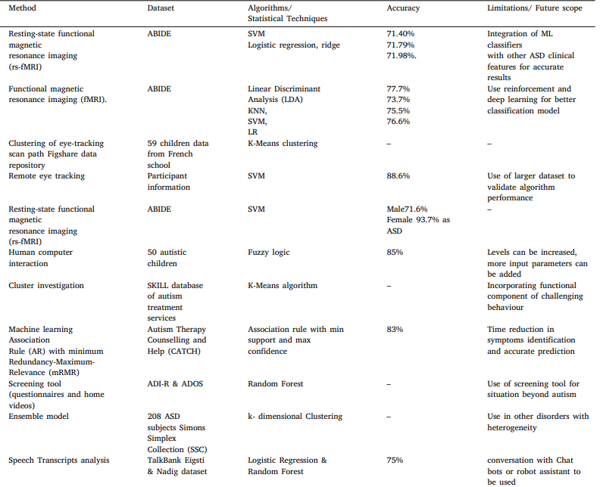

School of Computer Engineering, KIIT, BBSR 5

Autism Spectrum Disorder

Chapter 6

Overview of Machine Learning and Deep Learning Algorithms

The machine learning algorithms have been applied widely in diverse aspects of investigating and detecting autism spectrum disorder.
Various data sources such as Autism Spectrum Quotient and Childhood Autism Rating Scale are available based on different age group that can be leveraged to classify different aspects of Autism.

Details of Machine Learning Algorithms

Following classification machine learning algos have been tried for ASD:
- Support Vector Machine (SVM): Support Vector Machine (SVM) is a powerful supervised learning algorithm used for classification and regression tasks. It works by finding the hyperplane that maximizes the margin between classes, with support vectors defining this boundary. SVM can efficiently handle non-linear data through kernel tricks, but it's sensitive to outliers and requires proper parameter tuning for optimal performance.
- Random Forest(RF): Random Forest is a versatile ensemble learning method that operates by constructing a multitude of decision trees during training. It excels in both classification and regression tasks, leveraging the wisdom of crowds to make predictions. By averaging or voting on the outputs of multiple trees, it reduces overfitting and enhances generalization performance. Random Forest is robust to noisy data and missing values, and it automatically evaluates feature importance, making it widely applicable in various domains without extensive preprocessing. Random Forest works as follows:
  - Choose random N data samples from the training dataset
  - Construct the decision tree using chosen data samples
  - Select the number of decision trees to be built.
  - On arrival of new data sample, Classifier predicts final decision using majority of votes given by decision constructed trees.
- Naive Bayes (NB): Naive Bayes is a simple yet effective probabilistic classifier based on Bayes' theorem with an assumption of independence between features. It's particularly useful for text classification tasks, such as spam detection and sentiment analysis. Despite its simplicity, Naive Bayes often performs well, especially with high-dimensional data, and it's computationally efficient. It works by calculating the probability of a given instance belonging to each class and selecting the class with the highest probability.

School of Computer Engineering, KIIT, BBSR 6

Autism Spectrum Disorder

Naive Bayes models are robust to irrelevant features and can handle missing data gracefully, making them widely used in various machine learning applications.P (A|B) = P (B|A) ∗ P (A)/p (B).
- Logistic Regression (LR): Logistic Regression is a widely used statistical method for binary classification, estimating the probability of a binary outcome based on predictor variables. It utilizes the logistic function to map predictions to probabilities, offering simplicity, interpretability, and efficiency in modeling tasks. Despite its linear nature, it's versatile and extends to multiclass classification with suitable techniques.
- Decision tree (DT): Decision tree is a supervised machine learning algorithm used for classification.
- K-nearest Neighbour

Details of Deep Learning Algorithms

Followin deep learning algos have been tried for ASD:
- Artificial Neural Network (ANN): Artificial Neural Networks (ANNs) are versatile machine learning models inspired by the human brain's structure. Comprising interconnected nodes organized in layers, ANNs excel in learning complex patterns from data through forward and backward propagation. They're widely used for tasks like image recognition and natural language processing due to their flexibility and scalability.
- LSTM (Long Short-Term Memory): LSTM is a type of Recurrent Neural Network (RNN) designed to handle sequential data and long-range dependencies. Unlike traditional RNNs, LSTMs use memory cells and gating mechanisms (input, forget, and output gates) to control the flow of information and mitigate issues like vanishing gradients. They are particularly effective for tasks such as speech recognition, time series forecasting, and natural language processing.
- CNN (Convolutional Neural Network): CNNs are specialized neural networks designed for processing grid-like data, such as images. They consist of convolutional layers that apply filters to detect features like edges, textures, and patterns. CNNs are commonly used in computer vision tasks, including image classification, object detection, and facial recognition, as they can efficiently capture spatial hierarchies in data.
- DNN (Deep Neural Network): DNNs are multi-layered feedforward neural networks with more than one hidden layer. These deep networks allow the model to learn complex, hierarchical representations of data. DNNs are used in a wide range of applications, from image and speech recognition to natural language processing, with their ability to model intricate patterns and high-dimensional data making them especially powerful in complex tasks

School of Computer Engineering, KIIT, BBSR 7
Autism Spectrum Disorder

- XGB (XGBoost): XGBoost is a highly efficient and scalable machine learning algorithm that uses gradient boosting to create an ensemble of decision trees. It builds trees sequentially, where each tree corrects the errors of the previous one. XGBoost incorporates regularization to reduce overfitting and utilizes advanced techniques like parallelization and tree pruning to improve computational efficiency. Due to its speed, accuracy, and flexibility, XGBoost has become one of the go-to algorithms in data science competitions and practical machine learning applications.

Chapter 7

Data processing framework
- Data sources :All data sources to have seamless collection of data from existing system without human intervention irrespective of mode of data transfer.
- Governance and Quality: All the Data Collected be it Flat file, Hive Tables, SQL Database/Table , Json file etc will be tagged for governance, lineage, attribute dictionary etc to enable to ensure that data sets are tracked, identifiable by business terms, governed and managed. Business users can manage the role driven access to system.
- Unify and Transform: Unify all the data uploaded on the basis of auto workflow to ensure no manual intervention. Business users can write new workflow as per their needs. Dynamic data structure will provide flexibility to add more dimension to data in future. To explore the data , transform the data, Aggregate the data etc
- Feature Engineering: Leverages data to create new variables that aren't in the training set. It can produce new features for both supervised and unsupervised learning, with the goal of simplifying and speeding up data transformations while also enhancing model accuracy.

School of Computer Engineering, KIIT, BBSR 8

Autism Spectrum Disorder

Chapter 8

Finally Selected Model

Ranking of the models based on the results of below parameters:
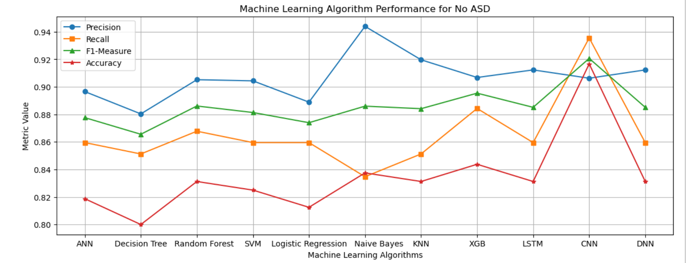
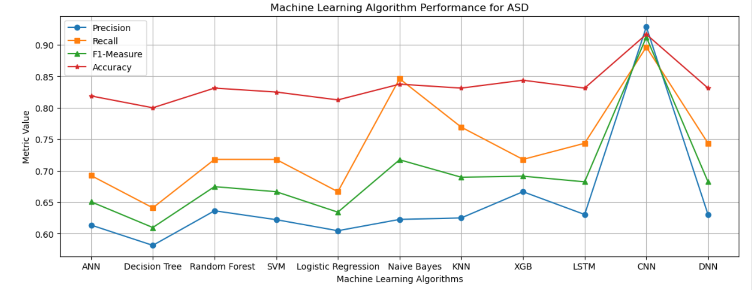

It can be concluded that better performance is given by Naive Bayes, XGB and CNN.

School of Computer Engineering, KIIT, BBSR 9
Autism Spectrum Disorder

Chapter 9

Diagrams

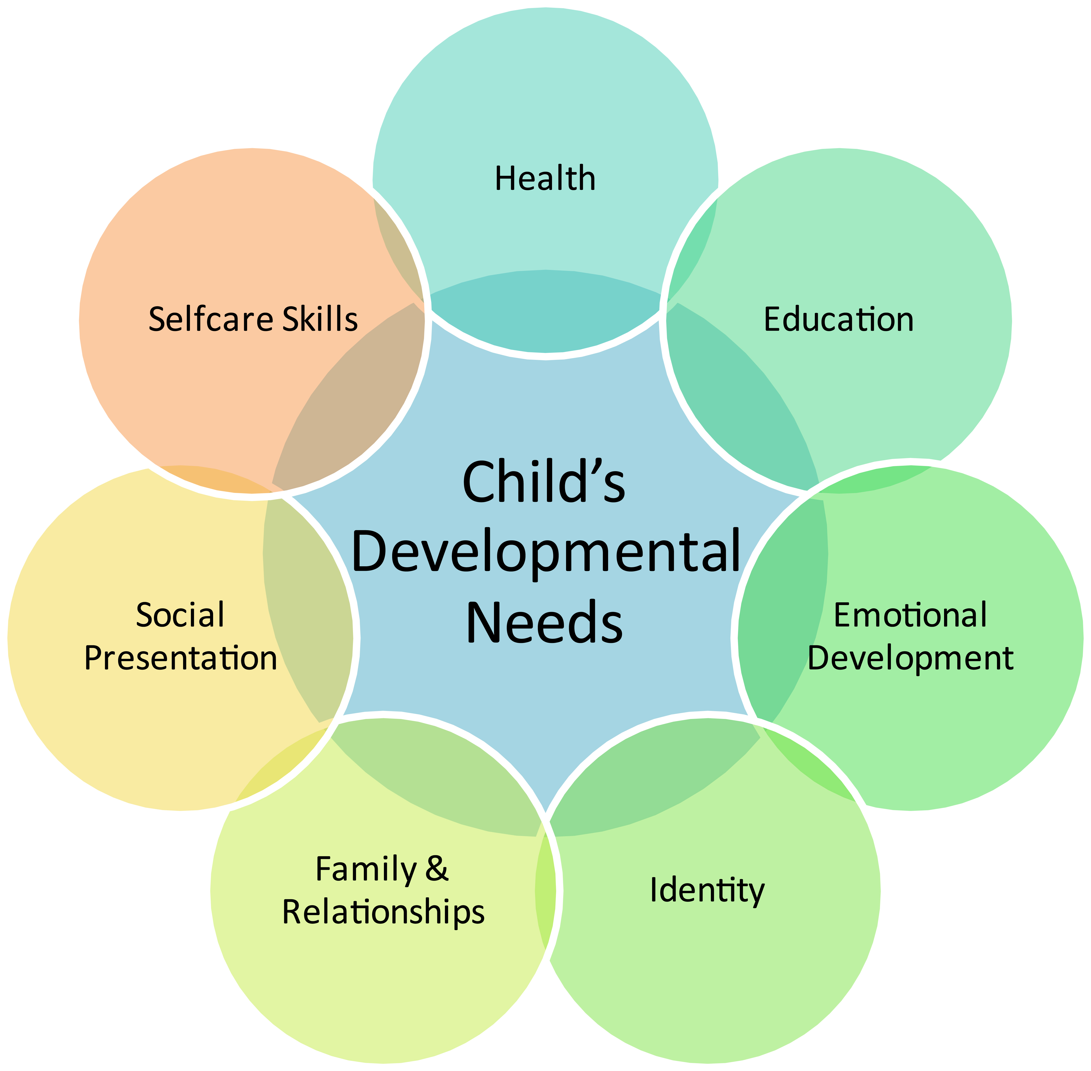
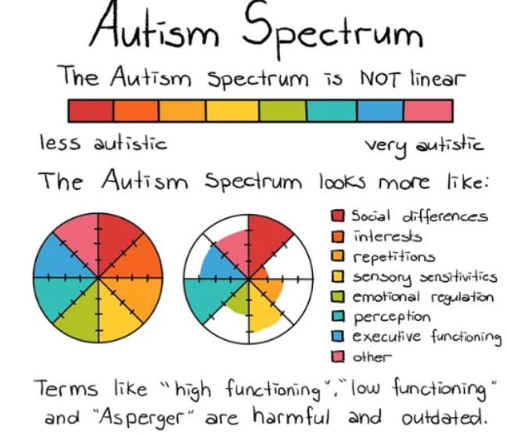

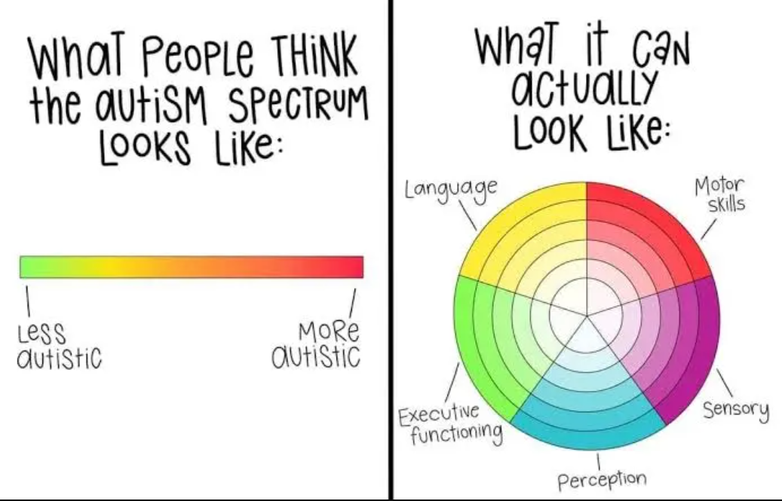

Applying ML Algorithms
System Architecture

Data Reprocessing (Normalization & Eliminating missing values)
Autism Raw Dataset
Loading of Preprocessed Data
Evaluation of ASD and no ASD classes

Applying DL Algorithms

School of Computer Engineering, KIIT, BBSR 10

Autism Spectrum Disorder

Chapter 10

Result comparison with different Algos

Below are the charts of all the algorithms based on different parameters:
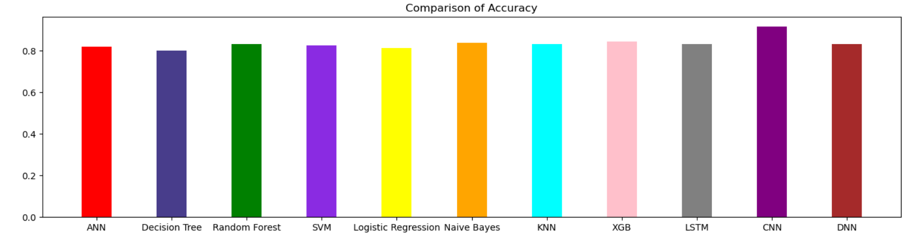
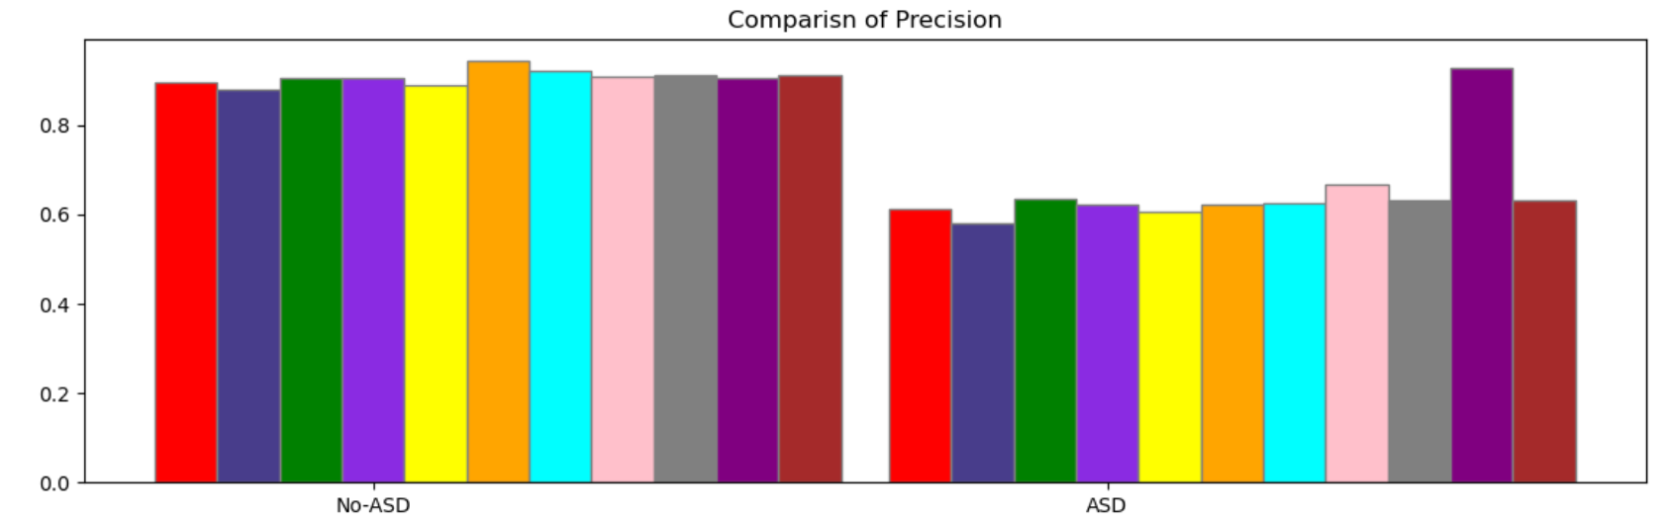
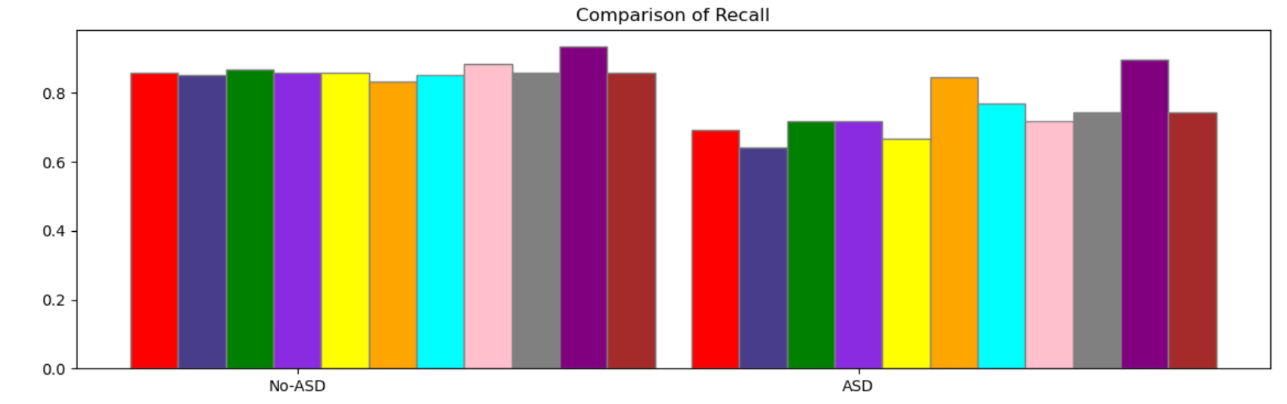
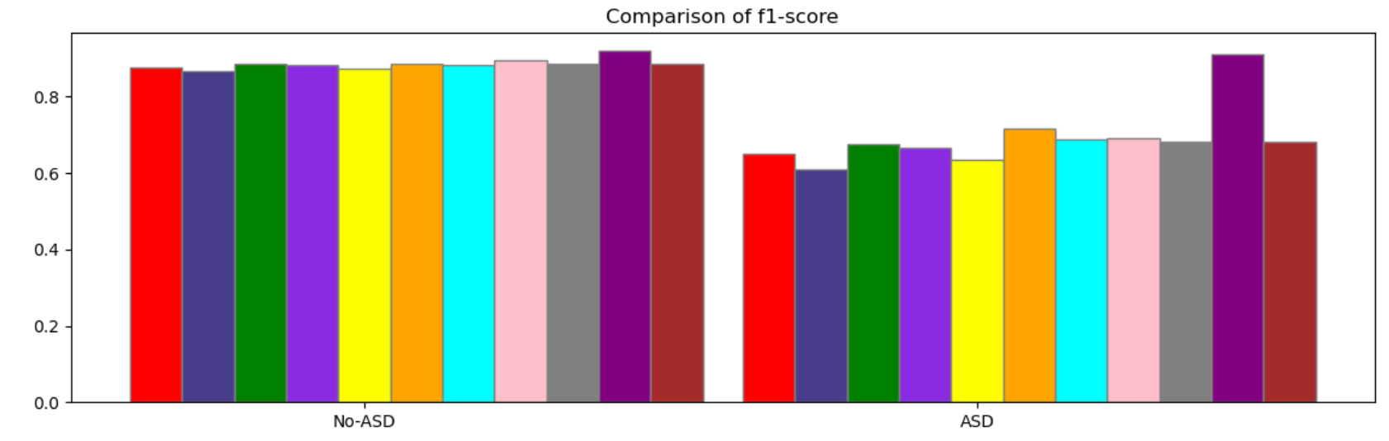

School of Computer Engineering, KIIT, BBSR 11
Autism Spectrum Disorder

Chapter 11

11.1 Design Standards

The dataset which we are using in research purpose is from UCI Machine Learning Repository made available by Fadi Fayez Thabtah.The Attributes used for our model training are mentioned below:

i). A1_Score to A10_Score - Score based on Autism Spectrum Quotient (AQ) 10 item screening tool
ii). age - Age of the patient in years
iii). gender - Gender of the patient
iv). ethnicity - Ethnicity of the patient
v). jaundice - Whether the patient had jaundice at the time of birth
vi). autism - Whether an immediate family member has been diagnosed with autism
vii). country_of_res - Country of residence of the patient
viii) .used_app_before - Whether the patient has undergone a screening test before
ix). result - Score for AQ1-10 screening test
x). age_desc - Age of the patient
xi). Class/ASD - Classified result as 0 or 1. Here 0 represents No and 1 represents Yes. This is the target column, and during submission submit the values as 0 or 1 only.

11.2 Coding Standards

Followings are the attributes that are taken to train our model:

- Is able to hear sound that others can't.
- Targeting on broad things than small details.
- Pursue the discussions of people in a community group.
- If can effectively switch between available actions.
- Having no idea how to chitchat with peers.
- Fine for day-today small chats.
- Finding hard to understand emotions while reading a book.
- Fond of playing role plays as part of pre-school education.
- Recognize their experience by observing facial expressions.
- Hard to make new friends.
- Background('White-European', 'South Asian','Asian', 'Middle Eastern 'Pasifika','Hispanic', 'Turkish','Latino', 'Black','Others', 'Unknown').
- Born with jaundice .
- Family member with PDD.
- Country.
- Familiar with the screening app .
- Score.
- Age_desc.
- If attempted the test before.
- Class/ASD.

School of Computer Engineering, KIIT, BBSR 12
Autism Spectrum Disorder

11.3 Testing Standards

i. Accuracy=(TP+TN)/(TP+TN+FP+FN)
ii. Precision= TP/(TP+FP)
iii. Recall = TP/(TP+FN)
iv. F1-Score =2(Recall*Precision)/(Recall+Precision)

Classification Report:
NAME | accuracy | precision | recall | f1-score
ANN | 0.81875 | 0.61 | 0.69 | 0.65
Decision Tree | 0.8 | 0.58 | 0.64 | 0.61
Random Forest | 0.83125 | 0.64 | 0.72 | 0.67
SVM | 0.825 | 0.62 | 0.72 | 0.67
Logistic Regression | 0.8125 | 0.60 | 0.67 | 0.63
Naive Bayes | 0.8375 | 0.62 | 0.85 | 0.72
KNN | 0.83125 | 0.62 | 0.77 | 0.69
XGB | 0.84375 | 0.67 | 0.72 | 0.69
CNN | 0.91666 | 0.93 | 0.90 | 0.91
LSTM | 0.83125 | 0.63 | 0.74 | 0.68
DNN | 0.83125 | 0.63 | 0.74 | 0.68

School of Computer Engineering, KIIT, BBSR 13
Autism Spectrum Disorder

Chapter 12

Conclusion and Future Scope

Conclusion
In conclusion, autism spectrum disorder (ASD) is a complex neurodevelopmental condition that affects individuals in diverse ways. Through this presentation, we've explored the key characteristics, diagnostic criteria, prevalence, and potential causes of autism. It's crucial to recognize that each person with autism is unique, with their own strengths and challenges.

While there is still much to learn about autism, increased awareness, acceptance, and support are essential for improving the lives of individuals on the spectrum. Early intervention and personalized therapies can significantly enhance outcomes and help individuals with autism reach their full potential.

As we continue to advance our understanding of autism, let us strive for a society that embraces neurodiversity, promotes inclusivity, and provides equal opportunities for individuals of all abilities. Together, we can create a more compassionate and supportive world for everyone, including those with autism.

Future Scope

As we move forward, the future holds promising developments in the understanding, diagnosis, and treatment of autism spectrum disorder (ASD). Here are some areas of future scope in the field:

Early Detection and Intervention: Advances in neuroimaging, genetic testing, and behavioral assessments may lead to earlier detection of autism, allowing for timely intervention and improved outcomes. Research into early intervention strategies, such as targeted therapies and parent training programs, shows promise in maximizing developmental potential.

Personalized Medicine: The shift towards personalized medicine may revolutionize autism treatment by tailoring interventions to the individual's unique genetic, biological, and behavioral profile. Precision medicine approaches, including pharmacogenomics and targeted therapies, hold potential for optimizing treatment efficacy and minimizing side effects.

Neuroscience and Brain-Computer Interfaces: Continued research into the neurobiology of autism may uncover novel insights into the underlying neural mechanisms of the disorder. Advancements in neuroimaging techniques, such as functional magnetic resonance imaging (fMRI) and electroencephalography (EEG), could facilitate the development of brain-computer interfaces (BCIs) for augmentative communication and assistive technologies.

School of Computer Engineering, KIIT, BBSR 14

Autism Spectrum Disorder

Artificial Intelligence and Data Analytics: The integration of artificial intelligence (AI) and machine learning algorithms may enhance our ability to analyze large-scale datasets, identify patterns, and predict outcomes in autism research. AI-powered tools for early screening, diagnostic decision support, and personalized treatment planning have the potential to revolutionize clinical practice and improve patient care.

Digital Health Solutions: The proliferation of mobile health technologies and wearable devices presents opportunities for remote monitoring, real-time data collection, and personalized intervention delivery in autism management. Virtual reality (VR) and augmented reality (AR) applications may also offer innovative approaches for social skills training, sensory integration therapy, and behavior modification.

Community Support and Advocacy: The growing emphasis on community-based support services, inclusive education practices, and employment opportunities for individuals with autism reflects a broader societal shift towards promoting neurodiversity and social inclusion. Advocacy efforts aimed at raising awareness, reducing stigma, and fostering acceptance are essential for creating a more inclusive society.

By embracing interdisciplinary collaboration, leveraging technological innovations, and prioritizing the needs and voices of individuals with autism and their families, we can work towards a future where every person on the autism spectrum is empowered to thrive and fulfill their potential.

School of Computer Engineering, KIIT, BBSR 15
Autism Spectrum Disorder

References

- American Psychiatric Association. (2013). Diagnostic and Statistical Manual of Mental Disorders (5th ed.). Arlington, VA: American Psychiatric Publishing.
- Baio, J., Wiggins, L., Christensen, D. L., et al. (2018). Prevalence of Autism Spectrum Disorder Among Children Aged 8 Years — Autism and Developmental Disabilities Monitoring Network, 11 Sites, United States, 2014. MMWR. Surveillance Summaries, 67(6), 1–23.
- Happé, F., & Ronald, A. (2008). The ‘fractionable autism triad’: a review of evidence from behavioural, genetic, cognitive and neural research. Neuropsychology Review, 18(4), 287–304.
- Lai, M. C., Lombardo, M. V., & Baron-Cohen, S. (2014). Autism. The Lancet, 383(9920), 896–910.
- National Institute of Mental Health. (2019). Autism Spectrum Disorder. Retrieved from https://www.nimh.nih.gov/health/topics/autism-spectrum-disorders-asd/index.shtml
- Volkmar, F. R., & McPartland, J. C. (2014). From Kanner to DSM-5: Autism as an Evolving Diagnostic Concept. Annual Review of Clinical Psychology, 10, 193–212.
- World Health Organization. (2018). Autism Spectrum Disorders. Retrieved from https://www.who.int/news-room/fact-sheets/detail/autism-spectrum-disorders

School of Computer Engineering, KIIT, BBSR 16

Autism Spectrum Disorder

Individual Contribution

BRIJIT ADAK -> Lead and Coding
SAURABH SUSHANT -> Coding and Design
Diptendra Maity -> Planning and design
Arijit Mistry -> Research and Documentation

School of Computer Engineering, KIIT, BBSR 17

