Questions :

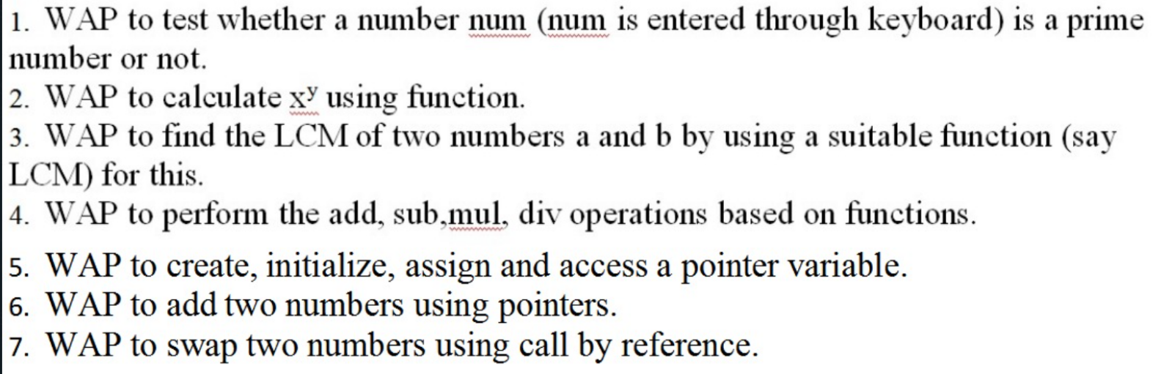

Answers :

1.

#include <stdio.h>

int main() {

int n, i, flag = 0;

printf("Enter a number to check prime or not: ");

scanf("%d", &n);

if(n>=0){

if (n == 0 || n == 1){

printf("%d is neither a prime number nor a composite number.\n",n);

flag = 2;

}

for (i = 2; i <= n / 2; ++i) {

if (n % i == 0) {

flag = 1;

break;

}

}

}

else{

printf("Entered number is negative.");

flag =2;

}

if (flag == 0)

printf("%d is a prime number.", n);

else if(flag ==1)

printf("%d is not a prime number.", n);

return 0;

}

**OUTPUT**

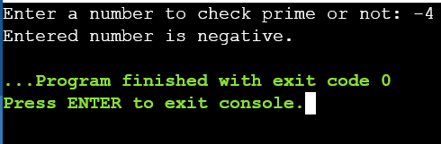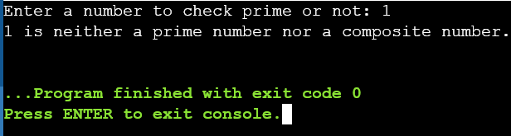

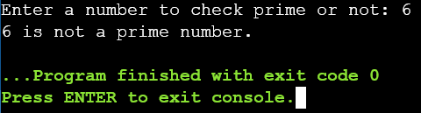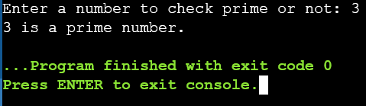

2.

#include <stdio.h>

#include <math.h>

int fun(int m, int n){

return pow(m,n);

}

int main()

{

int x,y,z;

printf("To calculate x to the power y\n");

printf("Enter the values of x and y respectively : \n");

scanf("%d %d",&x,&y);

z=fun(x,y);

printf("The ans is : %d",z);

return 0;

}

**OUTPUT**

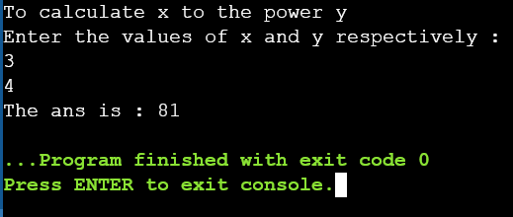

3.

#include <stdio.h>

void LCM (int e,int f,int g){

while (1) {

if (g % e == 0 && g % f == 0) {

printf("The LCM of %d and %d is %d.", e, f, g);

break;

}

++g;

}

}

int main() {

int a, b, max;

printf("Enter two positive integers: \n");

scanf("%d %d", &a, &b);

max = (a > b) ? a : b;

LCM(a,b,max);

return 0;

}

**OUTPUT**

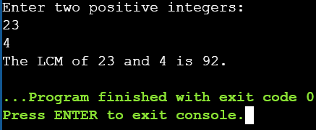

4.

#include <stdio.h>

int add(int a, int b){

return (a+b);

}

int sub(int a, int b){

return (a-b);

}

int mul(int a, int b){

return (a*b);

}

float divi(float a, float b){

return (a/b);

}

int main()

{

int a,b,c,d,e,z;

float f;

printf("Enter two numbers to perform\n");

printf("add, sub, mul, divi functions\n");

scanf("%d %d",&a,&b);

printf("Enter which one to perform\n1.Add\n2.Sub\n3.Mul\n4.Div\n");

scanf("%d",&z);

if(z==1)

printf("\nThe addition value is %d",add(a,b));

else if(z==2)

printf("\nThe substraction value is %d",sub(a,b));

else if(z==3)

printf("\nThe multiplication value is %d",mul(a,b));

else if(z==4)

printf("\nThe division value is %f",divi(a,b));

return 0;

}

**OUTPUT**

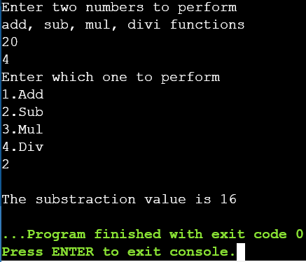

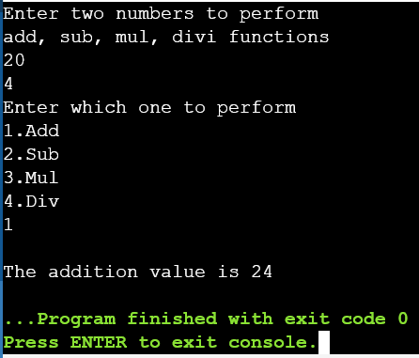

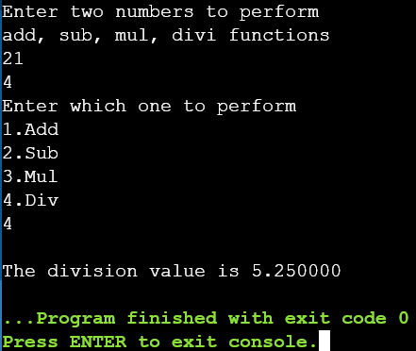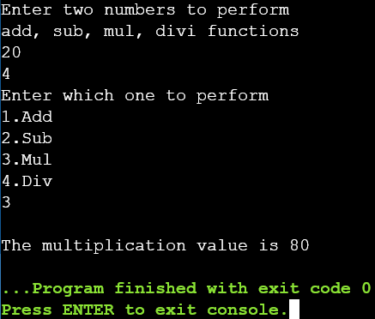

5.

#include <stdio.h>

int main() {

char cha;

char *ptrCha;

ptrCha = &cha;

cha = 'A';

printf("The Value of cha: %c\n", cha);

printf("The Address of cha: %p\n", &cha);

printf("ptrcha is pointing to : %c\n", *ptrCha);

printf("The value of ptrcha: %p", ptrCha);

return 0;

}

**OUTPUT**

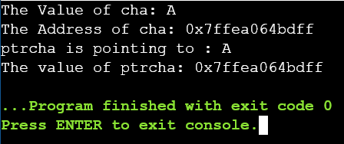

6.

#include <stdio.h>

int main()

{

int first, second, *p, *q, sum;

printf("Enter two integers to add\n");

scanf("%d%d", &first, &second);

p = &first;

q = &second;

sum = *p + *q;

printf("Sum of the numbers = %d\n", sum);

return 0;

}

**OUTPUT**

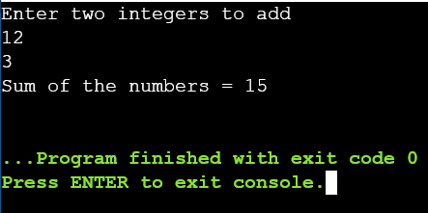

7.

#include <stdio.h>

void swap (int *x, int *y)

{

int temp;

temp = *x;

*x = *y;

*y = temp;

}

int main()

{

int a, b;

printf("Enter value of a & b: \n");

scanf("%d %d", &a, &b);

printf("\nBefore Swapping:\n");

printf("\na = %d\n\nb = %d\n", a, b);

swap(&a, &b);

printf("\nAfter Swapping:\n");

printf("\na = %d\n\nb = %d", a, b);

return 0;

}

**OUTPUT**

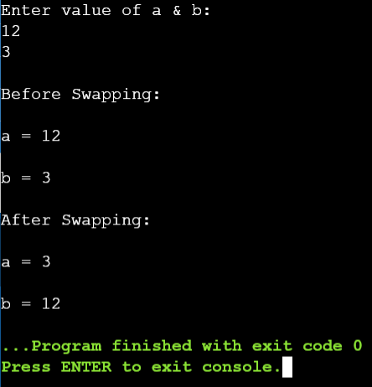

END