Questions

1. WAP to find the largest number and counts the occurrence of the largest number in a dynamic array of n integers using a single loop.
2. Given a dynamic array, WAP to print the next greater element (NGE) for every element. The next greater element for an element x is the first greater element on the right side of x in array. Elements for which no greater element exist, consider next greater element as -1. E.g. For the input array [2, 5, 3, 9, 7], the next greater elements for each elements are as follows.

|  |  |
| --- | --- |
| Element | NGE |
| 2 | 5 |
| 5 | 9 |
| 3 | 9 |
| 9 | -1 |
| 7 | -1 |

1. WAP to store n student’s information (i.e. student’s roll no, name, gender, marks etc) of an educational institute and display all the data, using array of structure.
2. WAP to store n employee’s data such as employee name, gender, designation, department, basic pay. Calculate the gross pay of each employees as follows:

Gross pay = basic pay + HR + DA

HR=25% of basic and DA=75% of basic.

1. WAP to declare one distance structure (with members kilometer and meter) and create the variables for addition of two distances using Pointers to structure.

10km500m--D1

21km600m--D2

D3.meter=D1.meter+D2.meter (100)

D3.KM=D1.KM+D2.KM (32)

If(D3.meter>=1000)

D3.KM++;

D3.meter=D3.meter-1000;

Answers

1.

#include <stdlib.h>

#include<stdio.h>

int main()

{

int n;

printf("Enter number of elements : ");

scanf("%d",&n);

int* arr;

arr = (int*)malloc(n * sizeof(int));

for (int i = 0; i < n; ++i) {

printf("Enter element no %d : ",i+1);

scanf("%d",arr+i);

}

int x = *arr,y=0;

for (int i = 0; i <n;i++){

if(x<*(arr+i)){

x=*(arr+i);

y=0;

}

if (*(arr+i)==x){

y++;

}

}

free(arr);

printf("Largerst Number is : %d\n",x);

printf("Largerst count is : %d",y);

return 0;

}

OUTPUT

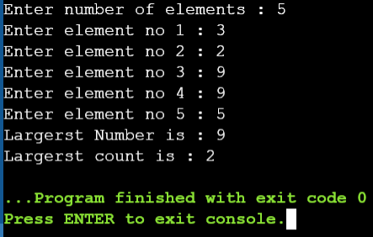

2.

#include <stdio.h>

#include <stdlib.h>

int main()

{

int i,j,n;

printf("Enter the number of elements : ");

scanf("%d",&n);

int* arr;

int* a;

arr = (int*)malloc(n * sizeof(int));

a=(int*)malloc(n * sizeof(int));

for (int i = 0; i < n; ++i)

scanf("%d",arr+i);

for(i=0;i<n-1;i++){

for(j=i+1;j<n;j++){

if(*(arr+i)<*(arr+j)){

*(a+i)=*(arr+j);

break;

}

else

*(a+i)=-1;

}

*(a+n-1)=-1;

}

printf("\nDisplaying\n\n");

for(i=0;i<n;i++)

printf("%d\t%d\n",*(arr+i),*(a+i));

return 0;

}

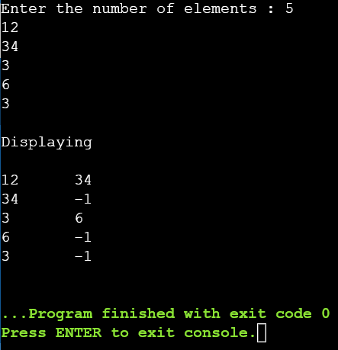OUTPUT

3.

#include <stdio.h>

struct student {

char Name[50];

int roll;

char Gender[6];

float marks;

};

int main() {

int i,n;

printf("Enter number of students : ");

scanf("%d",&n);

struct student s[n];

printf("Enter information of students :\n");

for (i = 0; i < n; ++i) {

s[i].roll = i + 1;

printf("\nFor roll number %d :\n", s[i].roll);

printf("Enter name : ");

scanf("%s", s[i].Name);

printf("Enter Gender : ");

scanf("%s", s[i].Gender);

printf("Enter marks : ");

scanf("%f", &s[i].marks);

}

printf("\n\nDisplaying Information :\n");

for (i = 0; i < n; ++i) {

printf("\nRoll number : %d\n", i + 1);

printf("Name : ");

puts(s[i].Name);

printf("Marks : %.1f", s[i].marks);

printf("\nGender : %s",s[i].Gender);

printf("\n");

}

return 0;

}

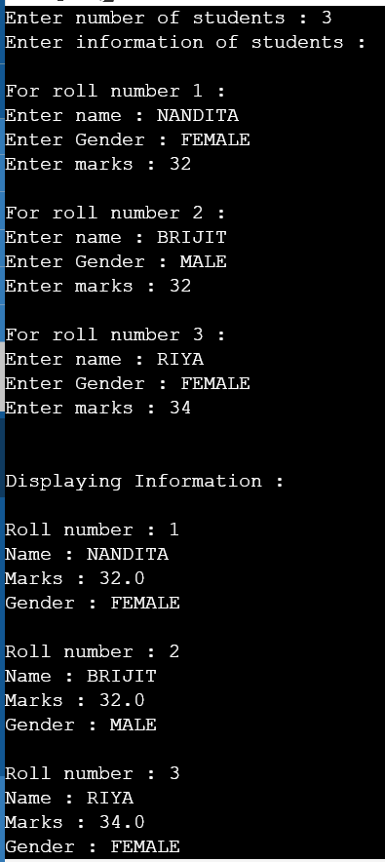OUTPUT

4.

#include <stdio.h>

struct employee{

char Name[50];

char Gender[7];

char Designation[30];

char Department[30];

int Basic_pay;

float total;

};

int main()

{ int n,i;

printf("Enter Number of empoyee : ");

scanf("%d",&n);

struct employee s[n];

for(i=0;i<n;i++){

printf("\nFor Employee %d ",i+1);

printf("\n\nName : ");

scanf("%s",s[i].Name);

printf("\nGender : ");

scanf("%s",s[i].Gender);

printf("\nDesignation : ");

scanf("%s",s[i].Designation);

printf("\nDepartment : ");

scanf("%s",s[i].Department);

printf("\nBasic pay : ");

scanf("%d",&s[i].Basic_pay);

}

printf("\n\nShowing Data\n\n");

for(int i = 0; i < n; i++){

printf("Name of employee %d is %s \n", (i+1), s[i].Name);

printf("Gender is %s \n",s[i].Gender);

printf("Designation is %s\n",s[i].Designation);

printf("Department is %s\n",s[i].Department);

s[i].total = s[i].Basic_pay + s[i].Basic_pay*0.25 + s[i].Basic_pay*0.75;

printf("Gross pay is %.1f \n\n",s[i].total);

}

return 0; }

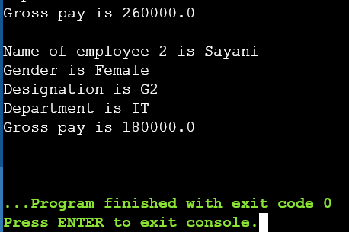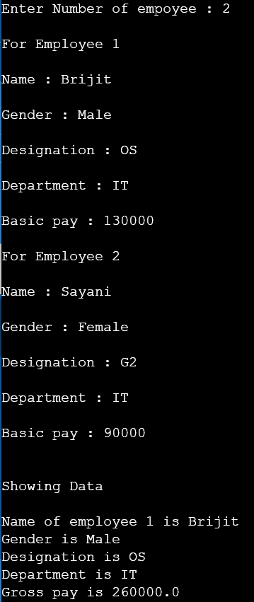OUTPUT

5.

#include<stdio.h>

#include <string.h>

#include <stdlib.h>

struct distance{

int kilometer;

int meter;

};

int main(){

struct distance *p1,*p2,*p3;

p1= (struct distance*)malloc(sizeof(struct distance));

p2= (struct distance*)malloc(sizeof(struct distance));

p3= (struct distance*)malloc(sizeof(struct distance));

printf("Distance 1 in KM - ");

scanf("%d", &p1->kilometer);

printf("Distance 1 in M - ");

scanf("%d", &p1->meter);

printf("\n\nDistance 2 in KM - ");

scanf("%d", &p2->kilometer);

printf("Distance 2 in M - ");

scanf("%d", &p2->meter);

(p3->meter)=(p2->meter)+(p1->meter);

(p3->kilometer)=(p2->kilometer)+((p1->kilometer));

if ((p3->meter)>=1000){

(p3->kilometer)++;

(p3->meter)-=1000;

}

printf("\n\nTotal Distance - %d Km and %d m",p3->kilometer,p3->meter);

return 0;

}

OUTPUT

