Questions

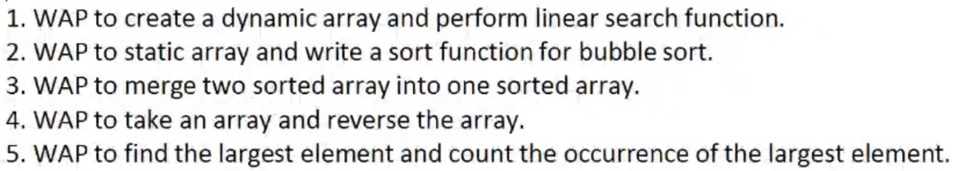

Answers

1.

#include <stdio.h>

#include <stdlib.h>

int search(int array[], int n, int x) {

for (int i = 0; i < n; i++)

if (array[i] == x)

return i;

return -1;

}

int main() {

int \*array;

int n;

printf("Enter the size of array : ");

scanf("%d",&n);

array=(int \*)malloc(n\*sizeof(int));

printf("\nEnter array elements : \n");

for(int i=0;i<n;i++)

scanf("%d",(array+i));

int x;

printf("\nEnter the element to find out : ");

scanf("%d",&x);

int result = search(array, n, x);

(result == -1) ? printf("Element not found") : printf("Element found at index: %d", result+1);

return 0;

}

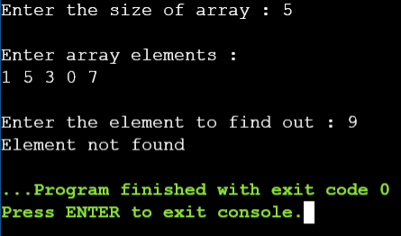OUTPUT

2.

#include <stdio.h>

void swap(int\* xp, int\* yp)

{

int temp = \*xp;

\*xp = \*yp;

\*yp = temp;

}

void bubbleSort(int arr[], int n)

{

int i, j;

for (i = 0; i < n - 1; i++)

for (j = 0; j < n - i - 1; j++)

if (arr[j] > arr[j + 1])

swap(&arr[j], &arr[j + 1]);

}

void printArray(int arr[], int size)

{

int i;

for (i = 0; i < size; i++)

printf("%d ", arr[i]);

printf("\n");

}

int main()

{

int n;

printf("Enter the size of array : ");

scanf("%d",&n);

printf("Enter array elements : \n");

int arr[n];

for(int i=0;i<n;i++)

scanf("%d",&arr[i]);

printf("Array before sorting : \n");

for (int i = 0; i < n; i++)

printf("%d ",arr[i]);

bubbleSort(arr, n);

printf("\n\nSorted array: \n");

printArray(arr, n);

return 0;

}

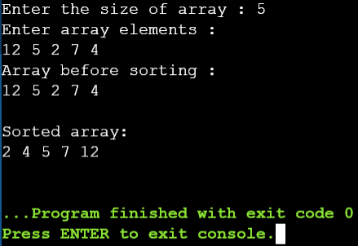OUTPUT

3.

#include <stdio.h>

int main()

{

int n1,n2,n3,i=0,j=0,k=0;

printf("Enter the size of first array ");

scanf("%d",&n1);

printf("\nEnter the size of second array ");

scanf("%d",&n2);

n3=n1+n2;

int a[n1],b[n2],c[n3];

printf("\nEnter the first array elements\n");

for(i=0;i<n1;i++)

{

scanf("%d",&a[i]);

}

printf("\nEnter the second array elements\n");

for(j=0;j<n2;j++)

{

scanf("%d",&b[j]);

}

i=0;j=0;

while(i<n1 && j<n2){

if(a[i]<b[j]){

c[k]=a[i];

i++;k++;

}

else

{

c[k]=b[j];

j++;k++;

}

}

while(i<n1){

c[k]=a[i];

i++;k++;

}

while(j<n2){

c[k]=b[j];

j++;k++;

}

printf("\nThe merged and sorted array is \n");

for(i=0 ; i<n3 ; i++)

{

printf("%d ",c[i]);

}

return 0;

}

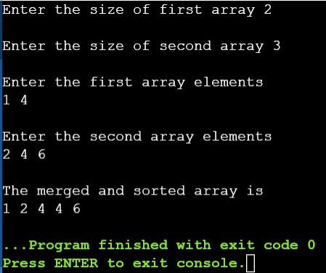OUTPUT

4.

#include<stdio.h>

void reverseArray(int arr[], int start, int end)

{

int temp;

while (start < end)

{

temp = arr[start];

arr[start] = arr[end];

arr[end] = temp;

start++;

end--;

}

}

void printArray(int arr[], int size)

{

int i;

for (i=0; i < size; i++)

printf("%d ", arr[i]);

printf("\n");

}

int main()

{

int n;

printf("Enter the size of array : ");

scanf("%d",&n);

printf("Enter array elements : \n");

int arr[n];

for(int i=0;i<n;i++)

scanf("%d",&arr[i]);

reverseArray(arr, 0, n-1);

printf("Reversed array is \n");

printArray(arr, n);

return 0;

}

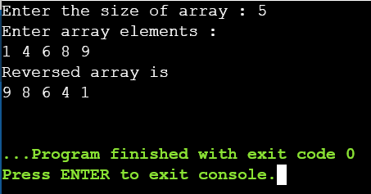OUTPUT

5.

#include <stdlib.h>

#include<stdio.h>

int main()

{

int n;

printf("Enter number of elements : ");

scanf("%d",&n);

int\* arr;

arr = (int\*)malloc(n \* sizeof(int));

for (int i = 0; i < n; ++i) {

printf("Enter element no %d : ",i+1);

scanf("%d",arr+i);

}

int x = \*arr,y=0;

for (int i = 0; i <n;i++){

if(x<\*(arr+i)){

x=\*(arr+i);

y=0;

}

if (\*(arr+i)==x){

y++;

}

}

free(arr);

printf("Largerst Number is : %d\n",x);

printf("Largerst count is : %d",y);

return 0;

}

OUTPUT

