Software Requirements Specification
for
Emotion Detection through Facial Expressions
Version 1.0 approved
Prepared by Debjit Goswami, Brijit Adak, Shreyansh Upadhyay
Guided by Dr. Prachet Bhuyan
KIIT
01.09.23
Table of Contents

1. INTRODUCTION..............................................................................................................1
2. STUDY OF SIMILAR PROJECTS OR TECHNOLOGY\ LITERATURE REVIEW 1
3. BASIC CONCEPTS/ TECHNOLOGY USED......................................................................2

4.PROJECT COMPONENTS......................................................................................................2
5. PROPOSED MODEL / ARCHITECTURE / METHODOLOGY/ MODEL TOOL.......2
6. IMPLEMENTATION AND RESULTS 4

7. PERFOMANCE ANALYSIS....................................................................................................4

8. SOCIETAL IMPACT AND FUTURE SCOPE......................................................................4

9. CONCLUSION..........................................................................................................................4
10. REFERENCES.................................................................................................................4

Revision History
Name | Date | Reason For Changes | Version

Emotion Detection through Facial Expressions
Abstract- It is said that “Face is the index of the mind and Eyes are the mirror of the soul”. This paper describes how to train a program to predict emotional state of mind based on facial expressions of a human face detected at real time through a video feed and play a suitable song to express that emotion.
Index Terms- Emotion Detection, Facial Expression, Machine Learning, Mood Prediction

- INTRODUCTION
Since a person's sentiments, moods and emotions produce strong impressions on the body language, especially the facial expressions, there are unmistakable ways in which we can decode the subtle thoughts doing rounds in that person's mind. The emotional state of a person – whether it is sadness, happiness, anxiety, fear, or any other human mood – reflect in eye dilation, muscle movement, lip formation, forehead wrinkles, and many other facial features.
For a human, it is often easy, almost instinctive, to read other's face and guess the mood. Actually, this is often the most important clue - in addition to verbal tones and (sometimes) language used – to a person's sentiment. Sentiment detection is an evolutionary attribute of animals because it is a great indicator of the environment. Humans in particular use it all the time to both understand the situation and act accordingly; this often controls the direction of communication for mutual benefit.
Since detecting human emotion is thus an important activity, and reading facial expressions is a good way to do it, it is imperative to find an automated way of achieving the task. This will have immense value in a lot of activities that depend on human emotion – including man-machine interaction, security, learning and education, entertainment, behavioral research, medical diagnosis, and others. In this era of visually- interactive platforms and intelligent information analysis, a good emotion detection can have a positive impact on the society.
The rest of the paper attempts to describe an approach to automatically detect human emotion through facial analysis, Written in Python, and deploying machine learning techniques, the approach is to read facial expressions of a subject, match it with similar expressions, and based on that predict which emotional state these expressions translate to. As a proof of the emotion detected, and also as a reward to the subject, a mood-appropriate song is selected and played for the person, with hope to boost positive moods and to help tackle negative moods.

- STUDY OF SIMILAR PROJECTS OR TECHNOLOGY\ LITERATURE REVIEW
Facial Expression Recognition (FER) techniques are often a subject of interest both in the academia^{1,} ² and in the industry3. As human life is met with cameras everywhere, including personal artifacts like phone and laptop, as well as public places like airports, roads, railway stations, and buildings, both government agencies and private enterprises are trying to detect human faces and make use of the data.
FER is a subset of these activities that is seeing recent growth in interest due to obvious reasons. A vast number of works and studies in this area is available in print media, journals, websites, and other channels.

- BASIC CONCEPTS/ TECHNOLOGY USED
Emotion detection through facial expressions fall into a category in supervised machine learning known as classification process. In short, a program is first provided with a known set of data along with the classification of each element. This is called training of the algorithm. Once the algorithm builds its learning data, it is tested and verified with another known set of data. After the whole process is complete, the program can now classify a new, previously unknown data set.
In the current scenario, a set of images of human faces are classified into different emotions – happy, sad, angry, neutral, disgusted, surprise, fear. This is provided to the program, which analyzes each image – its pixel formation in particular – and gathers useful information from it. It then compares the information with the emotion provided and correlates the two. After a considerable number of image analysis, a pattern emerges within the program – it has now learnt to associate a pixel formation to an emotion. In human analogy, a broad smile with lips bent upward, teeth showing, and eyes contracted often resembles a happy mood. On the other hand, large eyes with oval lips are usually an indicator of surprise.
Once the program has learnt an algorithm – after training and testing cycles – this information is saved and used for subsequent steps. In this phase, program interacts with a person through a camera for the purpose of this implementation. When the person looks directly into the camera, the program captures frames at a certain interval. For each of this frame, the program applies the algorithm learnt earlier in the process, and classifies the framed image into an emotion, which is displayed back to the user. The emotion detected changes over time based on change in facial expression. This continues till the person escapes the video mode, in which case the last captured emotion is sent back to the calling program. The calling program can then use the information as it chooses – in current implementation, a suitable song from a library is played.
There are many libraries available in Python – both standard and public domain – that have been used for this. The core of the logic resides in machine learning libraries. However, there are other supporting libraries for image processing, video capturing, numerical analysis, music playing, and such.

PROJECT COMPONENTS
The program can be broken into some parts for ease of analysis.
Build Detection Algorithm – Use a model and train it with a known set of images to detect emotion.
Detect Emotion – Get an image of user face and analyze the expression to detect emotion. Use video capture to get the image at runtime.
Play Music – Play a music appropriate for the emotion detected.

- PROPOSED MODEL / ARCHITECTURE / METHODOLOGY/ MODEL TOOL
We are using Tensorflow Keras Deep Learning module to train our program.

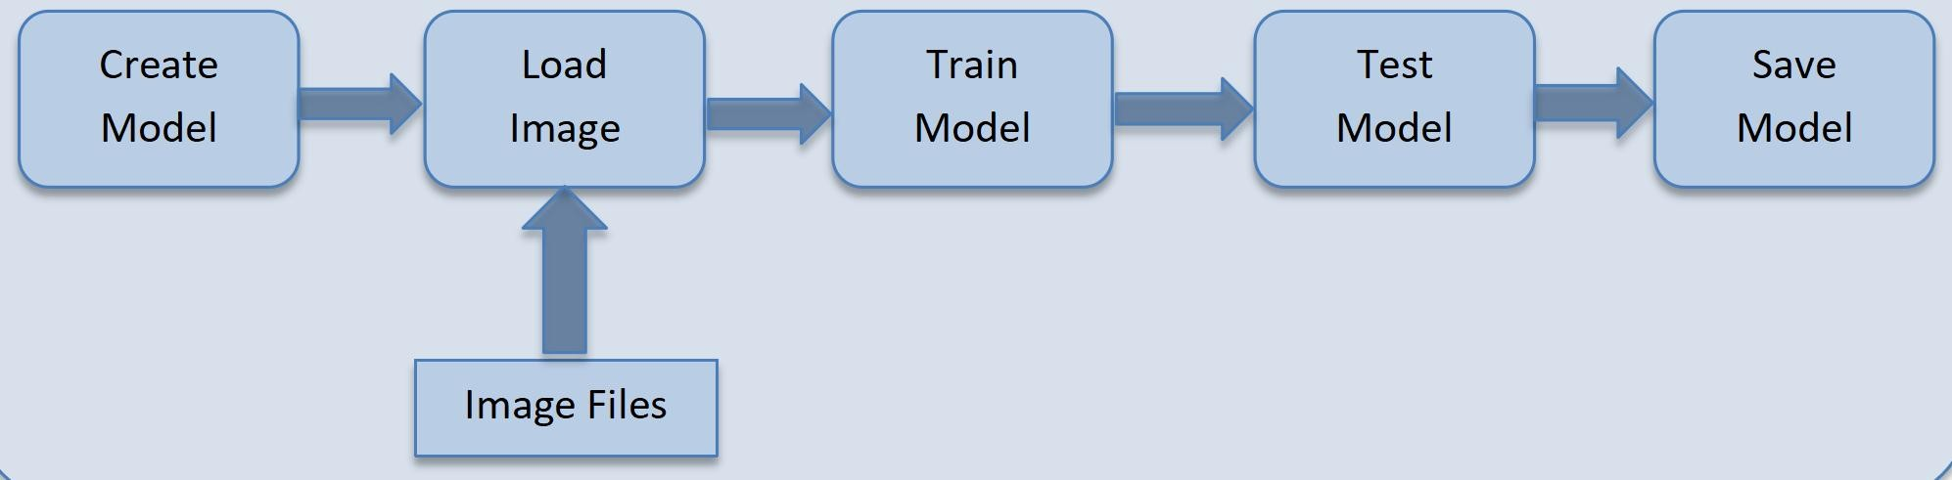

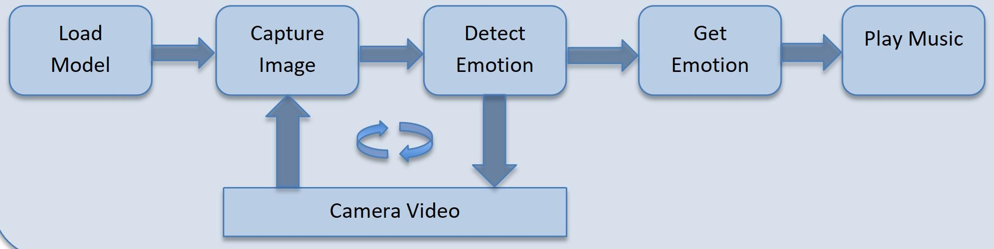

- A model is created using MobileNet for image classification
- Train the model with pre-classified images. We have used about 350 images classified into 7 emotions (Angry, Disgust, Fear, Happy, Neutral, Sad, Surprise). The images are taken from a net image repository with the expectation that they should provide a representative sample suitable for the purpose.
- The model is then trained based on this data and its accuracy is found to be about 98%, with minimal loss of information.
- It is then tested with some sample data, again gathered from the web, and is found to be fairly accurate in detecting the emotion (9 correct out of 10 tested).
The model is now used to detect emotion of user. We are using OpenCV to process video and image captured.

- The model is loaded into the program
- A screen is opened to capture video
- The video detects the face, gets the image and converts into pixels
- The image pixel is used by the model to detect emotion and feedback is provided to the user in the video itself
- The process continues till the user quits the video capturing screen
- The last detected emotion is sent back to the calling program
- The program now matches the emotion to a suitable song in a local library and plays the song till user stops.
- IMPLEMENTATION AND RESULTS
The project is currently implemented as Python modules. This is an interactive software, meaning an active user runs the program to get desired result. This is also an audio-visual type of software, it uses camera for image capture and speaker for music play. The design and development of the core solution has been done in Anaconda Jupyter environment, and source codes are available as Jupyter notebooks.

PERFOMANCE ANALYSIS

Not Applicable in this implementation.

SOCIETAL IMPACT AND FUTURE SCOPE
Emotion detection through facial expression is an activity that humans exercise all the time during communication, social gathering, at work, and many other places. While biological evolution and learning through social interaction has helped human in this task, it is often required to mimic the capability in an automated way. This is more so in this era when man-machine interface is often visual and there is a need for smart, intelligent interactive computer programs. While this paper has focused on the entertainment side, this finds varied utilities in the society in many fields - including security (e.g., in an airport, find anxious and sad people), app-based marketing (e.g., target customers presented with products based on their emotion), medical (e.g., detect pain for babies/children with disability), etc.

CONCLUSION
The program is working as expected based on the input provided. A larger training set is recommended to make the prediction more accurate; however, getting appropriate images and classifying those will be a one-time manual task. The program can also be enhanced to detect multiple faces, to feed data continuously to another processing program, and so on. Also, various model parameters can be tweaked to find optimum algorithm.

- REFERENCES
- Zhenjie Song, Facial Expression Emotion Recognition Model Integrating Philosophy and Machine Learning Theory, Front. Psychol., September 2021, https://doi.org/10.3389/fpsyg.2021.759485.
- I. Michael Revina, W.R. Sam Emmanuel, A Survey on Human Face Expression Recognition Techniques, Journal of King Saud University - Computer and Information Sciences, Volume 33, Issue 6, July 2021, Pages 619-628 , https://doi.org/10.1016/j.jksuci.2018.09.002.
- Archana Modawal, Know the benefits of facial recognition and emotion detection tools, May 2022, https://www.softwebsolutions.com/resources/benefits-of-facial-recognition.html

