NAME : BRIJIT ADAK
ROLL NO : 21052410
SEC : CSE 31

Q1. Write a python program to input two numbers and do all basic arithmetic operations on them.

print("Hello roll 21052410, Enter values of 2 numbers a and b to do all basic arithmetic operations")
a=eval(input("Enter a "))
b=eval(input("Enter b "))
c=a+b
print("a+b=",c)
c=a-b
print("a-b=",c)
c=a*b
print("a*b=",c)
c=a/b
print("a/b=",c)

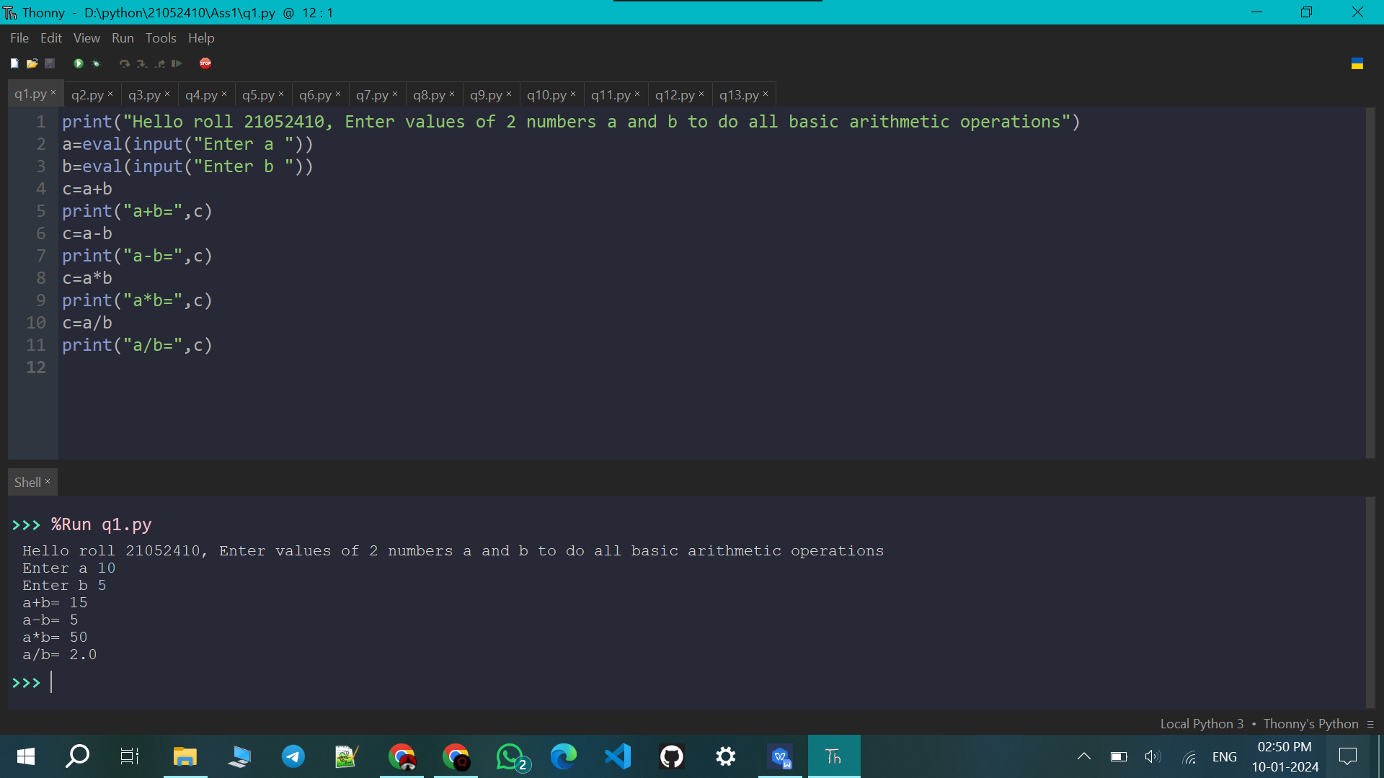

Q2. Write a python program to input two number and swap their values without using any third variable.

print("Hello roll 21052410, Enter values of 2 numbers a and b to swap their values without using 3rd variable")
a=eval(input("Enter a "))
b=eval(input("Enter b "))
a=a+b
b=a-b
a=a-b
print("Now a=",a," b=",b)

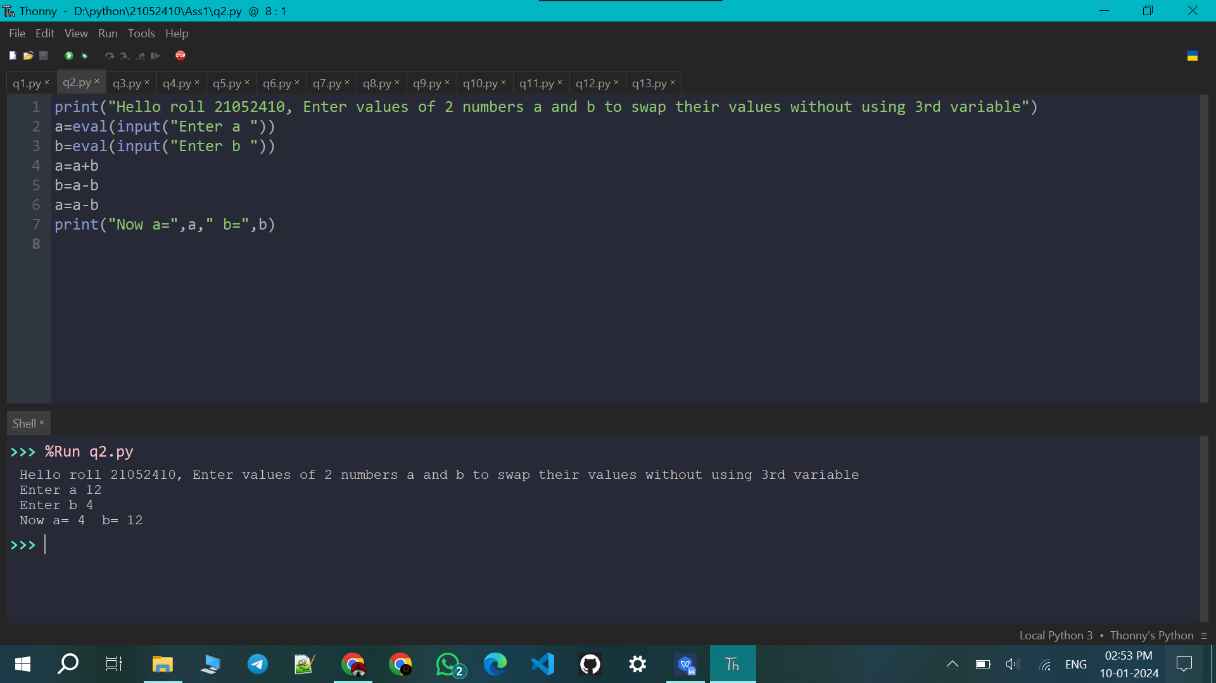

Q3. Write a python program to input the temperature in Fahrenheit and change it to Celsius.

print("Hello roll 21052410, Enter the temperature in Fahrenheit to change it to Celsius")
a=eval(input())
a=(a-32)*5/9
print(a)

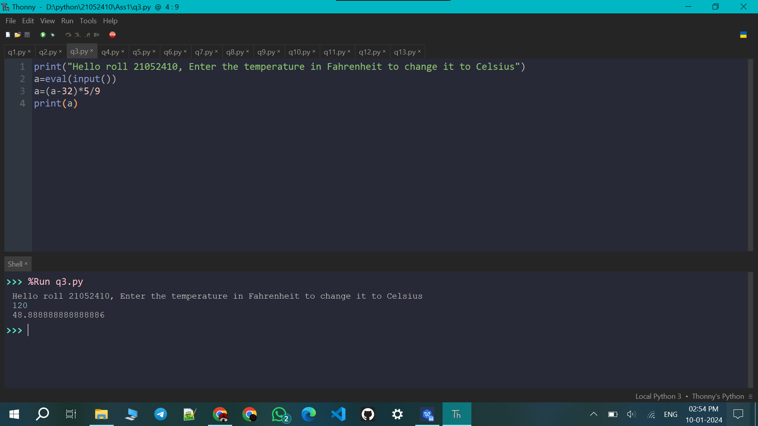

Q4. Write a python program to input the basic salary of a person and compute its TA (20% of basic), DA (120% of basic), HRA (30% of basic), Gross (basic + ta + da + hra).

print("Hello roll 21052410, Enter the the basic salary of a person to compute its TA (20% of basic), DA (120% of basic), HRA (30% of basic), Gross (basic + ta + da + hra)")
b=eval(input("Enter the basic salary "))
ta=.2*b
da=1.2*b
hra=.3*b
gross=b+ta+da+hra
print("TA=",ta," DA=",da," HRA=",hra," Gross=",gross)

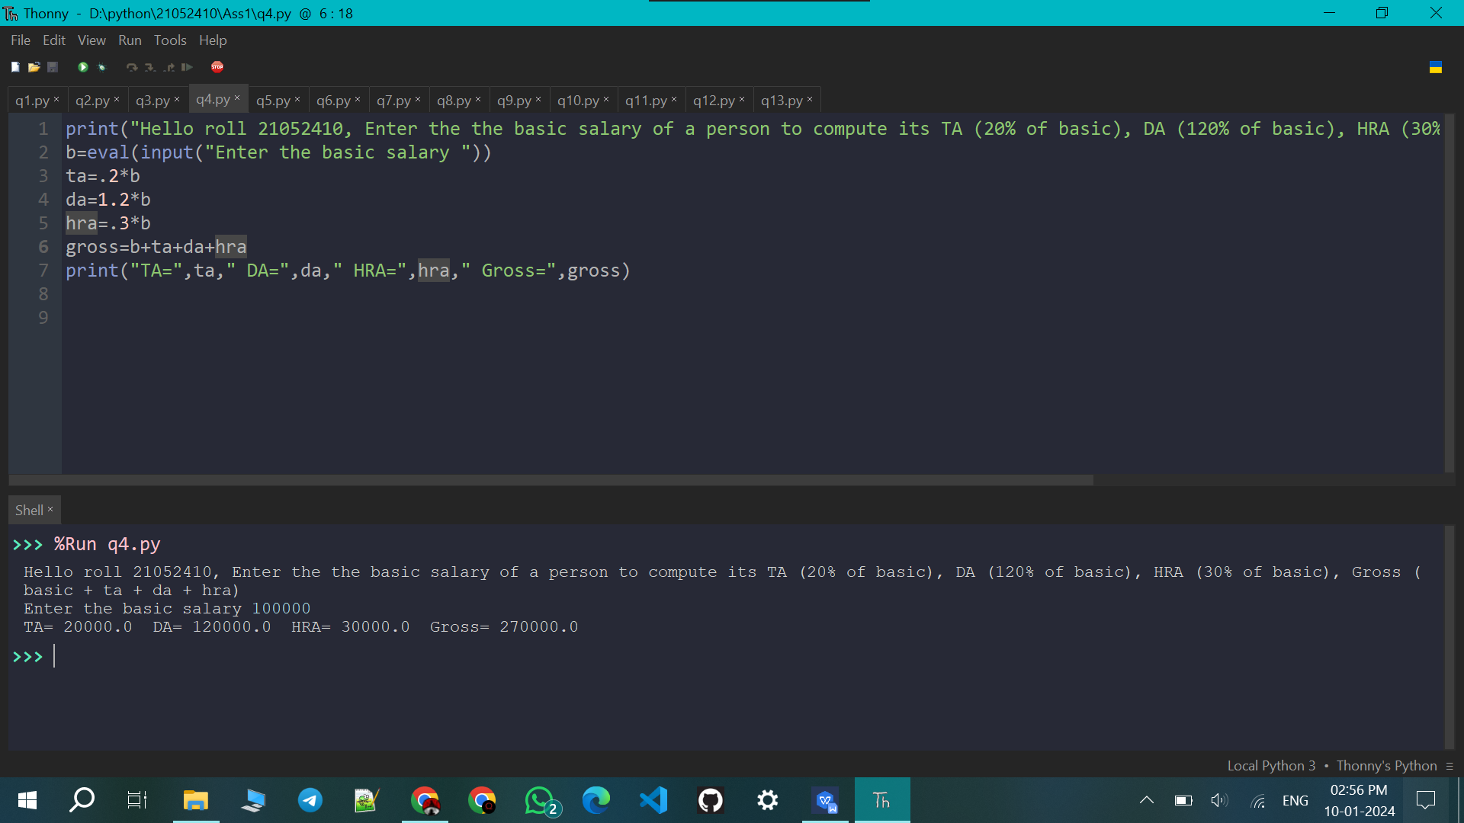

Q5. Write a python program to swap three variables.

print("Hello roll 21052410, Enter values of a, b and c to swap their values")
a=eval(input("a="))
b=eval(input("b="))
c=eval(input("c="))
d=a
a=c
c=d
d=b
b=c
c=d
print(a,b,c)

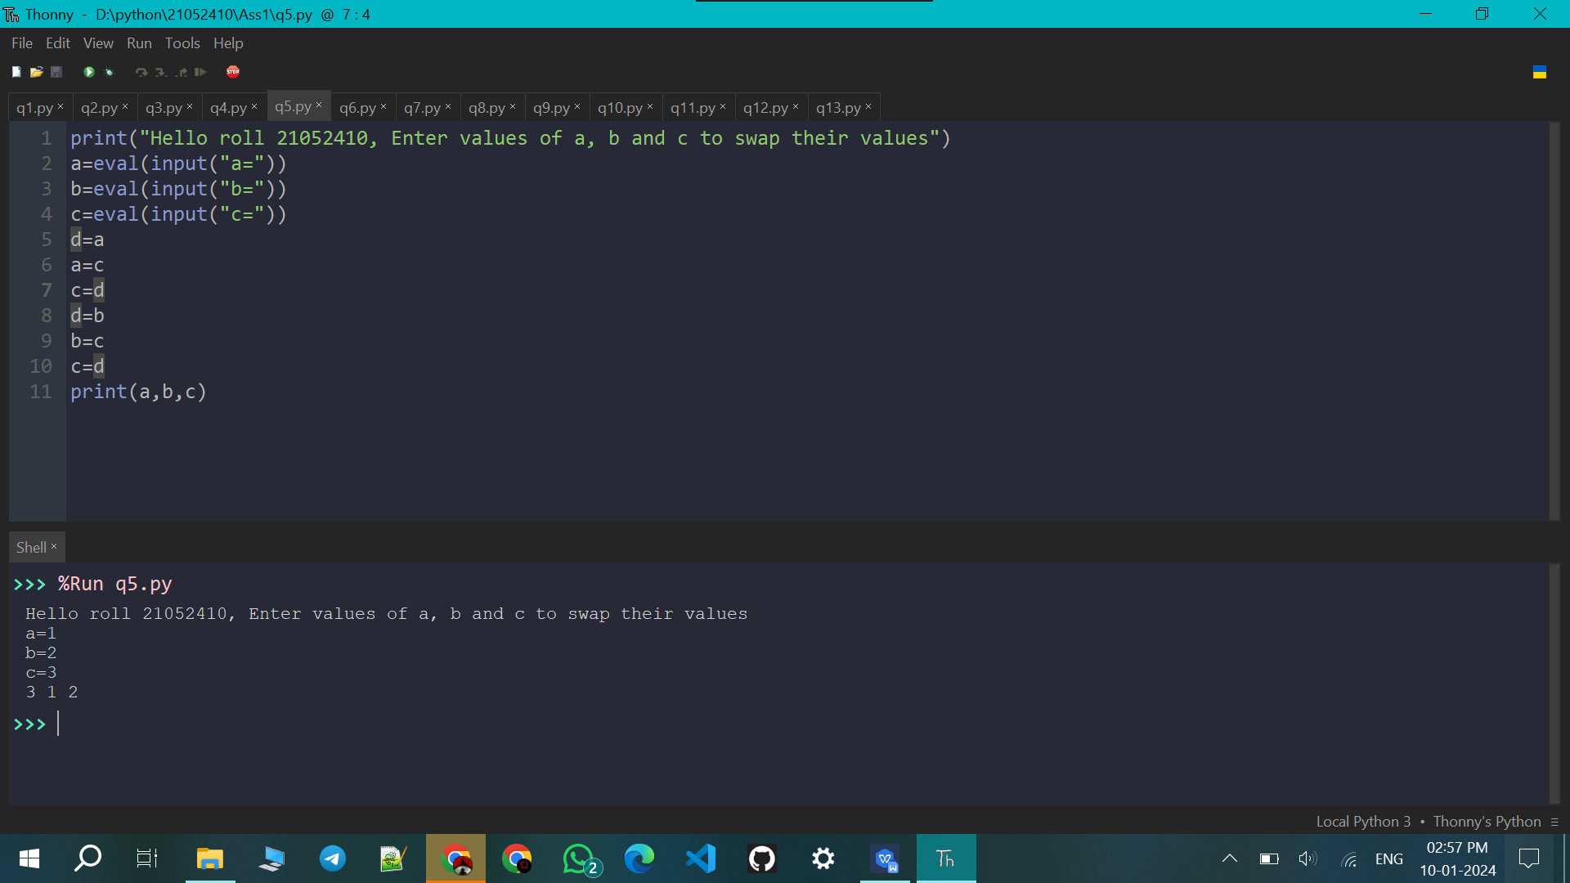

Q6. Write a python program to evaluate the expression
4x^4 + 3y^3 -9z + 6

from math import *
print("Hello roll 21052410, Enter values of x, y, z to evaluate the expression 4x^4 + 3y^3 -9z + 6")
x=eval(input("x="))
y=eval(input("y="))
z=eval(input("z="))
ans=4*pow(x,4)+3*pow(y,3)-9*z+6
print("Ans = ",ans)

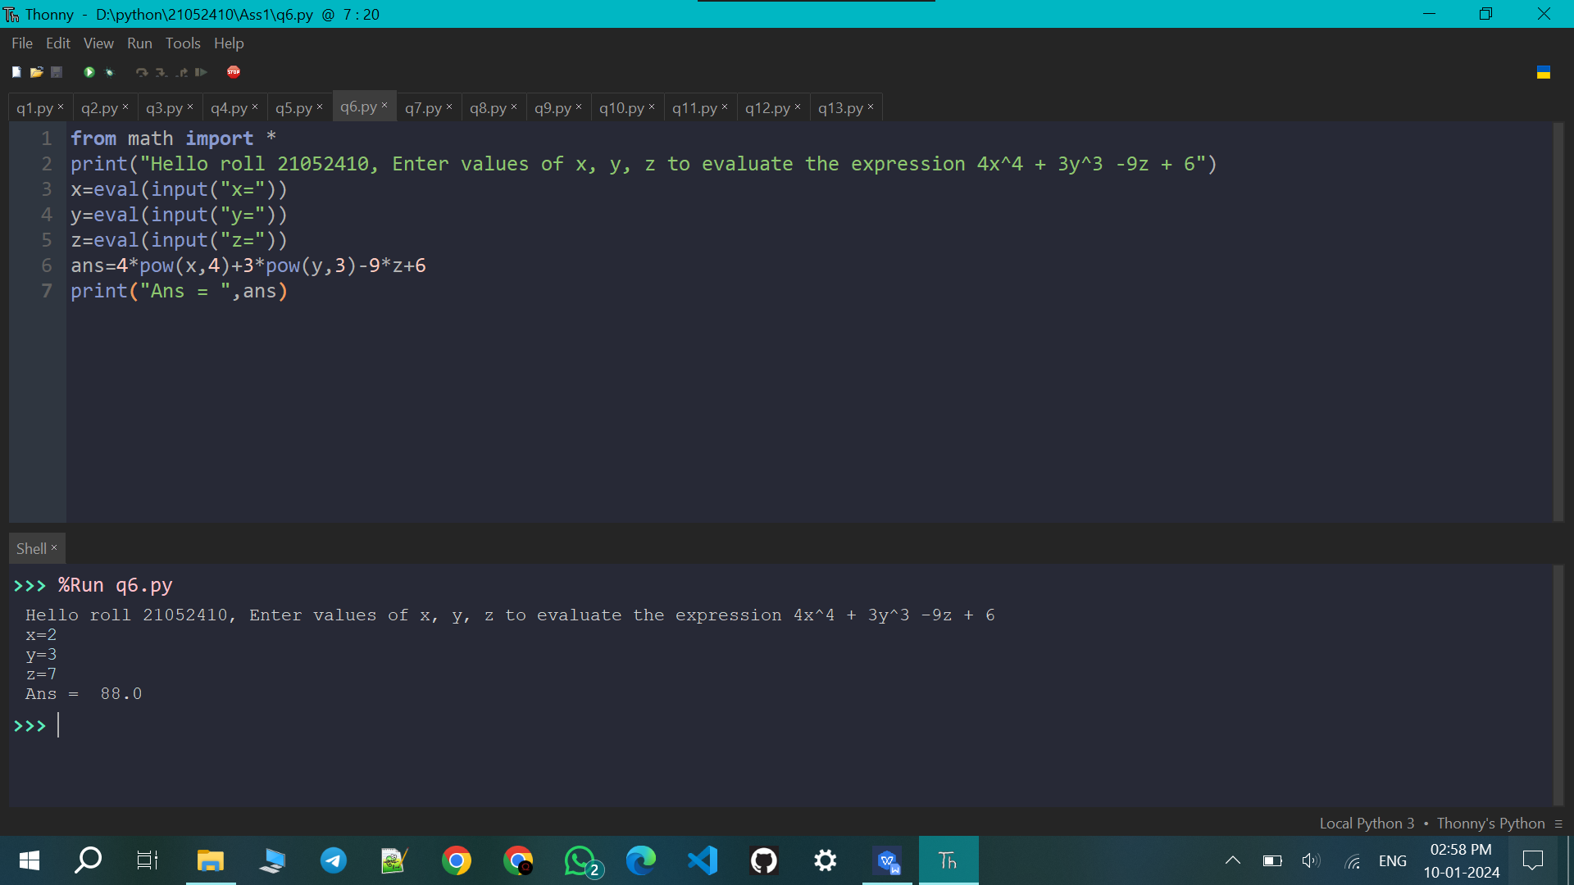

Q7. Write a python program to take a input in uppercase and change it to lower case

print("Hello roll 21052410, Enter a string in uppercase to change it to lower case")
u = input("")
l = u.lower()
print("Input in lowercase:", l)

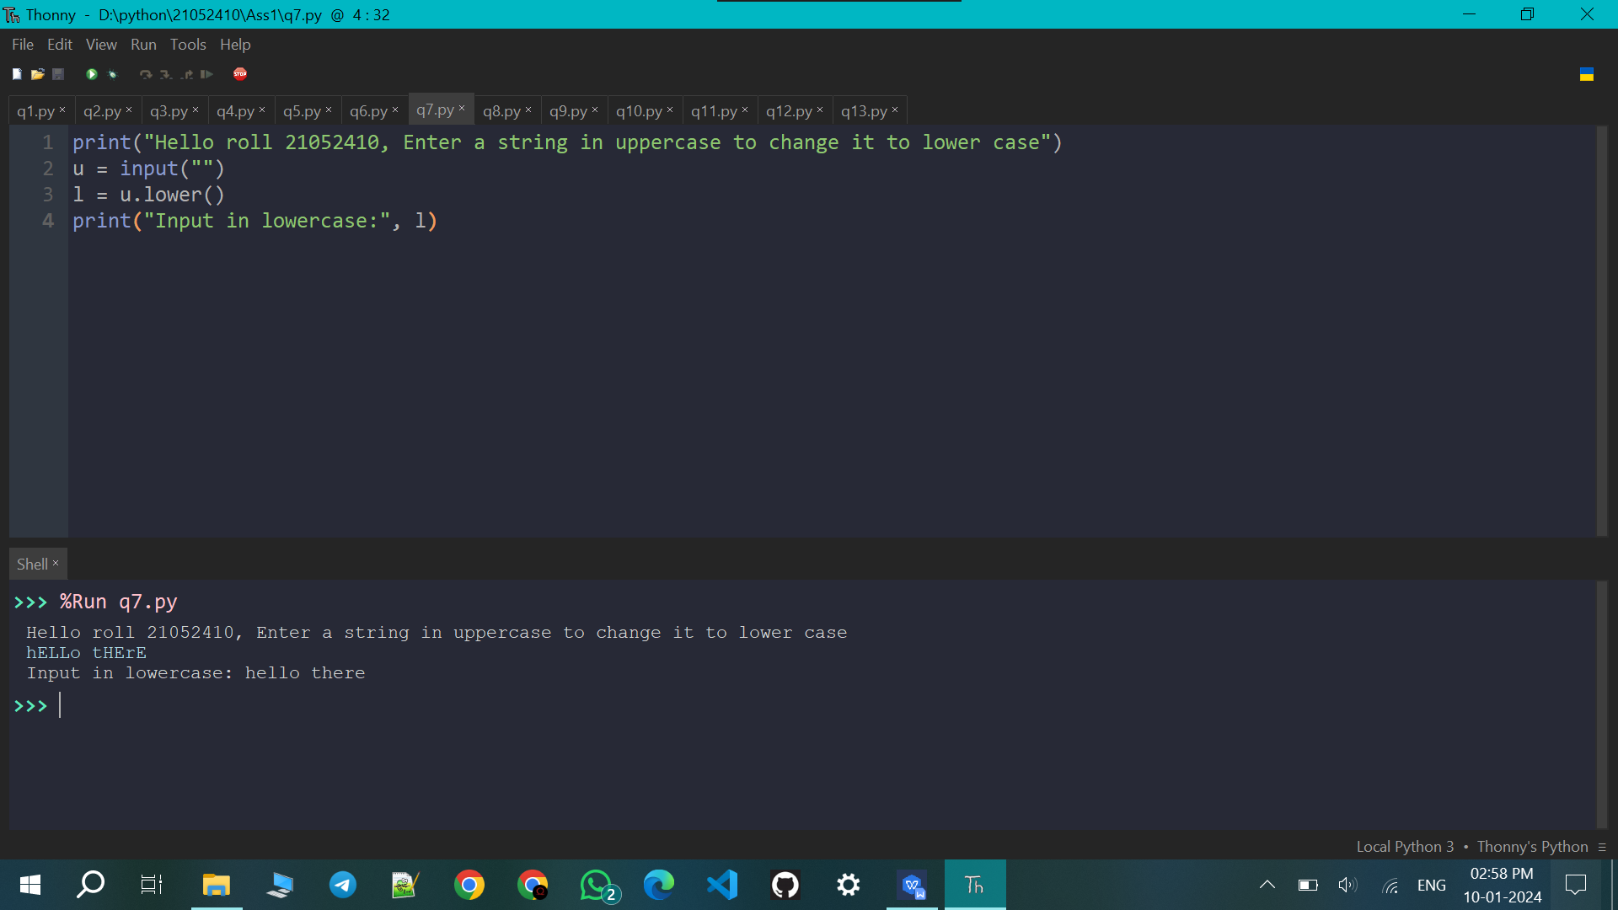

Q8. Write a python program to input the radius of a circle and print its area and perimeter.

from math import *
print("Hello roll 21052410, Enter the radius of a circle to print its area and perimeter")
r=eval(input("r="))
a=pi*r*r
p=2*pi*r
print("Area = ",a," Perimeter = ",p)

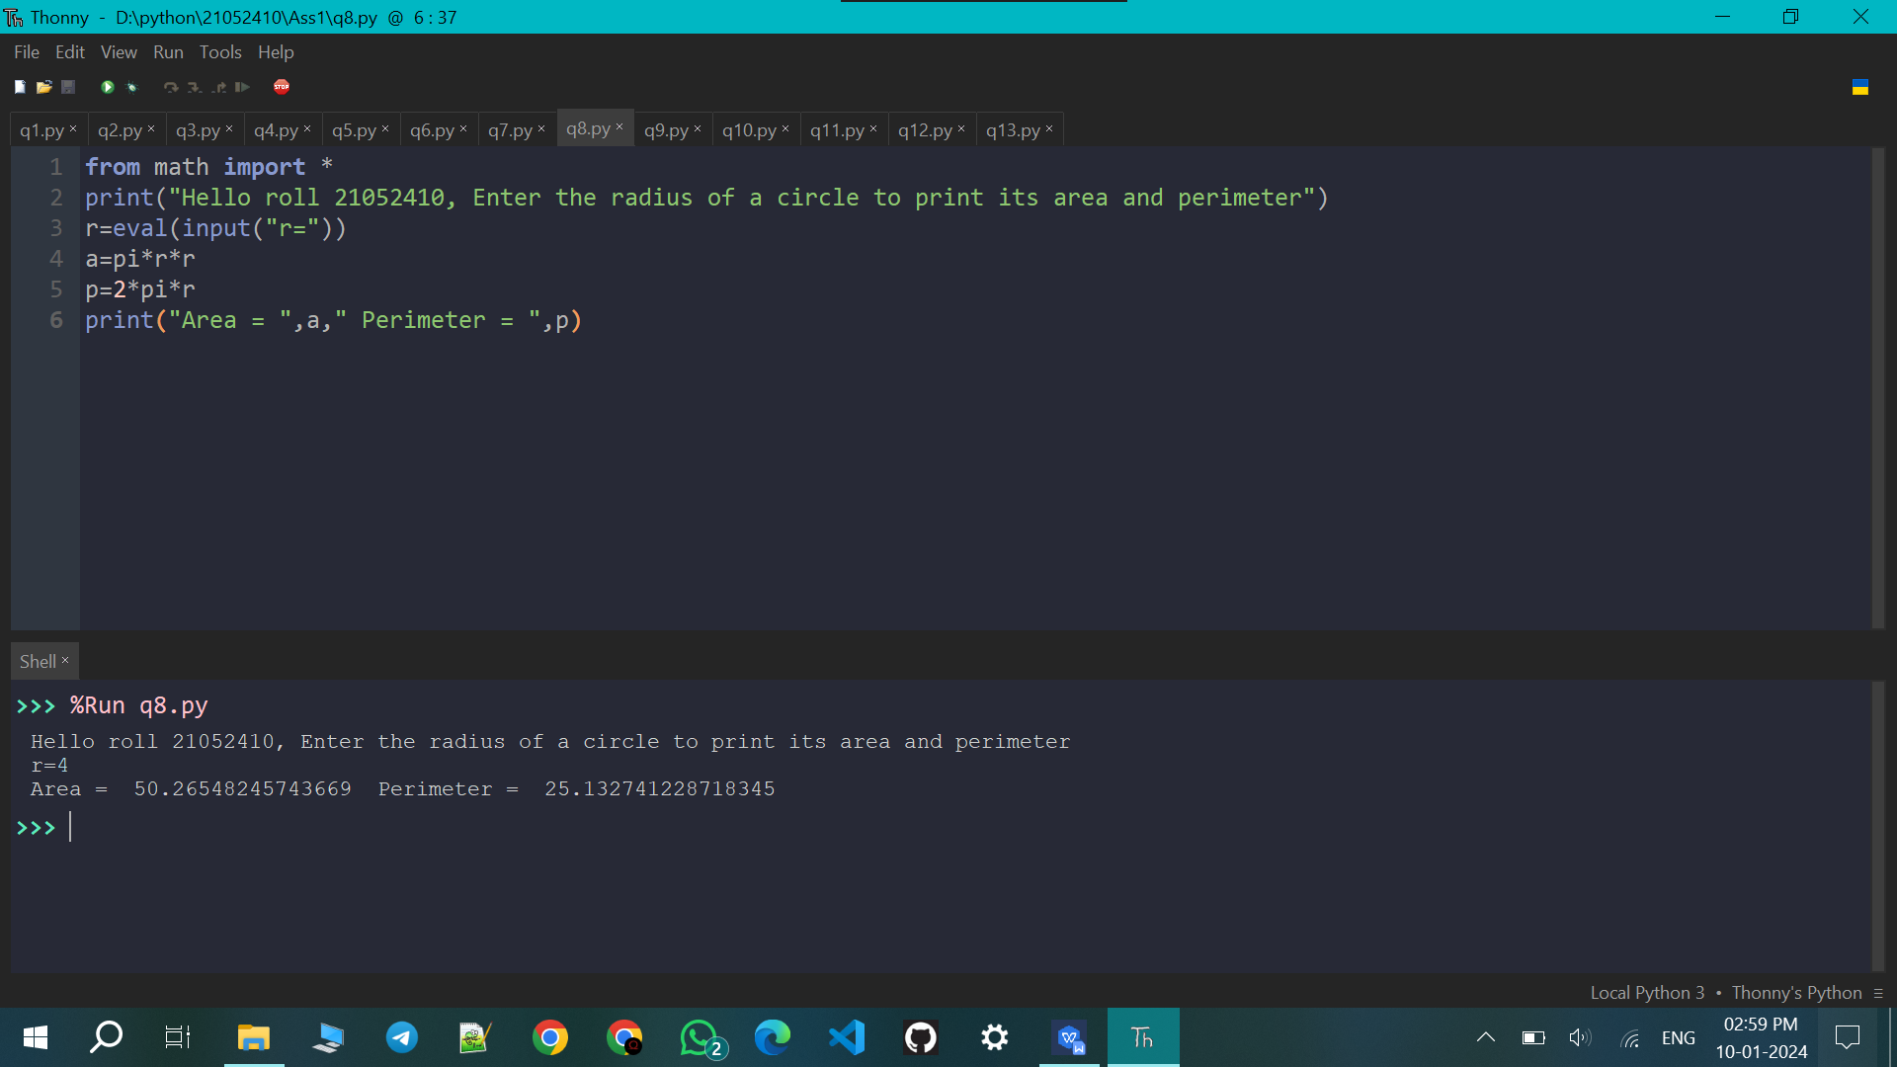

Q9. Write a python program to input marks in 5 subjects of a student and print its average mark.

print("Hello roll 21052410, input marks in 5 subjects of a student to print its average mark")
a=eval(input("Math="))
b=eval(input("Physics="))
c=eval(input("Biology="))
d=eval(input("Chemistry="))
e=eval(input("Computer Science="))
avg=(a+b+c+d+e)/5
print("Avg = ",avg)

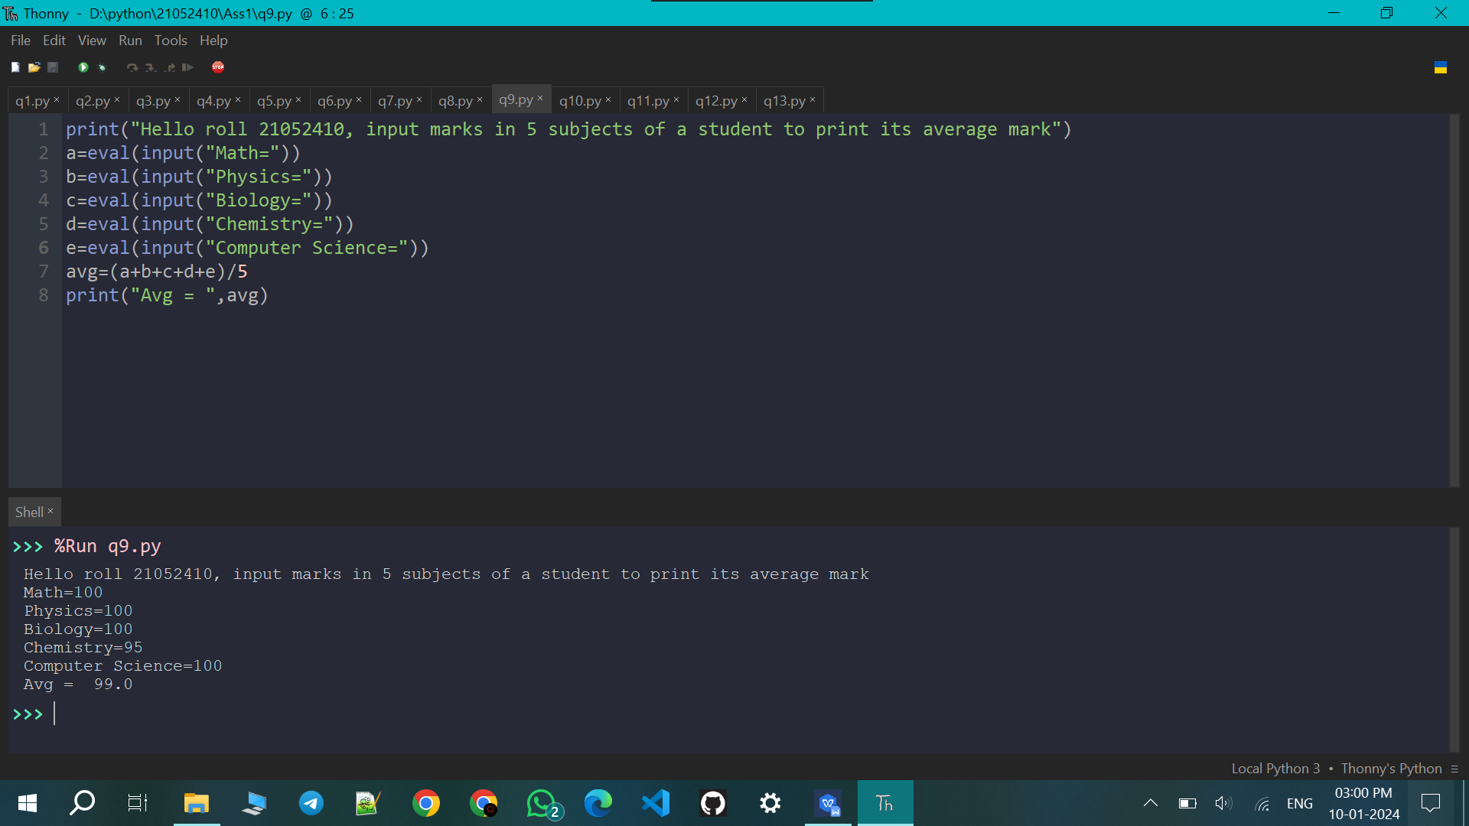

Q10. Write a python program to input a number and print its square, cube and fourth power.

print("Hello roll 21052410, enter a number to calculate its square, cube and fourth power")
n = eval(input("Enter a number: "))

square = n ** 2
cube = n ** 3
fourth_power = n ** 4

print("Square of ",n,":",square)
print("Cubeof ",n,":",cube)
print("Fourth powerof ",n,":",fourth_power)

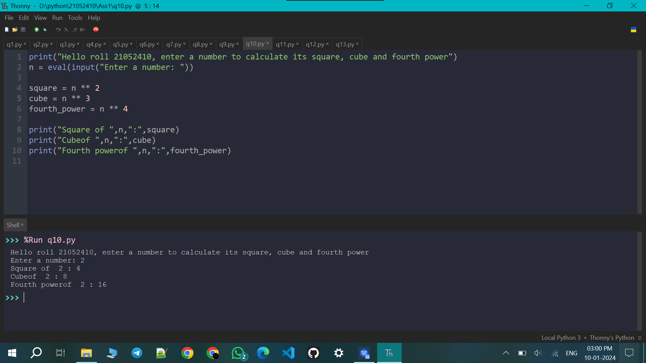

Q11. Write a python program to input a the sides of a triangle and print its area.

print("Hello roll 21052410, input the sides of a triangle to print its area")

import math

def calculate_triangle_area(side1, side2, side3):
s = (side1 + side2 + side3) / 2
area = math.sqrt(s * (s - side1) * (s - side2) * (s - side3))
return area

side1 = float(input("Enter the length of side 1: "))
side2 = float(input("Enter the length of side 2: "))
side3 = float(input("Enter the length of side 3: "))

if side1 + side2 > side3 and side2 + side3 > side1 and side1 + side3 > side2:

area = calculate_triangle_area(side1, side2, side3)
print(f"The area of the triangle is: {area:.2f}")
else:
print("The entered side lengths do not form a valid triangle.")

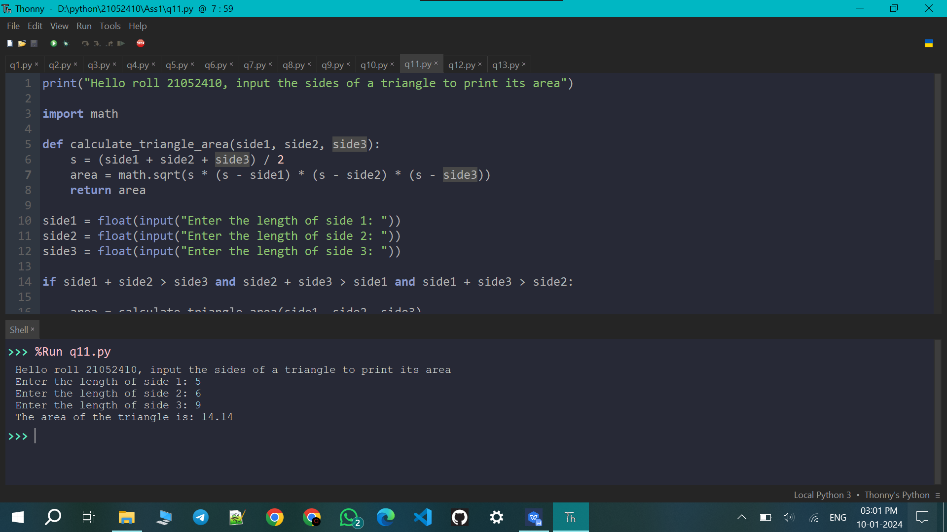

Q12. Write a python program to compute SI and CI.

print("Hello roll 21052410, input the p, r, t to calculate SI and CI")

def calculate_simple_interest(principal, rate, time):
simple_interest = (principal * rate * time) / 100
return simple_interest

def calculate_compound_interest(principal, rate, time):
compound_interest = principal * (pow((1 + rate / 100), time)) - principal
return compound_interest

# input
principal_amount = float(input("Enter the principal amount: "))
interest_rate = float(input("Enter the annual interest rate (in percentage): "))
time_period = float(input("Enter the time period (in years): "))

# Calculate
simple_interest = calculate_simple_interest(principal_amount, interest_rate, time_period)
compound_interest = calculate_compound_interest(principal_amount, interest_rate, time_period)

# Print
print(f"\nSimple Interest: {simple_interest:.2f}")
print(f"Compound Interest: {compound_interest:.2f}")

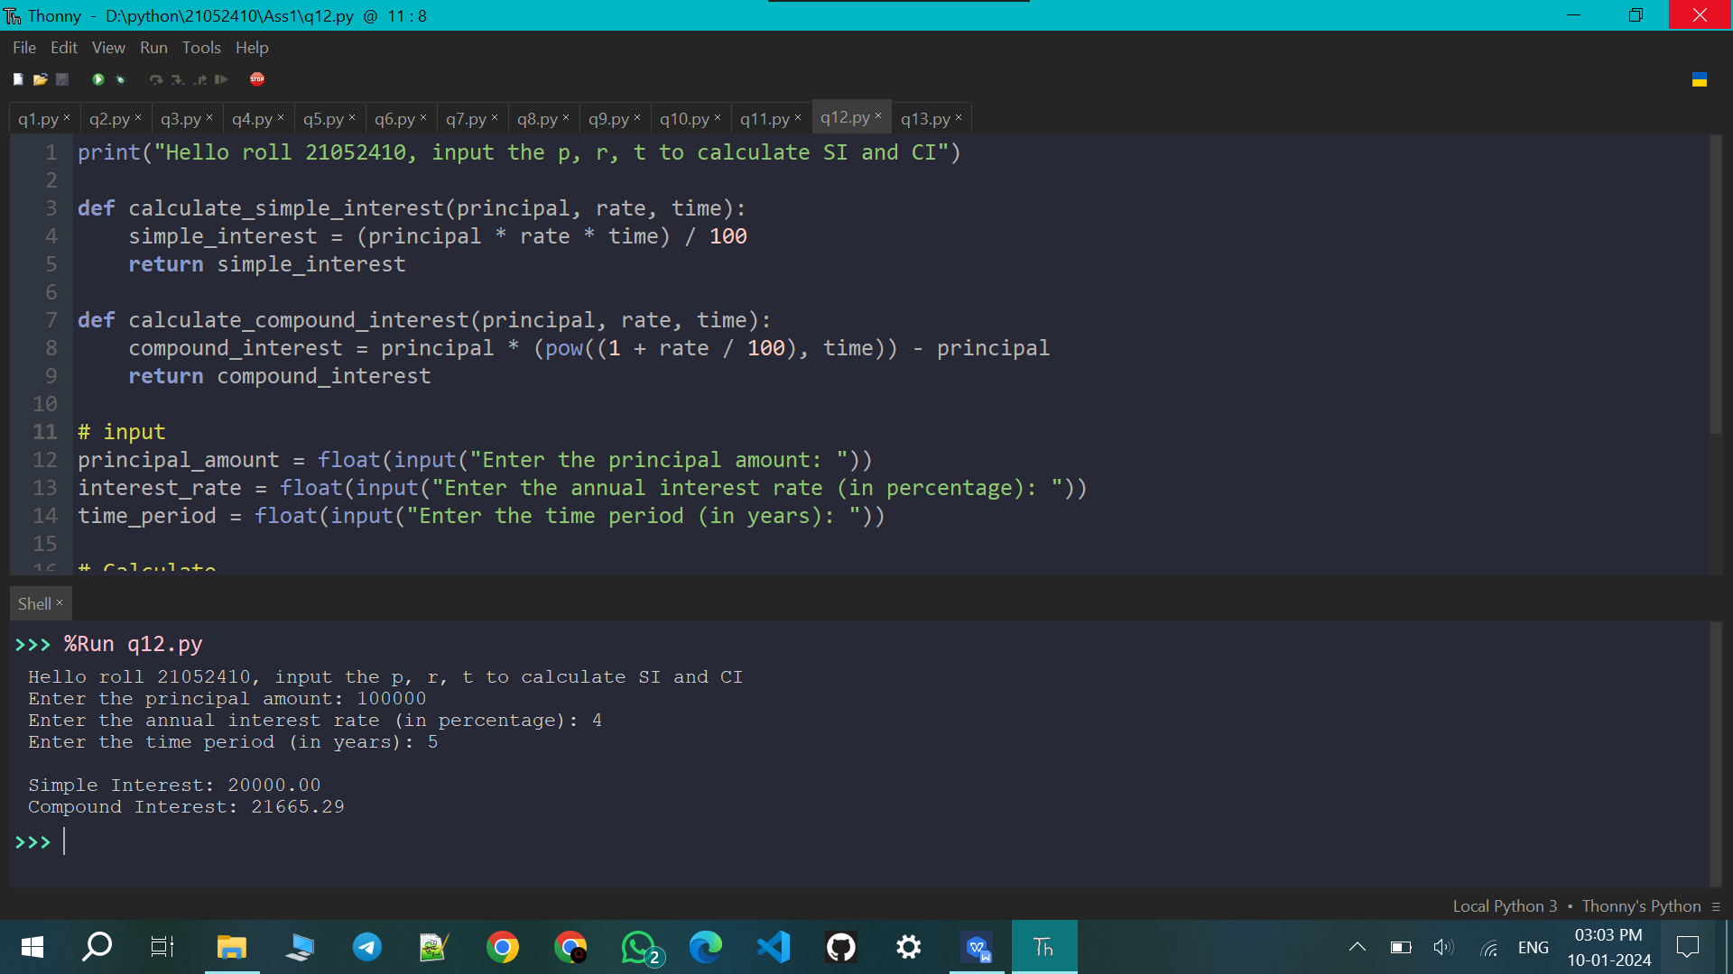

Q13. Ask the user to enter a number x. Use the sep optional argument to print out x, 2x, 3x, 4x, and 5x, each separated by three dashes, like below.
Enter a number: 7
- --14---21---28---35

print("Hello roll 21052410, enter a number for Using the sep optional argument to print out x, 2x, 3x, 4x, and 5x, each separated by three dashes")
x = int(input("Enter a number: "))

print(x, 2*x, 3*x, 4*x, 5*x, sep='---')

