Name:Ankita Sanjay Kakde

Class: AI-B

Roll No.:19

Subject: Computer Network

Assignment No.4

Report:

1. Cyclic Redundancy Check (CRC): It is a widely used method for error detection in digital data transmission and storage. It involves appending redundant information (checksum) to the data, which allows the recipient to verify the integrity of the received data.
2. Principles of CRC:
3. Polynomial Division:

* CRC involves polynomial division in which the data bits are treated as coefficients of a polynomial.
* A predetermined generator polynomial is used to perform polynomial division.

1. Checksum Calculation:

* The sender computes the CRC checksum by dividing the data polynomial by the generator polynomial using modulo-2 arithmetic (binary arithmetic with no carry or borrow).
* The remainder obtained from the division is the CRC checksum.

1. Checksum Appending:
   * The CRC checksum is appended to the data before transmission.
   * The receiver performs the same polynomial division with the received data and checks if the remainder is zero. If it is, the data is assumed to be error-free.
2. Error Detection:
   * CRC can effectively detect a variety of errors, including burst errors and random errors.
   * Burst errors refer to consecutive bit errors, which can occur due to noise or interference during transmission.
   * Random errors are individual bit errors that may happen randomly.
   * By choosing an appropriate generator polynomial, CRC can detect a high percentage of errors.
3. Error Correction:
   * CRC itself is an error detection mechanism and does not correct errors.
   * In scenarios where error correction is necessary, additional techniques like retransmission or forward error correction (FEC) are used.
   * FEC methods introduce redundancy into the data stream, allowing the receiver to reconstruct the original data even in the presence of errors.
4. Advantages of CRC:
   * Efficiency:CRC is computationally efficient, making it suitable for real-time applications.
   * Widely Used: CRC is widely adopted in various communication protocols, including Ethernet, Wi-Fi, Bluetooth, and many others.
   * Robustness: CRC can detect a wide range of errors, making it highly reliable for error detection purposes.
5. Limitations:
   * CRC cannot correct errors; it can only detect them.
   * The effectiveness of CRC depends on the choice of the generator polynomial and the error characteristics of the transmission medium.
6. Conclusion:

Cyclic Redundancy Check (CRC) is a fundamental technique for error detection in digital communication systems. By appending a checksum to the data, CRC ensures the integrity of transmitted information. While CRC is not capable of error correction, its efficiency, wide adoption, and robust error detection capabilities make it an essential component of modern communication protocols.

Problem Statement : Write a program for error detection and correction for

7/8 bits ASCII codes using CRC.

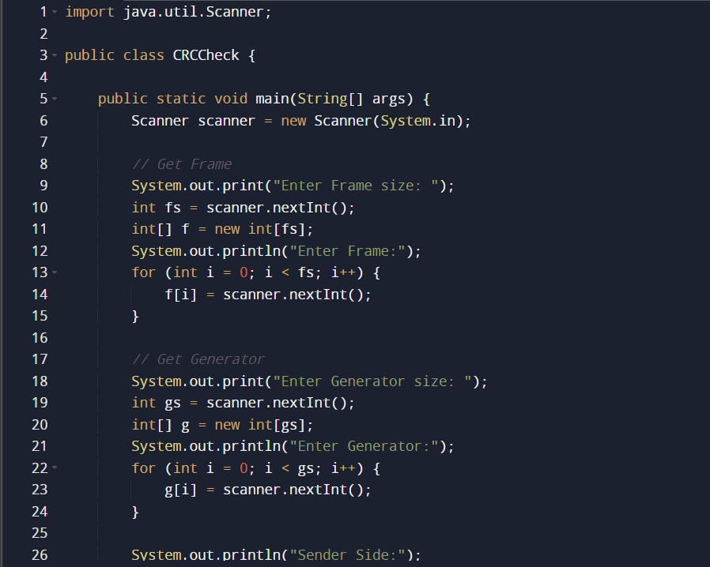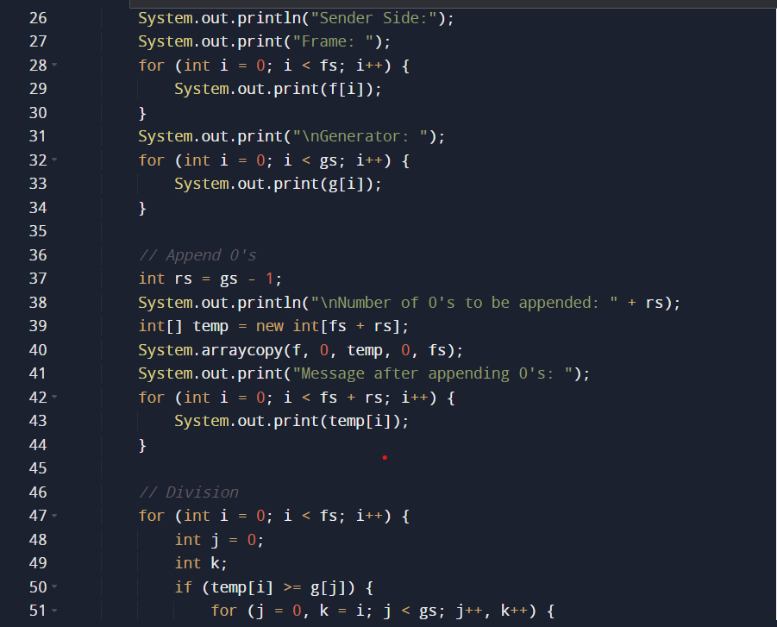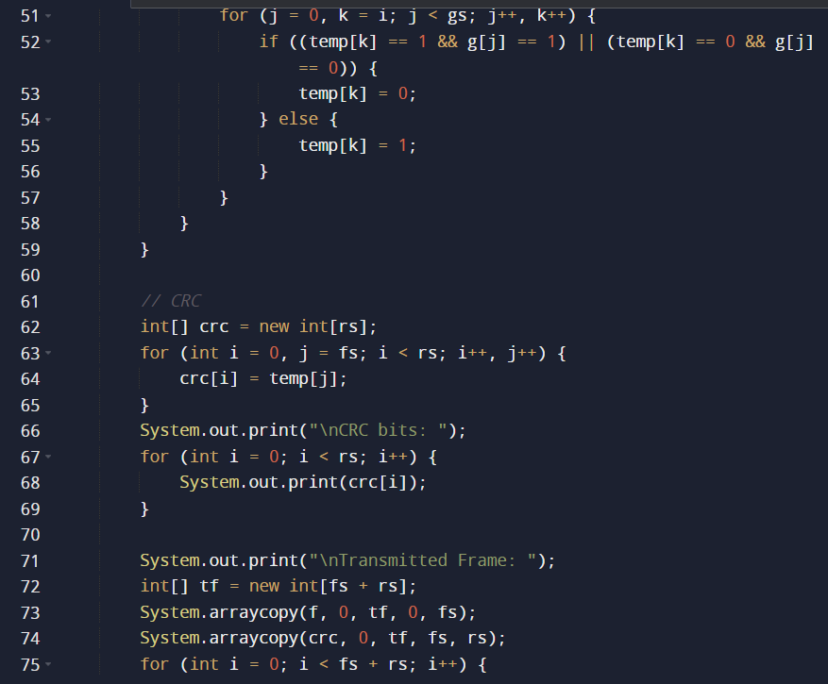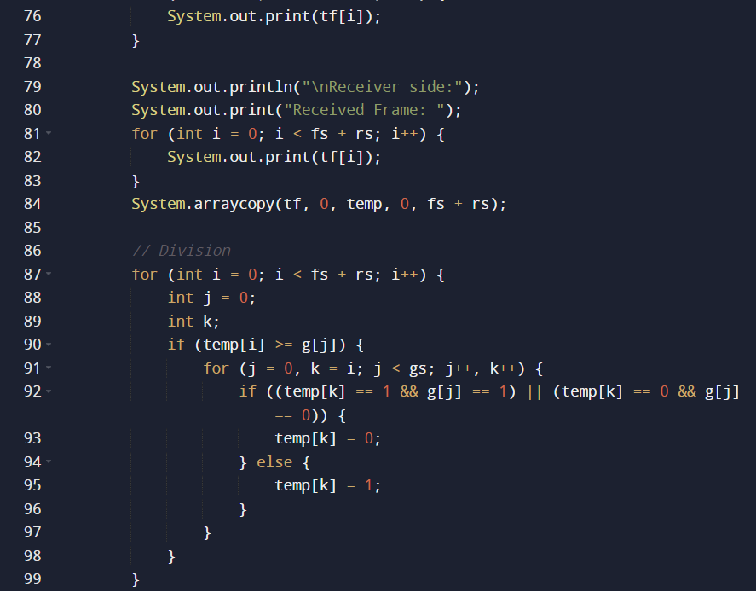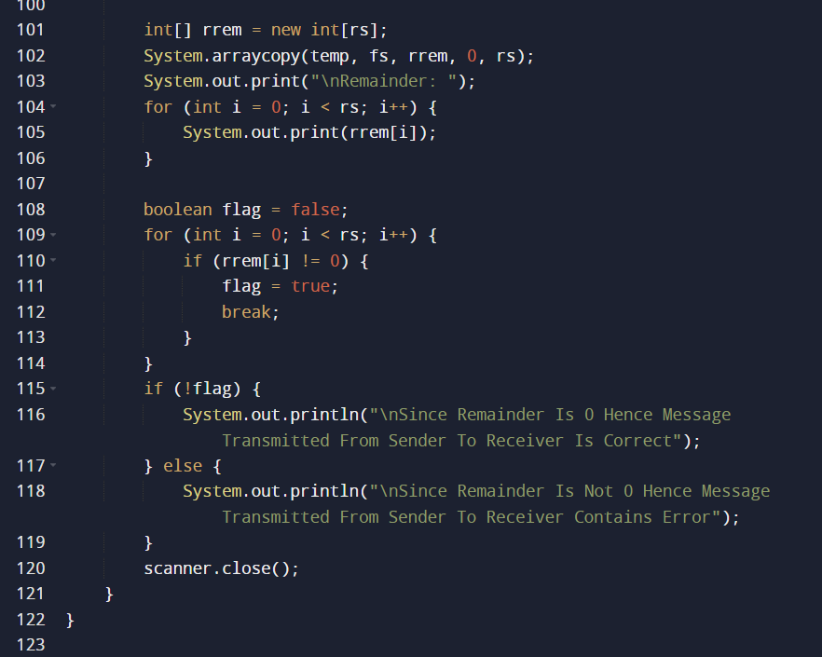

Output:

