Name: Ankita Sanjay Kakade

Class: AI-B

Roll No.: 19

Subject: Computer Network

Assignment No.5

Problem Statement: Write a program for error detection and correction for 7/8 bits ASCII codes using HammingCodes.

Code:

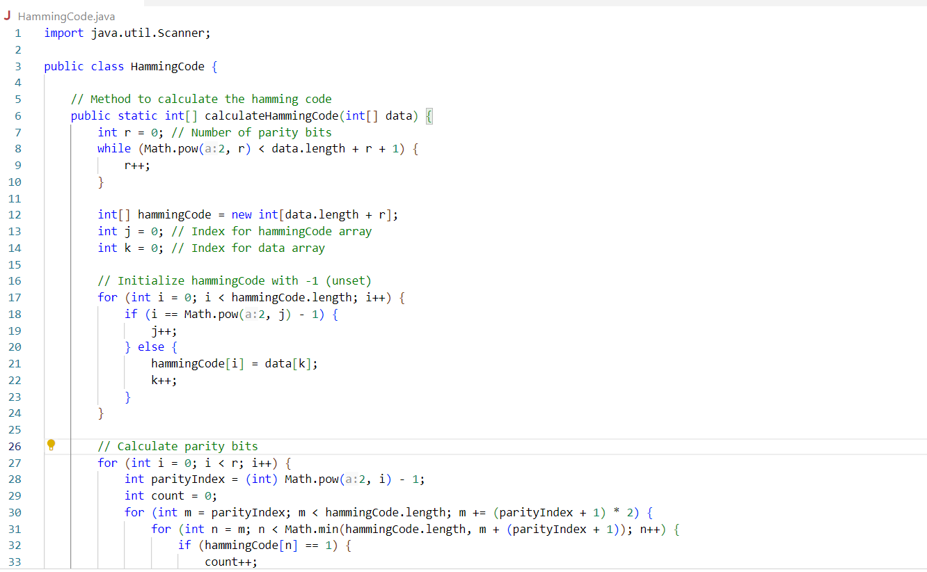

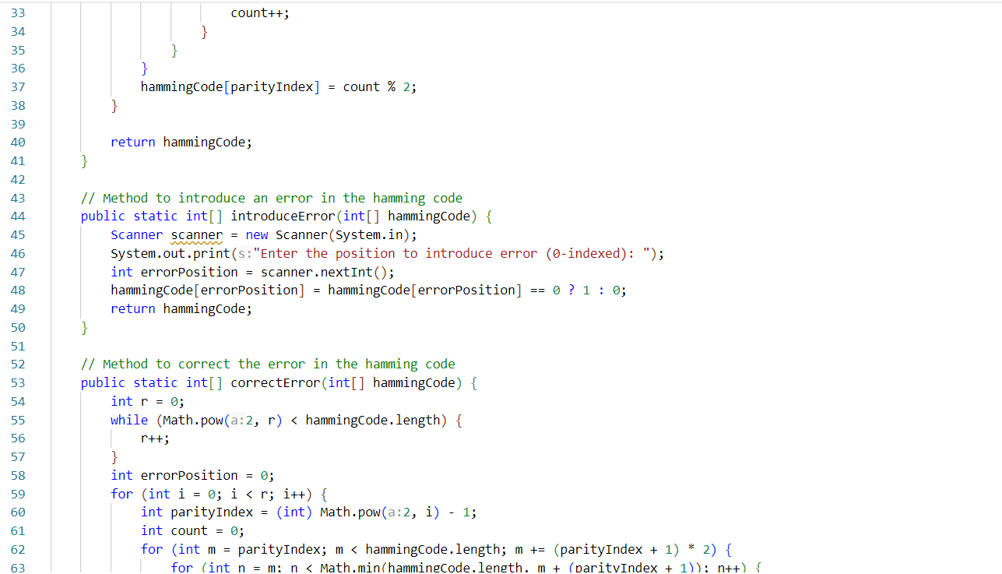

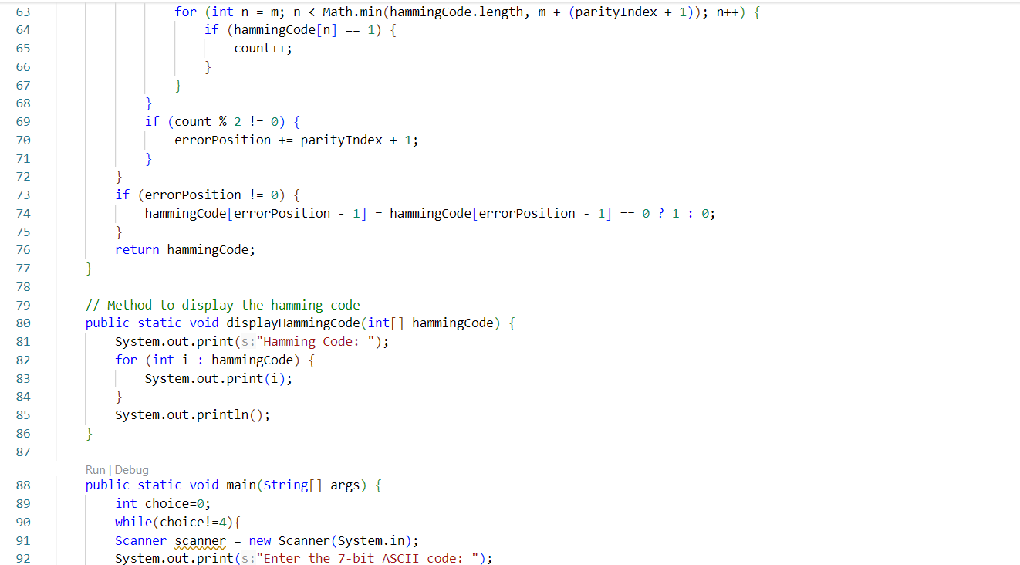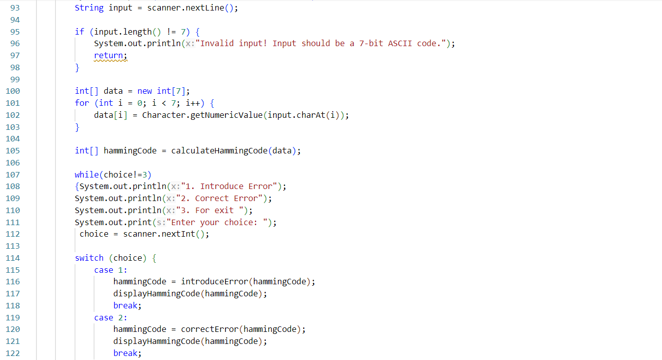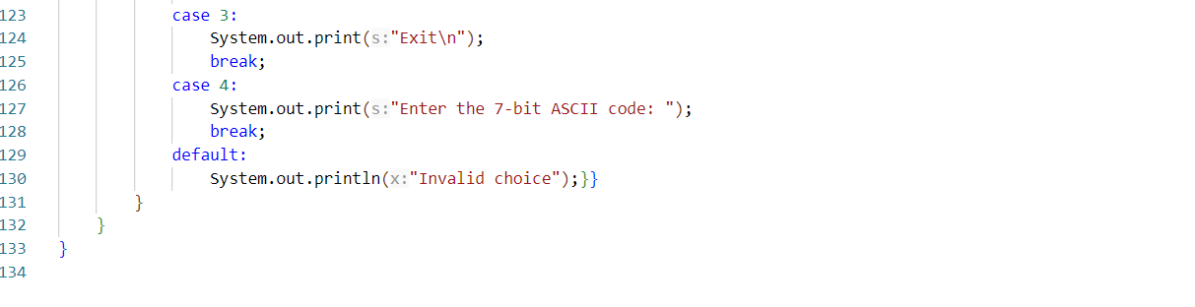

Output:

