Name: Ankita Sanjay Kakade

Class : AI-B

Roll No.: 19

PRN: 12210626

Subject: Computer Network

Assignment No. 6

**Problem Statement: Write a program to simulate Go back N Sliding Window Protocol in peer-to-peer mode. (attach PDF contains the description of the Go back N and Selective Repeat Protocols, Program and output)**

1. Define Classes:

GBNProtocol: This class would contain the main logic of the Go-Back-N protocol.

* + Packet: A class to represent packets sent over the network, including sequence numbers, acknowledgment numbers, data, etc.
  + Sender: Represents the sending side of the peer.
  + Receiver: Represents the receiving side of the peer.

1. Implement Go-Back-N Protocol Logic:

Implement the Go-Back-N protocol logic in the GBNProtocol class. This involves maintaining sender and receiver windows, handling timeouts, acknowledgments, and retransmissions.

1. Simulate Network Communication:

Simulate network communication between sender and receiver by using some form of inter-process communication. You can use sockets, threads, or any other suitable method for communication between sender and receiver.

1. Handle Packet Loss and Corruption:

Introduce mechanisms to simulate packet loss and corruption to test the reliability of your protocol implementation.

1. Testing:

Test your implementation thoroughly to ensure that it behaves as expected under different network conditions and scenarios.

Code:

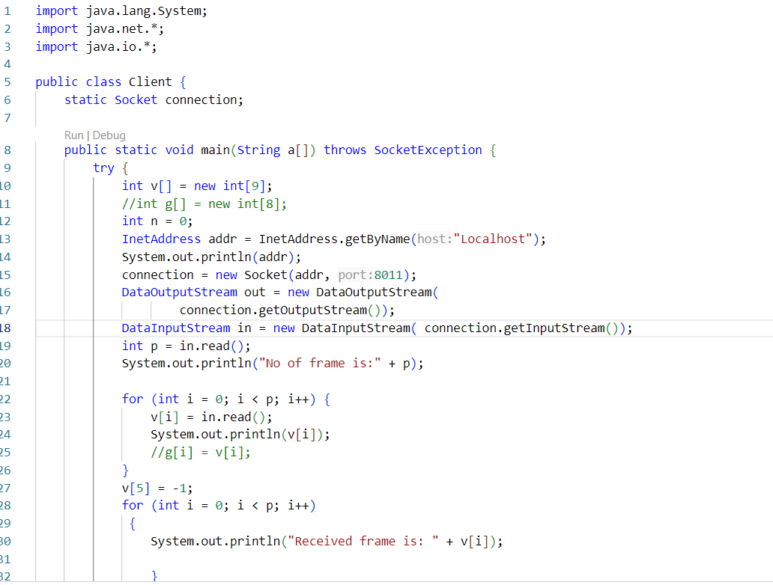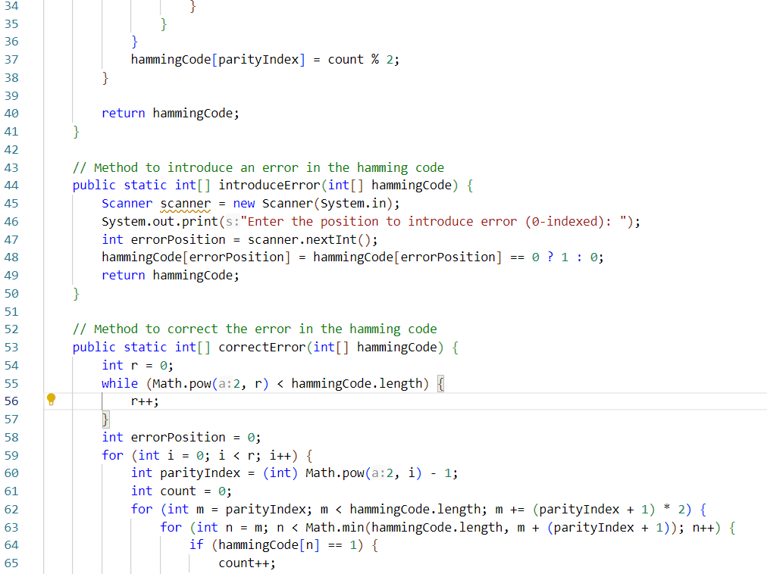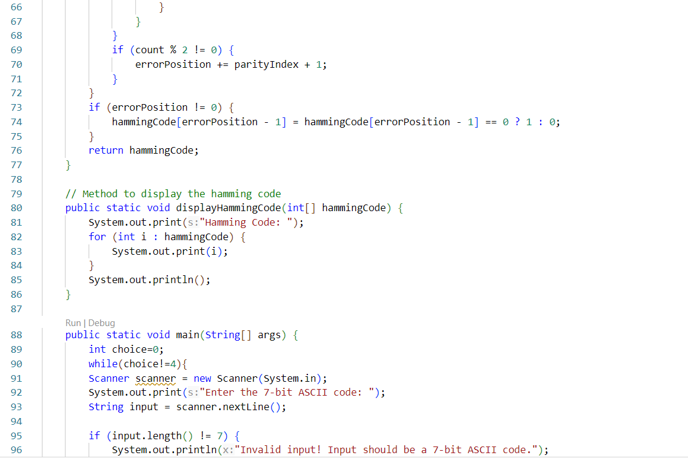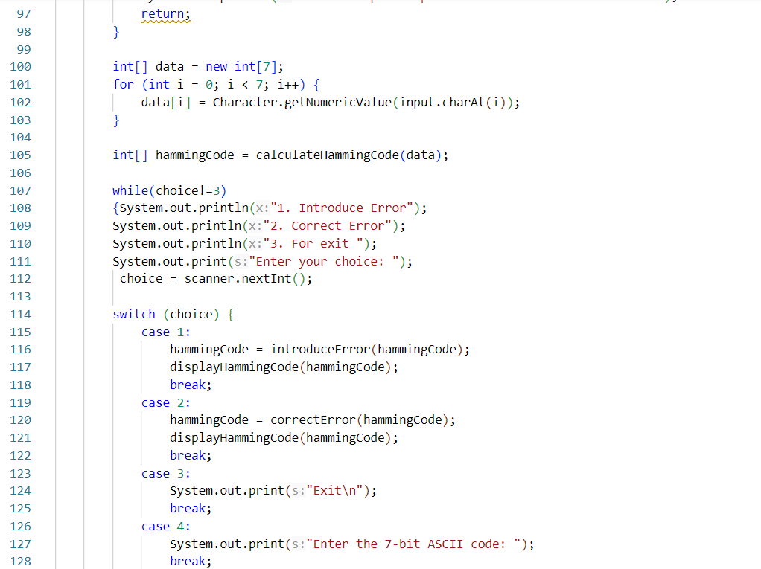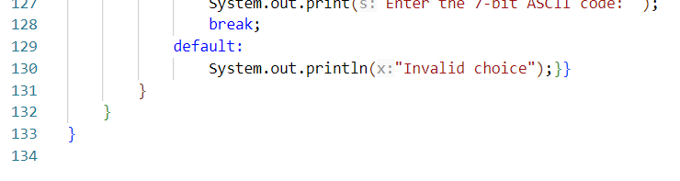

Output:

