Name: Ankita Sanjay Kakade

Class: AI-B

Roll No.:19

Subject: Computer Network

**Assignment No.8**

**Problem Statement:** Write a program to demonstrate subnetting and find the subnet masks.

**Code:**

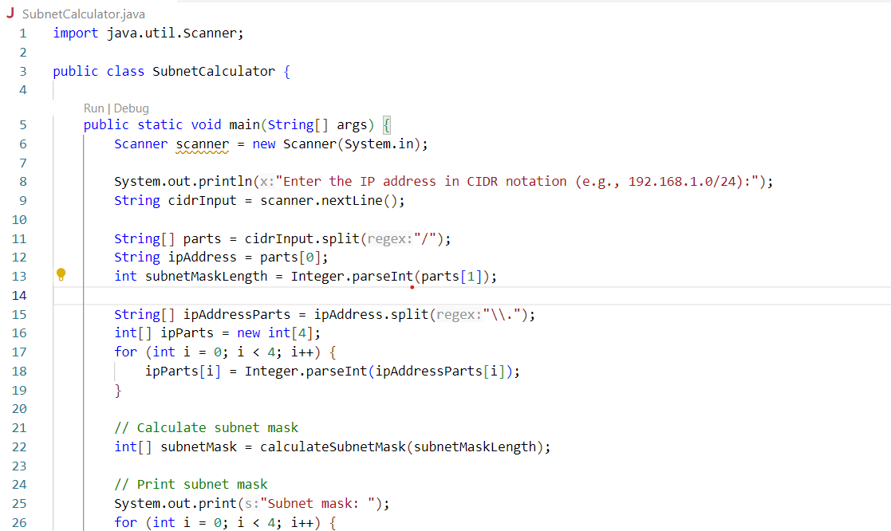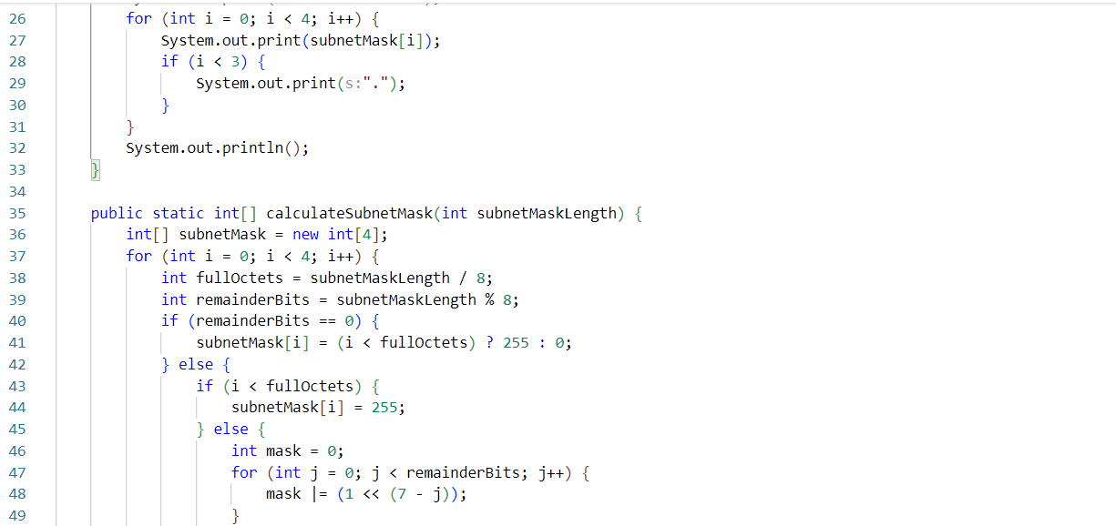

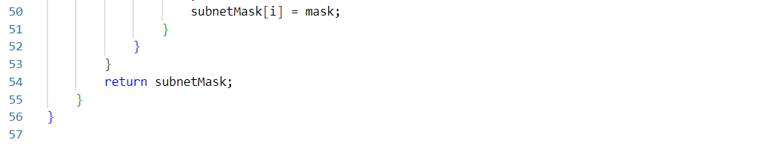

**Output:**

