**Name: Ankita Sanjay Kakade**

**Class: AI Div.: B**

**Roll No.: 19**

**PRN:12210626**

**Subject: Computer Network**

**Practical No.1**

Problem Statement : Study and implement various networking commands on terminal.

1. IP Configuration (ipconfig.c) : IP Config is a command-line tool that is used to display the current IP address configuration of a Windows machine. This includes the IP address, subnet mask, and default gateway. Additionally, IP Config can be used to release and renew DHCP leases. This command is particularly useful for troubleshooting networking issues. For example, if a machine is not receiving an IP address from a DHCP server, this can be easily checked using the IP Config command.

#include<stdio.h>

#include<stdlib.h>

int main(){

system(“ipconfig”);

return 0;}

Output:

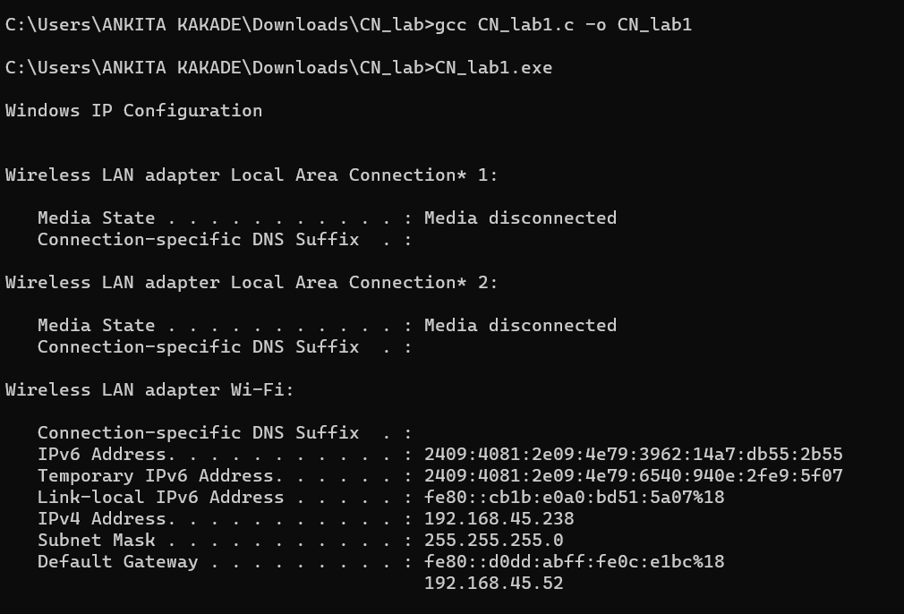

1. Ping (ping.c): The ping command serves as a networking tool designed to assess the accessibility of a host within an Internet Protocol (IP) network. Its primary function is to determine the reachability of a specified IP address, measuring the round-trip time for messages sent from the local system to a remote host. Furthermore, Ping offers insights into network routes and the corresponding traversal times required for these routes.

#include <stdio.h>

#include <stdlib.h>

int main() {

system("ping google.com");

return 0;

}

Output: 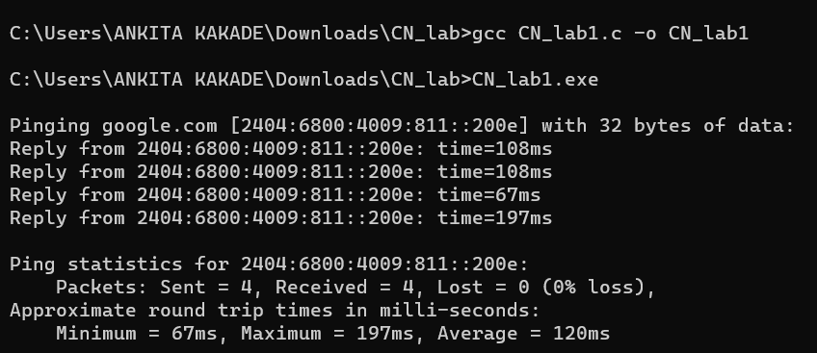

1. Traceroute (tracert.c): The tracert command is a Command Prompt command that displays the network packets being sent and received, as well as the number of hops required for them to reach their destination. A traceroute is another name for this command. It gives a lot of information about how a packet gets from the source to the designated destination.

#include <stdio.h>

#include <stdlib.h>

int main() {

system("tracert google.com");

return 0;

}

Output:

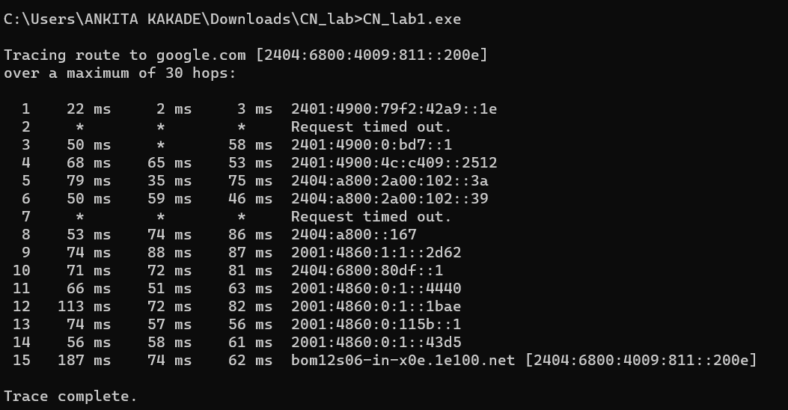

1. DNS Lookup (nslookup.c): Nslookup is a command-line networking tool used for querying Domain Name System (DNS) to obtain domain name or IP address mapping, or other DNS records. Nslookup has two modes: interactive and non-interactive.

#include<stdio.h>

#include<stdlib.h>

int main(){

system(“nslookup google.com”);

return 0;

}

Output:

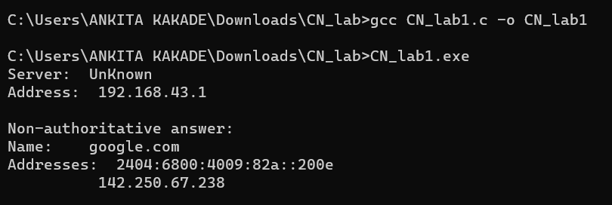

1. Network Statistics (netstat.c): NetStat is a networking utility that can be used to display all active network connections and their status. It can be used to identify which applications are using which ports and can be helpful in troubleshooting networking issues.Most Windows, Linux, UNIX, and other operating systems include Netstat as a Common TCP – IP networking command-line method.

#include <stdio.h>

#include <stdlib.h>

int main() {

system("netstat");

return 0;

}

Output:

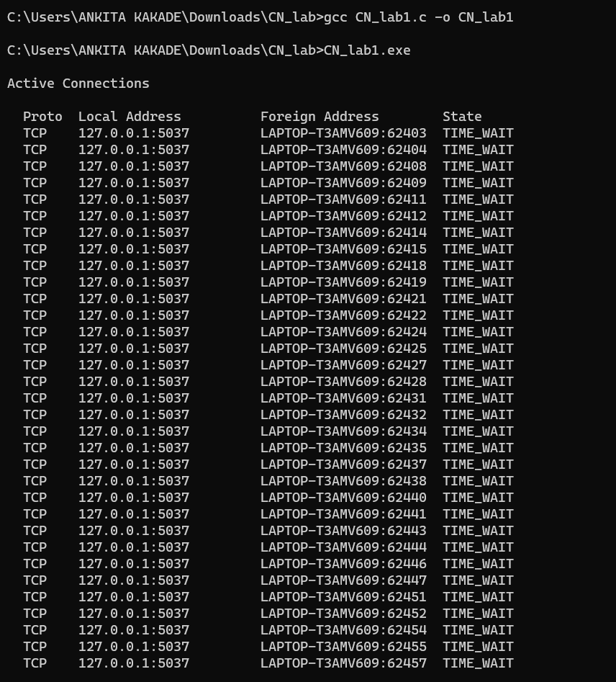

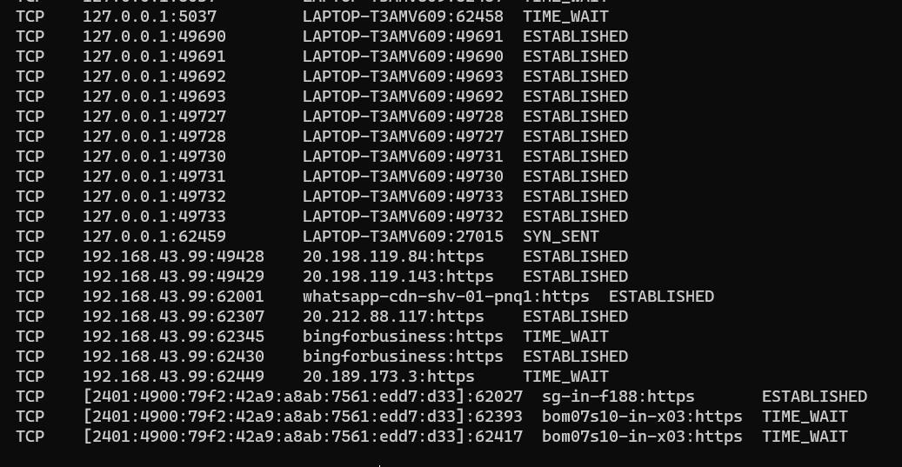

1. ARP Table (arp.c): The Address Resolution Protocol, or ARP, is a networking utility used for mapping network addresses to physical addresses.ARP is essential for networking communications, as it allows devices on a network to communicate with each other by translating IP addresses into physical addressess.Although IP addresses are commonly used in network communications, packet delivery is ultimately determined by media access control (MAC). The mechanism for address resolution kicks in at this point.

#include <stdio.h>

#include <stdlib.h>

int main() {

system("arp -c");

return 0;

}

Output: 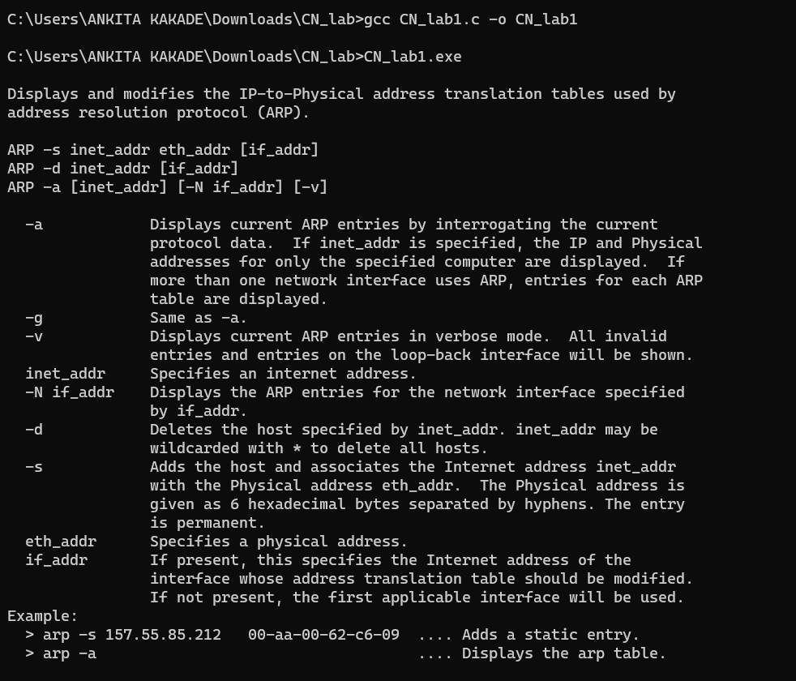

1. Routing Table (route.c):

#include <stdio.h>

#include <stdlib.h>

int main() {

system("route print");

return 0;}

Output:

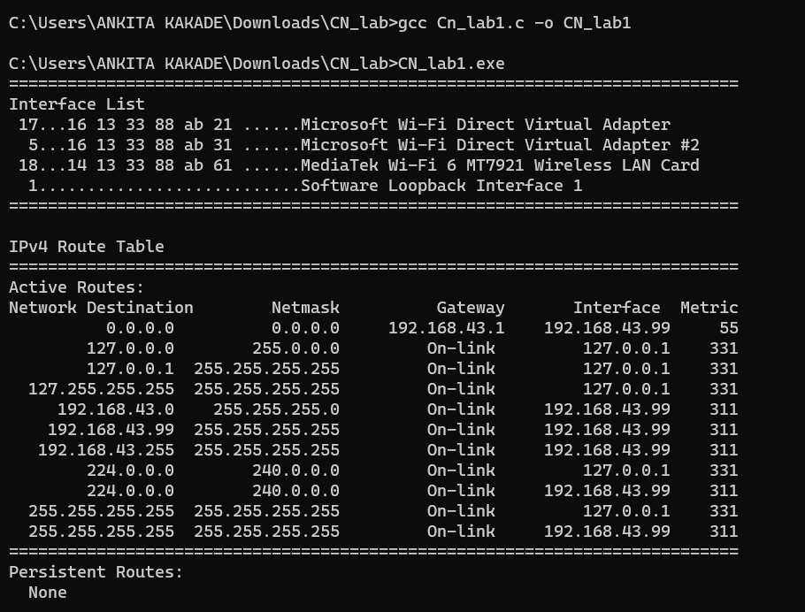

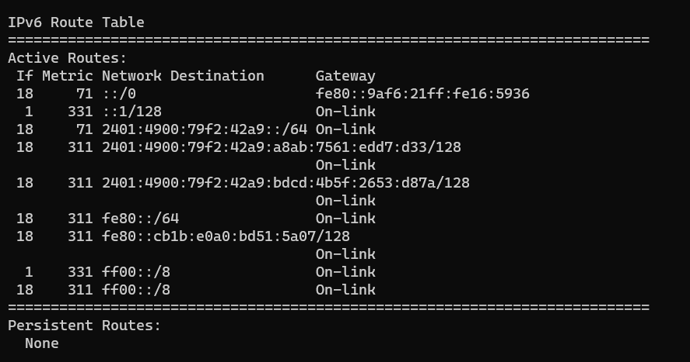

1. Hostname (hostname.c): If you know which switch to use with the command, NbtStat can provide you with the host name that has been assigned to a Windows device, as discussed earlier in this piece. If you’re only searching for a quick and easy way to verify a computer’s name, the Hostname command is a good option. The local machine name is returned by typing Hostname at the command prompt.

#include <stdio.h>

#include <stdlib.h>

int main() {

system("hostname");

return 0;

}

Output:

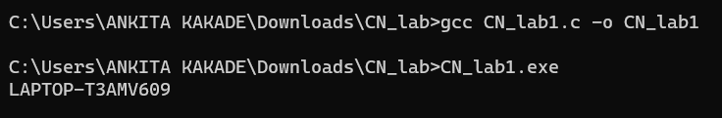

1. Interface Information (netsh.c):

#include <stdio.h>

#include <stdlib.h>

int main() {

system("netsh interface show interface");

return 0;

}

Output:

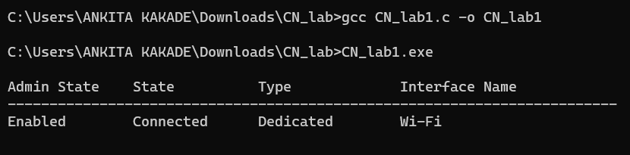

1. GetMac: The MAC address is a unique identifier for every network capable device on the internet. The number is assigned during the manufacturing process and is stored in the device’s hardware.The Getmac command is used to display the MAC addresses of all networking adapters on a Windows system. This information can be useful for troubleshooting networking issues or for identifying a specific networking device.

#include <stdio.h>

#include <stdlib.h>

int main() {

system("GetMac");

return 0;

}

Output:

