Name: Ankita Sanjay Kakade

Class:AI-B

Roll No.: 19

PRN: 12210626

Subject: Computer Network

Assignment No.3

**Report:**

1. IP Address: An IP address is a 32-bit address that uniquely and universally defines the connection of a host or a router to the Internet. The address space of IPv4 is 2^32 or 4,294,967,296.

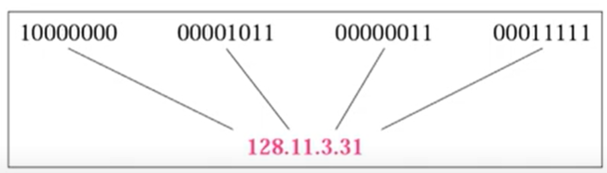

This is Dotted-Decimal and Binary Equivalent Notation

1. There are Four types of IP addresses
2. PRIVATE IP ADDRESS: These IP addresses are used within a local network and are not accessible from the internet. They are assigned by the network administrator or automatically by the network's Dynamic Host Configuration Protocol (DHCP) server. Private IP addresses are divided into three classes:
   * 10.0.0.0 to 10.255.255.255 (10.0.0.0/8)
   * 172.16.0.0 to 172.31.255.255 (172.16.0.0/12)
   * 192.168.0.0 to 192.168.255.255 (192.168.0.0/16)
3. PUBLIC IP ADDRESS: These IP addresses are used to identify devices on the internet. They are assigned by the Internet Service Provider (ISP) or the network administrator. Public IP addresses are divided into two classes:
   * IPv4: These are 32-bit addresses and are limited in number. They are assigned by the Internet Assigned Numbers Authority (IANA).
   * IPv6: These are 128-bit addresses and are much larger than IPv4 addresses. They are assigned by the IANA.
4. STATIC IP ADDRESS: These IP addresses are manually assigned by the network administrator or the DHCP server. They remain the same even after the device is restarted or disconnected from the network.Example- google’s DNS is 8.8.8.8
5. DYNAMIC IP ADDRESS: These IP addresses are automatically assigned by the DHCP server when a device connects to the network. They can change every time the device connects to the network.
6. IP Address Formats and ranges :

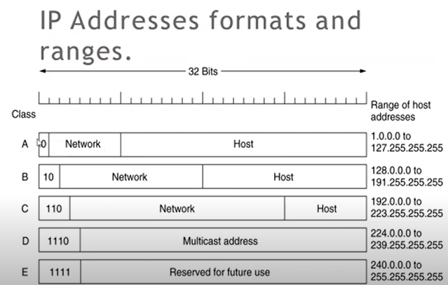

Finding The class in decimal notation

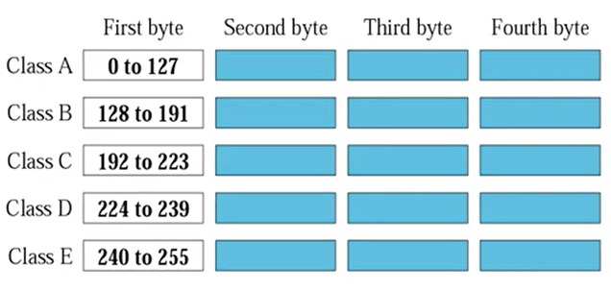

1. Netid and Hosted

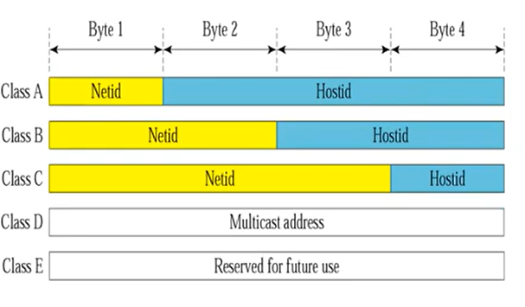

The table includes the following terms:

* Byte 1, Byte 2, Byte 3, Byte 4: These are the four bytes of an IP address.
* Netid: This stands for "network identifier." It identifies the network to which the device is connected.
* Hostid: This stands for "host identifier." It identifies the device on the network.
* Class A, Class B, Class C, Class D, Class E: These are the five classes of IP addresses.

Class A: It uses the first byte for the network identifier and the remaining three bytes for the host identifier. It allows for a large number of hosts but only a small number of networks.

Class B: It uses the first two bytes for the network identifier and the last two bytes for the host identifier. It allows for a moderate number of hosts and networks.

Class C: It uses the first three bytes for the network identifier and the last byte for the host identifier. It allows for a small number of hosts and a large number of networks.

Class D: It is used for multicasting, where a single message is sent to a group of devices.

Class E: It is reserved for future use.

Code:

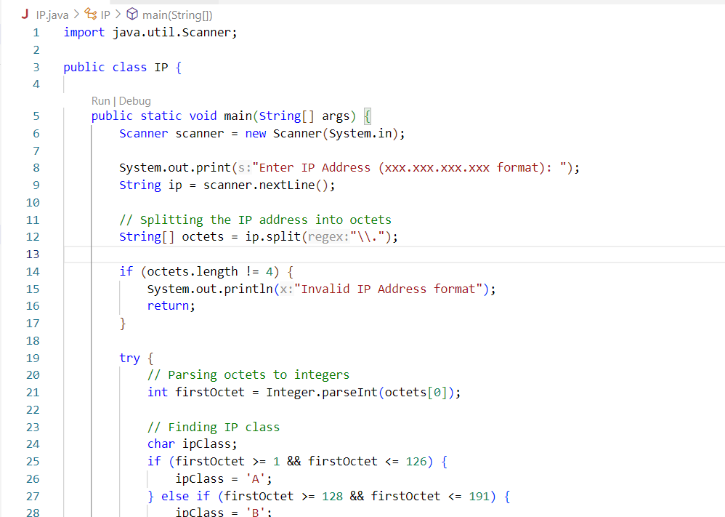

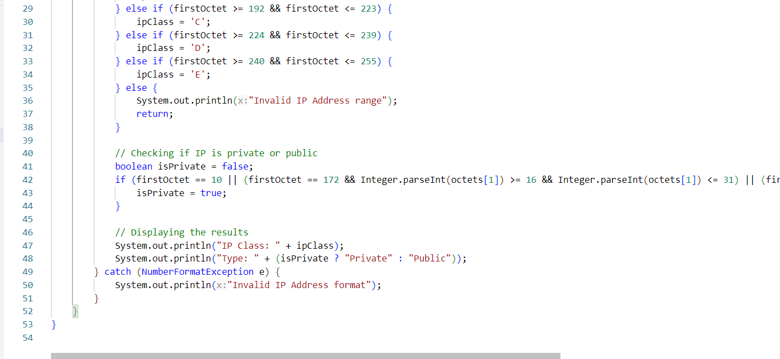

Output:

