**Security In Computing Practical**

**Practical 7: Layer 2 Security**

**Topology:**

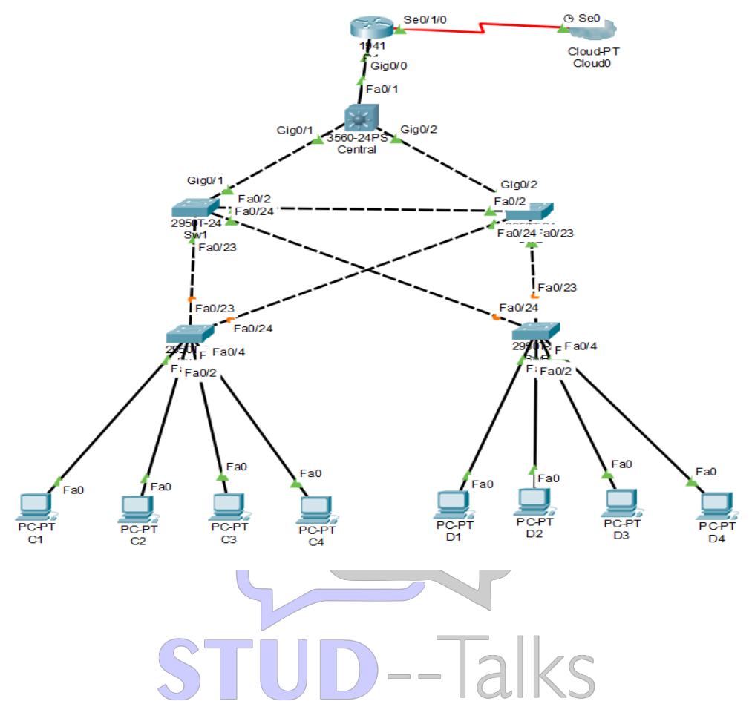

**Addressing Table:**

| **Device** | **Interface** | **IP Address** | **Subnet Mask** | **Default Gateway** |
| --- | --- | --- | --- | --- |
|  | gig0/0 | 192.168.1.1 | 255.255.255.0 | N/A |
| R1 |  |  |  |  |
| Se0/1/0 | 209.165.200.1 | 255.255.255.0 | N/A |
|  |
| C1 | NIC | 10.1.1.10 | 255.255.255.0 | 10.1.1.1 |
| C2 | NIC | 10.1.1.11 | 255.255.255.0 | 10.1.1.1 |
| C3 | NIC | 10.1.1.12 | 255.255.255.0 | 10.1.1.1 |
| C4 | NIC | 10.1.1.13 | 255.255.255.0 | 10.1.1.1 |
| D1 | NIC | 10.1.1.14 | 255.255.255.0 | 10.1.1.1 |
| D2 | NIC | 10.1.1.15 | 255.255.255.0 | 10.1.1.1 |
| D3 | NIC | 10.1.1.16 | 255.255.255.0 | 10.1.1.1 |
| D4 | NIC | 10.1.1.17 | 255.255.255.0 | 10.1.1.1 |



**Objectives:**

* Assign the Central switch as the root bridge.
* Secure spanning-tree parameters to prevent STP manipulation attacks.
* Enable port security to prevent CAM table overflow attacks.

**Part 1: Configure Switch / Router**

**Step 1: Configure secret**

Execute command on all switches and router

R1/SW(config) # enable secret enpa55

**Step 2: Configure console password**

Execute command on all switches and router

R1/SW(config)# line console 0

R1/SW(config-line)# password conpa55

R1/SW(config-line)# login

**Step 3: Configure SSH login**

Execute command on all switches and router

R1/SW(config)# ip domain-name ccnasecurity.com

R1/SW(config)# username admin secret adminpa55

R1/SW(config)# line vty 0 4

R1/SW(config-line)# login local

R1/SW(config-line)# crypto key generate rsa

How many bits in the modulus [512]: 1024

**Part 2: Configure Root Bridge**

**Step 1: Determine the current root bridge.**

Central# show spanning-tree

SW1# show spanning-tree

**Step 2: Assign Central as the primary root bridge.**

Central(config)# spanning-tree vlan 1 root primary

Central# show spanning-tree

**Step 3: Assign SW-1 as a secondary root bridge.**

SW1(config)# spanning-tree vlan 1 root secondary

SW1# show spanning-tree

**Part 3: Protect Against STP Attacks**

**Step 1: Enable PortFast on all access ports**.

SWA/B(config)# int range fa0/1 - 4

SWA/B(config-if-range)# spanning-tree portfast

**Step 2: Enable BPDU guard on all access ports.**

SWA/B(config)# int range fa0/1 - 4

SWA/B(config-if-range)# spanning-tree bpduguard enable

**Step 3: Enable root guard.**

SW-1/2(config)# int range fa0/23 - 24

SW-1/2(config-if-range)# spanning-tree guard root

**Part 4: Configure Port Security and Disable Unused Ports**

**Step 1: Configure basic port security on all ports connected to host devices.**

SW-A/B(config)# int range fa0/1 - 22 0-4 7-24

SW-A/B(config-if-range)# switchport mode access

SW-A/B(config-if-range)# switchport port-security

SW-A/B(config-if-range)# switchport port-security maximum 2

SW-A/B(config-if-range)# switchport port-security violation shutdown

SW-A/B(config-if-range)# switchport port-security mac-address sticky

**Step 2: Verify port security.**

SW-A/B# show port-security int fa0/1

**Step 3: Disable unused ports.**

SW-A/B(config)# int range fa0/5 - 22

SW-A/B(config-if-range)# shutdown

**Step 4: Verify Connectivity**

Ping C1->C2 (Successful)

Ping C1->D1 (Successful)

**Step 5: Verify port security.**

SW-A/B# show port-security int fa0/1