**Security In Computing Practical**

**Practical 8: Layer 2 VLAN Security**

**Topology:**

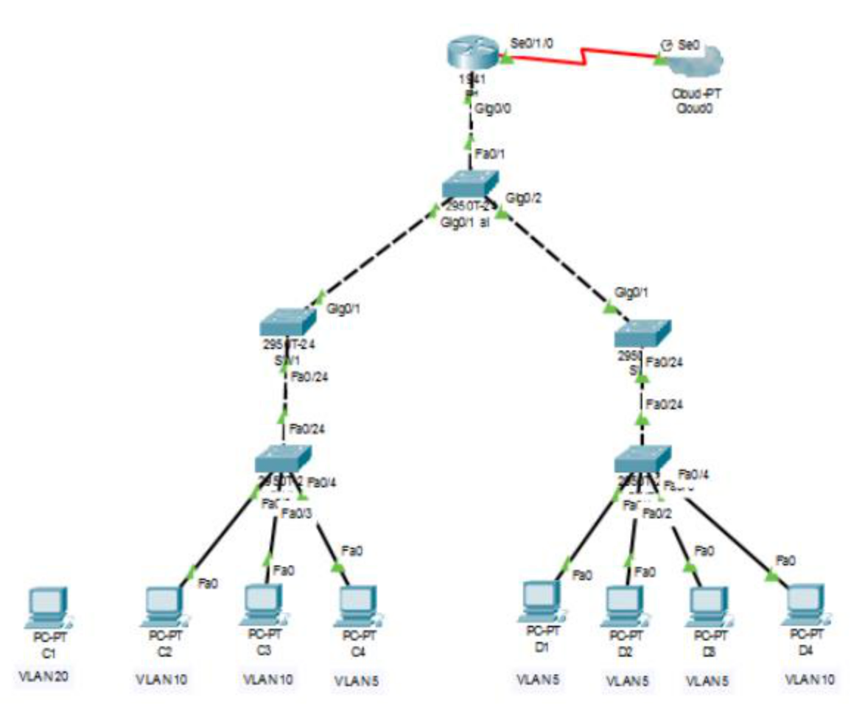

**Addressing Table:**

| **Device** | **Interface** | **IP Address** | **Subnet Mask** | **Default Gateway** |
| --- | --- | --- | --- | --- |
| R1 | gig0/0 |  |  |  |
|  | se0/1/0 | 209.165.200.1 | 255.255.255.0 | N/A |
|  |  |  |  |  |
| C2 | NIC | 192.168.10.1 | 255.255.255.0 | 192.168.10.100 |
|  |  |  |  |  |
| C3 | NIC | 192.168.10.2 | 255.255.255.0 | 192.168.10.100 |
|  |  |  |  |  |
| C4 | NIC | 192.168.5.1 | 255.255.255.0 | 192.168.5.100 |
|  |  |  |  |  |
| D1 | NIC | 192.168.5.2 | 255.255.255.0 | 192.168.5.100 |
|  |  |  |  |  |
| D2 | NIC | 192.168.5.3 | 255.255.255.0 | 192.168.5.100 |
|  |  |  |  |  |
| D3 | NIC | 192.168.5.4 | 255.255.255.0 | 192.168.5.100 |
|  |  |  |  |  |
| D4 | NIC | 192.168.10.3 | 255.255.255.0 | 192.168.10.100 |



**Objectives**

* Connect a new redundant link between SW-1 and SW-2.
* Enable trunking and configure security on the new trunk link between SW-1 and SW-2.
* Create a new management VLAN (VLAN 20) and attach a management PC to that VLAN.
* Implement an ACL to prevent outside users from accessing the management VLAN

**Scenario**

A company’s network is currently set up using two separate VLANs: VLAN 5 and VLAN 10. In addition, all trunk ports are configured with native VLAN 15.

**Part 1: Configure Switch/Router**

**Step 1: Configure secret**

Execute command on all switches/router

SW/R1(config)# enable secret enpa55

**Step 2: Configure console password**

Execute command on all switches/router

SW/R1(config)# line console 0

SW/R1(config-line)# password conpa55

SW/R1(config-line)# login

**Step 3: Configure SSH login**

Execute command on all switches/router

SW/R1(config)# ip domain-name ccnasecurity.com

SW/R1(config)# username admin secret adminpa55

SW/R1(config)# line vty 0 4

SW/R1(config-line)# login local

SW/R1(config-line)# crypto key generate rsa

How many bits in the modulus [512]: 1024

**Part 2: Create VLAN and assign access mode and trunk mode to interfaces**

**Step 1: Check existing VLAN**

Execute command on all switches

SW# show vlan brief

**Step 2: Create new VLAN**

Execute command on all switches

SW(config)# vlan 5

SW(config-vlan) # exit

SW(config)# vlan 10

SW(config-vlan) # exit

SW(config)# vlan 15

SW(config-vlan) # exit

**Step 3: Check the new VLAN**

Execute command on all switches

SW# show vlan brief

**Step 4: Assign access mode to VLAN switch interfaces**

Execute command on switches SWA/SWB

SWA(config)# int fa0/2

SWA(config -if)# switchport mode access

SWA(config -if)# switchport access vlan 10

SWA(config)# int fa0/3

SWA(config -if)# switchport mode access

SWA(config -if)# switchport access vlan 10

SWA(config)# int fa0/4

SWA(config -if)# switchport mode access

SWA(config -if)# switchport access vlan 5

SWB(config)# int fa0/1

SWB(config -if)# switchport mode access

SWB(config -if)# switchport access vlan 5

SWB(config)# int fa0/2

SWB(config -if)# switchport mode access

SWB(config -if)# switchport access vlan 5

SWB(config)# int fa0/3

SWB(config -if)# switchport mode access

SWB(config -if)# switchport access vlan 5

SWB(config)# int fa0/4

SWB(config -if)# switchport mode access

SWB(config -if)# switchport access vlan 10

**Step 5: Check the access mode allocations**

SWA# show vlan brief

SWB# show vlan brief

**Step 6: Assign trunk mode to other switch interfaces** SWA(config)# int fa0/24

SWA(config -if)# switchport mode trunk

SWA(config -if)# switchport trunk native vlan 15

SWB(config)# int fa0/24

SWB(config -if)# switchport mode trunk

SWB(config -if)# switchport trunk native vlan 15

SW1(config)# int fa0/24

SW1(config -if)# switchport mode trunk

SW1(config -if)# switchport trunk native vlan 15

SW1(config)# int gig0/1

SW1(config -if)# switchport mode trunk

SW1(config -if)# switchport trunk native vlan 15

SW2(config)# int fa0/24

SW2(config -if)# switchport mode trunk

SW2(config -if)# switchport trunk native vlan 15

SW2(config)# int gig0/1

SW2(config -if)# switchport mode trunk

SW2(config -if)# switchport trunk native vlan 15

Central(config)# int range gig0/1-2

Central(config –if-range)# switchport mode trunk

Central(config –if-range)# switchport trunk native vlan 15

Central(config)# int fa0/1

Central(config –if)# switchport mode trunk

Central(config –if)# switchport trunk native vlan 15

**Step 7: Check the trunk mode allocations**

Central# show int trunk

SW1/2# show int trunk

SWA/B# show int trunk

**Step 8: Create sub-interfaces on router to support VLAN**

R1(config)# int gig0/0.1

R1(config - subif)# encapsulation dot1q 5

R1(config - subif)# ip address 192.168.5.100 255.255.255.0

R1(config)# int gig0/0.2

R1(config - subif)# encapsulation dot1q 10

R1(config - subif)# ip address 192.168.10.100 255.255.255.0

R1(config)# int gig0/0.15

R1(config - subif)# encapsulation dot1q 15

R1(config - subif)# ip address 192.168.15.100 255.255.255.0

**Part 3: Verify Connectivity**

**Step 1: Verify connectivity between C2 (VLAN 10) and C3 (VLAN 10).**

C2> ping 192.168.10.2

(Successful)

**Step 2: Verify connectivity between C2 (VLAN 10) and D1 (VLAN 5).**

PC2> ping 192.168.5.2

(Successful)

**Part 4: Create a Redundant Link between SW-1 and SW-2**

**Step 1: Connect SW-1 and SW-2.**

Using a crossover cable, connect port Fa0/23 on SW-1 to port Fa0/23

on SW-2.

**Step 2: Enable trunking, including all trunk security mechanisms on the link between SW-1 and SW-2.**

(Execute command on SW- 1 and SW-2) SW1/2(config)# int fa0/23 SW1/2(config-if)# switchport mode trunk SW1/2(config-if)# switchport trunk native vlan 15 SW1/2(config-if)# switchport nonegotiate

**Part 5: Enable VLAN 20 as a Management VLAN**

**Step 1: Enable a management VLAN (VLAN 20) on SW-A.**

SW-A(config)# vlan 20

SW-A(config-vlan)# exit

SW-A(config)# int vlan 20

SW-A(config-if)# ip address 192.168.20.1 255.255.255.0

**Step 2: Enable the same management VLAN on all other switches**

(Execute command on SW-B, SW-1, SW-2, and Central)

SW(config)# vlan 20

SW(config-vlan)# exit

***Create an interface VLAN 20 on all switches and assign an IP address within the 192.168.20.0/24 network.***

SW-B(config)# int vlan 20

SW-B(config-if)# ip address 192.168.20.2 255.255.255.0

SW-1(config)#int vlan 20

SW-1(config-if)#ip address 192.168.20.3 255.255.255.0

SW-2(config)#int vlan 20

SW-2(config-if)#ip address 192.168.20.4 255.255.255.0

Central(config)# int vlan 20

Central(config-if)# ip address 192.168.20.5 255.255.255.0

**Step 3: Connect and configure the management PC.**

***Connect the management PC using copper straight-through to SW-A port Fa0/1 and ensure that it is assigned an available IP address 192.168.20.50***

**Step 4: On SW-A, ensure the management PC is part of VLAN 20.**

SW-A(config)# int fa0/1

SW-A(config)# switchport mode access

SW-A(config-if)# switchport access vlan 20

**Step 5: Verify connectivity of the management PC to all switches.**

C1> ping 192.168.20.1 (SW-A)

(Successful)

C1> ping 192.168.20.2 (SW-B)

(Successful)

C1> ping 192.168.20.3 (SW-1)

(Successful)

C1> ping 192.168.20.4 (SW-2)

(Successful)

C1> ping 192.168.20.5 (Central)

(Successful)

**Part 6: Enable the Management PC to Access Router R1**

**Step 1: Enable a new subinterface on router R1.**

R1(config)# int gig0/0.3

R1(config-subif)# encapsulation dot1q 20

R1(config-subif)# ip address 192.168.20.100 255.255.255.0

**Step 2: Set default gateway in management PC.**

C1 – 192.168.20.100

**Step 3: Verify connectivity between the management PC and R1.**

C1> ping 192.168.20.100

(Successful)

**Step 4: Enable security.**

R1(config)# access-list 101 deny ip any 192.168.20.0 0.0.0.255 R1(config)# access-list 101 permit ip any any

R1(config)# access-list 102 permit ip host 192.168.20.50 any

**Step 5: Apply ACL on correct interfaces** R1(config)# int gig0/0.1 R1(config-subif)# ip access-group 101 in R1(config-subif)# int gig0/0.2 R1(config-subif)# ip access-group 101 in R1(config-subif)# line vty 0 4

R1(config-line)# access-class 102 in

**Step 6: Verify connectivity between the management PC and SW-A, SW-B and R1**

C1> ping 192.168.20.1 (SW-A)

(Successful)

C1> ping 192.168.20.2 (SW-B)

(Successful)

C1> ping 192.168.20.100 (R1)

(Successful)

**Step 7: Verify connectivity between the D1 and management PC.**

D1>ping 192.168.20.50

(Unsuccessful – Destination host unreachable)