PROJECT TOPIC: AInOne – Unified Agentic AI Workspace

Group No.: G17

Project Group Members:
1. Anubhav Singh (4AB / 2315000358) 2. Rishav Haldar (4T / 2315001837)
3. Aakash Sharma (4V / 2315000193) 4. Tanisha Jain (4Z / 2315002280)
5. Kapil Varshney (4G / 2315001063)

Project Supervisor: Mr. Vikas Kumar, Dept. of CSE

About the Project: AInOne is a web-based AI workspace that lets a user chat with several AI models from one place without losing the thread of a project. Most AI tools keep their own separate conversation, so when a free plan runs out or a service goes down, the user has to move to another tool and explain everything again. AInOne keeps the conversation, summaries and project notes in its own PostgreSQL database instead of inside any one provider. When a request fails for a reason another model can handle, such as a rate limit or an outage, the system picks an alternative model, rebuilds the needed context from the stored history and carries on in the same conversation. The user can also switch models by hand. A rule-based router chooses a model using its availability and capability, and a limited number of retries prevents endless loops. The frontend is built in React and the backend in Java with Spring Boot, and each AI provider is connected through its own adapter. Login, per-user access checks and server-side storage of API keys protect user data.
Motivation: Students depend on free AI plans and cannot pay for several subscriptions, so a limit reached halfway through a bug or a report breaks their work. AInOne is meant to reduce that loss of time. It brings together full-stack development, database design, API integration, security and AI orchestration, which makes it suitable as a final year major project. Any student or independent developer can use it to get more out of the AI access they already have.
Innovation:
1. Provider-independent memory: the full conversation, summaries and project notes stay in the application’s own database, not inside any one AI service.
2. Error-aware fallback: failures are classified first (rate limit, outage, wrong key, empty balance), and a switch happens only when another model can actually help.
3. Context rebuilding: for the new model, the system assembles recent messages, the latest summary and the project notes within that model’s context limit.
4. Adapter per provider: each AI service has its own adapter, so a new one can be added without changing the rest of the code.
5. Transparent switching: the user can see which model answered and why a switch happened, and the app does not claim any extra free usage.
Project Planning: The work is spread over seven months, from September 2026 to March 2027. The first month goes into learning React, Spring Boot, PostgreSQL and the AI provider APIs. After that the requirements and design are finalised, the backend and chat interface are built, the second provider and manual switching are added, and fallback with summaries follows. The last two months are kept for testing, deployment and the report. A rough Gantt chart is shown below.
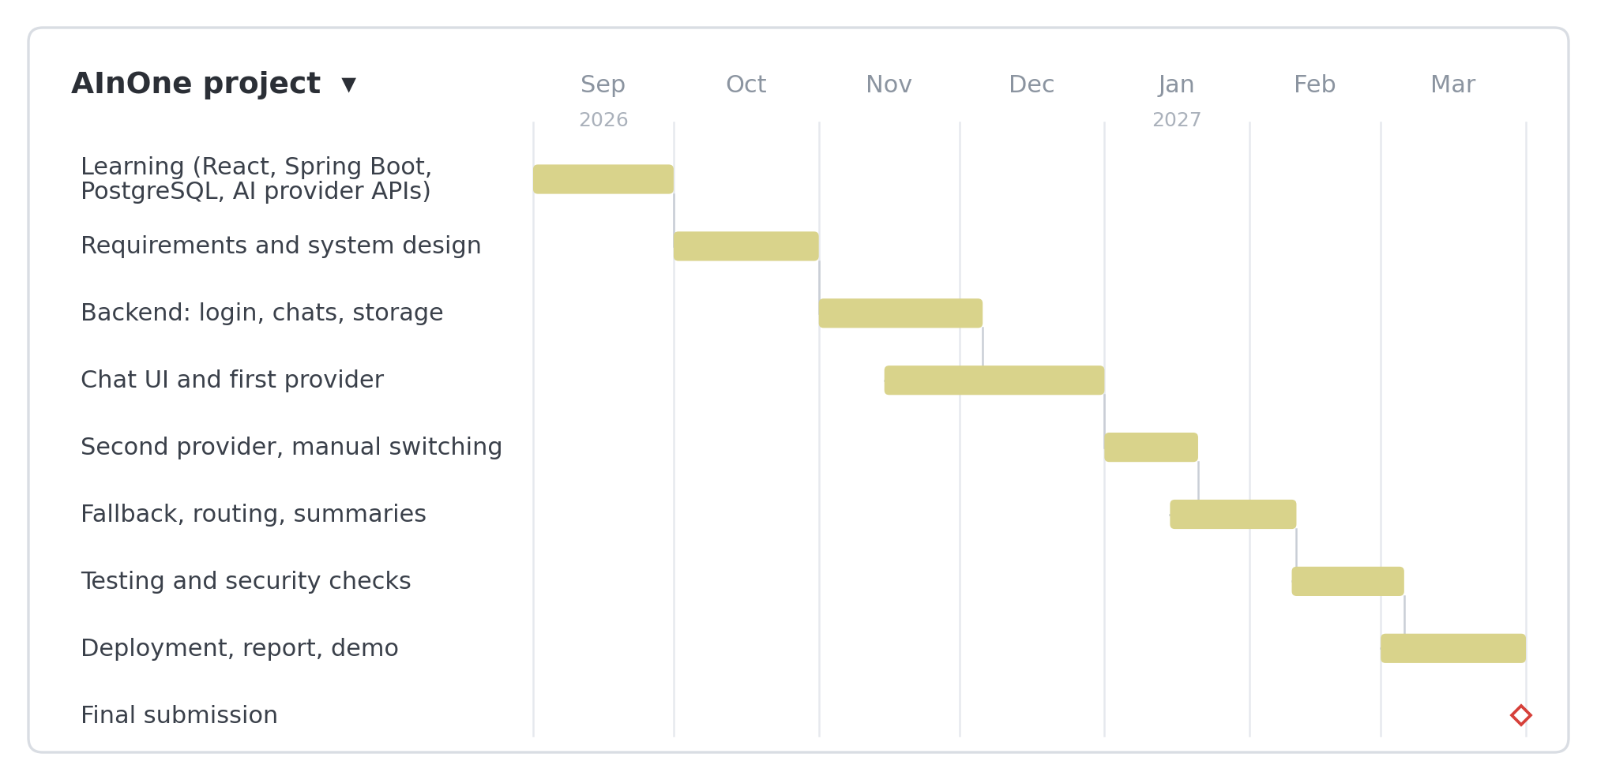
Tools required:
- Hardware Requirements: Laptop or PC with at least 8 GB RAM (16 GB preferred), Intel i5 or equivalent processor, 256 GB SSD and a stable internet connection.
- Software Requirements: Java 17 or later with Spring Boot, React with Node.js, PostgreSQL, Git and GitHub, VS Code or IntelliJ IDEA, Postman, JUnit, Docker (optional), AI provider APIs (such as Gemini and DeepSeek) and a cloud host for deployment.

Signature of Project Supervisor: _____________________

