Mobile App Development Proposal:
Paws & Prognosis: Clinic & Care Companion

Prepared For: Paws & Prognosis Veterinary Clinic
Prepared By: Miranda, Marvin A., Baguisa, Gerald Andrei P.

Date: February 10, 2026

Version: 1.0
1. Executive Summary
The need for veterinary services like examinations, immunizations, and surgeries has grown as more people own pets. Many veterinary clinics continue to use manual scheduling and paper-based records in spite of this. These systems frequently result in issues like missed follow-ups, overlapping appointments or check-ups, and trouble locating patient information. Additionally, keeping track of a pet's medical history can become tedious and confusing, and there's a chance that a record could be lost or misplaced. Clinic operations become less efficient as a result, staff spend more time on paperwork or administrative tasks, and clinics find it more difficult to manage an increasing number of clients because the outdated system requires more staff.
This study proposes Paws & Prognosis: Veterinary Clinic, a centralized, mobile-first platform that digitizes appointment scheduling, pet health records, and inventory oversight to modernize veterinary practice management. By integrating self-service booking, secure record access, and automated notifications, the system is designed to reduce administrative burden, lower no-shows, and improve throughput without needing more staff or manpower to operate the clinic. The anticipated outcomes include enhanced data accuracy, mobile-enabled access to real-time operational insights (such as peak-hour trends and vaccination compliance tracking), and improved continuity of care. By making essential clinic functions accessible anytime through a mobile app, the system supports measurable gains in client retention and service quality—positioning veterinary clinics for scalable, data-driven growth.
2. Project Overview
2.1 The Problem
The veterinary industry plays a crucial role in providing medical care, grooming, and essential pet supplies to owners. With continuous growth of pet ownership, veterinary clinics and pet shops face heavy demands to efficiently manage records, inventory, and appointment scheduling. Traditionally, many veterinary shops rely on paper-based record-keeping and manual reservation systems, which often lead to inaccuracies, inefficiencies, and delays in delivering quality services. To ensure better operational efficiency and enhance user satisfaction, veterinary clinics must transition to digital solutions that offer streamlined management, better accessibility, and improved workflow efficiency.
A significant challenge encountered by veterinary clinics is ineffective management of their operations, especially in relation to managing patient files, scheduling appointments, and monitoring inventory levels. The 2023 research titled “Digital Record Keeping: The Key to Efficient Veterinary Practice Management” indicates that utilizing digital records greatly enhances operational efficiency by allowing quick and precise access to patient information. Record-keeping done by hand can often lead to lost documents, unreadable writing, and challenges in retrieving previous medical records, which can have an adverse impact on the quality of care provided to patients. Furthermore, the appointment booking process in conventional veterinary clinics suffers from a lack of automation, resulting in difficulties in efficiently handling reservations and causing issues such as overbooked calendars, missed visits, and extended wait times.
The current problem in veterinary shop operations is the continuous usage and reliance on an outdated system which is the paper-based record keeping system, where it lacks a centralized method of managing the clients’ pet records, appointments, and inventory. It is a common problem that clinics find it difficult to keep track of pet health records and the prescription histories which also some of the pet owners do not know or commonly forgets. In the field of inventory, it is also a problem to keep track of pet supplies as it is needed to record one by one and every item, which is inefficient and leads to stock shortages or excessive inventory. Additionally, because of the traditional scheduling systems that do not provide automated reminders, there is a higher chance that the client might forget the schedule they have with the veterinarian which results in no-show or last-minute cancellations. Because of the no-show or last-minute cancellations, it heavily affects the clinic operation and can result in financial losses. Based on the 2023 study titled “From Note Taking To Scheduling, Technology Can Help Veterinary Practices In Many Ways”, digital tools can bring significant improvements to the veterinary field by automating scheduling, enhancing and digitalizing record-keeping, and reducing human error.
2.2 The Solution
To address these inefficiencies, we propose a centralized mobile-based veterinary scheduling and digital pet profile management platform. The system is designed to streamline core clinical operations by digitizing appointment scheduling for surgeries, vaccinations, and check-ups while maintaining secure, structured pet health records. By consolidating scheduling and patient data into a unified platform, clinics gain real-time visibility over daily operations, appointment load, and medical histories. Pet owners benefit from self-service booking, automated reminders, and continuous access to their pets’ health information.
From a business and technical perspective, the platform is highly feasible due to its reliance on proven technologies such as native iOS development, Firebase for backend operations, and MongoDB for flexible data storage. Implementation is further supported by the platform's modular architecture, which allows for iterative development and easy integration with existing clinic workflows. Operational throughput is improved by minimizing double bookings and reducing no-show rates through automated notifications. Digital record management reduces administrative processing time, enhancing staff productivity and enabling clinics to accommodate increased patient volume without proportionally increasing staffing. Data centralization supports analytics-driven decision-making, enabling clinics to identify peak service hours, monitor inventory levels, and track vaccination compliance rates. The use of cloud-based infrastructure, such as AWS, ensures scalability and reliability as client demands grow. These factors collectively demonstrate the technical and operational feasibility of deploying the proposed solution in a typical veterinary clinic environment.
Core Concept: A Native mobile application for iOS built specifically for healthcare.
Key Objective: To provide a seamless, on-the-go veterinary care experience for pet owners while optimizing clinic operations.
3. Scope of Work (SOW)
3.1 Target Platforms
- iOS: iOS 16.0+
- Device Support: Optimized for iPhone 13 to 17 series
3.2 User Roles
- Guest/Unregistered User: Can view but cannot interact, and needs to register first.
- Registered User: Can manage pets, appointments, chat with vets, and receive reminders.
- Admin: Manage users, appointments, and clinic contents.
3.3 Key Features List
- Onboarding
  - Loading Screen of the App
  - Social Login / Registration (Sign up)

- Core Functionality:
  - Pet Profile Management (Multiple Pets)
  - Appointment Scheduling & Calendar View
  - Medication & Vaccination Reminders
  - Real-time chat with Clinic Staff
  - In-app notifications
  - Pet Medical History

- Core Functionality (Admin / Veterinary Panel):
  - Dashboard Analytics
  - Appointment Management
  - Pet Records Management
  - Chat Monitoring

- Payment Gateway:
  - GCash / Maya (Thru QR / Send Money option)

- Notifications: Push notifications for updates, vaccination for the animal (Program/Free or Promo/Discounts), and upcoming appointments.

4. UI/UX Design Strategy
- Wireframing: Initial Low-fidelity screens to define flow.
- Prototyping: Clickable/Interactive prototypes using Figma based on the user journey.
- High-Fidelity UI: Final designs showcasing the brand’s green-and-brown soft aesthetic, modern typography, and pet-friendly icons.
Provide a screenshot of your GUI.
Admin/Veterinarian
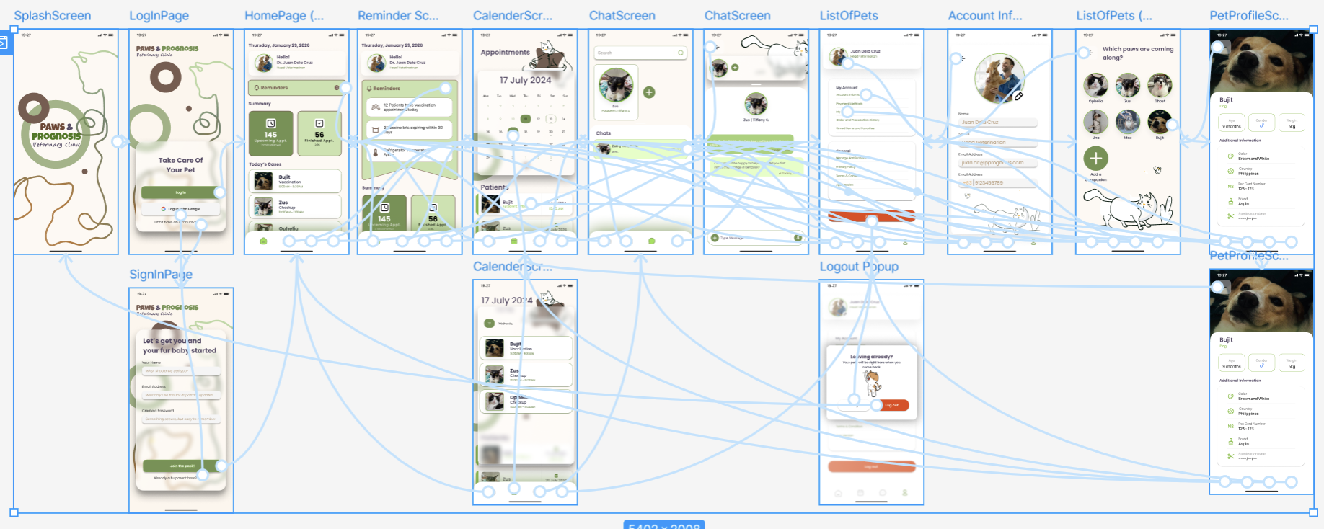

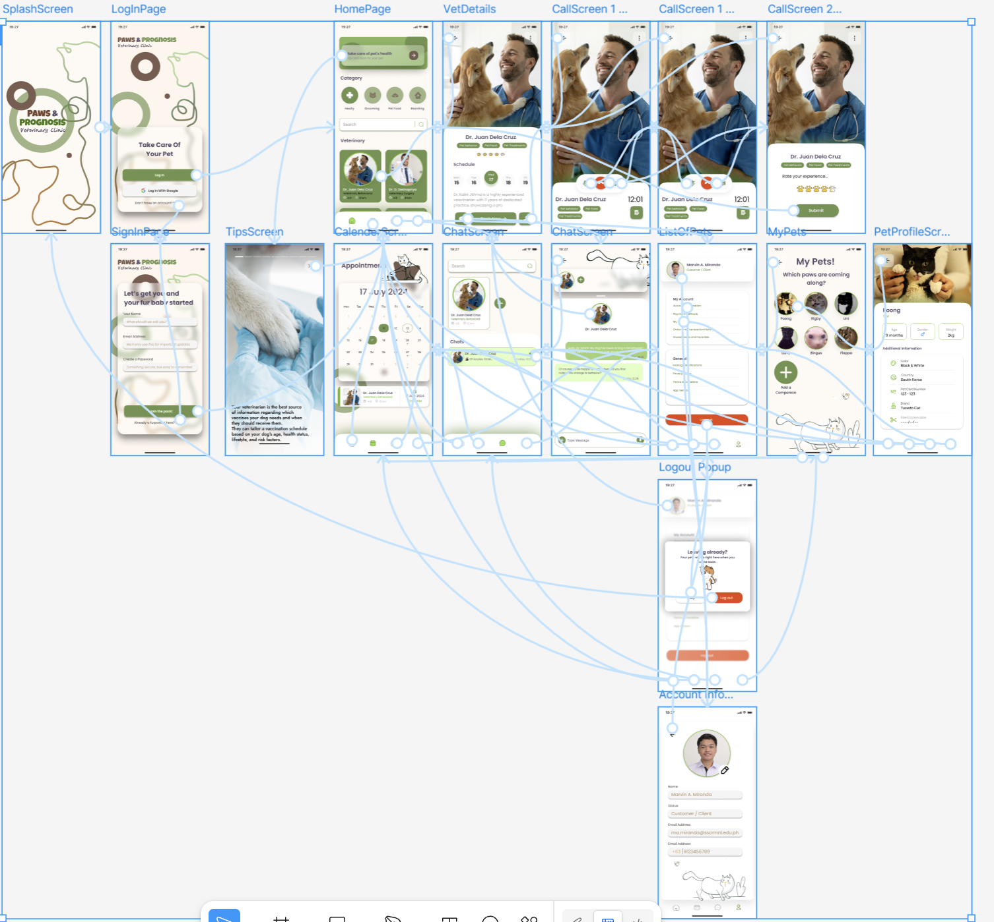
Client/Customer
5. Technical Approach
5.1 Tech Stack
The proposed system prioritizes iOS development, focusing on a native mobile experience optimized for clinic administrators, veterinarians, and pet owners.
Component | Technology Choice | Why we chose it
Front-End | Swift (Native iOS) | Offers superior performance, security, and seamless integration with Apple’s ecosystem. Ideal for long-term scalability and a polished user experience.
Back-End | Firebase | Provides rapid development, real-time synchronization, and built-in authentication tools, allowing fast deployment with reduced server overhead.
Database | MongoDB | Supports flexible document-based storage, making it suitable for dynamic pet profiles, medical histories, and appointment data.
Cloud/Hosting | AWS | Ensures high reliability, robust security infrastructure, and scalable cloud services to support future system expansion.
5.2 Security & Compliance
- Data Encryption: AES-256 for data at rest combined with TLS 1.3 for data in transit.
- GDPR/CCPA Compliance (if applicable): adherence to local health data privacy standards and Apple’s privacy manifests.
- Secure API Authentication: OAuth 2.0
6. Project Roadmap & Timeline
Development follows an iterative SDLC approach, ensuring continuous testing, validation, and stakeholder feedback.

Phase 1: Discovery & Strategy (Weeks 1–2)
- Requirement gathering
- Competitive and market analysis
- Technical architecture planning

Phase 2: UI/UX Design (Weeks 3–5)
- Wireframe development
- High-fidelity mockups
- User flow validation and approval

Phase 3: Development (Weeks 6–12)
- Sprint 1: Core architecture and database structure
- Sprint 2: iOS front-end development
- Sprint 3: API integration and backend synchronization

Phase 4: Testing & Quality Assurance (Weeks 13–14)
- Functional and non-functional testing
- Bug resolution
- User Acceptance Testing (UAT)

Phase 5: Deployment & Launch (Week 15)
- App Store preparation and submission
- Post-launch validation

7. Commercials (Investment)
7.1 Cost Breakdown (Cost of the Project)
Provide a transparent pricing model (Fixed Price or Time & Materials).
Deliverable | Estimated Hours | Cost (USD)
UI/UX Design | 70 | $3,349
Front-End Development | 150 | $9,254
Back-End Development | 200 | $13,152
QA & Testing | 60 | $3,076
Total Project Cost | 480 Hours | $28,831
7.2 Payment Schedule
Based on $28,831 total, here are the correct amounts:
- 30% upon signing (Mobilization fee):
$8,649.30
- 30% upon design approval:
$8,649.30
- 20% upon Beta release (Initial release):
$5,766.20
- 20% upon final launch (Final release to app store):
$5,766.20

8. Maintenance & Support
- Warranty Period: 60 days of free bug fixing and solving issues post-launch
- Annual Maintenance Contract (AMC): $400/month for maintenance of the server, OS updates, and security patches.
9. Terms & Next Steps
- Validity: This proposal is valid until [Date].
- Next Steps:
  - Review and sign the included agreement.
  - Return the signed document by the specified date.
  - A project kickoff meeting will be scheduled immediately after confirmation.

Signatures
Client:________________
Agency:________________

Reference:
Remote Online Digital Veterinary Records | IDEXX Software. (n.d.). https://software.idexx.com/resources/blog/digital-record-keeping-the-key-to-efficient-veterinary-practice-management

From note taking to scheduling, technology can help veterinary practices in many ways | American Veterinary Medical Association. (2023, December 6). Www.avma.org. https://www.avma.org/news/note-taking-scheduling-technology-can-help-veterinary-practices-many-ways

