NCIP Document Tracking and Routing System
Complete System Guide — Improved Laravel Version • Version 2

Plain-language guide to modules, roles, workflows, and system boundaries
Reviewed: 28 October 2026
Prepared for: NCIP users, administrators, project sponsors, and business stakeholders
This guide describes the current source code in the project workspace. It is an informative system overview, not a confirmation that every feature is enabled in production. Actual access depends on deployment settings, account roles, office assignments, database data, email and queue operation, and external service availability. The recipient may edit this guide to fit local policy and training needs.

Contents
- DOTS at a glance
- What the improved version brings
- Who uses the system
- Navigation and module map
- Sign-in, account security, and access
- Dashboard and notifications
- Document lifecycle overview
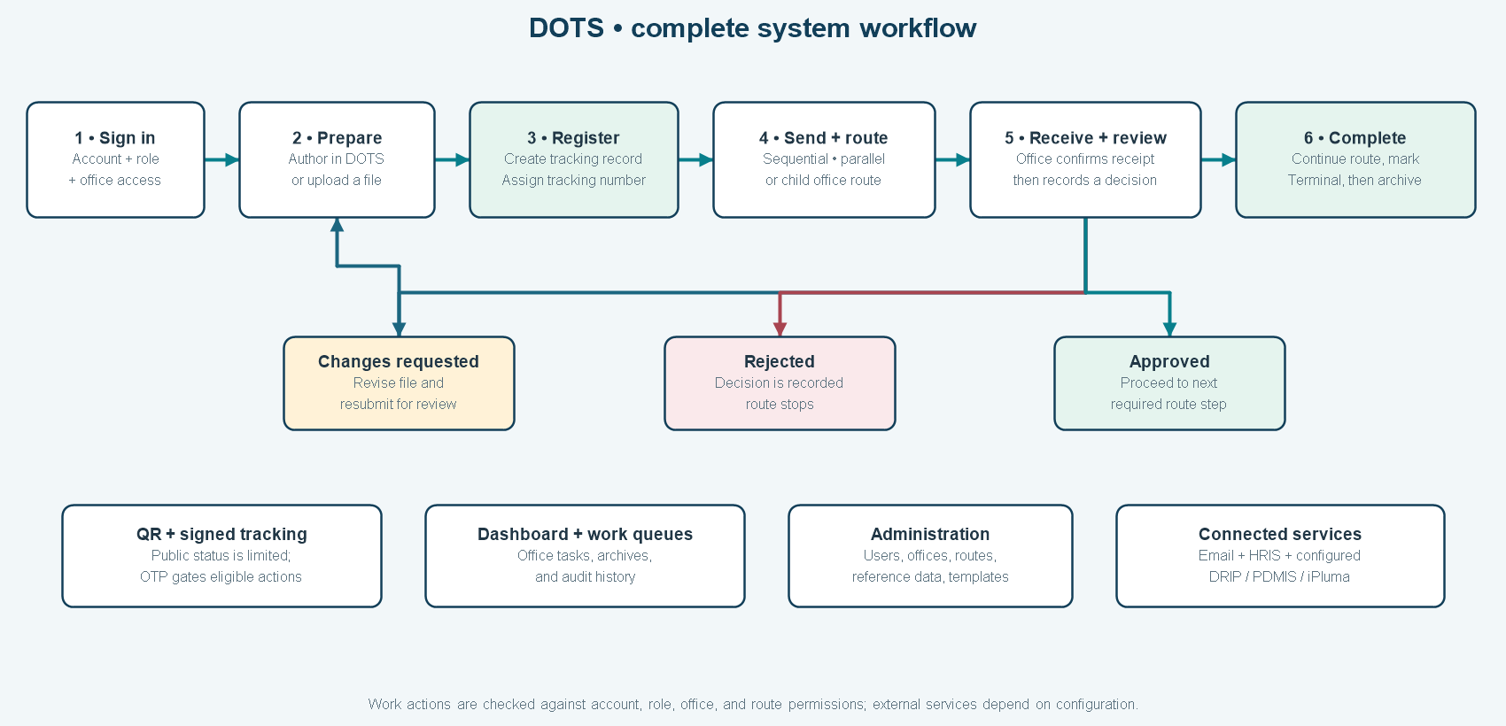
- Document register, tracking, and files
- Sequential approval routing
- Parallel approval routing and child branches
- Document Creation and PDF generation
- Document Workflow and Drafts
- Public tracking, QR codes, and email OTP
- Wet-signed PDF workflow and iPluma boundary
- Archives and restore
- Audit Trail
- User accounts, offices, and HRIS
- Libraries and system setup
- Connected systems: PDMIS, DRIP, and iPluma
- Email notifications
- Navigation Access and System Maintenance
- Profile, privacy notice, and application shell
- Legacy-data migration
- Security and data handling
- Data areas and technical architecture
- Terms and status meanings
- Items to confirm or plan further
- Quick reference

Version 2 review summary
This is a review copy of the full DOTS system guide. It adds context from the supplied 2024 user manual, 2024 system analysis and design document, and 2025 MIS analysis, then checks those materials against the current project source reviewed on 28 October 2026. “Version 2” identifies this document revision, not a DOTS application release.

How to read Version 2
Current implementation notes describe features found in the Laravel application source. Historical source notes describe what the earlier user manual and analyses documented or recommended at the time. A feature mentioned as a recommendation is not assumed to be implemented unless it is present in current routes, pages, or services.

What the supplied documents contribute
Reference document | Context carried into this review
USER MANUAL DOTS.pdf (version 01.19, February 2024) | Historic step-by-step guidance for account creation, first sign-in and password change, dashboard counts, document creation and drafts, release/receive actions, disposition forms, annual archives, action icons, and access-control guidance.
System Analysis and Design - DOTS.docx (document history dated April 2024) | Earlier system purpose, actors, requirements, functional decomposition, access-control expectations, non-functional goals, maintenance/support procedures, and technical deployment assumptions from that period.
DOTS MIS ANALYSIS.docx (30 June 2025) | Recorded single-recipient routing, static/all-at-once list loading, missing user-log reporting, and desktop-dependent receipt/release as improvement opportunities; recommended multi-office release, dynamic pagination, user activity reporting, and QR plus six-digit verification.
Current repository and current workflow notes (reviewed 28 October 2026) | Used to confirm current navigation, module implementation, authorization boundaries, route modes, OTP details, signatures, integrations, import tools, and features still pending or deployment-dependent.

Improvements and expanded capabilities reflected in the current source
- Multi-office routing — implemented. A document can follow sequential or parallel office routes. Child routes support consultation branches; progress is shown per office, required decisions are enforced, and an active parent step resumes after its child route completes.
- QR-based protected actions — implemented. Signed, rate-limited tracking URLs and QR codes can open a limited public tracking page. Email OTP can authorize an eligible existing user for document-scoped receipt, decision, or forwarding actions. The current guide documents a six-digit, 10-minute code, 60-second resend cooldown, five-attempt limit, and 20-minute document-scoped session.
- Mobile-friendly receipt and review — expanded. A recipient can open the QR route on a phone and verify using the registered official email. Receiving remains separate from approval, and route-step, office, and role rules still apply.
- Document authoring and versioned PDFs — added. The editor supports templates, rich text, saved versions, PDF preview, and a Ready for Routing stage. A tracking number is assigned later when the source file is registered; eligible generated PDFs can be stamped with it.
- Office-level approvals and signatures — expanded. Approvers can approve, request changes, or reject the current tracked version. Required wet-signed PDFs are stored as a separate file version with route-step and source-version metadata plus a SHA-256 checksum.
- Search, lists, and performance — improved in the source. Current lists use server-side search/filter/pagination in key operational areas; indexed queries, bounded imports, and deferred dashboard calculations are present. This code review does not provide a production load benchmark.
- Audit and administration — expanded. The current application includes a searchable Audit Trails area, account and reference-data administration, role/office checks, Navigation Access controls, System Maintenance modes, and configurable email notification settings.
- Protected files and migration support — added. New document files use private storage and authorized downloads. Preview/apply tools support selected legacy directory, document/trail, attachment metadata, and audit imports with target-database safeguards.

Partially addressed, unavailable, or still requiring confirmation
- User log reports — partial. Application events are available in the Audit Trails module with filtering and office/actor context where recorded. A separate report module for user-by-user or bureau/region reports is not present in the current top-level navigation. The audit history is not a guarantee that every read or database change is logged.
- Reports menu — not verified in current source. The older analysis expected report generation, but this checkout provides dashboard counts and selected charts rather than a comprehensive Reports module.
- Separate legacy File Upload repository — not a current top-level module. Current document attachments and staged uploads serve tracking workflows; do not assume the old ZIP file repository remains available.
- PDMIS linking — older description differs from current module. The current Laravel Connected Systems area presents configured summaries. The legacy linking/suggestions workflow is not part of the current standard navigation and requires separate deployment evidence.
- iPluma signing — incomplete integration. DOTS can display iPluma summary/signing information and record signature need. PDF submission, signer setup, signed-file return, and status reconciliation remain unavailable pending the API contract and implementation.
- Records retention and disposition — policy/module gap. Terminal tagging, archive search, and eligible restore are operational functions. They do not by themselves provide a retention schedule, legal hold, transfer, or destruction authorization.
- Historical attachment binaries — not included by the supported import. Legacy import can carry file metadata; the original physical files need a separate migration and reconciliation plan.
- Deployment and security assumptions — verify locally. The 2024 SAD contains historic PHP/MySQL, server, and browser assumptions. They are not current deployment specifications. Production hosts, TLS, database state, queues, mail, backups, monitoring, and external API availability were not established by repository review.
- MFA/SSO — not confirmed as implemented. Current code includes optional reCAPTCHA, login-attempt protections, account-state checks, email verification, and HRIS-related flows. Confirm any broader MFA or single-sign-on requirement separately.

Main current workflow figures
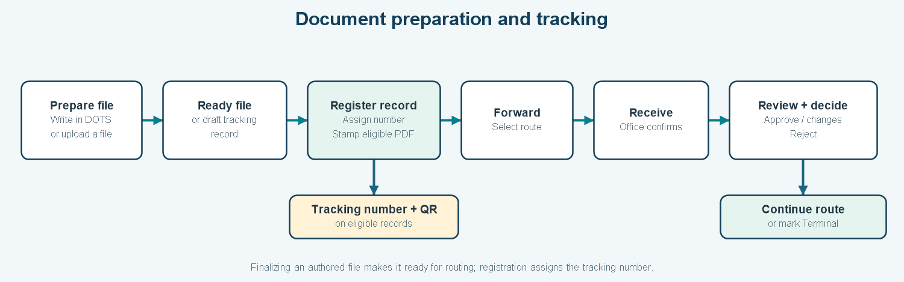
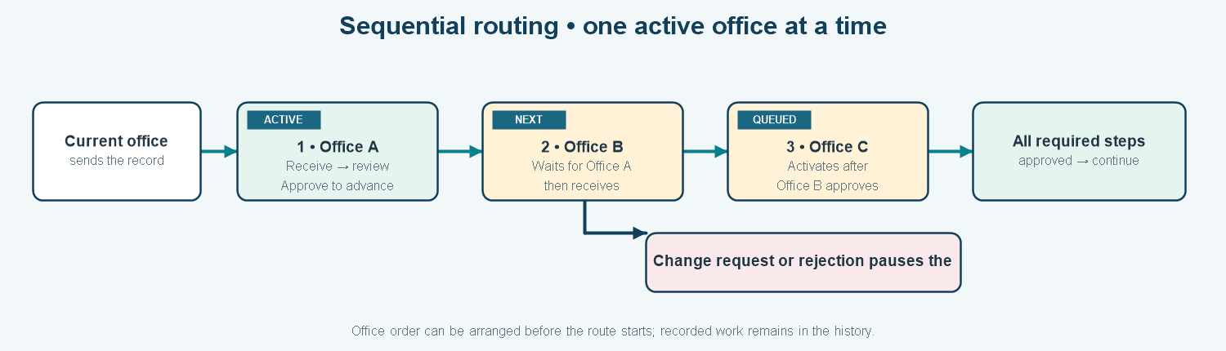
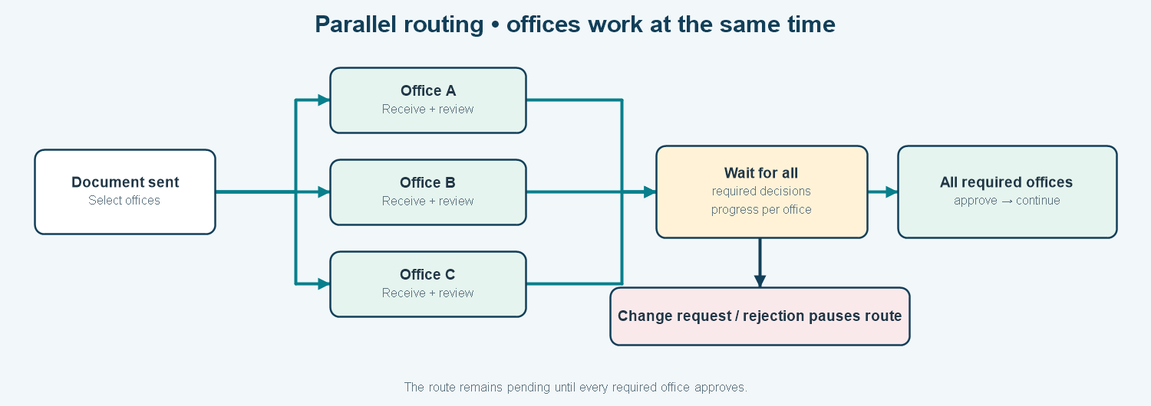
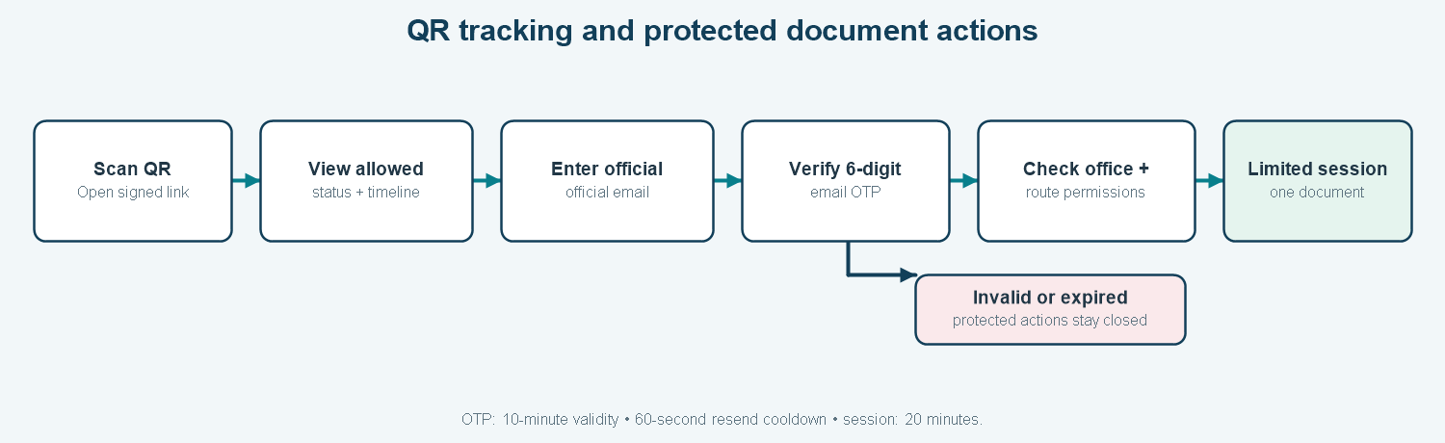

Review notes and editable areas
This Version 2 copy is for review and editing. Confirm the official system owner, supported roles, public disclosure fields, exact deployment status, report requirements, records policies, and integration plans before using it as an approved manual or formal system specification. The dated manuals and analyses remain useful historical references but do not override current source behavior or agency decisions.

1. DOTS at a glance
The National Commission on Indigenous Peoples (NCIP) Document Tracking and Routing System (DOTS) is an office-based web application for preparing, registering, routing, receiving, reviewing, and completing official documents. Each tracked document has a record, a tracking number, a source file or file versions, and a history of office actions.
DOTS has two connected document paths:
- Prepare a document: write a document in DOTS, use an assigned template, preview it, and finalize the generated file as ready for routing.
- Track a document: register an existing file or a ready generated file, receive a tracking number, then route and review the record through the appropriate offices.
Finalizing a generated file does not create a tracking number. The tracking number is assigned when the document is registered into the tracking workflow. This separation helps distinguish a prepared file from an officially tracked item.
Figure 1. The main document lifecycle, from preparation or intake through routing and completion.

2. What the improved version brings
The current DOTS application expands the earlier system into a more integrated workflow. Improvements and additional capabilities in the current project include:
- A modern Laravel, React, and TypeScript application with a shared, responsive navigation and page layout.
- Separate document authoring, tracking, review, approval, and archive work areas.
- Versioned document templates, rich-text editing, PDF preview, and generated PDF output.
- Tracking numbers stamped onto eligible generated PDFs at registration.
- Sequential, parallel, and nested child-office routing with visible route progress.
- Office-level receipt and approval actions, including requests for changes and rejection.
- File-version history and wet-signed PDF storage for signature-required office steps.
- Signed, rate-limited public tracking links, QR access, and email one-time-password verification for protected QR actions.
- Private file storage with authorized viewing and download routes for new document files.
- Office-scoped dashboards, processing charts, audit history, configurable navigation visibility, and system-maintenance controls.
- HRIS support, configurable email delivery, and connected-system summary pages.
- Guarded legacy directory, document, and audit import tools with preview and reporting.
Some services still depend on external credentials and operating arrangements. iPluma PDF submission and signed-file return are not complete in the current implementation. The connected-system pages are summaries, not a general synchronization console.

3. Who uses the system
User group | Typical work in DOTS
Document originators and encoders | Create a generated document or register an existing file; complete metadata; follow submissions and records they can access.
Receiving-office staff | Confirm physical or electronic receipt, see current office work, and route items onward when authorized.
Approvers and office administrators | Review the current file version, record approve/change/reject decisions, and manage office routing steps within their authority.
Executives and oversight users | Review broader document activity, queues, archives, or audit information where their role permits.
System administrators | Maintain user accounts, office structure, references, templates, navigation visibility, notifications, and maintenance settings.
Records and administrative personnel | Retrieve routed files and historical records, review activity, and coordinate records handling under agency policy.
Public recipients | Use a signed tracking link to view selected status and routing information; QR actions require additional email verification when enabled.
Role labels and permissions must be confirmed against the agency's current role assignments. Navigation visibility helps organize the interface, while server-side checks determine whether an account can access a page or perform an action.

4. Navigation and module map
The authenticated sidebar groups the current application areas. Some controls are visible only to privileged users, and individual actions can have narrower office or role rules.
Navigation group | Current links and contents | Main purpose
Main | Dashboard | Work counts, incoming work, recent records, and selected charts.
Documents | Latest documents; All documents; Document creation; Document Workflow; Drafts | Document registration, routing, authoring, review queues, and saved work.
Connected systems | PDMIS; DRIP; iPluma | Browse configured data summaries supplied by other systems.
Archives | Archived documents | Find completed/terminal tracking records and restore eligible records.
Administration | User accounts; Navigation Access; System Maintenance; Libraries; Email notifications; Audit trails | Administer identities, configuration, service delivery, and activity review.
Account menu | My profile; Sign out | Update personal settings or end the session.
Public entry | Signed /track/{tracking number} page and QR actions | Public status view and eligible document-scoped actions without a regular DOTS sign-in.
Libraries contains Offices, Ranges, Document types, Purpose types, Action types, and HRIS Employees. The public tracking page is not a general search page. A separate legacy File Upload repository and Reports link are described in older material but are not current top-level modules in this Laravel navigation.

5. Sign-in, account security, and access
Internal users sign in with their DOTS account. The application includes password reset, password changes, email verification, profile management, account active/locked checks, login-attempt tracking, cooldowns, and optional reCAPTCHA challenges. Eligible imported accounts can use configured HRIS credential verification to establish local credentials. Operational application routes require authentication and the relevant account checks.
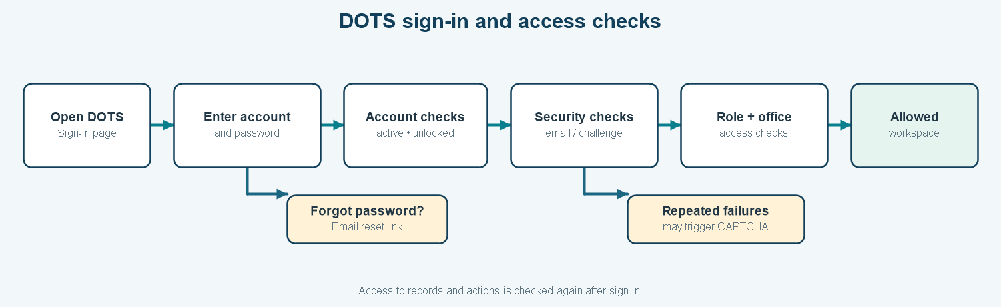
Figure 2. Sign-in and access checks. The exact challenge depends on account state and security configuration.
Access is scoped by role and office. Ordinary document users generally see records associated with their office and routing history; privileged roles may receive broader access and office filters. Receiving, releasing, approving, terminal tagging, restoring, and administration each have additional action rules. An office must generally be a valid route destination and have an eligible active user before a route can be sent there.
The Super Admin controls Navigation Access and System Maintenance. Navigation Access can show or hide supported sidebar areas for selected roles, and the related route middleware also enforces these settings. Navigation settings do not replace document-level office checks or action authorization.

6. Dashboard and notifications
The dashboard provides an office-oriented overview of current work. Depending on the user's access, it can include:
- Counts for incoming, pending, released, and archived/terminal documents.
- Counts or links for authored work, approval queues, revisions, and other workflow indicators.
- Recent records and an incoming-document list with search support.
- Document-type and processing-performance charts, with office filters for privileged users.
- Asynchronously loaded summaries so the page shell can display before all chart calculations finish.
- A notification menu with counts and links for work that may need attention.
The current dashboard is not a complete compliance-reporting or executive analytics module. A chart only measures what its source history and calculation support. In particular, confirm the calculation used before treating a chart as an official report of tracked-route approval time.

7. Document lifecycle overview
An existing document can start at registration. A newly authored document first becomes Ready for Routing and is then attached to a tracking record. When a tracking record is finalized, DOTS assigns its tracking number and records the first event. The record then moves through office dispatch, receipt, decisions, possible further routing, and terminal/archive handling.
At a destination office, receipt means that the office has received the item. It is separate from approval, which records the office's decision after review. A file replacement can keep the same tracking number while adding a new version and returning the item to approval.

8. Document register, tracking, and files
The Documents area is the main work surface for official tracking records.

Common document details
Registration captures information such as document type, purpose, origin, title, action, remarks, urgency, and notification preference. Reference choices come from Libraries. Supported forms provide an “Other” option for custom document types, purposes, or actions where configured.

Lists and record history
- Latest documents focuses on recently created records.
- All documents provides the broader authorized document list, with search, filters, sorting, and pagination.
- A details view can show document metadata, route state, source files, file versions, and chronological trail events.
- A tracking record may begin as a draft. Finalizing it assigns a tracking number and writes its initial history event.
- A QR code or signed tracking link can be made available for eligible records.

Receive, release, forward, and close
- Release/forward: send the document from the current holding office to one or more eligible destination offices, record the action and remarks, and optionally attach a replacement file version.
- Receive: an eligible user at the destination office confirms receipt. The route becomes active for that office.
- Review: an authorized office approver reviews the current file and records approval, requests changes, or rejects the work.
- Terminal/archive: when processing is complete, the current holding office can mark the document terminal, with related remarks and history.
Search and table operations support retrieval of tracked records. The exact filters and export controls may vary by active view and current implementation; do not assume the old system's CSV/PDF exports remain available everywhere.

Document files and versions
The route record has a disposition/routing history generated from DOTS data. The user attaches a source document (generated PDF or uploaded file); the disposition form is not a second source-file upload. New source-file versions are linked to the same tracking record and prior versions remain associated with its history. Upload validation, allowed formats, and size limits vary by operation. New document files use private storage and authorized view/download routes.
Short-lived staged uploads are used for supported upload flows so temporary files can be associated with the later document action and cleaned up when expired.

9. Sequential approval routing
Sequential routing sends the document through offices one at a time. The order can be arranged before the route starts. The next office becomes active only when the current required step is complete. Every selected office is part of the configured route requirement.
At each office, DOTS can show waiting, available-to-receive, in-progress, approved, changes-requested, or rejected states. Route history records actions in chronological order. Authorized users can edit eligible future steps under the supported rules; received or completed work cannot be silently erased. Changes, replacements, and route progression need to preserve history.

10. Parallel approval routing and child branches

Parallel routing
Parallel routing sends work to multiple selected offices at the same time. Each office can receive and decide independently. The overall route remains pending until the required offices approve. A request for changes or a rejection pauses the route and appears as its own result.

Child routes
An active office can create a child route to additional offices where permitted. The parent office waits while the branch completes. Once every required child step is done, the parent office resumes and still has to record its own decision. This makes nested consultation visible without losing the parent office's responsibility.
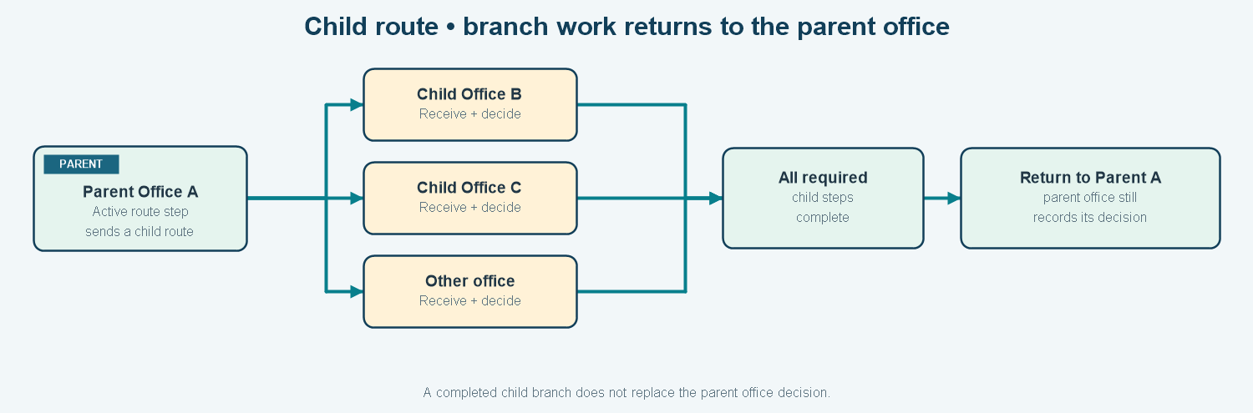
The staff and public route views can show route progress and nested branches, with chronological activity and offices still waiting. Routing constraints prevent sending work to the same office or creating a branch loop to an ancestor; destinations must fall within the user's permitted routing range and have eligible approvers.

11. Document Creation and PDF generation
Document Creation is the authoring area for generated documents.
- Authors select a document type and its assigned template.
- A rich-text editor supports common text formatting, lists, alignment, and tables on a paginated Letter-size writing surface.
- Templates and header assets are versioned. A saved draft or submitted version retains the template/content snapshot used at that point.
- Authors can save drafts and preview the rendered PDF without first finalizing the document.
- Finalizing produces a generated file marked ready to be routed; it does not by itself assign a tracking number.
- When the file is later registered to the tracking system, the tracking number is stamped on eligible generated PDFs.
- Generated files can be reused when creating a new tracking record or adding an approved replacement/version to an existing record where allowed.
PDF output uses the current document renderer and server-side PDF generation. Font files, layout rules, page breaks, and template assets affect the final result. Review generated PDFs before official use.

12. Document Workflow and Drafts
Document Workflow gathers generated work by stage. Depending on ownership and office authority, it can show:
- Ready for Routing generated files.
- My Submissions and their current tracked or review status.
- Approval Tasks for records that match the user's office, role, and state.
- Approved Documents available for the next permitted step.
For routed records, approval is performed in the tracked-document workflow after receipt by the office, not by simply finalizing the generated draft. An approver normally must be an eligible active administrator/approver for the current office and cannot be the document creator. Receiving and approving are distinct actions.
Drafts lets users return to unfinished work that they own or may access. Generated-document drafts have a separate archive/restore path from terminal tracking records. A draft is not yet a finalized official tracking record and may not have a tracking number.

13. Public tracking, QR codes, and email OTP
A finalized record can be reached through a signed tracking URL or QR code. Public tracking presents selected document details and a route timeline; it is not system-wide browsing. Public access is rate-limited, and draft or unapproved records can be hidden from the public page.
For a protected QR action, an eligible existing DOTS user enters their registered official email and receives a six-digit one-time code. In the current implementation described by the workflow guide:
- The code is valid for 10 minutes and has a maximum of five failed attempts.
- Resending is subject to a 60-second cooldown.
- A successful code creates a 20-minute session scoped to that one document, not a full DOTS login.
- The user must be active, unlocked, assigned to the relevant office, and authorized for the requested action.
- Receive, approval decisions, forwarding, file view/download, and related actions remain subject to route-step rules.
- Security emails for one-time codes remain necessary even if optional automated document notifications are paused.
Figure. QR access uses a signed link and a limited email-verified session for protected actions.

14. Wet-signed PDF workflow and iPluma boundary
Some route steps may require a signature. The current implementation supports wet-signed PDF handling for required steps:
- An approver reviews the tracked document at the active office.
- If that step requires a signature, ordinary approval is blocked until the signed PDF is provided.
- The authorized user uploads the signed PDF as a new signed version when approving.
- DOTS associates the signed file with its source version and route step, records the wet-ink method and a SHA-256 checksum, and writes audit history.
- The signed file remains a separate version from the original reviewed document.
iPluma connected-system pages can display summary/signing information supplied by iPluma. The actual DOTS action to submit the PDF for signing, receive the signed file, and synchronize signature status remains unavailable until the service contract and implementation are complete. Keep iPluma status distinct from office approval and route status.

15. Archives and restore
The Archives area is for tracked records marked terminal/archived. It supports year and text filtering, sorting, pagination, and office filters for users with broader access. Eligible holding-office users may restore a terminal record; restoration creates a new trail event and returns it to active status under the configured rules.
Generated-document drafts have their own archive and restore process. Operational archive status does not itself define a legal retention period, legal hold, final transfer, or destruction authorization. Those remain records-management responsibilities.

16. Audit Trail
Audit Trails provide a searchable and filterable view of recorded application events, with information such as actor, office context, action, subject, result, and timestamp where captured. Examples include authentication, document registration/routing/receipt, approval decisions, archive actions, account and library changes, and migration events.
The audit history supports accountability and investigation. It is application-level activity logging; it does not guarantee that every database change or every external-system event has been captured. Retention, monitoring, export, and tamper-resistance policy should be defined operationally.

17. User accounts, offices, and HRIS

User Accounts
Administrators can search accounts, create or update users, set role and active state, assign an office/division, and use HRIS employee lookups where configured. Account administration supports the office and role scope used by document access and route eligibility.

HRIS Employees
The library includes an HRIS employee list and synchronization feature. HRIS can support employee lookup, office assignment data, and eligible credential verification. Functionality depends on current endpoint settings, credentials, and data quality. Confirm account changes and office assignments against the authoritative personnel process.

Offices and route ranges
Offices represent participating organizational units. Divisions and ranges provide organizational and routing context. A user's office, the record's current holding office, and the office's range affect which records they can see and where they can route work.

18. Libraries and system setup
Administrators maintain reference information used by document forms and routing:
Library | What it controls
Offices | Office names, identifiers, hierarchy/contact details, and office relationships.
Ranges | Which office groupings or routing scopes apply to a user's office.
Document types | Classification choices and the templates associated with generated documents.
Purpose types | Reasons or purposes selected during document registration.
Action types | Actions available for receipt, forwarding, review, or processing.
HRIS Employees | Employee information synced from the HRIS connection.
The shared Libraries page groups these modules. Setup and library views are protected and may be permission-dependent. Keep reference values consistent because they affect forms, filtering, reports, and routing choices.

19. Connected systems: PDMIS, DRIP, and iPluma
Connected Systems is a landing page with separate summary views:
System | Information displayed in DOTS | Boundary
PDMIS | Configured document tracking or status summary information. | Current Laravel pages are summary-oriented. Older PDMIS linking/suggestion workflows are not surfaced as current standard navigation modules.
DRIP | Certificate/document details and available status or certificate-file information, where provided by the API. | Depends on a configured DRIP endpoint, credentials, and the remote service.
iPluma | File and signer summary/trail information supplied by iPluma. | Summary display does not mean DOTS can initiate signing or retrieve signed output.
The Connected Systems layout labels these pages as read-only summaries. A blank list can mean that no records are shared or that the connection is unavailable; the page does not necessarily provide a definitive connection-health status. Credentials and live API behavior were not verified by this source review.

20. Email notifications
Email notifications can cover supported document workflow events, including approval requests, decisions, routing, and receipt. Notices can be queued so a slow email service does not have to block every page action. Administrative email settings include automation controls and a test message flow.
Email delivery requires valid sender configuration, queue workers, reachable email infrastructure, current recipient addresses, and proper operational monitoring. A global pause can prevent optional outgoing email. One-time-password security emails are part of the protected QR flow and may have separate delivery behavior. Verify the current settings and actual email provider in the deployment.

21. Navigation Access and System Maintenance

Navigation Access
Super Admin can configure the visibility and route access of supported sidebar areas for selected roles, including Executive and Admin Staff. The settings apply to desktop and mobile navigation. Hiding a navigation area is supported by server-side checks for its associated routes, while other checks such as office scope and role-specific actions still apply.

System Maintenance
Super Admin can manage system-maintenance settings. The application supports a notice mode and full maintenance behavior, with an administrative bypass for authorized maintenance work. The configured message and schedule are shown through the application shell or maintenance page as appropriate. Keep maintenance schedules, user communications, and operational checks aligned before changing modes.

22. Profile, privacy notice, and application shell
The shared interface provides responsive navigation, a notification menu, the signed-in user's office and role information, account/profile access, privacy notice access, and sign out. The privacy notice can appear at sign-in and can be reopened from the sidebar. The profile area supports personal information and password changes; account deletion is controlled through the profile flow and applicable authorization.
The application shell also displays maintenance messaging when active. On mobile screens the sidebar becomes a navigation drawer; on larger screens it can be collapsed.

23. Legacy-data migration
The Laravel project includes a separate legacy database connection, legacy model adapters, import services, and command-line import tools. Supported import areas include:
- Organizational directory data: ranges, offices, divisions, and users.
- Documents, document trails, and attachment metadata.
- Historical audit events.
- A combined import command that runs the supported stages in dependency order.
Import commands support a read-only preview. Applying records requires an explicit assertion of the exact target database, and the combined workflow uses transactional protections and reports. Existing imported identities are generally skipped on reruns rather than overwriting later local edits. Exceptions and records needing review should be reconciled before operational cutover.
The document import currently brings attachment metadata, not the actual historical file binaries. A successful import does not prove that every imported record is ready for ordinary routing or that every attachment can be downloaded.

24. Security and data handling
Current code includes layered application safeguards such as:
- Authentication, active/locked account checks, email verification, password reset, session regeneration, and login-failure controls.
- Optional reCAPTCHA and throttles on selected sensitive endpoints.
- Role, office, holding-office, destination-range, and route-step checks for document actions.
- Signed and rate-limited public tracking URLs; document-scoped OTP sessions for protected QR actions.
- Private storage and authorization checks for new document file downloads, with safe path handling and private response headers.
- Validation and content limits for rich-text documents and template image assets.
- Encrypted storage of configured integration credentials/tokens where implemented.
- Audited action records and guarded legacy imports.
Production security also depends on TLS, secrets management, approved email settings, database privileges, queue and scheduler operation, secure backups, monitoring, file scanning, incident response, access reviews, and release management. A source-code review cannot confirm these deployment controls.

25. Data areas and technical architecture

Main information stored
Data area | Examples | Why it matters
Users and organization | User accounts, offices, divisions, ranges, HRIS employees | Determines identity, office assignment, and routing context.
Tracking | Documents, trails, route records, route steps | Holds the tracking number, current state, dispatch/receipt/approval history, and office responsibilities.
Files and uploads | Document files, versions, signed versions, assets, staged upload tokens | Links source documents and supporting items to records, with metadata and controlled access.
Authoring | Drafts, versions, events, template versions, template assets | Preserves written content and template snapshots before and during routing.
Access and operations | Navigation visibility, maintenance settings, email settings, OTP challenges, signature claims | Supports administrative operation and protected QR workflow.
Accountability and migration | Audit trails, legacy identities, import exceptions/reports | Supports activity review and reconciliation of older records.

Application architecture
The browser interface is built with React and TypeScript through Inertia. Laravel routes and middleware call controllers and services; Eloquent models access the relational database; files are served through configured storage routes; and Inertia returns page data to the interface. Document rendering uses Tiptap content and PDF generation services. Queued jobs handle supported notifications.
Current source stack: Laravel 12, PHP 8.2+, Eloquent, Inertia 2, React 18, TypeScript, Vite, Tailwind CSS, Tiptap, Dompdf, and a relational database configured for the deployment. Legacy-system access uses a separate database connection and adapter models.

26. Terms and status meanings
Term/status | Plain-language meaning
Draft | Saved work that has not been finalized as a tracked record, or a saved authored document.
Ready for Routing | A generated file is finalized and ready to be attached to a tracking record; it does not yet have a tracking number from that step alone.
Pending | An office or route step has work to do. Interpret with the current trail/route step.
Available | A document was dispatched and is waiting for the destination office to receive it.
In progress | The office received the document and its route step is active.
Approved | The required reviewer or route step approved the current file/version.
Changes requested | The sender/author must revise or correct the document before work continues.
Rejected | The office or reviewer declined the item; continuation follows the defined workflow.
Terminal / archived | The holding office recorded processing completion and the record moved to the archive.
Needs signature / signed | A signature is required or a signed PDF version has been recorded; this is separate from routing approval.
The main tracking record and its latest trail/route steps may each hold status information. When a screen's status is unclear, open the route map and chronological history rather than inferring from a single label.

27. Items to confirm or plan further
These boundaries are included so users can distinguish an available system function from a policy or integration that still needs work:
- Confirm production deployment, live migrations, credentials, API reachability, queue workers, mail delivery, and external-system contracts.
- Confirm agency-approved role definitions, office responsibilities, public-disclosure fields, approval authority, and user-provisioning process.
- Complete iPluma PDF submission, signer setup, status callback/polling, signed-file return, and signature event reconciliation before representing DOTS as fully integrated for signing.
- Decide whether a full records-retention, legal-hold, transfer, and disposition module is required. Operational archive/restore is not a retention schedule.
- Decide whether to add a comprehensive reports/compliance analytics area, SLA deadlines, reminders, and escalations. The current dashboard is not a substitute for these modules.
- Plan physical migration of legacy file binaries and validate imported attachment links separately from metadata import.
- Confirm file-scanning/quarantine and disaster-recovery controls in the production environment.
- Treat the older File Upload repository, Reports menu, and PDMIS linking tools as legacy or unverified in this current source checkout unless deployment evidence shows otherwise.
- Review current test/build/release baseline and exercise sequential, parallel, child-route, OTP, and signed-file workflows with representative offices before broad rollout.

28. Quick reference
I need to… | Start here
See what is waiting for my office | Dashboard, then Incoming or the relevant count/link.
Find a tracked record | Latest documents or All documents; search by tracking number/title and check filters.
Write a new document | Document creation; select type/template, save, preview, then finalize as Ready for Routing.
Start official tracking | All documents or the appropriate registration action; attach the source file and finalize the tracking record to receive its tracking number.
Receive or route a document | Open the tracked record and use Receive or Forward if your role, office, and route state allow it.
Approve or request changes | Document Workflow / Approval Tasks or the tracked record after receipt at the assigned office.
Check a public status | Open the signed tracking URL or scan its QR code; protected actions may require registered-email OTP.
Find completed work | Archived documents; filter by year and restore only when permitted.
Check who acted | Audit trails and the document's own route history.
Manage reference choices | Libraries: Offices, Ranges, Document types, Purpose types, Action types, and HRIS Employees.
Check information from PDMIS, DRIP, or iPluma | Connected systems; availability depends on each configured external service.
Manage users or application settings | Administration items available to your account; Navigation Access and System Maintenance are Super Admin controls.
Source basis: Current navigation and route definitions, active React pages, Laravel controllers/services/models/migrations, and project workflow documentation in the repository; especially docs/legacy-dots-system-features.md for the older CodeIgniter module inventory and the current workflow documents for the Laravel routing, OTP, multi-office, and signature behavior. Descriptions are based on source review, not a production acceptance test.

