**Practical no. 04**

**AIM: AGGREGATION USING MONGODB**

**Commands:**

1. 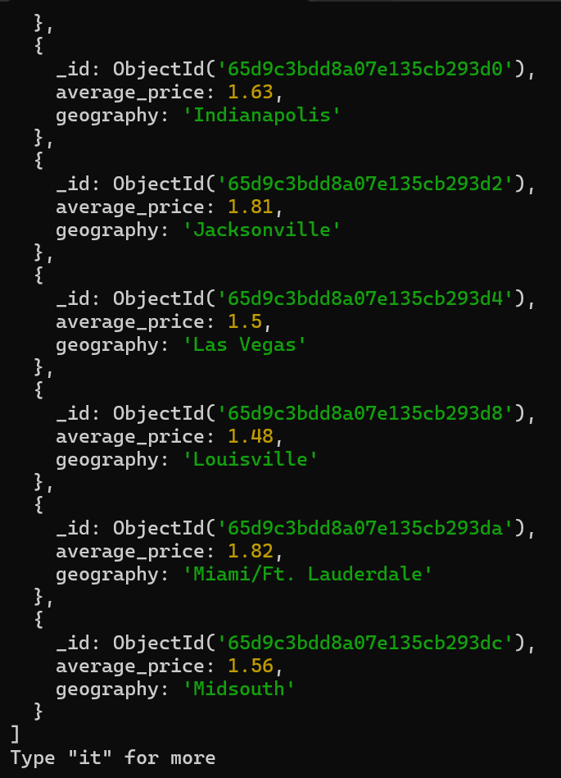db.avo.find({$and:[{geography:{$nin:["boston"]}},{average_price:{$gt:1.4}}]},{_id:1,geography:1,average_price:1})
2. db.avo.find({$or:[{geography:{$nin:["boston"]}},{average_price:{$gt:1.4}}]},{_id:1,geography:1,average_price:1})

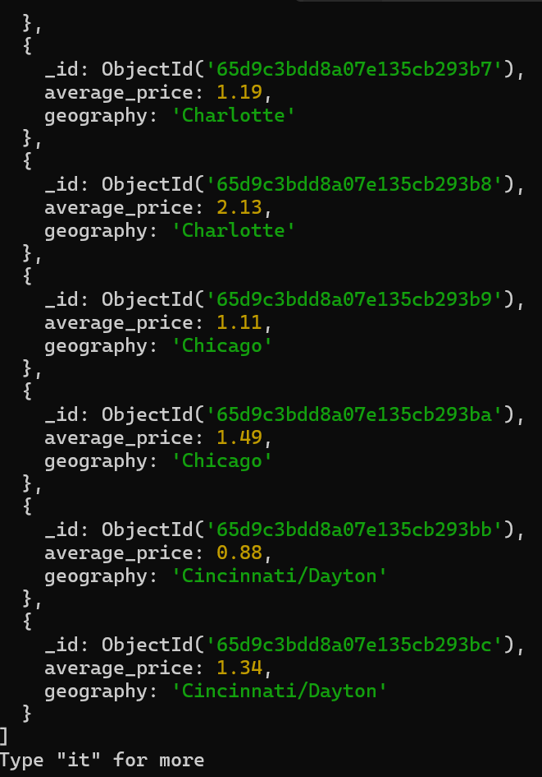

1. db.avo.find({geography:{$nin:["chicago"] }},{})

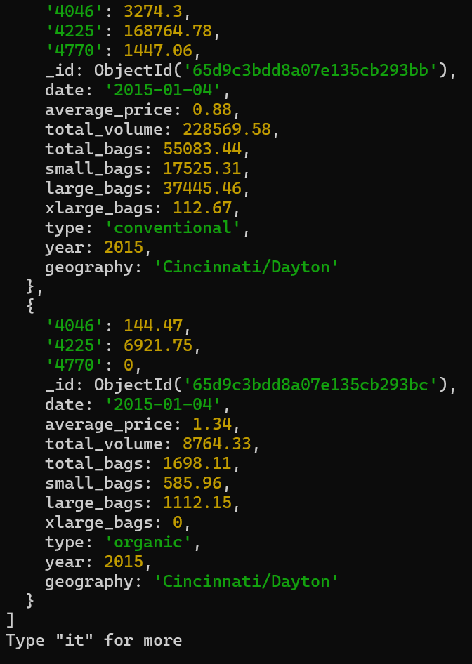

1. db.avo.find({average_price:{$gte: 1}},{_id:1, average_price:1})

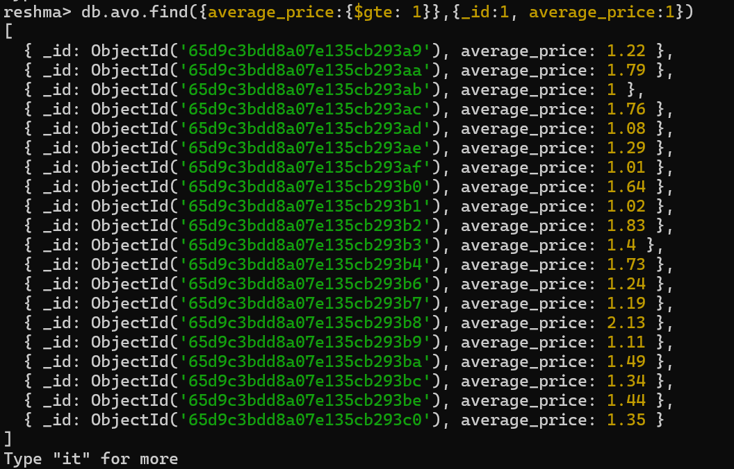

1. db.avo.find({large_bags:{$lte: 112}},{_id:1, average_price:1,large_bags:1})

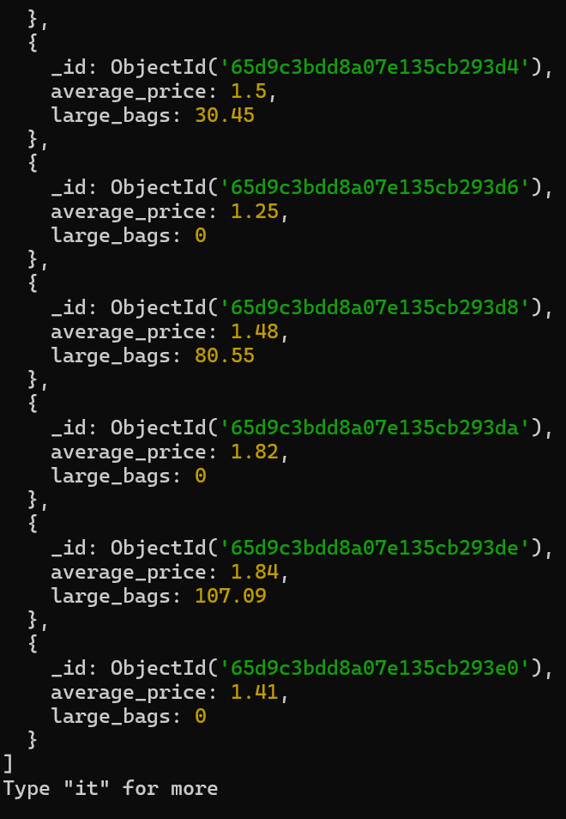

1. db.avo.find({large_bags:{$lte: 112}},{_id:1, average_price:1})

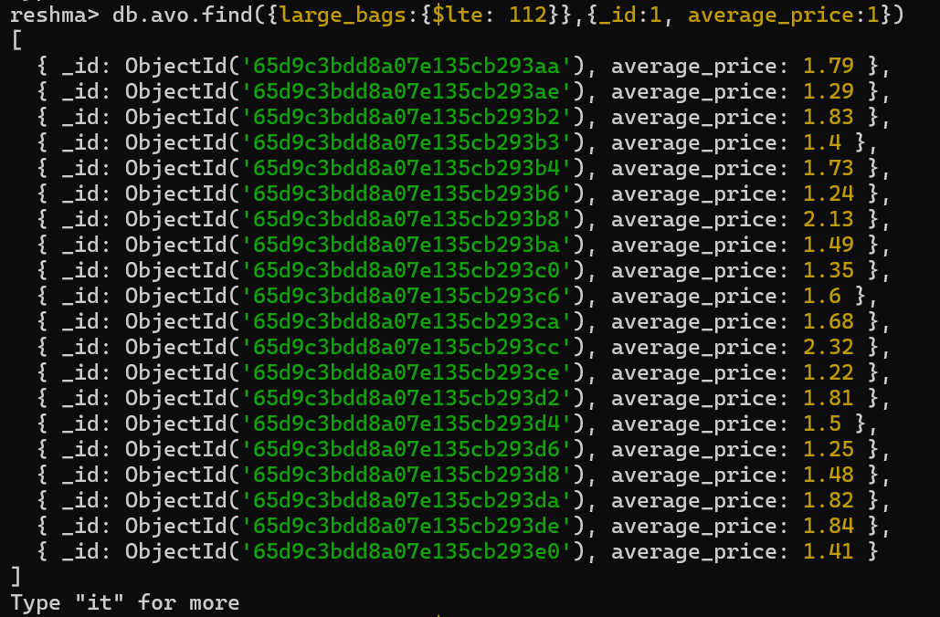

1. db.avo.find({large_bags:{$lte: 112}},{_id:1, date:1})

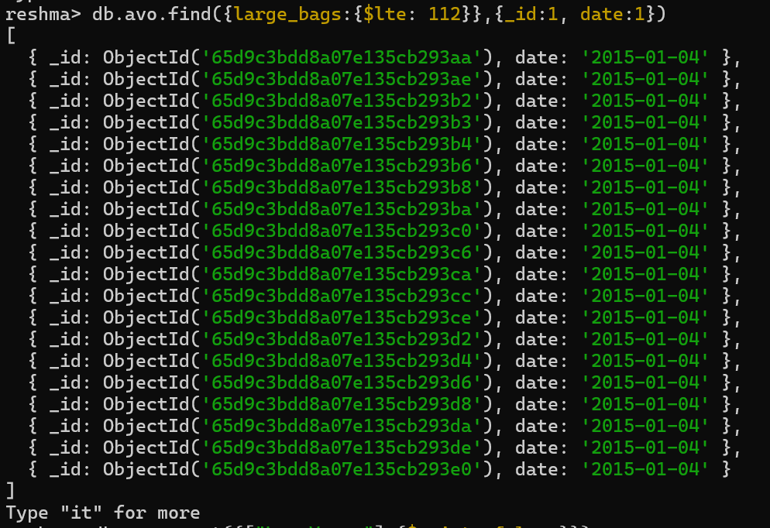

1. db.avo.count({["Las Vegas"]:{$exists:false }})



1. db.avo.count({["Las Vegas"]:{$exists:true}})



1. db.avo.count({average_price:{$type:"string" }})



1. db.avo.count({average_price:{$type:"int" }})

