部分代码：

1. **<div** class="django-panel"**>**
2. **<div** class="post-list"**>**
3. {% for post in posts%}
4. **<div** class="post-block"**>**
5. **<div** class="post-item"**>**
6. **<div** class="post-title" **>**
7. **<a** title="{{ post.title }}" href="{{ post.get_absolute_url }}" **>**{{ post.title | slice:":50" }}**</a>**
8. **</div>**
10. **<div** class="post-excerpt"**>**
11. **<p>**{{ post.excerpt}}......**</p>**
12. **</div>**
14. **<div** class="post-meta"**>**
15. **<span>**日期：{{ post.created_time| date:"Y-m-d" }}**</span>**
16. **<span>**分类：{{ post.category }}**</span>**
17. **<span>**阅读({{ post.views }})**</span>**
18. **<span>**评论({% get_comment_count post %})**</span>**
19. **</div>**
20. **</div>**
21. **</div>**
22. {% endfor %}
23. **</div>**
24. **</div>**

效果截图：

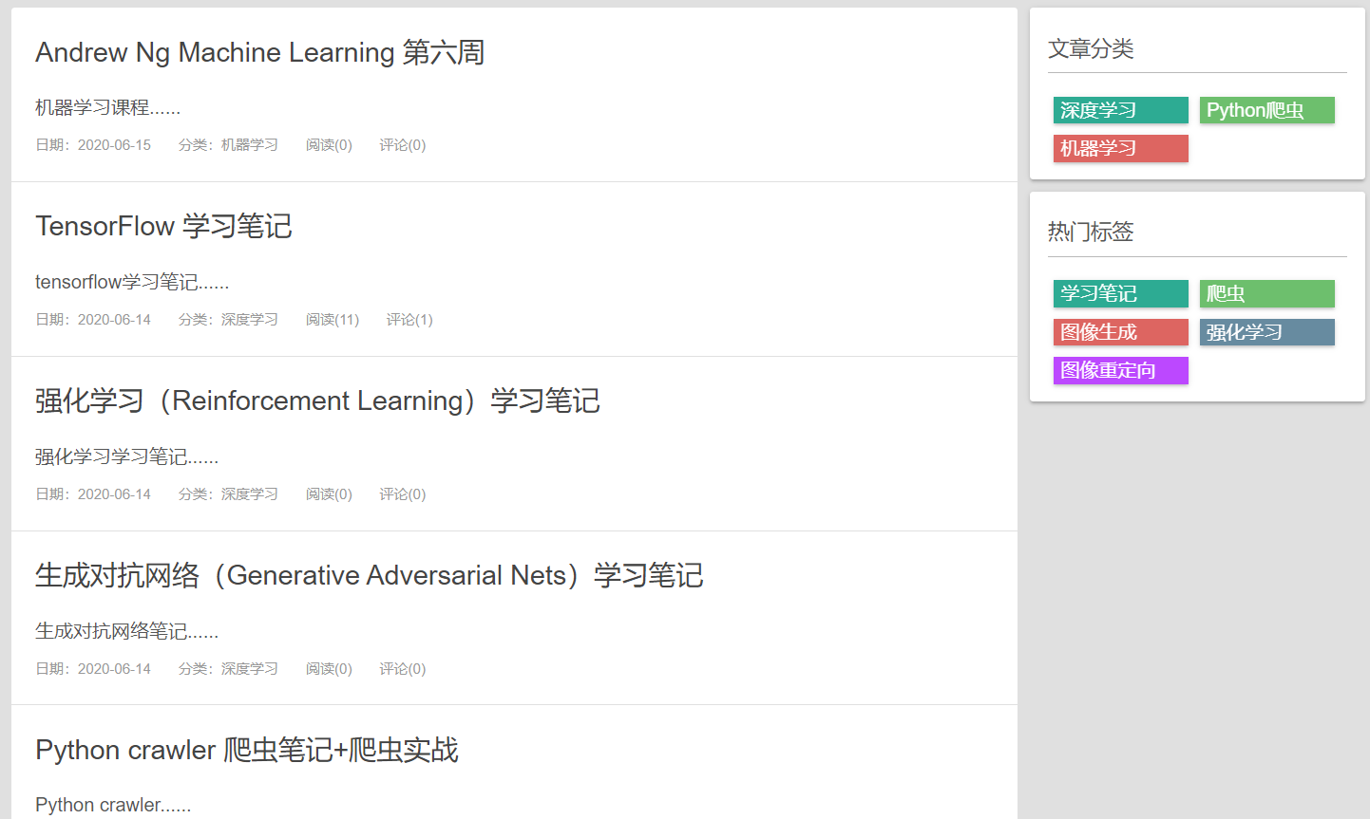

图 6文章目录

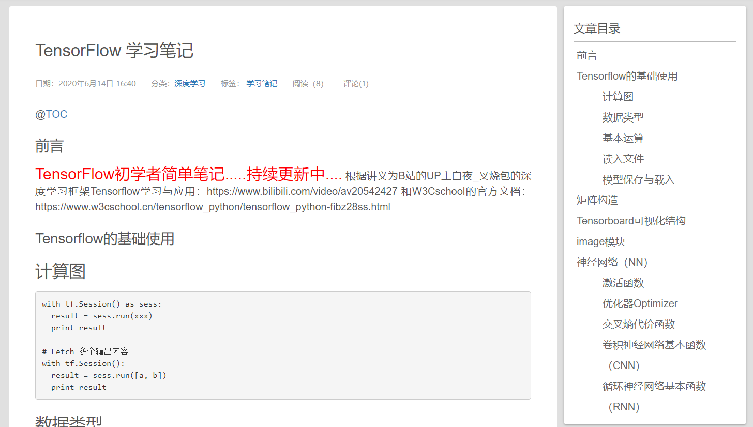

图 7文章阅读