部分代码：

1. **<div** class="django-panel-padding"**>**
2. **<div** class="mobile-archives"**>**
3. {% regroup posts|dictsort:"category_id" by category.name as post_list %}
4. **<h4** class="archives-year"**>**共 {{ cate_count }} 类**</h4>**
5. **<div** class="panel-group" id="accordion" role="tablist" aria-multiselectable="true"**>**
6. **<div** class="panel-default"**>**
7. **<div** class="panel-heading" role="tab" id="heading{{ posts.grouper }}"**>**
8. **<a** role="button" data-toggle="collapse" data-parent="#accordion" href="#collapse{{ posts.grouper }}" aria-expanded="false" aria-controls="collapse{{ posts.grouper }}" class="collapsed"**>**
9. **<h4** class="panel-title"**>**
10. {{ posts.grouper }} **<span** class="panel-title-count"**>**共 {{ posts.list | length }} 篇**</span>**
11. **</h4>**
12. **</a>**
13. **</div>**
14. **<div** id="collapse{{ posts.grouper }}" class="panel-collapse collapse" role="tabpanel" aria-labelledby="heading{{ posts.grouper }}"**>**
15. **<div** class="panel-body"**>**
16. **<ul>**
17. **<li** class="archives"**>**
18. **<span>**{{ post.created_time | date:"Y.m.d" }}**</span>**
19. **<a** href="{{ post.get_absolute_url }}" target="_blank"**><span></span>**{{ post.title }}**</a>**
20. **<span** class="archives-view"**>**{{ post.views }}  views**</span>**
21. **</li>**
22. **</ul>**
23. **</div>**
24. **</div>**
25. **</div>**
26. **</div>**
27. **</div>**
28. **</div>**

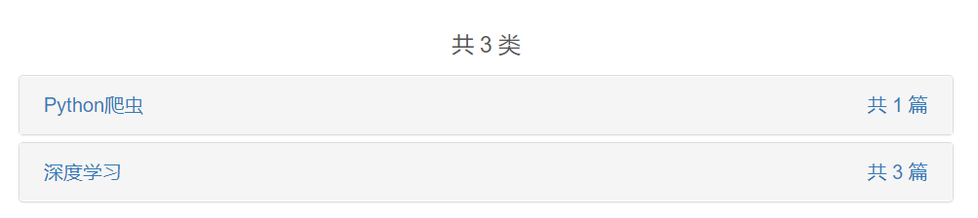

图 8类型分类

部分代码:

1. **<div** class="django-panel-padding"**>**
2. **<div** class="mobile-archives"**>**
3. **<h4** class="archives-year"**>**{{ year.grouper }}年 (共 {{ year.list | length }} 篇)**</h4>**
4. **<div** class="panel-group" id="accordion" role="tablist" aria-multiselectable="true"**>**
5. **<div** class="panel panel-default"**>**
6. **<div** class="panel-heading" role="tab" id="heading{{ year.grouper }}{{ month.grouper }}"**>**
8. **<a** role="button" data-toggle="collapse" data-parent="#accordion" href="#collapse{{ year.grouper }}{{ month.grouper }}" aria-expanded="false" aria-controls="collapse{{ year.grouper }}{{ month.grouper }}" class="collapsed"**>**
9. **<h4** class="panel-title"**>**
10. {{ month.grouper }}月 **<span** class="panel-title-count"**>**共 {{ month.list | length }} 篇**</span>**
11. **</h4>**
12. **</a>**
13. **</div>**
14. **<div** id="collapse{{ year.grouper }}{{ month.grouper }}" class="panel-collapse collapse" role="tabpanel" aria-labelledby="heading{{ year.grouper }}{{ month.grouper }}"**>**
15. **<div** class="panel-body"**>**
16. **<ul>**
17. **<li** class="archives"**>**
18. **<span>**{{ post.created_time | date:"d" }}日**</span>**
19. **<a** href="{{ post.get_absolute_url }}"**>**{{ post.title | slice:":50"}}**</a>**
20. **<span** class="archives-view"**>**{{ post.views }}  阅读量**</span>**
21. **</li>**
22. **</ul>**
23. **</div>**
24. **</div>**
25. **</div>**
26. **</div>**
27. **</div>**
28. **</div>**

效果截图：

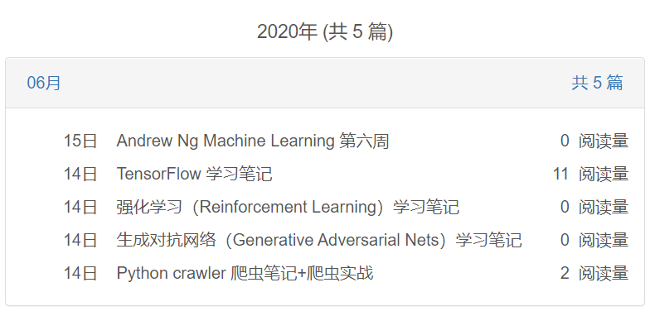

图 9时间分类