1. 添加评论之间的回复功能，可直接对文章下方的某一评论进行直接回复，且支持markdown

部分代码：

1. referer = request.META.get('HTTP_REFERER', reverse('blog:index'))
2. comment_form = CommentForm(request.POST, user=request.user)
3. **if** comment_form.is_valid():
4. comment = Comment()
5. comment.user = comment_form.cleaned_data['user']
6. comment.text = comment_form.cleaned_data['text']
7. comment.content_object = comment_form.cleaned_data['content_object']
8. parent = comment_form.cleaned_data['parent']
9. **if** **not** parent **is** None:
10. comment.root = parent.root **if** **not** parent.root **is** None **else** parent
11. comment.parent = parent
12. comment.reply_to = parent.user
13. comment.save()
14. **return** redirect(referer+'#comment')

效果截图：

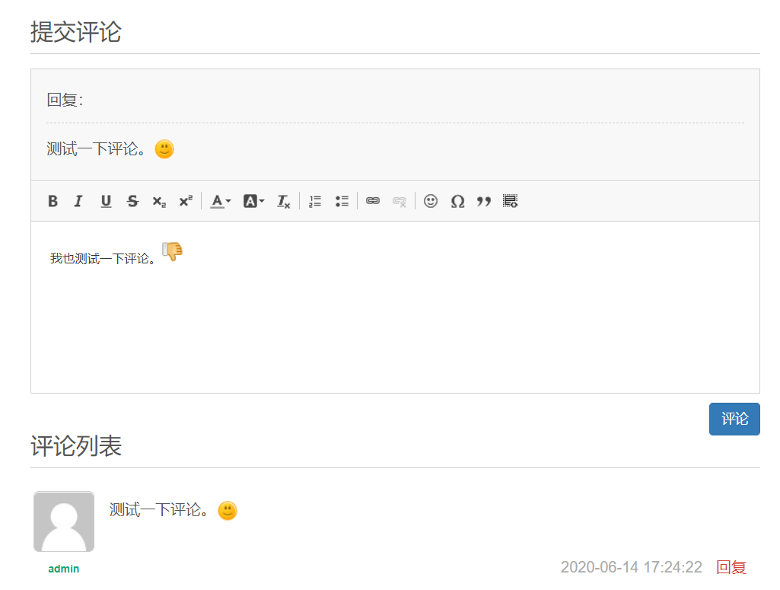

图 23评论回复