
ATRIA INSTITUTE OF TECHNOLOGY
ASKB Campus, 1st Main Road, AGs Colony, Anand Nagar, Bengaluru, Karnataka 560024

ATRIA SOCIETAL IMPACT PROJECT-III DIARY

[BSDPK588]
ACADEMIC YEAR
2026 - 2027
PROJECT ID. [Old ASIP]: ASIP-177

SL.  No. | USN | NAME
1 | 1AT24CS119 | Mohammed Danish Siddiq
2 | 1AT24CS165 | Rajath N N
3 | 1AT24IS165 | Riya Sharma D
4 | 1AT24CS095 | Khushi M
5 | 1AT24CS109 | Manasa N
6 | 1AT24IS101 | Lavanya Mudda

ATRIA INSTITUTE OF TECHNOLOGY
ATRIA SOCIETAL IMPACT PROJECT - III DIARY
ACADEMIC YEAR
2026- 2027

PROJECT TITLE
Child Safety Wearable System (BLE-based Early-Warning & Alert Propagation for Child Protection)
PROJECT GROUP MEMBERS (First Name will be the Team lead)
SL.No | USN |  | NAME | MOBILE | EMAIL
1 | 1AT24CS119 |  | Mohammed Danish Siddiq | 9019907886 | 1at24cs119@atria.edu
2 | 1AT24CS165 |  | Rajath N N | 8904482708 | 1at24cs165@atria.edu
3 | 1AT24IS165 |  | Riya Sharma D | 8088292707 | 1at24is165@atria.edu
4 | 1AT24CS095 |  | Khushi M | 6363261558 | 1at24cs095@atria.edu
5 | 1AT24CS109 |  | Manasa N | 6361120043 | 1at24cs109@atria.edu
6 | 1AT24IS101 |  | Lavanya Mudda | 9380965633 | 1at24is101@atria.edu
PROJECT GUIDE(S)
GUIDE NAME  DESIGNATION MOB & EMAIL |  | Prof. Tanmoy Kundu
 |  | [DETAIL REQUIRED]
 |  | [DETAIL REQUIRED]
CO-GUIDE NAME  DESIGNATION MOB & EMAIL |  | [DETAIL REQUIRED]
 |  | [DETAIL REQUIRED]
 |  | [DETAIL REQUIRED]

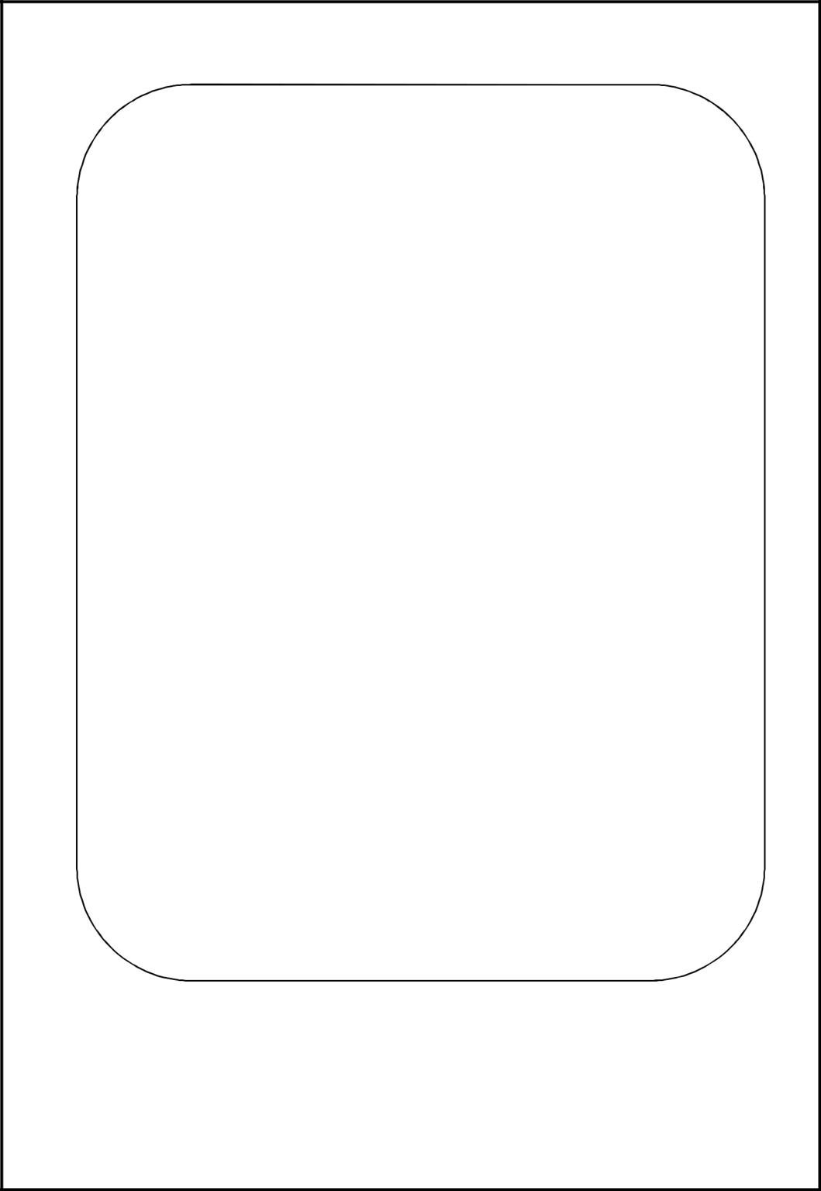
ABSTRACT OF THE PROJECT
Project purpose: SafeBand Guardian is a privacy-conscious child-safety wearable designed to reduce the time between a safety event and notification of responsible adults. Its BLE-first, event-driven approach supports SDG 16 and avoids continuous GPS tracking as the default.
System architecture: The documented prototype pairs an ESP32-S3 child node with an Android application. The node broadcasts an event over BLE and nearby phones are intended to relay it. Fixed hubs and cloud services appear in the target architecture; their deployment is not established.
Reported application scope: Project records describe parent, child and relay roles; geofence and risk states; incident IDs, duplicate suppression, timelines and replay; offline store-and-forward; and pickup, school, journey, escalation and guardian-response workflows.
Prototype and verification: The wearable supports a BOOT-button SOS hold of about two seconds with local RGB feedback. Reports prepared 05 November 2026 state that Kotlin compilation succeeded, 95 unit tests and six BLE-contract tests passed, and a debug APK of about 19.4 MB was built. These are reported software/build results.
Evidence and scope note: The current node is not documented as having operational GPS, cellular service, a battery gauge, IMU or strap-tamper sensing. End-to-end phone receipt, background reliability across devices, production update deployment and field validation remain unverified. The reports do not date every milestone by diary week; entries below are grouped by matching template topics, and later dates remain planned.

Project Work Phase III
Week No. | Activities carried out during the | Activities planned | Remarks of
(Period) | Week | for next week | guide(s) & students with date
Week 1 | 03/09/2026 | Product-comparison notes were consolidated. Recurring strengths included alerts, communication and geofencing; design criteria were set around affordability, low power, privacy and prompt guardian response. | Finalize feature priorities and system requirements.
Week 2 | 10/09/2026 | Features were grouped across the wearable, Android guardian app and phone relay. The scope distinguishes currently reported prototype features from proposed GPS/cellular and infrastructure functions. | Refine architecture, data flow and privacy boundaries.
Week 3 | 17/09/2026 | The design was organized as ESP32-S3 node, phone relay, guardian app and proposed hub/cloud layers. Event severity, delivery state and human acknowledgement were kept distinct. | Implement the application safety and incident baseline.
Week 4 | 24/09/2026 | The reported V2.0.0 Android foundation includes geofence/risk logic, incident records, offline states and trust roles. The report records 59/59 tests for this milestone. | Integrate the ESP32-S3 node and BLE event contract.

Project Work Phase III
Week No. | Activities carried out during the | Activities planned | Signature of
(Period) | Week | for next week | guide(s) & students with date
Week 5 | 01/10/2026 | The reported V2.1.0 work added the ESP32-S3 BLE node, held SOS and local LED feedback; the advertisement was corrected using a scan response. A 64/64 test snapshot is reported. | Add background monitoring and notification handling.
Week 6 | 08/10/2026 | The reported V2.1.1 work added foreground BLE monitoring, SOS notifications, duplicate handling and a boot receiver. A 73/73 test snapshot is reported; real-device background reliability remains unverified. | Consolidate test cases and prepare CIE-1 evidence.
Week 7 | 15/10/2026 | Successive report snapshots record 59/59, 64/64 and 73/73 tests, plus a regression matrix for BLE parsing, duplicates, offline relay, geofence jitter and location confidence. Counts are not cumulative. | Complete CIE-1 as scheduled and prepare physical integration tests.
Week 8 | 29/10/2026 | CIE-1 is scheduled in the diary for 29/10/2026. The supplied engineering records provide no marks or evaluator feedback. | Run ESP32-to-phone SOS and multi-phone background checks.

Project Work Phase III
Week No. | Activities carried out during the | Activities planned | Signature of
(Period) | Week | for next week | guide(s) & students with date
Week 9 | 05/11/2026 | As at 05/11/2026, reports state Kotlin compile success, 95/95 unit tests, six BLE-contract tests, Room v2-to-v3 migration and a 19.4 MB debug APK. Physical SOS reception is not documented. | Run physical SOS smoke tests and record device/OS evidence.
Week 10 | 12/11/2026 | Scheduled for 12/11/2026; no completed activity report is available as of 05/11/2026. | Complete integration matrix; log defects and retest fixes.
Week 11 | 19/11/2026 | Scheduled for 19/11/2026; deployment and system-test outcomes are not present in the supplied records. | Validate signed release, migration, update and rollback path.
Week 12 | 26/11/2026 | Final prototype demonstration is scheduled for 26/11/2026; no demonstration or evaluation outcome is yet documented. | Demonstrate the verified prototype and record evaluator feedback.

DETAILS OF SOFTWARE / HARDWARE PROCURED DURING PROJECT WORK (If any)
Sl. No. | Hardware / Software | Cost (Rs.) | Contact Details (address, email, and phone) /  (if Open Source – URL and procedure for installation)
1 | ESP32-S3 BLE child-node prototype; one board is noted, exact model not identified. | [DETAIL REQUIRED: purchase cost or confirmation of no charge] | [DETAIL REQUIRED: exact board model, supplier and contact]
2 | Android software stack: Kotlin, Jetpack Compose, Material 3, Room and Gradle. | [DETAIL REQUIRED: confirm any paid software/license cost] | Project source: github.com/Unknsn/childgaurd. Install via Android Studio or Gradle wrapper ./gradlew installDebug; vendor/contact not stated.
3 | A few Android phones are referenced as relay/test resources; models and purchase status are not stated. | [DETAIL REQUIRED: device cost/ownership if purchased] | [DETAIL REQUIRED: device models and supplier, if applicable]

WEEK 1: DATE: 03/09/2026
Consolidation of product literature survey- Pros and cons
• Comparison material: The supplied successful-product sheet lists AngelSense, Jiobit, Verizon Gizmo, Relay and TickTalk. Its notes emphasize alerts, communication, geofencing and parental controls.
• Limitations recorded: The supplied unsuccessful-product sheet lists Filip, HereO, Trax Play, PocketFinder and Tinitell. Handwritten notes flag cost or subscriptions, battery life, connectivity/reliability, bulk and limited feature scope.
• Design implications: The comparison suggests prioritizing a compact, low-power wearable, event-based BLE alerts, clear guardian workflows and offline relay, while avoiding always-on location collection where it is not needed.
• Earlier project context: The supplied project history records an RT Nagar Police Station visit on 23 October 2025. The report highlights rapid reporting, structured last-known information and technology as support for human investigation.
• Evidence note: The product sheets are qualitative student comparison notes; product URLs, dated specifications and independent market verification were not supplied.
WEEK 2: DATE: 10/09/2026
Consolidation of product features
• Wearable features: The reported child node uses an ESP32-S3, BLE identity/event advertising, a held BOOT-button SOS action of about two seconds, and local RGB status feedback.
• Android features: The application groups parent, child and relay roles with geofence states, confidence-aware location, risk classification, incident history, duplicate suppression and offline delivery status.
• Safety workflows: Later reported work adds time-limited pickup/handover, school arrival and departure, journey monitoring, multi-tier escalation and an “I’m Responding” guardian claim.
• Feature boundaries: The phone application carries the safety interpretation and guardian workflows. The current node does not establish GPS, cellular, battery-percentage, motion or strap-tamper sensing; location must remain UNKNOWN without a trusted source.
• Development phases: The version history describes V0 research/design, V1 software prototype, V2.0.0 application foundation, V2.1.0 hardware integration, V2.1.1 background monitoring and a later software update. The supplied reports do not assign these stages to semester Phase 1/Phase 2.
WEEK 3: DATE:17/09/2026
Refinement of Design
• Layered design: The target design separates the BLE child node, nearby phone relay, fixed hubs, cloud processing and parent/authority interfaces. The ESP32-S3 and Android application are the documented prototype components; hubs and cloud remain proposed.
• Event flow: A child SOS is broadcast by BLE, parsed by a nearby Android relay and represented as an incident for authorized guardians. Receipt by a relay, server receipt and human acknowledgement are separate states.
• Safety logic: The reported geofence states are SAFE, APPROACHING, EXIT_PENDING, OUTSIDE and REENTERED. The location model records source, accuracy and confidence; risk logic distinguishes immediate manual SOS from confirmation-based non-SOS signals.
• Privacy and reliability: The design uses an event-driven approach and a rotating BLE identity. It avoids treating an unknown or stale coordinate as current location and separates event severity from delivery progress.
• BLE refinement: Project records describe correcting an oversized legacy advertisement into a 29-byte primary advertisement plus a 28-byte scan response, with Android parsing adjusted. Exact hardware contract values remain subject to board verification.
WEEK 4: DATE:24/09/2026
Implementation -I
• Application foundation: The V2.0.0 milestone records the Kotlin Android application with Material 3 interface work and core safety models. The project documents identify Room for local persistence.
• Geofence and location: The application introduced SAFE, APPROACHING, EXIT_PENDING, OUTSIDE and REENTERED transitions and a VerifiedLocation model that distinguishes source, freshness, accuracy and HIGH/MEDIUM/LOW/UNKNOWN confidence.
• Risk and incident handling: Reported logic combines SOS, geofence and other signals into LOW/MEDIUM/HIGH/CRITICAL severity. Manual SOS is immediate; non-SOS signals use a reported 15-second confirmation window. Incident IDs, observation IDs, de-duplication, timelines and replay support a coherent incident record.
• Offline and trust states: The store-and-forward states are LOCAL_ONLY, PENDING_SYNC, RELAYED, ACKNOWLEDGED, SYNCED and EXPIRED. Role models distinguish owners, trusted guardians, institutions, emergency authorities and anonymous relays.
• Reported verification: The Version-Wise Report records commit 8de666a and 59/59 tests for V2.0.0. This is an automated test snapshot; it does not establish physical ESP32-to-phone acceptance at that milestone.
WEEK 5: DATE:01/10/2026
Implementation -II
• Physical child node: The V2.1.0 workstream introduced an ESP32-S3 board as the BLE child-side prototype, replacing a software-only or simulated node for the reported hardware milestone.
• Manual SOS and feedback: The described firmware uses a BOOT-button hold of about two seconds for manual SOS. The RGB LED shows boot, normal, countdown and SOS states locally; it does not confirm that a phone received the alert.
• Advertisement correction: An oversized legacy BLE advertisement was split into a 29-byte primary advertisement and 28-byte scan response. Android parsing was adjusted to read the event across those BLE components.
• Event mapping and test status: Physical SOS maps to MANUAL_SOS / CRITICAL; without a verified location source the event remains UNKNOWN. The project history reports firmware flashing/advertising, a V2.1.0 tag and a 64/64 test snapshot; end-to-end phone receipt still required device confirmation.
WEEK 6: DATE:08/10/2026
Implementation -III
• Background monitoring: The V2.1.1 software milestone reports a foreground BLE monitoring service, persistent notification channel, SOS notification handling, duplicate suppression and a boot receiver intended to restore monitoring after restart.
• Interface and location fixes: Project records describe improved semantic/theme-adaptive contrast and removal of a misleading simulated location. ESP32 events without GPS remain UNKNOWN rather than inheriting a phone or demo coordinate.
• Compatibility boundary: The reported Android service is subject to OS permissions, battery optimization, doze, manufacturer policy and force-stop behavior. A boot receiver does not establish reliable scanning on every device.
• Reported verification: A later update associates commit 559c561 with 73/73 passing tests and a debug build. V2.1.1 was discussed as a tag, but the supplied records do not confirm that tag; screen-off and multi-phone background results are not provided.
WEEK 7: DATE:15/10/2026
Unit Testing and Fixing the Bugs
• Regression history: The version report lists separate test snapshots: 59/59 for V2.0.0, 64/64 at the hardware milestone and 73/73 at a later software milestone. These are separate historical runs and must not be added together.
• Cases covered in project records: The documented acceptance matrix includes held/short SOS behavior, BLE advertisement and scan-response parsing, duplicate suppression, offline relay and sync, geofence boundary jitter, no-GPS UNKNOWN location, pickup expiry/revocation, guardian claims, database migration and update installation.
• Debugging outcomes described: The supplied history describes the BLE payload-size correction, more tolerant Android parsing, removal of a misleading simulated location and safeguards around duplicate incidents and uncertain location.
• Week-specific evidence: The PDFs do not provide a dated Week 7 defect list or a test-run log tied specifically to 15 October. Use the dated run record if the evaluator requires issue-by-issue evidence.
WEEK 8: DATE:29/10/2026
ASIP CIE-1
• Scheduled assessment: The diary schedules ASIP CIE-1 for 29 October 2026. The supplied engineering reports do not include marks, evaluator feedback or an assessment result.
• Evidence available: The project reports describe the application, ESP32-S3 prototype, BLE contract and automated test snapshots. These records can support an assessment review but do not substitute for the official CIE result.
• Next workstream: The next diary topic is integration testing: verify a physical SOS broadcast, phone reception, correct incident state, duplicate handling and UNKNOWN location when the node has no GPS.
WEEK 9: DATE:05/11/2026
Integration Testing
• Latest software status: As of 05 November 2026, project records report successful Kotlin compilation, 95/95 unit tests, six BLE-contract regression tests, Room migration v2-to-v3 and a debug APK of about 19.4 MB.
• Additional reported features: The latest update describes pickup approval/revocation, three-tier emergency escalation, school schedules and arrival/departure checks, journey alerts, an “I’m Responding” claim, app branding and an application update manager.
• Hardware contract: The latest report lists BOOT GPIO 0, WS2812 GPIO 48, BLE Company ID 0x5AFE, service UUID 00005afe-0000-1000-8000-00805f9b34fb and a 22-byte manufacturer payload. Confirm these values against the actual board and firmware before treating them as final specifications.
• Release status: The latest local commit is reported as 9fe0be6; no version tag or remote push is confirmed in the supplied log. The APK is a debug build, not a production-signed release.
• Integration evidence: The supplied records do not establish a successful end-to-end ESP32-to-phone SOS, multi-vendor background reliability, production cloud/hub deployment or acceptance of the update path. Record physical test devices and results when available.
WEEK 10: DATE:12/11/2026
Integration Testing
• Scheduled work: Integration testing is scheduled for 12 November 2026, after the latest supplied status date of 05 November. No results for this future week are present in the PDFs.
• Recommended test sequence: Trigger a physical SOS; capture BLE reception on at least two Android phones; verify incident severity, notification timing, duplicate suppression and UNKNOWN location without GPS.
• Background scenarios: Repeat with screen off, doze, battery saver, reboot and permission changes. Record phone model, Android version, app state, timestamps and observed failures.
• Result entry: Enter outcomes only after the tests are run; preserve logs/screenshots and distinguish a received beacon from a guardian acknowledgement.
WEEK 11: DATE:19/11/2026
Deployment and system Testing
• Scheduled work: Deployment and system testing are scheduled for 19 November 2026. The supplied reports do not establish a production deployment, signed APK release or operational cloud/hub service.
• Release gate: Verify the remote commit and build from a clean checkout; rerun the suite; test the Room v2-to-v3 migration with an existing database; validate package identity, signature and update installation.
• Operational checks: Document checksum and release notes, update failure handling, rollback procedure, permissions and privacy behavior. Keep debug builds distinct from signed release artifacts.
• Result entry: Record deployment target, version, system-test cases and defects only if completed.
WEEK 12: DATE:26/11/2026
Final Demo of Prototype and Evaluation
• Scheduled demonstration: The template schedules the final prototype demonstration and evaluation for 26 November 2026. No demo or evaluation result appears in the project records prepared 05 November.
• Demonstration flow: A clear demo can show the child-node SOS interaction, local LED states, BLE event reception, guardian incident view, relay/delivery status and the system response to unknown location.
• Evidence and limits: Capture the actual devices, software build, test conditions, feedback and limitations. If a step is simulated or not physically verified, label it clearly rather than presenting it as a live integration result.
WEEK 13: DATE:03/12/2026
Project report finalization
• Scheduled report work: Project report finalization is scheduled for 03 December 2026; the supplied PDFs do not establish submission or approval.
• Suggested report contents: Include the problem statement, product comparison, requirements, architecture/data flow, BLE contract, Android modules, implementation milestones, test matrix, screenshots, limitations and future scope.
• Evidence to reconcile: Use one dated test table, identify debug versus release builds, list the exact board and phones used, and include procurement cost/vendor information only when supported by records.
WEEK 14: DATE: 09th to 12th Dec 2026
ASIP Final CIE
• Scheduled assessment: ASIP Final CIE is scheduled for 09–12 December 2026. This date is future to the latest supplied project status, and no marks or feedback are available.
• Pending official entries: Guide designation, department and contact; co-guide details; exact board supplier and purchase cost; assessment results; guide remarks and signatures must be entered by the responsible people.

