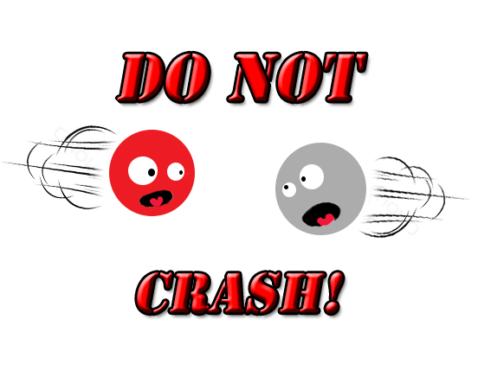

Done by

NehaBalasundaram

Shashank R

BONAFIDE CERTIFICATE

Certified to be the Bonafide Record of the work done by

Shashank R of class XII in the Sri Sankara Senior Secondary School, Adyar, Chennai.

During the year 2015-2016

Dated ……………… Subject Teacher

Submitted for all India Higher Secondary Practical Examination held in Computer Science at Sri Sankara Senior Secondary School, Chennai.

External Examiner

Dated ……………. Seal

**ACKNOWLEDGEMENTS**

I sincerely thank our

Computer Science faculty

Mrs. Vidyalakshmi and Mrs. Revathy

for their support, guidance and assistance in the completion of this project.

**An Overview:**

This game, ‘Do not Crash’ was inspired by an already existing android application. It’s based on the players’ quick responses to the changing situations. It was created using the graphics mode in C++. The concept of files and classes has been implemented.

(Compiler: Neutron C++ for windows 7)

**The Code:**

**#1- The Introduction page, rules and mouse initialization**

#include<iostream.h>

#include<conio.h>

#include<dos.h>

#include<graphics.h>

#include<process.h>

#include<stdio.h>

#include"fgame.cpp"

union REGS in,out;

int callmouse()

{

in.x.ax=1;

int86(51,&in,&out);

return 1;

}

void mouseposi(int &xpos,int &ypos,int &click)

{

in.x.ax=3;

int86(51,&in,&out);

click=out.x.bx;

xpos=out.x.cx;

ypos=out.x.dx;

}

int mousehide()

{

in.x.ax=2;

int86(51,&in,&out);

return 1;

}

void setposi(int &xpos,int &ypos)

{

in.x.ax=4;

in.x.cx=xpos;

in.x.dx=ypos;

int86(51,&in,&out);

}

void rules()

{

setcolor(1);

settextstyle(TRIPLEX_FONT,0,5);

outtextxy(120,50,"RULES");

setcolor(4);

settextstyle(TRIPLEX_FONT,0,2);

outtextxy(120,120,"1. You are the hero- the red circle.");

outtextxy(120,160,"2. You have to make sure that you don't ");

outtextxy(120,180," crash into the white circles- they are your");

outtextxy(120,200," villains! ");

outtextxy(120,240,"3. Use the up and down arrow keys to change ");

outtextxy(120,260," tracks");

outtextxy(120,300,"4. You also lose if you jump out of the tracks!");

outtextxy(120,340,"5. Now, just go on and PLAY!");

setcolor(3);

rectangle(400,390,453,450);

outtextxy(405,400,"back");

}

void main()

{

int gdriver = DETECT,gmode,errcode;

initgraph(&gdriver,&gmode,"C:\\TURBOC3\\BGI");

int i,x,y,cl;

f:

cleardevice();

setcolor(1);

settextstyle(GOTHIC_FONT,0,7);

outtextxy(120,50,"Do Not Crash");

setcolor(4);

settextstyle(GOTHIC_FONT,0,4);

rectangle(250,200,400,250);

outtextxy(300,200,"Play");

rectangle(250,275,400,325);

outtextxy(290,275,"Rules");

rectangle(248,350,400,400);

outtextxy(253,350,"Highscores");

int a=100,b=400;char o;

setposi(a,b);

callmouse();

do

{

mouseposi(x,y,cl);

if( x>250 && x<400 && cl==1 && y>200 &&y<250)

{ newgame();

}

else if(x>250 && x<400 && cl==1 && y>275 && y<325)

{ cleardevice();

rules();

do

{ mouseposi(x,y,cl);

if( x>400 && x<450 && cl==1 && y>390 &&y<450)

{goto f;}

} while(!kbhit());}

if( x>250 && x<400 && cl==1 && y>350 &&y<400)

{cleardevice();

hidc(0);

do

{ mouseposi(x,y,cl);

if( x>400 && x<450 && cl==1 && y>390 &&y<450)

{goto f;}

}while(!kbhit());}

}while(!kbhit());

getch();

}

**#2-The game and highscores (sorted)**

#include<fstream.h>

#include<dos.h>

#include<graphics.h>

#include<conio.h>

#include<process.h>

#include<stdlib.h>

#include<stdio.h>

#include<string.h>

void track()

{

setbkcolor(34);

setcolor(1);

line(150,90,450,90);

line(150,140,450,140);

line(150,190,450,190);

line(150,290,450,290);

line(150,340,450,340);

line(150,390,450,390);

setfillstyle(SOLID_FILL,RED);

setcolor(BLUE);

rectangle(150,190,450,290);

floodfill(200,250,1);

arc(150,240,90,270,50);

arc(150,240,90,270,100);

arc(150,240,90,270,150);

arc(450,240,270,90,50);

arc(450,240,270,90,100);

arc(450,240,270,90,150);

circle(150,315,15);

circle(150,365,15);

circle(450,115,15);

circle(450,315,15);

circle(450,365,15);

circle(450,115,15);

circle(150,115,15);

circle(150,165,15);

circle(450,165,15);

}

void hero(int i,int j, int r) //the user moves the circle

{

setcolor(4);

circle(i,j,r);

setcolor(0);

circle(i-1,j,5);

setcolor(4);

}

void en1(int a, int b, int c) //displays enemy 1

{

setcolor(63);

circle(a,b,c);

setcolor(0);

circle(a+1,b,c);

setcolor(63);

}

void en2(int h,int k,int l)

{

setcolor(63);

circle(h,k,l);

setcolor(0);

circle(h+1,k,l);

setcolor(63);

}

void hdelay(int lap)

{

if(lap>=0 && lap<4)

delay(3);

if(lap>=4 && lap<7)

delay(2);

if(lap>=7 && lap<9)

delay(1);

if(lap>9)

delay(0);

}

class player

{

char name[20];

public:

int lap;

int rtnl()

{

return lap;

}

void input()

{

cout<<"\n\n\n\n\n\n\n\n\n Enter name :";

gets(name);

}

char *rtnname()

{

return name;

}

void output()

{

cout<<name<<"\t\t"<<lap<<endl;

}

};

void hidc(int z)

{

if(z==0)

{ fstream f;

cleardevice();

player s1[80],t;int i=0;

rectangle(400,390,470,450);

outtextxy(405,400,"back");

settextstyle(0,0,3);

outtextxy(400,200,"Highscores");

settextstyle(0,0,1);

outtextxy(400,230,"Number of laps");

f.open("final.dat",ios::in|ios::out|ios::app);

while(f.read((char*)&s1[i],sizeof(s1[i])))

{

i++;

};

for(int x=0; x<i; x++)

for(int y=0;y<i-x-1;y++)

{

if(s1[y].lap<s1[y+1].lap)

{

t=s1[y];

s1[y]=s1[y+1];

s1[y+1]=t;

}

}

for(x=0;x<i;x++)

s1[x].output();

}

else

{ fstream f;

cleardevice();

player s1[80],t;int i=0;

settextstyle(0,0,3);

outtextxy(400,200,"Highscores");

settextstyle(0,0,1);

outtextxy(400,230,"Number of laps");

f.open("final.dat",ios::in|ios::out|ios::app);

while(f.read((char*)&s1[i],sizeof(s1[i])))

{

i++;

};

for(int x=0; x<i; x++)

for(int y=0;y<i-x-1;y++)

{

if(s1[y].lap<s1[y+1].lap)

{

t=s1[y];

s1[y]=s1[y+1];

s1[y+1]=t;

}

}

for(x=0;x<i;x++)

s1[x].output();

getch();

cleardevice();

}

}

void newgame()

{

player s;

s.input();

fstream f;

f.open("final.dat",ios::in|ios::out|ios::app);

int i=298,j=315,x=0,y=0,ch;

int a=315,b=365,h=300,k=365;

int xe=0,ye=0,lap=0,sp[4],d;

int gd=DETECT,gm;

initgraph(&gd,&gm,"c:\\turboc3\\bgi");

setcolor(RED);

settextstyle(SANS_SERIF_FONT,0,7);

outtextxy(5,5,"Do Not Crash");

track();

lap=0;

while(1)

{ hero(i,j,5);

en1(a,b,5);

en2(h,k,5);

if(kbhit()) //check if a key is pressed

{

ch=getch();

if(ch==72 && j==365) //to switch tracks also to replace the previous frame

{ j-=50;

setcolor(0);

circle(i,j+50,5);

setcolor(63);

}

else if (ch==72 && j==165)

{ j-=50;

setcolor(0);

circle(i,j+50,5);

setcolor(63);

}

else if (ch==80 && j==115)

{ j+=50;

setcolor(0);

circle(i,j-50,5);

setcolor(63);

}

else if (ch==80 && j==315)

{ j+=50;

setcolor(0);

circle(i,j-50,5);

setcolor(63);

}

else if (ch==80 && j==365) //exits if you press arrow key which makes the circle move out of the tracks

{cleardevice();goto g;}

else if (ch==72 && j==115)

{cleardevice();goto g;}

if(ch==77) //move right continuously

{

x=1;

y=0;

xe=-1;

ye=0;

}

if(ch==27) //exit when esc pressed

exit(0);

}

i=i+x;

j=j+y;

a=a+xe; // X Coordinate of Enemy 1

b=b+ye; // Y Coordinate of Enemy 1

h=h+xe; // X Coordinate of Enemy 2

k=k+ye; // Y Coordinate of Enemy 2

if(i==450 && j==365) //Portal Entry of Hero Circle

{i=150;j=115;}

if(i==450 && j==115)

{i=150;j=365;}

if(i==450 && j==165)

{i=150;j=315;}

if(i==450 &&j==315)

{i=150;j=165;}

if(a==150 && b==365) //Portal Entry of Enemy 1

{a=450;b=115;cleardevice();track();}

if(a==150 && b==315)

{a=450;b=165;cleardevice();track();}

if(a==150 && b==115)

{a=450;b=365;cleardevice();track();}

if(a==150 && b==165)

{a=450;b=315;cleardevice();track();}

randomize(); //Randomises the position tof the enemy

int l[4];

l[0]=365;

l[1]=315;

l[2]=115;

l[3]=165;

b=l[random(4)];

if(h==150 && k==365) //Portal Entry of Enemy 2

{h=450;k=115;cleardevice();track();}

if(h==150 && k==315)

{h=450;k=165;cleardevice();track();}

if(h==150 && k==115)

{h=450;k=365;cleardevice();track();}

if(h==150 && k==165)

{h=450;k=315;cleardevice();track();}

if(i==300 && j>=315)

{++lap;cleardevice();track();}

if(i+5== a-5 && j==b )

{ cleardevice(); goto g; }

else if(i+5== h-5 && j==k)

{ cleardevice(); goto g; }

hdelay(lap);

char li[50];;

settextstyle(SANS_SERIF_FONT,0,1);

outtextxy(200,250,"No of laps completed :");

sprintf(li,"%d",lap);

outtextxy(400,250,li);

}

g:

setfillstyle(SOLID_FILL, 0);

s.lap=lap;

cout<<s.lap;

f.write((char*)&s,sizeof(s));

f.close();

floodfill(1,1,0);

setcolor(YELLOW);

settextstyle(0,0,7);

outtextxy(80,50,"Game Over");

settextstyle(0,0,6);

outtextxy(70,175,"You Crashed");

getch();

cleardevice();

hidc(1);

}

**Pictures**

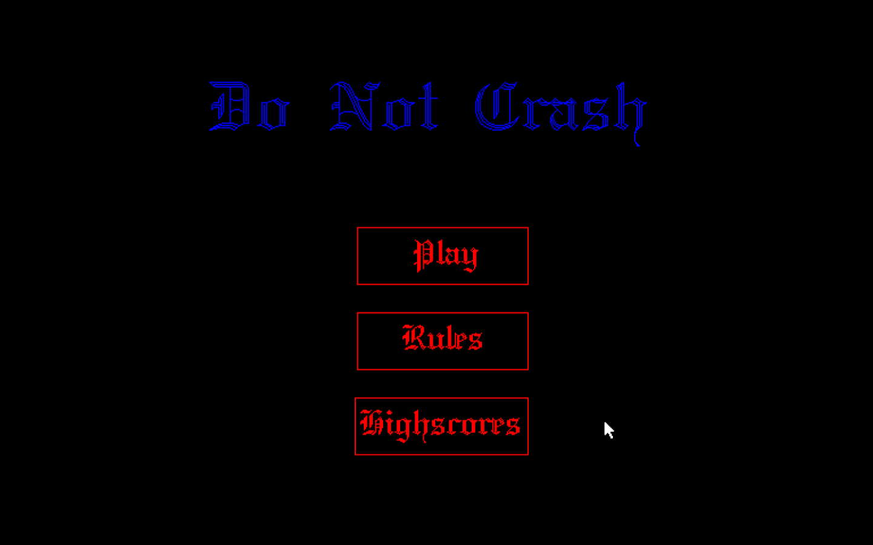The Front Page:

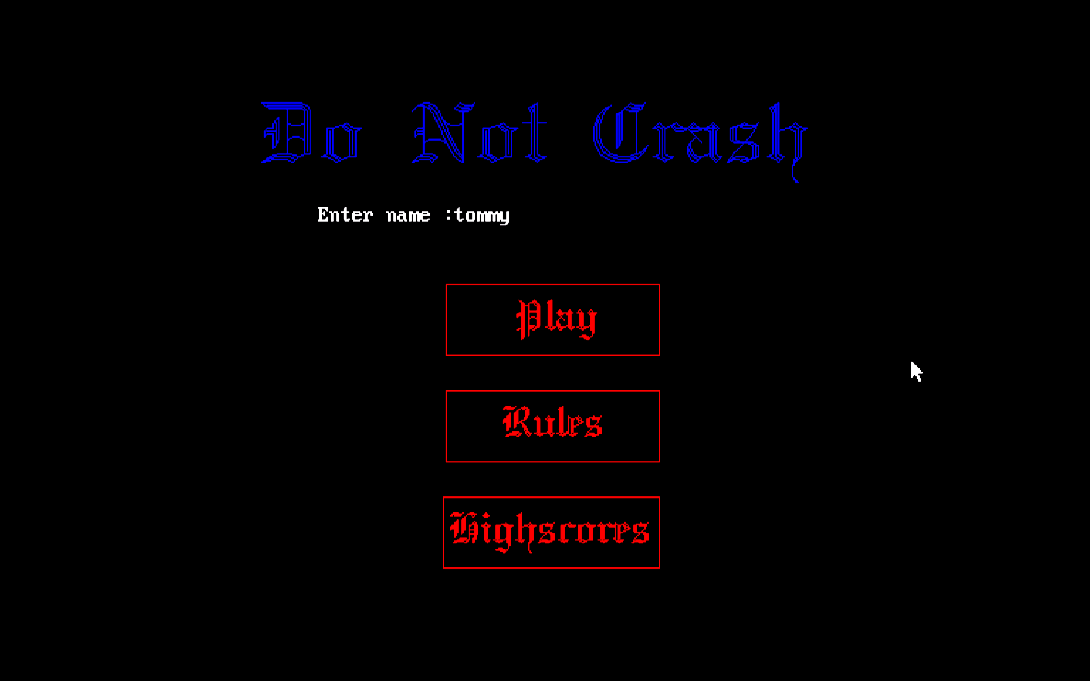To enter your name when you press ‘play’:

The ‘Rules’ page:

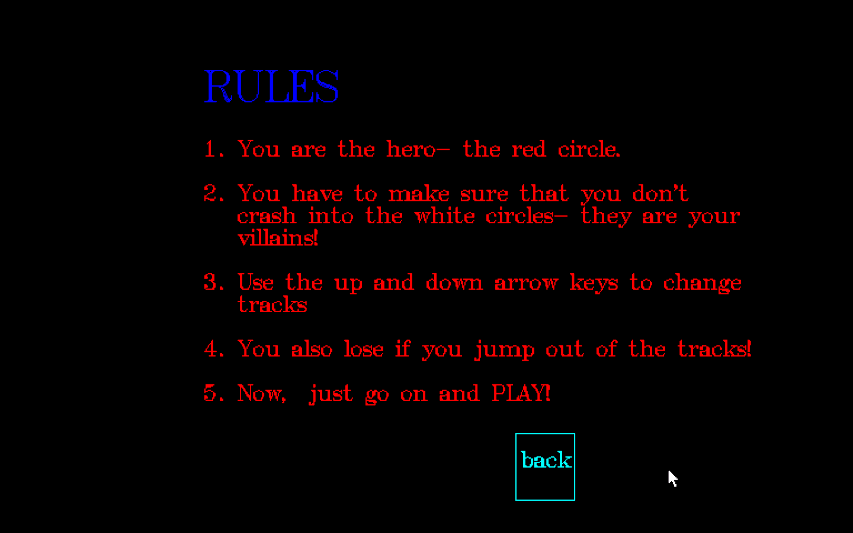

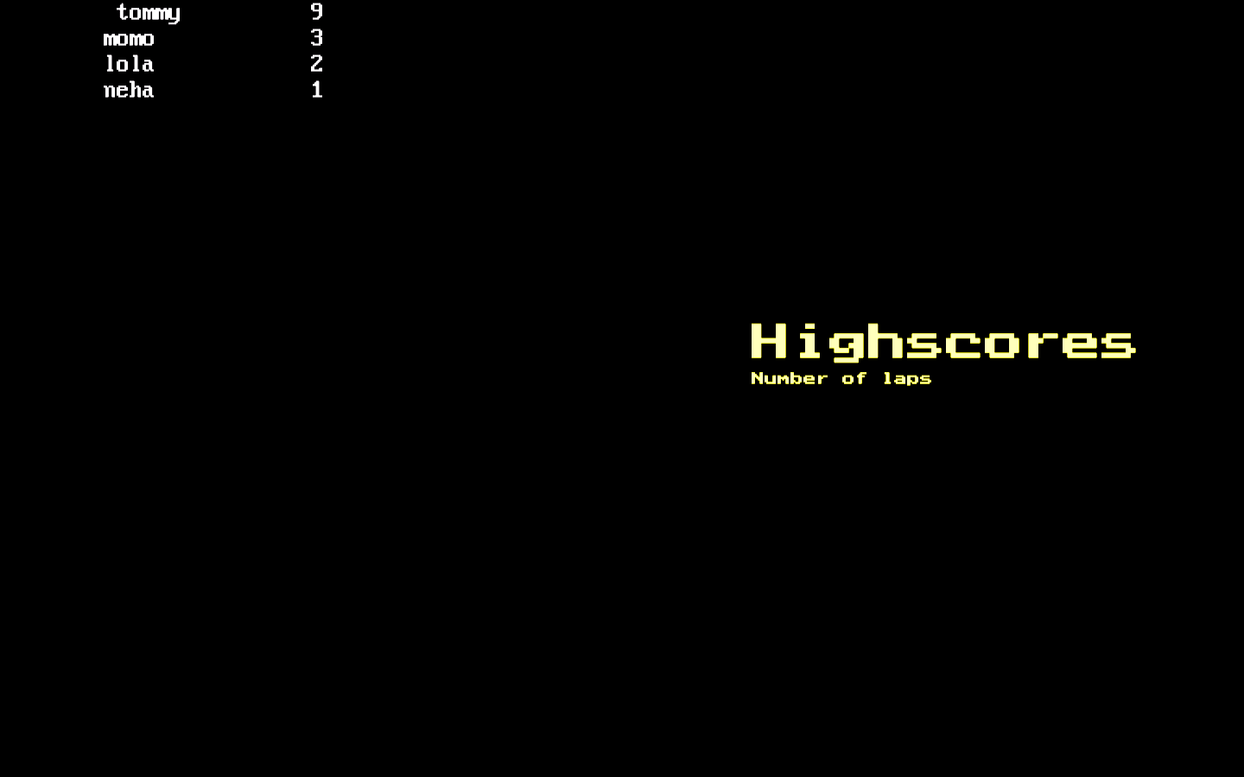The High scores page:

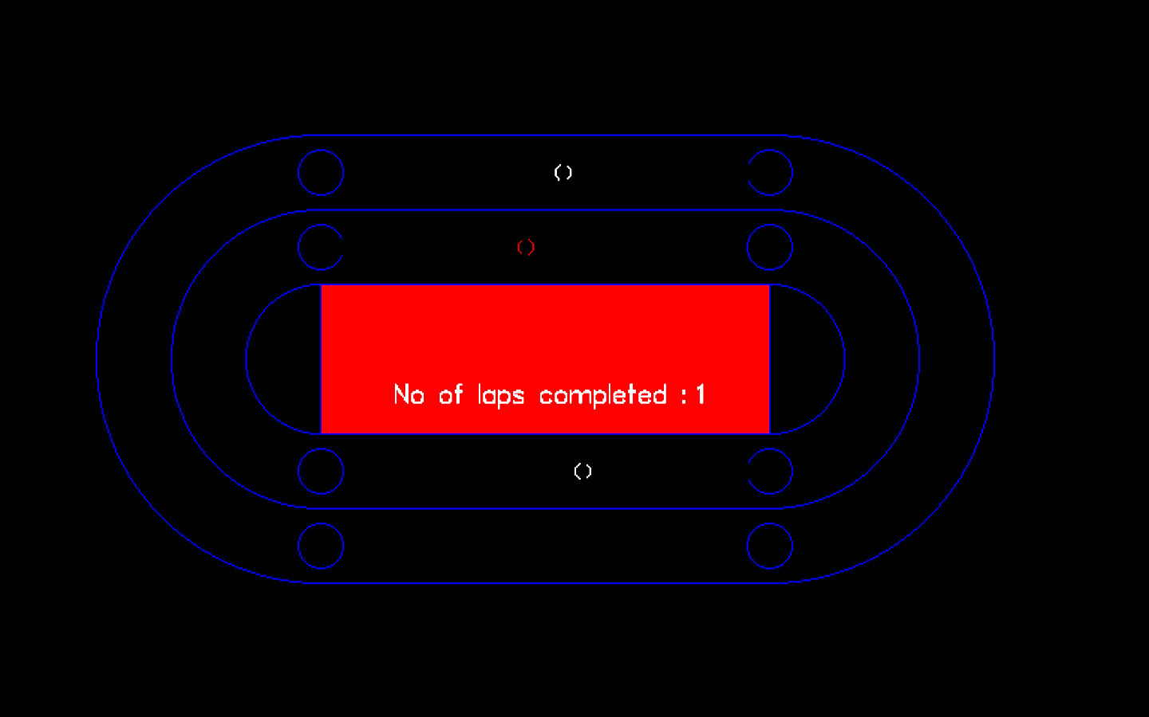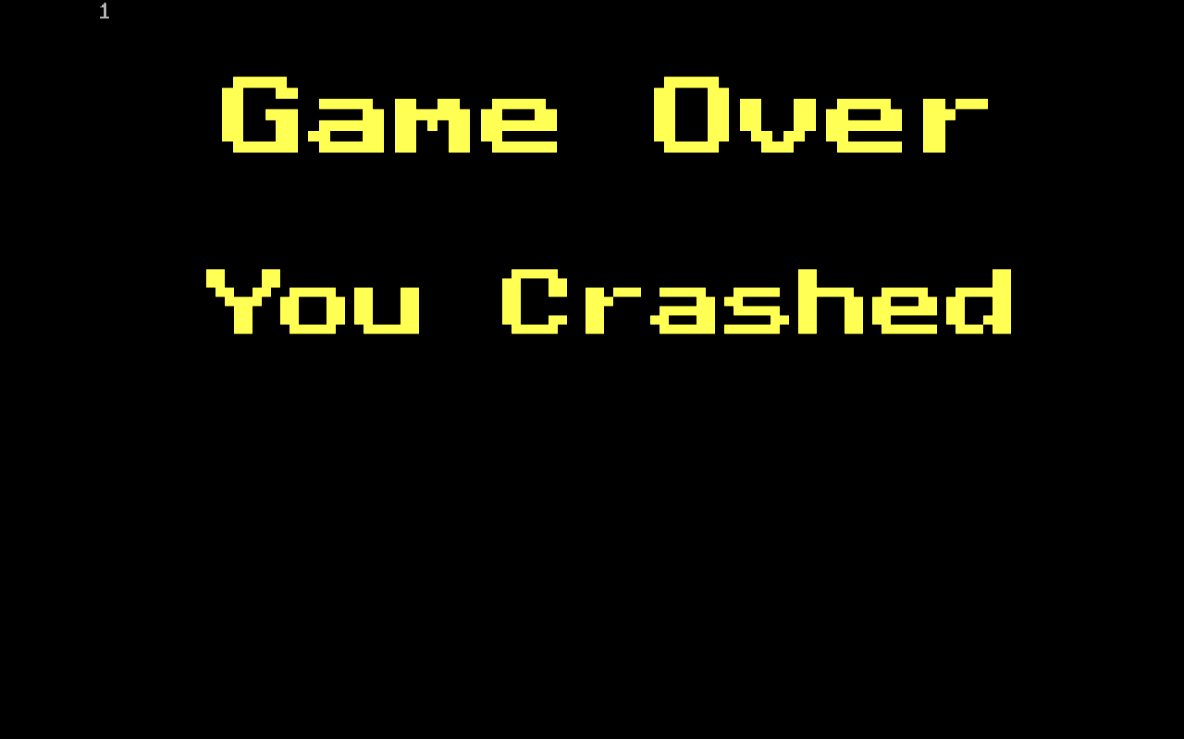The game during runtime:

The message displayed when the game is over:

**Conclusion**

We hope this game was interesting and the coding and its explanations were precise. Creating this game has been a good learning experience and we look forward for more such opportunities.

**Bibliography**

1. [www.thecrazyprogrammer.com](http://www.thecrazyprogrammer.com)
2. Computer Science With C++ Class : XII (Book by Sumita Arora)
3. Help- Neutron C++