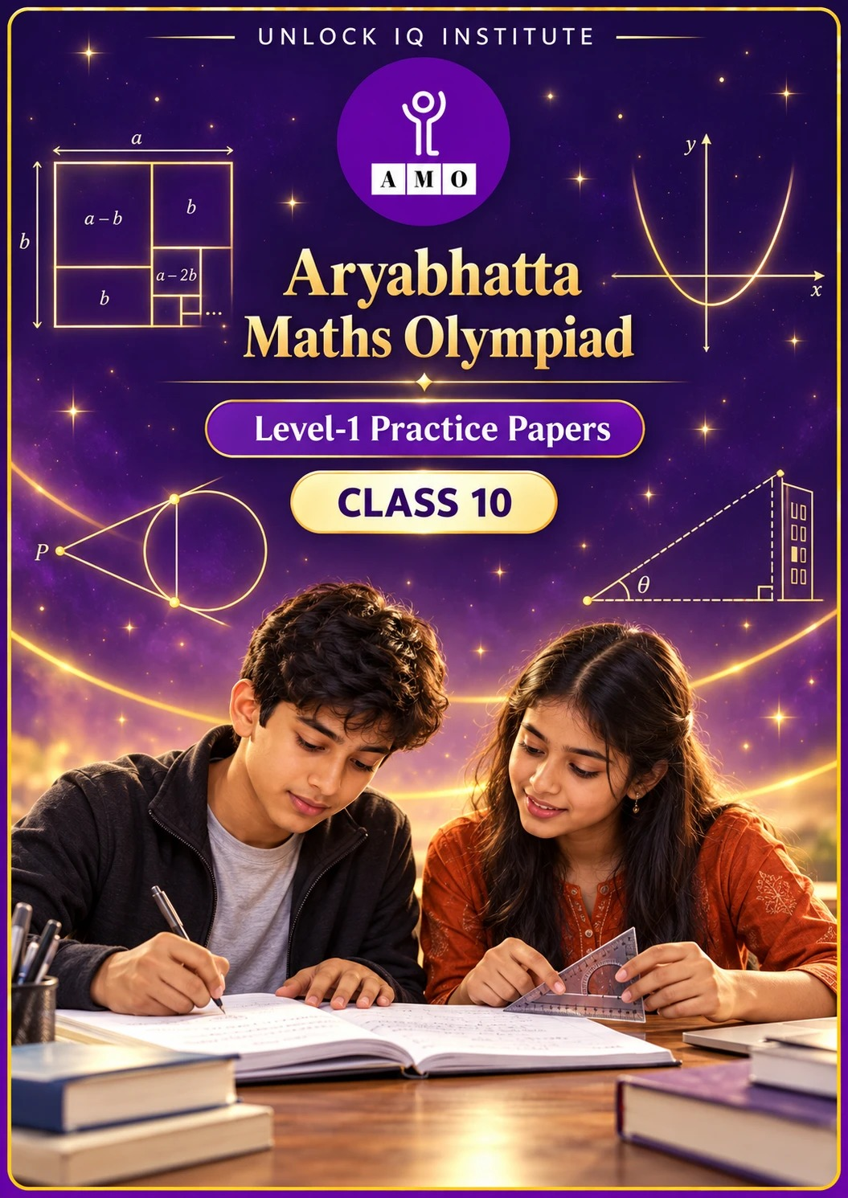
Five full practice papers · with answer keys & detailed solutions
Name: ____________________ | Class & Section: ________________
Roll No.: ________________ | School: ____________________
City: ____________________ | Date: ____________________

Published by Unlock IQ Institute Pvt. Ltd.
Register for Olympiads: www.aryabhattamathsolympiad.com/student-registration

ARYABHATTA MATHS OLYMPIAD
Level 1
PRACTICE PAPER-1
CLASS 10
Total Questions | 45 multiple-choice questions
Total Marks | 100
Time | 60 minutes
Section I | 40 questions × 2 marks = 80 marks
Section II | 5 Star Questions × 4 marks = 20 marks
Negative Marking | No negative marking
Calculator | Not allowed
Chapters | Number System · Fractions, Decimals & Percentages · Algebra · Geometry · Mensuration · Trigonometry · Data Handling · Applied Mathematics · Mathematical Reasoning

Instructions to candidates
• This paper has 45 multiple-choice questions. Each question has four answer choices, of which exactly one is correct.
• Section I (Q1–Q40) carries 2 marks per question. Section II (Q41–Q45) carries 4 marks per question.
• There is no negative marking. Unanswered questions score zero.
• Calculators are not permitted. Rough work may be done on a separate sheet.
• Mark your answers on the answer sheet at the end of the paper.
• All figures are not necessarily drawn to scale unless stated.

For parents and teachers
• Print or view this paper in colour. Pictures are part of the questions.
• Parts follow the AMO syllabus chapters. Chapter 2 is not part of the Class 10 syllabus, so the chapter numbers shown in the Part headings have gaps.
• The answer sheet and the answer key are at the end. Remove only the answer key before the student begins.

SECTION I 40 questions × 2 marks each
Part 1 — Number System (Syllabus Chapter 1)
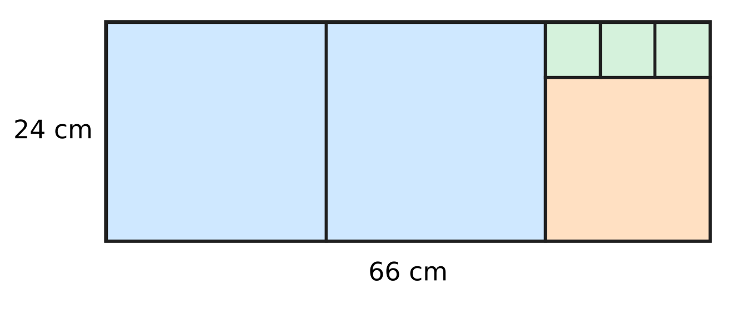
Q1. A card measures 66 cm by 24 cm. Each time, the largest possible square is cut from the part that is left, as shown in the figure, until nothing is left. What is the side of the smallest square?
(A) 3 cm | (B) 24 cm | (C) 6 cm | (D) 18 cm

Q2. Which of these fractions has a decimal expansion that ends after exactly three decimal places?
(A) $\frac{21}{40}$ | (B) $\frac{13}{16}$ | (C) $\frac{7}{24}$ | (D) $\frac{27}{150}$

Q3. What is the smallest natural number k for which 360 × k is a perfect cube?
(A) 10 | (B) 15 | (C) 30 | (D) 75

Part 2 — Fractions, Decimals & Percentages (Syllabus Chapter 3)
Q4. Swati and Chirag run a school bus service. At the start of a year, each of them puts in ₹55,000. Chirag takes all his money out after 8 months, and Swati keeps hers in for the whole year. The year's profit of ₹42,000 is shared in the ratio of capital × time. What is Swati's share?
(A) ₹31,500 | (B) ₹16,800 | (C) ₹21,000 | (D) ₹25,200

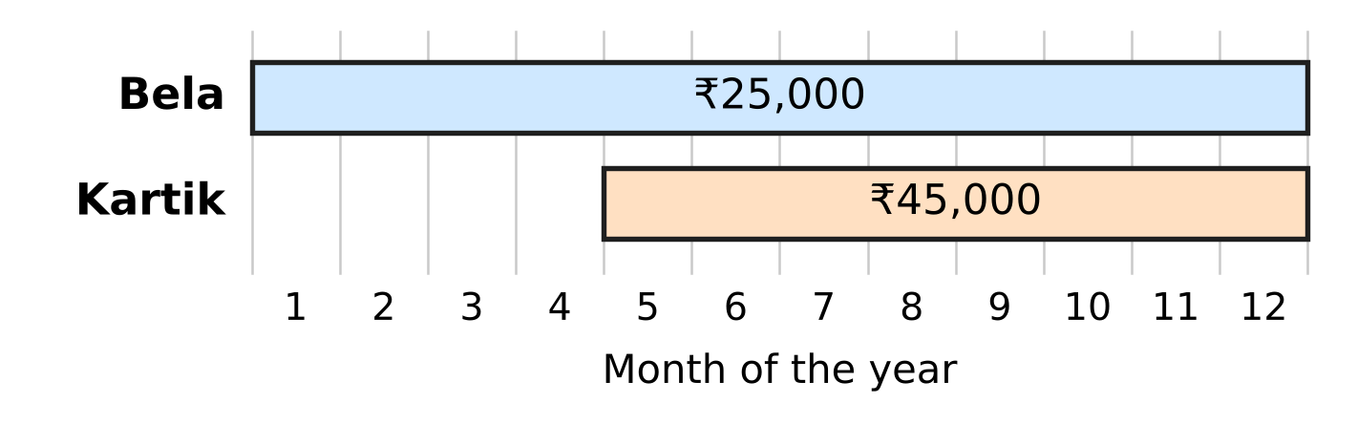
Q5. Bela and Kartik run a farm with cows and hens. The chart shows how much money each of them put into the farm and for which months of the year it was there. In what ratio should the year's profit be shared between Bela and Kartik?
(A) 20 : 21 | (B) 6 : 5 | (C) 5 : 6 | (D) 5 : 9

Q6. A deposit earns 20% per year, compounded half-yearly. By what percentage does the deposit grow in one full year?
(A) 40% | (B) 21% | (C) 20% | (D) 44%

Passbook of a deposit compounded half-yearly
Half-year | Balance at start | Interest | Balance at end
1st | ₹30,000 | ₹1,200 | ₹31,200
2nd | ₹31,200 | ? | ?

Q7. The table shows a deposit that earns compound interest, added every half-year at the same rate. What is the balance at the end of the 2nd half-year?
(A) ₹32,448 | (B) ₹32,480 | (C) ₹32,400 | (D) ₹33,696

Q8. Ruhi opens a stationery shop with ₹48,000 at the start of the year. Arun joins some months later and puts in ₹72,000. At the end of the year they share the profit equally. After how many months from the start did Arun join?
(A) 8 months | (B) 3 months | (C) 4 months | (D) 6 months

Part 3 — Algebra (Syllabus Chapter 4)
Q9. The figure shows the graph of $y=x^{2}+bx+c$. It cuts the x-axis at the two marked points. What is the value of b? | 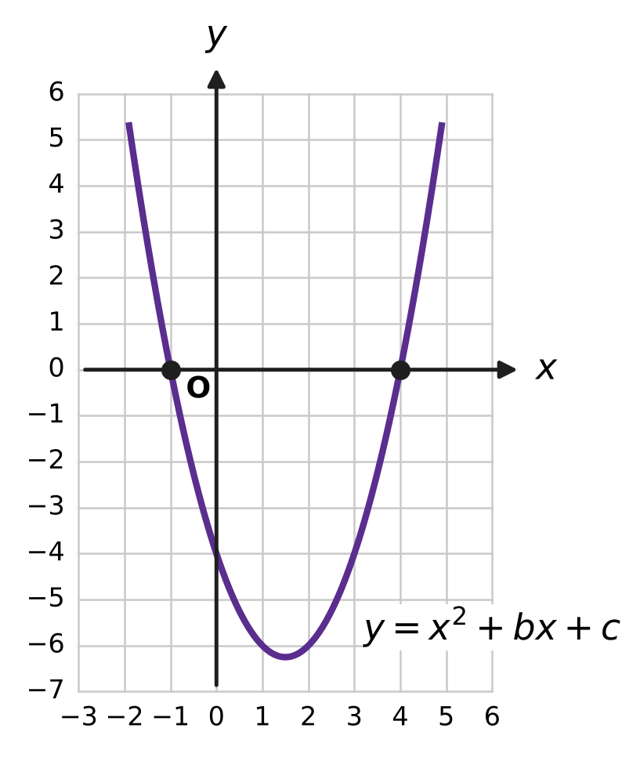
  (A) −3 | (B) 5 | (C) 3 | (D) −4

Q10. For which value of k does the pair of equations $3x+ky=7$ and $6x+10y=11$ have no solution?
(A) −5 | (B) 5 | (C) 20 | (D) 10

Q11. When a polynomial p(x) is divided by $x^{2}−1$, the quotient is $2x+3$ and the remainder is $x−4$. What is p(2)?
(A) 17 | (B) 23 | (C) 21 | (D) 19

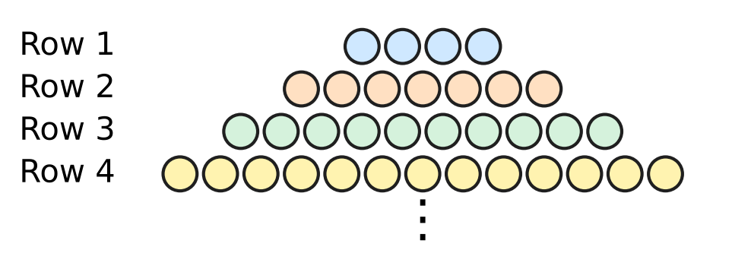
Q12. Esha lays marbles in rows on a table. The figure shows the first four rows, and the pattern continues in the same way. How many marbles are there in the first 12 rows altogether?
(A) 246 | (B) 209 | (C) 264 | (D) 37

Q13. For how many integer values of k does the equation $2x^{2}+kx+8=0$ have no real roots?
(A) 7 | (B) 17 | (C) 15 | (D) 14

Q14. The two zeroes of the polynomial $x^{2}−10x+k$ differ by 4. What is the value of k?
(A) 16 | (B) 25 | (C) 24 | (D) 21

Part 4 — Geometry (Syllabus Chapter 5)
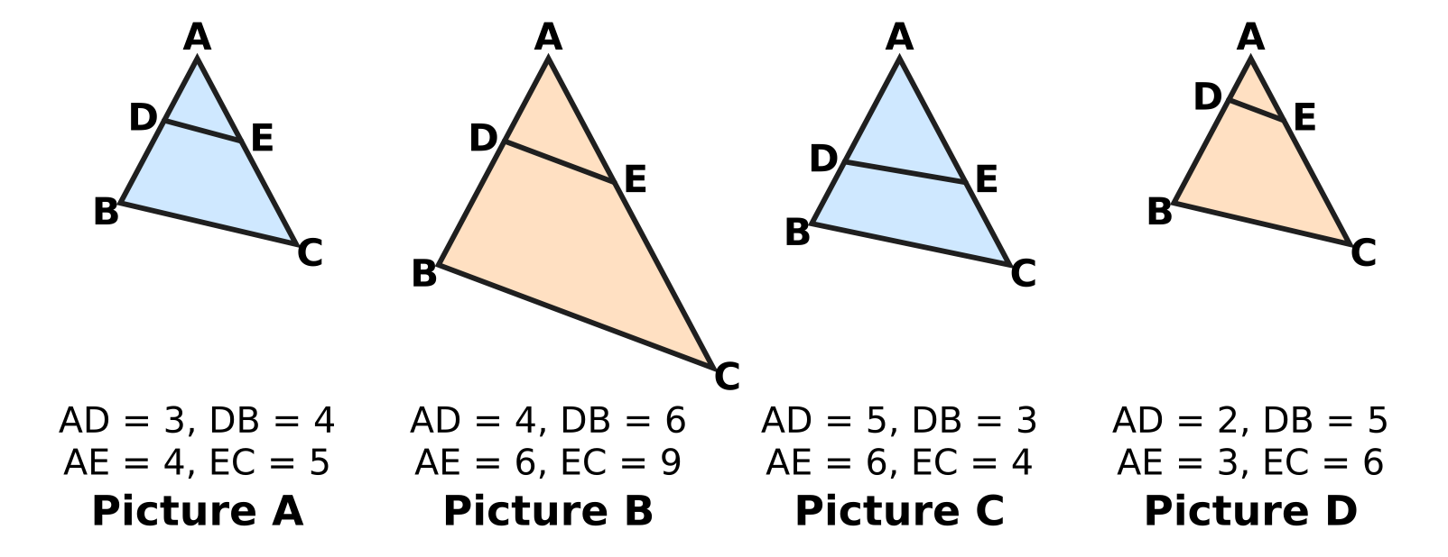
Q15. In each triangle ABC in the figure, D lies on AB and E lies on AC, and the lengths are in cm. In which picture is DE parallel to BC?
(A) Picture A | (B) Picture B
(C) Picture C | (D) Picture D

Q16. The figure shows the points R and S on a square grid. The point M lies on RS and RM : MS = 3 : 1. What are the coordinates of M? | 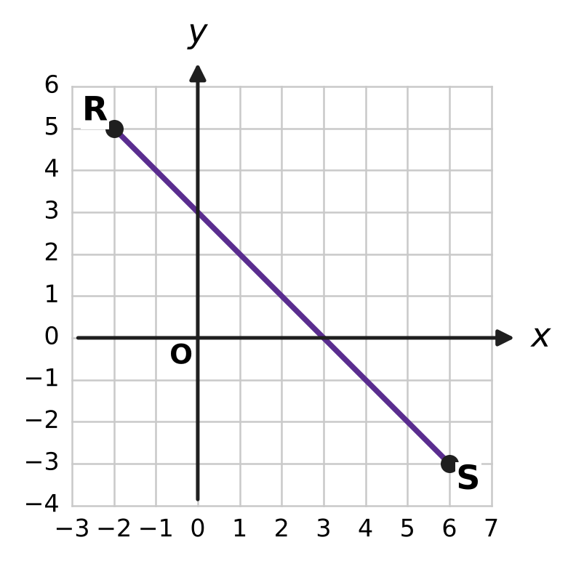
  (A) (4, 1) | (B) (4, −1) | (C) (2, 1) | (D) (0, 3)

Q17. In the figure, PA and PB are tangents from P to the circle with centre O. In cm, PA = $3x−2$ and PB = $x+6$, as marked. What is the length of PA? | 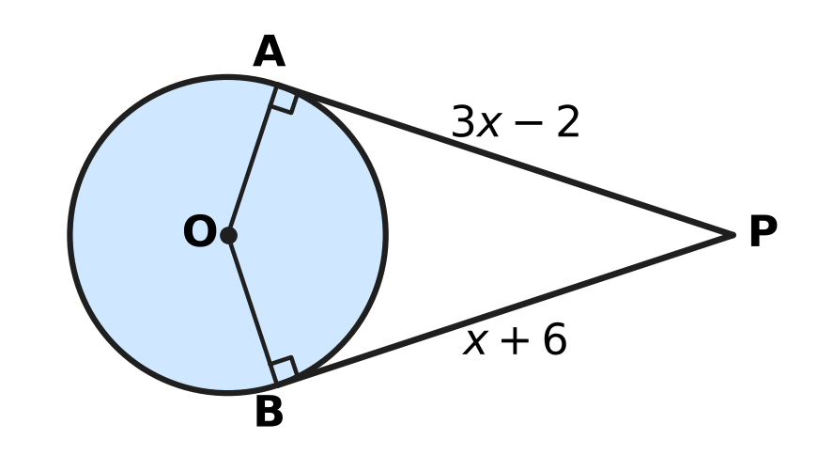
  (A) 10 cm | (B) 4 cm | (C) 8 cm | (D) 20 cm

Q18. In the figure, ABCD is a trapezium with AB ∥ DC, AB = 12 cm and DC = 8 cm. The diagonals meet at O. If AC = 15 cm, what is the length of AO? | 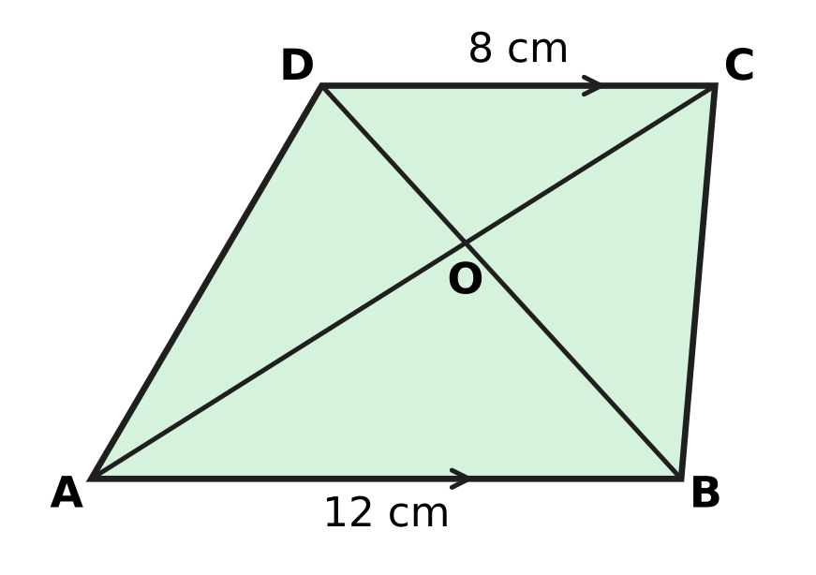
  (A) 10 cm | (B) 7.5 cm | (C) 9 cm | (D) 6 cm

Q19. The figure shows a right triangle ABC with ∠B = 90°, AB = 8 cm and BC = 15 cm. A circle touches all three sides. What is its radius r? | 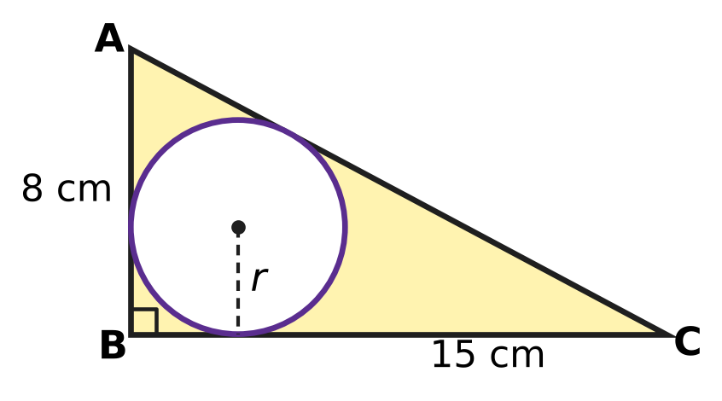
  (A) 8.5 cm | (B) 4 cm | (C) 6 cm | (D) 3 cm

Part 5 — Mensuration (Syllabus Chapter 6)
Q20. Ishan's vegetable bed is a sector of a circle with radius 14 m and angle 135°, as shown. How long is its curved edge? (Use π = 22/7.) | 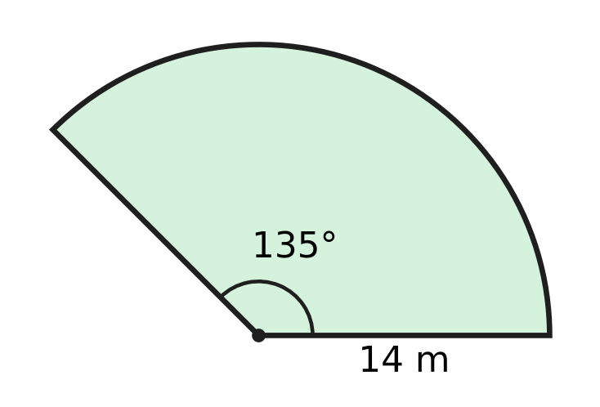
  (A) 61 m | (B) 33 m | (C) 16.5 m | (D) 66 m

Q21. A lampshade is the curved part of a frustum, open at both ends. Its end radii are 10.5 cm and 7 cm and its slant height is 12 cm, as shown. What is the area of cloth on it? (Use π = 22/7.) | 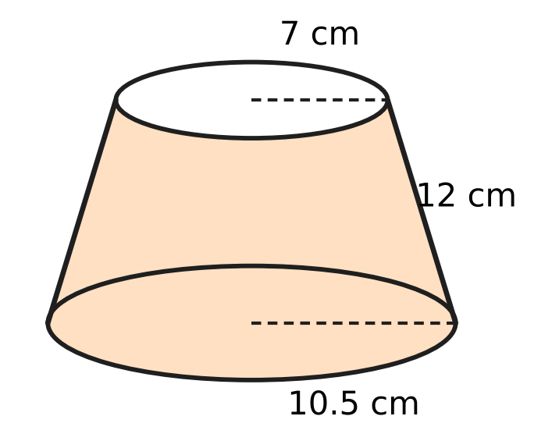
  (A) 330 cm² | (B) 814 cm²
  (C) 1,320 cm² | (D) 660 cm²

Q22. A solid is made of a cylinder of radius 7 cm and height 9 cm, with a cone of the same radius and height 6 cm on top, as shown. What is its volume? (Use π = 22/7.) | 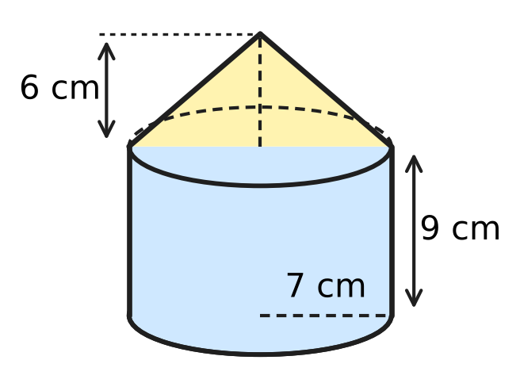
  (A) 2,310 cm³ | (B) 1,848 cm³
  (C) 1,694 cm³ | (D) 1,386 cm³

Q23. ABCD is a square of side 21 cm. Two quarter circles of radius 21 cm are drawn with centres A and C, as shown. What is the area of the shaded leaf shape? (Use π = 22/7.) | 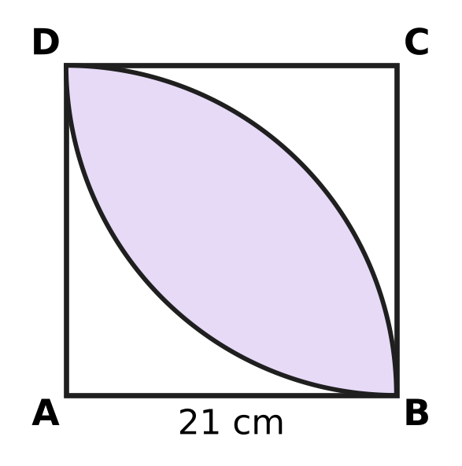
  (A) 189 cm² | (B) 252 cm² | (C) 693 cm² | (D) 126 cm²

Q24. A flat roof measures 22 m by 20 m. Rain falls on it to a depth of 2 cm, and all the water drains into an empty cylindrical rainwater tank of radius 1 m. How high does the water rise in the tank? (Use π = 22/7.)
(A) 2.8 m | (B) 28 m | (C) 8.8 m | (D) 11.2 m

Part 6 — Trigonometry & Heights and Distances (Syllabus Chapter 7)
Q25. The figure shows a right triangle KLM with ∠L = 90°, KL = 21 cm and LM = 20 cm, and ∠MKL = θ. What is the value of cosec θ? | 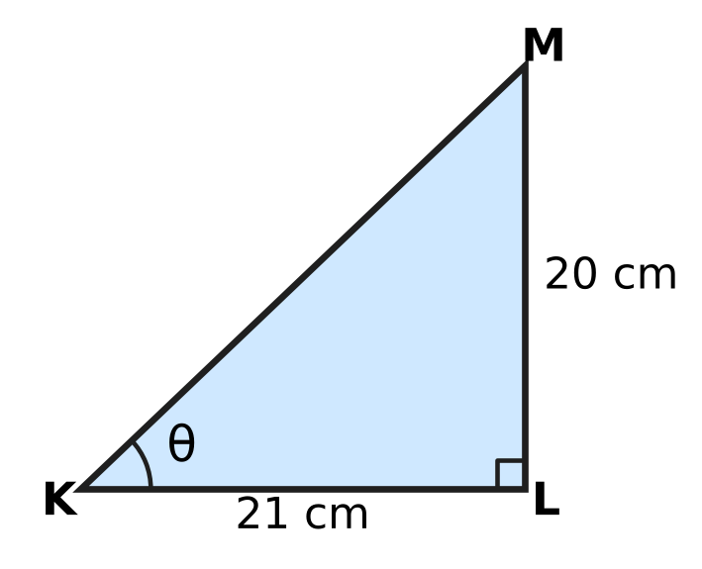
  (A) $\frac{20}{29}$ | (B) $\frac{29}{21}$ | (C) $\frac{29}{20}$ | (D) $\frac{21}{20}$

Q26. The angle θ is acute and cos θ = $\frac{1}{2}$. What is the value of sin θ × tan θ?
(A) $\frac{\sqrt{3}}{6}$ | (B) $\frac{3}{2}$
(C) $\frac{3}{4}$ | (D) $\frac{1}{2}$

Q27. From the top of a 30 m tall school building, the angle of depression of the bottom G of a tree is 60° and that of its top T is 30°, as shown in the figure. The building and the tree stand on the same level ground. How tall is the tree? | 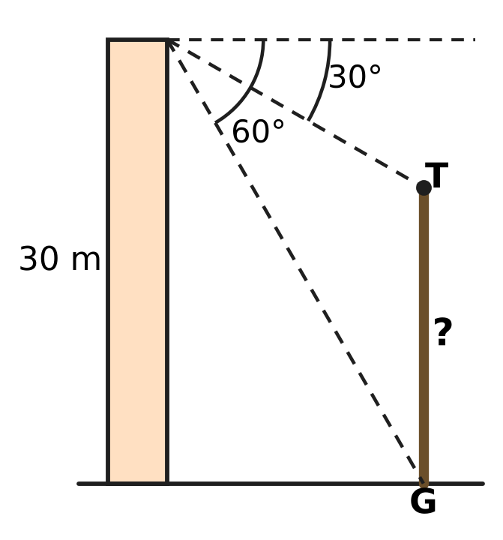
  (A) 20 m | (B) 10 m
  (C) 40 m | (D) $10\sqrt{3}$ m

Part 7 — Data Handling, Statistics & Probability (Syllabus Chapter 8)
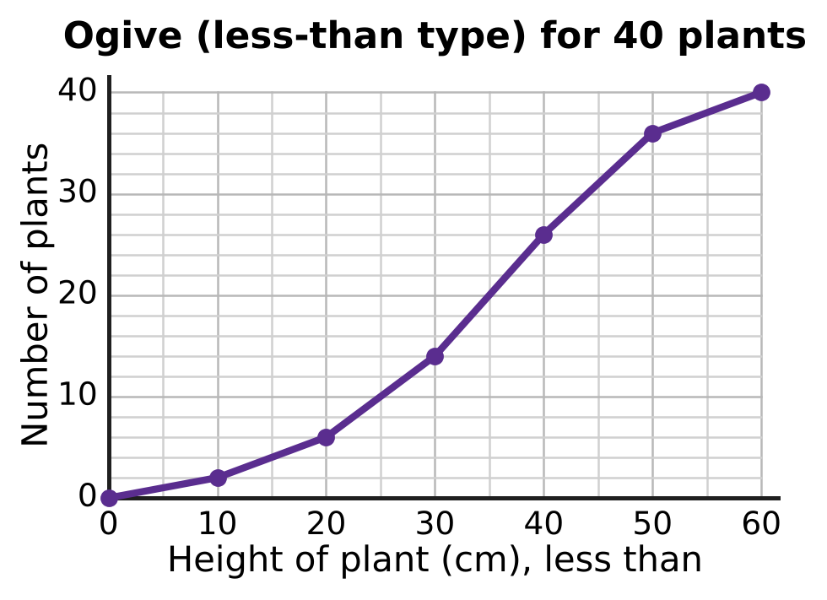
Q28. The less-than ogive shows the heights of 40 plants. The thin grid lines are every 5 cm across and every 2 plants up. What is the median height?
(A) 40 cm | (B) 20 cm | (C) 30 cm | (D) 35 cm

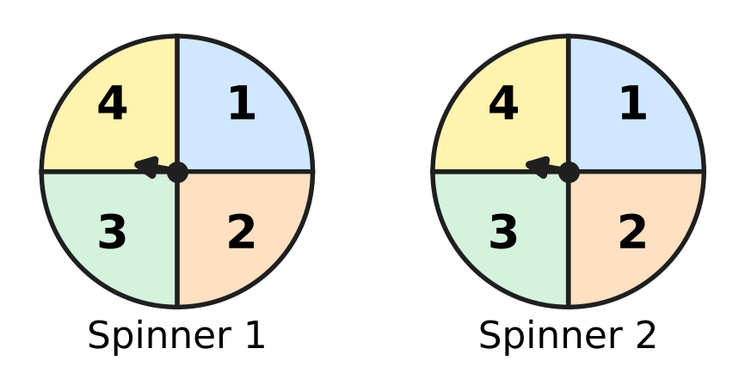
Q29. Each fair spinner in the figure has four equal parts numbered 1 to 4. Both are spun once and the two numbers are added. What is the probability that the sum is at least 3?
(A) $\frac{15}{16}$ | (B) $\frac{6}{7}$ | (C) $\frac{1}{16}$ | (D) $\frac{13}{16}$

Times of 30 swimmers in a swimming pool
Time for one length (seconds) | 20–30 | 30–40 | 40–50 | 50–60 | 60–70
Number of swimmers | 2 | 4 | 13 | 7 | 4

Q30. The table shows the time 30 swimmers took to swim one length of a pool. What is the mode of these times?
(A) 45 seconds | (B) 44 seconds
(C) 40 seconds | (D) 46 seconds

Part 8 — Applied Mathematics (Syllabus Chapter 9)
Bill from an electronics shop (sale within the state)
Item | Quantity | Price (₹)
Headphones | 1 | 900
Charging cable | 2 | 150 each
CGST |  | 9%
SGST |  | 9%

Q31. The table shows a shop bill. CGST and SGST are each charged on the total price of the items. How much does the customer pay in all?
(A) ₹1,308 | (B) ₹1,362 | (C) ₹1,416 | (D) ₹1,632

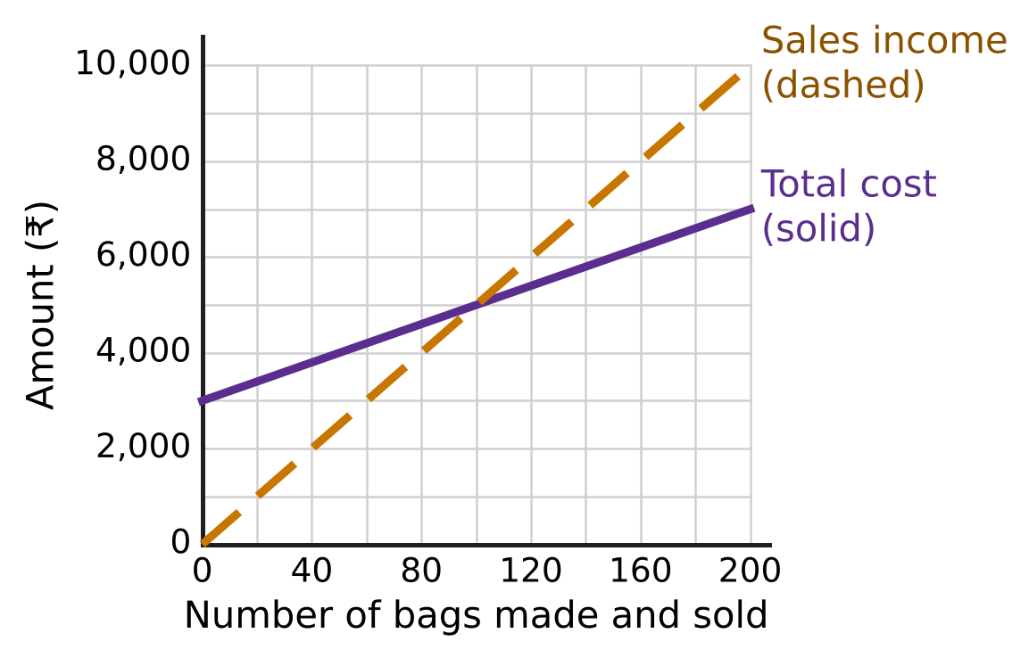
Q32. The graph shows the total cost (solid line) and the sales income (dashed line) of a small workshop that makes school bags. What is the profit when 200 bags are made and sold?
(A) ₹10,000 | (B) ₹3,000 | (C) ₹6,000 | (D) ₹7,000

Q33. Naveen's motorboat moves at 13 km/h in still water. The river flows at 3 km/h. He goes 40 km upstream and then comes back to his starting point. How long does the whole trip take?
(A) 6.5 hours | (B) 4 hours
(C) 8 hours | (D) 5 hours

Repayment of a bicycle loan
Month | Loan at start of month | Loan paid back | Interest for the month | Payment
1 | ₹14,000 | ₹5,000 | ₹210 | ₹5,210
2 | ₹9,000 | ₹4,000 | ? | ?
3 | ? | ₹3,000 | ? | ?
4 | ? | ₹2,000 | ? | ?

Q34. A ₹14,000 bicycle loan is repaid in 4 months, as shown in the table. Each month, the part of the loan shown is paid back together with that month's interest on the loan still unpaid, at the same monthly rate. What is the total interest paid over the 4 months?
(A) ₹420 | (B) ₹840 | (C) ₹240 | (D) ₹450

Q35. Leela can cover all the new books of the school library in 7 days, and Advait can do the same job in 35 days. Leela works alone for 2 days and then stops. Advait finishes the rest alone. For how many days does Advait work?
(A) 33 days | (B) 5 days | (C) 25 days | (D) 27 days

Part 9 — Mathematical Reasoning & Problem-Solving (Syllabus Chapter 10)
Q36. Some points are marked on a circle. Every pair of points is joined by a straight line, and 28 lines are drawn in all. How many points are marked?
(A) 14 | (B) 8 | (C) 7 | (D) 9

Q37. Seven whole numbers add up to 50. Some of them may be equal. What is the smallest possible value of the largest of them?
(A) 8 | (B) 6 | (C) 44 | (D) 7

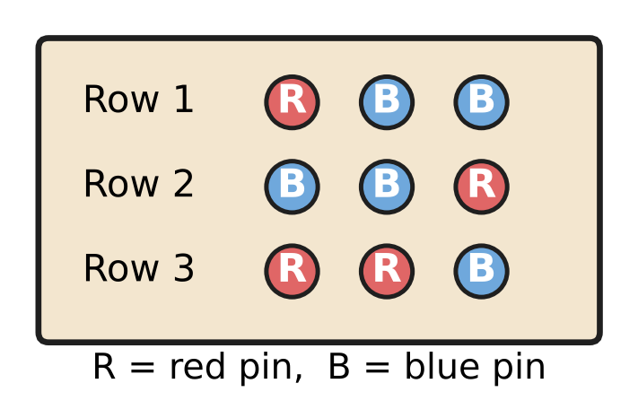
Q38. On the classroom notice board, each row has 3 pins in a line, and each pin is red or blue. The figure shows three such rows. What is the least number of rows that makes sure two rows have exactly the same colours in the same order?
(A) 8 | (B) 5 | (C) 7 | (D) 9

Q39. Uday's counter shows 7. Each press of button A adds 6 to the number shown, and each press of button B subtracts 9. Which of these numbers can the counter show after some presses?
(A) 77 | (B) 100 | (C) 50 | (D) 63

Q40. A path goes along the lines of the grid from S to F, moving only right or up at each step. The crossing marked ⊗ is closed and no path may pass through it. How many paths are there? | 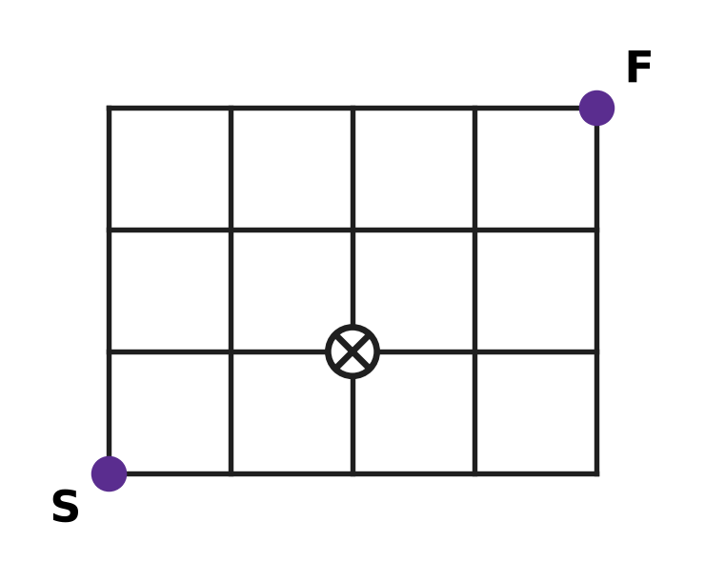
  (A) 15 | (B) 18 | (C) 17 | (D) 35

SECTION II — Star Questions 5 questions × 4 marks each
Q41. Mona puts all 100 stamps of her stamp collection into an album. Every page she uses holds at least one stamp, and no two pages hold the same number of stamps. What is the greatest number of pages she can use? [4 marks]
(A) 13 | (B) 10 | (C) 14 | (D) 9

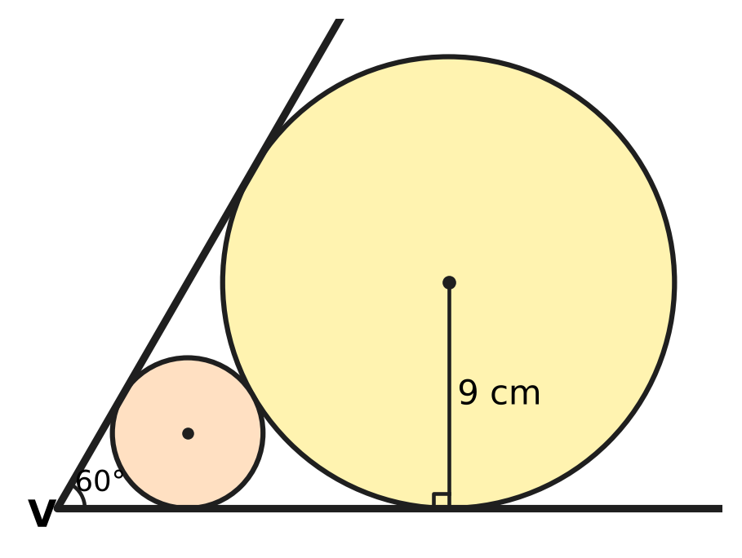
Q42. Two straight edges meet at V at an angle of 60°, as shown. A large round disc of radius 9 cm touches both edges. A smaller round disc lies between V and the large disc; it touches both edges and also the large disc. What is the radius of the smaller disc? [4 marks]
(A) 4.5 cm | (B) 3 cm
(C) 6 cm | (D) $3\sqrt{3}$ cm

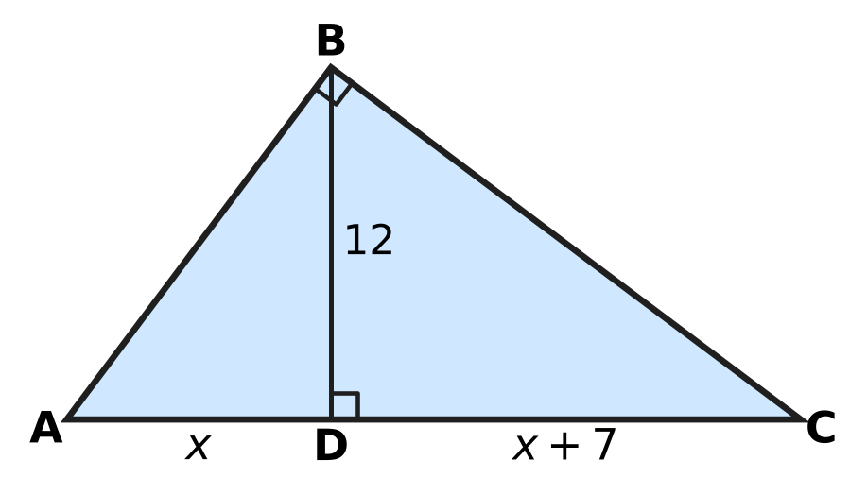
Q43. In the triangle ABC, ∠ABC = 90° and BD ⊥ AC, as shown. All lengths are in cm: BD = 12, AD = x and DC = x + 7. What is the length of AB? [4 marks]
(A) 9 cm | (B) 20 cm | (C) 25 cm | (D) 15 cm

Q44. Farhan and Mia run a workshop that makes kites for windy days. Farhan puts in ₹60,000 for the whole year, and Mia puts in ₹90,000 for the last 4 months of the year. In the year, the fixed costs are ₹30,000, each kite costs ₹40 to make and sells for ₹70, and 2,500 kites are sold. The profit is shared in the ratio of capital × time. What is Mia's share? [4 marks]
(A) ₹27,000 | (B) ₹30,000 | (C) ₹15,000 | (D) ₹25,000

Q45. A circular apple orchard has a fence 132 m long around it. It is divided into equal sectors, each of area 77 m². Saplings are planted so that each one lies inside exactly one sector. What is the least number of saplings that makes sure some sector has at least 3 saplings? (Use π = 22/7.) [4 marks]
(A) 54 | (B) 36 | (C) 37 | (D) 19

Answer Sheet AMO Level 1 · Class 10 · Practice Paper 1
Name: | School: | Roll No.:
Shade or tick one circle for each question.
1. Ⓐ Ⓑ Ⓒ Ⓓ | 16. Ⓐ Ⓑ Ⓒ Ⓓ | 31. Ⓐ Ⓑ Ⓒ Ⓓ
2. Ⓐ Ⓑ Ⓒ Ⓓ | 17. Ⓐ Ⓑ Ⓒ Ⓓ | 32. Ⓐ Ⓑ Ⓒ Ⓓ
3. Ⓐ Ⓑ Ⓒ Ⓓ | 18. Ⓐ Ⓑ Ⓒ Ⓓ | 33. Ⓐ Ⓑ Ⓒ Ⓓ
4. Ⓐ Ⓑ Ⓒ Ⓓ | 19. Ⓐ Ⓑ Ⓒ Ⓓ | 34. Ⓐ Ⓑ Ⓒ Ⓓ
5. Ⓐ Ⓑ Ⓒ Ⓓ | 20. Ⓐ Ⓑ Ⓒ Ⓓ | 35. Ⓐ Ⓑ Ⓒ Ⓓ
6. Ⓐ Ⓑ Ⓒ Ⓓ | 21. Ⓐ Ⓑ Ⓒ Ⓓ | 36. Ⓐ Ⓑ Ⓒ Ⓓ
7. Ⓐ Ⓑ Ⓒ Ⓓ | 22. Ⓐ Ⓑ Ⓒ Ⓓ | 37. Ⓐ Ⓑ Ⓒ Ⓓ
8. Ⓐ Ⓑ Ⓒ Ⓓ | 23. Ⓐ Ⓑ Ⓒ Ⓓ | 38. Ⓐ Ⓑ Ⓒ Ⓓ
9. Ⓐ Ⓑ Ⓒ Ⓓ | 24. Ⓐ Ⓑ Ⓒ Ⓓ | 39. Ⓐ Ⓑ Ⓒ Ⓓ
10. Ⓐ Ⓑ Ⓒ Ⓓ | 25. Ⓐ Ⓑ Ⓒ Ⓓ | 40. Ⓐ Ⓑ Ⓒ Ⓓ
11. Ⓐ Ⓑ Ⓒ Ⓓ | 26. Ⓐ Ⓑ Ⓒ Ⓓ | 41. Ⓐ Ⓑ Ⓒ Ⓓ
12. Ⓐ Ⓑ Ⓒ Ⓓ | 27. Ⓐ Ⓑ Ⓒ Ⓓ | 42. Ⓐ Ⓑ Ⓒ Ⓓ
13. Ⓐ Ⓑ Ⓒ Ⓓ | 28. Ⓐ Ⓑ Ⓒ Ⓓ | 43. Ⓐ Ⓑ Ⓒ Ⓓ
14. Ⓐ Ⓑ Ⓒ Ⓓ | 29. Ⓐ Ⓑ Ⓒ Ⓓ | 44. Ⓐ Ⓑ Ⓒ Ⓓ
15. Ⓐ Ⓑ Ⓒ Ⓓ | 30. Ⓐ Ⓑ Ⓒ Ⓓ | 45. Ⓐ Ⓑ Ⓒ Ⓓ
Q41–Q45 are Section II Star Questions (4 marks each).
For the parent or teacher
Section I correct: ______ / 40 × 2 = ______ marks Section II correct: ______ / 5 × 4 = ______ marks
Correct: ______ / 45 Score: ______ / 100
Answer Key and Solutions AMO Level 1 · Class 10 · Practice Paper 1
Quick answers
1 C | 6 B | 11 D | 16 B | 21 D | 26 B | 31 C | 36 B | 41 A
2 A | 7 A | 12 A | 17 A | 22 C | 27 A | 32 B | 37 A | 42 B
3 D | 8 C | 13 C | 18 C | 23 B | 28 D | 33 A | 38 D | 43 D
4 D | 9 A | 14 D | 19 D | 24 A | 29 A | 34 D | 39 B | 44 C
5 C | 10 B | 15 B | 20 B | 25 C | 30 D | 35 C | 40 C | 45 C
Solutions
Q | Part · level | Answer | Why?
1 | Part 1 · Ch1 · Easy | (C) 6 cm | The cuts follow Euclid's algorithm: 66 = 2 × 24 + 18, 24 = 1 × 18 + 6, 18 = 3 × 6. The last square has side HCF(66, 24) = 6 cm.
2 | Part 1 · Ch1 · Easy | (A) $\frac{21}{40}$ | Since 40 = 2³ × 5, 21/40 ends after 3 places: 21/40 = 0.525. Also, 13/16 has 4 places, 27/150 = 9/50 has 2 places and 7/24 does not end.
3 | Part 1 · Ch1 · Medium | (D) 75 | Here 360 = 2³ × 3² × 5. Each power must become a multiple of 3, so k = 3 × 5² = 75 (360 × 75 = 27,000 = 30³).
4 | Part 2 · Ch3 · Easy | (D) ₹25,200 | The amounts are equal, so the shares follow the months: 12 : 8 = 3 : 2. Swati gets 3/5 of ₹42,000 = ₹25,200.
5 | Part 2 · Ch3 · Easy | (C) 5 : 6 | Bela: 25,000 × 12 = 300,000. Kartik (months 5 to 12): 45,000 × 8 = 360,000. The ratio is 300,000 : 360,000 = 5 : 6.
6 | Part 2 · Ch3 · Easy | (B) 21% | The rate is 10% for each half-year, so 1.1 × 1.1 = 1.21: the deposit grows by 21% in a year.
7 | Part 2 · Ch3 · Medium | (A) ₹32,448 | The half-yearly rate is 1,200 ÷ 30,000 = 4%. Interest for the 2nd half-year = 4% of 31,200 = ₹1,248, so the balance is ₹32,448.
8 | Part 2 · Ch3 · Medium | (C) 4 months | Equal shares need 48,000 × 12 = 72,000 × t, so t = 8 months. Arun joined 12 − 8 = 4 months after the start.
9 | Part 3 · Ch4 · Easy | (A) −3 | The zeroes are −1 and 4. Their sum is 3 and the sum of the zeroes equals −b, so b = −3.
10 | Part 3 · Ch4 · Easy | (B) 5 | No solution needs 3/6 = k/10 ≠ 7/11. So k/10 = 1/2 and k = 5.
11 | Part 3 · Ch4 · Easy | (D) 19 | p(x) = (x² − 1)(2x + 3) + (x − 4). So p(2) = 3 × 7 + (2 − 4) = 21 − 2 = 19.
12 | Part 3 · Ch4 · Medium | (A) 246 | The rows form an AP with a = 4 and d = 3. S = 12/2 × (2 × 4 + 11 × 3) = 6 × 41 = 246.
13 | Part 3 · Ch4 · Medium | (C) 15 | No real roots needs k² − 4 × 2 × 8 < 0, so k² < 64 and −8 < k < 8. The integers −7 to 7 give 15 values.
14 | Part 3 · Ch4 · Medium | (D) 21 | The zeroes add up to 10 and differ by 4, so they are 7 and 3. Their product is k = 21.
15 | Part 4 · Ch5 · Easy | (B) Picture B | DE ∥ BC exactly when AD/DB = AE/EC. Only 4/6 = 6/9 (both 2/3) is a match; 3/4 ≠ 4/5, 5/3 ≠ 6/4 and 2/5 ≠ 3/6.
16 | Part 4 · Ch5 · Easy | (B) (4, −1) | R(−2, 5) and S(6, −3). M = ((3 × 6 + 1 × (−2))/4, (3 × (−3) + 1 × 5)/4) = (16/4, −4/4) = (4, −1).
17 | Part 4 · Ch5 · Easy | (A) 10 cm | Tangents from an outside point are equal: 3x − 2 = x + 6, so x = 4 and PA = 3 × 4 − 2 = 10 cm.
18 | Part 4 · Ch5 · Medium | (C) 9 cm | Triangles AOB and COD are similar (AB ∥ DC), so AO : OC = 12 : 8 = 3 : 2. AO = 3/5 × 15 = 9 cm.
19 | Part 4 · Ch5 · Medium | (D) 3 cm | AC = √(64 + 225) = 17 cm. Tangents from each vertex are equal, so AB + BC − AC = 2r: 8 + 15 − 17 = 6 and r = 3 cm.
20 | Part 5 · Ch6 · Easy | (B) 33 m | Arc = 135/360 × 2 × 22/7 × 14 = 3/8 × 88 = 33 m.
21 | Part 5 · Ch6 · Easy | (D) 660 cm² | Curved surface area = π(R + r)l = 22/7 × 17.5 × 12 = 660 cm².
22 | Part 5 · Ch6 · Easy | (C) 1,694 cm³ | Volume = πr²(9) + (1/3)πr²(6) = 154 × 9 + 154 × 2 = 154 × 11 = 1,694 cm³.
23 | Part 5 · Ch6 · Medium | (B) 252 cm² | Each half of the leaf is a quarter circle minus a right triangle: 346.5 − 220.5 = 126 cm². The leaf is 2 × 126 = 252 cm².
24 | Part 5 · Ch6 · Medium | (A) 2.8 m | Water = 22 × 20 × 0.02 = 8.8 m³. Height = 8.8 ÷ (22/7 × 1²) = 8.8 × 7/22 = 2.8 m.
25 | Part 6 · Ch7 · Easy | (C) $\frac{29}{20}$ | KM = √(21² + 20²) = √841 = 29 cm. cosec θ = hypotenuse/opposite = 29/20.
26 | Part 6 · Ch7 · Easy | (B) $\frac{3}{2}$ | cos θ = 1/2 gives θ = 60°. sin 60° × tan 60° = (√3/2) × √3 = 3/2.
27 | Part 6 · Ch7 · Medium | (A) 20 m | Distance = 30/tan 60° = 10√3 m. The drop to the top of the tree is 10√3 × tan 30° = 10 m, so the tree is 30 − 10 = 20 m tall.
28 | Part 7 · Ch8 · Easy | (D) 35 cm | N/2 = 20. On the ogive, 20 plants is reached at a height of 35 cm (halfway from 14 at 30 cm to 26 at 40 cm), so the median is 35 cm.
29 | Part 7 · Ch8 · Easy | (A) $\frac{15}{16}$ | There are 4 × 4 = 16 equally likely outcomes. Only (1, 1) gives a sum less than 3, so P = 1 − 1/16 = 15/16.
30 | Part 7 · Ch8 · Medium | (D) 46 seconds | The modal class is 40–50. Mode = 40 + (13 − 4)/(2 × 13 − 4 − 7) × 10 = 40 + 9/15 × 10 = 46 seconds.
31 | Part 8 · Ch9 · Easy | (C) ₹1,416 | Items: 900 + 2 × 150 = ₹1,200. CGST + SGST = 9% + 9% = 18% of 1,200 = ₹216. Total = ₹1,416.
32 | Part 8 · Ch9 · Easy | (B) ₹3,000 | At 200 bags the sales income is ₹10,000 and the total cost is ₹7,000, so the profit is ₹3,000.
33 | Part 8 · Ch9 · Easy | (A) 6.5 hours | Upstream speed = 13 − 3 = 10 km/h and downstream speed = 13 + 3 = 16 km/h. Time = 40/10 + 40/16 = 4 + 2.5 = 6.5 hours.
34 | Part 8 · Ch9 · Medium | (D) ₹450 | The monthly rate is 210 ÷ 14,000 = 1.5%. The loan still unpaid is ₹14,000, ₹9,000, ₹5,000 and ₹2,000, so the interest is 210 + 135 + 75 + 30 = ₹450.
35 | Part 8 · Ch9 · Medium | (C) 25 days | In 2 days Leela does 2/7 of the work, leaving 5/7. Advait does 1/35 a day, so he needs 5/7 × 35 = 25 days.
36 | Part 9 · Ch10 · Easy | (B) 8 | With n points there are n(n − 1)/2 lines. Since 8 × 7 ÷ 2 = 28, there are 8 points.
37 | Part 9 · Ch10 · Easy | (A) 8 | If every number were 7 or less, the total would be at most 49. So the largest is at least 8, and 8 + 7 + 7 + 7 + 7 + 7 + 7 = 50 shows 8 is possible.
38 | Part 9 · Ch10 · Easy | (D) 9 | Each pin has 2 colours, so a row can look 2 × 2 × 2 = 8 ways. With 8 rows all could differ; the 9th row must repeat one (pigeonhole), so 9 rows.
39 | Part 9 · Ch10 · Medium | (B) 100 | Each press changes the number by a multiple of 3, so the remainder on division by 3 stays 1 (as for 7). Only 100 leaves remainder 1; for example 17 presses of A and 1 of B give 100.
40 | Part 9 · Ch10 · Medium | (C) 17 | Write at each crossing the number of ways to reach it (left + below), with 0 at the closed crossing. The top row then reads 1, 4, 7, 11, 17, so there are 17 paths.
41 | Section II · Ch4 + Ch10 · Hard | (A) 13 | With n pages all different, the fewest stamps needed is 1 + 2 + … + n = n(n + 1)/2. This is 91 for 13 pages but 105 for 14 pages. So 14 or more pages cannot all differ (pigeonhole); 1, 2, …, 12 and 22 stamps shows 13 works.
42 | Section II · Ch5 + Ch7 · Hard | (B) 3 cm | Each centre lies on the bisector of the 60° angle, and the radius to an edge is ⊥ to it, so the centre is at distance radius ÷ sin 30° = 2 × radius from V. The centres are 18 and 2r from V and 9 + r apart: 18 − 2r = 9 + r, so r = 3 cm.
43 | Section II · Ch4 + Ch5 · Hard | (D) 15 cm | Triangles ADB and BDC are similar, so BD² = AD × DC: x(x + 7) = 144, so x² + 7x − 144 = (x + 16)(x − 9) = 0 and x = 9. Then AC = 25 and AB² = AD × AC = 225, so AB = 15 cm.
44 | Section II · Ch3 + Ch9 · Hard | (C) ₹15,000 | Profit = 2,500 × (70 − 40) − 30,000 = ₹45,000. Ratio = 60,000 × 12 : 90,000 × 4 = 2 : 1, so Mia gets 1/3 of 45,000 = ₹15,000.
45 | Section II · Ch6 + Ch10 · Hard | (C) 37 | Here 2πr = 132 gives r = 21 m and area = 22/7 × 21 × 21 = 1,386 m², so there are 1,386 ÷ 77 = 18 sectors. With 36 saplings there could be 2 in every sector, so 2 × 18 + 1 = 37 saplings are needed.

ARYABHATTA MATHS OLYMPIAD
Level 1
PRACTICE PAPER-2
CLASS 10
Total Questions | 45 multiple-choice questions
Total Marks | 100
Time | 60 minutes
Section I | 40 questions × 2 marks = 80 marks
Section II | 5 Star Questions × 4 marks = 20 marks
Negative Marking | No negative marking
Calculator | Not allowed
Chapters | Number System · Fractions, Decimals & Percentages · Algebra · Geometry · Mensuration · Trigonometry · Data Handling · Applied Mathematics · Mathematical Reasoning

Instructions to candidates
• This paper has 45 multiple-choice questions. Each question has four answer choices, of which exactly one is correct.
• Section I (Q1–Q40) carries 2 marks per question. Section II (Q41–Q45) carries 4 marks per question.
• There is no negative marking. Unanswered questions score zero.
• Calculators are not permitted. Rough work may be done on a separate sheet.
• Mark your answers on the answer sheet at the end of the paper.
• All figures are not necessarily drawn to scale unless stated.

For parents and teachers
• Print or view this paper in colour. Pictures are part of the questions.
• Parts follow the AMO syllabus chapters. Chapter 2 is not part of the Class 10 syllabus, so the chapter numbers shown in the Part headings have gaps.
• The answer sheet and the answer key are at the end. Remove only the answer key before the student begins.

SECTION I 40 questions × 2 marks each
Part 1 — Number System (Syllabus Chapter 1)
Q1. Two numbers are written as products of primes: a = 2⁴ × 3 × 5² and b = 2² × 3³ × 7. Which of these is the HCF of a and b?
(A) 2⁴ × 3³ | (B) 2² × 3 × 5² × 7
(C) 2⁴ × 3³ × 5² × 7 | (D) 2² × 3

Q2. For which of these values of k does $\frac{k}{150}$ have a terminating decimal expansion?
(A) 21 | (B) 35 | (C) 40 | (D) 25

Q3. Euclid's algorithm is used to find the HCF of two numbers a and b, where a > b. The steps are a = 3 × b + r, then b = 2 × r + s, then r = 4 × s + 0. The HCF of a and b is 7. What is the value of a?
(A) 189 | (B) 217 | (C) 266 | (D) 63

Part 2 — Fractions, Decimals & Percentages (Syllabus Chapter 3)
Q4. A machine bought for ₹80,000 loses value at 10% per year. The loss is worked out every half-year on the value at that time. What is the value of the machine after one year?
(A) ₹64,800 | (B) ₹72,000 | (C) ₹72,200 | (D) ₹76,000

Q5. Jai and Gita run a toy shop for one year. The profit is shared in the ratio of capital × time. Which of these plans gives them equal shares of the profit?
(A) Jai ₹35,000 for 12 months; Gita ₹35,000 for 9 months
(B) Jai ₹25,000 for 12 months; Gita ₹35,000 for 8 months
(C) Jai ₹45,000 for 8 months; Gita ₹36,000 for 10 months
(D) Jai ₹60,000 for 6 months; Gita ₹40,000 for 8 months

Q6. Pavan, Lena and Vijay start a business. Their capitals are in the ratio 2 : 3 : 5. They keep their money in the business for times in the ratio 5 : 4 : 2. In what ratio should the profit be shared?
(A) 5 : 6 : 5 | (B) 1 : 1 : 1
(C) 2 : 3 : 5 | (D) 5 : 4 : 2

Q7. Atharv and Nitya run a juice stall for a year. Atharv puts in ₹40,000 at the start, and after 4 months he adds ₹30,000 more. Nitya puts in ₹50,000 for the whole year. The year's profit is ₹15,840, shared in the ratio of capital × time. What is Atharv's share?
(A) ₹7,200 | (B) ₹7,040 | (C) ₹9,240 | (D) ₹8,640

Q8. ₹60,000 is deposited for one year. Which of these schemes gives the greatest amount at the end of the year?
(A) 8% per year for the first half-year and 12% per year for the second half-year, compounded half-yearly
(B) 10% per year, compounded half-yearly
(C) 8% per year, compounded half-yearly
(D) 10% per year, compounded yearly

Part 3 — Algebra (Syllabus Chapter 4)
Q9. Which of these quadratic equations has two equal roots?
(A) $9x^{2}+30x−25=0$ | (B) $x^{2}−6x+18=0$
(C) $9x^{2}−30x+25=0$ | (D) $4x^{2}−8x+16=0$

Q10. Which of these numbers is a term of the arithmetic progression −4, 3, 10, 17, …?
(A) 188 | (B) 196 | (C) 200 | (D) 192

Q11. At a fruit market, 1 kg of apples, 1 kg of bananas and 1 kg of grapes together cost ₹310. Apples and bananas, 1 kg each, cost ₹190. Bananas and grapes, 1 kg each, cost ₹170. What is the price of 1 kg of bananas?
(A) ₹50 | (B) ₹140 | (C) ₹120 | (D) ₹85

Q12. The numbers 2 and −3 are zeroes of the polynomial $x^{3}+ax^{2}+bx−30$. What is its third zero?
(A) 5 | (B) −5 | (C) 6 | (D) 1

Q13. The desks in an examination hall are set out in equal rows. Each row has 4 more desks than the number of rows. There are 117 desks in all. How many rows are there?
(A) 11 | (B) 13 | (C) 10 | (D) 9

Q14. An arithmetic progression has first term 48. The sum of its first 10 terms is equal to the sum of its first 15 terms. What is the sum of its first 25 terms?
(A) 300 | (B) 2,400 | (C) 0 | (D) 1,200

Part 4 — Geometry (Syllabus Chapter 5)
Q15. Which of these points is at a distance of 13 units from the point (2, −1)?
(A) (11, 3) | (B) (7, 11) | (C) (−6, 4) | (D) (7, 13)

Q16. A triangle has sides 4 cm, 6 cm and 8 cm. A second triangle is similar to it. Which of these could be the sides of the second triangle?
(A) 6 cm, 9 cm and 12 cm | (B) 5 cm, 7 cm and 9 cm
(C) 6 cm, 8 cm and 10 cm | (D) 8 cm, 12 cm and 14 cm

Q17. The point M(1, 2) lies on the segment AB, where A is (−1, 4) and AM : MB = 1 : 2. What are the coordinates of B?
(A) (3, 0) | (B) (7, −4) | (C) (2, 1) | (D) (5, −2)

Q18. In the figure, PA and PB are tangents from P to the circle with centre O, and ∠APB = 50°. The chord AB is drawn. What is the measure of ∠OAB? | 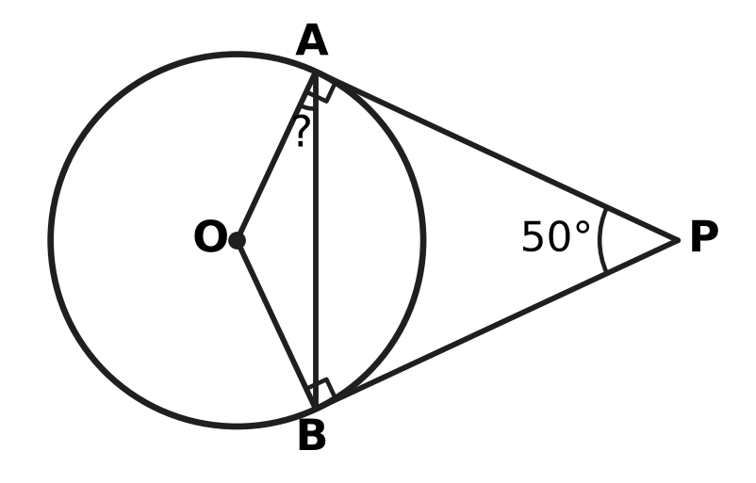
  (A) 65° | (B) 40° | (C) 25° | (D) 130°

Q19. In the figure, D lies on AB and E lies on AC, and ∠ADE = ∠ACB (marked). AD = 6 cm, DB = 6 cm and AE = 4 cm. What is the length of AC? | 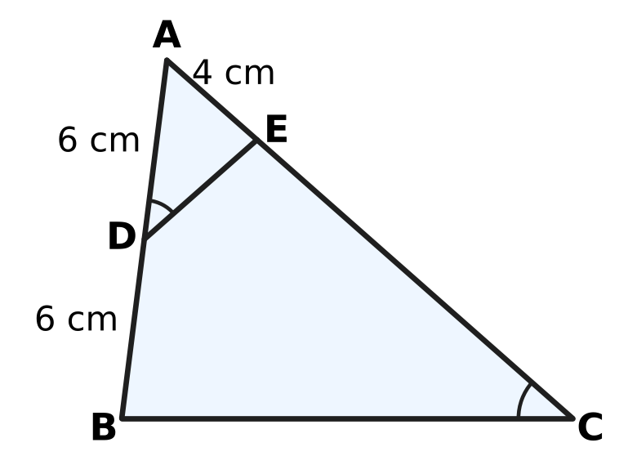
  (A) 18 cm | (B) 13 cm | (C) 8 cm | (D) 12 cm

Part 5 — Mensuration (Syllabus Chapter 6)
Q20. Which of these sectors of a circle has the largest area?
(A) radius 28 cm, angle 20° | (B) radius 21 cm, angle 45°
(C) radius 7 cm, angle 300° | (D) radius 14 cm, angle 90°

Q21. A paper cup used at a picnic is shaped like a frustum of a cone. Its top radius is 5 cm, its bottom radius is 3 cm and its height is 6 cm, as shown. How much water can it hold when full? (Use π = $\frac{22}{7}$.) | 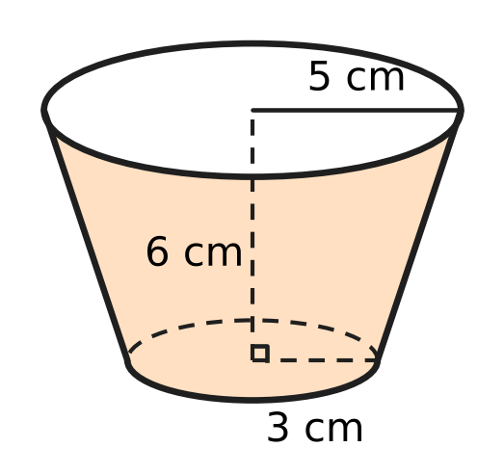
  (A) 462 cm³ | (B) 308 cm³ | (C) 924 cm³ | (D) 616 cm³

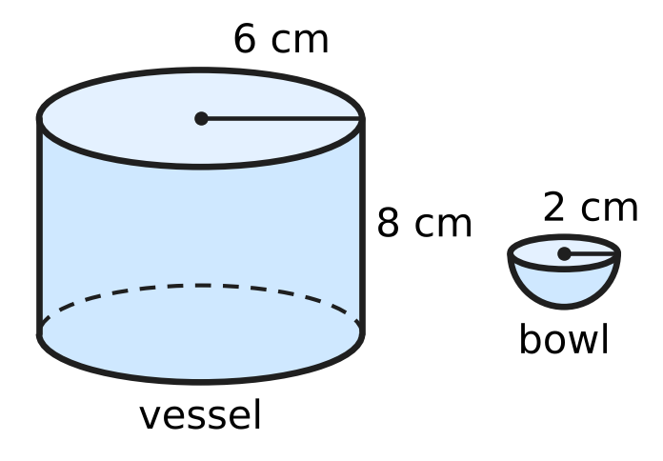
Q22. A cylindrical vessel of radius 6 cm and height 8 cm is full of water. All the water is poured into hemispherical bowls of radius 2 cm, shown in the figure, and each bowl is filled to the brim. How many bowls are filled?
(A) 27 | (B) 36 | (C) 108 | (D) 54

Q23. A sector of a circle has an arc of length 18 cm and an area of 81 cm², as shown. What is the radius r of the circle? | 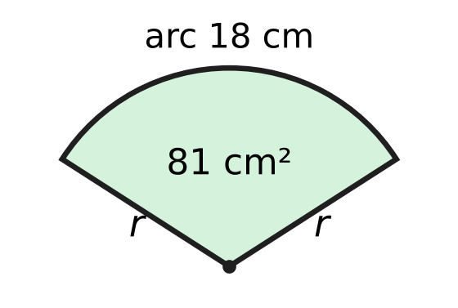
  (A) 9 cm | (B) 12 cm | (C) 4.5 cm | (D) 18 cm

Q24. A solid is made of a cube of edge 14 cm with a hemisphere of radius 7 cm fixed on its top face, as shown. What is the total surface area of the solid? (Use π = $\frac{22}{7}$.) | 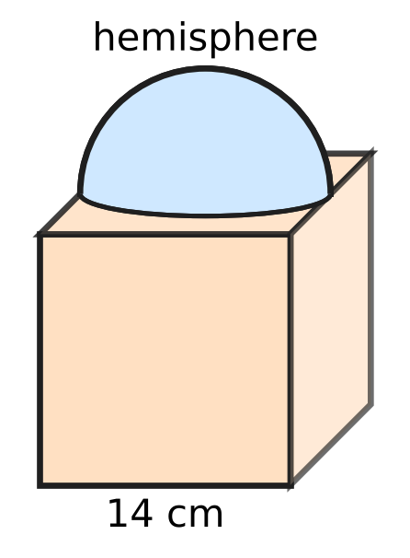
  (A) 1,022 cm² | (B) 1,484 cm²
  (C) 1,330 cm² | (D) 1,176 cm²

Part 6 — Trigonometry & Heights and Distances (Syllabus Chapter 7)
Q25. Which of these has the greatest value?
(A) sin 60° + cos 60° | (B) sec 45°
(C) tan 60° | (D) cosec 30°

Q26. Which of these is equal to $\sin^{4}θ−\cos^{4}θ$ for every angle θ?
(A) $2\sin^{2}θ−1$ | (B) ${(sinθ−cosθ)}^{2}$
(C) $1−2\sin^{2}θ$ | (D) $1$

Q27. A ladder 10 m long stands with its bottom end at one point of a level lane between two vertical walls. Leaning on one wall, it makes an angle of 60° with the ground. Turned about its bottom end to lean on the other wall, it makes 30° with the ground, as shown. How far apart are the two walls? | 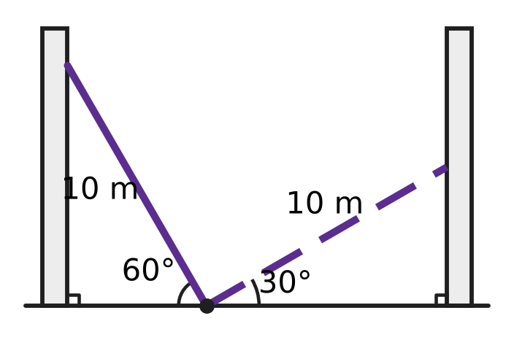
  (A) 20 m | (B) $5(\sqrt{3}−1)$ m
  (C) $5(\sqrt{3}+1)$ m | (D) $5\sqrt{3}$ m

Part 7 — Data Handling, Statistics & Probability (Syllabus Chapter 8)
Lengths of the fish in an aquarium
Length (cm) | 2–6 | 6–10 | 10–14 | 14–18 | 18–22
Number of fish | 3 | 7 | 6 | 3 | 1

Q28. The table shows the lengths of the 20 fish in an aquarium. What is the mean length of a fish, using the class marks?
(A) 8 cm | (B) 10.4 cm | (C) 8.4 cm | (D) 12 cm

Q29. Bowl X has 1 red bead and 3 white beads. Bowl Y has 1 red bead and 4 white beads. One bead is taken at random from each bowl. What is the probability that both beads are white?
(A) $\frac{2}{5}$ | (B) $\frac{3}{5}$ | (C) $\frac{7}{9}$ | (D) $\frac{1}{20}$

Q30. A fair coin is tossed and a fair die is thrown at the same time. Which of these events has the greatest probability?
(A) a head, or a number from 3 to 6 | (B) a number greater than 2
(C) a head, or a number greater than 3 | (D) a tail and a number less than 6

Part 8 — Applied Mathematics (Syllabus Chapter 9)
Q31. A shoe rack is marked ₹2,400. Which of these offers gives the lowest price?
(A) a single discount of 30% | (B) 20% off, then a further 15% off
(C) 10% off, then a further 25% off | (D) 15% off, then a further 15% off

Q32. Akash paints twice as fast as Rekha. Working together, they paint a fence in 6 days. How many days would Rekha take to paint the fence alone?
(A) 3 days | (B) 12 days | (C) 9 days | (D) 18 days

Q33. A bill for goods sold within a state shows SGST of ₹63, charged at 9%. CGST is charged at the same rate. What is the price of the goods before GST?
(A) ₹1,400 | (B) ₹826 | (C) ₹700 | (D) ₹350

Q34. A tap fills an empty water tank in 3 hours. Because of a leak at the bottom, the tank takes 3 hours 30 minutes to fill. If the tank is full and the tap is closed, how long will the leak take to empty it?
(A) 21 hours | (B) 0.5 hours
(C) 10.5 hours | (D) 6.5 hours

Q35. Two towns stand 80 km apart on the bank of a river that flows at 4 km/h. Two boats, each with a speed of 16 km/h in still water, start at the same time from the two towns towards each other. How long after starting do they meet?
(A) 2 hours | (B) 5 hours
(C) 3 hours 20 minutes | (D) 2 hours 30 minutes

Part 9 — Mathematical Reasoning & Problem-Solving (Syllabus Chapter 10)
Q36. A tree has 8 nests. Birds settle in them, and every bird is in some nest. What is the least number of birds that makes sure that some nest has at least 5 birds?
(A) 32 | (B) 33 | (C) 40 | (D) 41

Q37. How many of the whole numbers from 1 to 100 are divisible by 2 or by 5 (or by both)?
(A) 40 | (B) 60 | (C) 70 | (D) 50

Q38. Two players take turns to remove 1, 2, 3 or 4 matchsticks from a pile of 38. The player who removes the last matchstick wins. How many matchsticks should the first player remove at the start to be sure of winning?
(A) 3 | (B) 1 | (C) 4 | (D) 2

Q39. On sports day, 6 teams play a tug-of-war league. Each team plays every other team once, and every match has a winner (no draws). What is the greatest number of teams that can each win at least 4 matches?
(A) 5 | (B) 4 | (C) 2 | (D) 3

Q40. How many different triangles have sides that are whole numbers of centimetres and a perimeter of 15 cm? Triangles with the same three side lengths count as the same triangle.
(A) 6 | (B) 3 | (C) 7 | (D) 19

SECTION II — Star Questions 5 questions × 4 marks each
Q41. The berths in a train coach are numbered so that the numbers form an arithmetic progression. The first berth is numbered 2 and the 24th (last) berth is numbered 71. Passengers each take a different berth of this coach. What is the least number of passengers that makes sure that four of them have berth numbers with the same tens digit, where 2, 5 and 8 count as having tens digit 0? [4 marks]
(A) 25 | (B) 31 | (C) 22 | (D) 23

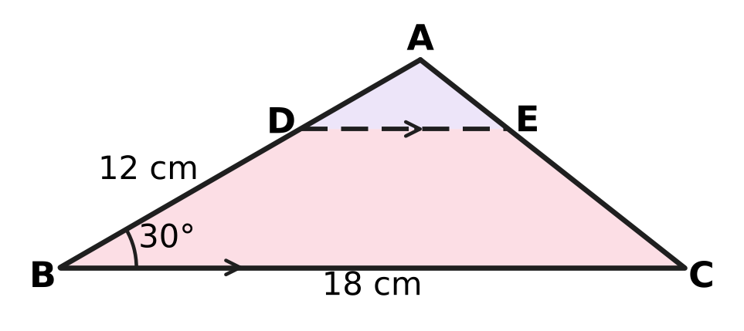
Q42. A triangular piece of cloth ABC has AB = 12 cm, BC = 18 cm and ∠ABC = 30°, as shown. It is cut along DE, where D is on AB, E is on AC, DE ∥ BC and AD : DB = 1 : 2. What is the area of the piece DBCE? [4 marks]
(A) 72 cm² | (B) 36 cm² | (C) 48 cm² | (D) 54 cm²

Q43. The three sides of a right triangle, in cm, form an arithmetic progression, and its perimeter is 48 cm. A perpendicular is drawn from the vertex of the right angle to the longest side. How long is this perpendicular? [4 marks]
(A) 9.6 cm | (B) 7.2 cm | (C) 10 cm | (D) 12 cm

Q44. Mira has ₹50,000 in a bank that pays interest at 12% per year, compounded half-yearly. She wants a laptop priced ₹50,000. The shop lets her either pay now with a 10% discount, or pay the full ₹50,000 one year from now with no extra charge. Any money left unspent stays in the bank. Which way leaves her with more money one year from now, and by how much? [4 marks]
(A) Paying later, by ₹1,180 | (B) Paying later, by ₹562
(C) Paying now, by ₹562 | (D) Paying later, by ₹400

Q45. A solid clay cone of radius 7 cm and height 12 cm, shown in the figure, is reshaped, with no clay lost, into a cuboid. Each edge of the cuboid is a whole number of centimetres. What is the least possible total surface area of the cuboid? (Use π = $\frac{22}{7}$.) [4 marks] | 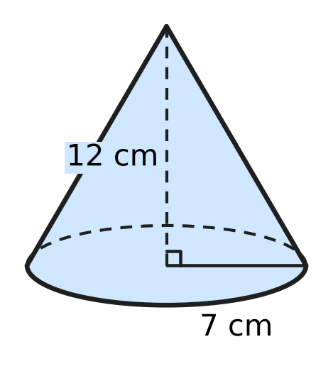
  (A) 221 cm² | (B) 540 cm² | (C) 508 cm² | (D) 442 cm²
Answer Sheet AMO Level 1 · Class 10 · Practice Paper 2
Name: | School: | Roll No.:
Shade or tick one circle for each question.
1. Ⓐ Ⓑ Ⓒ Ⓓ | 16. Ⓐ Ⓑ Ⓒ Ⓓ | 31. Ⓐ Ⓑ Ⓒ Ⓓ
2. Ⓐ Ⓑ Ⓒ Ⓓ | 17. Ⓐ Ⓑ Ⓒ Ⓓ | 32. Ⓐ Ⓑ Ⓒ Ⓓ
3. Ⓐ Ⓑ Ⓒ Ⓓ | 18. Ⓐ Ⓑ Ⓒ Ⓓ | 33. Ⓐ Ⓑ Ⓒ Ⓓ
4. Ⓐ Ⓑ Ⓒ Ⓓ | 19. Ⓐ Ⓑ Ⓒ Ⓓ | 34. Ⓐ Ⓑ Ⓒ Ⓓ
5. Ⓐ Ⓑ Ⓒ Ⓓ | 20. Ⓐ Ⓑ Ⓒ Ⓓ | 35. Ⓐ Ⓑ Ⓒ Ⓓ
6. Ⓐ Ⓑ Ⓒ Ⓓ | 21. Ⓐ Ⓑ Ⓒ Ⓓ | 36. Ⓐ Ⓑ Ⓒ Ⓓ
7. Ⓐ Ⓑ Ⓒ Ⓓ | 22. Ⓐ Ⓑ Ⓒ Ⓓ | 37. Ⓐ Ⓑ Ⓒ Ⓓ
8. Ⓐ Ⓑ Ⓒ Ⓓ | 23. Ⓐ Ⓑ Ⓒ Ⓓ | 38. Ⓐ Ⓑ Ⓒ Ⓓ
9. Ⓐ Ⓑ Ⓒ Ⓓ | 24. Ⓐ Ⓑ Ⓒ Ⓓ | 39. Ⓐ Ⓑ Ⓒ Ⓓ
10. Ⓐ Ⓑ Ⓒ Ⓓ | 25. Ⓐ Ⓑ Ⓒ Ⓓ | 40. Ⓐ Ⓑ Ⓒ Ⓓ
11. Ⓐ Ⓑ Ⓒ Ⓓ | 26. Ⓐ Ⓑ Ⓒ Ⓓ | 41. Ⓐ Ⓑ Ⓒ Ⓓ
12. Ⓐ Ⓑ Ⓒ Ⓓ | 27. Ⓐ Ⓑ Ⓒ Ⓓ | 42. Ⓐ Ⓑ Ⓒ Ⓓ
13. Ⓐ Ⓑ Ⓒ Ⓓ | 28. Ⓐ Ⓑ Ⓒ Ⓓ | 43. Ⓐ Ⓑ Ⓒ Ⓓ
14. Ⓐ Ⓑ Ⓒ Ⓓ | 29. Ⓐ Ⓑ Ⓒ Ⓓ | 44. Ⓐ Ⓑ Ⓒ Ⓓ
15. Ⓐ Ⓑ Ⓒ Ⓓ | 30. Ⓐ Ⓑ Ⓒ Ⓓ | 45. Ⓐ Ⓑ Ⓒ Ⓓ
Q41–Q45 are Section II Star Questions (4 marks each).
For the parent or teacher
Section I correct: ______ / 40 × 2 = ______ marks Section II correct: ______ / 5 × 4 = ______ marks
Correct: ______ / 45 Score: ______ / 100
Answer Key and Solutions AMO Level 1 · Class 10 · Practice Paper 2
Quick answers
1 D | 6 A | 11 A | 16 A | 21 B | 26 A | 31 C | 36 B | 41 D
2 A | 7 D | 12 B | 17 D | 22 D | 27 C | 32 D | 37 B | 42 C
3 B | 8 B | 13 D | 18 C | 23 A | 28 B | 33 C | 38 A | 43 A
4 C | 9 C | 14 C | 19 A | 24 C | 29 B | 34 A | 39 D | 44 B
5 C | 10 D | 15 B | 20 B | 25 D | 30 A | 35 D | 40 C | 45 D
Solutions
Q | Part · level | Answer | Why?
1 | Part 1 · Ch1 · Easy | (D) 2² × 3 | The HCF takes only the common primes 2 and 3, each to its smaller power: 2² × 3 = 12.
2 | Part 1 · Ch1 · Easy | (A) 21 | Here 150 = 2 × 3 × 5². The factor 3 must cancel, so k must be a multiple of 3: $\frac{21}{150}=\frac{7}{50}$ = 0.14.
3 | Part 1 · Ch1 · Medium | (B) 217 | The HCF is the last non-zero remainder, so s = 7. Then r = 4 × 7 = 28, b = 2 × 28 + 7 = 63 and a = 3 × 63 + 28 = 217.
4 | Part 2 · Ch3 · Easy | (C) ₹72,200 | The rate is 5% per half-year for 2 half-years: 80,000 × 0.95 × 0.95 = ₹72,200.
5 | Part 2 · Ch3 · Easy | (C) Jai ₹45,000 for 8 months; Gita ₹36,000 for 10 months | Capital × months: 45,000 × 8 = 360,000 and 36,000 × 10 = 360,000, which are equal.
6 | Part 2 · Ch3 · Easy | (A) 5 : 6 : 5 | Multiply term by term: 2 × 5 : 3 × 4 : 5 × 2 = 10 : 12 : 10 = 5 : 6 : 5.
7 | Part 2 · Ch3 · Medium | (D) ₹8,640 | Atharv: 40,000 × 4 + 70,000 × 8 = 720,000. Nitya: 50,000 × 12 = 600,000. Ratio 6 : 5, so Atharv gets 15,840 × 6/11 = ₹8,640.
8 | Part 2 · Ch3 · Medium | (B) 10% per year, compounded half-yearly | Amounts: (A) 60,000 × 1.04 × 1.06 = ₹66,144; (B) 60,000 × 1.05 × 1.05 = ₹66,150; (C) 60,000 × 1.04 × 1.04 = ₹64,896; (D) ₹66,000. Scheme (B) gives the most.
9 | Part 3 · Ch4 · Easy | (C) 9x² − 30x + 25 = 0 | Equal roots need b² − 4ac = 0: for 9x² − 30x + 25 = 0, 900 − 4 × 9 × 25 = 0. It is (3x − 5)² = 0.
10 | Part 3 · Ch4 · Easy | (D) 192 | A term is −4 + 7(n − 1), so 192 + 4 = 196 must be a multiple of 7: 196 = 7 × 28, so 192 is the 29th term.
11 | Part 3 · Ch4 · Easy | (A) ₹50 | Adding the two pair totals counts bananas twice: 190 + 170 = 360, and 360 − 310 = ₹50.
12 | Part 3 · Ch4 · Medium | (B) −5 | For x³ + ax² + bx + d, the product of the zeroes is −d = 30. So 2 × (−3) × k = 30, giving k = −5.
13 | Part 3 · Ch4 · Medium | (D) 9 | If there are x rows, x(x + 4) = 117, so x² + 4x − 117 = 0, which is (x + 13)(x − 9) = 0. So x = 9.
14 | Part 3 · Ch4 · Medium | (C) 0 | S₁₀ = S₁₅ gives 5(96 + 9d) = 7.5(96 + 14d), so d = −4. Then S₂₅ = 12.5 × (96 + 24 × (−4)) = 0.
15 | Part 4 · Ch5 · Easy | (B) (7, 11) | From (2, −1) to (7, 11): √(5² + 12²) = √169 = 13.
16 | Part 4 · Ch5 · Easy | (A) 6 cm, 9 cm and 12 cm | The ratios 6/4 = 9/6 = 12/8 = 1.5 are equal, so the triangles are similar (SSS similarity).
17 | Part 4 · Ch5 · Easy | (D) (5, −2) | By the section formula, M = (2A + B) ÷ 3, so B = 3M − 2A = (3 + 2, 6 − 8) = (5, −2).
18 | Part 4 · Ch5 · Medium | (C) 25° | PA = PB, so ∠PAB = (180° − 50°) ÷ 2 = 65°. OA ⊥ PA, so ∠OAB = 90° − 65° = 25°.
19 | Part 4 · Ch5 · Medium | (A) 18 cm | Triangles ADE and ACB share ∠A and have ∠ADE = ∠ACB, so they are similar: AD/AC = AE/AB, so AC = 6 × 12 ÷ 4 = 18 cm.
20 | Part 5 · Ch6 · Easy | (B) radius 21 cm, angle 45° | The area is proportional to r² × angle: 441 × 45 = 19,845, more than 196 × 90 = 17,640, 784 × 20 = 15,680 and 49 × 300 = 14,700.
21 | Part 5 · Ch6 · Easy | (B) 308 cm³ | V = ⅓πh(R² + r² + Rr) = ⅓ × 22/7 × 6 × (25 + 9 + 15) = 44/7 × 49 = 308 cm³.
22 | Part 5 · Ch6 · Easy | (D) 54 | Water: π × 36 × 8 = 288π cm³. One bowl: ⅔π × 8 = 16π/3 cm³. 288π ÷ 16π/3 = 54 bowls.
23 | Part 5 · Ch6 · Medium | (A) 9 cm | Area of a sector = ½ × r × (arc length), because θ/360 × πr² = ½ × r × (θ/360 × 2πr). So 81 = ½ × r × 18 and r = 9 cm.
24 | Part 5 · Ch6 · Medium | (C) 1,330 cm² | The cube gives 6 × 196 = 1,176. Subtract the hidden circle 154 and add the curved surface 2 × 154 = 308: 1,176 − 154 + 308 = 1,330 cm².
25 | Part 6 · Ch7 · Easy | (D) cosec 30° | cosec 30° = 1 ÷ sin 30° = 2, while tan 60° ≈ 1.73, sec 45° ≈ 1.41 and sin 60° + cos 60° ≈ 1.37.
26 | Part 6 · Ch7 · Easy | (A) $2\sin^{2}θ−1$ | sin⁴θ − cos⁴θ = (sin²θ + cos²θ)(sin²θ − cos²θ) = sin²θ − (1 − sin²θ) = 2sin²θ − 1.
27 | Part 6 · Ch7 · Medium | (C) $5(\sqrt{3}+1)$ m | Distances from the bottom end: 10 × cos 60° = 5 m and 10 × cos 30° = 5√3 m. Width = 5 + 5√3 = 5(√3 + 1) m.
28 | Part 7 · Ch8 · Easy | (B) 10.4 cm | Σfx = 3 × 4 + 7 × 8 + 6 × 12 + 3 × 16 + 1 × 20 = 208, and 208 ÷ 20 = 10.4 cm.
29 | Part 7 · Ch8 · Easy | (B) $\frac{3}{5}$ | P(white from X) = 3/4 and P(white from Y) = 4/5. Both: 3/4 × 4/5 = 3/5.
30 | Part 7 · Ch8 · Medium | (A) a head, or a number from 3 to 6 | There are 12 equally likely outcomes. Only a tail with a 1 or 2 fails "a head, or a number from 3 to 6", so it has 10/12 = 5/6, more than 3/4, 2/3 and 5/12.
31 | Part 8 · Ch9 · Easy | (C) 10% off, then a further 25% off | Prices: 2,400 × 0.9 × 0.75 = ₹1,620; × 0.8 × 0.85 = ₹1,632; × 0.7 = ₹1,680; × 0.85 × 0.85 = ₹1,734.
32 | Part 8 · Ch9 · Easy | (D) 18 days | Rekha does 1 part and Akash 2 parts a day, so together they do 3 times Rekha's rate. Rekha alone takes 3 × 6 = 18 days.
33 | Part 8 · Ch9 · Easy | (C) ₹700 | ₹63 is 9% of the price, so the price is 63 × 100 ÷ 9 = ₹700.
34 | Part 8 · Ch9 · Medium | (A) 21 hours | Per hour: tap 1/3, tap with leak 2/7. Leak = 1/3 − 2/7 = 1/21 of the tank per hour, so 21 hours.
35 | Part 8 · Ch9 · Medium | (D) 2 hours 30 minutes | They close the gap at (16 + 4) + (16 − 4) = 32 km/h: the stream helps one boat and slows the other equally. 80 ÷ 32 = 2.5 hours, which is 2 hours 30 minutes.
36 | Part 9 · Ch10 · Easy | (B) 33 | With 32 birds, each nest can hold 4, so 32 is not enough. With 33 birds, 4 or fewer in each nest would hold at most 32, so some nest has at least 5.
37 | Part 9 · Ch10 · Easy | (B) 60 | There are 50 multiples of 2 and 20 multiples of 5, but the 10 multiples of 10 are counted twice: 50 + 20 − 10 = 60.
38 | Part 9 · Ch10 · Easy | (A) 3 | Taking 3 leaves 35, a multiple of 5. After that, whatever the other player takes (1 to 4), the first player takes enough to make 5 in that round, so the pile stays a multiple of 5 until the first player takes the last matchstick.
39 | Part 9 · Ch10 · Medium | (D) 3 | There are 15 matches, so 15 wins in all. Four teams with 4 wins would need 16 wins. Three is possible: three teams beat the other three and beat each other in a cycle, 3 + 1 = 4 wins each.
40 | Part 9 · Ch10 · Medium | (C) 7 | The longest side must be less than half of 15, so it is 5, 6 or 7: (5, 5, 5), (4, 5, 6), (3, 6, 6), (1, 7, 7), (2, 6, 7), (3, 5, 7), (4, 4, 7).
41 | Section II · Ch4 + Ch10 · Hard | (D) 23 | d = (71 − 2) ÷ 23 = 3, so the berths are 2, 5, 8, 11, …, 71. Tens digits 0 to 6 have 3, 3, 4, 3, 3, 4, 3 berths and 7 has only 71. Taking at most 3 from each group gives 3 × 7 + 1 = 22 passengers with no four alike, so 23 make sure of it.
42 | Section II · Ch5 + Ch7 · Hard | (C) 48 cm² | The height of A above BC is 12 × sin 30° = 6 cm, so ABC has area 54 cm². By BPT, DE = 18 ÷ 3 = 6 cm and D is 4 cm above BC. DBCE = ½ × (6 + 18) × 4 = 48 cm².
43 | Section II · Ch4 + Ch5 · Hard | (A) 9.6 cm | Sides a − d, a, a + d: 3a = 48, so a = 16. (16 − d)² + 16² = (16 + d)² gives d = 4: sides 12, 16, 20. The perpendicular is 12 × 16 ÷ 20 = 9.6 cm.
44 | Section II · Ch3 + Ch9 · Hard | (B) Paying later, by ₹562 | Paying now: the ₹5,000 saved grows to 5,000 × 1.06 × 1.06 = ₹5,618. Paying later: ₹50,000 grows to ₹56,180, and ₹6,180 is left after paying. Paying later is ahead by 6,180 − 5,618 = ₹562.
45 | Section II · Ch6 + Ch10 · Hard | (D) 442 cm² | Volume = ⅓ × 22/7 × 49 × 12 = 616 = 2³ × 7 × 11. The surface is least when the edges are as close as possible: 7 × 8 × 11, with area 2(56 + 88 + 77) = 442 cm². Checking every way of writing 616 as a product of three whole numbers confirms this; the next best, 4 × 11 × 14, gives 508 cm².

ARYABHATTA MATHS OLYMPIAD
Level 1
PRACTICE PAPER-3
CLASS 10
Total Questions | 45 multiple-choice questions
Total Marks | 100
Time | 60 minutes
Section I | 40 questions × 2 marks = 80 marks
Section II | 5 Star Questions × 4 marks = 20 marks
Negative Marking | No negative marking
Calculator | Not allowed
Chapters | Number System · Fractions, Decimals & Percentages · Algebra · Geometry · Mensuration · Trigonometry · Data Handling · Applied Mathematics · Mathematical Reasoning

Instructions to candidates
• This paper has 45 multiple-choice questions. Each question has four answer choices, of which exactly one is correct.
• Section I (Q1–Q40) carries 2 marks per question. Section II (Q41–Q45) carries 4 marks per question.
• There is no negative marking. Unanswered questions score zero.
• Calculators are not permitted. Rough work may be done on a separate sheet.
• Mark your answers on the answer sheet at the end of the paper.
• All figures are not necessarily drawn to scale unless stated.

For parents and teachers
• Print or view this paper in colour. Pictures are part of the questions.
• Parts follow the AMO syllabus chapters. Chapter 2 is not part of the Class 10 syllabus, so the chapter numbers shown in the Part headings have gaps.
• The answer sheet and the answer key are at the end. Remove only the answer key before the student begins.

SECTION I 40 questions × 2 marks each
Part 1 — Number System (Syllabus Chapter 1)
Q1. What is the smallest natural number that is divisible by every whole number from 1 to 10?
(A) 1,260 | (B) 2,520
(C) 3,628,800 | (D) 5,040

Q2. The number 3 × 5 × 7 × 11 + 11 is composite. It can be written as 11 × $□$. Which number goes in the box?
(A) 106 | (B) 1,155 | (C) 105 | (D) 116

Q3. A natural number n leaves a remainder of 5 when it is divided by 9. What remainder does n² leave when it is divided by 9?
(A) 1 | (B) 4 | (C) 5 | (D) 7

Part 2 — Fractions, Decimals & Percentages (Syllabus Chapter 3)
Q4. Charu and Bharat run the school canteen as partners for a year. Charu puts in ₹24,000 and Bharat puts in ₹40,000. The year's profit is shared in the ratio of their capitals, and Charu's share is ₹4,500. What is the total profit?
(A) ₹9,000 | (B) ₹7,200 | (C) ₹12,000 | (D) ₹7,500

Q5. A deposit earns compound interest at 10% per year, added once a year. The interest for the 2nd year is ₹2,200. The interest for the 3rd year is $□$. Which amount completes the statement?
(A) ₹2,640 | (B) ₹2,200 | (C) ₹2,662 | (D) ₹2,420

Q6. Vidya deposits her savings of ₹26,000 for 2 years at 5% per year, compounded yearly. The interest she earns is $□$. Which amount completes the statement?
(A) ₹2,600 | (B) ₹2,665 | (C) ₹28,665 | (D) ₹1,365

Q7. A sum of money is lent at 24% per year, compounded half-yearly. After one year, ₹78,400 is due. What sum was lent?
(A) ₹59,584 | (B) ₹68,992 | (C) ₹62,500 | (D) ₹70,000

Q8. Sneha starts a beekeeping business with ₹50,000. After 5 months, Vikram joins with ₹80,000. The profit at the end of the year is shared in the ratio of capital × time, and Sneha gets ₹1,000 more than Vikram. What is the total profit?
(A) ₹29,000 | (B) ₹15,000 | (C) ₹5,000 | (D) ₹14,000

Part 3 — Algebra (Syllabus Chapter 4)
Q9. One zero of the polynomial $3x^{2}−8x+k$ is 2. Its other zero is $□$. Which number goes in the box?
(A) 6 | (B) $\frac{14}{3}$ | (C) $\frac{2}{3}$ | (D) $\frac{4}{3}$

Q10. The numbers x + 2, 3x and 4x + 1 are consecutive terms of an arithmetic progression. Then x = $□$. Which number goes in the box?
(A) 5 | (B) 3 | (C) −3 | (D) 9

Q11. Look at the equations:
x + 2y + 3z = 14; 2x + 3y + z = 11; 3x + y + 2z = 11.
From these, x + y + z = $□$. Which number goes in the box?
(A) 6 | (B) 18 | (C) 36 | (D) 12

Q12. When $p(x)=x^{3}+ax+b$ is divided by $x−1$, the remainder is 3. When it is divided by $x+2$, the remainder is 6. Then a = $□$. Which number goes in the box?
(A) 4 | (B) 2 | (C) 6 | (D) −4

Q13. Three numbers are in an arithmetic progression with a positive common difference. Their sum is 27 and their product is 648. The largest of the three numbers is $□$. Which number goes in the box?
(A) 12 | (B) 15 | (C) 6 | (D) 9

Q14. As x takes all real values, the least value of $x^{2}−8x+21$ is $□$. Which number goes in the box?
(A) 4 | (B) 5 | (C) 37 | (D) 21

Part 4 — Geometry (Syllabus Chapter 5)
Q15. △ABC is similar to △DEF, with A matching D and B matching E. AB = 6 cm, DE = 9 cm and the perimeter of △ABC is 24 cm. The perimeter of △DEF is $□$. Which length goes in the box?
(A) 16 cm | (B) 27 cm | (C) 36 cm | (D) 54 cm

Q16. The points A(−3, 2) and B(5, k) are 10 units apart, and k is positive. Then k = $□$. Which number goes in the box?
(A) 10 | (B) 4 | (C) 6 | (D) 8

Q17. In the figure, two straight lines through P touch a circle of radius 5 cm, centre O, at A and B. The two lines meet at right angles at P. How far is P from A? | 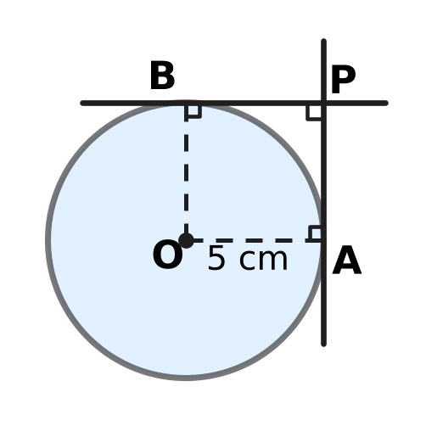
  (A) 5√2 cm | (B) 10 cm | (C) 5 cm | (D) 2.5 cm

Q18. R is (−2, −1) and S is (10, 8). The point M($□$, 5) lies on the segment RS. Which number goes in the box?
(A) 6 | (B) 2 | (C) 5.5 | (D) 4

Q19. Two vertical poles, 10 m and 15 m tall, stand 20 m apart on level ground. A straight wire runs from the top of each pole to the bottom of the other, as shown. At what height h above the ground do the wires cross? | 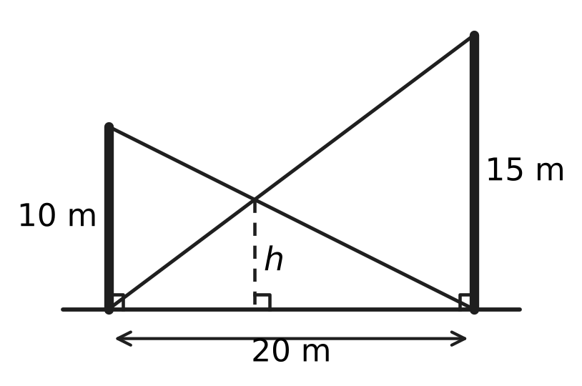
  (A) 7.5 m | (B) 5 m | (C) 12.5 m | (D) 6 m

Part 5 — Mensuration (Syllabus Chapter 6)
Q20. A glass window is a rectangle 14 cm wide and 10 cm tall with a semicircle on its top side, as shown. What is the area of the glass? (Use π = 22/7.) | 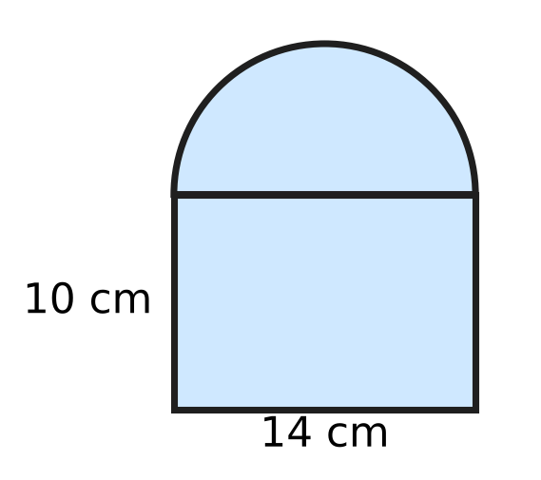
  (A) 448 cm² | (B) 217 cm² | (C) 294 cm² | (D) 162 cm²

Q21. Three solid metal cubes with edges 3 cm, 4 cm and 5 cm are melted and recast into one solid cube, with no metal lost. The edge of the new cube is $□$. Which length goes in the box?
(A) 216 cm | (B) 12 cm | (C) 6 cm | (D) 4 cm

Q22. A bucket is shaped like a frustum of a cone. The circumference of its top rim is 110 cm, the circumference of its bottom is 66 cm, and its slant height is 16 cm, as shown. What is its curved surface area? | 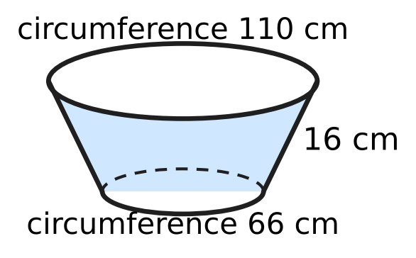
  (A) 2,816 cm² | (B) 880 cm²
  (C) 528 cm² | (D) 1,408 cm²

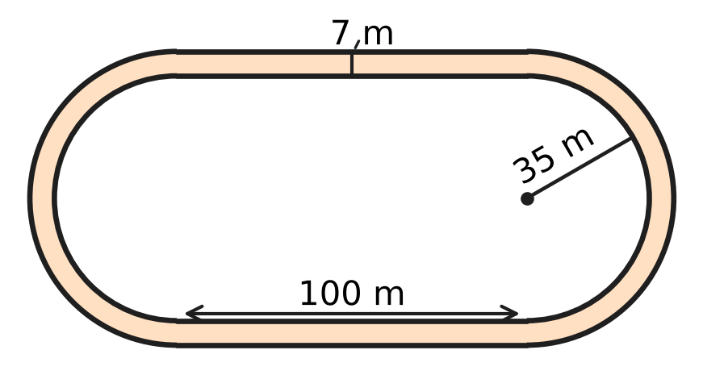
Q23. The running track in the figure has two straight parts of 100 m and two semicircular ends. The inner edge of each end has radius 35 m, and the track is 7 m wide. Kavin runs one lap along the outer edge. How much farther does he run than a runner who goes along the inner edge? (Use π = 22/7.)
(A) 14 m | (B) 44 m | (C) 22 m | (D) 88 m

Q24. A solid wooden cylinder has radius 21 cm and height 20 cm. A cone of the same radius and height is hollowed out of it from the top face, as shown (the dashed lines). What is the total surface area of the remaining solid? (Use π = 22/7.) | 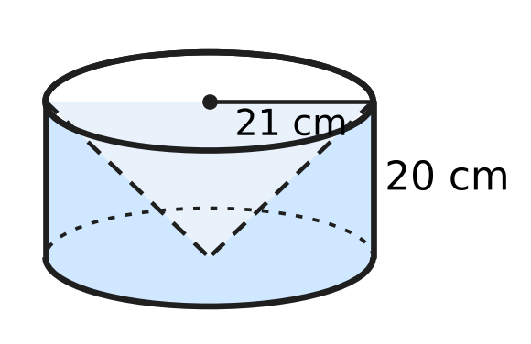
  (A) 5,940 cm² | (B) 5,346 cm²
  (C) 4,026 cm² | (D) 7,326 cm²

Part 6 — Trigonometry & Heights and Distances (Syllabus Chapter 7)
Q25. For every acute angle θ, $1−\frac{\sin^{2}θ}{1+cosθ}$ = $□$. Which expression goes in the box?
(A) $1+cosθ$ | (B) $cosθ$
(C) $1−cosθ$ | (D) $sinθ$

Q26. The angle 3θ − 15° is acute and tan(3θ − 15°) = 1. Then θ = $□$. Which angle goes in the box?
(A) 20° | (B) 15° | (C) 25° | (D) 10°

Q27. A flagpole BT stands on the flat roof of a building, at its front edge B. From a point P on level ground, 24 m from the building, the angle of elevation of B is 30° and that of the top T is 60°, as shown. How tall is the flagpole? | 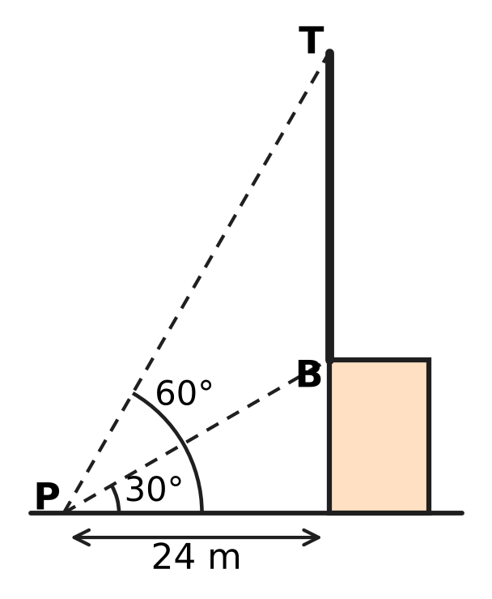
  (A) $8\sqrt{3}$ m | (B) 16 m
  (C) $16\sqrt{3}$ m | (D) $24\sqrt{3}$ m

Part 7 — Data Handling, Statistics & Probability (Syllabus Chapter 8)
Q28. A post office has three postboxes. Two letters are posted, one at a time. Each letter is equally likely to go into any of the three boxes, whatever happened to the other letter. What is the probability that both letters go into the same box?
(A) $\frac{1}{6}$ | (B) $\frac{2}{3}$ | (C) $\frac{1}{9}$ | (D) $\frac{1}{3}$

Q29. In a board game, a player throws two fair dice and multiplies the two numbers. What is the probability that the product is even?
(A) $\frac{3}{4}$ | (B) $\frac{1}{2}$ | (C) $\frac{1}{4}$ | (D) $\frac{2}{3}$

Time taken by 40 students to finish a puzzle
Time (minutes) | 10–20 | 20–30 | 30–40 | 40–50 | 50–60
Number of students | 6 | 12 | 10 | 7 | 5

Q30. The table shows how long 40 students took to finish a puzzle. What is the median time, found by the formula for grouped data?
(A) 35 minutes | (B) 22 minutes
(C) 32 minutes | (D) 52 minutes

Part 8 — Applied Mathematics (Syllabus Chapter 9)
Q31. At a flour mill, 75% of the mass of grain becomes flour. Grain comes in sacks of 50 kg each. How many sacks of grain are needed to make 600 kg of flour?
(A) 12 sacks | (B) 16 sacks | (C) 9 sacks | (D) 15 sacks

Q32. Juhi's club sells paper-plane kits. Its fixed costs are ₹9,000, and each kit costs ₹45 to make. To break even by selling exactly 600 kits, the selling price of a kit must be $□$. Which amount completes the statement?
(A) ₹15 | (B) ₹30 | (C) ₹75 | (D) ₹60

Q33. Three identical pipes, working together, fill an empty tank in 12 hours. Four such pipes, working together, fill it in $□$ hours. Which number goes in the box?
(A) 16 | (B) 36 | (C) 9 | (D) 3

Q34. A wall clock shop sells a clock within the state for ₹5,900. This price includes GST at 18%, which is split equally into CGST and SGST. How much CGST is included in the price?
(A) ₹1,062 | (B) ₹900 | (C) ₹531 | (D) ₹450

Q35. Ankit's motorboat leaves the harbour and goes up a river to a jetty, then comes back the same way. Going upstream takes 3 times as long as coming back downstream. What is the ratio of the speed of the boat in still water to the speed of the stream?
(A) 2 : 1 | (B) 4 : 3 | (C) 1 : 2 | (D) 3 : 1

Part 9 — Mathematical Reasoning & Problem-Solving (Syllabus Chapter 10)
Q36. Bus tickets carry the numbers 1,000 to 9,999. A ticket is lucky if its number reads the same forwards and backwards, such as 3,883. How many lucky tickets are there?
(A) 900 | (B) 90 | (C) 100 | (D) 81

Q37. On a museum visit, each of 35 students saw the science gallery, the art gallery, both or neither. Of them, 28 saw the science gallery and 25 saw the art gallery. What is the least possible number of students who saw both galleries?
(A) 25 | (B) 3 | (C) 7 | (D) 18

Q38. Each of 9 friends sends one message to every other friend in the group. How many messages are sent in all?
(A) 81 | (B) 36 | (C) 72 | (D) 18

Q39. What is the least number n such that among ANY n different whole numbers, there are always two whose sum or whose difference is divisible by 10?
(A) 7 | (B) 11 | (C) 6 | (D) 5

Q40. Twelve cards lie on a table, all face up. In one move you must turn over exactly 5 of the cards (any 5, face up or face down). What is the least number of moves needed to have all 12 cards face down?
(A) 3 | (B) 4 | (C) 5 | (D) 6

SECTION II — Star Questions 5 questions × 4 marks each
Q41. Three different numbers are chosen from the whole numbers 1 to 30 so that, written in increasing order, they form an arithmetic progression. For example, 4, 11, 18 is one such choice. How many such choices are there? [4 marks]
(A) 392 | (B) 420 | (C) 435 | (D) 210

Q42. A straight wire 24 m long runs from the top A of a vertical mast OA to a point B on the level ground, as shown. The angle of elevation of A from B is 30°. A lamp is fixed on the wire at M, where AM : MB = 1 : 3. How far is the lamp from the point O at the bottom of the mast? [4 marks] | 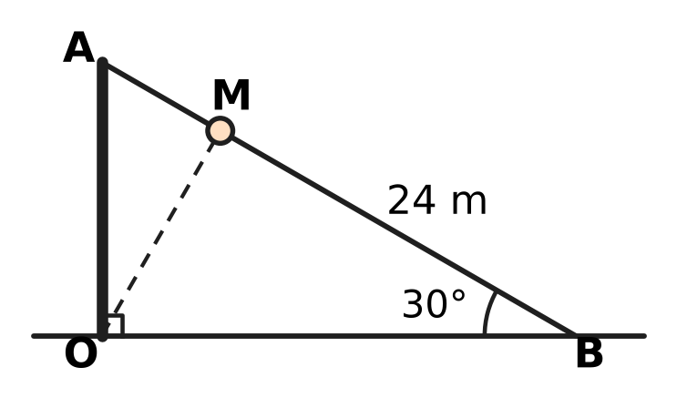
  (A) $6\sqrt{7}$ m | (B) $6\sqrt{3}$ m
  (C) 6 m | (D) 12 m

Q43. The figure shows the points A(0, 4) and B(6, 2). A point C is to be chosen on the x-axis so that ∠ACB = 90°. Which of these gives ALL the possible positions of C? [4 marks] | 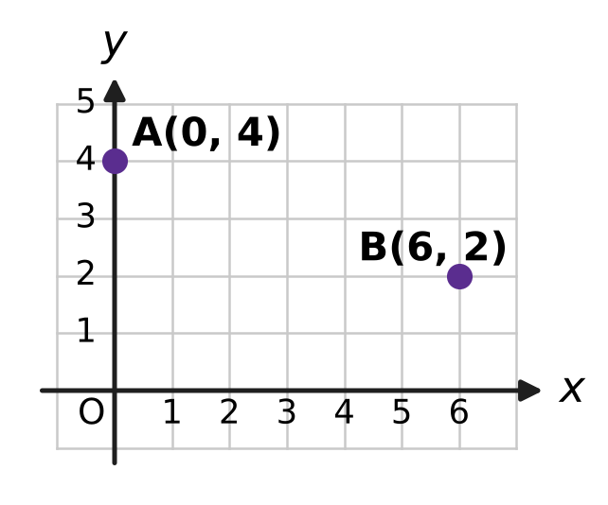
  (A) (2, 0) and (4, 0) | (B) (2, 0) only
  (C) (−2, 0) and (−4, 0) | (D) (3, 0) only

Q44. Hema borrows ₹40,000 to buy a kiln for clay pots, at 10% per year compounded half-yearly. She repays the whole amount at the end of one year. During the year she also spends ₹5,900 on fuel. Each pot costs ₹30 in clay and paint and sells for ₹80. What is the least number of pots she must sell in the year to cover the loan repayment and the fuel? [4 marks]
(A) 1,086 | (B) 998 | (C) 1,000 | (D) 882

Q45. Nirav melts a solid metal cylinder of radius 6 cm and height 7 cm. He recasts ALL the metal into solid spheres of radius 3 cm and solid cones of radius 3 cm and height 4 cm, with no metal lost. He makes at least one sphere and at least one cone. What is the greatest possible total number of solids? [4 marks]
(A) 7 | (B) 21 | (C) 9 | (D) 19

Answer Sheet AMO Level 1 · Class 10 · Practice Paper 3
Name: | School: | Roll No.:
Shade or tick one circle for each question.
1. Ⓐ Ⓑ Ⓒ Ⓓ | 16. Ⓐ Ⓑ Ⓒ Ⓓ | 31. Ⓐ Ⓑ Ⓒ Ⓓ
2. Ⓐ Ⓑ Ⓒ Ⓓ | 17. Ⓐ Ⓑ Ⓒ Ⓓ | 32. Ⓐ Ⓑ Ⓒ Ⓓ
3. Ⓐ Ⓑ Ⓒ Ⓓ | 18. Ⓐ Ⓑ Ⓒ Ⓓ | 33. Ⓐ Ⓑ Ⓒ Ⓓ
4. Ⓐ Ⓑ Ⓒ Ⓓ | 19. Ⓐ Ⓑ Ⓒ Ⓓ | 34. Ⓐ Ⓑ Ⓒ Ⓓ
5. Ⓐ Ⓑ Ⓒ Ⓓ | 20. Ⓐ Ⓑ Ⓒ Ⓓ | 35. Ⓐ Ⓑ Ⓒ Ⓓ
6. Ⓐ Ⓑ Ⓒ Ⓓ | 21. Ⓐ Ⓑ Ⓒ Ⓓ | 36. Ⓐ Ⓑ Ⓒ Ⓓ
7. Ⓐ Ⓑ Ⓒ Ⓓ | 22. Ⓐ Ⓑ Ⓒ Ⓓ | 37. Ⓐ Ⓑ Ⓒ Ⓓ
8. Ⓐ Ⓑ Ⓒ Ⓓ | 23. Ⓐ Ⓑ Ⓒ Ⓓ | 38. Ⓐ Ⓑ Ⓒ Ⓓ
9. Ⓐ Ⓑ Ⓒ Ⓓ | 24. Ⓐ Ⓑ Ⓒ Ⓓ | 39. Ⓐ Ⓑ Ⓒ Ⓓ
10. Ⓐ Ⓑ Ⓒ Ⓓ | 25. Ⓐ Ⓑ Ⓒ Ⓓ | 40. Ⓐ Ⓑ Ⓒ Ⓓ
11. Ⓐ Ⓑ Ⓒ Ⓓ | 26. Ⓐ Ⓑ Ⓒ Ⓓ | 41. Ⓐ Ⓑ Ⓒ Ⓓ
12. Ⓐ Ⓑ Ⓒ Ⓓ | 27. Ⓐ Ⓑ Ⓒ Ⓓ | 42. Ⓐ Ⓑ Ⓒ Ⓓ
13. Ⓐ Ⓑ Ⓒ Ⓓ | 28. Ⓐ Ⓑ Ⓒ Ⓓ | 43. Ⓐ Ⓑ Ⓒ Ⓓ
14. Ⓐ Ⓑ Ⓒ Ⓓ | 29. Ⓐ Ⓑ Ⓒ Ⓓ | 44. Ⓐ Ⓑ Ⓒ Ⓓ
15. Ⓐ Ⓑ Ⓒ Ⓓ | 30. Ⓐ Ⓑ Ⓒ Ⓓ | 45. Ⓐ Ⓑ Ⓒ Ⓓ
Q41–Q45 are Section II Star Questions (4 marks each).
For the parent or teacher
Section I correct: ______ / 40 × 2 = ______ marks Section II correct: ______ / 5 × 4 = ______ marks
Correct: ______ / 45 Score: ______ / 100
Answer Key and Solutions AMO Level 1 · Class 10 · Practice Paper 3
Quick answers
1 B | 6 B | 11 A | 16 D | 21 C | 26 A | 31 B | 36 B | 41 D
2 A | 7 C | 12 D | 17 C | 22 D | 27 C | 32 D | 37 D | 42 B
3 D | 8 A | 13 A | 18 A | 23 B | 28 D | 33 C | 38 C | 43 A
4 C | 9 C | 14 B | 19 D | 24 A | 29 A | 34 D | 39 A | 44 C
5 D | 10 B | 15 C | 20 B | 25 B | 30 C | 35 A | 40 B | 45 D
Solutions
Q | Part · level | Answer | Why?
1 | Part 1 · Ch1 · Easy | (B) 2,520 | Take the highest power of each prime up to 10: 2³ × 3² × 5 × 7 = 2,520.
2 | Part 1 · Ch1 · Easy | (A) 106 | 3 × 5 × 7 × 11 + 11 = 11 × (3 × 5 × 7 + 1) = 11 × 106, so it has the factor 11 and is composite.
3 | Part 1 · Ch1 · Medium | (D) 7 | Write n = 9q + 5. Then n² = 81q² + 90q + 25 = 9(9q² + 10q + 2) + 7, so the remainder is 7.
4 | Part 2 · Ch3 · Easy | (C) ₹12,000 | The ratio is 24,000 : 40,000 = 3 : 5. Charu has 3 of the 8 parts, so one part is ₹1,500 and the profit is 8 × 1,500 = ₹12,000.
5 | Part 2 · Ch3 · Easy | (D) ₹2,420 | Each year's interest is 10% more than the year before, because the balance has grown by 10%: 2,200 × 1.1 = ₹2,420.
6 | Part 2 · Ch3 · Easy | (B) ₹2,665 | Amount = 26,000 × 1.05 × 1.05 = ₹28,665, so the interest is 28,665 − 26,000 = ₹2,665 (₹65 more than simple interest).
7 | Part 2 · Ch3 · Medium | (C) ₹62,500 | The rate is 12% per half-year for 2 half-years, so the sum × 1.12 × 1.12 = 78,400. The sum is 78,400 ÷ 1.2544 = ₹62,500.
8 | Part 2 · Ch3 · Medium | (A) ₹29,000 | Sneha: 50,000 × 12 = 600,000. Vikram: 80,000 × 7 = 560,000. The ratio is 15 : 14, so 1 part = ₹1,000 and the profit is 29 × 1,000 = ₹29,000.
9 | Part 3 · Ch4 · Easy | (C) $\frac{2}{3}$ | The sum of the zeroes is 8/3. So the other zero is 8/3 − 2 = 2/3. (Also k = 4 and 2 × 2/3 = 4/3.)
10 | Part 3 · Ch4 · Easy | (B) 3 | For an AP, twice the middle term equals the sum of the other two: 6x = 5x + 3, so x = 3 (terms 5, 9, 13).
11 | Part 3 · Ch4 · Easy | (A) 6 | Adding the three equations gives 6x + 6y + 6z = 36, so x + y + z = 6.
12 | Part 3 · Ch4 · Medium | (D) −4 | p(1) = 1 + a + b = 3 and p(−2) = −8 − 2a + b = 6. So a + b = 2 and b − 2a = 14; subtracting, 3a = −12 and a = −4.
13 | Part 3 · Ch4 · Medium | (A) 12 | Take the numbers as 9 − d, 9, 9 + d. Then 9(81 − d²) = 648, so d² = 9 and d = 3. The numbers are 6, 9, 12.
14 | Part 3 · Ch4 · Medium | (B) 5 | x² − 8x + 21 = (x − 4)² + 5. A square is never negative, so the least value is 5, at x = 4.
15 | Part 4 · Ch5 · Easy | (C) 36 cm | In similar triangles the perimeters are in the ratio of matching sides, 9 : 6 = 3 : 2. So the perimeter is 24 × 3/2 = 36 cm.
16 | Part 4 · Ch5 · Easy | (D) 8 | 8² + (k − 2)² = 10², so (k − 2)² = 36 and k − 2 = 6 or −6. As k is positive, k = 8.
17 | Part 4 · Ch5 · Easy | (C) 5 cm | ∠OAP = ∠OBP = 90° and ∠APB = 90°, so OAPB is a rectangle with OA = OB; it is a square. Hence PA = OB = 5 cm.
18 | Part 4 · Ch5 · Medium | (A) 6 | From R to S, y rises by 9; from R to M it rises by 6. So RM : MS = 6 : 3 = 2 : 1 and x = −2 + (2/3) × 12 = 6.
19 | Part 4 · Ch5 · Medium | (D) 6 m | Let the crossing be x m from the 10 m pole. By similar triangles, h/10 = (20 − x)/20 and h/15 = x/20. Adding, h/10 + h/15 = 1, so h = 6 m.
20 | Part 5 · Ch6 · Easy | (B) 217 cm² | Rectangle 14 × 10 = 140 cm². Semicircle of radius 7 cm: ½ × 22/7 × 49 = 77 cm². Total 217 cm².
21 | Part 5 · Ch6 · Easy | (C) 6 cm | Volume = 27 + 64 + 125 = 216 cm³ = 6³, so the edge is 6 cm.
22 | Part 5 · Ch6 · Easy | (D) 1,408 cm² | CSA = π(R + r)l = ½(2πR + 2πr) × l = ½ × (110 + 66) × 16 = 1,408 cm².
23 | Part 5 · Ch6 · Medium | (B) 44 m | The straight parts are the same. The two semicircles make a full circle, so the extra distance is 2π × 42 − 2π × 35 = 2π × 7 = 44 m.
24 | Part 5 · Ch6 · Medium | (A) 5,940 cm² | Slant height = √(21² + 20²) = 29 cm. Area = curved surface 2πrh (2,640) + base πr² (1,386) + cone inside πrl (1,914) = 5,940 cm².
25 | Part 6 · Ch7 · Easy | (B) $cosθ$ | sin²θ = 1 − cos²θ = (1 − cos θ)(1 + cos θ), so the fraction is 1 − cos θ and the expression is 1 − (1 − cos θ) = cos θ.
26 | Part 6 · Ch7 · Easy | (A) 20° | tan 45° = 1, so 3θ − 15° = 45°. Then 3θ = 60° and θ = 20°.
27 | Part 6 · Ch7 · Medium | (C) $16\sqrt{3}$ m | Building = 24 tan 30° = 8√3 m. Top T = 24 tan 60° = 24√3 m above the ground. Flagpole = 24√3 − 8√3 = 16√3 m.
28 | Part 7 · Ch8 · Easy | (D) $\frac{1}{3}$ | There are 3 × 3 = 9 equally likely outcomes, and 3 of them put both letters in the same box: 3/9 = 1/3.
29 | Part 7 · Ch8 · Easy | (A) $\frac{3}{4}$ | The product is odd only when both numbers are odd: 3/6 × 3/6 = 1/4. So P(even) = 1 − 1/4 = 3/4.
30 | Part 7 · Ch8 · Medium | (C) 32 minutes | N/2 = 20, so the median class is 30–40, with cf before it 18 and f = 10. Median = 30 + (20 − 18)/10 × 10 = 32 minutes.
31 | Part 8 · Ch9 · Easy | (B) 16 sacks | Grain needed = 600 ÷ 0.75 = 800 kg, which is 800 ÷ 50 = 16 sacks.
32 | Part 8 · Ch9 · Easy | (D) ₹60 | At break-even, income = total cost: 600 × price = 9,000 + 600 × 45. So price = 45 + 15 = ₹60.
33 | Part 8 · Ch9 · Easy | (C) 9 | One pipe alone takes 3 × 12 = 36 hours. Four pipes take 36 ÷ 4 = 9 hours.
34 | Part 8 · Ch9 · Medium | (D) ₹450 | Price before GST = 5,900 ÷ 1.18 = ₹5,000, so GST = ₹900. CGST is half of it: ₹450.
35 | Part 8 · Ch9 · Medium | (A) 2 : 1 | For the same distance, downstream speed = 3 × upstream speed: b + s = 3(b − s), so 2b = 4s and b : s = 2 : 1.
36 | Part 9 · Ch10 · Easy | (B) 90 | The first digit (1–9) and the second digit (0–9) fix the number, since the last two digits repeat them: 9 × 10 = 90.
37 | Part 9 · Ch10 · Easy | (D) 18 | At most 35 students saw at least one gallery, so at least 28 + 25 − 35 = 18 saw both. This is possible when every student saw a gallery.
38 | Part 9 · Ch10 · Easy | (C) 72 | Each of the 9 friends sends 8 messages, so 9 × 8 = 72 messages. (A message from A to B and one from B to A are different.)
39 | Part 9 · Ch10 · Medium | (A) 7 | Use 6 boxes of remainders: {0}, {5}, {1, 9}, {2, 8}, {3, 7}, {4, 6}. Two numbers in one box have a sum or difference divisible by 10, so 7 numbers are enough. The numbers 0, 1, 2, 3, 4, 5 show that 6 are not.
40 | Part 9 · Ch10 · Medium | (B) 4 | Each move changes the number of face-up cards by an odd amount, so the number of moves must be even; two moves turn at most 10 cards. Four moves work: 12 → 7 → 2 → 5 → 0 face-up cards.
41 | Section II · Ch4 + Ch10 · Hard | (D) 210 | For common difference d, the first term can be 1 to 30 − 2d, giving 28, 26, …, 2 choices for d = 1 to 14. This is an AP with 14 terms, so the total is 14 × (28 + 2)/2 = 210.
42 | Section II · Ch5 + Ch7 · Hard | (B) $6\sqrt{3}$ m | OA = 24 sin 30° = 12 m and OB = 24 cos 30° = 12√3 m. M is 1/4 of the way from A to B, so it is 3/4 × 12 = 9 m high and 1/4 × 12√3 = 3√3 m from the mast. OM = √(27 + 81) = √108 = 6√3 m.
43 | Section II · Ch4 + Ch5 · Hard | (A) (2, 0) and (4, 0) | For C(k, 0): CA² + CB² = AB² gives (k² + 16) + ((k − 6)² + 4) = 40, so k² − 6k + 8 = 0 and k = 2 or 4. Both give a right angle.
44 | Section II · Ch3 + Ch9 · Hard | (C) 1,000 | Amount = 40,000 × 1.05² = ₹44,100. With fuel, she needs ₹50,000. Each pot gives 80 − 30 = ₹50, so she must sell 50,000 ÷ 50 = 1,000 pots.
45 | Section II · Ch6 + Ch10 · Hard | (D) 19 | In units of π cm³: cylinder 252, sphere 36, cone 12. So 36a + 12b = 252, i.e. 3a + b = 21, and the total a + b = 21 − 2a is greatest when a = 1: 1 + 18 = 19.

ARYABHATTA MATHS OLYMPIAD
Level 1
PRACTICE PAPER-4
CLASS 10
Total Questions | 45 multiple-choice questions
Total Marks | 100
Time | 60 minutes
Section I | 40 questions × 2 marks = 80 marks
Section II | 5 Star Questions × 4 marks = 20 marks
Negative Marking | No negative marking
Calculator | Not allowed
Chapters | Number System · Fractions, Decimals & Percentages · Algebra · Geometry · Mensuration · Trigonometry · Data Handling · Applied Mathematics · Mathematical Reasoning

Instructions to candidates
• This paper has 45 multiple-choice questions. Each question has four answer choices, of which exactly one is correct.
• Section I (Q1–Q40) carries 2 marks per question. Section II (Q41–Q45) carries 4 marks per question.
• There is no negative marking. Unanswered questions score zero.
• Calculators are not permitted. Rough work may be done on a separate sheet.
• Mark your answers on the answer sheet at the end of the paper.
• All figures are not necessarily drawn to scale unless stated.

For parents and teachers
• Print or view this paper in colour. Pictures are part of the questions.
• Parts follow the AMO syllabus chapters. Chapter 2 is not part of the Class 10 syllabus, so the chapter numbers shown in the Part headings have gaps.
• The answer sheet and the answer key are at the end. Remove only the answer key before the student begins.

SECTION I 40 questions × 2 marks each
Part 1 — Number System (Syllabus Chapter 1)
Q1. Dividing 1,001 by 455 gives 1,001 = 2 × 455 + 91. Taking this as the first step of Euclid's algorithm, what is the HCF of 1,001 and 455?
(A) 455 | (B) 7 | (C) 2 | (D) 91

Q2. For every natural number n greater than 1, the number n³ − n is divisible by which of these?
(A) 24 | (B) 6 | (C) 4 | (D) 12

Q3. The HCF of two different natural numbers is 18, and their sum is 216. How many such pairs of numbers are there? A pair is counted once, whichever number is written first.
(A) 2 | (B) 6 | (C) 4 | (D) 5

Part 2 — Fractions, Decimals & Percentages (Syllabus Chapter 3)
Q4. A savings deposit of ₹40,000 grows at 12% per year, with the interest added every three months. How many months does it take to grow to ₹42,436?
(A) 12 months | (B) 3 months
(C) 6 months | (D) 2 months

Q5. Garima and Omar start a cycle repair shop. Garima puts in ₹39,000 and Omar puts in ₹65,000, both for the whole year. Garima also runs the shop. Out of the year's profit of ₹56,000, Garima is first paid ₹12,000 for running it. The rest is shared in the ratio of their capitals. What is Omar's share?
(A) ₹35,000 | (B) ₹16,500 | (C) ₹22,000 | (D) ₹27,500

Tailoring unit — first year
Partner | Capital (₹) | Months in the business
Chitra | 40,000 | 12
Ayaan | 60,000 | 6
Zara | 20,000 | 6

Q6. Chitra, Ayaan and Zara start a tailoring unit. The table shows the money each put in and for how many months. The first year's profit of ₹32,000 is shared in the ratio of capital × time. What is Ayaan's share?
(A) ₹8,000 | (B) ₹12,000 | (C) ₹4,000 | (D) ₹16,000

Q7. Sonal and Vivek run a milk dairy. Sonal's money stays in the dairy for 10 months and Vivek's for 12 months. They share the profit in the ratio of capital × time, and their shares are in the ratio 5 : 3. In what ratio did they put in money?
(A) 2 : 1 | (B) 25 : 18 | (C) 1 : 2 | (D) 5 : 3

Q8. Eva opens a savings account with ₹25,000. It earns interest at 8% per year, compounded half-yearly. Six months later, just after the first interest is added, she puts in ₹15,000 more. What is her balance at the end of the year, just after the second interest is added?
(A) ₹42,040 | (B) ₹42,640 | (C) ₹43,264 | (D) ₹42,600

Part 3 — Algebra (Syllabus Chapter 4)
Q9. The polynomial $(k+2)x^{2}−13x+6$ has two zeroes, and one zero is the reciprocal of the other. What is the value of k?
(A) 4 | (B) −8 | (C) 11 | (D) 6

Q10. Neel packs 312 eggs into 20 containers. Some are small boxes that hold 6 eggs each, and the rest are large trays that hold 30 eggs each. Every container is full, and no egg is left over. How many large trays does he use?
(A) 12 | (B) 13 | (C) 8 | (D) 10

Q11. On a mountain hike, Rehan climbs 300 m in the first hour. In each later hour he climbs 20 m less than in the hour before. In which hour does he climb exactly 160 m?
(A) the 6th hour | (B) the 9th hour
(C) the 7th hour | (D) the 8th hour

Q12. What is the sum of the positive roots of the equation $x^{4}−13x^{2}+36=0$?
(A) 6 | (B) 13 | (C) 5 | (D) 0

Q13. The three zeroes of the polynomial $x^{3}−12x^{2}+kx−28$ form an arithmetic progression. What is the value of k?
(A) 48 | (B) 28 | (C) 4 | (D) 39

Q14. The first ten terms of an arithmetic progression add up to 155. The ten terms after them, the 11th to the 20th, add up to 455. Find the first term of the progression.
(A) 2 | (B) 3 | (C) 15.5 | (D) 3.5

Part 4 — Geometry (Syllabus Chapter 5)
Q15. The points A(1, 2), B(4, 3) and C(6, 6) are three vertices of a parallelogram ABCD, taken in that order. What are the coordinates of D?
(A) (−1, −1) | (B) (3, 5) | (C) (3.5, 4) | (D) (9, 7)

Q16. Kiara's eyes are 1.5 m above level ground. A small mirror M lies flat on the ground 2 m in front of her, and a tree stands 12 m beyond the mirror, as shown. Looking into the mirror, she sees the top of the tree. Light leaves the mirror at the same angle to the ground as it arrives. How tall is the tree? | 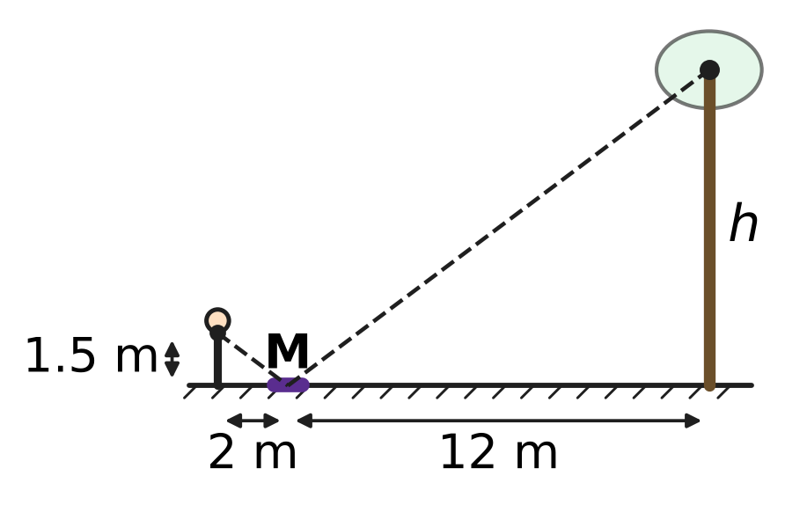
  (A) 16 m | (B) 10.5 m | (C) 9 m | (D) 18 m

Q17. In the figure, O is the centre of a circle of radius 6 cm. The line from P to O meets the circle at A, and PA = 4 cm. PT touches the circle at T. What is the length of PT? | 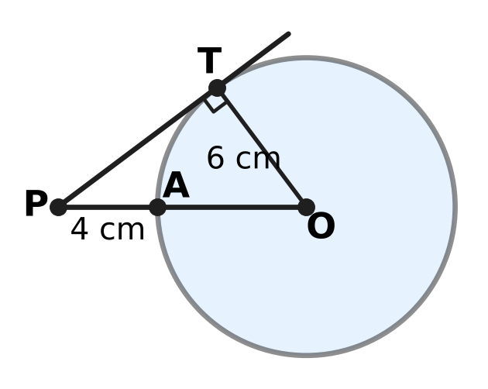
  (A) 8 cm | (B) 10 cm
  (C) $2\sqrt{13}$ cm | (D) 6 cm

Q18. The points A(1, 1), B(7, 1) and C(1, 9) are given. Which point is at the same distance from A, from B and from C?
(A) (4, 1) | (B) (5, 4) | (C) (1, 5) | (D) (4, 5)

Q19. Two circles with centres M and N have radii 9 cm and 4 cm, and they touch each other externally, as shown. A straight line touches the larger circle at A and the smaller circle at B. What is the length of AB? | 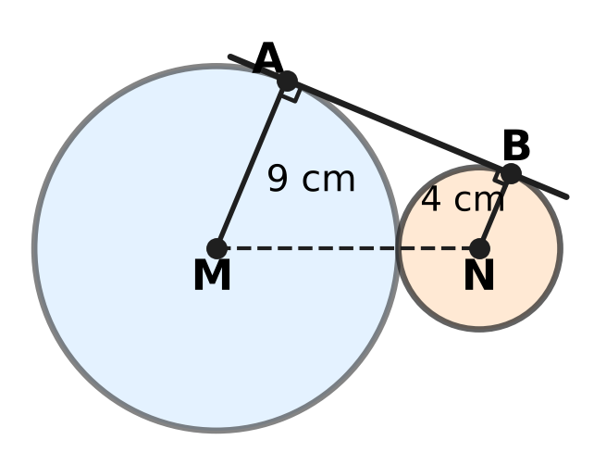
  (A) 5 cm | (B) 12 cm
  (C) 13 cm | (D) $\sqrt{194}$ cm

Part 5 — Mensuration (Syllabus Chapter 6)
Q20. A lawn sprinkler turns to and fro through a fixed angle and waters a sector of radius 21 m. The watered area is 462 m². Take π = 22/7. Through what angle does the sprinkler turn?
(A) 240° | (B) 30° | (C) 120° | (D) 60°

Q21. A ball fits exactly inside a closed cylindrical box: it touches the top, the bottom and the curved side, as shown. What fraction of the space inside the box is NOT filled by the ball? | 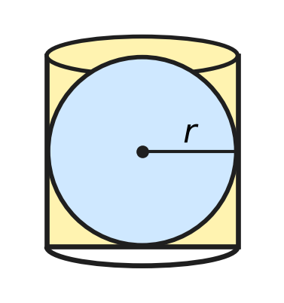
  (A) $\frac{2}{3}$ | (B) $\frac{1}{3}$ | (C) $\frac{1}{4}$ | (D) $\frac{1}{2}$

Q22. A cylindrical jar of radius 6 cm contains some water. Sixteen metal balls, each of radius 1.5 cm, are dropped into it, and the water still covers them all. By how much does the water level rise?
(A) 2 cm | (B) 0.5 cm | (C) 16 cm | (D) 1.5 cm

Q23. A bucket is a frustum of a cone with top radius 12 cm, bottom radius 8 cm and height 15 cm, as shown. Vihaan estimates its capacity as the volume of a cylinder of height 15 cm whose radius is the average of the two radii. By how much is his estimate less than the true capacity? | 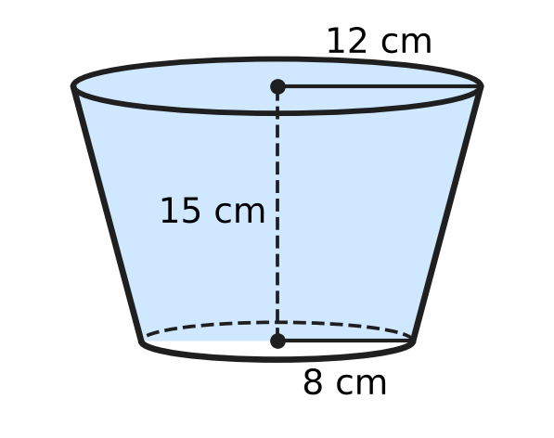
  (A) $40π$ cm³ | (B) $460π$ cm³
  (C) $80π$ cm³ | (D) $20π$ cm³

Q24. In the figure, ABC is a triangle with ∠C = 90°, CA = 6 cm and CB = 8 cm. Semicircles are drawn outwards on CA and on CB. A third semicircle, on AB, passes through C. What is the total area of the two shaded crescents? | 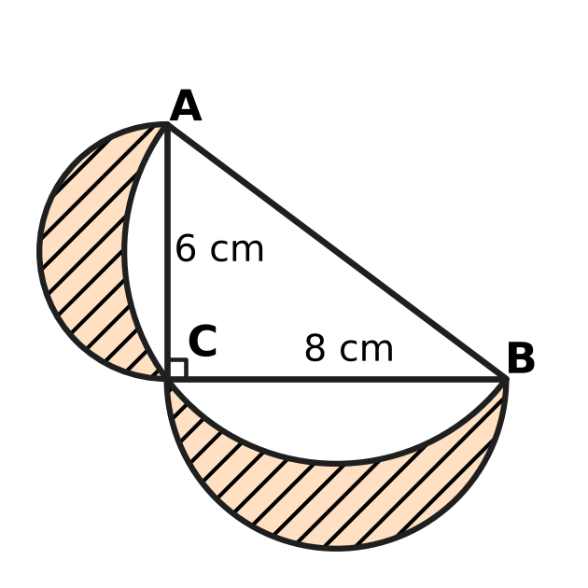
  (A) $\frac{25π}{2}$ cm² | (B) 24 cm²
  (C) 48 cm² | (D) $\frac{25π−48}{2}$ cm²

Part 6 — Trigonometry & Heights and Distances (Syllabus Chapter 7)
Q25. What is the value of $\frac{1−\tan^{2}{30}^{∘}}{1+\tan^{2}{30}^{∘}}$?
(A) $−\frac{1}{2}$ | (B) $\frac{3}{4}$ | (C) $\frac{1}{2}$ | (D) $\frac{2}{3}$

Q26. For every acute angle θ, tan θ + cot θ is equal to which of these?
(A) sec θ + cosec θ | (B) sin θ × cos θ
(C) 1 | (D) sec θ × cosec θ

Q27. Vinay stands at P on a jetty, 8 m above a still lake. A bird hovers above the lake. From P, the angle of elevation of the bird is 30° and the angle of depression of its reflection is 60°, as shown. The reflection is as far below the water as the bird is above it. How high above the water is the bird? | 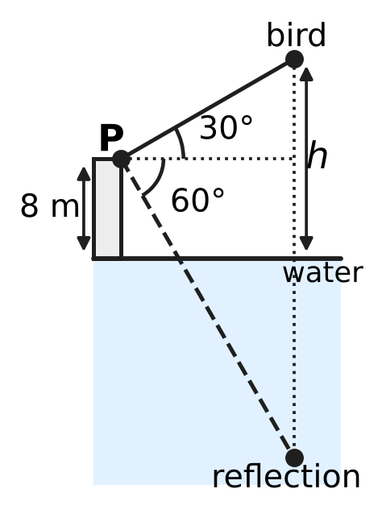
  (A) 16 m | (B) 12 m
  (C) $8\sqrt{3}$ m | (D) 24 m

Part 7 — Data Handling, Statistics & Probability (Syllabus Chapter 8)
Saplings in a plant nursery (none is shorter than 20 cm or taller than 70 cm)
Height of sapling | 20 cm or more | 30 cm or more | 40 cm or more | 50 cm or more | 60 cm or more
Number of saplings | 60 | 52 | 37 | 15 | 4

Q28. The table shows the heights of the 60 saplings in a plant nursery. How many saplings are at least 40 cm tall but less than 50 cm tall?
(A) 15 | (B) 37 | (C) 22 | (D) 33

Q29. An umbrella stand holds 4 black and 6 blue umbrellas, alike apart from colour. Tia takes one at random; it is black, and she keeps it. Then Noor takes one of the remaining umbrellas at random. What is the probability that Noor's umbrella is blue?
(A) $\frac{3}{5}$ | (B) $\frac{2}{3}$ | (C) $\frac{4}{15}$ | (D) $\frac{1}{3}$

Q30. A fair die is thrown twice. What is the probability that the second number is greater than the first?
(A) $\frac{5}{12}$ | (B) $\frac{7}{12}$ | (C) $\frac{1}{6}$ | (D) $\frac{1}{2}$

Part 8 — Applied Mathematics (Syllabus Chapter 9)
Q31. A bookshop sale offers "buy 3 books, get 1 more free" on books of the same price. Eshan takes 4 books and pays for 3. What is the effective discount on the 4 books?
(A) $33\frac{1}{3}$% | (B) 75% | (C) 20% | (D) 25%

Q32. Komal makes candles at home. Her fixed costs are ₹6,000 a month. Each candle costs ₹25 to make and sells for ₹40. How many candles must she sell in a month to make a profit of ₹3,000?
(A) 225 | (B) 400 | (C) 200 | (D) 600

Q33. In a school kitchen, 6 cooks make 240 sandwiches in 2 hours. All the cooks work at the same steady rate. How many sandwiches can 9 cooks make in 3 hours?
(A) 360 | (B) 540 | (C) 160 | (D) 1,080

Q34. A river ferry goes downstream from jetty X to jetty Y in 2 hours. With the same engine speed, it comes back upstream in 3 hours. How long would a raft, carried only by the current, take to drift from X to Y?
(A) 6 hours | (B) 2.5 hours
(C) 12 hours | (D) 5 hours

Q35. Ojas can paint a wall alone in 5 days, and Kriti can paint it alone in 10 days. They work on alternate days, with only one of them working each day, and Ojas works on the first day. In how many days is the wall painted?
(A) $6\frac{1}{2}$ days | (B) $3\frac{1}{3}$ days
(C) 7 days | (D) 6 days

Part 9 — Mathematical Reasoning & Problem-Solving (Syllabus Chapter 10)
Q36. There are 37 players in a badminton singles knockout. In each match two players play, the loser is out, and there are no draws. In some rounds a player may get a free pass to the next round. How many matches are played to find the champion?
(A) 36 | (B) 18 | (C) 666 | (D) 37

Q37. The figure is a grid of 5 × 3 small squares. How many squares of all sizes can be traced along its lines? | 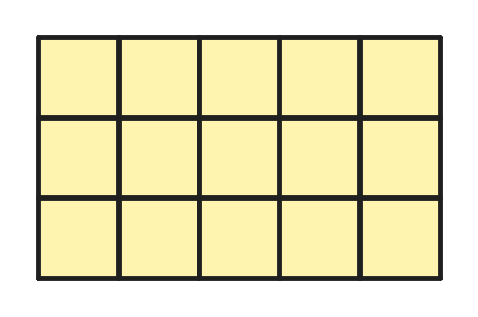
  (A) 23 | (B) 18 | (C) 26 | (D) 15

Q38. Rupa colours flags with 3 horizontal stripes, using crayons of 6 different colours. Each stripe is one colour, and stripes that touch must be different colours. How many different flags can she make?
(A) 180 | (B) 150 | (C) 120 | (D) 216

Q39. Some whole numbers are chosen from 1 to 20 so that no chosen number is double another chosen number. What is the greatest number of whole numbers that can be chosen?
(A) 10 | (B) 15 | (C) 13 | (D) 14

Q40. A box has 12 red, 15 green and 17 blue counters. In one move, you take out one counter of each of two different colours and put in two counters of the third colour. After some moves, all 44 counters are of one colour. What is that colour?
(A) red | (B) green
(C) blue | (D) it could be any of the three colours

SECTION II — Star Questions 5 questions × 4 marks each
Q41. A group buys 12 tickets for a zoo visit and pays ₹400 in all. A child ticket costs ₹20, a senior ticket ₹30 and an adult ticket ₹50. The group has at least one child, at least one senior and at least one adult. In how many different ways could the 12 tickets be made up of these three kinds? [4 marks]
(A) 6 | (B) 3 | (C) 1 | (D) 4

Q42. A large hoop of radius 1.5 m stands upright on level ground and touches the ground at T. K is the highest point of the hoop. From a point P on the ground, the angle of elevation of K is 60°. A straight rod rests with one end at P and touches the hoop at A, where A is a different point from T, as shown. How long is PA? [4 marks] | 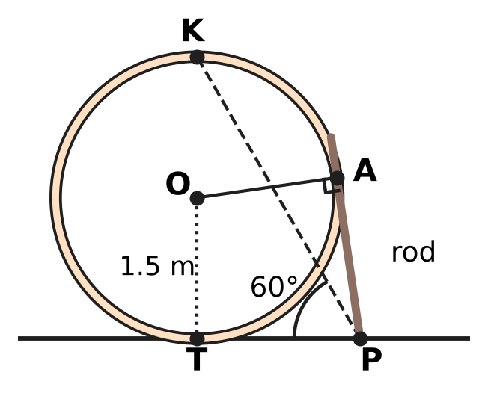
  (A) $3\sqrt{3}$ m | (B) $\frac{\sqrt{3}}{2}$ m
  (C) $2\sqrt{3}$ m | (D) $\sqrt{3}$ m

Q43. Jayesh has a flat wooden plank shaped like a right triangle whose two shorter sides are 60 cm and 80 cm. He cuts a rectangular shelf from it. Two sides of the shelf lie along the two shorter sides of the plank, and the fourth corner of the shelf lies on the longest side, as shown. What is the greatest possible area of the shelf? [4 marks] | 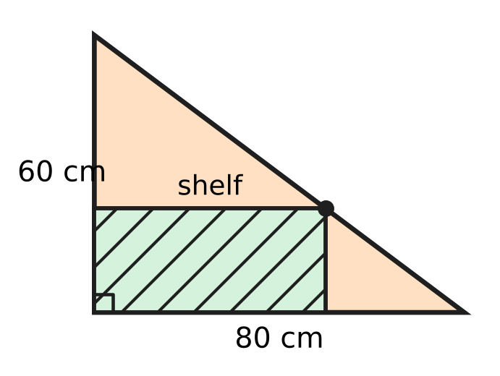
  (A) 1,200 cm² | (B) 4,800 cm²
  (C) 1,600 cm² | (D) 2,400 cm²

Q44. Trisha and Manu take a contract to lay a stone path. Trisha alone could finish it in 30 days and Manu alone in 20 days. Trisha starts alone and puts ₹30,000 into the job on the first day. After 10 days, Manu joins with ₹60,000, and they finish the path together. The profit of ₹51,000 is shared in the ratio of capital × number of days that capital was in the job. What is Manu's share? [4 marks]
(A) ₹34,000 | (B) ₹25,500 | (C) ₹24,000 | (D) ₹20,400

Q45. Imran has one solid metal ball of radius 8 cm. In each round, he melts every ball he has and recasts each one into 8 equal smaller balls, with no metal lost. After how many rounds is the total surface area of all his balls 16 times the surface area of the first ball? [4 marks]
(A) 4 | (B) 3 | (C) 8 | (D) 2

Answer Sheet AMO Level 1 · Class 10 · Practice Paper 4
Name: | School: | Roll No.:
Shade or tick one circle for each question.
1. Ⓐ Ⓑ Ⓒ Ⓓ | 16. Ⓐ Ⓑ Ⓒ Ⓓ | 31. Ⓐ Ⓑ Ⓒ Ⓓ
2. Ⓐ Ⓑ Ⓒ Ⓓ | 17. Ⓐ Ⓑ Ⓒ Ⓓ | 32. Ⓐ Ⓑ Ⓒ Ⓓ
3. Ⓐ Ⓑ Ⓒ Ⓓ | 18. Ⓐ Ⓑ Ⓒ Ⓓ | 33. Ⓐ Ⓑ Ⓒ Ⓓ
4. Ⓐ Ⓑ Ⓒ Ⓓ | 19. Ⓐ Ⓑ Ⓒ Ⓓ | 34. Ⓐ Ⓑ Ⓒ Ⓓ
5. Ⓐ Ⓑ Ⓒ Ⓓ | 20. Ⓐ Ⓑ Ⓒ Ⓓ | 35. Ⓐ Ⓑ Ⓒ Ⓓ
6. Ⓐ Ⓑ Ⓒ Ⓓ | 21. Ⓐ Ⓑ Ⓒ Ⓓ | 36. Ⓐ Ⓑ Ⓒ Ⓓ
7. Ⓐ Ⓑ Ⓒ Ⓓ | 22. Ⓐ Ⓑ Ⓒ Ⓓ | 37. Ⓐ Ⓑ Ⓒ Ⓓ
8. Ⓐ Ⓑ Ⓒ Ⓓ | 23. Ⓐ Ⓑ Ⓒ Ⓓ | 38. Ⓐ Ⓑ Ⓒ Ⓓ
9. Ⓐ Ⓑ Ⓒ Ⓓ | 24. Ⓐ Ⓑ Ⓒ Ⓓ | 39. Ⓐ Ⓑ Ⓒ Ⓓ
10. Ⓐ Ⓑ Ⓒ Ⓓ | 25. Ⓐ Ⓑ Ⓒ Ⓓ | 40. Ⓐ Ⓑ Ⓒ Ⓓ
11. Ⓐ Ⓑ Ⓒ Ⓓ | 26. Ⓐ Ⓑ Ⓒ Ⓓ | 41. Ⓐ Ⓑ Ⓒ Ⓓ
12. Ⓐ Ⓑ Ⓒ Ⓓ | 27. Ⓐ Ⓑ Ⓒ Ⓓ | 42. Ⓐ Ⓑ Ⓒ Ⓓ
13. Ⓐ Ⓑ Ⓒ Ⓓ | 28. Ⓐ Ⓑ Ⓒ Ⓓ | 43. Ⓐ Ⓑ Ⓒ Ⓓ
14. Ⓐ Ⓑ Ⓒ Ⓓ | 29. Ⓐ Ⓑ Ⓒ Ⓓ | 44. Ⓐ Ⓑ Ⓒ Ⓓ
15. Ⓐ Ⓑ Ⓒ Ⓓ | 30. Ⓐ Ⓑ Ⓒ Ⓓ | 45. Ⓐ Ⓑ Ⓒ Ⓓ
Q41–Q45 are Section II Star Questions (4 marks each).
For the parent or teacher
Section I correct: ______ / 40 × 2 = ______ marks Section II correct: ______ / 5 × 4 = ______ marks
Correct: ______ / 45 Score: ______ / 100
Answer Key and Solutions AMO Level 1 · Class 10 · Practice Paper 4
Quick answers
1 D | 6 B | 11 D | 16 C | 21 B | 26 D | 31 D | 36 A | 41 B
2 B | 7 A | 12 C | 17 A | 22 A | 27 A | 32 D | 37 C | 42 D
3 A | 8 B | 13 D | 18 D | 23 D | 28 C | 33 B | 38 B | 43 A
4 C | 9 A | 14 A | 19 B | 24 B | 29 B | 34 C | 39 D | 44 C
5 D | 10 C | 15 B | 20 C | 25 C | 30 A | 35 A | 40 C | 45 A
Solutions
Q | Part · level | Answer | Why?
1 | Part 1 · Ch1 · Easy | (D) 91 | Next step: 455 = 5 × 91 + 0. The remainder is 0, so the HCF is the last divisor, 91.
2 | Part 1 · Ch1 · Easy | (B) 6 | n³ − n = (n − 1) × n × (n + 1) is a product of three consecutive numbers, so it always has a factor 2 and a factor 3. For n = 2 it is exactly 6.
3 | Part 1 · Ch1 · Medium | (A) 2 | Write the numbers as 18m and 18n with m + n = 12 and HCF(m, n) = 1. Only 1 + 11 and 5 + 7 work, giving 18, 198 and 90, 126: two pairs.
4 | Part 2 · Ch3 · Easy | (C) 6 months | The rate is 3% per quarter. Then 40,000 × 1.03 = 41,200 and 41,200 × 1.03 = 42,436, so it takes 2 quarters, which is 6 months.
5 | Part 2 · Ch3 · Easy | (D) ₹27,500 | The rest is 56,000 − 12,000 = 44,000. The capitals are in the ratio 3 : 5, so Omar gets 5/8 of 44,000 = ₹27,500.
6 | Part 2 · Ch3 · Easy | (B) ₹12,000 | Capital × months: 480,000 : 360,000 : 120,000 = 4 : 3 : 1. Ayaan gets 3/8 of 32,000 = ₹12,000.
7 | Part 2 · Ch3 · Medium | (A) 2 : 1 | Each capital is in proportion to share ÷ time: 5/10 : 3/12 = 1/2 : 1/4 = 2 : 1.
8 | Part 2 · Ch3 · Medium | (B) ₹42,640 | The rate is 4% per half-year. After 6 months: 25,000 × 1.04 = 26,000, plus 15,000 gives 41,000. At the end of the year: 41,000 × 1.04 = ₹42,640.
9 | Part 3 · Ch4 · Easy | (A) 4 | If the zeroes are α and 1/α, their product is 1. The product is 6 ÷ (k + 2), so k + 2 = 6 and k = 4.
10 | Part 3 · Ch4 · Easy | (C) 8 | Let there be s boxes and l trays: s + l = 20 and 6s + 30l = 312. Taking 6 × 20 = 120 away leaves 24l = 192, so l = 8.
11 | Part 3 · Ch4 · Easy | (D) the 8th hour | The amounts form an AP: aₙ = 300 − 20(n − 1). Setting 300 − 20(n − 1) = 160 gives n − 1 = 7, so n = 8.
12 | Part 3 · Ch4 · Medium | (C) 5 | Put y = x²: y² − 13y + 36 = 0 gives y = 4 or 9. So x = ±2 or ±3, and the positive roots add up to 2 + 3 = 5.
13 | Part 3 · Ch4 · Medium | (D) 39 | Let the zeroes be a − d, a, a + d. Their sum is 3a = 12, so a = 4. Product: 4(16 − d²) = 28 gives d = 3, so the zeroes are 1, 4, 7 and k = 1 × 4 + 4 × 7 + 1 × 7 = 39.
14 | Part 3 · Ch4 · Medium | (A) 2 | Each of the next 10 terms is 10d more than the matching earlier term, so 100d = 455 − 155 = 300 and d = 3. Then 5(2a + 27) = 155, so 2a = 4 and a = 2.
15 | Part 4 · Ch5 · Easy | (B) (3, 5) | The diagonals of a parallelogram bisect each other, so the midpoint of BD is the midpoint of AC, (3.5, 4). Then D = (7 − 4, 8 − 3) = (3, 5).
16 | Part 4 · Ch5 · Easy | (C) 9 m | The two right triangles have equal angles at the mirror, so they are similar: h ÷ 12 = 1.5 ÷ 2, giving h = 9 m.
17 | Part 4 · Ch5 · Easy | (A) 8 cm | OP = 4 + 6 = 10 cm. The radius OT is perpendicular to the tangent, so PT² = 10² − 6² = 64 and PT = 8 cm.
18 | Part 4 · Ch5 · Medium | (D) (4, 5) | AB is horizontal and AC is vertical, so ∠A = 90° and BC = 10 is the longest side. The midpoint of BC, (4, 5), is 5 units from each of A, B and C.
19 | Part 4 · Ch5 · Medium | (B) 12 cm | MN = 9 + 4 = 13 cm. MA and NB are both perpendicular to AB, so AB² = 13² − (9 − 4)² = 144 and AB = 12 cm.
20 | Part 5 · Ch6 · Easy | (C) 120° | The whole circle has area 22/7 × 21 × 21 = 1,386 m². The area 462 m² is one-third of this, so the angle is 360° ÷ 3 = 120°.
21 | Part 5 · Ch6 · Easy | (B) $\frac{1}{3}$ | With radius r, the box has height 2r and volume πr² × 2r = 2πr³. The ball has volume (4/3)πr³, which is 2/3 of it, so 1/3 is empty.
22 | Part 5 · Ch6 · Easy | (A) 2 cm | The balls push up a volume of 16 × (4/3)π × 1.5³ = 72π cm³. The jar has base area 36π cm², so the level rises 72π ÷ 36π = 2 cm.
23 | Part 5 · Ch6 · Medium | (D) $20π$ cm³ | True capacity: (1/3)π × 15 × (144 + 96 + 64) = 1,520π cm³. Estimate: π × 10² × 15 = 1,500π cm³. The estimate is 20π cm³ less.
24 | Part 5 · Ch6 · Medium | (B) 24 cm² | Small semicircles: (π/2)(3² + 4²) = 25π/2. By Pythagoras AB = 10 cm, so the semicircle on AB is (π/2)(5²) = 25π/2. Crescents = 25π/2 + 24 − 25π/2 = 24 cm², the area of the triangle.
25 | Part 6 · Ch7 · Easy | (C) $\frac{1}{2}$ | tan²30° = 1/3. So the value is (1 − 1/3) ÷ (1 + 1/3) = (2/3) ÷ (4/3) = 1/2.
26 | Part 6 · Ch7 · Easy | (D) sec θ × cosec θ | tan θ + cot θ = sin θ/cos θ + cos θ/sin θ = (sin²θ + cos²θ)/(sin θ cos θ) = 1/(sin θ cos θ) = sec θ cosec θ.
27 | Part 6 · Ch7 · Medium | (A) 16 m | Let the horizontal distance be d. Then h − 8 = d tan 30° and h + 8 = d tan 60°, so h + 8 = 3(h − 8), which gives h = 16 m.
28 | Part 7 · Ch8 · Easy | (C) 22 | Saplings of 40 cm or more: 37. Saplings of 50 cm or more: 15. So 37 − 15 = 22 are at least 40 cm but less than 50 cm.
29 | Part 7 · Ch8 · Easy | (B) $\frac{2}{3}$ | After Tia keeps a black one, 3 black and 6 blue are left. The probability of blue is 6/9 = 2/3.
30 | Part 7 · Ch8 · Medium | (A) $\frac{5}{12}$ | Of the 36 equally likely outcomes, 6 have equal numbers. The other 30 split evenly, so 15 have the second number greater: 15/36 = 5/12.
31 | Part 8 · Ch9 · Easy | (D) 25% | He gets 4 books for the price of 3, so he saves 1 book's price out of 4: 1/4 = 25%.
32 | Part 8 · Ch9 · Easy | (D) 600 | Each candle adds 40 − 25 = ₹15. To cover ₹6,000 and earn ₹3,000 she needs 9,000 ÷ 15 = 600 candles.
33 | Part 8 · Ch9 · Easy | (B) 540 | One cook makes 240 ÷ (6 × 2) = 20 sandwiches an hour. So 9 cooks make 9 × 3 × 20 = 540 in 3 hours.
34 | Part 8 · Ch9 · Medium | (C) 12 hours | Let XY = d. Downstream speed d/2, upstream speed d/3. Stream speed = (d/2 − d/3) ÷ 2 = d/12, so the raft takes 12 hours.
35 | Part 8 · Ch9 · Medium | (A) $6\frac{1}{2}$ days | Each pair of days paints 1/5 + 1/10 = 3/10. After 6 days 9/10 is done; on day 7 Ojas needs (1/10) ÷ (1/5) = half a day. Total 6½ days.
36 | Part 9 · Ch10 · Easy | (A) 36 | Each match puts exactly one player out. To leave one champion, 36 players must be put out, so 36 matches are played.
37 | Part 9 · Ch10 · Easy | (C) 26 | Squares of size 1 × 1: 5 × 3 = 15. Size 2 × 2: 4 × 2 = 8. Size 3 × 3: 3 × 1 = 3. Total 15 + 8 + 3 = 26.
38 | Part 9 · Ch10 · Easy | (B) 150 | The top stripe has 6 choices, the middle 5 (unlike the top), and the bottom 5 (unlike the middle): 6 × 5 × 5 = 150.
39 | Part 9 · Ch10 · Medium | (D) 14 | Split 1–20 into chains 1, 2, 4, 8, 16; 3, 6, 12; 5, 10, 20; 7, 14; 9, 18; and the single odd numbers 11–19. At most 3, 2, 2, 1, 1 and 5 can be taken from them: 14 in all, for example the odd numbers with 4, 12, 16, 20.
40 | Part 9 · Ch10 · Medium | (C) blue | Each move changes the difference of any two counts by 0 or 3. Red − green = −3 is a multiple of 3, so red and green can both reach 0 together; green − blue = −2 and red − blue = −5 are not, so all blue is the only possibility.
41 | Section II · Ch4 + Ch10 · Hard | (B) 3 | With c, s, a tickets: c + s + a = 12 and 2c + 3s + 5a = 40. Subtracting twice the first gives s + 3a = 16, so s = 16 − 3a and c = 2a − 4. With each at least 1, a = 3, 4 or 5: three ways.
42 | Section II · Ch5 + Ch7 · Hard | (D) $\sqrt{3}$ m | OT is perpendicular to the ground, so T, O and K lie on one vertical line and TK = 3 m. Then PT = 3 ÷ tan 60° = √3 m. PT and PA are both tangents from P, so PA = PT = √3 m.
43 | Section II · Ch4 + Ch5 · Hard | (A) 1,200 cm² | If the shelf is x cm along the 80 cm side, similar triangles give its height as 60 − 3x/4. Area = 60x − 3x²/4 = 1,200 − (3/4)(x − 40)², greatest when x = 40: 40 × 30 = 1,200 cm².
44 | Section II · Ch3 + Ch9 · Hard | (C) ₹24,000 | Trisha does 10/30 = 1/3 alone. Together they do 1/30 + 1/20 = 1/12 a day, so the other 2/3 takes 8 days; the job lasts 18 days. Capital × days: 30,000 × 18 : 60,000 × 8 = 9 : 8, so Manu gets 8/17 of 51,000 = ₹24,000.
45 | Section II · Ch6 + Ch10 · Hard | (A) 4 | One ball of radius r gives 8 balls of radius r/2 (same volume). Each has 1/4 of the surface area, so the total is 8 × 1/4 = 2 times as much. After n rounds the total is 2^{n} times, and 2⁴ = 16: 4 rounds.

ARYABHATTA MATHS OLYMPIAD
Level 1
PRACTICE PAPER-5
CLASS 10
Total Questions | 45 multiple-choice questions
Total Marks | 100
Time | 60 minutes
Section I | 40 questions × 2 marks = 80 marks
Section II | 5 Star Questions × 4 marks = 20 marks
Negative Marking | No negative marking
Calculator | Not allowed
Chapters | Number System · Fractions, Decimals & Percentages · Algebra · Geometry · Mensuration · Trigonometry · Data Handling · Applied Mathematics · Mathematical Reasoning

Instructions to candidates
• This paper has 45 multiple-choice questions. Each question has four answer choices, of which exactly one is correct.
• Section I (Q1–Q40) carries 2 marks per question. Section II (Q41–Q45) carries 4 marks per question.
• There is no negative marking. Unanswered questions score zero.
• Calculators are not permitted. Rough work may be done on a separate sheet.
• Mark your answers on the answer sheet at the end of the paper.
• All figures are not necessarily drawn to scale unless stated.

For parents and teachers
• Print or view this paper in colour. Pictures are part of the questions.
• Parts follow the AMO syllabus chapters. Chapter 2 is not part of the Class 10 syllabus, so the chapter numbers shown in the Part headings have gaps.
• The answer sheet and the answer key are at the end. Remove only the answer key before the student begins.

SECTION I 40 questions × 2 marks each
Part 1 — Number System (Syllabus Chapter 1)
Q1. I am a two-digit number. My HCF with 70 is 14, and my LCM with 70 is 420. Who am I?
(A) 42 | (B) 60 | (C) 30 | (D) 84

Q2. Written as a decimal, $\frac{7}{2^{a}×5^{2}}$ (where a is a whole number) stops after exactly 5 digits past the decimal point. Find a.
(A) 3 | (B) 10 | (C) 5 | (D) 7

Q3. How many factors of 360 are multiples of 6?
(A) 12 | (B) 6 | (C) 24 | (D) 10

Part 2 — Fractions, Decimals & Percentages (Syllabus Chapter 3)
Q4. Lata, Tarun and Usha start a flower shop that makes bouquets. The money they put in is in the ratio $\frac{1}{2}:\frac{1}{3}:\frac{1}{5}$, and it stays in the shop for the whole year. The year's profit of ₹62,000 is shared in the ratio of the money put in. What is Usha's share?
(A) ₹12,400 | (B) ₹31,000 | (C) ₹12,000 | (D) ₹20,000

Q5. Ana and Kian run an ice-cream stall for a whole year. The profit is shared in the ratio of their capitals. The year's profit is ₹36,000, and Ana's share is ₹20,000. Ana put in ₹50,000. How much did Kian put in?
(A) ₹16,000 | (B) ₹40,000 | (C) ₹90,000 | (D) ₹62,500

Q6. Dhruv's deposit of ₹20,000 earns 5% in the first year. In the second year it earns interest at a different rate, on the amount at the end of the first year. After two years the amount is ₹23,520. What was the rate in the second year?
(A) 12.6% | (B) 5% | (C) 17.6% | (D) 12%

Q7. Myra splits ₹22,000 into two deposits, both at 20% per year, compounded annually. She takes one deposit out after 1 year and the other after 2 years, and both give her the same amount. How much did she put in the 2-year deposit?
(A) ₹10,000 | (B) ₹14,400 | (C) ₹12,000 | (D) ₹11,000

Q8. Hana puts ₹60,000 into a workshop that makes fishing nets. After 3 months, Ivan joins with ₹40,000. After 8 months from the start, Hana takes out ₹20,000. The year's profit is ₹50,000, shared in the ratio of capital × time. What is Ivan's share?
(A) ₹32,000 | (B) ₹20,000 | (C) ₹18,000 | (D) ₹25,000

Part 3 — Algebra (Syllabus Chapter 4)
Q9. For the school play, 3 front-row tickets and 5 back-row tickets cost ₹550 in all. Also, 5 front-row tickets and 3 back-row tickets cost ₹650 in all. What is the price of one front-row ticket?
(A) ₹50 | (B) ₹150 | (C) ₹75 | (D) ₹100

Q10. The terms of an arithmetic progression start at 4 and end at 64, and together they add up to 340. How many terms are there?
(A) 10 | (B) 20 | (C) 11 | (D) 5

Q11. What are the roots of the equation (x − 2)(x + 5) = 18?
(A) 7 and −4 | (B) 4 and −7
(C) 2 and −5 | (D) 20 and 13

Q12. What must be subtracted from $x^{3}+3x^{2}−5x+2$ so that the result is exactly divisible by $x^{2}+2x−3$?
(A) $−4x+5$ | (B) $−4x−1$ | (C) $4x−5$ | (D) $x+1$

Q13. The number $3+\sqrt{2}$ is a zero of the polynomial $x^{2}−6x+c$, where c is a number. What is the value of c?
(A) −7 | (B) 7 | (C) 9 | (D) 11

Q14. The fourth term of an arithmetic progression is 11. Whatever the common difference is, the first seven terms always add up to the same total. What is that total?
(A) 88 | (B) 44 | (C) 38.5 | (D) 77

Part 4 — Geometry (Syllabus Chapter 5)
Q15. In the figure, a playground ladder AB stands upright on level ground and a straight slide AC runs from its top to the ground. AB = 2.4 m and BC = 3.2 m. A bar DE, parallel to the ground, joins the ladder to the slide 0.9 m above the ground. How long is the bar DE? | 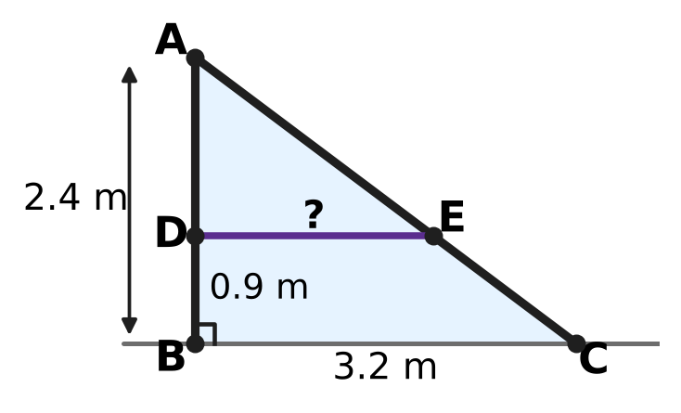
  (A) 1.2 m | (B) 1.5 m | (C) 2 m | (D) 1.6 m

Q16. The points A(−3, 1) and C(1, 7) are opposite corners of a square ABCD. What is the area of the square?
(A) 26 square units | (B) 13 square units
(C) 104 square units | (D) 52 square units

Q17. In the figure, each side of quadrilateral PQRS touches the circle. The perimeter of PQRS is 50 cm and PQ = 11 cm. What is the length of RS? | 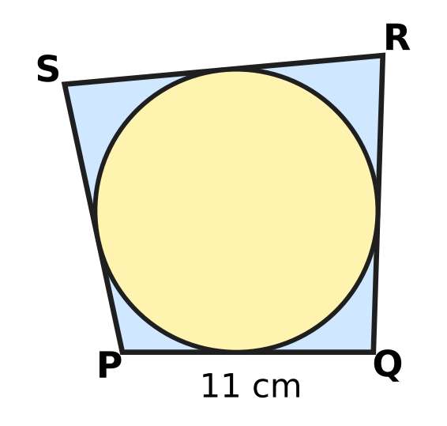
  (A) 13 cm | (B) 39 cm | (C) 28 cm | (D) 14 cm

Q18. Start at A(−2, 1) and move exactly 5 units along the straight line towards B(10, 10). At which point do you stop?
(A) (4, 5.5) | (B) (6, 7) | (C) (2, 4) | (D) (3, 6)

Q19. In the figure, AB is a diameter of a circle with centre O. The tangents at A and B meet the tangent at C at the points P and Q. AP = 3 cm and BQ = 12 cm. What is the radius of the circle? | 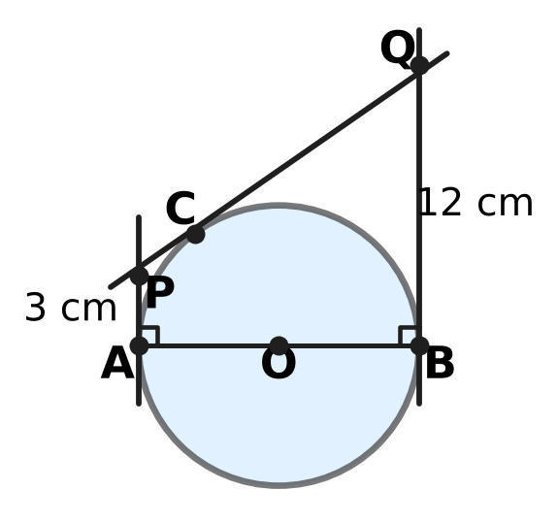
  (A) 7.5 cm | (B) 6 cm | (C) 12 cm | (D) 9 cm

Part 5 — Mensuration (Syllabus Chapter 6)
Q20. An open paper fan has the shape of a sector of a circle of radius 35 cm with an angle of 72°, as shown. What is the length of the boundary of the sector? (Use π = 22/7.) | 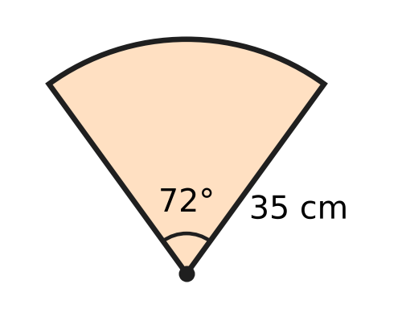
  (A) 44 cm | (B) 158 cm | (C) 114 cm | (D) 79 cm

Q21. A frustum-shaped flower vase has a top radius of 6 cm and a base radius of 3 cm, as shown. It takes exactly 660 cm³ of water to fill it. Find its height h. (Use π = 22/7.) | 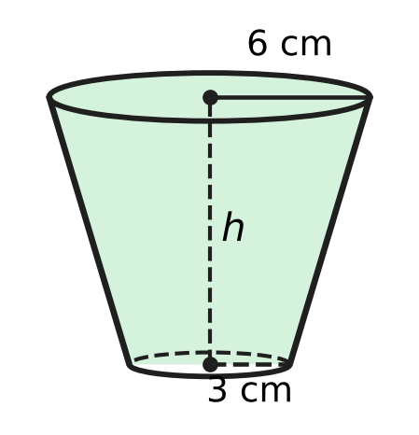
  (A) 2.5 cm | (B) 14 cm | (C) 17.5 cm | (D) 10 cm

Q22. A wiper arm turns about O through 120°. Its rubber blade is 21 cm long and starts 7 cm from O, so it cleans the shaded region shown. What is the area of the shaded region? (Use π = 22/7.) | 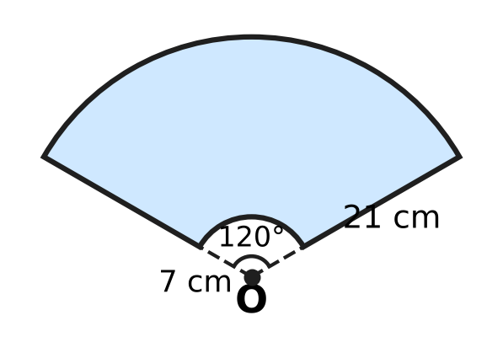
  (A) 770 cm² | (B) 385 cm²
  (C) 2,310 cm² | (D) 462 cm²

Q23. A cylindrical well 6 m wide (diameter) is dug 6 m deep. All the earth taken out is spread evenly around the well to form an embankment in the shape of a ring 3 m wide, as shown in the cross-section. How high is the embankment? | 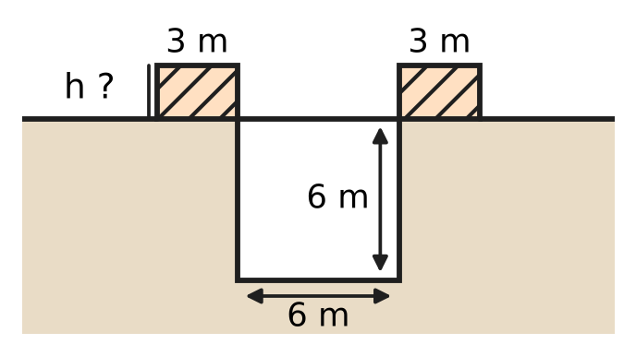
  (A) 8 m | (B) 2 m | (C) 1.5 m | (D) 6 m

Q24. The cloth of a hot-air balloon is a hemisphere of radius 10.5 m on top of a frustum of a cone. The frustum has radii 10.5 m and 3.5 m and height 24 m, as shown, and it is open at the bottom. What is the area of the cloth? (Use π = 22/7.) | 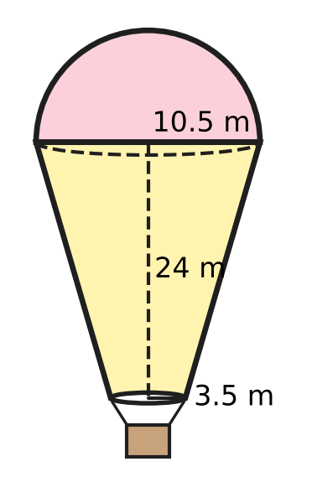
  (A) 1,793 m² | (B) 1,749 m² | (C) 2,486 m² | (D) 1,100 m²

Part 6 — Trigonometry & Heights and Distances (Syllabus Chapter 7)
Q25. Write $\frac{sinθ}{1+cosθ}+\frac{sinθ}{1−cosθ}$, where θ is acute, as a single term. What do you get?
(A) 2 sec θ | (B) 2 cosec θ
(C) 2 sin θ | (D) 2

Q26. The angle θ is acute, so 0° < θ < 90°. Which of these could be the value of sec θ?
(A) $\frac{\sqrt{3}}{2}$ | (B) 1
(C) $\frac{1}{2}$ | (D) $\frac{2}{\sqrt{3}}$

Q27. Isha stands at O on level ground near an airport. An aeroplane flies in a straight line at a fixed height of $600\sqrt{3}$ m, away from her. Its angle of elevation is 60° at A and 30° at B, ten seconds later, as shown. How far does the aeroplane fly from A to B? | 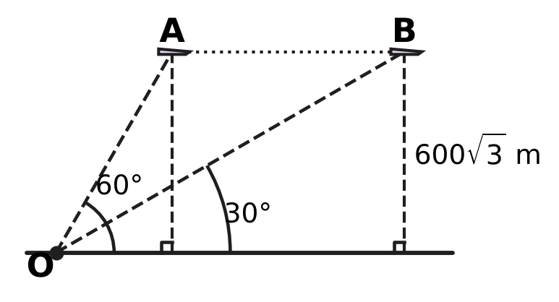
  (A) $1,200\sqrt{3}$ m | (B) 1,800 m
  (C) 1,200 m | (D) 600 m

Part 7 — Data Handling, Statistics & Probability (Syllabus Chapter 8)
Q28. The less-than ogive shows the marks of 60 students in a test. The thin grid lines are every 2 students up. How many students scored at least 20 marks but less than 40 marks? | 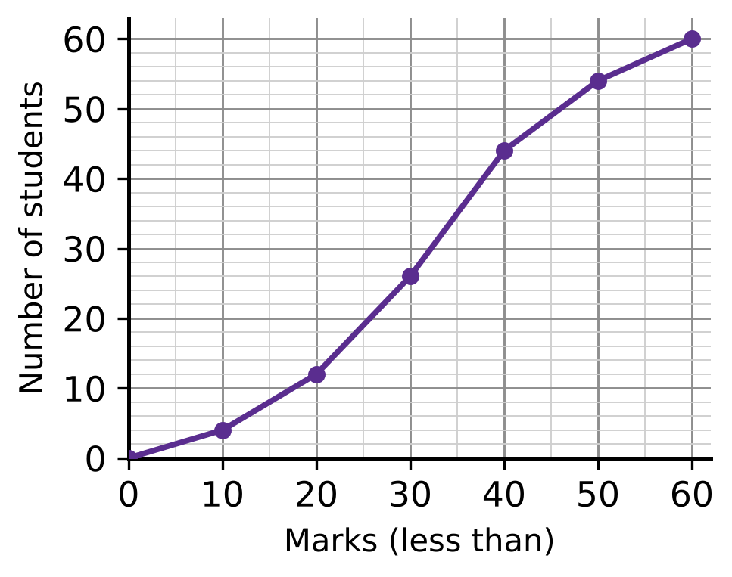
  (A) 14 | (B) 32 | (C) 44 | (D) 18

Q29. In the rainy season in a town, the probability that it rains on any given day is $\frac{2}{5}$, whatever happens on other days. What is the probability that it rains on exactly one of two given days?
(A) $\frac{6}{25}$ | (B) $\frac{4}{25}$ | (C) $\frac{16}{25}$ | (D) $\frac{12}{25}$

Q30. Six cards are numbered 1 to 6. One card is drawn at random and kept aside. Then a second card is drawn at random from the other five. What is the probability that the sum of the two numbers is even?
(A) $\frac{2}{5}$ | (B) $\frac{3}{5}$ | (C) $\frac{1}{2}$ | (D) $\frac{1}{5}$

Part 8 — Applied Mathematics (Syllabus Chapter 9)
Q31. A car park charges ₹40 for each hour, or ₹250 for a day pass. Parth parks for a whole number of hours. What is the least number of hours for which the day pass costs less than paying by the hour?
(A) 8 hours | (B) 5 hours | (C) 7 hours | (D) 6 hours

Q32. A keyboard for Urvi's music class is marked ₹2,500. The shop gives 20% off and then a further discount on the reduced price. Urvi pays ₹1,700. What is the second discount?
(A) 32% | (B) 15% | (C) 20% | (D) 12%

Q33. A team of 25 gardeners can plant all the saplings in a park in 12 days. How many days would 20 gardeners take, all working at the same rate?
(A) 17 days | (B) 9.6 days | (C) 12 days | (D) 15 days

Q34. Heena, a furniture dealer, buys a table for ₹8,000 plus GST at 18%. She sells it for ₹10,000 plus GST at 18%. She may subtract the GST she paid from the GST she collected. How much GST must she pay to the government on this table?
(A) ₹360 | (B) ₹3,240 | (C) ₹1,440 | (D) ₹1,800

Q35. Nakul's motorboat moves at 15 km/h in still water. On a river, a 20 km trip against the current takes 1 hour longer than the same 20 km trip with the current. What is the speed of the current?
(A) 20 km/h | (B) 4 km/h | (C) 5 km/h | (D) 10 km/h

Part 9 — Mathematical Reasoning & Problem-Solving (Syllabus Chapter 10)
Q36. Deepa and Jatin get into an empty lift on the ground floor of a building. Each of them gets out at one of the floors 1 to 6, and they get out at different floors. In how many different ways can this happen?
(A) 36 | (B) 11 | (C) 15 | (D) 30

Q37. A counter starts on square S of the board shown. In each move it goes to a square that shares a side with the square it is on. After exactly 9 moves, on which of the lettered squares could the counter be? | 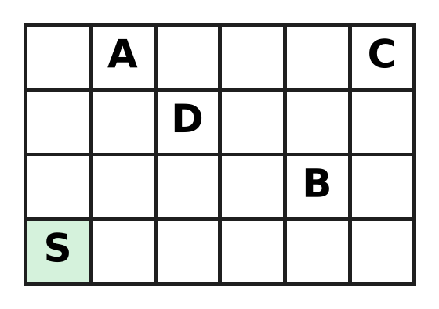
  (A) square A | (B) square B | (C) square C | (D) square D

Q38. How many three-digit numbers have digits that add up to 3?
(A) 5 | (B) 6 | (C) 3 | (D) 10

Q39. A suitcase lock can be set to any 3-digit code from 000 to 999. How many of these codes have at least one digit 7?
(A) 300 | (B) 729 | (C) 271 | (D) 243

Q40. A floor is covered with 5 rows of 5 square tiles. Some tiles are painted so that no two painted tiles share a side. What is the greatest number of tiles that can be painted?
(A) 13 | (B) 15 | (C) 12 | (D) 10

SECTION II — Star Questions 5 questions × 4 marks each
Q41. Each student in a class writes one quadratic equation $x^{2}−bx+c=0$, where b and c are whole numbers and c is at most 12. Both roots of each equation are positive whole numbers; the two roots may be equal. What is the least number of students in the class that makes sure that two of them write the same equation? [4 marks]
(A) 19 | (B) 13 | (C) 36 | (D) 20

Q42. On a ground plan with axes marked in metres, a vertical tower stands at the point T(2, −1). From the point P(8, 7) on the level ground, the angle of elevation of the top of the tower is 60°. From which of these points on the ground is the angle of elevation of the top 30°? [4 marks]
(A) (−6, 5) | (B) (18, 11) | (C) (20, 23) | (D) (20, 11)

Q43. In the figure, the incircle of right-angled △ABC (∠C = 90°) touches the longest side AB at T, splitting it into AT = 14 cm and TB = 15 cm. How long is the radius r of the incircle? [4 marks] | 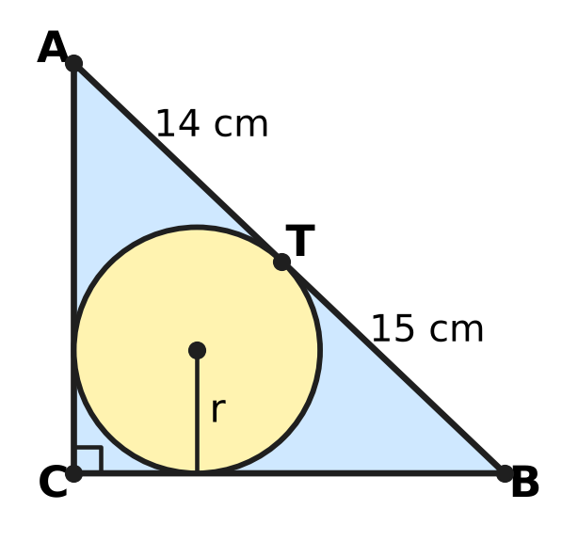
  (A) 14.5 cm | (B) 6 cm | (C) 12 cm | (D) 35 cm

Q44. Rani and Yash run a tea stall for a whole year. Rani puts in ₹80,000 and Yash puts in ₹120,000. The year's sales are ₹295,000, and this amount includes GST at 18%, which is all paid to the government. The other costs for the year, without GST, are ₹190,000. From the profit, each partner is first paid 10% of the money he or she put in. The rest of the profit is shared equally. How much does Yash get in all? [4 marks]
(A) ₹32,000 | (B) ₹36,000 | (C) ₹54,500 | (D) ₹20,000

Q45. At a science exhibition, Zubin has a cylinder of radius 3.5 cm and height 16 cm, and a cone of radius 10.5 cm and height 12 cm held point down, as shown. In one move he may fill a vessel to the brim from a tap, empty a vessel, or pour from one vessel into the other until the first is empty or the second is full. Which amount of water can he NOT end up with in the cone? (Use π = 22/7.) [4 marks] | 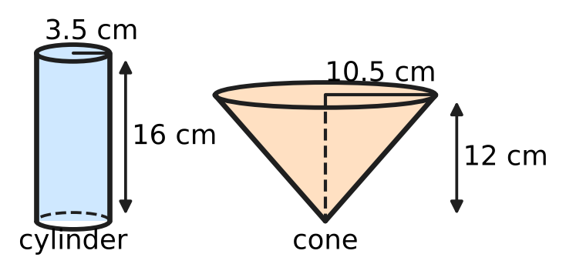
  (A) 1,232 cm³ | (B) 462 cm³
  (C) 770 cm³ | (D) 693 cm³
Answer Sheet AMO Level 1 · Class 10 · Practice Paper 5
Name: | School: | Roll No.:
Shade or tick one circle for each question.
1. Ⓐ Ⓑ Ⓒ Ⓓ | 16. Ⓐ Ⓑ Ⓒ Ⓓ | 31. Ⓐ Ⓑ Ⓒ Ⓓ
2. Ⓐ Ⓑ Ⓒ Ⓓ | 17. Ⓐ Ⓑ Ⓒ Ⓓ | 32. Ⓐ Ⓑ Ⓒ Ⓓ
3. Ⓐ Ⓑ Ⓒ Ⓓ | 18. Ⓐ Ⓑ Ⓒ Ⓓ | 33. Ⓐ Ⓑ Ⓒ Ⓓ
4. Ⓐ Ⓑ Ⓒ Ⓓ | 19. Ⓐ Ⓑ Ⓒ Ⓓ | 34. Ⓐ Ⓑ Ⓒ Ⓓ
5. Ⓐ Ⓑ Ⓒ Ⓓ | 20. Ⓐ Ⓑ Ⓒ Ⓓ | 35. Ⓐ Ⓑ Ⓒ Ⓓ
6. Ⓐ Ⓑ Ⓒ Ⓓ | 21. Ⓐ Ⓑ Ⓒ Ⓓ | 36. Ⓐ Ⓑ Ⓒ Ⓓ
7. Ⓐ Ⓑ Ⓒ Ⓓ | 22. Ⓐ Ⓑ Ⓒ Ⓓ | 37. Ⓐ Ⓑ Ⓒ Ⓓ
8. Ⓐ Ⓑ Ⓒ Ⓓ | 23. Ⓐ Ⓑ Ⓒ Ⓓ | 38. Ⓐ Ⓑ Ⓒ Ⓓ
9. Ⓐ Ⓑ Ⓒ Ⓓ | 24. Ⓐ Ⓑ Ⓒ Ⓓ | 39. Ⓐ Ⓑ Ⓒ Ⓓ
10. Ⓐ Ⓑ Ⓒ Ⓓ | 25. Ⓐ Ⓑ Ⓒ Ⓓ | 40. Ⓐ Ⓑ Ⓒ Ⓓ
11. Ⓐ Ⓑ Ⓒ Ⓓ | 26. Ⓐ Ⓑ Ⓒ Ⓓ | 41. Ⓐ Ⓑ Ⓒ Ⓓ
12. Ⓐ Ⓑ Ⓒ Ⓓ | 27. Ⓐ Ⓑ Ⓒ Ⓓ | 42. Ⓐ Ⓑ Ⓒ Ⓓ
13. Ⓐ Ⓑ Ⓒ Ⓓ | 28. Ⓐ Ⓑ Ⓒ Ⓓ | 43. Ⓐ Ⓑ Ⓒ Ⓓ
14. Ⓐ Ⓑ Ⓒ Ⓓ | 29. Ⓐ Ⓑ Ⓒ Ⓓ | 44. Ⓐ Ⓑ Ⓒ Ⓓ
15. Ⓐ Ⓑ Ⓒ Ⓓ | 30. Ⓐ Ⓑ Ⓒ Ⓓ | 45. Ⓐ Ⓑ Ⓒ Ⓓ
Q41–Q45 are Section II Star Questions (4 marks each).
For the parent or teacher
Section I correct: ______ / 40 × 2 = ______ marks Section II correct: ______ / 5 × 4 = ______ marks
Correct: ______ / 45 Score: ______ / 100
Answer Key and Solutions AMO Level 1 · Class 10 · Practice Paper 5
Quick answers
1 D | 6 D | 11 B | 16 A | 21 D | 26 D | 31 C | 36 D | 41 D
2 C | 7 A | 12 A | 17 D | 22 A | 27 C | 32 B | 37 B | 42 C
3 A | 8 C | 13 B | 18 C | 23 B | 28 B | 33 D | 38 B | 43 B
4 C | 9 D | 14 D | 19 B | 24 A | 29 D | 34 A | 39 C | 44 A
5 B | 10 A | 15 C | 20 C | 25 B | 30 A | 35 C | 40 A | 45 D
Solutions
Q | Part · level | Answer | Why?
1 | Part 1 · Ch1 · Easy | (D) 84 | HCF × LCM = product of the two numbers, so the number is 14 × 420 ÷ 70 = 84. Check: HCF(84, 70) = 14 and LCM = 420.
2 | Part 1 · Ch1 · Easy | (C) 5 | A fraction 7/(2ᵃ × 5²) in lowest terms ends after the larger of a and 2 decimal places. For 5 places, a = 5: 7/800 = 0.00875.
3 | Part 1 · Ch1 · Medium | (A) 12 | 360 = 2³ × 3² × 5. A factor that is a multiple of 6 is 6 × (a factor of 60), and 60 = 2² × 3 × 5 has 3 × 2 × 2 = 12 factors.
4 | Part 2 · Ch3 · Easy | (C) ₹12,000 | Multiply each fraction by 30: the ratio is 15 : 10 : 6, which adds up to 31. Usha gets 6/31 of 62,000 = ₹12,000.
5 | Part 2 · Ch3 · Easy | (B) ₹40,000 | Kian's share is 36,000 − 20,000 = 16,000, so capitals are in the ratio 20 : 16 = 5 : 4. Kian put in 4/5 of 50,000 = ₹40,000.
6 | Part 2 · Ch3 · Easy | (D) 12% | After year 1 the amount is 21,000. In year 2 it grows by 2,520, and 2,520 ÷ 21,000 = 12%.
7 | Part 2 · Ch3 · Medium | (A) ₹10,000 | The 1-year part × 1.2 = the 2-year part × 1.44, so the parts are in the ratio 1.2 : 1 = 6 : 5. The 2-year part is 5/11 of 22,000 = ₹10,000 (both grow to 14,400).
8 | Part 2 · Ch3 · Medium | (C) ₹18,000 | Hana: 60,000 × 8 + 40,000 × 4 = 640,000. Ivan: 40,000 × 9 = 360,000. Ratio 16 : 9, so Ivan gets 9/25 of 50,000 = ₹18,000.
9 | Part 3 · Ch4 · Easy | (D) ₹100 | Adding: 8 front + 8 back = 1,200, so front + back = 150. Subtracting: 2 front − 2 back = 100, so front − back = 50. Front = ₹100.
10 | Part 3 · Ch4 · Easy | (A) 10 | Sₙ = n(a + l)/2, so 340 = n × 68 ÷ 2 = 34n and n = 10.
11 | Part 3 · Ch4 · Easy | (B) 4 and −7 | Expand: x² + 3x − 10 = 18, so x² + 3x − 28 = 0, which is (x − 4)(x + 7) = 0. The roots are 4 and −7.
12 | Part 3 · Ch4 · Medium | (A) $−4x+5$ | Dividing gives quotient x + 1 and remainder −4x + 5. Taking away the remainder leaves (x + 1)(x² + 2x − 3) = x³ + 3x² − x − 3.
13 | Part 3 · Ch4 · Medium | (B) 7 | The sum of the zeroes is 6, so the other zero is 3 − √2. Their product is c = (3 + √2)(3 − √2) = 9 − 2 = 7.
14 | Part 3 · Ch4 · Medium | (D) 77 | S₇ = 7 × (a₁ + a₇)/2, and a₁ + a₇ = 2a₄ = 22. So S₇ = 7 × 11 = 77, whatever the common difference is.
15 | Part 4 · Ch5 · Easy | (C) 2 m | AD = 2.4 − 0.9 = 1.5 m. △ADE is similar to △ABC, so DE = 3.2 × 1.5 ÷ 2.4 = 2 m.
16 | Part 4 · Ch5 · Easy | (A) 26 square units | AC² = 4² + 6² = 52. The diagonal of a square of side s has d² = 2s², so the area s² = 52 ÷ 2 = 26 square units.
17 | Part 4 · Ch5 · Easy | (D) 14 cm | Equal tangents from each corner give PQ + RS = QR + SP, so each pair is half the perimeter, 25 cm. RS = 25 − 11 = 14 cm.
18 | Part 4 · Ch5 · Medium | (C) (2, 4) | AB = √(12² + 9²) = 15, so AP : PB = 5 : 10 = 1 : 2. P = ((1 × 10 + 2 × (−2))/3, (1 × 10 + 2 × 1)/3) = (2, 4).
19 | Part 4 · Ch5 · Medium | (B) 6 cm | PC = PA = 3 and QC = QB = 12, so PQ = 15. AP and BQ are both ⊥ AB, so PQ² = (12 − 3)² + AB²: 225 = 81 + AB², AB = 12, radius 6 cm.
20 | Part 5 · Ch6 · Easy | (C) 114 cm | Arc = (72/360) × 2 × (22/7) × 35 = 44 cm. Boundary = 44 + 35 + 35 = 114 cm.
21 | Part 5 · Ch6 · Easy | (D) 10 cm | V = (1/3) × (22/7) × h × (6² + 6 × 3 + 3²) = (22/21) × 63 × h = 66h. So 66h = 660 and h = 10 cm.
22 | Part 5 · Ch6 · Easy | (A) 770 cm² | Area = (120/360) × (22/7) × (28² − 7²) = (1/3) × (22/7) × 735 = 770 cm².
23 | Part 5 · Ch6 · Medium | (B) 2 m | Earth = π × 3² × 6 = 54π m³. Ring area = π(6² − 3²) = 27π m². Height = 54π ÷ 27π = 2 m.
24 | Part 5 · Ch6 · Medium | (A) 1,793 m² | Slant height = √(24² + 7²) = 25 m. Hemisphere: 2 × (22/7) × 10.5² = 693. Frustum: (22/7) × 25 × (10.5 + 3.5) = 1,100. Total 1,793 m².
25 | Part 6 · Ch7 · Easy | (B) 2 cosec θ | Over a common denominator: sin θ(1 − cos θ + 1 + cos θ)/(1 − cos²θ) = 2 sin θ/sin²θ = 2/sin θ = 2 cosec θ.
26 | Part 6 · Ch7 · Easy | (D) $\frac{2}{\sqrt{3}}$ | For an acute angle, 0 < cos θ < 1, so sec θ = 1/cos θ is greater than 1. Only 2/√3 (= sec 30°) is greater than 1.
27 | Part 6 · Ch7 · Medium | (C) 1,200 m | Below A the ground distance is 600√3 ÷ tan 60° = 600 m; below B it is 600√3 ÷ tan 30° = 1,800 m. The plane flies 1,800 − 600 = 1,200 m.
28 | Part 7 · Ch8 · Easy | (B) 32 | From the ogive, 44 students scored less than 40 and 12 scored less than 20. So 44 − 12 = 32 students scored from 20 up to 40.
29 | Part 7 · Ch8 · Easy | (D) $\frac{12}{25}$ | Rain then dry: 2/5 × 3/5 = 6/25. Dry then rain: 6/25. Exactly one rainy day: 6/25 + 6/25 = 12/25.
30 | Part 7 · Ch8 · Medium | (A) $\frac{2}{5}$ | The sum is even when both are odd or both are even. Both odd: 3/6 × 2/5 = 1/5. Both even: 1/5. Total 2/5.
31 | Part 8 · Ch9 · Easy | (C) 7 hours | By the hour, 6 hours cost ₹240 (less than ₹250) and 7 hours cost ₹280 (more than ₹250). So the pass is cheaper from 7 hours.
32 | Part 8 · Ch9 · Easy | (B) 15% | After 20% off, the price is ₹2,000. The second discount is ₹300, and 300 ÷ 2,000 = 15%.
33 | Part 8 · Ch9 · Easy | (D) 15 days | The job needs 25 × 12 = 300 gardener-days. With 20 gardeners it takes 300 ÷ 20 = 15 days.
34 | Part 8 · Ch9 · Medium | (A) ₹360 | GST collected = 18% of 10,000 = 1,800. GST paid = 18% of 8,000 = 1,440. She pays 1,800 − 1,440 = ₹360 (18% of the ₹2,000 added value).
35 | Part 8 · Ch9 · Medium | (C) 5 km/h | Let the current be c. Then 20/(15 − c) − 20/(15 + c) = 1, so c² + 40c − 225 = 0 = (c − 5)(c + 45) and c = 5 km/h. Check: 20 ÷ 10 = 2 hours, 20 ÷ 20 = 1 hour.
36 | Part 9 · Ch10 · Easy | (D) 30 | Deepa has 6 choices of floor, and then Jatin has 5 different floors left: 6 × 5 = 30 ways.
37 | Part 9 · Ch10 · Easy | (B) square B | Colour the board like a chessboard. Each move changes the colour, so after 9 moves (an odd number) the counter is on the other colour from S. Only B is that colour (it is 4 + 1 = 5 steps from S, an odd number).
38 | Part 9 · Ch10 · Easy | (B) 6 | The first digit is 1, 2 or 3. First digit 3: 300. First digit 2: 210, 201. First digit 1: 120, 102, 111. That makes 6.
39 | Part 9 · Ch10 · Medium | (C) 271 | There are 1,000 codes. Codes with no 7 have 9 choices for each digit: 9 × 9 × 9 = 729. So 1,000 − 729 = 271 codes have at least one 7.
40 | Part 9 · Ch10 · Medium | (A) 13 | Painting like the dark squares of a chessboard, with the corners painted, gives 13. More is impossible: split the floor into 12 pairs of side-by-side tiles and 1 single tile; each pair holds at most one painted tile, so at most 12 + 1 = 13.
41 | Section II · Ch4 + Ch10 · Hard | (D) 20 | An equation is fixed by its roots p ≤ q, with p + q = b and pq = c ≤ 12. p = 1: q = 1 to 12 (12 pairs); p = 2: q = 2 to 6 (5); p = 3: q = 3 or 4 (2). That is 19 equations, so 20 students make a repeat certain.
42 | Section II · Ch5 + Ch7 · Hard | (C) (20, 23) | TP = √(6² + 8²) = 10 m, so the tower is 10 × tan 60° = 10√3 m tall. For 30°, the distance must be 10√3 ÷ tan 30° = 30 m. Only (20, 23) is 30 m from T: √(18² + 24²) = 30.
43 | Section II · Ch4 + Ch5 · Hard | (B) 6 cm | Equal tangents: AC = r + 14 and BC = r + 15 (from C both tangents equal r, as the radii make a square). Pythagoras: (r + 14)² + (r + 15)² = 29², so r² + 29r − 210 = 0 = (r − 6)(r + 35), and r = 6 cm.
44 | Section II · Ch3 + Ch9 · Hard | (A) ₹32,000 | Sales without GST = 295,000 × 100/118 = 250,000, so the profit is 250,000 − 190,000 = 60,000. Rani gets 8,000 and Yash 12,000 first; the remaining 40,000 is split 20,000 each, so Yash gets 12,000 + 20,000 = ₹32,000.
45 | Section II · Ch6 + Ch10 · Hard | (D) 693 cm³ | Cylinder: (22/7) × 3.5² × 16 = 616 cm³. Cone: (1/3) × (22/7) × 10.5² × 12 = 1,386 cm³. HCF(616, 1,386) = 154. Every move keeps both amounts multiples of 154, and 693 is not a multiple of 154 (it is half the cone). The other three can be reached. 770: fill the cone and pour into the cylinder; 770 stays in the cone. 1,232: fill the cylinder and pour it into the cone, twice. 462: with 1,232 in the cone, fill the cylinder and top up the cone, leaving 462 in the cylinder; empty the cone and pour the 462 into it.

