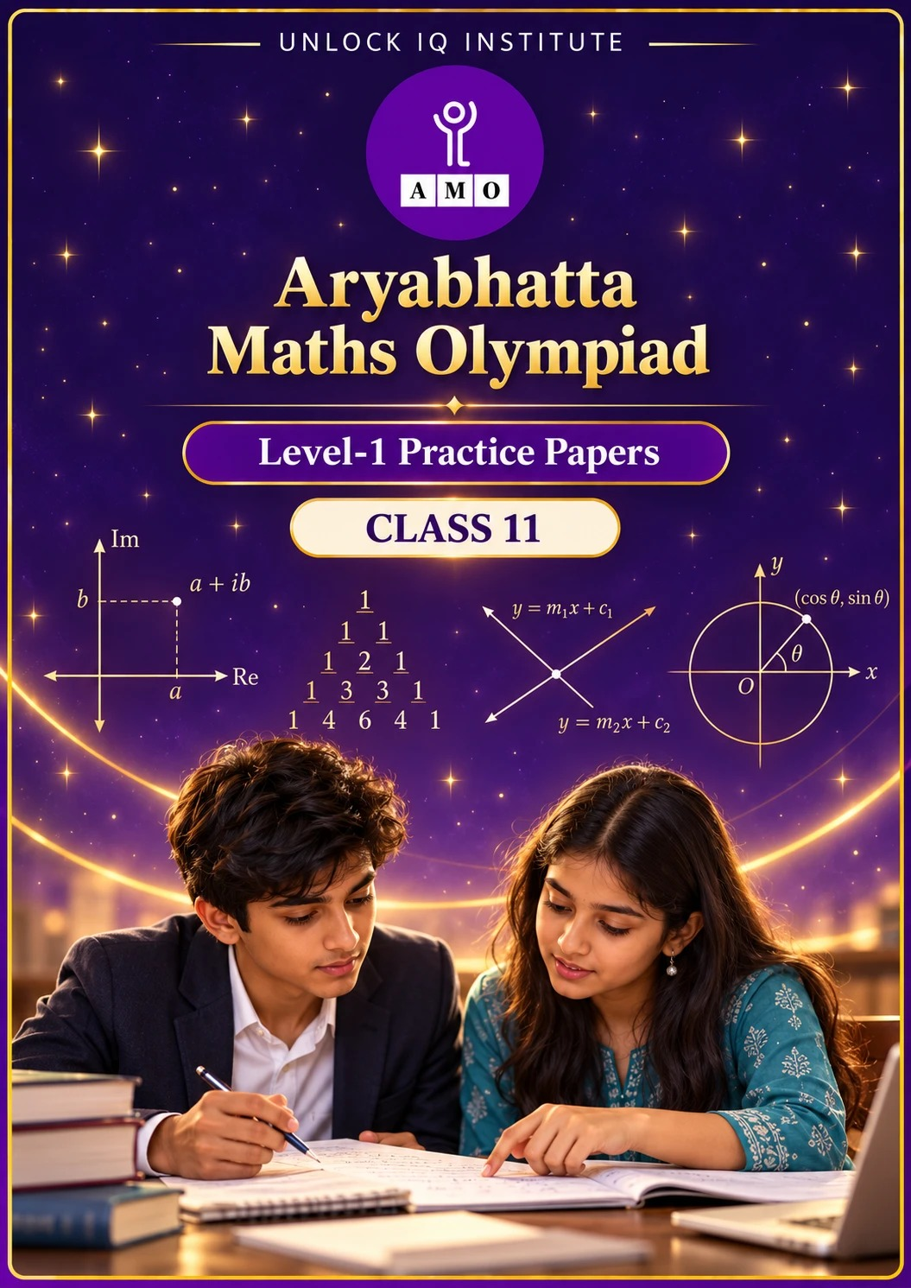
Five full practice papers · with answer keys & detailed solutions
Name: ____________________ | Class & Section: ________________
Roll No.: ________________ | School: ____________________
City: ____________________ | Date: ____________________

Published by Unlock IQ Institute Pvt. Ltd.
Register for Olympiads: www.aryabhattamathsolympiad.com/student-registration

ARYABHATTA MATHS OLYMPIAD
Level 1
PRACTICE PAPER-1
CLASS 11
Total Questions | 45 multiple-choice questions
Total Marks | 100
Time | 60 minutes
Section I | 40 questions × 2 marks = 80 marks
Section II | 5 Star Questions × 4 marks = 20 marks
Negative Marking | No negative marking
Calculator | Not allowed
Chapters | Number System · Algebra · Geometry · Trigonometry · Data Handling · Applied Mathematics · Mathematical Reasoning

Instructions to candidates
• This paper has 45 multiple-choice questions. Each question has four answer choices, of which exactly one is correct.
• Section I (Q1–Q40) carries 2 marks per question. Section II (Q41–Q45) carries 4 marks per question.
• There is no negative marking. Unanswered questions score zero.
• Calculators are not permitted. Rough work may be done on a separate sheet.
• Mark your answers on the answer sheet at the end of the paper.
• All figures are not necessarily drawn to scale unless stated.

For parents and teachers
• Print or view this paper in colour. Pictures are part of the questions.
• Parts follow the AMO syllabus chapters. Chapters 2, 3 and 6 are not part of the Class 11 syllabus, so the chapter numbers shown in the Part headings have gaps.
• The answer sheet and the answer key are at the end. Remove only the answer key before the student begins.

SECTION I 40 questions × 2 marks each
Part 1 — Number System (Syllabus Chapter 1)
Q1. Which of these is equal to −i?
(A) $i^{75}$ | (B) $i^{50}$ | (C) $i^{100}$ | (D) $i^{81}$

Q2. In the Argand diagram, the point P represents the complex number z. Which point represents $\overline{z}$, the conjugate of z? | 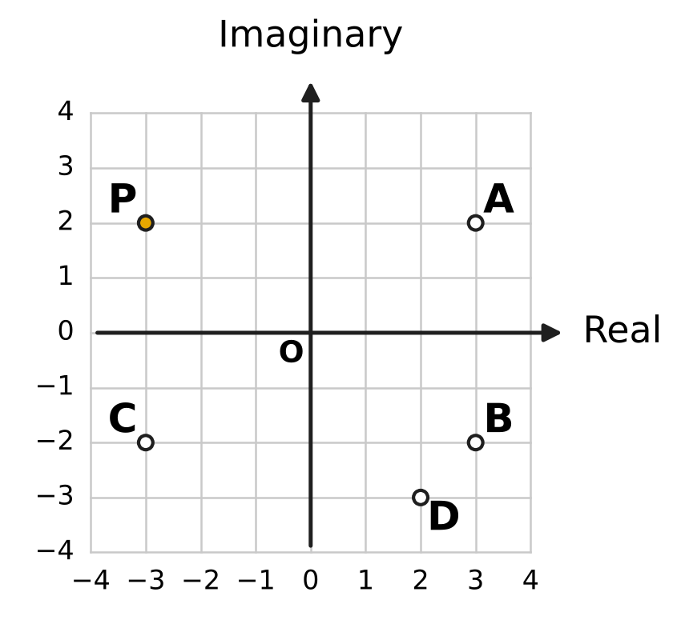
  (A) Point A | (B) Point B | (C) Point C | (D) Point D

Q3. If z = 5 − 2i, what is the value of $z\overline{z}$?
(A) $\sqrt{29}$ | (B) 29
(C) 21 | (D) 10

Q4. For which real number k does the product (k + 2i)(1 + 3i) have real part 0?
(A) $\frac{2}{3}$ | (B) $−\frac{2}{3}$ | (C) −6 | (D) 6

Q5. What is the principal argument of $\frac{3+i}{1+2i}$, taking the principal argument in the interval −π < θ ≤ π?
(A) $−\frac{π}{4}$ | (B) $\frac{π}{4}$ | (C) $\frac{7π}{4}$ | (D) $\frac{3π}{4}$

Part 2 — Algebra (Syllabus Chapter 4)
Q6. How many terms of the geometric progression 4, 12, 36, 108, … are less than 10,000?
(A) 9 | (B) 7 | (C) 8 | (D) 4

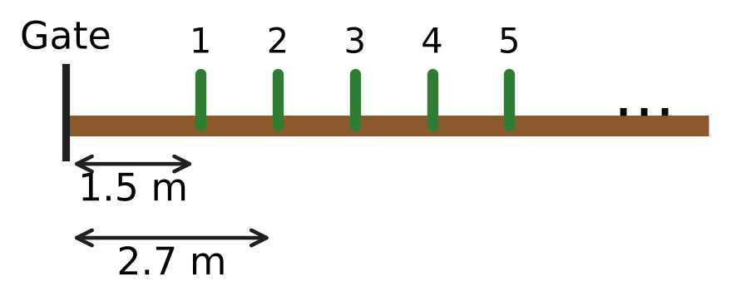
Q7. Uday puts bean stakes in a straight line along a vegetable bed, with equal gaps between them. The figure shows the distances of the first two stakes from the gate. How far is the 25th stake from the gate?
(A) 31.5 m | (B) 28.8 m | (C) 29.1 m | (D) 30.3 m

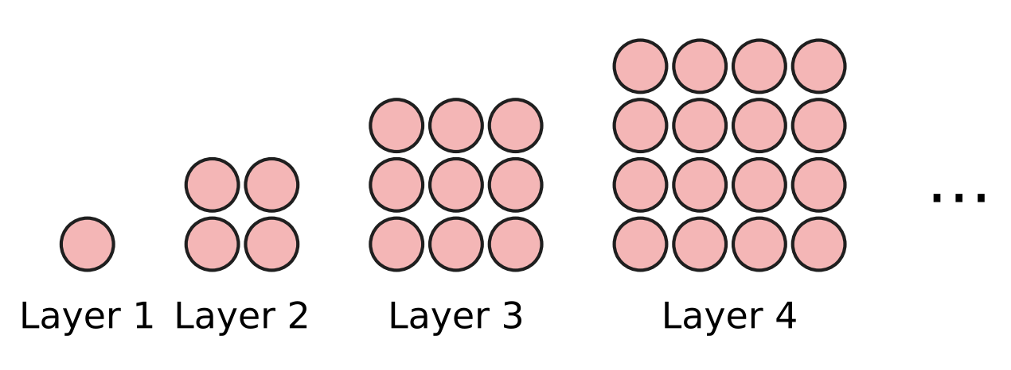
Q8. At an apple orchard, apples are stacked in a square pyramid. Seen from above, the layers from the top are 1 × 1, 2 × 2, 3 × 3, 4 × 4, … apples, as shown. How many apples are there in a pyramid with 12 layers?
(A) 144 | (B) 650 | (C) 78 | (D) 6,084

Q9. What is the fourth term in the expansion of (x² + 2)⁷?
(A) 280x⁸ | (B) 560x⁶ | (C) 84x¹⁰ | (D) 35x⁸

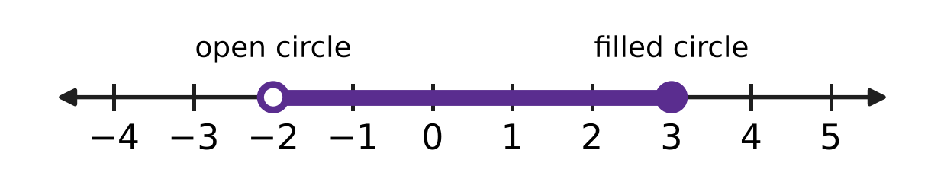
Q10. The number line shows all the solutions of an inequality in x. The open circle means the number is left out; the filled circle means it is included. Which inequality has exactly these solutions?
(A) −4 < 2x ≤ 3 | (B) −5 < 2x − 1 ≤ 5
(C) −5 < 1 − 2x ≤ 5 | (D) −3 < 2x − 1 ≤ 7

Q11. A ball is dropped from a height of 12 m. Each time it hits the ground, it bounces up to $\frac{1}{4}$ of the height it has just fallen, as shown. If it goes on bouncing like this for ever, what is the total distance it travels up and down? | 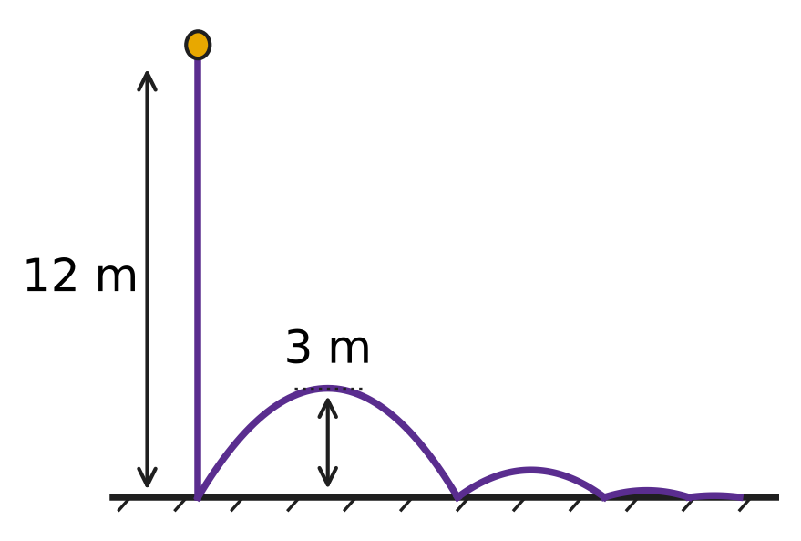
  (A) 18 m | (B) 32 m | (C) 16 m | (D) 20 m

Q12. What is the value of ${(\sqrt{2}+1)}^{4}+{(\sqrt{2}−1)}^{4}$?
(A) $17+12\sqrt{2}$ | (B) 10
(C) 34 | (D) $24\sqrt{2}$

Q13. The counting numbers are written in rows as shown. Row 1 has one number, and each row has one number more than the row above it. What is the sum of the numbers in row 10? | 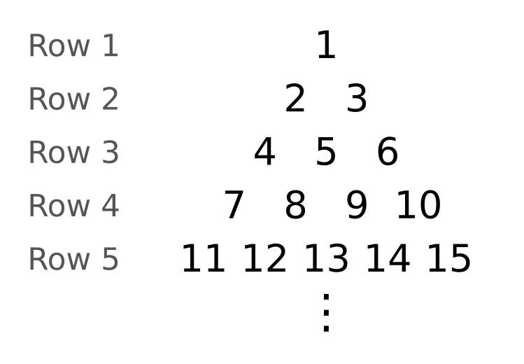
  (A) 505 | (B) 55 | (C) 550 | (D) 495

Q14. Three numbers are in geometric progression. Their product is 216 and their sum is 21. What is the largest of the three numbers?
(A) 6 | (B) 12 | (C) 24 | (D) 18

Part 3 — Geometry (Syllabus Chapter 5)
Q15. The line in the figure passes through the two marked grid points. What is its equation? | 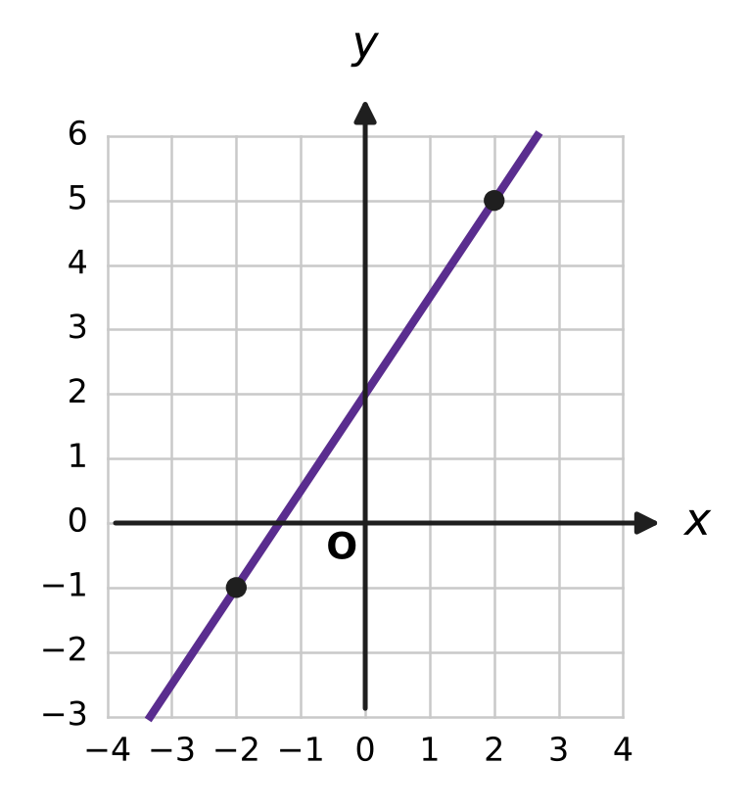
  (A) 3x + 2y + 8 = 0 | (B) 3x − 2y − 4 = 0
  (C) 2x − 3y + 1 = 0 | (D) 3x − 2y + 4 = 0

Q16. A line passes through the point (−2, 3) and makes an angle of 135° with the positive direction of the x-axis. At which point does it cross the y-axis?
(A) (1, 0) | (B) (0, −1) | (C) (0, 1) | (D) (0, 5)

Q17. The line through the points (1, k) and (3, 8) is parallel to the line 5x − 2y + 1 = 0. What is the value of k?
(A) $\frac{44}{5}$ | (B) 13 | (C) $\frac{36}{5}$ | (D) 3

Q18. Triangle ABC is drawn on the grid, with its corners at grid points. The dashed segment is perpendicular to BC. How long is the perpendicular from A to BC? | 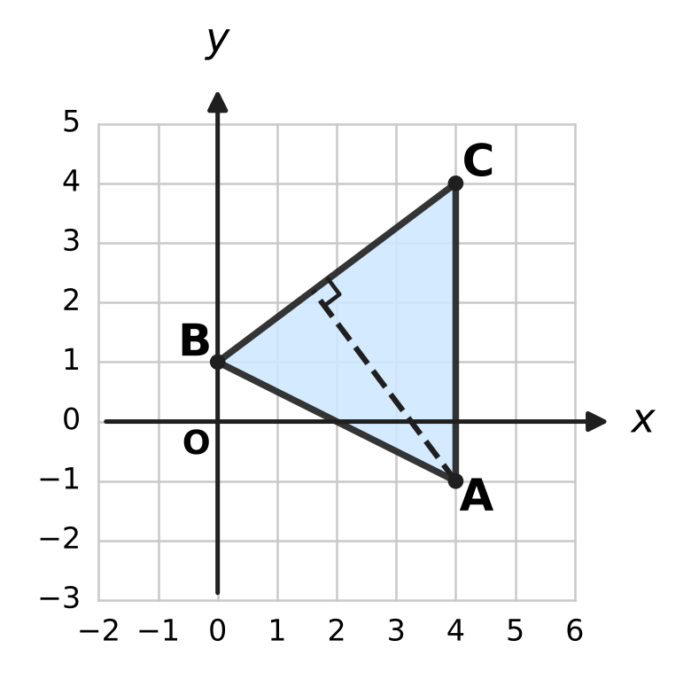
  (A) 4 units | (B) 5 units
  (C) $\frac{12}{5}$ units | (D) 20 units

Q19. A line through the origin has a positive slope and makes an acute angle of 45° with the line y = 4x. What is its slope?
(A) 3 | (B) $\frac{5}{3}$ | (C) $\frac{3}{5}$ | (D) 5

Part 4 — Trigonometry & Heights and Distances (Syllabus Chapter 7)
Q20. The circle has centre O and radius 1. The angle from the positive x-axis to OP, measured anticlockwise, is 210°, as shown. What are the coordinates of P? | 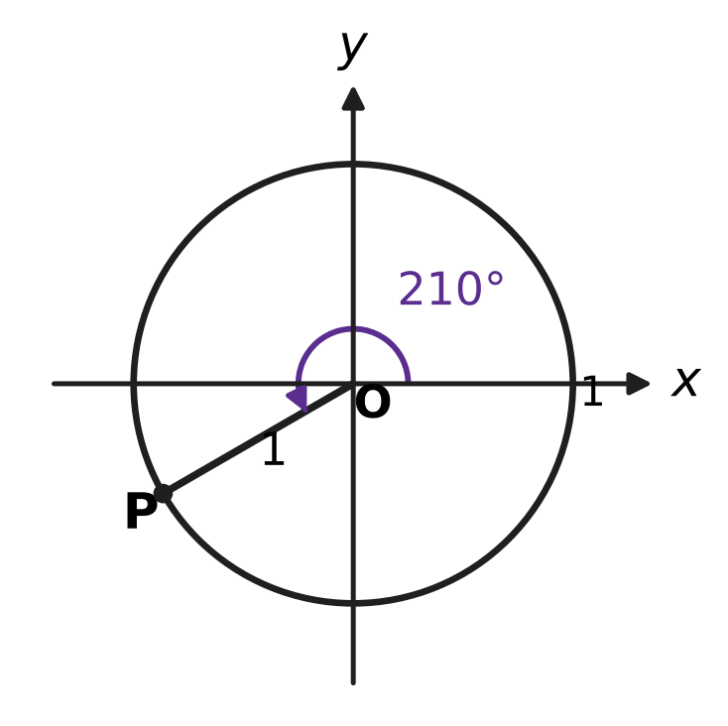
  (A) (√3/2, −1/2) | (B) (−√3/2, −1/2)
  (C) (−√3/2, 1/2) | (D) (−1/2, −√3/2)

Q21. What is the value of sin 80° cos 20° − cos 80° sin 20°?
(A) $\frac{\sqrt{3}}{2}$ | (B) 1
(C) $−\frac{\sqrt{3}}{2}$ | (D) $\frac{1}{2}$

Q22. Which of these is a simpler form of cos⁴A − sin⁴A?
(A) sin 2A | (B) cos² 2A | (C) 1 | (D) cos 2A

Q23. What is the value of cos 20° + cos 100° + cos 140°?
(A) $\frac{1}{2}$ cos 20° | (B) 2 cos 20°
(C) 0 | (D) 1

Q24. A notice board hangs on a classroom wall. Its lower edge is 0.5 m above Leela's eye level and the board is 1.5 m tall, as shown. Leela stands 2 m from the wall. The board makes an angle θ at her eye. What is tan θ? | 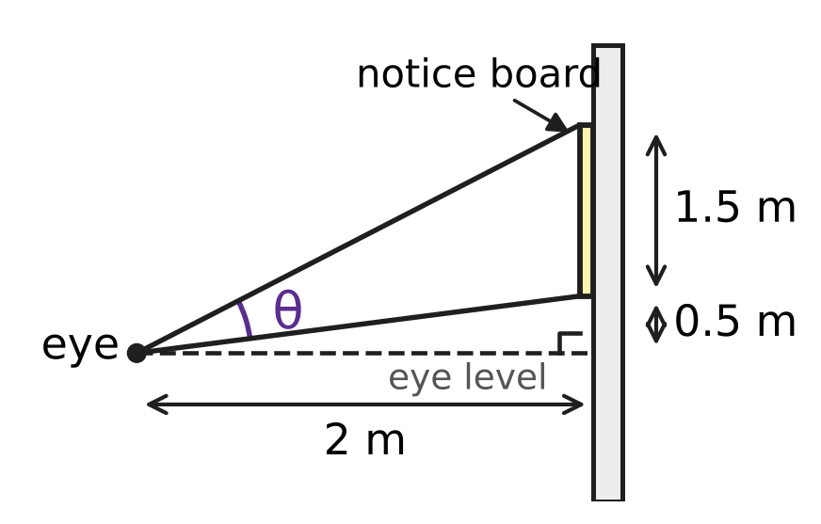
  (A) $\frac{5}{3}$ | (B) $\frac{3}{5}$ | (C) $\frac{5}{4}$ | (D) $\frac{3}{4}$

Part 5 — Data Handling, Statistics & Probability (Syllabus Chapter 8)
Q25. In her stamp collection, Mia has 5 different stamps and also 3 identical copies of one other stamp. In how many different ways can she arrange all 8 stamps in a row?
(A) 120 | (B) 6,720 | (C) 56 | (D) 40,320

Q26. The figure shows a cube with its 8 vertices marked. How many different triangles have all three corners at vertices of the cube? | 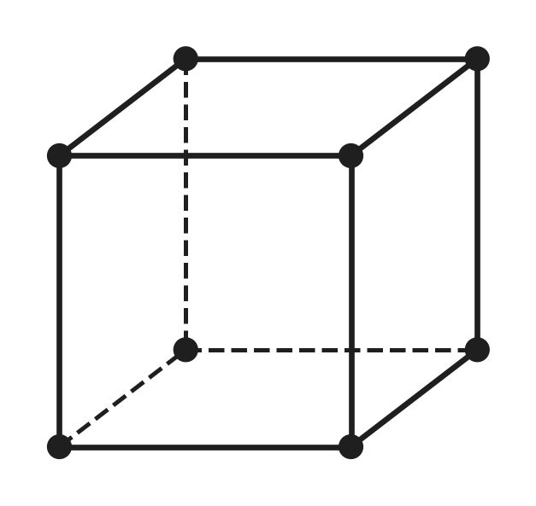
  (A) 168 | (B) 24 | (C) 28 | (D) 56

Q27. The spinner shown has 3 equal sectors, and one of them is shaded. It is spun 3 times. What is the probability that it stops on the shaded sector exactly once? | 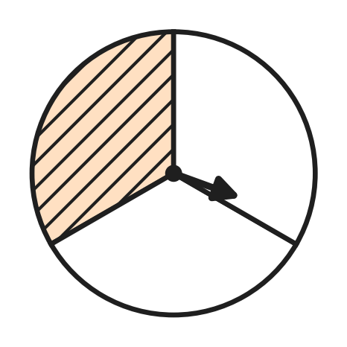
  (A) $\frac{4}{9}$ | (B) $\frac{4}{27}$ | (C) $\frac{8}{27}$ | (D) $\frac{1}{3}$

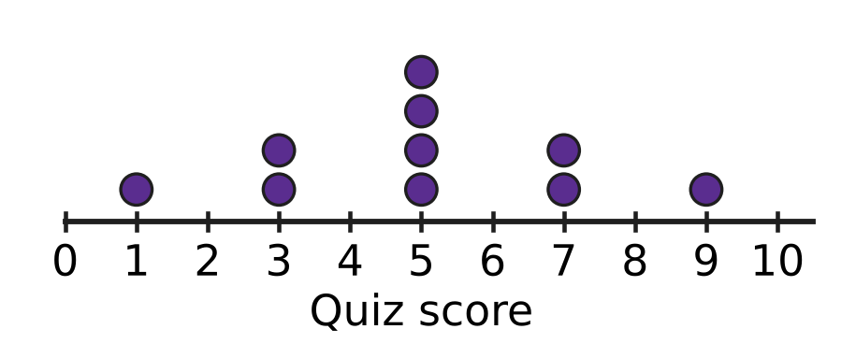
Q28. The dot plot in the figure shows the scores of 10 students in a short quiz. Each dot stands for one student. What is the variance of the scores?
(A) 48 | (B) 29.8 | (C) 4.8 | (D) 9.6

Q29. Six swimmers, including Ira and Arnav, are each given one of the 6 lanes of a swimming pool, numbered 1 to 6 across the pool. In how many ways can the lanes be given out if there is exactly one lane between Ira's lane and Arnav's lane?
(A) 240 | (B) 48 | (C) 96 | (D) 192

Q30. The variance of 2, 4, 6, 8, 10 is 8. What is the variance of 13, 16, 19, 22, 25?
(A) 18 | (B) 8 | (C) 12 | (D) 28

Q31. On any school day, the probability that the school bus is late is $\frac{1}{5}$, independently of other days. What is the probability that the bus is late on at most one of the next 4 school days?
(A) $\frac{113}{625}$ | (B) $\frac{64}{125}$ | (C) $\frac{512}{625}$ | (D) $\frac{256}{625}$

Part 6 — Applied Mathematics (Syllabus Chapter 9)
Q32. Naveen buys a school bag at a stationery shop. The price before tax is ₹1,400, and GST of 18% is charged. The sale is within one state, so the GST is shared equally as CGST and SGST. How much CGST does Naveen pay?
(A) ₹1,526 | (B) ₹126 | (C) ₹252 | (D) ₹63

Q33. A bakery bakes x trays of buns and y trays of biscuits each morning. The shaded region on the grid shows all the plans its oven time and flour allow, with x ≥ 0 and y ≥ 0. Which two other inequalities describe the shaded region? | 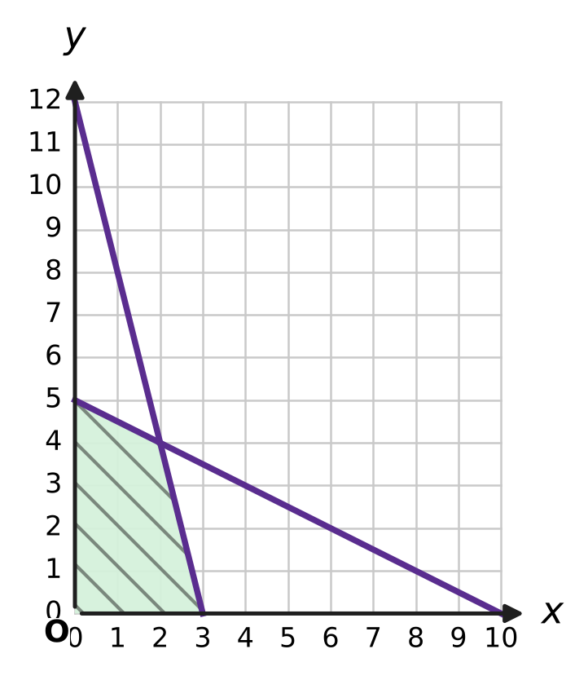
  (A) x + 4y ≤ 12 and 2x + y ≤ 10 | (B) 4x + y ≤ 12 and x + 2y ≤ 10
  (C) 4x + y ≥ 12 and x + 2y ≤ 10 | (D) x + y ≤ 12 and x + y ≤ 10

Q34. Two inlet pipes can fill an empty rainwater tank in 4 hours and 6 hours on their own. A drain pipe can empty the full tank in 12 hours. All three pipes are opened together when the tank is empty. How long does the tank take to fill?
(A) 2 hours | (B) 6 hours
(C) 3 hours | (D) 2.4 hours

Q35. Farah takes a loan of ₹8,200 to buy a bicycle. Interest of 5% a year is charged on the balance outstanding. She clears the loan with two equal instalments of ₹4,410, one at the end of each year. How much of the second instalment is interest?
(A) ₹410 | (B) ₹310 | (C) ₹205 | (D) ₹210

Part 7 — Mathematical Reasoning & Problem-Solving (Syllabus Chapter 10)
Q36. A glass jar holds 5 red, 7 blue and 9 green marbles. Advait takes marbles out one at a time without looking. What is the least number he must take out to be sure of having 4 marbles of the same colour?
(A) 10 | (B) 12 | (C) 13 | (D) 9

Q37. In a class of 30 students, every student borrowed at least one book from the school library this month, and 70 books were borrowed in all. What is the greatest number of books that one student could have borrowed?
(A) 40 | (B) 69 | (C) 41 | (D) 3

Q38. Shreya wants to prove that n² + n + 1 is even for every natural number n. She shows correctly that if k² + k + 1 is even, then (k + 1)² + (k + 1) + 1 is also even. Which statement is true?
(A) The claim is false: n² + n + 1 is odd for every natural number n.
(B) The claim is true for every even n, because n² + n is then even.
(C) The claim is true for every n ≥ 2, because the proof can start at n = 2.
(D) The claim is true for every natural number n, because the step is correct.

Q39. The numbers 1, 2, 3, …, 10 are written on the board. In one move, any two of the numbers, say a and b, are rubbed out and the single number a + b − 1 is written in their place. After 9 moves only one number is left. What is that number?
(A) 64 | (B) 46 | (C) 55 | (D) 45

Q40. On a windy day, 13 identical kites are shared among 5 children so that every child gets at least 2 kites. In how many ways can this be done?
(A) 495 | (B) 125 | (C) 15 | (D) 35

SECTION II — Star Questions 5 questions × 4 marks each
Q41. A geometric progression has every term a whole number from 100 to 1,000 (both included), and each term is greater than the term before it. What is the greatest possible number of terms in such a progression? [4 marks]
(A) 7 | (B) 6 | (C) 5 | (D) 4

Q42. Navya and Kartik take turns to throw a fair die, and Navya throws first. The first person to throw a six wins, and the game then stops. What is the probability that Navya wins? [4 marks]
(A) $\frac{6}{11}$ | (B) $\frac{5}{11}$ | (C) $\frac{1}{2}$ | (D) $\frac{1}{6}$

Q43. Let z = 1 + i. What is the value of z + z² + z³ + … + z⁸? [4 marks]
(A) −15 + 15i | (B) −17 + 17i
(C) 15 − 15i | (D) 16 − 16i

Q44. The line L: x − 2y + 4 = 0 meets the y-axis at A. The line is turned anticlockwise through 45° about A, as shown. At which point does the new line meet the x-axis? [4 marks] | 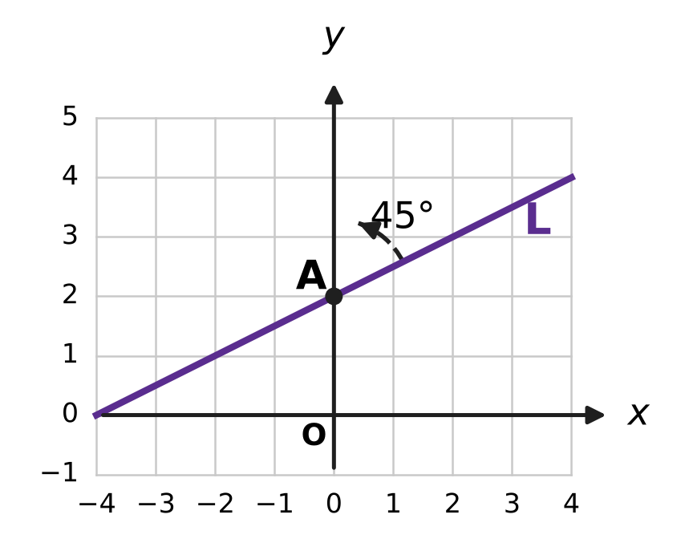
  (A) (1, 0) | (B) (6, 0)
  (C) (−4/3, 0) | (D) (−2/3, 0)

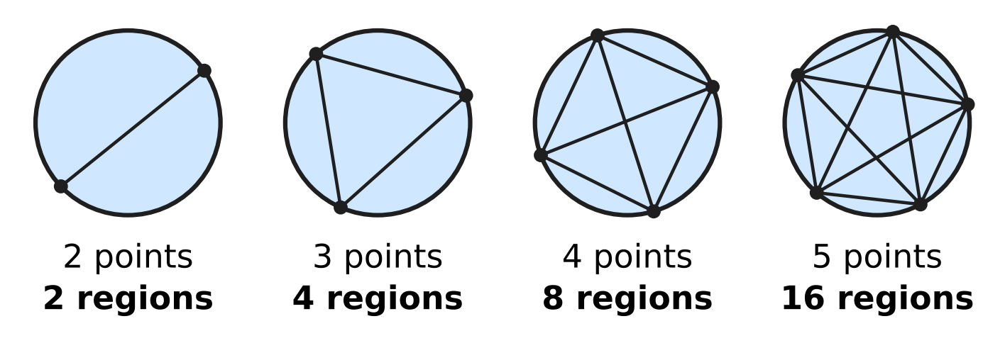
Q45. Points are marked on a circle and every two of them are joined by a straight chord. The points are placed so that no three chords pass through the same point inside the circle. The figure shows the number of regions inside the circle for 2, 3, 4 and 5 points. How many regions are there for 6 points? [4 marks]
(A) 32 | (B) 31 | (C) 16 | (D) 57

Answer Sheet AMO Level 1 · Class 11 · Practice Paper 1
Name: | School: | Roll No.:
Shade or tick one circle for each question.
1. Ⓐ Ⓑ Ⓒ Ⓓ | 16. Ⓐ Ⓑ Ⓒ Ⓓ | 31. Ⓐ Ⓑ Ⓒ Ⓓ
2. Ⓐ Ⓑ Ⓒ Ⓓ | 17. Ⓐ Ⓑ Ⓒ Ⓓ | 32. Ⓐ Ⓑ Ⓒ Ⓓ
3. Ⓐ Ⓑ Ⓒ Ⓓ | 18. Ⓐ Ⓑ Ⓒ Ⓓ | 33. Ⓐ Ⓑ Ⓒ Ⓓ
4. Ⓐ Ⓑ Ⓒ Ⓓ | 19. Ⓐ Ⓑ Ⓒ Ⓓ | 34. Ⓐ Ⓑ Ⓒ Ⓓ
5. Ⓐ Ⓑ Ⓒ Ⓓ | 20. Ⓐ Ⓑ Ⓒ Ⓓ | 35. Ⓐ Ⓑ Ⓒ Ⓓ
6. Ⓐ Ⓑ Ⓒ Ⓓ | 21. Ⓐ Ⓑ Ⓒ Ⓓ | 36. Ⓐ Ⓑ Ⓒ Ⓓ
7. Ⓐ Ⓑ Ⓒ Ⓓ | 22. Ⓐ Ⓑ Ⓒ Ⓓ | 37. Ⓐ Ⓑ Ⓒ Ⓓ
8. Ⓐ Ⓑ Ⓒ Ⓓ | 23. Ⓐ Ⓑ Ⓒ Ⓓ | 38. Ⓐ Ⓑ Ⓒ Ⓓ
9. Ⓐ Ⓑ Ⓒ Ⓓ | 24. Ⓐ Ⓑ Ⓒ Ⓓ | 39. Ⓐ Ⓑ Ⓒ Ⓓ
10. Ⓐ Ⓑ Ⓒ Ⓓ | 25. Ⓐ Ⓑ Ⓒ Ⓓ | 40. Ⓐ Ⓑ Ⓒ Ⓓ
11. Ⓐ Ⓑ Ⓒ Ⓓ | 26. Ⓐ Ⓑ Ⓒ Ⓓ | 41. Ⓐ Ⓑ Ⓒ Ⓓ
12. Ⓐ Ⓑ Ⓒ Ⓓ | 27. Ⓐ Ⓑ Ⓒ Ⓓ | 42. Ⓐ Ⓑ Ⓒ Ⓓ
13. Ⓐ Ⓑ Ⓒ Ⓓ | 28. Ⓐ Ⓑ Ⓒ Ⓓ | 43. Ⓐ Ⓑ Ⓒ Ⓓ
14. Ⓐ Ⓑ Ⓒ Ⓓ | 29. Ⓐ Ⓑ Ⓒ Ⓓ | 44. Ⓐ Ⓑ Ⓒ Ⓓ
15. Ⓐ Ⓑ Ⓒ Ⓓ | 30. Ⓐ Ⓑ Ⓒ Ⓓ | 45. Ⓐ Ⓑ Ⓒ Ⓓ
Q41–Q45 are Section II Star Questions (4 marks each).
For the parent or teacher
Section I correct: ______ / 40 × 2 = ______ marks Section II correct: ______ / 5 × 4 = ______ marks
Correct: ______ / 45 Score: ______ / 100
Answer Key and Solutions AMO Level 1 · Class 11 · Practice Paper 1
Quick answers
1 A | 6 C | 11 D | 16 C | 21 A | 26 D | 31 C | 36 A | 41 B
2 C | 7 D | 12 C | 17 D | 22 D | 27 A | 32 B | 37 C | 42 A
3 B | 8 B | 13 A | 18 A | 23 C | 28 C | 33 B | 38 A | 43 C
4 D | 9 A | 14 B | 19 C | 24 B | 29 D | 34 C | 39 B | 44 D
5 A | 10 B | 15 D | 20 B | 25 B | 30 A | 35 D | 40 D | 45 B
Solutions
Q | Part · level | Answer | Why?
1 | Part 1 · Ch1 · Easy | (A) $i^{75}$ | Only the remainder on division by 4 matters: 75 = 4 × 18 + 3, so i⁷⁵ = i³ = −i. (i⁵⁰ = −1, i⁸¹ = i, i¹⁰⁰ = 1.)
2 | Part 1 · Ch1 · Easy | (C) Point C | P is z = −3 + 2i, so z̄ = −3 − 2i: the reflection of P in the real axis, which is point C.
3 | Part 1 · Ch1 · Easy | (B) 29 | z z̄ = (5 − 2i)(5 + 2i) = 25 − 4i² = 25 + 4 = 29, which is |z|².
4 | Part 1 · Ch1 · Medium | (D) 6 | (k + 2i)(1 + 3i) = k + 3ki + 2i + 6i² = (k − 6) + (3k + 2)i. The real part k − 6 = 0 gives k = 6 (the product is then 20i).
5 | Part 1 · Ch1 · Medium | (A) $−\frac{π}{4}$ | Multiply top and bottom by 1 − 2i: (3 + i)(1 − 2i) = 5 − 5i and (1 + 2i)(1 − 2i) = 5, so the number is 1 − i. It lies in the fourth quadrant with tan α = 1, so the argument is −π/4.
6 | Part 2 · Ch4 · Easy | (C) 8 | The nth term is 4 × 3^{n−1} < 10,000, so 3^{n−1} < 2,500. Since 3⁷ = 2,187 and 3⁸ = 6,561, n − 1 can be at most 7, so 8 terms (the 8th term is 8,748).
7 | Part 2 · Ch4 · Easy | (D) 30.3 m | The distances 1.5, 2.7, … form an AP with common difference 1.2 m. The 25th term is 1.5 + 24 × 1.2 = 30.3 m.
8 | Part 2 · Ch4 · Easy | (B) 650 | Total = 1² + 2² + … + 12² = 12 × 13 × 25 ÷ 6 = 650 apples.
9 | Part 2 · Ch4 · Easy | (A) 280x⁸ | T₄ = T₃₊₁ = C(7, 3) (x²)⁴ × 2³ = 35 × 8 × x⁸ = 280x⁸.
10 | Part 2 · Ch4 · Easy | (B) −5 < 2x − 1 ≤ 5 | The picture shows −2 < x ≤ 3. From −5 < 2x − 1 ≤ 5, add 1 to get −4 < 2x ≤ 6, then halve: −2 < x ≤ 3.
11 | Part 2 · Ch4 · Medium | (D) 20 m | The first fall is 12 m. After that, each bounce is travelled up and down: 2(3 + 0.75 + …) = 2 × 3 ÷ (1 − 1/4) = 8 m. The total is 12 + 8 = 20 m.
12 | Part 2 · Ch4 · Medium | (C) 34 | In the two expansions the terms with odd powers of √2 cancel, and the others double: 2[(√2)⁴ + 6(√2)² + 1] = 2(4 + 12 + 1) = 34.
13 | Part 2 · Ch4 · Medium | (A) 505 | Rows 1 to 9 hold 1 + 2 + … + 9 = 45 numbers, so row 10 is 46, 47, …, 55. Its sum is 10 × (46 + 55) ÷ 2 = 505.
14 | Part 2 · Ch4 · Medium | (B) 12 | Write the numbers as 6/r, 6, 6r (product 6³ = 216). Then 6/r + 6 + 6r = 21 gives 2r² − 5r + 2 = 0, so r = 2 or 1/2: the numbers are 3, 6, 12.
15 | Part 3 · Ch5 · Easy | (D) 3x − 2y + 4 = 0 | The marked points are (−2, −1) and (2, 5), so the slope is 6/4 = 3/2. Then y + 1 = (3/2)(x + 2), which gives 3x − 2y + 4 = 0.
16 | Part 3 · Ch5 · Easy | (C) (0, 1) | The slope is tan 135° = −1. So y − 3 = −(x + 2), that is y = −x + 1, which crosses the y-axis at (0, 1).
17 | Part 3 · Ch5 · Easy | (D) 3 | 5x − 2y + 1 = 0 has slope 5/2. So (8 − k)/(3 − 1) = 5/2, which gives 8 − k = 5 and k = 3.
18 | Part 3 · Ch5 · Medium | (A) 4 units | A = (4, −1), B = (0, 1), C = (4, 4). The line BC is 3x − 4y + 4 = 0, so the distance is |12 + 4 + 4| ÷ √(9 + 16) = 20 ÷ 5 = 4 units.
19 | Part 3 · Ch5 · Medium | (C) $\frac{3}{5}$ | tan 45° = |(m − 4)/(1 + 4m)| = 1. Either m − 4 = 1 + 4m, giving m = −5/3, or m − 4 = −(1 + 4m), giving m = 3/5. The positive slope is 3/5.
20 | Part 4 · Ch7 · Easy | (B) (−√3/2, −1/2) | P = (cos 210°, sin 210°). 210° = 180° + 30° is in the third quadrant, so P = (−cos 30°, −sin 30°) = (−√3/2, −1/2).
21 | Part 4 · Ch7 · Easy | (A) $\frac{\sqrt{3}}{2}$ | sin A cos B − cos A sin B = sin(A − B), so the value is sin(80° − 20°) = sin 60° = √3/2.
22 | Part 4 · Ch7 · Easy | (D) cos 2A | cos⁴A − sin⁴A = (cos²A − sin²A)(cos²A + sin²A) = (cos²A − sin²A) × 1 = cos 2A.
23 | Part 4 · Ch7 · Medium | (C) 0 | cos 100° + cos 140° = 2 cos 120° cos 20° = 2 × (−1/2) cos 20° = −cos 20°. Adding cos 20° gives 0.
24 | Part 4 · Ch7 · Medium | (B) $\frac{3}{5}$ | The top edge is 2 m above eye level, so the angles to the top and bottom have tangents 2/2 = 1 and 0.5/2 = 1/4. tan θ = (1 − 1/4) ÷ (1 + 1 × 1/4) = (3/4) ÷ (5/4) = 3/5.
25 | Part 5 · Ch8 · Easy | (B) 6,720 | There are 8 stamps with 3 alike, so there are 8!/3! = 40,320 ÷ 6 = 6,720 arrangements.
26 | Part 5 · Ch8 · Easy | (D) 56 | No three vertices of a cube lie on one straight line, so every choice of 3 vertices gives a triangle: C(8, 3) = 56.
27 | Part 5 · Ch8 · Easy | (A) $\frac{4}{9}$ | P(exactly 1) = C(3, 1) × (1/3) × (2/3)² = 3 × 4/27 = 4/9.
28 | Part 5 · Ch8 · Easy | (C) 4.8 | The mean is 50 ÷ 10 = 5. The squared deviations add up to 16 + 2 × 4 + 4 × 0 + 2 × 4 + 16 = 48, so the variance is 48 ÷ 10 = 4.8.
29 | Part 5 · Ch8 · Medium | (D) 192 | The lane pairs with one lane between are (1, 3), (2, 4), (3, 5), (4, 6): 4 pairs. Ira and Arnav can take each pair in 2 ways, and the other 4 swimmers in 4! = 24 ways: 4 × 2 × 24 = 192.
30 | Part 5 · Ch8 · Medium | (A) 18 | Each new value is 1.5 × (old value) + 10. Adding 10 does not change the variance, and multiplying by 1.5 multiplies it by 1.5² = 2.25: 8 × 2.25 = 18.
31 | Part 5 · Ch8 · Medium | (C) $\frac{512}{625}$ | P(0 late) + P(1 late) = (4/5)⁴ + 4 × (1/5) × (4/5)³ = 256/625 + 256/625 = 512/625.
32 | Part 6 · Ch9 · Easy | (B) ₹126 | CGST is half of 18%, that is 9%. 9% of ₹1,400 = ₹126.
33 | Part 6 · Ch9 · Easy | (B) 4x + y ≤ 12 and x + 2y ≤ 10 | One line goes through (3, 0) and (0, 12): 4x + y = 12. The other goes through (10, 0) and (0, 5): x + 2y = 10. The origin is in the region, so both are "≤": 4x + y ≤ 12 and x + 2y ≤ 10.
34 | Part 6 · Ch9 · Easy | (C) 3 hours | In one hour: 1/4 + 1/6 − 1/12 = (3 + 2 − 1)/12 = 1/3 of the tank. So the tank fills in 3 hours.
35 | Part 6 · Ch9 · Medium | (D) ₹210 | After year 1 Farah owes 8,200 × 1.05 = ₹8,610; after paying ₹4,410 she owes ₹4,200. Interest in year 2 is 5% of ₹4,200 = ₹210 (and 4,200 + 210 = 4,410 clears the loan).
36 | Part 7 · Ch10 · Easy | (A) 10 | He could take 3 of each colour, 9 marbles, without having 4 alike. The 10th marble must give 4 of one colour.
37 | Part 7 · Ch10 · Easy | (C) 41 | For one student to have as many as possible, each of the other 29 students has just 1 book. That student then has 70 − 29 = 41 books.
38 | Part 7 · Ch10 · Easy | (A) The claim is false: n² + n + 1 is odd for every natural number n. | n² + n = n(n + 1) is a product of two consecutive numbers, so it is even and n² + n + 1 is odd for every n. The step is correct, but there is no true base case to start from (n = 1 gives 3).
39 | Part 7 · Ch10 · Medium | (B) 46 | Each move lowers the total of the numbers on the board by exactly 1. The total starts at 55 and 9 moves are made, so the last number is 55 − 9 = 46, whatever the order.
40 | Part 7 · Ch10 · Medium | (D) 35 | Give each child 2 kites first; 3 kites are left. Sharing 3 identical kites among 5 children: C(3 + 4, 4) = C(7, 4) = 35 ways.
41 | Section II · Ch4 + Ch10 · Hard | (B) 6 | Ratio 3/2 from 128 gives 128, 192, 288, 432, 648, 972: 6 terms. With ratio p/q in lowest terms, n terms need (p/q)^{n−1} ≤ 10, and the last term is a multiple of p^{n−1}. For 7 terms, (p/q)⁶ ≤ 10 rules out q = 1 (ratio ≥ 2) and q = 2 ((3/2)⁶ > 11), so q ≥ 3, p ≥ 4 and the last term is at least 4⁶ = 4,096, which is too big.
42 | Section II · Ch4 + Ch8 · Hard | (A) $\frac{6}{11}$ | Navya wins on her 1st, 2nd, 3rd, … throw with probabilities 1/6, (5/6)²(1/6), (5/6)⁴(1/6), … . This is a GP with ratio 25/36, so the sum is (1/6) ÷ (1 − 25/36) = (1/6) × (36/11) = 6/11.
43 | Section II · Ch1 + Ch4 · Hard | (C) 15 − 15i | (1 + i)² = 2i, so (1 + i)⁸ = (2i)⁴ = 16. The GP sum is z(z⁸ − 1)/(z − 1) = (1 + i)(15)/i = 15(1 + i)(−i) = 15 − 15i.
44 | Section II · Ch5 + Ch7 · Hard | (D) (−2/3, 0) | L has slope tan θ = 1/2 and A = (0, 2). The new slope is tan(θ + 45°) = (1/2 + 1)/(1 − 1/2) = 3, so the new line is y = 3x + 2. It meets the x-axis where 3x + 2 = 0, at (−2/3, 0).
45 | Section II · Ch8 + Ch10 · Hard | (B) 31 | Each chord adds one region, and each crossing point inside adds one more. Every 4 points give exactly one crossing, so regions = 1 + C(6, 2) + C(6, 4) = 1 + 15 + 15 = 31, not 32.

ARYABHATTA MATHS OLYMPIAD
Level 1
PRACTICE PAPER-2
CLASS 11
Total Questions | 45 multiple-choice questions
Total Marks | 100
Time | 60 minutes
Section I | 40 questions × 2 marks = 80 marks
Section II | 5 Star Questions × 4 marks = 20 marks
Negative Marking | No negative marking
Calculator | Not allowed
Chapters | Number System · Algebra · Geometry · Trigonometry · Data Handling · Applied Mathematics · Mathematical Reasoning

Instructions to candidates
• This paper has 45 multiple-choice questions. Each question has four answer choices, of which exactly one is correct.
• Section I (Q1–Q40) carries 2 marks per question. Section II (Q41–Q45) carries 4 marks per question.
• There is no negative marking. Unanswered questions score zero.
• Calculators are not permitted. Rough work may be done on a separate sheet.
• Mark your answers on the answer sheet at the end of the paper.
• All figures are not necessarily drawn to scale unless stated.

For parents and teachers
• Print or view this paper in colour. Pictures are part of the questions.
• Parts follow the AMO syllabus chapters. Chapters 2, 3 and 6 are not part of the Class 11 syllabus, so the chapter numbers shown in the Part headings have gaps.
• The answer sheet and the answer key are at the end. Remove only the answer key before the student begins.

SECTION I 40 questions × 2 marks each
Part 1 — Number System (Syllabus Chapter 1)
Q1. Which of these complex numbers has the greatest modulus?
(A) 5 + 2i | (B) −6 | (C) −4 + 4i | (D) 1 − 6i

Q2. In the Argand plane, in which quadrant does the point representing $\frac{2−i}{i}$ lie?
(A) the first quadrant | (B) the second quadrant
(C) the third quadrant | (D) the fourth quadrant

Q3. Which of these complex numbers has its square equal to 7 + 24i?
(A) 4 + 3i | (B) 3 + 4i | (C) 3 − 4i | (D) 4 − 3i

Q4. The roots of the equation x² − 2x + 26 = 0 are z₁ and z₂. What is the modulus of z₁ − z₂?
(A) 2 | (B) 26
(C) $\sqrt{26}$ | (D) 10

Q5. The complex number z satisfies $z+2\overline{z}=12+7i$, where $\overline{z}$ is the conjugate of z. What is z?
(A) −4 + 7i | (B) 4 − 7i | (C) 12 − 7i | (D) 4 + 7i

Part 2 — Algebra (Syllabus Chapter 4)
Q6. Which of these sequences is a geometric progression?
(A) 16, 24, 36, 54 | (B) 16, 24, 32, 40
(C) 16, 20, 25, 30 | (D) 16, 8, 4, 0

Q7. Two positive numbers have arithmetic mean (AM) and geometric mean (GM) as given. Which of these pairs is NOT possible?
(A) AM = 10 and GM = 6 | (B) AM = 5 and GM = 4
(C) AM = 7 and GM = 8 | (D) AM = 6 and GM = 6

Q8. Which of these numbers is a term of the arithmetic progression 200, 193, 186, …?
(A) −53 | (B) −56 | (C) −50 | (D) −52

Q9. Write 99 = 100 − 1 and use the binomial theorem. What is the value of 99⁴?
(A) 104,060,401 | (B) 96,059,601
(C) 96,059,599 | (D) 96,060,401

Q10. The sum to infinity of a geometric progression is 3 times its first term. What is its common ratio?
(A) $\frac{2}{3}$ | (B) −2 | (C) $\frac{1}{3}$ | (D) $\frac{3}{2}$

Q11. For a natural number n, 1³ + 2³ + 3³ + … + n³ = 4,356. What is n?
(A) 66 | (B) 10 | (C) 11 | (D) 12

Q12. What is the coefficient of x⁶ in the expansion of (1 + x)⁵(1 − x)⁵?
(A) 210 | (B) −10 | (C) 0 | (D) 10

Q13. The numbers x, x + 8 and x + 24 are three consecutive terms of a geometric progression. What is its common ratio?
(A) 4 | (B) 16 | (C) 8 | (D) 2

Q14. The sum of the first n terms of a sequence is $S_{n}=5^{n}−1$ for every natural number n. What is the 4th term of the sequence?
(A) 500 | (B) 124 | (C) 625 | (D) 624

Part 3 — Geometry (Syllabus Chapter 5)
Q15. Which of these lines is perpendicular to the line 3x − 4y + 7 = 0?
(A) 3x + 4y − 2 = 0 | (B) 4x + 3y − 1 = 0
(C) 4x − 3y + 5 = 0 | (D) 6x − 8y + 1 = 0

Q16. The points (−2, 1), (1, k) and (7, 13) lie on one straight line. What is the value of k?
(A) 9 | (B) 4 | (C) 7 | (D) 5

Q17. Which of these points is nearest to the line 4x − 3y + 2 = 0?
(A) (0, 2) | (B) (−1, 1) | (C) (2, 4) | (D) (1, 1)

Q18. In the figure, O is the origin, A = (3, 1) and B = (1, 3). What is the value of tan ∠AOB? | 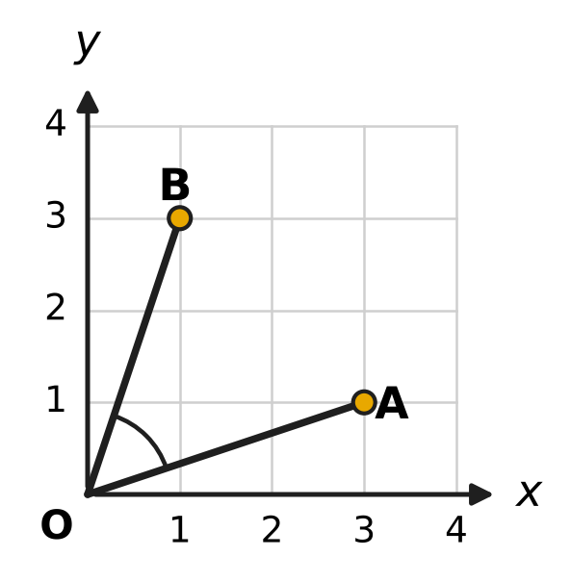
  (A) $\frac{4}{3}$ | (B) 1 | (C) $\frac{8}{3}$ | (D) $\frac{3}{4}$

Q19. In the figure, a line meets the x-axis at M and the y-axis at N. The point P(3, 4) is the midpoint of MN. What is the equation of the line? | 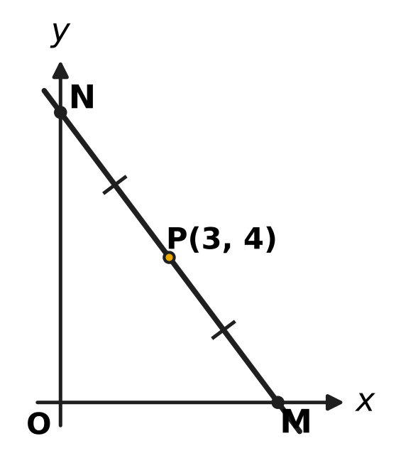
  (A) 4x + 3y = 12 | (B) 3x + 4y = 25
  (C) 3x + 4y = 24 | (D) 4x + 3y = 24

Part 4 — Trigonometry & Heights and Distances (Syllabus Chapter 7)
Q20. Which of these has a negative value?
(A) tan 225° | (B) sin 240°
(C) cos 300° | (D) sin(−330°)

Q21. Which of these is equal to sin 70° + sin 50°?
(A) √3 cos 10° | (B) √3 sin 10°
(C) cos 10° | (D) sin 120°

Q22. A ribbon is wound on a round spool of radius 3.5 cm. The spool turns through 270°, as shown in the figure, and the ribbon unwound equals the arc length. How much ribbon is unwound? (Use π = 22/7.) | 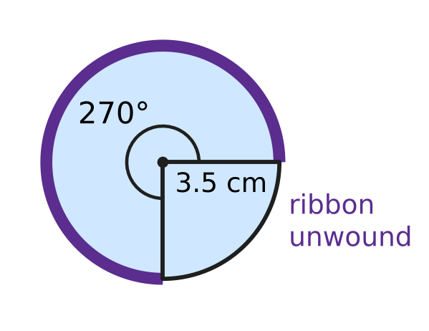
  (A) 33 cm | (B) 945 cm | (C) 16.5 cm | (D) 11 cm

Q23. If sin A − cos A = $\frac{1}{2}$, what is the value of sin 2A?
(A) $\frac{1}{4}$ | (B) $\frac{5}{4}$ | (C) $\frac{3}{4}$ | (D) $−\frac{3}{4}$

Q24. What is the value of 4 cos 52.5° cos 7.5°?
(A) 1 + √3 | (B) 2 + √2
(C) $\frac{1+\sqrt{2}}{2}$ | (D) 1 + √2

Part 5 — Data Handling, Statistics & Probability (Syllabus Chapter 8)
Q25. Here P(n, r) is the number of arrangements of r things chosen from n different things, and C(n, r) is the number of selections. Which of these has the greatest value?
(A) C(9, 6) | (B) P(6, 4) | (C) 4! × 3! | (D) C(10, 5)

Q26. At a picnic in a park, three friends sit on a bench that has 5 seats in a row, one friend to a seat. Two seats stay empty. In how many different ways can they sit?
(A) 60 | (B) 6 | (C) 10 | (D) 125

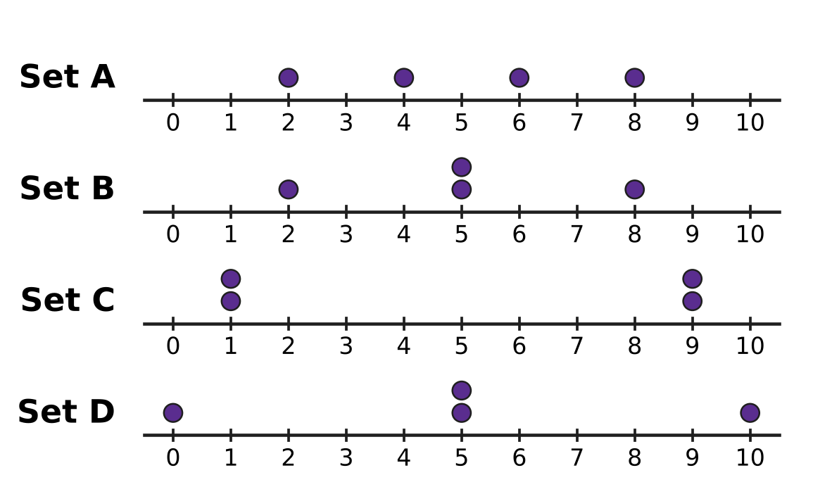
Q27. The dot plots in the figure show four data sets, each of four numbers with mean 5. Each dot stands for one number. Which data set has the greatest standard deviation?
(A) Set A | (B) Set B | (C) Set C | (D) Set D

Q28. On sports day, Akash scores each basketball free throw with probability $\frac{3}{4}$, independently of his other throws. He takes 3 free throws. What is the probability that he scores exactly 2 of them?
(A) $\frac{27}{64}$ | (B) $\frac{9}{16}$ | (C) $\frac{27}{32}$ | (D) $\frac{9}{64}$

Q29. A team of 4 students is to be chosen from 6 girls and 5 boys. The team must have at least 3 girls. How many different teams are possible?
(A) 160 | (B) 115 | (C) 330 | (D) 100

Q30. A bird has 6 eggs in its nest. Each egg hatches with probability 4/5, independently of the others. Which number of eggs hatching is the most likely?
(A) exactly 6 eggs | (B) exactly 5 eggs
(C) exactly 4 eggs | (D) exactly 3 eggs

Q31. The lengths of the 6 fish in an aquarium have mean 8 cm and variance 9 cm². What is the sum of the squares of the 6 lengths?
(A) 73 cm² | (B) 330 cm² | (C) 384 cm² | (D) 438 cm²

Part 6 — Applied Mathematics (Syllabus Chapter 9)
Q32. At a toy shop, a toy train is marked ₹2,000. Which of these offers gives the lowest price?
(A) 25% off, then a further 6% off | (B) 20% off, then a further 12% off
(C) a single discount of 30% | (D) 10% off, then a further 22% off

Q33. Mira deposits ₹25,000 in a bank. Interest is compounded yearly at 8% for the first year and 10% for the second year. What is the amount after 2 years?
(A) ₹29,160 | (B) ₹29,700 | (C) ₹29,500 | (D) ₹30,250

Q34. Jaya has ₹600 to buy water bottles at ₹25 each and juice packs at ₹40 each for a class trip. She must buy at least 6 juice packs. What is the greatest number of water bottles she can buy?
(A) 14 | (B) 24 | (C) 11 | (D) 15

Q35. Ashok wants ₹5,304 in his savings plan at the end of 2 years. He will put the same amount into the plan at the start of each of the 2 years. The plan pays 4% a year, compounded yearly. How much must he put in each year?
(A) ₹2,550 | (B) ₹2,652 | (C) ₹2,600 | (D) ₹2,500

Part 7 — Mathematical Reasoning & Problem-Solving (Syllabus Chapter 10)
Q36. Which of these statements is true for every natural number n?
(A) 2^{n} > n² | (B) n² + n + 41 is a prime number
(C) 4^{n} ≥ 3n + 1 | (D) n² + n is divisible by 4

Q37. At a fruit market, there are 50 baskets of mangoes. Each basket holds at least 20 and at most 26 mangoes. What is the largest number k for which we can be sure that some k baskets hold the same number of mangoes?
(A) 9 | (B) 7 | (C) 2 | (D) 8

Q38. To prove that $7^{n}−3^{n}$ is divisible by 4 for every natural number n, assume that $7^{k}−3^{k}$ is divisible by 4 and write $7^{k+1}−3^{k+1}=7(7^{k}−3^{k})+c×3^{k}$. What is the number c that makes this true?
(A) 10 | (B) 3 | (C) 4 | (D) −4

Q39. A row in the school garden has 20 spaces, numbered 1 to 20. Veena puts 5 pots in 5 different spaces. She wants the pots spread out, so that the smallest difference between the space numbers of any two of her pots is as large as possible. What is this greatest possible smallest difference?
(A) 3 | (B) 4 | (C) 6 | (D) 5

Q40. The desks in a classroom stand in 4 rows of 6 desks each, making 6 columns. The teacher picks 2 of the desks so that they are in different rows and in different columns. In how many ways can she pick them?
(A) 180 | (B) 90 | (C) 360 | (D) 276

SECTION II — Star Questions 5 questions × 4 marks each
Q41. A load is put on the left pan of a two-pan balance. Lena may choose 5 weights, each a whole number of grams, and may put any of them on either pan or leave them out. She wants to be able to balance every load of 1 g, 2 g, 3 g, … up to N g. What is the greatest possible value of N? [4 marks]
(A) 40 | (B) 242 | (C) 121 | (D) 31

Q42. A class has n students, where n ≥ 3. The number of ways of choosing 1 student, the number of ways of choosing 2 students and the number of ways of choosing 3 students, in that order, are in arithmetic progression. What is n? [4 marks]
(A) 7 | (B) 14 | (C) 9 | (D) 21

Q43. For how many whole numbers n from 1 to 30 (both included) is $i×i^{2}×i^{3}×…×i^{n}$ equal to 1? [4 marks]
(A) 14 | (B) 7 | (C) 8 | (D) 6

Q44. In the figure, the circle has centre O and radius 1. OA makes an angle of 20° and OB an angle of 100° with the positive x-axis, so A = (cos 20°, sin 20°) and B = (cos 100°, sin 100°). What is the slope of the line AB? [4 marks] | 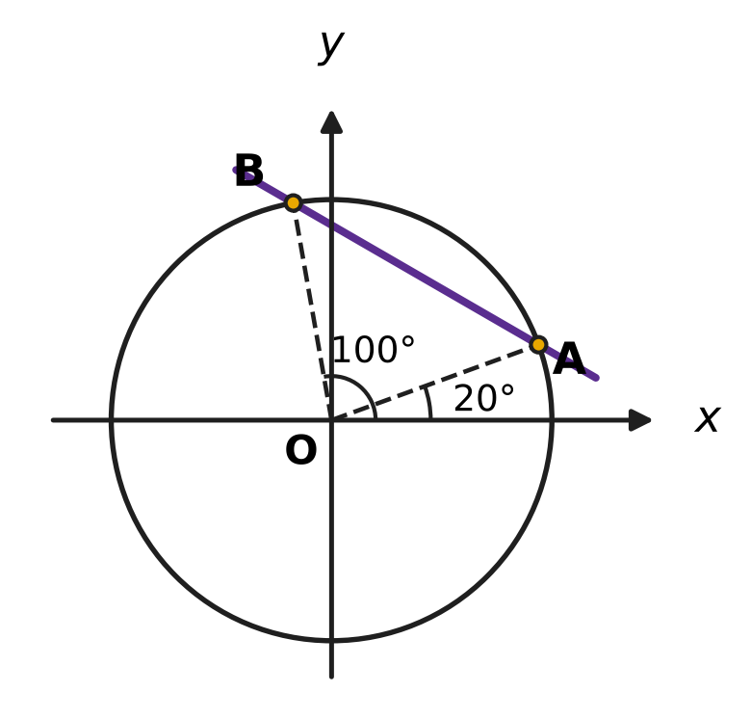
  (A) $\sqrt{3}$ | (B) $−\frac{1}{\sqrt{3}}$
  (C) $−\sqrt{3}$ | (D) $\frac{1}{\sqrt{3}}$

Q45. Six whole numbers are written down. Each is from 1 to 9 (both included), and numbers may repeat. What is the greatest possible variance of the six numbers? [4 marks]
(A) $\frac{128}{9}$ | (B) 4 | (C) 16 | (D) 64

Answer Sheet AMO Level 1 · Class 11 · Practice Paper 2
Name: | School: | Roll No.:
Shade or tick one circle for each question.
1. Ⓐ Ⓑ Ⓒ Ⓓ | 16. Ⓐ Ⓑ Ⓒ Ⓓ | 31. Ⓐ Ⓑ Ⓒ Ⓓ
2. Ⓐ Ⓑ Ⓒ Ⓓ | 17. Ⓐ Ⓑ Ⓒ Ⓓ | 32. Ⓐ Ⓑ Ⓒ Ⓓ
3. Ⓐ Ⓑ Ⓒ Ⓓ | 18. Ⓐ Ⓑ Ⓒ Ⓓ | 33. Ⓐ Ⓑ Ⓒ Ⓓ
4. Ⓐ Ⓑ Ⓒ Ⓓ | 19. Ⓐ Ⓑ Ⓒ Ⓓ | 34. Ⓐ Ⓑ Ⓒ Ⓓ
5. Ⓐ Ⓑ Ⓒ Ⓓ | 20. Ⓐ Ⓑ Ⓒ Ⓓ | 35. Ⓐ Ⓑ Ⓒ Ⓓ
6. Ⓐ Ⓑ Ⓒ Ⓓ | 21. Ⓐ Ⓑ Ⓒ Ⓓ | 36. Ⓐ Ⓑ Ⓒ Ⓓ
7. Ⓐ Ⓑ Ⓒ Ⓓ | 22. Ⓐ Ⓑ Ⓒ Ⓓ | 37. Ⓐ Ⓑ Ⓒ Ⓓ
8. Ⓐ Ⓑ Ⓒ Ⓓ | 23. Ⓐ Ⓑ Ⓒ Ⓓ | 38. Ⓐ Ⓑ Ⓒ Ⓓ
9. Ⓐ Ⓑ Ⓒ Ⓓ | 24. Ⓐ Ⓑ Ⓒ Ⓓ | 39. Ⓐ Ⓑ Ⓒ Ⓓ
10. Ⓐ Ⓑ Ⓒ Ⓓ | 25. Ⓐ Ⓑ Ⓒ Ⓓ | 40. Ⓐ Ⓑ Ⓒ Ⓓ
11. Ⓐ Ⓑ Ⓒ Ⓓ | 26. Ⓐ Ⓑ Ⓒ Ⓓ | 41. Ⓐ Ⓑ Ⓒ Ⓓ
12. Ⓐ Ⓑ Ⓒ Ⓓ | 27. Ⓐ Ⓑ Ⓒ Ⓓ | 42. Ⓐ Ⓑ Ⓒ Ⓓ
13. Ⓐ Ⓑ Ⓒ Ⓓ | 28. Ⓐ Ⓑ Ⓒ Ⓓ | 43. Ⓐ Ⓑ Ⓒ Ⓓ
14. Ⓐ Ⓑ Ⓒ Ⓓ | 29. Ⓐ Ⓑ Ⓒ Ⓓ | 44. Ⓐ Ⓑ Ⓒ Ⓓ
15. Ⓐ Ⓑ Ⓒ Ⓓ | 30. Ⓐ Ⓑ Ⓒ Ⓓ | 45. Ⓐ Ⓑ Ⓒ Ⓓ
Q41–Q45 are Section II Star Questions (4 marks each).
For the parent or teacher
Section I correct: ______ / 40 × 2 = ______ marks Section II correct: ______ / 5 × 4 = ______ marks
Correct: ______ / 45 Score: ______ / 100
Answer Key and Solutions AMO Level 1 · Class 11 · Practice Paper 2
Quick answers
1 D | 6 A | 11 C | 16 D | 21 A | 26 A | 31 D | 36 C | 41 C
2 C | 7 C | 12 B | 17 C | 22 C | 27 C | 32 C | 37 D | 42 A
3 A | 8 D | 13 D | 18 A | 23 C | 28 A | 33 B | 38 C | 43 D
4 D | 9 B | 14 A | 19 D | 24 D | 29 B | 34 A | 39 B | 44 B
5 B | 10 A | 15 B | 20 B | 25 B | 30 B | 35 D | 40 A | 45 C
Solutions
Q | Part · level | Answer | Why?
1 | Part 1 · Ch1 · Easy | (D) 1 − 6i | The moduli are √29, √32, √37 and √36 = 6 for 5 + 2i, −4 + 4i, 1 − 6i and −6. The greatest is √37, for 1 − 6i.
2 | Part 1 · Ch1 · Easy | (C) the third quadrant | Since 1/i = −i, the number is (2 − i)(−i) = −2i + i² = −1 − 2i. Both parts are negative, so the point is in the third quadrant.
3 | Part 1 · Ch1 · Easy | (A) 4 + 3i | (4 + 3i)² = 16 + 24i + 9i² = 16 − 9 + 24i = 7 + 24i.
4 | Part 1 · Ch1 · Medium | (D) 10 | The roots are (2 ± √(4 − 104))/2 = 1 ± 5i. Their difference is 10i, whose modulus is 10.
5 | Part 1 · Ch1 · Medium | (B) 4 − 7i | With z = a + ib, z + 2z̄ = 3a − ib. So 3a = 12 and −b = 7, giving a = 4 and b = −7: z = 4 − 7i.
6 | Part 2 · Ch4 · Easy | (A) 16, 24, 36, 54 | Each term of 16, 24, 36, 54 is 3/2 times the one before it. The other lists change ratio (or have a constant difference).
7 | Part 2 · Ch4 · Easy | (C) AM = 7 and GM = 8 | For positive numbers AM ≥ GM, so a GM of 8 with an AM of 7 is impossible. The other pairs come from 18 and 2, 8 and 2, and 6 and 6.
8 | Part 2 · Ch4 · Easy | (D) −52 | A term is 200 − 7k for a whole number k. 200 − (−52) = 252 = 7 × 36, so −52 is the 37th term; 256, 253 and 250 are not multiples of 7.
9 | Part 2 · Ch4 · Easy | (B) 96,059,601 | (100 − 1)⁴ = 100,000,000 − 4,000,000 + 60,000 − 400 + 1 = 96,059,601.
10 | Part 2 · Ch4 · Easy | (A) $\frac{2}{3}$ | a/(1 − r) = 3a gives 1 − r = 1/3, so r = 2/3.
11 | Part 2 · Ch4 · Medium | (C) 11 | 1³ + … + n³ = [n(n + 1)/2]². So n(n + 1)/2 = √4,356 = 66, n(n + 1) = 132 and n = 11.
12 | Part 2 · Ch4 · Medium | (B) −10 | (1 + x)⁵(1 − x)⁵ = (1 − x²)⁵. The x⁶ term is C(5, 3)(−x²)³ = −10x⁶.
13 | Part 2 · Ch4 · Medium | (D) 2 | (x + 8)² = x(x + 24) gives x² + 16x + 64 = x² + 24x, so x = 8. The terms are 8, 16, 32 and the ratio is 2.
14 | Part 2 · Ch4 · Medium | (A) 500 | The 4th term is S₄ − S₃ = (625 − 1) − (125 − 1) = 500.
15 | Part 3 · Ch5 · Easy | (B) 4x + 3y − 1 = 0 | The given line has slope 3/4. A perpendicular line has slope −4/3, and 4x + 3y − 1 = 0 has slope −4/3; (3/4) × (−4/3) = −1.
16 | Part 3 · Ch5 · Easy | (D) 5 | The slope from (−2, 1) to (7, 13) is 12/9 = 4/3. From x = −2 to x = 1 is 3 units, so k = 1 + 3 × 4/3 = 5.
17 | Part 3 · Ch5 · Easy | (C) (2, 4) | Distance = |4x − 3y + 2| ÷ 5. The four distances are 3/5 for (1, 1), 2/5 for (2, 4), 1 for (−1, 1) and 4/5 for (0, 2). The least is 2/5.
18 | Part 3 · Ch5 · Medium | (A) $\frac{4}{3}$ | Slope of OA = 1/3 and slope of OB = 3. tan ∠AOB = (3 − 1/3) ÷ (1 + 3 × 1/3) = (8/3) ÷ 2 = 4/3.
19 | Part 3 · Ch5 · Medium | (D) 4x + 3y = 24 | As P is the midpoint, M = (6, 0) and N = (0, 8). Intercept form: x/6 + y/8 = 1, that is 4x + 3y = 24.
20 | Part 4 · Ch7 · Easy | (B) sin 240° | sin 240° = sin(180° + 60°) = −sin 60° = −√3/2. The others are sin(−330°) = 1/2, cos 300° = 1/2 and tan 225° = 1.
21 | Part 4 · Ch7 · Easy | (A) √3 cos 10° | sin C + sin D = 2 sin((C + D)/2) cos((C − D)/2) = 2 sin 60° cos 10° = √3 cos 10°.
22 | Part 4 · Ch7 · Easy | (C) 16.5 cm | 270° = 3π/2 radians. Arc length = rθ = 3.5 × 3/2 × 22/7 = 16.5 cm.
23 | Part 4 · Ch7 · Medium | (C) $\frac{3}{4}$ | Square both sides: sin²A + cos²A − 2 sin A cos A = 1/4, so 1 − sin 2A = 1/4 and sin 2A = 3/4.
24 | Part 4 · Ch7 · Medium | (D) 1 + √2 | 4 cos A cos B = 2[cos(A + B) + cos(A − B)] = 2(cos 60° + cos 45°) = 2(1/2 + √2/2) = 1 + √2.
25 | Part 5 · Ch8 · Easy | (B) P(6, 4) | P(6, 4) = 6 × 5 × 4 × 3 = 360, C(10, 5) = 252, 4! × 3! = 144 and C(9, 6) = 84. The greatest is P(6, 4).
26 | Part 5 · Ch8 · Easy | (A) 60 | The first friend has 5 seats, the next 4 and the last 3: P(5, 3) = 5 × 4 × 3 = 60.
27 | Part 5 · Ch8 · Easy | (C) Set C | Variances (mean of squared deviations from 5): A = (9 + 1 + 1 + 9)/4 = 5, B = 4.5, C = (16 × 4)/4 = 16, D = (25 + 0 + 0 + 25)/4 = 12.5. Set C has the greatest variance and hence the greatest SD.
28 | Part 5 · Ch8 · Easy | (A) $\frac{27}{64}$ | P(exactly 2) = C(3, 2) × (3/4)² × (1/4) = 3 × 9/16 × 1/4 = 27/64.
29 | Part 5 · Ch8 · Medium | (B) 115 | Exactly 3 girls: C(6, 3) × C(5, 1) = 20 × 5 = 100. All 4 girls: C(6, 4) = 15. Total = 115.
30 | Part 5 · Ch8 · Medium | (B) exactly 5 eggs | P(5)/P(4) = (2/5) × 4 = 8/5 > 1 and P(6)/P(5) = (1/6) × 4 = 2/3 < 1, so the chances rise up to 5 eggs and then fall. Exactly 5 eggs is the most likely (6,144/15,625).
31 | Part 5 · Ch8 · Medium | (D) 438 cm² | Variance = Σx²/n − mean², so Σx² = n(variance + mean²) = 6 × (9 + 64) = 438 cm².
32 | Part 6 · Ch9 · Easy | (C) a single discount of 30% | Successive discounts multiply: the prices are ₹1,410 for (A), ₹1,408 for (B), ₹1,400 for (C) and ₹1,404 for (D). The single 30% discount is lowest.
33 | Part 6 · Ch9 · Easy | (B) ₹29,700 | Amount = 25,000 × 1.08 × 1.10 = 27,000 × 1.10 = ₹29,700.
34 | Part 6 · Ch9 · Easy | (A) 14 | Six juice packs cost ₹240, leaving ₹360. Then 25w ≤ 360 gives w ≤ 14.4, so at most 14 bottles.
35 | Part 6 · Ch9 · Medium | (D) ₹2,500 | The first deposit grows for 2 years and the second for 1 year: D × (1.0816 + 1.04) = 2.1216D = 5,304, so D = ₹2,500.
36 | Part 7 · Ch10 · Easy | (C) 4^{n} ≥ 3n + 1 | 4^{n} ≥ 3n + 1 holds at n = 1 (4 ≥ 4), and if 4ᵏ ≥ 3k + 1 then 4ᵏ⁺¹ ≥ 12k + 4 ≥ 3k + 4. The others fail at n = 2, n = 40 and n = 1.
37 | Part 7 · Ch10 · Easy | (D) 8 | There are 7 possible amounts (20 to 26). If no amount had 8 baskets, there would be at most 7 × 7 = 49 baskets. So some 8 baskets match, and 8, 7, 7, 7, 7, 7, 7 shows 9 is not forced.
38 | Part 7 · Ch10 · Easy | (C) 4 | 7(7ᵏ − 3ᵏ) = 7ᵏ⁺¹ − 7 × 3ᵏ. Adding 4 × 3ᵏ gives 7ᵏ⁺¹ − 3 × 3ᵏ = 7ᵏ⁺¹ − 3ᵏ⁺¹, and both parts are divisible by 4.
39 | Part 7 · Ch10 · Medium | (B) 4 | The 4 gaps between neighbouring pots add up to at most 20 − 1 = 19, so the smallest gap is at most 4 (as 4 × 5 = 20 > 19). Spaces 1, 5, 9, 13, 17 give gaps of 4.
40 | Part 7 · Ch10 · Medium | (A) 180 | The first desk can be any of 24; the second must avoid its row and column, leaving 3 × 5 = 15. Order does not matter: 24 × 15 ÷ 2 = 180.
41 | Section II · Ch4 + Ch10 · Hard | (C) 121 | Each weight is on the left, on the right or off: 3⁵ = 243 placements. One gives 0 and the rest come in ± pairs, so at most 121 positive loads. Weights 1, 3, 9, 27 and 81 reach every load up to 1 + 3 + 9 + 27 + 81 = (3⁵ − 1)/2 = 121.
42 | Section II · Ch4 + Ch8 · Hard | (A) 7 | 2C(n, 2) = C(n, 1) + C(n, 3) gives n(n − 1) = n + n(n − 1)(n − 2)/6. Dividing by n: 6n − 6 = 6 + (n − 1)(n − 2), so n² − 9n + 14 = 0, n = 2 or 7. As n ≥ 3, n = 7 (7, 21, 35).
43 | Section II · Ch1 + Ch4 · Hard | (D) 6 | The product is i raised to 1 + 2 + … + n = n(n + 1)/2. It equals 1 when n(n + 1)/2 is a multiple of 4, that is, when n leaves remainder 0 or 7 on division by 8: n = 7, 8, 15, 16, 23, 24. That is 6 values.
44 | Section II · Ch5 + Ch7 · Hard | (B) $−\frac{1}{\sqrt{3}}$ | Slope = (sin 100° − sin 20°)/(cos 100° − cos 20°) = (2 cos 60° sin 40°)/(−2 sin 60° sin 40°) = −cot 60° = −1/√3.
45 | Section II · Ch8 + Ch10 · Hard | (C) 16 | A number strictly between 1 and 9 can be moved to the end farther from the mean, which increases the variance; so the greatest variance uses only 1s and 9s. With k nines, variance = 64k(6 − k)/36, greatest at k = 3: three 1s and three 9s have mean 5 and variance 16.

ARYABHATTA MATHS OLYMPIAD
Level 1
PRACTICE PAPER-3
CLASS 11
Total Questions | 45 multiple-choice questions
Total Marks | 100
Time | 60 minutes
Section I | 40 questions × 2 marks = 80 marks
Section II | 5 Star Questions × 4 marks = 20 marks
Negative Marking | No negative marking
Calculator | Not allowed
Chapters | Number System · Algebra · Geometry · Trigonometry · Data Handling · Applied Mathematics · Mathematical Reasoning

Instructions to candidates
• This paper has 45 multiple-choice questions. Each question has four answer choices, of which exactly one is correct.
• Section I (Q1–Q40) carries 2 marks per question. Section II (Q41–Q45) carries 4 marks per question.
• There is no negative marking. Unanswered questions score zero.
• Calculators are not permitted. Rough work may be done on a separate sheet.
• Mark your answers on the answer sheet at the end of the paper.
• All figures are not necessarily drawn to scale unless stated.

For parents and teachers
• Print or view this paper in colour. Pictures are part of the questions.
• Parts follow the AMO syllabus chapters. Chapters 2, 3 and 6 are not part of the Class 11 syllabus, so the chapter numbers shown in the Part headings have gaps.
• The answer sheet and the answer key are at the end. Remove only the answer key before the student begins.

SECTION I 40 questions × 2 marks each
Part 1 — Number System (Syllabus Chapter 1)
Q1. What number goes in the box to make $(1+3i)×□=10$ true?
(A) −1 + 3i | (B) 1 − 3i | (C) 3 + i | (D) 1 + 3i

Q2. In the figure, the x-axis is the real axis and the y-axis is the imaginary axis of the Argand plane. The point A represents the complex number z₁ and the point B represents z₂. What is the product z₁ × z₂? | 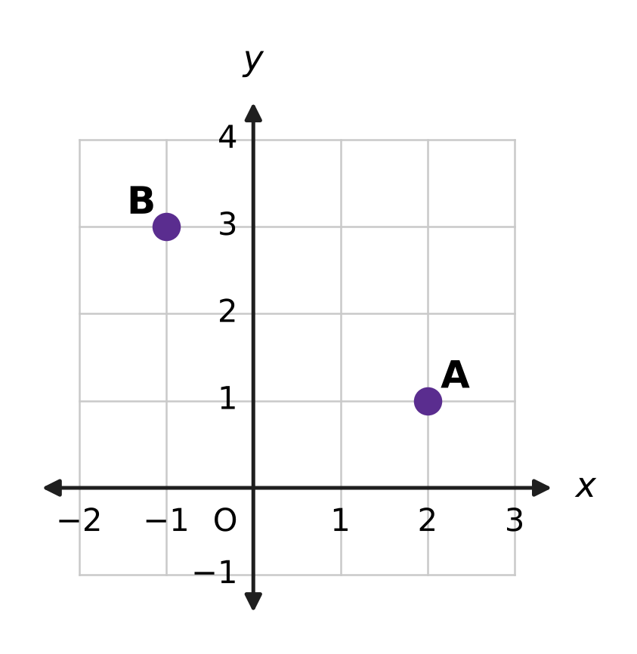
  (A) 1 + 4i | (B) −2 + 3i | (C) 1 + 5i | (D) −5 + 5i

Q3. What is the modulus of the complex number ${(2+i)}^{4}$?
(A) 16 | (B) 625 | (C) 5 | (D) 25

Q4. What is the value of ${(1−i)}^{6}$?
(A) 8i | (B) −8i | (C) 8 | (D) −8

Q5. The roots of the equation x² + 2x + 10 = 0 are α and β. What is the value of α² + β²?
(A) 24 | (B) −16 | (C) 20 | (D) 16

Part 2 — Algebra (Syllabus Chapter 4)
Q6. The expression ${(x+y)}^{10}+{(x−y)}^{10}$ is expanded and like terms are collected. The result has $□$ terms. What number goes in the box?
(A) 22 | (B) 5 | (C) 11 | (D) 6

Q7. The solution set of the inequality 4 − 3x ≥ $□$ is x ≤ −2. What number goes in the box?
(A) 10 | (B) −2 | (C) −6 | (D) 2

Q8. In an arithmetic progression, the 5th term and the 16th term add up to 40. The sum of the first 20 terms is $□$. What number goes in the box?
(A) 420 | (B) 400 | (C) 800 | (D) 200

Q9. The sum of the first $□$ terms of the geometric series 5 + 15 + 45 + … is 1,820. What number goes in the box?
(A) 5 | (B) 7 | (C) 6 | (D) 8

Q10. The geometric progression 27, 9, 3, … goes on for ever. What is the sum to infinity of its terms from the 4th term onward?
(A) $\frac{81}{2}$ | (B) $\frac{9}{2}$ | (C) $\frac{1}{2}$ | (D) $\frac{3}{2}$

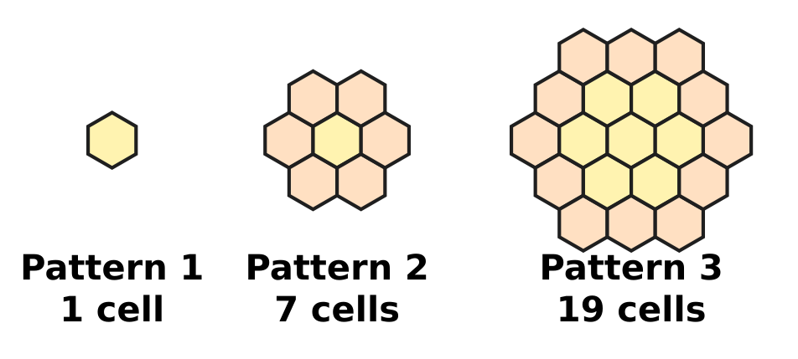
Q11. Honey bees build six-sided wax cells. The figure shows the first three patterns of a growing honeycomb, in which each pattern adds a ring of cells around the one before. Pattern n has 3n² − 3n + 1 cells. What is the total number of cells in patterns 1 to 10 taken together?
(A) 1,000 | (B) 271 | (C) 1,330 | (D) 990

Q12. In the expansion of ${(1+2x)}^{7}$, which power of x has the greatest coefficient?
(A) x³ | (B) x⁴ | (C) x⁵ | (D) x⁷

Q13. Every term of a geometric progression is positive, and each term is equal to the sum of the two terms that come right after it. What is the common ratio?
(A) $\frac{\sqrt{5}+1}{2}$ | (B) $\frac{1}{2}$
(C) $\frac{\sqrt{5}−1}{2}$ | (D) $\frac{3−\sqrt{5}}{2}$

Q14. In a harbour, boats are moored in rows. The first row has 3 boats, and each row has 4 boats more than the row before it. All the rows are full, and there are 300 boats in all. How many rows are there?
(A) 25 | (B) 12 | (C) 75 | (D) 47

Part 3 — Geometry (Syllabus Chapter 5)
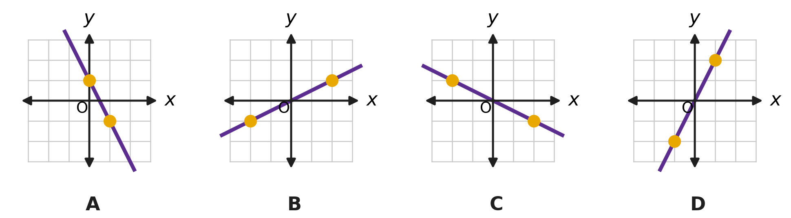
Q15. Four straight lines are drawn, one in each picture on a grid of unit squares. On each line, two points where grid lines cross are marked with dots. Which picture shows a line with slope $−\frac{1}{2}$?
(A) Picture A | (B) Picture B
(C) Picture C | (D) Picture D

Q16. In the figure, the lines $y=\sqrt{3} x+1$ and x = 2 meet, making the acute angle θ. What is θ? | 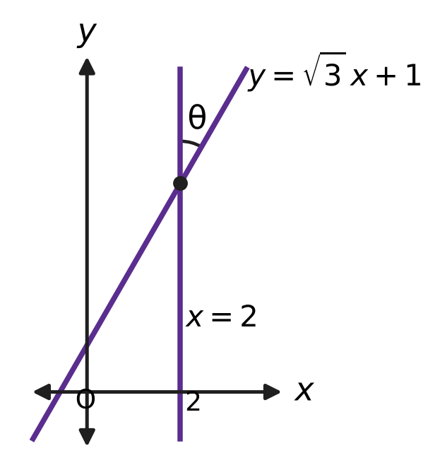
  (A) 90° | (B) 30° | (C) 60° | (D) 45°

Q17. The line $□$$x+3y=6$ cuts off intercepts on the x-axis and the y-axis that add up to 5. What number goes in the box?
(A) 2 | (B) $\frac{6}{5}$ | (C) $\frac{1}{2}$ | (D) 3

Q18. In the figure, A = (−1, 2) and B = (5, 6). Every point that is the same distance from A as from B lies on a certain straight line. What is the equation of that line? | 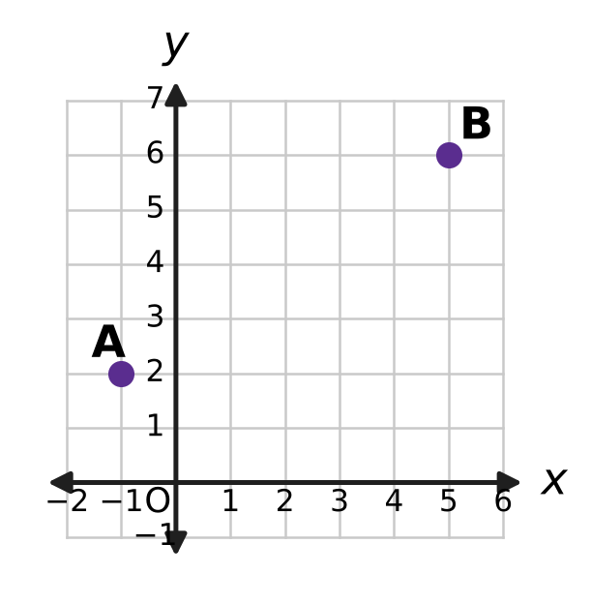
  (A) 3x + 2y = 1 | (B) 2x − 3y = −8
  (C) 3x + 2y = 14 | (D) 2x + 3y = 16

Q19. On a museum floor plan with coordinates in metres, a square display platform has one side along the line L₁: 8x + 15y + 34 = 0 and the opposite side along the line L₂: 8x + 15y − 17 = 0, as shown in the figure. What is the area of the platform? | 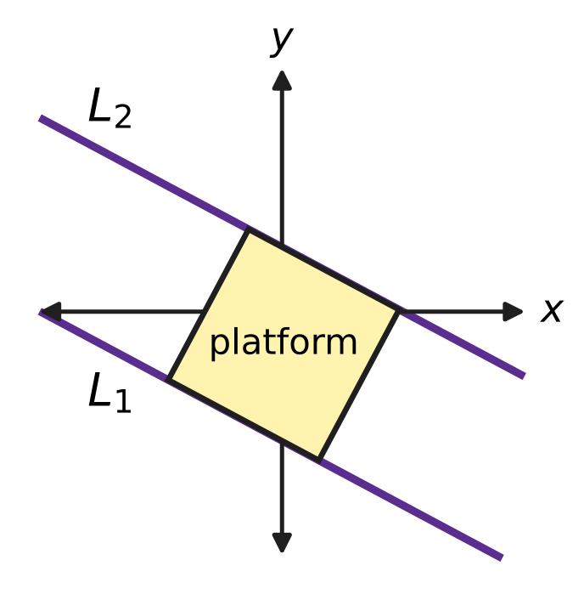
  (A) 3 m² | (B) 1 m² | (C) 4.5 m² | (D) 9 m²

Part 4 — Trigonometry & Heights and Distances (Syllabus Chapter 7)
Q20. In a wall clock shop, a clock is started at 3:00 and stopped at 3:40, as shown in the figure. Through how many radians does its minute hand turn? | 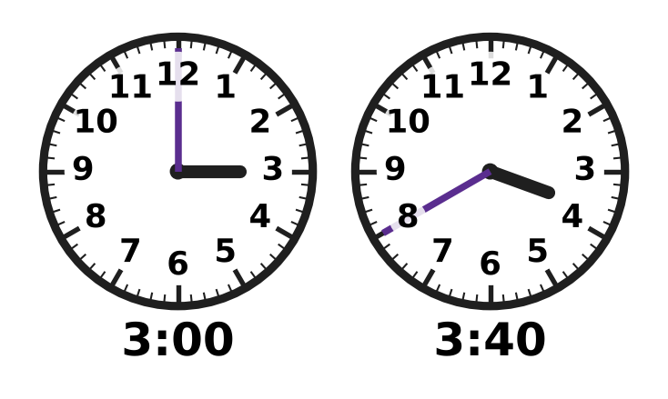
  (A) $\frac{2π}{3}$ | (B) $\frac{2π}{9}$ | (C) $\frac{4π}{3}$ | (D) $\frac{8π}{3}$

Q21. For every angle x, $sin(x+{30}^{∘})+sin(x−{30}^{∘})=□×sinx$. What number goes in the box?
(A) √3 | (B) 1
(C) $\frac{\sqrt{3}}{2}$ | (D) 2

Q22. For every angle A, $cos3A=cosA×□$. Which expression goes in the box?
(A) 1 − 4 sin²A | (B) 3 − 4 sin²A
(C) 4 sin²A − 3 | (D) 4 sin²A − 1

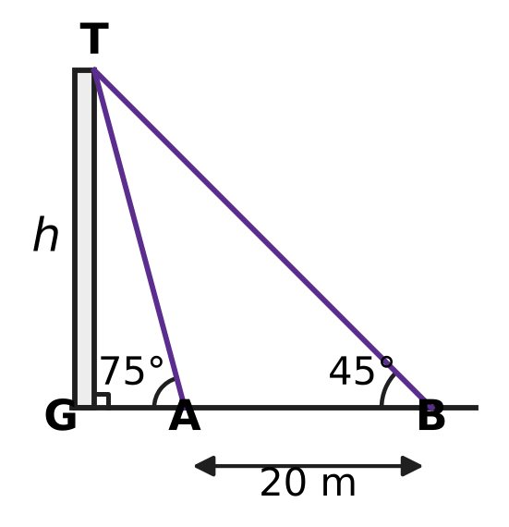
Q23. Vikram walks on level ground straight towards a tower GT. From point B, the angle of elevation of the top T is 45°. After walking 20 m to point A, the angle of elevation is 75°, as shown in the figure. What is the height h of the tower?
(A) 20(√3 + 1) m | (B) 10(√3 − 1) m
(C) 10(3 + √3) m | (D) 10(√3 + 1) m

Q24. What number goes in the box? $tan{70}^{∘}−tan{20}^{∘}=□×tan{50}^{∘}$
(A) √3 | (B) 2 | (C) 1 | (D) $\frac{1}{2}$

Part 5 — Data Handling, Statistics & Probability (Syllabus Chapter 8)
Q25. A bus route has 10 stops. Each ticket is printed with the stop where a journey starts and a different stop where it ends. How many different tickets are needed to cover every possible journey?
(A) 100 | (B) 45 | (C) 90 | (D) 81

Q26. At a board games club, every two players played exactly one game against each other. In all, 28 games were played. How many players were there?
(A) 14 | (B) 8 | (C) 28 | (D) 7

Daksh's 8 laps
Lap time (seconds) | Number of laps
62 | 4
70 | 4

Q27. Daksh runs 8 laps of a running track. The table shows his lap times. What is the standard deviation of the 8 lap times?
(A) 16 s | (B) 2 s | (C) 8 s | (D) 4 s

Q28. The school canteen has 6 different sandwich fillings. A sandwich may have any selection of these fillings, but it must have at least one. How many different sandwiches can be made, if sandwiches differ only in their fillings?
(A) 63 | (B) 21 | (C) 64 | (D) 720

Q29. Five cards show the digits 1, 2, 3, 4 and 5. All five cards are placed in a row to make a 5-digit number. How many of the numbers made in this way are divisible by 4?
(A) 48 | (B) 24 | (C) 12 | (D) 30

Q30. Avni throws paper planes at a hoop. Each throw goes through the hoop with the same probability p, independently of the other throws. In 4 throws, getting exactly 1 hit is just as likely as getting exactly 2 hits. What is p?
(A) $\frac{2}{5}$ | (B) $\frac{2}{3}$ | (C) $\frac{3}{5}$ | (D) $\frac{1}{2}$

Q31. Nine sacks of grain have a mean mass of 50 kg and a variance of 4 kg². A tenth sack, of mass exactly 50 kg, is added to them. What is the variance of the masses of the ten sacks?
(A) 4.4 kg² | (B) 4 kg² | (C) 3.6 kg² | (D) 3.24 kg²

Part 6 — Applied Mathematics (Syllabus Chapter 9)
Q32. Harsh sends a large parcel from a post office. The charge is ₹2,950, and this already includes GST at 18%. How much of the ₹2,950 is GST?
(A) ₹2,500 | (B) ₹531 | (C) ₹225 | (D) ₹450

Q33. Roshni makes clay pots. Her fixed costs are ₹4,500 a month, and each pot costs her ₹45 in clay and paint. She expects to sell 150 pots a month. What is the least price per pot at which she makes no loss?
(A) ₹30 | (B) ₹100 | (C) ₹45 | (D) ₹75

Q34. Kavin has ₹200 in his piggy bank. He puts in ₹35 at the end of every week and takes nothing out. After how many weeks will he first have at least ₹1,000 in it?
(A) 35 | (B) 22 | (C) 23 | (D) 29

Q35. Sneha borrows ₹15,000 from a cooperative society to buy a sewing machine. At the end of each year, 8% of what she owes at that time is added to her debt, and then she repays ₹6,000. How much does she owe just after her second repayment?
(A) ₹5,016 | (B) ₹3,720 | (C) ₹3,000 | (D) ₹5,400

Part 7 — Mathematical Reasoning & Problem-Solving (Syllabus Chapter 10)
Q36. The statement $3^{n}>n^{3}$ is true for every natural number n ≥ $□$, and this can be proved by induction. What is the least number that can go in the box?
(A) 2 | (B) 4 | (C) 3 | (D) 1

Q37. What is the least number of different whole numbers that must be chosen so that, however they are chosen, two of them always have a difference divisible by 9?
(A) 9 | (B) 10 | (C) 18 | (D) 11

Q38. A statement P(n) about natural numbers n has this property: whenever P(k) is true, P(k + 1) is also true. It is also known that P(5) is false. Which of these MUST be true?
(A) P(3) is false.
(B) P(n) is false for every natural number n.
(C) P(6) is false.
(D) P(3) is true.

Q39. A convex polygon has 9 sides. What is the greatest possible number of its interior angles that are acute?
(A) 9 | (B) 4 | (C) 3 | (D) 6

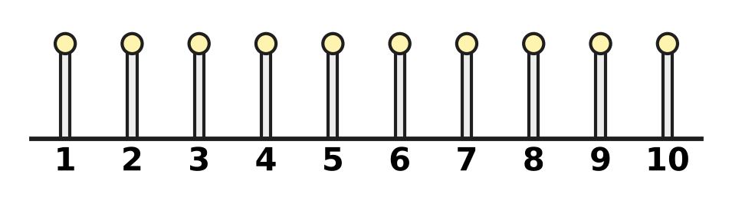
Q40. The figure shows 10 posts standing in a row, numbered 1 to 10. Three of the posts are to be painted so that no two painted posts are next to each other. In how many ways can the three posts be chosen?
(A) 48 | (B) 120 | (C) 35 | (D) 56

SECTION II — Star Questions 5 questions × 4 marks each
Q41. A sequence of whole numbers $a_{1},a_{2},a_{3},…$ has $a_{1}=1$. Every later term is greater than the term just before it, and is also at least as large as the sum of all the terms before it. What is the least possible value of $a_{10}$? [4 marks]
(A) 512 | (B) 768 | (C) 192 | (D) 384

Q42. Seven numbers form an arithmetic progression with a positive common difference. Their mean is 10 and their variance is 36. What is the largest of the seven numbers? [4 marks]
(A) 28 | (B) 19 | (C) 13 | (D) 16

Q43. Let $z=\frac{1+i}{2}$. On the Argand plane, a path goes in straight steps from the point 1 to the point z, then to z², then to z³, and so on for ever, as shown in the figure. What is the total length of the path? [4 marks] | 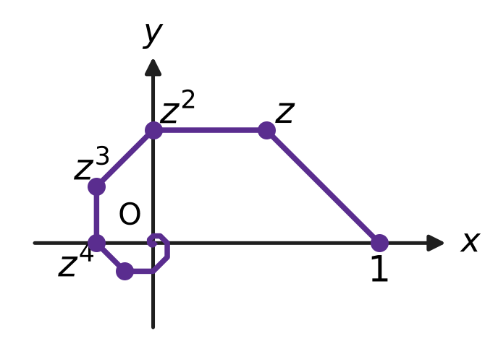
  (A) √2 + 1 | (B) √2 | (C) 1 | (D) 2 + √2

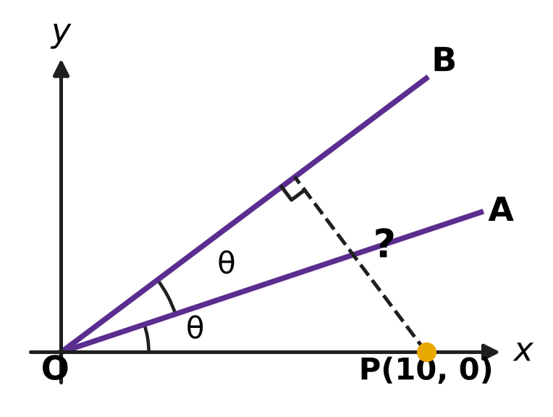
Q44. In the figure, O is the origin and P = (10, 0). The line OA has slope $\frac{1}{3}$, and the angle between the x-axis and OA equals the angle between OA and OB, as marked θ. What is the distance of P from the line OB? [4 marks]
(A) √10 | (B) 8 | (C) 6 | (D) 7.5

Q45. A school has 6 clubs. Every student joins either exactly 2 or exactly 3 of the clubs. What is the least number of students the school must have to be sure that at least three students have joined exactly the same set of clubs? [4 marks]
(A) 70 | (B) 36 | (C) 106 | (D) 71

Answer Sheet AMO Level 1 · Class 11 · Practice Paper 3
Name: | School: | Roll No.:
Shade or tick one circle for each question.
1. Ⓐ Ⓑ Ⓒ Ⓓ | 16. Ⓐ Ⓑ Ⓒ Ⓓ | 31. Ⓐ Ⓑ Ⓒ Ⓓ
2. Ⓐ Ⓑ Ⓒ Ⓓ | 17. Ⓐ Ⓑ Ⓒ Ⓓ | 32. Ⓐ Ⓑ Ⓒ Ⓓ
3. Ⓐ Ⓑ Ⓒ Ⓓ | 18. Ⓐ Ⓑ Ⓒ Ⓓ | 33. Ⓐ Ⓑ Ⓒ Ⓓ
4. Ⓐ Ⓑ Ⓒ Ⓓ | 19. Ⓐ Ⓑ Ⓒ Ⓓ | 34. Ⓐ Ⓑ Ⓒ Ⓓ
5. Ⓐ Ⓑ Ⓒ Ⓓ | 20. Ⓐ Ⓑ Ⓒ Ⓓ | 35. Ⓐ Ⓑ Ⓒ Ⓓ
6. Ⓐ Ⓑ Ⓒ Ⓓ | 21. Ⓐ Ⓑ Ⓒ Ⓓ | 36. Ⓐ Ⓑ Ⓒ Ⓓ
7. Ⓐ Ⓑ Ⓒ Ⓓ | 22. Ⓐ Ⓑ Ⓒ Ⓓ | 37. Ⓐ Ⓑ Ⓒ Ⓓ
8. Ⓐ Ⓑ Ⓒ Ⓓ | 23. Ⓐ Ⓑ Ⓒ Ⓓ | 38. Ⓐ Ⓑ Ⓒ Ⓓ
9. Ⓐ Ⓑ Ⓒ Ⓓ | 24. Ⓐ Ⓑ Ⓒ Ⓓ | 39. Ⓐ Ⓑ Ⓒ Ⓓ
10. Ⓐ Ⓑ Ⓒ Ⓓ | 25. Ⓐ Ⓑ Ⓒ Ⓓ | 40. Ⓐ Ⓑ Ⓒ Ⓓ
11. Ⓐ Ⓑ Ⓒ Ⓓ | 26. Ⓐ Ⓑ Ⓒ Ⓓ | 41. Ⓐ Ⓑ Ⓒ Ⓓ
12. Ⓐ Ⓑ Ⓒ Ⓓ | 27. Ⓐ Ⓑ Ⓒ Ⓓ | 42. Ⓐ Ⓑ Ⓒ Ⓓ
13. Ⓐ Ⓑ Ⓒ Ⓓ | 28. Ⓐ Ⓑ Ⓒ Ⓓ | 43. Ⓐ Ⓑ Ⓒ Ⓓ
14. Ⓐ Ⓑ Ⓒ Ⓓ | 29. Ⓐ Ⓑ Ⓒ Ⓓ | 44. Ⓐ Ⓑ Ⓒ Ⓓ
15. Ⓐ Ⓑ Ⓒ Ⓓ | 30. Ⓐ Ⓑ Ⓒ Ⓓ | 45. Ⓐ Ⓑ Ⓒ Ⓓ
Q41–Q45 are Section II Star Questions (4 marks each).
For the parent or teacher
Section I correct: ______ / 40 × 2 = ______ marks Section II correct: ______ / 5 × 4 = ______ marks
Correct: ______ / 45 Score: ______ / 100
Answer Key and Solutions AMO Level 1 · Class 11 · Practice Paper 3
Quick answers
1 B | 6 D | 11 A | 16 B | 21 A | 26 B | 31 C | 36 B | 41 D
2 D | 7 A | 12 C | 17 A | 22 A | 27 D | 32 D | 37 B | 42 B
3 D | 8 B | 13 C | 18 C | 23 D | 28 A | 33 D | 38 A | 43 A
4 A | 9 C | 14 B | 19 D | 24 B | 29 B | 34 C | 39 C | 44 C
5 B | 10 D | 15 C | 20 C | 25 C | 30 A | 35 A | 40 D | 45 D
Solutions
Q | Part · level | Answer | Why?
1 | Part 1 · Ch1 · Easy | (B) 1 − 3i | The number a + ib times its conjugate a − ib is a² + b². So (1 + 3i)(1 − 3i) = 1 + 9 = 10.
2 | Part 1 · Ch1 · Easy | (D) −5 + 5i | From the figure, z₁ = 2 + i and z₂ = −1 + 3i. Then (2 + i)(−1 + 3i) = −2 + 6i − i + 3i² = −2 + 5i − 3 = −5 + 5i.
3 | Part 1 · Ch1 · Easy | (D) 25 | The modulus of 2 + i is √(4 + 1) = √5. The modulus of a power is the power of the modulus: (√5)⁴ = 25.
4 | Part 1 · Ch1 · Medium | (A) 8i | First, (1 − i)² = 1 − 2i + i² = −2i. So (1 − i)⁶ = (−2i)³ = −8i³ = −8 × (−i) = 8i.
5 | Part 1 · Ch1 · Medium | (B) −16 | The roots are −1 ± 3i. Then α² + β² = (α + β)² − 2αβ = (−2)² − 2 × 10 = −16.
6 | Part 2 · Ch4 · Easy | (D) 6 | In (x − y)¹⁰ the terms with odd powers of y have a minus sign, so they cancel. The terms with y⁰, y², y⁴, y⁶, y⁸ and y¹⁰ remain: 6 terms.
7 | Part 2 · Ch4 · Easy | (A) 10 | At the end point x = −2, 4 − 3x = 4 + 6 = 10. Since 4 − 3x ≥ 10 gives −3x ≥ 6, that is x ≤ −2, the box is 10.
8 | Part 2 · Ch4 · Easy | (B) 400 | Since 5 + 16 = 1 + 20, the 1st and 20th terms also add up to 40. So S₂₀ = 20 × 40 ÷ 2 = 400.
9 | Part 2 · Ch4 · Easy | (C) 6 | The sum of n terms is 5(3^{n} − 1) ÷ 2 = 1,820, so 3^{n} − 1 = 728, 3^{n} = 729 and n = 6.
10 | Part 2 · Ch4 · Easy | (D) $\frac{3}{2}$ | The 4th term is 3 × 1/3 = 1, and the ratio is 1/3. So the sum from the 4th term onward is 1 ÷ (1 − 1/3) = 3/2.
11 | Part 2 · Ch4 · Medium | (A) 1,000 | Total = 3Σn² − 3Σn + 10 = 3 × 385 − 3 × 55 + 10 = 1,155 − 165 + 10 = 1,000.
12 | Part 2 · Ch4 · Medium | (C) x⁵ | The coefficient of xʳ is C(7, r) × 2ʳ: 280, 560, 672, 448, 128 for r = 3 to 7. The greatest, 672, belongs to x⁵.
13 | Part 2 · Ch4 · Medium | (C) $\frac{\sqrt{5}−1}{2}$ | a = ar + ar² gives r² + r − 1 = 0. The positive root is r = (√5 − 1)/2.
14 | Part 2 · Ch4 · Medium | (B) 12 | With n rows, the total is n/2 × (2 × 3 + 4(n − 1)) = n(2n + 1). Then n(2n + 1) = 300 gives n = 12, since 12 × 25 = 300.
15 | Part 3 · Ch5 · Easy | (C) Picture C | In Picture C the line goes from (−2, 1) to (2, −1): it falls 2 units over a run of 4, so the slope is −2/4 = −1/2.
16 | Part 3 · Ch5 · Easy | (B) 30° | The first line has slope √3, so it makes 60° with the x-axis. The line x = 2 is vertical and makes 90° with the x-axis, so θ = 90° − 60° = 30°.
17 | Part 3 · Ch5 · Easy | (A) 2 | The y-intercept is 6/3 = 2, so the x-intercept is 5 − 2 = 3. Then 6/k = 3 gives k = 2.
18 | Part 3 · Ch5 · Medium | (C) 3x + 2y = 14 | The line is perpendicular to AB through its midpoint (2, 4). AB has slope 4/6 = 2/3, so the line has slope −3/2: y − 4 = −3/2(x − 2), that is 3x + 2y = 14.
19 | Part 3 · Ch5 · Medium | (D) 9 m² | The distance between the parallel lines is (34 + 17) ÷ √(8² + 15²) = 51 ÷ 17 = 3 m. This is the side of the square, so the area is 3 × 3 = 9 m².
20 | Part 4 · Ch7 · Easy | (C) $\frac{4π}{3}$ | The minute hand turns 6° each minute, so 40 × 6° = 240°. In radians this is 240 × π/180 = 4π/3.
21 | Part 4 · Ch7 · Easy | (A) √3 | The cos x sin 30° terms cancel, leaving 2 sin x cos 30° = 2 × (√3/2) × sin x = √3 sin x.
22 | Part 4 · Ch7 · Easy | (A) 1 − 4 sin²A | Here cos 3A = 4 cos³A − 3 cos A = cos A (4 cos²A − 3). Since cos²A = 1 − sin²A, the bracket is 4 − 4 sin²A − 3 = 1 − 4 sin²A.
23 | Part 4 · Ch7 · Medium | (D) 10(√3 + 1) m | tan 75° = tan(45° + 30°) = 2 + √3. GB = h and GA = h ÷ (2 + √3) = h(2 − √3). So h − h(2 − √3) = 20, h(√3 − 1) = 20 and h = 10(√3 + 1) m.
24 | Part 4 · Ch7 · Medium | (B) 2 | Here tan 50° = (tan 70° − tan 20°)/(1 + tan 70° tan 20°). Since tan 70° = 1/tan 20°, the denominator is 1 + 1 = 2, so tan 70° − tan 20° = 2 tan 50°.
25 | Part 5 · Ch8 · Easy | (C) 90 | The start can be any of 10 stops and the end any of the other 9: 10 × 9 = 90.
26 | Part 5 · Ch8 · Easy | (B) 8 | The number of games is C(n, 2) = n(n − 1)/2. n(n − 1) = 56 gives n = 8.
27 | Part 5 · Ch8 · Easy | (D) 4 s | The mean is 66 s and every lap time is 4 s away from it. So the variance is 16 and the standard deviation is 4 s.
28 | Part 5 · Ch8 · Easy | (A) 63 | Each filling is either in or out: 2⁶ = 64 selections. Leaving out the empty one gives 63.
29 | Part 5 · Ch8 · Medium | (B) 24 | A number is divisible by 4 when its last two digits are. The possible endings are 12, 24, 32 and 52. For each, the other three digits can be arranged in 3! = 6 ways: 4 × 6 = 24.
30 | Part 5 · Ch8 · Medium | (A) $\frac{2}{5}$ | With q = 1 − p, the condition is 4pq³ = 6p²q². Dividing by 2pq² gives 2q = 3p, so 2(1 − p) = 3p and p = 2/5.
31 | Part 5 · Ch8 · Medium | (C) 3.6 kg² | The mean stays 50 kg. The sum of squared deviations is 9 × 4 = 36, and the new sack adds 0. The new variance is 36 ÷ 10 = 3.6 kg².
32 | Part 6 · Ch9 · Easy | (D) ₹450 | The charge before GST is 2,950 ÷ 1.18 = ₹2,500. The GST is 2,950 − 2,500 = ₹450.
33 | Part 6 · Ch9 · Easy | (D) ₹75 | The fixed cost per pot is 4,500 ÷ 150 = ₹30. Adding the ₹45 making cost, each pot must sell for at least ₹75.
34 | Part 6 · Ch9 · Easy | (C) 23 | After w weeks he has ₹(200 + 35w). Then 200 + 35w ≥ 1,000 gives w ≥ 800 ÷ 35 ≈ 22.9. The least whole number of weeks is 23.
35 | Part 6 · Ch9 · Medium | (A) ₹5,016 | Year 1: 15,000 + 1,200 − 6,000 = ₹10,200. Year 2: 10,200 + 816 − 6,000 = ₹5,016.
36 | Part 7 · Ch10 · Easy | (B) 4 | It holds at n = 1 and n = 2 (3 > 1, 9 > 8), but at n = 3 both sides equal 27, so it fails. From n = 4 on it holds (81 > 64), and the step 3k³ ≥ (k + 1)³ keeps it going. The least start is 4.
37 | Part 7 · Ch10 · Easy | (B) 10 | There are 9 possible remainders on division by 9. Among 10 numbers two share a remainder, and their difference is divisible by 9. The numbers 0 to 8 show that 9 are not enough.
38 | Part 7 · Ch10 · Easy | (A) P(3) is false. | If P(3) were true, the step would make P(4) and then P(5) true. Since P(5) is false, P(3) must be false. Nothing follows for P(6).
39 | Part 7 · Ch10 · Medium | (C) 3 | An acute interior angle has an exterior angle of more than 90°. The exterior angles add up to 360°, so at most 3 of them exceed 90°. Exterior angles 100°, 100°, 100° and six of 10° give a convex 9-sided polygon with 3 acute angles.
40 | Part 7 · Ch10 · Medium | (D) 56 | Picture the 7 unpainted posts in a row. The 3 painted posts go into 3 of the 8 gaps around them, one per gap: C(8, 3) = 56.
41 | Section II · Ch4 + Ch10 · Hard | (D) 384 | The least choices are 1, 2, 3, and then each term equal to the sum before it: 6, 12, 24, …, which doubles each time. By induction, aₖ ≥ 3 × 2ᵏ⁻³ for k ≥ 3, because the sum of the earlier terms is at least 3 × 2ᵏ⁻³. So a₁₀ ≥ 3 × 2⁷ = 384, and the sequence above reaches it.
42 | Section II · Ch4 + Ch8 · Hard | (B) 19 | The middle term is the mean, 10, and the deviations are −3d, −2d, …, 3d. The variance is 2(1² + 2² + 3²)d² ÷ 7 = 4d² = 36, so d = 3. The largest number is 10 + 3 × 3 = 19.
43 | Section II · Ch1 + Ch4 · Hard | (A) √2 + 1 | The step from zᵏ to zᵏ⁺¹ has length (modulus of zᵏ) × (modulus of 1 − z) = (1/√2)ᵏ × 1/√2, since 1 − z = (1 − i)/2. The steps form a GP with first term 1/√2 and ratio 1/√2, so the total is (1/√2) ÷ (1 − 1/√2) = 1 ÷ (√2 − 1) = √2 + 1.
44 | Section II · Ch5 + Ch7 · Hard | (C) 6 | OB makes the angle 2θ with the x-axis, where tan θ = 1/3. Then tan 2θ = (2/3)/(1 − 1/9) = 3/4, so OB is 3x − 4y = 0. The distance of P is (3 × 10 − 0)/5 = 6.
45 | Section II · Ch8 + Ch10 · Hard | (D) 71 | The possible sets number C(6, 2) + C(6, 3) = 15 + 20 = 35. With 70 students, each set could have exactly two. One more student forces a third: 2 × 35 + 1 = 71.

ARYABHATTA MATHS OLYMPIAD
Level 1
PRACTICE PAPER-4
CLASS 11
Total Questions | 45 multiple-choice questions
Total Marks | 100
Time | 60 minutes
Section I | 40 questions × 2 marks = 80 marks
Section II | 5 Star Questions × 4 marks = 20 marks
Negative Marking | No negative marking
Calculator | Not allowed
Chapters | Number System · Algebra · Geometry · Trigonometry · Data Handling · Applied Mathematics · Mathematical Reasoning

Instructions to candidates
• This paper has 45 multiple-choice questions. Each question has four answer choices, of which exactly one is correct.
• Section I (Q1–Q40) carries 2 marks per question. Section II (Q41–Q45) carries 4 marks per question.
• There is no negative marking. Unanswered questions score zero.
• Calculators are not permitted. Rough work may be done on a separate sheet.
• Mark your answers on the answer sheet at the end of the paper.
• All figures are not necessarily drawn to scale unless stated.

For parents and teachers
• Print or view this paper in colour. Pictures are part of the questions.
• Parts follow the AMO syllabus chapters. Chapters 2, 3 and 6 are not part of the Class 11 syllabus, so the chapter numbers shown in the Part headings have gaps.
• The answer sheet and the answer key are at the end. Remove only the answer key before the student begins.

SECTION I 40 questions × 2 marks each
Part 1 — Number System (Syllabus Chapter 1)
Q1. In the figure, the horizontal axis is the real axis and the vertical axis is the imaginary axis. The point P represents z₁ and the point R represents z₂. What is the modulus of z₁ + z₂? | 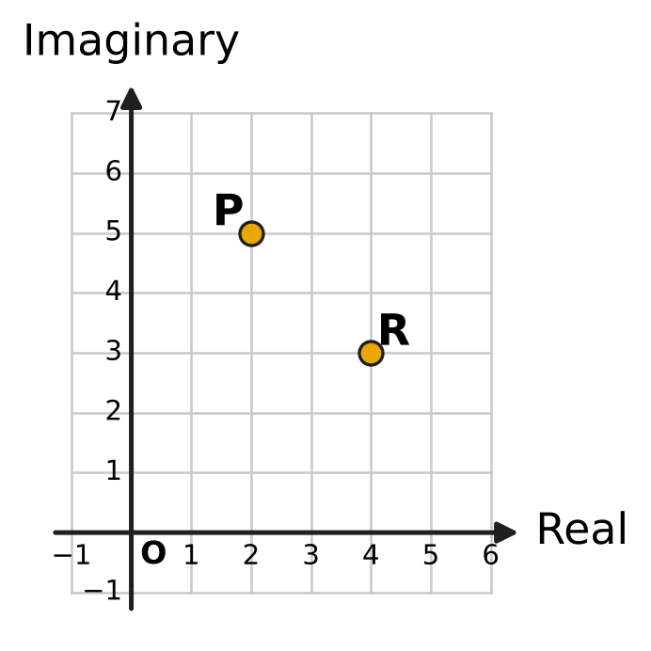
  (A) $2\sqrt{2}$ | (B) 10
  (C) 14 | (D) 100

Q2. Let z = 2 + 3i, and let $\overline{z}$ be its conjugate. What is the value of $z^{2}+{\overline{z}}^{2}$?
(A) −5 | (B) 26
(C) −10 | (D) −10 + 24i

Q3. What is the value of $i^{−1}+i^{−2}+i^{−3}+i^{−4}+i^{−5}$?
(A) −1 | (B) 0 | (C) i | (D) −i

Q4. Let z = 1 + 2i. What is the value of $z^{3}−3z^{2}+7z−5$?
(A) 0 | (B) 5
(C) 12 − 6i | (D) −18 + 24i

Q5. The complex number z = a + 4i, where a is a real number, has principal argument $\frac{3π}{4}$. What is z²?
(A) 0 | (B) −32i | (C) 32i | (D) 32 − 32i

Part 2 — Algebra (Syllabus Chapter 4)
Q6. Some arithmetic means are inserted between 3 and 43, so that 3, the means and 43 together form an arithmetic progression. The inserted means add up to 115. How many means are inserted?
(A) 4 | (B) 3 | (C) 5 | (D) 7

Q7. What is the greatest integer x for which $\frac{x}{2}−\frac{x−3}{5}<3$?
(A) 11 | (B) 8 | (C) −2 | (D) 7

Q8. In the expansion of ${(x+a)}^{6}$, where a is a non-zero number, the coefficient of x⁴ is equal to the coefficient of x³. What is a?
(A) $\frac{3}{4}$ | (B) $\frac{2}{3}$ | (C) 1 | (D) $\frac{4}{3}$

Q9. Small cubes of edge 1 cm are glued together to make 13 solid cubes, of edges 1 cm, 2 cm, 3 cm, …, 13 cm. How many small cubes are used in all?
(A) 819 | (B) 91 | (C) 8,281 | (D) 2,197

Q10. At the start of day 1, the water tank of Amrita's plant nursery holds 2,430 litres. No water is added. At the start of each later day, the tank holds $\frac{2}{3}$ of the water it held at the start of the day before. How many litres does it hold at the start of day 6?
(A) 480 litres | (B) 320 litres
(C) 10 litres | (D) 324 litres

Q11. In the figure, the largest square has side 8 cm. The corners of each next square are the midpoints of the sides of the square just outside it. The squares go on in this way forever. What is the total area of all the squares? | 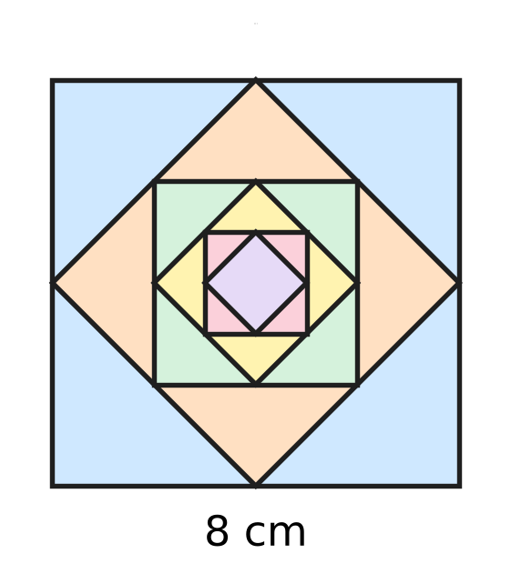
  (A) 112 cm² | (B) 128 cm² | (C) 256 cm² | (D) 64 cm²

Q12. The numbers a, ar, ar², ar³, … are all positive, and r ≠ 1. Adding the first six of them gives 28 times the total of the first three. What is r?
(A) 3 | (B) $\sqrt[3]{28}$
(C) $3\sqrt{3}$ | (D) 27

Q13. What is the sum of all the two-digit numbers that leave a remainder of 5 when they are divided by 8?
(A) 588 | (B) 530 | (C) 583 | (D) 684

Q14. The coefficients in the expansion of ${(1+3x)}^{n}$ add up to 4,096. What is the middle term of the expansion?
(A) 1,215x⁴ | (B) 180x³ | (C) 20x³ | (D) 540x³

Part 3 — Geometry (Syllabus Chapter 5)
Q15. In the figure, O is the origin. The perpendicular drawn from O to a straight line meets the line at N(2, −3). What is the equation of the line? | 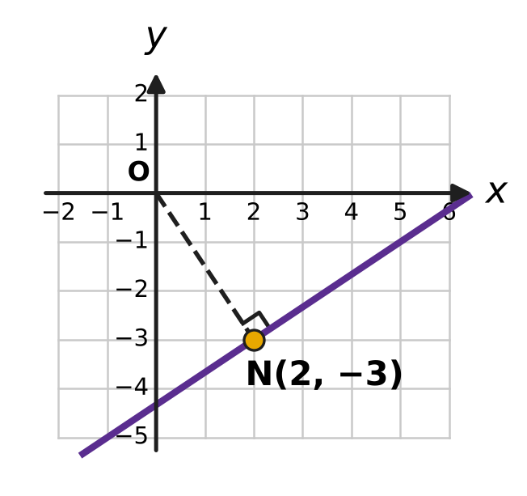
  (A) 2x − 3y = 13 | (B) 2x − 3y = −13
  (C) 3x + 2y = 0 | (D) 3x − 2y = 12

Q16. In the figure, the points A, B and C are grid points, and the drawn line passes through A and B. A second line is drawn through C, parallel to the line AB. At which point does this second line meet the y-axis? | 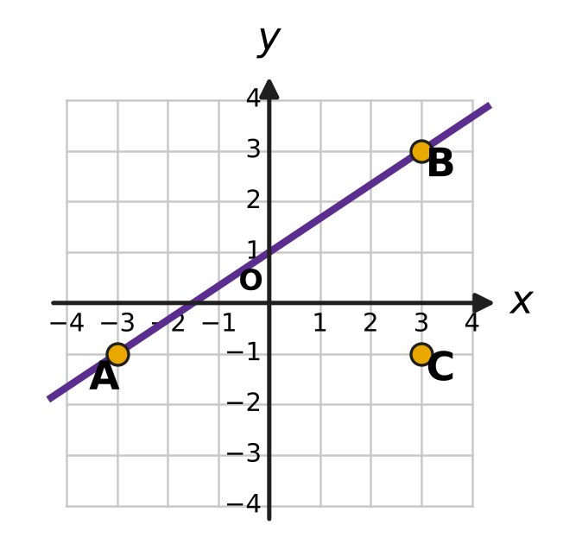
  (A) (0, −5.5) | (B) (0, 3.5)
  (C) (0, −3) | (D) (0, 1)

Q17. A straight line passes through the point (1, 3), and its y-intercept is equal to its slope. What is its equation?
(A) 3x − y = 0 | (B) x − y + 2 = 0
(C) 2x − 3y + 7 = 0 | (D) 3x − 2y + 3 = 0

Q18. The three lines x + y = 5, 2x − y = 4 and kx + 3y = 12 all pass through one point. What is the value of k?
(A) −2 | (B) 2 | (C) $\frac{3}{2}$ | (D) 4

Q19. On Vihaan's hiking map, one unit stands for 100 m on the ground. A straight trail runs along the line 4x − 3y + 12 = 0, and his camp is at the point (6, −2), as shown in the figure. What is the shortest distance on the ground from the camp to the trail? | 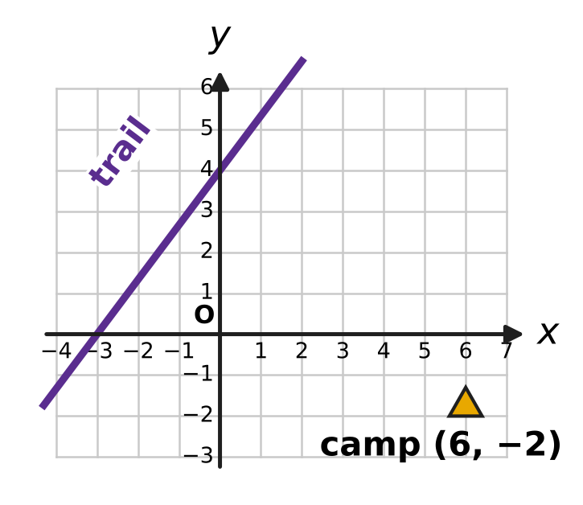
  (A) 4,200 m | (B) 600 m | (C) 1,050 m | (D) 840 m

Part 4 — Trigonometry & Heights and Distances (Syllabus Chapter 7)
Q20. For every angle θ, the expression sin(−θ) + sin(180° + θ) + sin(180° − θ) + sin(360° − θ) is equal to which of these?
(A) 2 sin θ | (B) −4 sin θ | (C) −2 sin θ | (D) 0

Q21. In the figure, the angle θ is measured anticlockwise from the positive x-axis to the ray OP, where P is the point (−12, −5). What is the value of sin θ + cos θ? | 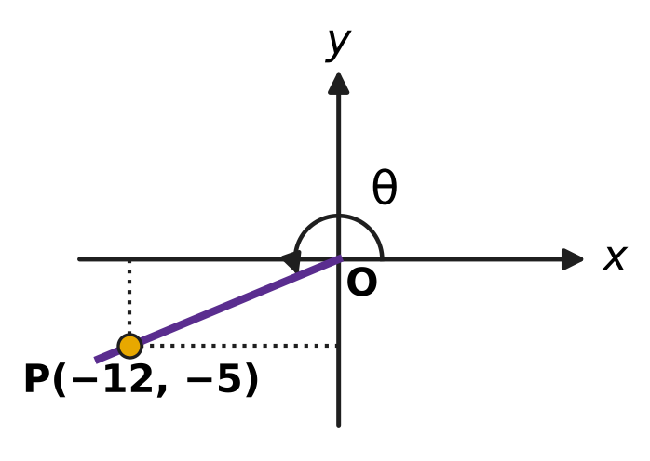
  (A) $−\frac{17}{13}$ | (B) $\frac{7}{13}$ | (C) $−\frac{7}{13}$ | (D) $\frac{17}{13}$

Q22. The angle A is acute and $cos2A=\frac{15}{17}$. What is tan A?
(A) 4 | (B) $\frac{1}{4}$ | (C) $\frac{8}{15}$ | (D) $\frac{1}{16}$

Q23. For two angles A and B, tan(A + B) = 3 and tan(A − B) = 2. What is the value of tan 2A?
(A) −1 | (B) 5 | (C) $\frac{5}{7}$ | (D) $\frac{1}{7}$

Q24. The angles A and B are acute and A + B = 45°. What is the value of (1 + tan A)(1 + tan B)?
(A) 4 | (B) 1 | (C) $\sqrt{2}$ | (D) 2

Part 5 — Data Handling, Statistics & Probability (Syllabus Chapter 8)
Q25. In art class, Kiara colours a flag that has 3 horizontal stripes. She has 7 crayons of different colours, and each stripe must be a different colour. Two flags are different if any stripe has a different colour. How many different flags can she make?
(A) 120 | (B) 35 | (C) 210 | (D) 343

Q26. A short quiz has 5 questions, and each question has 4 answer choices, of which exactly one is right. Sonal guesses every answer, choosing each answer choice with the same chance, independently. What is the probability that exactly 2 of her answers are right?
(A) $\frac{1}{16}$ | (B) $\frac{135}{512}$ | (C) $\frac{27}{1024}$ | (D) $\frac{45}{512}$

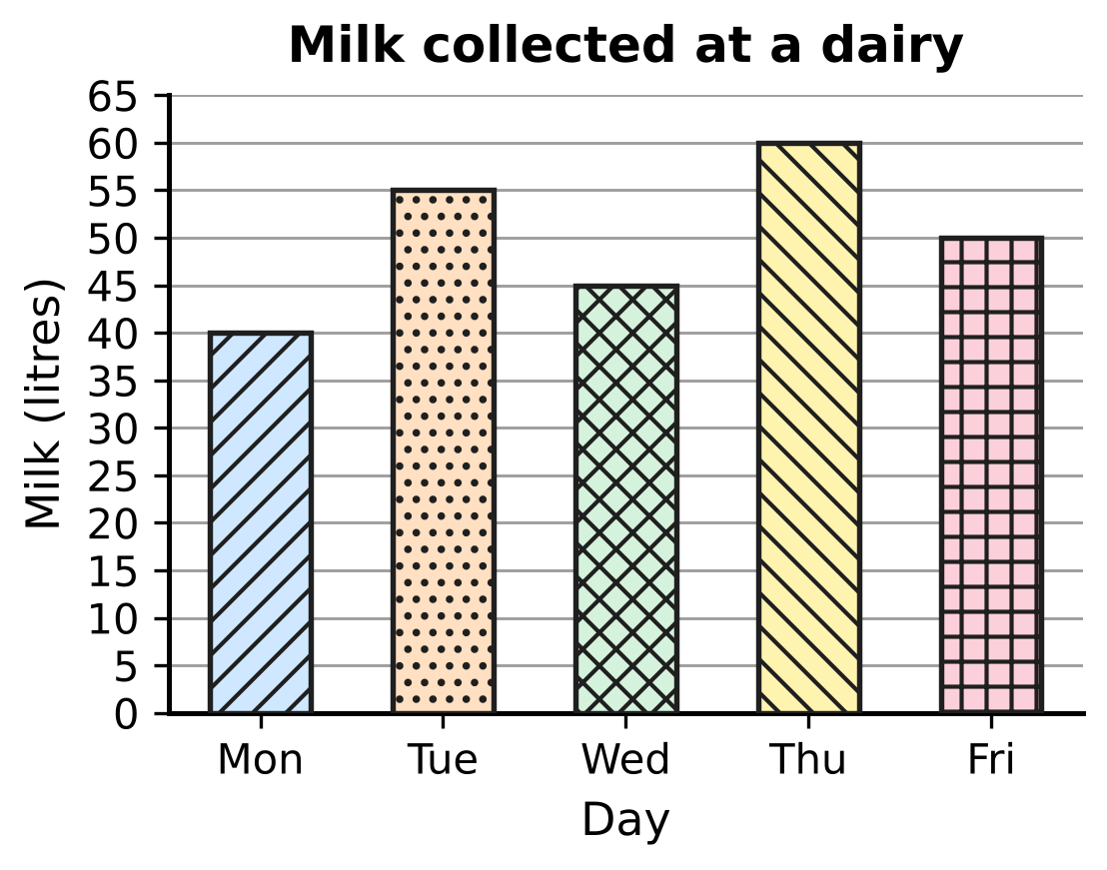
Q27. The bar graph in the figure shows the milk collected at a small dairy on five days. What is the standard deviation of the five amounts?
(A) $5\sqrt{2}$ litres | (B) 6 litres
(C) $5\sqrt{10}$ litres | (D) 50 litres

Q28. On a zoo visit, Noor will see 6 animal houses, one after another, visiting each house exactly once. She wants to see the lion house at some time before the tiger house, with or without other houses in between. In how many orders can she visit the 6 houses?
(A) 120 | (B) 360 | (C) 720 | (D) 240

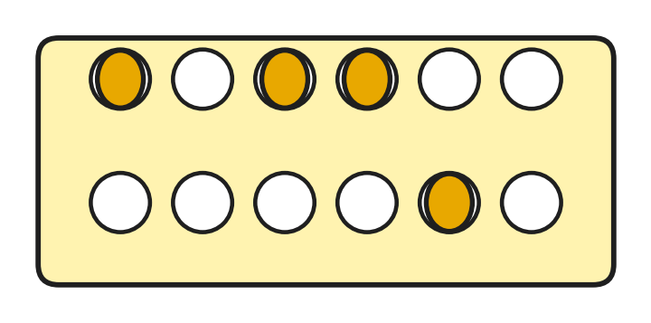
Q29. Zayan has an egg tray with 2 rows of 6 cups, as in the figure. He puts 4 identical eggs in the tray, one egg to a cup, so that neither row is left empty. The figure shows one way. In how many different ways can he place the 4 eggs?
(A) 225 | (B) 495 | (C) 480 | (D) 465

Q30. Trisha and 5 friends meet at a badminton court. A doubles match is played by two teams of 2 players each. Two matches are different if the two teams are different. How many different doubles matches can be chosen from these 6 players?
(A) 15 | (B) 30 | (C) 45 | (D) 90

Q31. Garima times how long candles burn. Her 10 small candles burn for a mean of 20 minutes with variance 4 min². Her 10 large candles burn for a mean of 30 minutes, also with variance 4 min². What is the variance of the burning times of all 20 candles together?
(A) 104 min² | (B) 29 min² | (C) 4 min² | (D) 8 min²

Part 6 — Applied Mathematics (Syllabus Chapter 9)
Q32. Rupa and Ojas open a bookshop. Rupa puts in ₹50,000 for the whole year. Ojas puts in ₹80,000, but only for the last 9 months of the year. They share the year's profit of ₹28,600 in the ratio of (money × time). What is Ojas's share?
(A) ₹15,600 | (B) ₹17,600 | (C) ₹13,000 | (D) ₹14,300

Q33. Eshan is cooking for a large group. When he peels potatoes, 20% of their weight is lost as peel, so the yield is 80%. His recipe needs 6 kg of peeled potatoes. What weight of unpeeled potatoes does he need?
(A) 7.2 kg | (B) 8 kg | (C) 4.8 kg | (D) 7.5 kg

Q34. Komal will need ₹17,640 in 2 years to buy wooden planks for new shelves. Her bank pays 5% a year, compounded yearly. How much must she deposit today so that it grows to exactly ₹17,640 in 2 years?
(A) ₹16,800 | (B) ₹15,876 | (C) ₹16,000 | (D) ₹16,758

Q35. Imran runs a river ferry that moves at 10 km/h in still water. One morning the ferry goes 24 km upstream and then comes 24 km back downstream. The round trip takes 5 hours of travel. What is the speed of the stream?
(A) 4 km/h | (B) 5.2 km/h | (C) 0.4 km/h | (D) 2 km/h

Part 7 — Mathematical Reasoning & Problem-Solving (Syllabus Chapter 10)
Q36. Points are marked inside or on the edge of a square of side 3 cm. What is the least number of points that makes it certain that some two of the points are at most √2 cm apart?
(A) 5 | (B) 10 | (C) 19 | (D) 9

Q37. One square (shaded) has been removed from the 8 × 8 board in the figure. An induction proof shows that such a board can be covered by L-shaped tiles of 3 squares. In the induction step, the board is cut into four 4 × 4 quarters, and one tile is put at the centre so that it covers one square from each quarter that has no removed square. Which of the four centre squares E, F, G and H is NOT covered by this tile? | 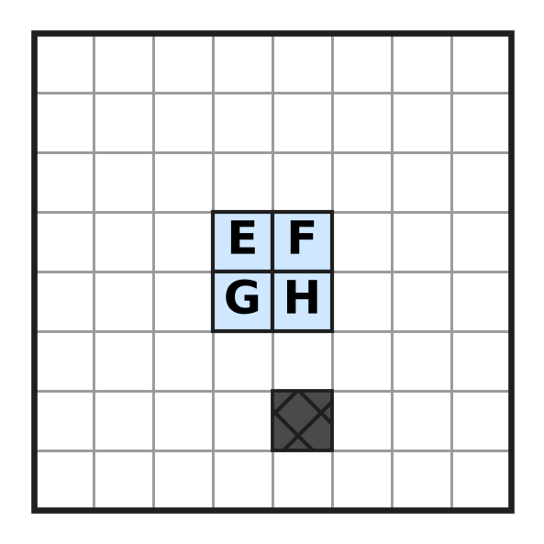
  (A) Square E | (B) Square F | (C) Square G | (D) Square H

Q38. By induction one can prove that (1 + x)ᵏ ≥ 1 + kx for every natural number k and every x > −1. Using this result, which of these statements is surely true?
(A) 1.01¹⁰⁰ ≥ 2 | (B) 1.1¹⁰ ≤ 2
(C) 0.99¹⁰⁰ ≥ 2 | (D) 1.05²⁰ ≥ 3

Q39. How many different numbers from the list 1, 2, 3, …, 20 must be picked to guarantee that one of the picked numbers is a factor of another picked number?
(A) 10 | (B) 9 | (C) 11 | (D) 21

Q40. Some squares of the 5 × 5 grid in the figure are to be shaded so that every 2 × 2 block of four squares inside the grid contains at least one shaded square. What is the least number of squares that must be shaded? | 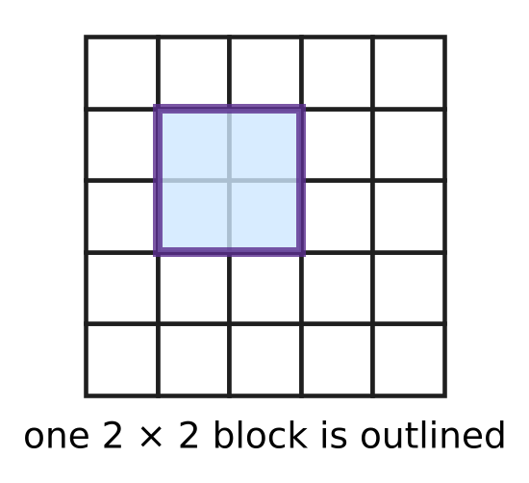
  (A) 4 | (B) 9 | (C) 5 | (D) 6

SECTION II — Star Questions 5 questions × 4 marks each
Q41. A sequence has $a_{1}=1$, $a_{2}=4$ and $a_{n+2}=4a_{n+1}−4a_{n}$ for every natural number n. What is the value of $a_{1}+a_{2}+a_{3}+…+a_{15}$? [4 marks]
(A) 491,521 | (B) 245,760 | (C) 458,753 | (D) 458,752

Q42. A bag holds 1 red ball and 3 blue balls. Chetan draws a ball at random, notes its colour and puts it back. He does this 8 times. What is the probability that he draws the red ball an even number of times? (If the red ball is never drawn, that counts as an even number of times.) [4 marks]
(A) $\frac{255}{512}$ | (B) $\frac{257}{512}$ | (C) $\frac{1}{256}$ | (D) $\frac{1}{2}$

Q43. What is the value of $1+2i+3i^{2}+4i^{3}+5i^{4}+…+20i^{19}$? [4 marks]
(A) 10 − 10i | (B) −20 − 20i
(C) −10 + 10i | (D) −10 − 10i

Q44. In the figure, the line x cos 22.5° + y sin 22.5° = 2 meets the x-axis at A and the y-axis at B. What is the length of AB? [4 marks] | 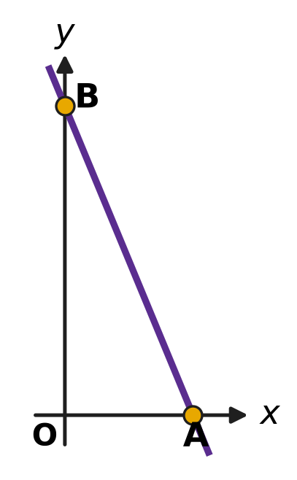
  (A) $4\sqrt{2}$ | (B) 4
  (C) $2\sqrt{2}$ | (D) 2

Q45. Ten different points are marked, and some pairs of them are joined by segments, so that no three of the points have all three of their segments drawn. The greatest possible number of segments is drawn. Two drawings are different if some segment is in one but not in the other. How many different drawings are possible? [4 marks]
(A) 252 | (B) 126 | (C) 25 | (D) 210

Answer Sheet AMO Level 1 · Class 11 · Practice Paper 4
Name: | School: | Roll No.:
Shade or tick one circle for each question.
1. Ⓐ Ⓑ Ⓒ Ⓓ | 16. Ⓐ Ⓑ Ⓒ Ⓓ | 31. Ⓐ Ⓑ Ⓒ Ⓓ
2. Ⓐ Ⓑ Ⓒ Ⓓ | 17. Ⓐ Ⓑ Ⓒ Ⓓ | 32. Ⓐ Ⓑ Ⓒ Ⓓ
3. Ⓐ Ⓑ Ⓒ Ⓓ | 18. Ⓐ Ⓑ Ⓒ Ⓓ | 33. Ⓐ Ⓑ Ⓒ Ⓓ
4. Ⓐ Ⓑ Ⓒ Ⓓ | 19. Ⓐ Ⓑ Ⓒ Ⓓ | 34. Ⓐ Ⓑ Ⓒ Ⓓ
5. Ⓐ Ⓑ Ⓒ Ⓓ | 20. Ⓐ Ⓑ Ⓒ Ⓓ | 35. Ⓐ Ⓑ Ⓒ Ⓓ
6. Ⓐ Ⓑ Ⓒ Ⓓ | 21. Ⓐ Ⓑ Ⓒ Ⓓ | 36. Ⓐ Ⓑ Ⓒ Ⓓ
7. Ⓐ Ⓑ Ⓒ Ⓓ | 22. Ⓐ Ⓑ Ⓒ Ⓓ | 37. Ⓐ Ⓑ Ⓒ Ⓓ
8. Ⓐ Ⓑ Ⓒ Ⓓ | 23. Ⓐ Ⓑ Ⓒ Ⓓ | 38. Ⓐ Ⓑ Ⓒ Ⓓ
9. Ⓐ Ⓑ Ⓒ Ⓓ | 24. Ⓐ Ⓑ Ⓒ Ⓓ | 39. Ⓐ Ⓑ Ⓒ Ⓓ
10. Ⓐ Ⓑ Ⓒ Ⓓ | 25. Ⓐ Ⓑ Ⓒ Ⓓ | 40. Ⓐ Ⓑ Ⓒ Ⓓ
11. Ⓐ Ⓑ Ⓒ Ⓓ | 26. Ⓐ Ⓑ Ⓒ Ⓓ | 41. Ⓐ Ⓑ Ⓒ Ⓓ
12. Ⓐ Ⓑ Ⓒ Ⓓ | 27. Ⓐ Ⓑ Ⓒ Ⓓ | 42. Ⓐ Ⓑ Ⓒ Ⓓ
13. Ⓐ Ⓑ Ⓒ Ⓓ | 28. Ⓐ Ⓑ Ⓒ Ⓓ | 43. Ⓐ Ⓑ Ⓒ Ⓓ
14. Ⓐ Ⓑ Ⓒ Ⓓ | 29. Ⓐ Ⓑ Ⓒ Ⓓ | 44. Ⓐ Ⓑ Ⓒ Ⓓ
15. Ⓐ Ⓑ Ⓒ Ⓓ | 30. Ⓐ Ⓑ Ⓒ Ⓓ | 45. Ⓐ Ⓑ Ⓒ Ⓓ
Q41–Q45 are Section II Star Questions (4 marks each).
For the parent or teacher
Section I correct: ______ / 40 × 2 = ______ marks Section II correct: ______ / 5 × 4 = ______ marks
Correct: ______ / 45 Score: ______ / 100
Answer Key and Solutions AMO Level 1 · Class 11 · Practice Paper 4
Quick answers
1 B | 6 C | 11 B | 16 C | 21 A | 26 B | 31 B | 36 B | 41 C
2 C | 7 D | 12 A | 17 D | 22 B | 27 A | 32 A | 37 D | 42 B
3 D | 8 A | 13 C | 18 B | 23 A | 28 B | 33 D | 38 A | 43 D
4 A | 9 C | 14 D | 19 D | 24 D | 29 D | 34 C | 39 C | 44 A
5 B | 10 B | 15 A | 20 C | 25 C | 30 C | 35 D | 40 A | 45 B
Solutions
Q | Part · level | Answer | Why?
1 | Part 1 · Ch1 · Easy | (B) 10 | z₁ = 2 + 5i and z₂ = 4 + 3i, so z₁ + z₂ = 6 + 8i. Its modulus is √(36 + 64) = √100 = 10.
2 | Part 1 · Ch1 · Easy | (C) −10 | z² = 4 + 12i + 9i² = −5 + 12i and the square of the conjugate is −5 − 12i. Their sum is −10.
3 | Part 1 · Ch1 · Easy | (D) −i | 1/i = −i, and the first four terms −i, −1, i, 1 add up to 0. So the sum is i⁻⁵ = i⁻¹ = −i.
4 | Part 1 · Ch1 · Medium | (A) 0 | z = 1 + 2i is a root of z² − 2z + 5 = 0 (roots 1 ± 2i). Since z³ − 3z² + 7z − 5 = (z² − 2z + 5)(z − 1), its value is 0.
5 | Part 1 · Ch1 · Medium | (B) −32i | An argument of 3π/4 puts z in the second quadrant with real part = −(imaginary part), so a = −4. Then z² = (−4 + 4i)² = 16 − 32i − 16 = −32i.
6 | Part 2 · Ch4 · Easy | (C) 5 | The means pair off from the ends, each pair adding to 3 + 43 = 46, so n means add up to 23n. Then 23n = 115 gives n = 5.
7 | Part 2 · Ch4 · Easy | (D) 7 | Multiply by 10: 5x − 2(x − 3) < 30, so 3x + 6 < 30 and x < 8. The greatest integer is 7.
8 | Part 2 · Ch4 · Easy | (A) $\frac{3}{4}$ | The x⁴ term is C(6, 2)a²x⁴ = 15a²x⁴ and the x³ term is C(6, 3)a³x³ = 20a³x³. So 15a² = 20a³, and a = 3/4.
9 | Part 2 · Ch4 · Easy | (C) 8,281 | A cube of edge k cm uses k³ small cubes. So the total is 1³ + 2³ + … + 13³ = (13 × 14 ÷ 2)² = 91² = 8,281.
10 | Part 2 · Ch4 · Easy | (B) 320 litres | The amounts form a GP with first term 2,430 and ratio 2/3. The 6th term is 2,430 × (2/3)⁵ = 2,430 × 32/243 = 320 litres.
11 | Part 2 · Ch4 · Medium | (B) 128 cm² | Each new square has half the area of the one before (its side is 1/√2 times as long). The areas 64, 32, 16, … form a GP with ratio 1/2, so the total is 64 ÷ (1 − 1/2) = 128 cm².
12 | Part 2 · Ch4 · Medium | (A) 3 | S₆ = S₃ + r³ × S₃, because terms 4 to 6 are terms 1 to 3 times r³. So 1 + r³ = 28, r³ = 27 and r = 3.
13 | Part 2 · Ch4 · Medium | (C) 583 | The numbers are 13, 21, 29, …, 93, an AP with common difference 8. There are (93 − 13) ÷ 8 + 1 = 11 of them, so the sum is 11 × (13 + 93) ÷ 2 = 583.
14 | Part 2 · Ch4 · Medium | (D) 540x³ | Putting x = 1, the coefficients add up to 4 to the power n, and 4,096 = 4⁶, so n = 6. The middle term is the 4th: C(6, 3)(3x)³ = 20 × 27x³ = 540x³.
15 | Part 3 · Ch5 · Easy | (A) 2x − 3y = 13 | ON has slope −3/2, so the line has slope 2/3. Through N: y + 3 = (2/3)(x − 2), which gives 2x − 3y = 13.
16 | Part 3 · Ch5 · Easy | (C) (0, −3) | AB has slope (3 + 1)/(3 + 3) = 2/3. Through C(3, −1): y = (2/3)x − 3, so it meets the y-axis at (0, −3).
17 | Part 3 · Ch5 · Easy | (D) 3x − 2y + 3 = 0 | Write y = mx + m. The point (1, 3) gives 3 = 2m, so m = 3/2 and y = (3/2)x + 3/2, that is 3x − 2y + 3 = 0.
18 | Part 3 · Ch5 · Medium | (B) 2 | The first two lines meet where 3x = 9, at (3, 2). Then 3k + 6 = 12, so k = 2.
19 | Part 3 · Ch5 · Medium | (D) 840 m | Distance = |4 × 6 − 3 × (−2) + 12| ÷ √(16 + 9) = 42 ÷ 5 = 8.4 units, and 8.4 × 100 m = 840 m.
20 | Part 4 · Ch7 · Easy | (C) −2 sin θ | sin(−θ) = −sin θ, sin(180° + θ) = −sin θ, sin(180° − θ) = sin θ and sin(360° − θ) = −sin θ. The total is −2 sin θ.
21 | Part 4 · Ch7 · Easy | (A) $−\frac{17}{13}$ | OP = √(144 + 25) = 13. So sin θ = −5/13 and cos θ = −12/13, and sin θ + cos θ = −17/13.
22 | Part 4 · Ch7 · Easy | (B) $\frac{1}{4}$ | tan²A = (1 − cos 2A)/(1 + cos 2A) = (2/17)/(32/17) = 1/16. A is acute, so tan A = 1/4.
23 | Part 4 · Ch7 · Medium | (A) −1 | 2A = (A + B) + (A − B), so tan 2A = (3 + 2) ÷ (1 − 3 × 2) = 5 ÷ (−5) = −1.
24 | Part 4 · Ch7 · Medium | (D) 2 | tan(A + B) = 1 gives tan A + tan B = 1 − tan A tan B. So (1 + tan A)(1 + tan B) = 1 + (tan A + tan B) + tan A tan B = 1 + 1 = 2.
25 | Part 5 · Ch8 · Easy | (C) 210 | The top stripe has 7 choices, the middle 6 and the bottom 5: P(7, 3) = 7 × 6 × 5 = 210.
26 | Part 5 · Ch8 · Easy | (B) $\frac{135}{512}$ | Each answer is right with probability 1/4. P(exactly 2) = C(5, 2)(1/4)²(3/4)³ = 10 × 27/1,024 = 135/512.
27 | Part 5 · Ch8 · Easy | (A) $5\sqrt{2}$ litres | The mean is 250 ÷ 5 = 50 L. The squared deviations are 100, 25, 25, 100 and 0, with mean 250 ÷ 5 = 50. So SD = √50 = 5√2 litres.
28 | Part 5 · Ch8 · Easy | (B) 360 | In exactly half of the 6! = 720 orders the lion house comes before the tiger house, so there are 360 orders.
29 | Part 5 · Ch8 · Medium | (D) 465 | Any 4 of the 12 cups: C(12, 4) = 495 ways. All 4 eggs in one row: 2 × C(6, 4) = 30 ways. So 495 − 30 = 465 ways leave neither row empty.
30 | Part 5 · Ch8 · Medium | (C) 45 | Choose the 4 players in C(6, 4) = 15 ways. Four players can be split into two pairs in 3 ways (partner of a fixed player). Total 15 × 3 = 45.
31 | Part 5 · Ch8 · Medium | (B) 29 min² | Mean of squares: small (4 + 400), large (4 + 900); together (404 + 904) ÷ 2 = 654. The combined mean is 25, so the variance is 654 − 625 = 29 min².
32 | Part 6 · Ch9 · Easy | (A) ₹15,600 | Rupa : Ojas = 50,000 × 12 : 80,000 × 9 = 600,000 : 720,000 = 5 : 6. Ojas gets 6/11 × ₹28,600 = ₹15,600.
33 | Part 6 · Ch9 · Easy | (D) 7.5 kg | Peeled weight = 0.8 × unpeeled weight. So the unpeeled weight is 6 ÷ 0.8 = 7.5 kg.
34 | Part 6 · Ch9 · Easy | (C) ₹16,000 | The deposit P grows to P × 1.05² = 1.1025P. So 1.1025P = 17,640 and P = ₹16,000.
35 | Part 6 · Ch9 · Medium | (D) 2 km/h | 24/(10 − s) + 24/(10 + s) = 5 gives 480 = 5(100 − s²), so s² = 4 and the stream flows at 2 km/h (8 km/h up for 3 h, 12 km/h down for 2 h).
36 | Part 7 · Ch10 · Easy | (B) 10 | Cut the square into 9 squares of side 1 cm; two points in one small square are at most √2 cm apart. With 10 points, two share a small square. But 9 points in a 3 × 3 grid, 1.5 cm apart, are all more than √2 cm apart, so 9 is too few.
37 | Part 7 · Ch10 · Easy | (D) Square H | The removed square is in the bottom-right quarter. The centre tile must cover one square of each of the other three quarters (E, F and G), so H, which belongs to the bottom-right quarter, stays uncovered.
38 | Part 7 · Ch10 · Easy | (A) 1.01¹⁰⁰ ≥ 2 | With x = 0.01 and n = 100: 1.01¹⁰⁰ ≥ 1 + 100 × 0.01 = 2. (The other three are false: 1.1¹⁰ ≈ 2.59, 0.99¹⁰⁰ < 1 and 1.05²⁰ ≈ 2.65.)
39 | Part 7 · Ch10 · Medium | (C) 11 | Write each number as 2ᵏ × (odd number). There are only 10 odd parts (1, 3, …, 19), so among 11 numbers two share an odd part, and the smaller divides the larger. The 10 numbers 11 to 20 show that 10 are not enough.
40 | Part 7 · Ch10 · Medium | (A) 4 | The four 2 × 2 blocks in the corners of the grid share no square, so at least 4 squares are needed. Shading the 4 squares in rows 2 and 4 and columns 2 and 4 meets every 2 × 2 block, so 4 is enough.
41 | Section II · Ch4 + Ch10 · Hard | (C) 458,753 | The terms 1, 4, 12, 32, 80, … are 1 × 1, 2 × 2, 3 × 4, 4 × 8, 5 × 16, so term k is k × 2ᵏ⁻¹; by induction, if it holds for k and k + 1 then the next term is 4(k + 1)2ᵏ − 4k × 2ᵏ⁻¹ = (k + 2)2ᵏ⁺¹. For S = 1 + 2 × 2 + 3 × 2² + … + 15 × 2¹⁴, 2S − S = 15 × 2¹⁵ − (1 + 2 + … + 2¹⁴) = 491,520 − 32,767 = 458,753.
42 | Section II · Ch4 + Ch8 · Hard | (B) $\frac{257}{512}$ | Expanding (3/4 + 1/4)⁸ = 1 and (3/4 − 1/4)⁸ = 1/256 by the binomial theorem, the terms for an odd number of reds cancel when the two are added. So the probability of an even number of reds is (1 + 1/256) ÷ 2 = 257/512.
43 | Section II · Ch1 + Ch4 · Hard | (D) −10 − 10i | Group the terms in fours: k + (k + 1)i − (k + 2) − (k + 3)i = −2 − 2i for k = 1, 5, 9, 13, 17. Five groups give 5 × (−2 − 2i) = −10 − 10i.
44 | Section II · Ch5 + Ch7 · Hard | (A) $4\sqrt{2}$ | The intercepts are OA = 2/cos 22.5° and OB = 2/sin 22.5°. So AB² = 4(sin²22.5° + cos²22.5°)/(sin 22.5° cos 22.5°)² = 4/(sin 22.5° cos 22.5°)², giving AB = 2/(sin 22.5° cos 22.5°) = 4/sin 45° = 4√2.
45 | Section II · Ch8 + Ch10 · Hard | (B) 126 | If a point with the most segments has d of them, its d partners are not joined to each other, so there are at most d(10 − d) ≤ 25 segments, with 25 only when the points split into two groups of 5 and every point is joined to all 5 points of the other group. Choosing the groups: C(10, 5) ÷ 2 = 126 drawings.

ARYABHATTA MATHS OLYMPIAD
Level 1
PRACTICE PAPER-5
CLASS 11
Total Questions | 45 multiple-choice questions
Total Marks | 100
Time | 60 minutes
Section I | 40 questions × 2 marks = 80 marks
Section II | 5 Star Questions × 4 marks = 20 marks
Negative Marking | No negative marking
Calculator | Not allowed
Chapters | Number System · Algebra · Geometry · Trigonometry · Data Handling · Applied Mathematics · Mathematical Reasoning

Instructions to candidates
• This paper has 45 multiple-choice questions. Each question has four answer choices, of which exactly one is correct.
• Section I (Q1–Q40) carries 2 marks per question. Section II (Q41–Q45) carries 4 marks per question.
• There is no negative marking. Unanswered questions score zero.
• Calculators are not permitted. Rough work may be done on a separate sheet.
• Mark your answers on the answer sheet at the end of the paper.
• All figures are not necessarily drawn to scale unless stated.

For parents and teachers
• Print or view this paper in colour. Pictures are part of the questions.
• Parts follow the AMO syllabus chapters. Chapters 2, 3 and 6 are not part of the Class 11 syllabus, so the chapter numbers shown in the Part headings have gaps.
• The answer sheet and the answer key are at the end. Remove only the answer key before the student begins.

SECTION I 40 questions × 2 marks each
Part 1 — Number System (Syllabus Chapter 1)
Q1. The real numbers x and y are such that 3 + (x − 2)i is the conjugate of y + 5i. What is the value of x + y?
(A) −4 | (B) 0 | (C) 4 | (D) 10

Q2. The complex number z = x + 3i, where x is real, satisfies |z| = |z − 4|. What is the value of x?
(A) −2 | (B) 4 | (C) 8 | (D) 2

Q3. How many of the twenty numbers i, i², i³, …, i²⁰ are real numbers?
(A) 11 | (B) 5 | (C) 10 | (D) 15

Q4. A complex number z satisfies z + |z| = 2 + 8i. What is the value of |z|?
(A) 17 | (B) 15
(C) 8 | (D) $2\sqrt{17}$

Q5. The numbers p and q are real. In the figure, the points P and R on the Argand plane represent the two roots of the equation x² + px + q = 0. What is the value of p + q? | 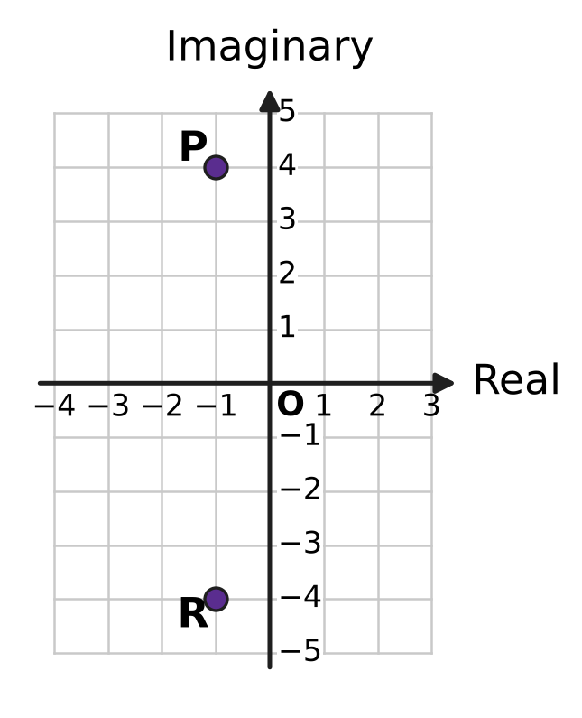
  (A) −13 | (B) 17 | (C) 15 | (D) 19

Part 2 — Algebra (Syllabus Chapter 4)
Q6. In a geometric progression, the second term is 6 and the fifth term is −48. What is the first term?
(A) −3 | (B) 3 | (C) 12 | (D) −12

Q7. The arithmetic progression 120, 116, 112, 108, … goes on for ever. Which term is its first negative term?
(A) the 30th term | (B) the 33rd term
(C) the 32nd term | (D) the 31st term

Q8. The five interior angles of a pentagon form an arithmetic progression. The smallest angle is 90°. What is the largest angle?
(A) 135° | (B) 126° | (C) 117° | (D) 108°

Q9. In the expansion of (1 + x)^{n}, where n is a natural number, the coefficient of x² is 36. What is n?
(A) 6 | (B) 18 | (C) 9 | (D) 72

Q10. A real number x satisfies both 3x + 2 > 14 and 13 − 2x ≥ −5. Which of these describes all such numbers x?
(A) 4 ≤ x ≤ 9 | (B) 4 < x ≤ 9
(C) x ≥ 9 | (D) $\frac{16}{3}$ < x ≤ 9

Q11. An arithmetic progression and a geometric progression of positive numbers both have first term 2 and third term 18. By how much is the second term of the arithmetic progression greater than the second term of the geometric progression?
(A) −4 | (B) 10 | (C) 6 | (D) 4

Q12. An infinite geometric progression has sum 3. The squares of its terms form another infinite geometric progression, whose sum is $\frac{9}{2}$. What is the first term of the first progression?
(A) 2 | (B) $\frac{1}{3}$ | (C) $\frac{3}{2}$ | (D) 3

Q13. What is the value of 1² − 2² + 3² − 4² + 5² − … − 28² + 29², where the signs of the squares alternate?
(A) 406 | (B) 434 | (C) 435 | (D) 841

Q14. The expansion of (2x + 3)⁵ in powers of x has two middle terms, one in x³ and one in x². What is the ratio of the coefficient of x³ to the coefficient of x²?
(A) 2 : 3 | (B) 1 : 1 | (C) 3 : 2 | (D) 4 : 9

Part 3 — Geometry (Syllabus Chapter 5)
Q15. A straight line meets the x-axis at (9, 0) and passes through the point (3, 4). At what value of y does it meet the y-axis?
(A) −6 | (B) $\frac{27}{5}$ | (C) 12 | (D) 6

Q16. In the figure, the line ℓ crosses the negative part of the x-axis and the positive part of the y-axis. Exactly one of these equations could be the equation of ℓ. Which one? | 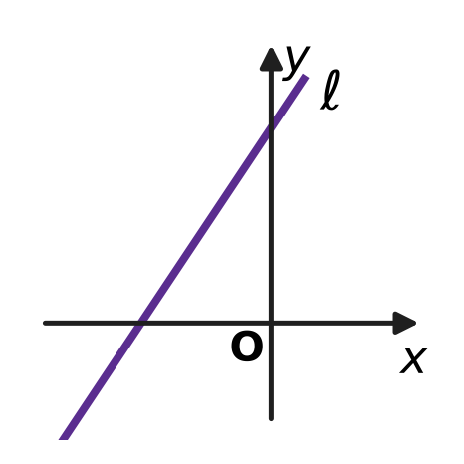
  (A) 3x − 2y − 6 = 0 | (B) 3x − 2y + 6 = 0
  (C) 3x + 2y + 6 = 0 | (D) 3x + 2y − 6 = 0

Q17. Two different points lie on the y-axis. Each of them is at a perpendicular distance of 12 units from the line 7x − 24y + 48 = 0. How far apart are the two points?
(A) 24 units | (B) 25 units
(C) 1 unit | (D) 12.5 units

Q18. In the figure, a flat mirror lies along the x-axis. A ray of light from A(2, 6) strikes the mirror at M and is reflected so that it passes through B(8, 3). The ray makes equal angles with the mirror before and after M. What are the coordinates of M? | 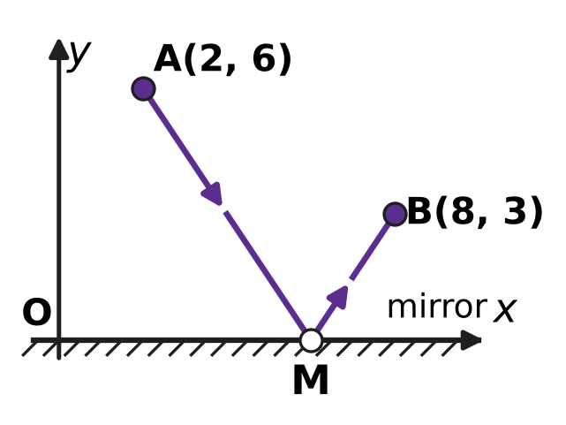
  (A) (14, 0) | (B) (4, 0) | (C) (5, 0) | (D) (6, 0)

Q19. For every real number k, the line (2 + k)x + (1 − k)y = 3 + 3k passes through one and the same point. What is that point?
(A) (1, 1) | (B) (−1, 2) | (C) (2, −1) | (D) (3, 0)

Part 4 — Trigonometry & Heights and Distances (Syllabus Chapter 7)
Q20. Which of these angles has the same sine as 200°?
(A) −20° | (B) 160° | (C) 380° | (D) 20°

Q21. In the figure, P$(\frac{3}{5},\frac{4}{5})$ and Q lie on a unit circle centred at the origin O. OP makes the angle θ with the positive x-axis, and OQ is OP turned anticlockwise through a right angle. What are the coordinates of Q? | 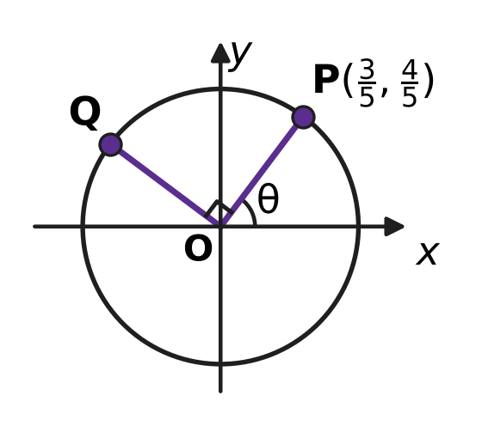
  (A) $(−\frac{4}{5},\frac{3}{5})$ | (B) $(\frac{4}{5},−\frac{3}{5})$
  (C) $(\frac{4}{5},\frac{3}{5})$ | (D) $(−\frac{3}{5},\frac{4}{5})$

Q22. What is the value of $\frac{sin{80}^{∘}−sin{20}^{∘}}{cos{50}^{∘}}$?
(A) $\frac{\sqrt{3}}{2}$ | (B) √3 tan 50°
(C) 1 | (D) 2

Q23. What is the exact value of tan 22.5°?
(A) −1 − √2 | (B) $\frac{1}{2}$ | (C) √2 + 1 | (D) √2 − 1

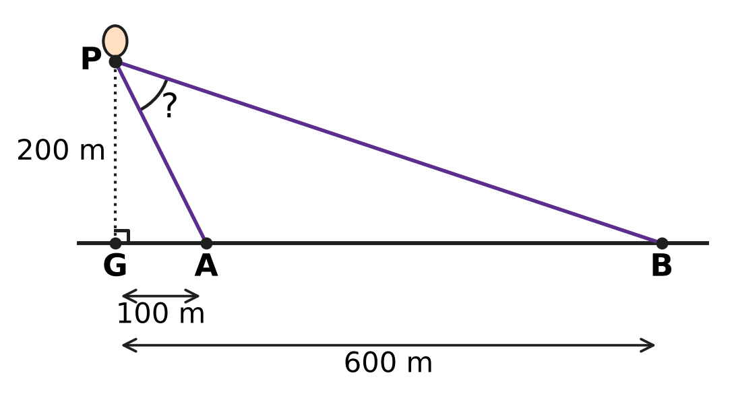
Q24. A hot-air balloon P is 200 m straight above the point G on level ground. Two observers stand at A and B on the ground, on the same side of G and in a straight line with it, with GA = 100 m and GB = 600 m, as in the figure. What is the angle APB between the two lines of sight at the balloon?
(A) 30° | (B) 45° | (C) 135° | (D) 60°

Part 5 — Data Handling, Statistics & Probability (Syllabus Chapter 8)
Q25. At an ice-cream stall, Kian chooses one of 3 kinds of cone and 2 scoops of different flavours from 6 flavours. The order of the two scoops is unimportant. In how many different ways can he choose his ice cream?
(A) 108 | (B) 18 | (C) 45 | (D) 90

Q26. In a music class, 7 students, including Myra, will each perform once, one after another. Myra must perform either first or last. In how many orders can the 7 performances take place?
(A) 240 | (B) 720 | (C) 5,040 | (D) 1,440

Q27. The weather office says that on each of the next 3 days the chance of rain is 0.3, and the days are independent of each other. What is the probability that it rains on at least one of the 3 days?
(A) 0.657 | (B) 0.343 | (C) 0.441 | (D) 0.973

Q28. At an airport, the numbers of planes that landed in each of five hours were recorded as 5, 8, 11, 14 and 17. The variance of these numbers is 18. Later it was found that the 17 was a mistake: the true number was 2. What is the variance of the corrected numbers?
(A) 33 | (B) 18 | (C) 22.5 | (D) 27

Q29. A team of 4 students is to be chosen from 10 students for a science exhibition. Two of the 10, Varsha and Jatin, are working on one model, so either both of them are in the team or neither of them is. How many different teams can be chosen?
(A) 112 | (B) 28 | (C) 98 | (D) 70

Q30. Each time Yash casts his fishing net, he catches a fish with the same probability, independently of the other casts. The probability that two casts both catch nothing is $\frac{4}{25}$. He now casts the net 3 times. What is the probability that he catches a fish on exactly 2 of the 3 casts?
(A) $\frac{81}{125}$ | (B) $\frac{54}{125}$ | (C) $\frac{36}{125}$ | (D) $\frac{18}{125}$

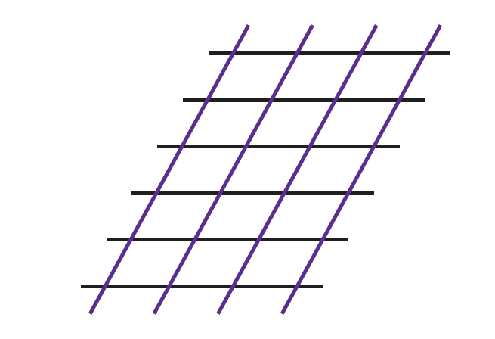
Q31. In the figure, 6 horizontal parallel lines are crossed by 4 slanting parallel lines. How many parallelograms of all sizes are formed whose four sides lie along these lines?
(A) 210 | (B) 15 | (C) 21 | (D) 90

Part 6 — Applied Mathematics (Syllabus Chapter 9)
Q32. Usha runs a tea stall. She buys a kettle for ₹2,000, on which GST is 5%, and paper cups for ₹1,000, on which GST is 18%. Both prices are before GST. How much does she pay in all?
(A) ₹3,280 | (B) ₹3,150 | (C) ₹3,540 | (D) ₹3,410

Q33. Anand puts money in a deposit that earns compound interest at a fixed yearly rate. The money doubles in 3 years. In how many years from the start will it become 8 times the money he put in?
(A) 21 years | (B) 24 years | (C) 12 years | (D) 9 years

Q34. The motor of a lift in a building is bought for ₹80,000. Each year it loses 10% of the value it had at the start of that year. What is its value after 3 years?
(A) ₹106,480 | (B) ₹64,800 | (C) ₹58,320 | (D) ₹56,000

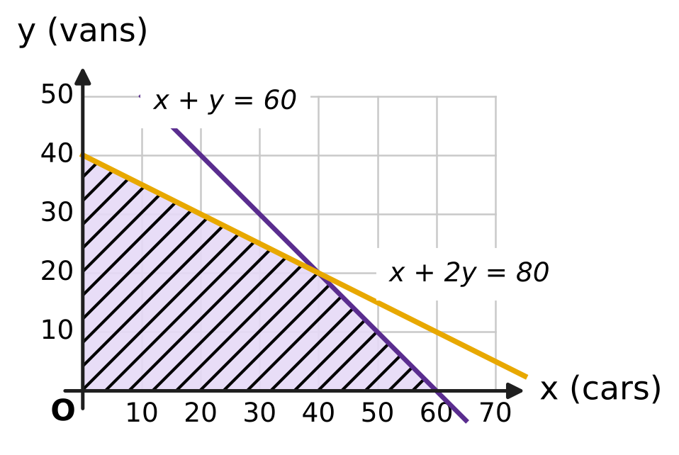
Q35. A car park can hold at most 60 vehicles. A car uses 1 unit of space and a van uses 2 units, and there are 80 units of space. With x cars and y vans, the shaded region in the figure shows all the allowed numbers. Each car pays ₹40 a day and each van pays ₹70 a day. What is the greatest possible income in a day?
(A) ₹2,400 | (B) ₹3,000 | (C) ₹4,200 | (D) ₹2,800

Part 7 — Mathematical Reasoning & Problem-Solving (Syllabus Chapter 10)
Q36. Nine students meet, and each pair of students shakes hands at most once. They want every student to shake hands with exactly k of the others. For which value of k is this impossible?
(A) k = 5 | (B) k = 4 | (C) k = 2 | (D) k = 6

Q37. In a game, a player scores either 3 points or 5 points at a time. A proof shows that every total of 8 or more points can be reached. It first checks some starting totals directly, and then uses this step: if a total n can be reached, so can n + 3. Which starting totals must it check?
(A) 8, 9 and 10 | (B) 8 and 9
(C) 8 only | (D) 3, 5 and 8

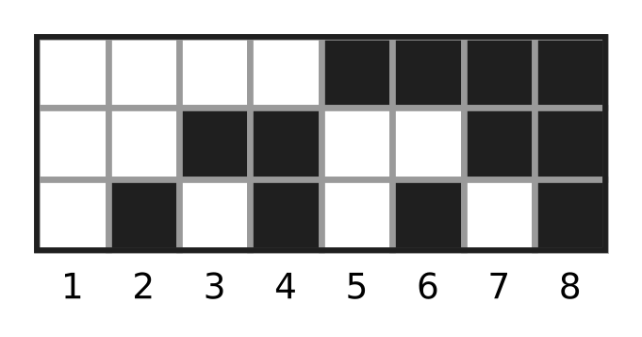
Q38. A board has 3 rows and some columns. Each square is painted black or white. The figure shows a board with 8 columns in which no two columns are painted alike. What is the least number of columns that makes sure that, however the squares are painted, some two columns are painted exactly alike?
(A) 7 | (B) 9 | (C) 4 | (D) 8

Q39. In a chess club, 7 players each play exactly one game against every other player, and no game is drawn. What is the greatest possible number of players who each win at least 5 games?
(A) 2 | (B) 4 | (C) 5 | (D) 3

Q40. How many 4-digit numbers have digits that strictly increase from left to right, such as 1358?
(A) 210 | (B) 252 | (C) 126 | (D) 3,024

SECTION II — Star Questions 5 questions × 4 marks each
Q41. In how many ways can 105 be written as a sum of two or more consecutive positive whole numbers? (For example, 105 = 52 + 53 is one way.) [4 marks]
(A) 3 | (B) 7 | (C) 14 | (D) 8

Q42. Three different numbers are chosen from the whole numbers 1 to 25, and the order of choosing is unimportant. In how many ways can they be chosen so that, written in increasing order, they form an arithmetic progression? [4 marks]
(A) 288 | (B) 222 | (C) 144 | (D) 132

Q43. The expression (x + 2i)⁶ is expanded in powers of x. Some of the coefficients are real numbers and the others are purely imaginary. What is the sum of the real coefficients? [4 marks]
(A) 365 | (B) 44 | (C) 161 | (D) 117

Q44. In the figure, OAB is an equilateral triangle, where O is the origin, the side OA lies along the line y = x, and B lies above that line. What is the sum of the slopes of OB and AB? [4 marks] | 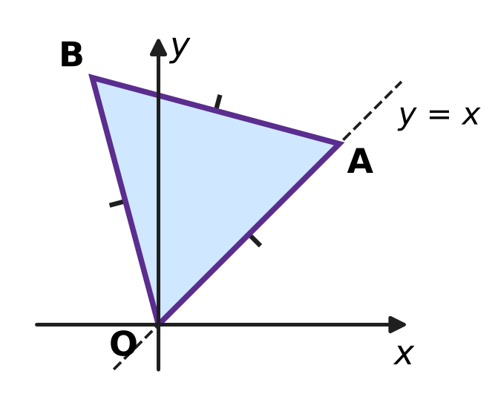
  (A) −4 | (B) −2√3 | (C) 2√3 | (D) 4

Q45. A school play has 7 actors. In every scene, exactly 3 of the actors are on stage. No two scenes have the same 3 actors, and no two actors are on stage together in more than one scene. What is the greatest possible number of scenes? [4 marks]
(A) 35 | (B) 21 | (C) 7 | (D) 2

Answer Sheet AMO Level 1 · Class 11 · Practice Paper 5
Name: | School: | Roll No.:
Shade or tick one circle for each question.
1. Ⓐ Ⓑ Ⓒ Ⓓ | 16. Ⓐ Ⓑ Ⓒ Ⓓ | 31. Ⓐ Ⓑ Ⓒ Ⓓ
2. Ⓐ Ⓑ Ⓒ Ⓓ | 17. Ⓐ Ⓑ Ⓒ Ⓓ | 32. Ⓐ Ⓑ Ⓒ Ⓓ
3. Ⓐ Ⓑ Ⓒ Ⓓ | 18. Ⓐ Ⓑ Ⓒ Ⓓ | 33. Ⓐ Ⓑ Ⓒ Ⓓ
4. Ⓐ Ⓑ Ⓒ Ⓓ | 19. Ⓐ Ⓑ Ⓒ Ⓓ | 34. Ⓐ Ⓑ Ⓒ Ⓓ
5. Ⓐ Ⓑ Ⓒ Ⓓ | 20. Ⓐ Ⓑ Ⓒ Ⓓ | 35. Ⓐ Ⓑ Ⓒ Ⓓ
6. Ⓐ Ⓑ Ⓒ Ⓓ | 21. Ⓐ Ⓑ Ⓒ Ⓓ | 36. Ⓐ Ⓑ Ⓒ Ⓓ
7. Ⓐ Ⓑ Ⓒ Ⓓ | 22. Ⓐ Ⓑ Ⓒ Ⓓ | 37. Ⓐ Ⓑ Ⓒ Ⓓ
8. Ⓐ Ⓑ Ⓒ Ⓓ | 23. Ⓐ Ⓑ Ⓒ Ⓓ | 38. Ⓐ Ⓑ Ⓒ Ⓓ
9. Ⓐ Ⓑ Ⓒ Ⓓ | 24. Ⓐ Ⓑ Ⓒ Ⓓ | 39. Ⓐ Ⓑ Ⓒ Ⓓ
10. Ⓐ Ⓑ Ⓒ Ⓓ | 25. Ⓐ Ⓑ Ⓒ Ⓓ | 40. Ⓐ Ⓑ Ⓒ Ⓓ
11. Ⓐ Ⓑ Ⓒ Ⓓ | 26. Ⓐ Ⓑ Ⓒ Ⓓ | 41. Ⓐ Ⓑ Ⓒ Ⓓ
12. Ⓐ Ⓑ Ⓒ Ⓓ | 27. Ⓐ Ⓑ Ⓒ Ⓓ | 42. Ⓐ Ⓑ Ⓒ Ⓓ
13. Ⓐ Ⓑ Ⓒ Ⓓ | 28. Ⓐ Ⓑ Ⓒ Ⓓ | 43. Ⓐ Ⓑ Ⓒ Ⓓ
14. Ⓐ Ⓑ Ⓒ Ⓓ | 29. Ⓐ Ⓑ Ⓒ Ⓓ | 44. Ⓐ Ⓑ Ⓒ Ⓓ
15. Ⓐ Ⓑ Ⓒ Ⓓ | 30. Ⓐ Ⓑ Ⓒ Ⓓ | 45. Ⓐ Ⓑ Ⓒ Ⓓ
Q41–Q45 are Section II Star Questions (4 marks each).
For the parent or teacher
Section I correct: ______ / 40 × 2 = ______ marks Section II correct: ______ / 5 × 4 = ______ marks
Correct: ______ / 45 Score: ______ / 100
Answer Key and Solutions AMO Level 1 · Class 11 · Practice Paper 5
Quick answers
1 B | 6 A | 11 D | 16 B | 21 A | 26 D | 31 D | 36 A | 41 B
2 D | 7 C | 12 A | 17 B | 22 C | 27 A | 32 A | 37 A | 42 C
3 C | 8 B | 13 C | 18 D | 23 D | 28 B | 33 D | 38 B | 43 D
4 A | 9 C | 14 A | 19 C | 24 B | 29 C | 34 C | 39 D | 44 A
5 D | 10 B | 15 D | 20 A | 25 C | 30 B | 35 B | 40 C | 45 C
Solutions
Q | Part · level | Answer | Why?
1 | Part 1 · Ch1 · Easy | (B) 0 | The conjugate of y + 5i is y − 5i. So y = 3 and x − 2 = −5, which gives x = −3, and x + y = 0.
2 | Part 1 · Ch1 · Easy | (D) 2 | x² + 9 = (x − 4)² + 9 gives x² = x² − 8x + 16, so 8x = 16 and x = 2.
3 | Part 1 · Ch1 · Easy | (C) 10 | i^{n} is real (1 or −1) exactly when n is even, and there are 10 even numbers from 1 to 20.
4 | Part 1 · Ch1 · Medium | (A) 17 | |z| is real, so z = a + 8i with a + √(a² + 64) = 2. Then a² + 64 = (2 − a)², so a = −15 and |z| = √(225 + 64) = 17.
5 | Part 1 · Ch1 · Medium | (D) 19 | The roots are −1 + 4i and −1 − 4i. Their sum is −2 = −p and their product is 1 + 16 = 17 = q. So p + q = 2 + 17 = 19.
6 | Part 2 · Ch4 · Easy | (A) −3 | r³ = −48 ÷ 6 = −8, so r = −2. The first term is 6 ÷ (−2) = −3.
7 | Part 2 · Ch4 · Easy | (C) the 32nd term | The nth term is 120 − 4(n − 1). The 31st term is 120 − 120 = 0, so the first negative term is the 32nd, which is −4.
8 | Part 2 · Ch4 · Easy | (B) 126° | The angles add up to 540°. So 5 × 90° + 10d = 540°, which gives d = 9°, and the largest angle is 90° + 4 × 9° = 126°.
9 | Part 2 · Ch4 · Easy | (C) 9 | The coefficient of x² is n(n − 1)/2 = 36, so n(n − 1) = 72 = 9 × 8, and n = 9.
10 | Part 2 · Ch4 · Easy | (B) 4 < x ≤ 9 | From 3x + 2 > 14, 3x > 12, so x > 4. From 13 − 2x ≥ −5, −2x ≥ −18, so x ≤ 9 (the sign turns round). Together, 4 < x ≤ 9.
11 | Part 2 · Ch4 · Medium | (D) 4 | The middle terms are the AM and the GM of 2 and 18: AM = 10 and GM = √36 = 6. The difference is 10 − 6 = 4.
12 | Part 2 · Ch4 · Medium | (A) 2 | a/(1 − r) = 3 and a²/(1 − r²) = 9/2. Dividing gives a/(1 + r) = 3/2, so 3(1 − r) = (3/2)(1 + r), r = 1/3 and a = 2.
13 | Part 2 · Ch4 · Medium | (C) 435 | Pair from the top: 29² − 28² = 57, 27² − 26² = 53, …, 3² − 2² = 5, and 1² = 1 is left. So the value is 1 + 5 + 9 + … + 57, an AP of 15 terms, which is 15 × 29 = 435.
14 | Part 2 · Ch4 · Medium | (A) 2 : 3 | The x³ term is C(5, 2) × 2³ × 3² = 720 and the x² term is C(5, 3) × 2² × 3³ = 1,080. So the ratio is 720 : 1,080 = 2 : 3.
15 | Part 3 · Ch5 · Easy | (D) 6 | In x/9 + y/b = 1, the point (3, 4) gives 1/3 + 4/b = 1, so 4/b = 2/3 and b = 6.
16 | Part 3 · Ch5 · Easy | (B) 3x − 2y + 6 = 0 | For 3x − 2y + 6 = 0, putting y = 0 gives x = −2 and putting x = 0 gives y = 3. The other three lines have an intercept of the wrong sign.
17 | Part 3 · Ch5 · Easy | (B) 25 units | For (0, b), the distance is |−24b + 48| ÷ 25 = 12, so −24b + 48 = 300 or −300. Then b = −10.5 or b = 14.5, and the points are 14.5 − (−10.5) = 25 units apart.
18 | Part 3 · Ch5 · Medium | (D) (6, 0) | Reflect B in the x-axis to B′(8, −3). The line AB′ has slope −9/6 = −3/2, so y − 6 = −(3/2)(x − 2). Putting y = 0 gives x = 6.
19 | Part 3 · Ch5 · Medium | (C) (2, −1) | Rewrite as (2x + y − 3) + k(x − y − 3) = 0. Both brackets are 0 when 2x + y = 3 and x − y = 3, that is x = 2, y = −1.
20 | Part 4 · Ch7 · Easy | (A) −20° | sin 200° = sin(180° + 20°) = −sin 20°, and sin(−20°) = −sin 20°. The other three angles have sine +sin 20°.
21 | Part 4 · Ch7 · Easy | (A) (−4/5, 3/5) | Q = (cos(θ + 90°), sin(θ + 90°)) = (−sin θ, cos θ) = (−4/5, 3/5).
22 | Part 4 · Ch7 · Easy | (C) 1 | sin 80° − sin 20° = 2 cos 50° sin 30° = cos 50°, so the value is 1.
23 | Part 4 · Ch7 · Medium | (D) √2 − 1 | With t = tan 22.5°, tan 45° = 2t/(1 − t²) = 1, so t² + 2t − 1 = 0 and t = −1 ± √2. As t > 0, t = √2 − 1.
24 | Part 4 · Ch7 · Medium | (B) 45° | The elevations at A and B have tangents 200/100 = 2 and 200/600 = 1/3. The angle at A is an exterior angle of triangle PAB, so angle APB is the difference of the two elevations, and tan(difference) = (2 − 1/3)/(1 + 2 × 1/3) = 1, so angle APB = 45°.
25 | Part 5 · Ch8 · Easy | (C) 45 | There are 3 cones and C(6, 2) = 15 pairs of flavours, so 3 × 15 = 45 ways.
26 | Part 5 · Ch8 · Easy | (D) 1,440 | Myra has 2 places, and the other 6 students fill the rest in 6! = 720 ways. So 2 × 720 = 1,440.
27 | Part 5 · Ch8 · Easy | (A) 0.657 | The chance that a day is dry is 0.7, so all 3 days are dry with chance 0.7³ = 0.343. At least one rainy day: 1 − 0.343 = 0.657.
28 | Part 5 · Ch8 · Easy | (B) 18 | The corrected numbers 2, 5, 8, 11, 14 are the old ones each reduced by 3. Shifting every value does not change the variance, so it is still 18.
29 | Part 5 · Ch8 · Medium | (C) 98 | Both in: choose 2 more from the other 8, C(8, 2) = 28. Neither in: choose all 4 from the other 8, C(8, 4) = 70. Total 28 + 70 = 98.
30 | Part 5 · Ch8 · Medium | (B) $\frac{54}{125}$ | The chance of no catch is √(4/25) = 2/5, so a catch has chance 3/5. Exactly 2 catches in 3 casts: 3 × (3/5)² × 2/5 = 54/125.
31 | Part 5 · Ch8 · Medium | (D) 90 | A parallelogram needs 2 of the 6 horizontal lines and 2 of the 4 slanting lines: C(6, 2) × C(4, 2) = 15 × 6 = 90.
32 | Part 6 · Ch9 · Easy | (A) ₹3,280 | GST is 5% of ₹2,000 = ₹100 and 18% of ₹1,000 = ₹180. Total = ₹3,000 + ₹280 = ₹3,280.
33 | Part 6 · Ch9 · Easy | (D) 9 years | Every 3 years the money is multiplied by 2. Since 8 = 2³, it takes 3 × 3 = 9 years.
34 | Part 6 · Ch9 · Easy | (C) ₹58,320 | Value = 80,000 × 0.9³ = 80,000 × 0.729 = ₹58,320.
35 | Part 6 · Ch9 · Medium | (B) ₹3,000 | The corners are (0, 0), (60, 0), (40, 20) and (0, 40), giving ₹0, ₹2,400, ₹3,000 and ₹2,800. The greatest is ₹3,000 at 40 cars and 20 vans.
36 | Part 7 · Ch10 · Easy | (A) k = 5 | Each handshake involves 2 students, so 9 × k must be even. That fails only for k = 5; for k = 2, 4, 6 seat them in a circle and shake with the nearest 1, 2 or 3 on each side.
37 | Part 7 · Ch10 · Easy | (A) 8, 9 and 10 | The step adds 3, so each starting total covers every third number. To cover all totals from 8 we need 8 = 3 + 5, 9 = 3 + 3 + 3 and 10 = 5 + 5.
38 | Part 7 · Ch10 · Easy | (B) 9 | A column can be painted in 2³ = 8 ways. With 9 columns, two must share a pattern, and the figure shows 8 columns are not enough.
39 | Part 7 · Ch10 · Medium | (D) 3 | If k players each win 5 or more, they win at least 5k games, but only C(k, 2) + k(7 − k) games involve them. This fails for k = 4 (20 > 18). For k = 3, let them beat each other in a cycle and beat all four others.
40 | Part 7 · Ch10 · Medium | (C) 126 | Any 4 different digits from 1 to 9 can be written in increasing order in exactly one way, and 0 cannot appear. So the count is C(9, 4) = 126.
41 | Section II · Ch4 + Ch10 · Hard | (B) 7 | n terms starting at a give n(2a + n − 1)/2 = 105, so n(2a + n − 1) = 210 with the two factors of opposite parity and n smaller. This gives n = 2, 3, 5, 6, 7, 10, 14: 7 ways.
42 | Section II · Ch4 + Ch8 · Hard | (C) 144 | With common difference d, the smallest number runs from 1 to 25 − 2d, giving 25 − 2d sets, for d = 1 to 12. Total = 23 + 21 + … + 1 = 144.
43 | Section II · Ch1 + Ch4 · Hard | (D) 117 | The real coefficients come from even powers of 2i: 1 + 15(2i)² + 15(2i)⁴ + (2i)⁶ = 1 − 60 + 240 − 64 = 117.
44 | Section II · Ch5 + Ch7 · Hard | (A) −4 | OB makes 45° + 60° = 105° and AB makes 45° + 120° = 165° with the x-axis. tan 105° = −(2 + √3) and tan 165° = −(2 − √3), so the sum is −4.
45 | Section II · Ch8 + Ch10 · Hard | (C) 7 | Each scene puts C(3, 2) = 3 pairs of actors together, and each of the C(7, 2) = 21 pairs can be together at most once, so there are at most 21 ÷ 3 = 7 scenes. Seven scenes are possible, for example with actors 1 to 7: 123, 145, 167, 246, 257, 347, 356.

