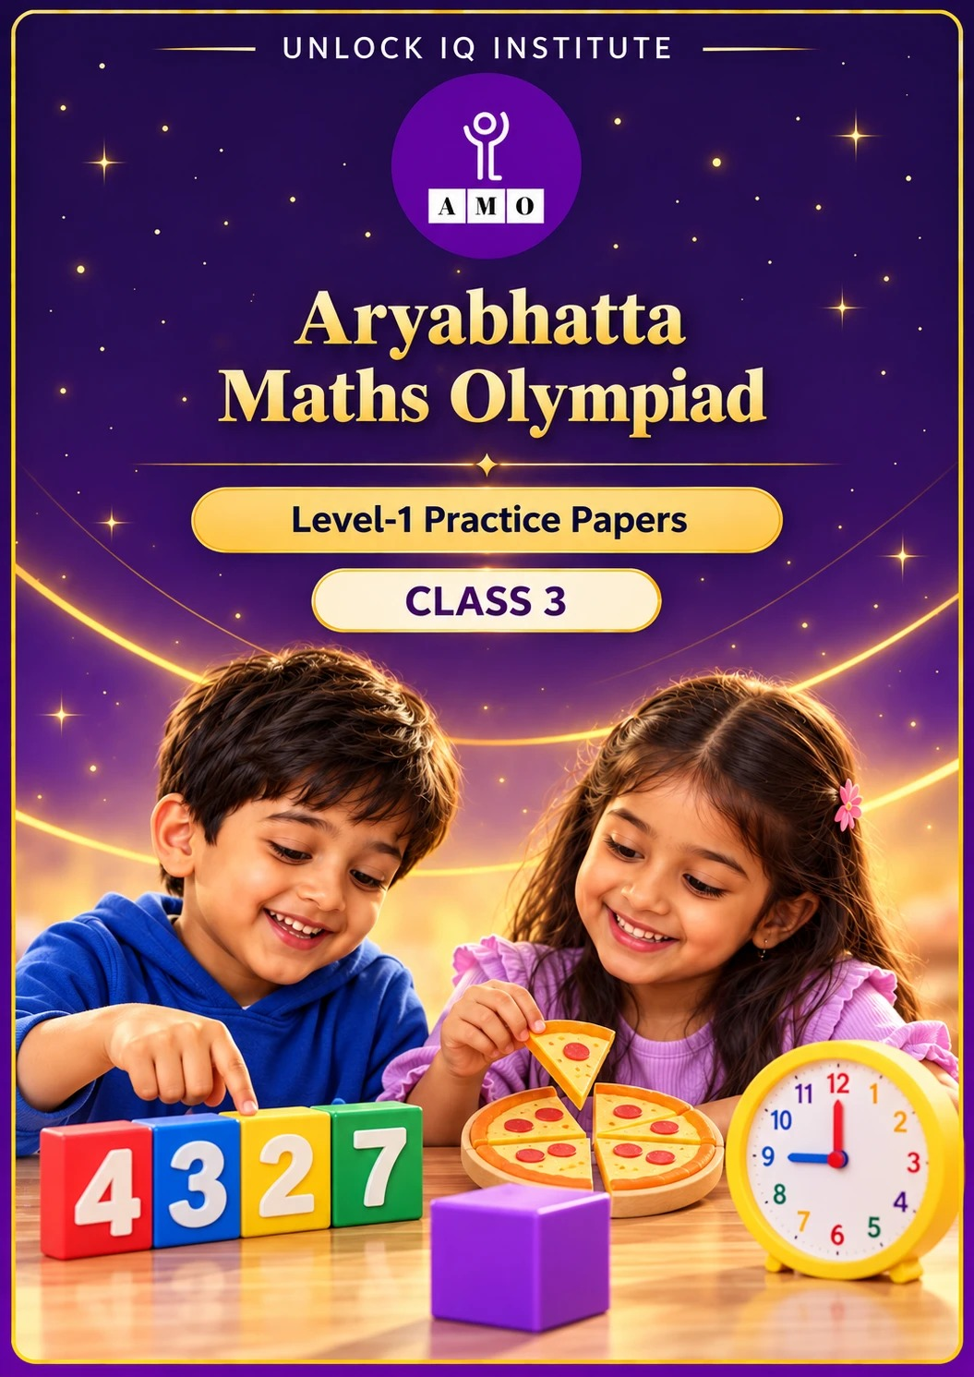
Five full practice papers · with answer keys & detailed solutions
Name: ____________________ | Class & Section: ________________
Roll No.: ________________ | School: ____________________
City: ____________________ | Date: ____________________

Published by Unlock IQ Institute Pvt. Ltd.
Register for Olympiads: www.aryabhattamathsolympiad.com/student-registration

ARYABHATTA MATHS OLYMPIAD
Level 1
PRACTICE PAPER-1
CLASS 3
Total Questions | 45 multiple-choice questions
Total Marks | 100
Time | 60 minutes
Section I | 40 questions × 2 marks = 80 marks
Section II | 5 Star Questions × 4 marks = 20 marks
Negative Marking | No negative marking
Calculator | Not allowed
Chapters | Number System · Operations · Fractions, Decimals & Percentages · Geometry · Mensuration · Applied Mathematics · Mathematical Reasoning

👋 Hello, friend! How to do this paper:
⭐ Every question has four answer choices: (A), (B), (C) and (D). Only one is correct.
⭐ Read each question and look at its picture carefully. Then mark your answer on the answer sheet at the end.
⭐ Section I has 40 questions of 2 marks each. Section II has 5 Star Questions of 4 marks each.
⭐ There is no negative marking, so try every question.
⭐ Do not use a calculator. You may do rough work on a separate sheet.
⭐ All figures are not necessarily drawn to scale unless stated.

For parents and teachers
• Print or view this paper in colour. Pictures are part of the questions.
• Parts follow the AMO syllabus chapters. Chapters 4, 7 and 8 are not part of the Class 3 syllabus, so the chapter numbers shown in the Part headings have gaps.
• The answer sheet and the answer key are at the end. Remove only the answer key before the child begins.

SECTION I 40 questions × 2 marks each
Part 1 — Number System (Syllabus Chapter 1)
Picture for Q1 and Q5
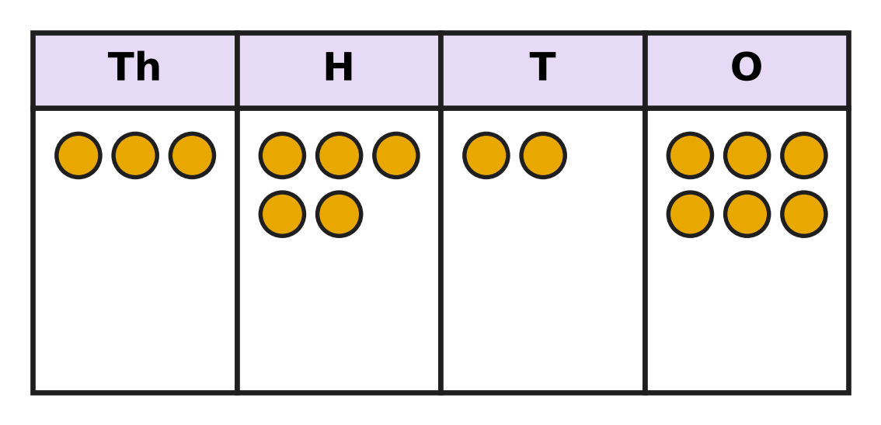
Q1. Look at the place-value chart. Each counter stands for one thousand, one hundred, one ten or one. Which sum is the same as the number on the chart?
(A) 3,000 + 500 + 20 + 6 | (B) 300 + 50 + 20 + 6
(C) 3 + 5 + 2 + 6 | (D) 3,000 + 50 + 20 + 6

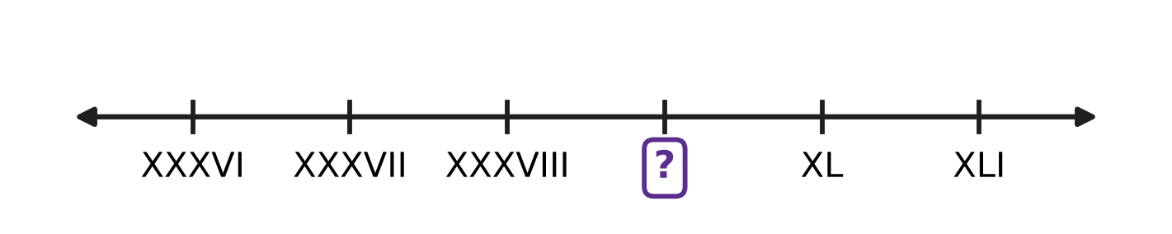
Q2. Look at the number line. The marks are labelled with Roman numerals, and each mark is one more than the mark before it. Which Roman numeral goes in the box?
(A) XXXX | (B) XXIX | (C) IXL | (D) XXXIX

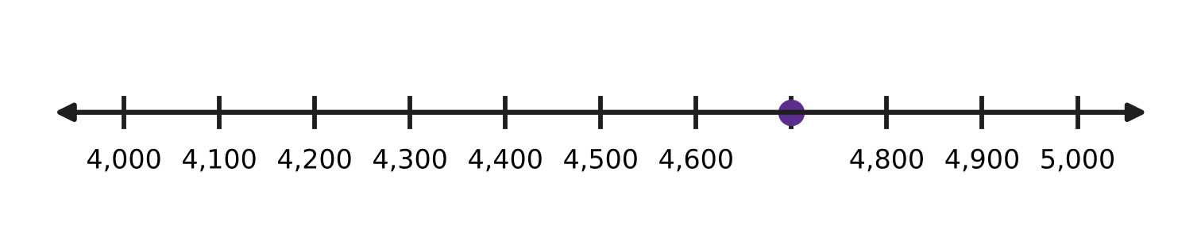
Q3. Look at the number line. The marks are equally spaced. Which number is at the dot?
(A) 4,700 | (B) 4,070 | (C) 4,600 | (D) 4,800

Apples picked in one week
Orchard | Apples picked
Hill Orchard | 3,907
River Orchard | 3,970
Lake Orchard | 3,790
Valley Orchard | 3,097

Q4. Use the table. Which orchard picked the most apples?
(A) Lake Orchard | (B) Hill Orchard
(C) Valley Orchard | (D) River Orchard

Picture for Q1 and Q5
Q5. Look at the place-value chart. Shreya moves one counter from the H column to the T column. By how much does the number become smaller?
(A) 90 | (B) 100 | (C) 10 | (D) 110

Q6. Reena writes the digits of 3,582 in the opposite order. What is the place value of the digit 8 in her new number?
(A) 8,000 | (B) 8 | (C) 800 | (D) 80

Part 2 — Operations & Number Properties (Syllabus Chapter 2)
Q7. To add 2,998 and 1,465, Ira first adds 3,000 and 1,465. Then she takes away 2. What is her answer?
(A) 4,467 | (B) 4,463 | (C) 3,463 | (D) 4,465

Q8. A farm has 3,040 hens and 1,785 ducks. How many more hens than ducks does it have?
(A) 1,355 | (B) 2,745 | (C) 4,825 | (D) 1,255

Q9. Madhu knows that 12 × 8 = 96. What is 12 × 9?
(A) 108 | (B) 105 | (C) 97 | (D) 104

Q10. There are 117 marbles. They are put equally into 9 glass jars. How many marbles are in each jar?
(A) 108 | (B) 14 | (C) 13 | (D) 12

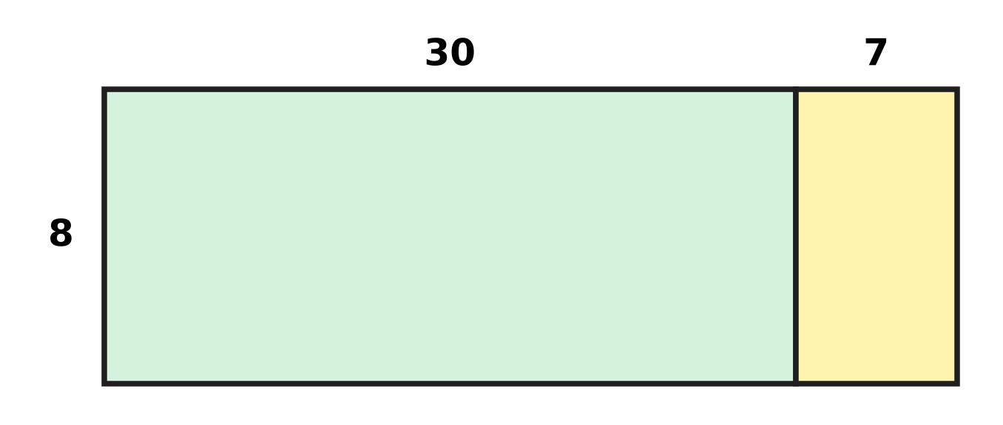
Q11. A garden bed has 8 rows with 37 plants in each row. The picture splits the bed into two parts. How many plants are there in all?
(A) 56 | (B) 296 | (C) 247 | (D) 286

Q12. A number is divided by 6. Which of these can NOT be the remainder?
(A) 1 | (B) 3 | (C) 5 | (D) 6

Q13. Farah has 6 sheets with 12 stamps on each sheet. She shares all the stamps equally among 8 pages of her album. How many stamps go on each page?
(A) 64 | (B) 26 | (C) 72 | (D) 9

Part 3 — Fractions, Decimals & Percentages (Syllabus Chapter 3)
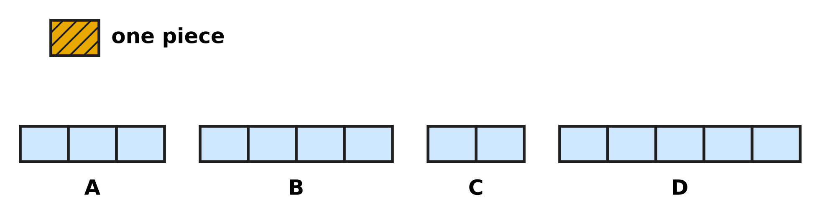
Q14. Look at the picture. The shaded piece at the top is $\frac{1}{4}$ of a whole bar. Each bar below is made of pieces of the same size. Which picture shows the whole bar?
(A) Picture A | (B) Picture B
(C) Picture C | (D) Picture D

Q15. An improper fraction has a top number equal to or bigger than its bottom number. How many of these five fractions are improper fractions?
$\frac{3}{7}$, $\frac{7}{3}$, $\frac{5}{5}$, $\frac{2}{9}$, $\frac{11}{10}$
(A) 1 | (B) 2 | (C) 3 | (D) 4

Q16. A rainwater tank is $\frac{7}{12}$ full. Water equal to $\frac{3}{12}$ of the tank is used for the garden. What fraction of the tank is full now?
(A) $\frac{4}{12}$ | (B) $\frac{10}{12}$ | (C) $\frac{3}{12}$ | (D) $\frac{4}{24}$

Q17. Four children read the same story book. Navya has read $\frac{5}{11}$ of it, Leo $\frac{9}{11}$, Bela $\frac{2}{11}$ and Chirag $\frac{7}{11}$. Who has read the second most?
(A) Chirag | (B) Bela | (C) Navya | (D) Leo

Q18. Mei and Kai bake with bags of flour of the same size. Mei uses $\frac{3}{8}$ of a bag for bread and $\frac{4}{8}$ of a bag for buns. Kai uses $\frac{6}{8}$ of a bag for cakes. Who uses more flour, and how much more?
(A) Mei, $\frac{7}{8}$ of a bag | (B) Kai, $\frac{3}{8}$ of a bag
(C) Kai, $\frac{2}{8}$ of a bag | (D) Mei, $\frac{1}{8}$ of a bag

Part 4 — Geometry (Syllabus Chapter 5)
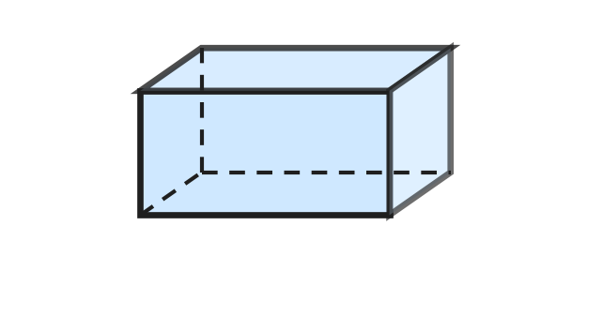
Q19. A cuboid box has 6 faces. Each face has one face opposite to it. How many pairs of opposite faces does the box have?
(A) 2 | (B) 3 | (C) 12 | (D) 6

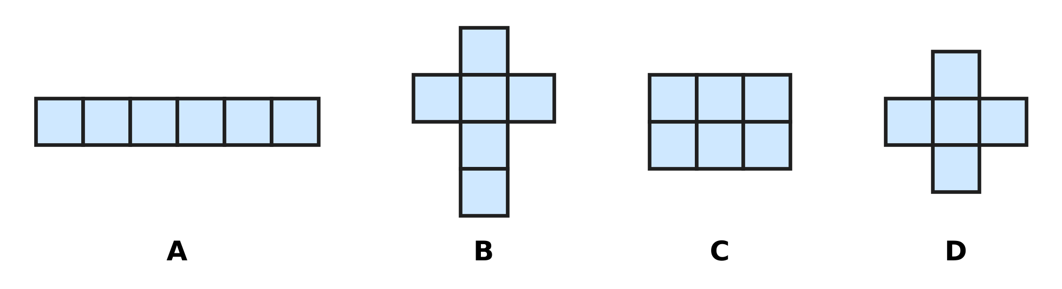
Q20. Look at the four drawings made of equal squares. Which one can be folded along its lines to make a closed cube?
(A) Picture A | (B) Picture B
(C) Picture C | (D) Picture D

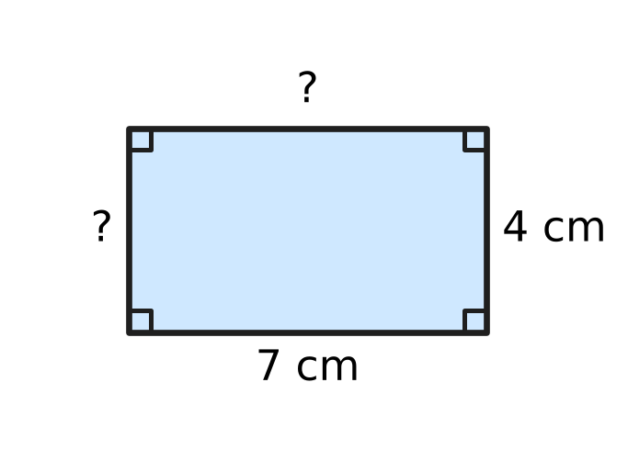
Q21. Look at the rectangle. Two of its sides are marked. How long are the other two sides?
(A) 11 cm and 3 cm | (B) 7 cm and 7 cm
(C) 7 cm and 4 cm | (D) 4 cm and 4 cm

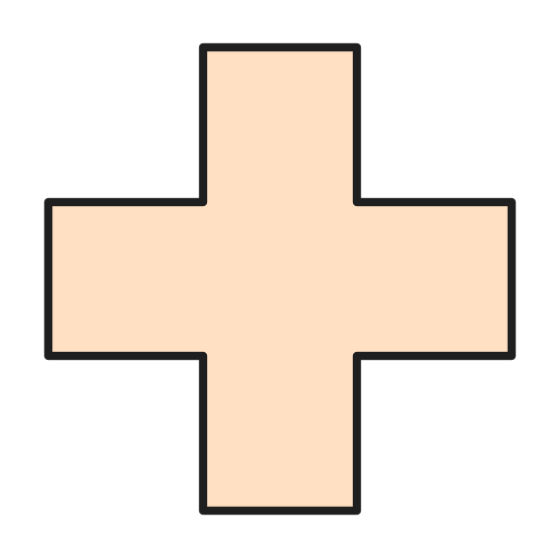
Q22. Look at the plus-shaped piece of paper. All its arms are the same size. How many lines of symmetry does it have?
(A) 2 | (B) 4 | (C) 1 | (D) 8

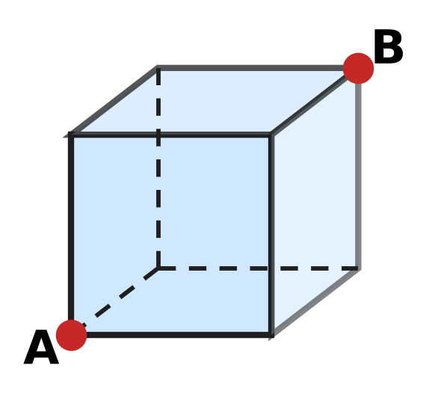
Q23. Look at the cube. An ant walks only along the edges of the cube, from corner A to corner B. What is the smallest number of edges it must walk along?
(A) 1 | (B) 2 | (C) 3 | (D) 4

Part 5 — Mensuration (Syllabus Chapter 6)
Q24. Viraj rides 2 km to school. Then he rides 500 m more to the park. How many metres does he ride in all?
(A) 2,050 m | (B) 502 m | (C) 2,500 m | (D) 700 m

Q25. Which of these is most likely to be the weight of one apple?
(A) 150 g | (B) 15 kg | (C) 1 g | (D) 150 kg

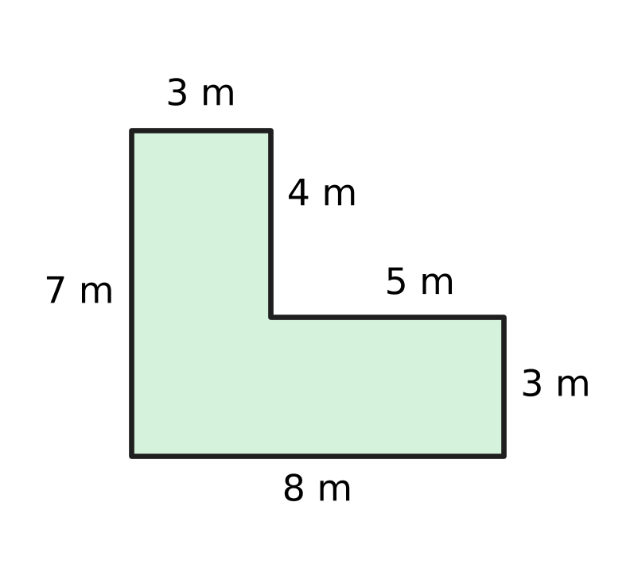
Q26. Look at the plan of a vegetable garden. A fence goes all the way round it. How long is the fence?
(A) 27 m | (B) 56 m | (C) 22 m | (D) 30 m

Q27. A swimming pool is 25 m long. Ishan has swum 8 lengths of the pool. How many more metres must he swim to complete 1 km?
(A) 975 m | (B) 992 m | (C) 200 m | (D) 800 m

Part 6 — Applied Mathematics (Syllabus Chapter 9)
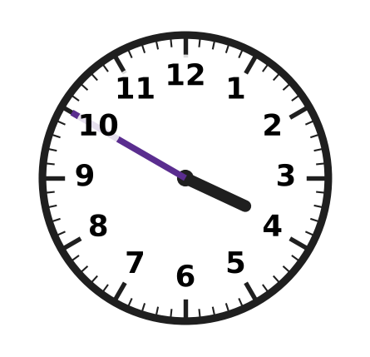
Q28. Look at the clock. Which is another way to say this time?
(A) 10 minutes to 3 | (B) 10 minutes to 4
(C) 50 minutes to 4 | (D) 10 minutes past 4

Q29. A film shown at school lasts 95 minutes. How long is that in hours and minutes?
(A) 9 hours 5 minutes | (B) 1 hour 5 minutes
(C) 1 hour 35 minutes | (D) 1 hour 45 minutes

Q30. The date 14 July is a Tuesday. Which of these dates in the same month is also a Tuesday?
(A) 28 July | (B) 22 July | (C) 20 July | (D) 30 July

Q31. Yuki pays exactly ₹360 using only ₹100, ₹50 and ₹10 notes. What is the smallest number of notes she can use?
(A) 9 | (B) 3 | (C) 5 | (D) 36

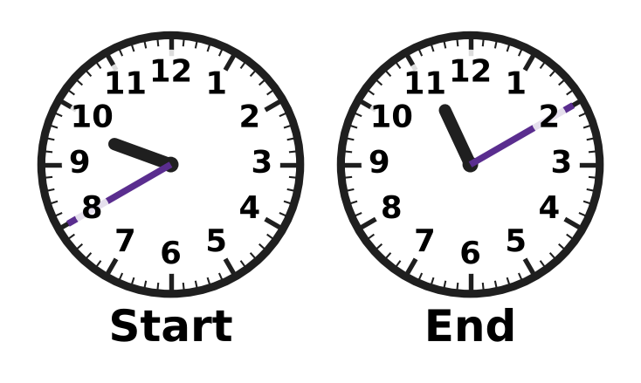
Q32. Look at the two clocks. They show when a bicycle trip starts and ends on the same morning. How long is the trip?
(A) 2 hours 10 minutes | (B) 1 hour 30 minutes
(C) 2 hours 30 minutes | (D) 1 hour 50 minutes

Q33. In a stationery shop, one pencil costs ₹6. A box of 10 pencils costs ₹50. Mona needs 10 pencils. How much money does she save by buying the box?
(A) ₹10 | (B) ₹5 | (C) ₹60 | (D) ₹44

Part 7 — Mathematical Reasoning & Problem-Solving (Syllabus Chapter 10)
Q34. Which number comes next in this pattern?
2, 6, 18, 54, ___
(A) 108 | (B) 90 | (C) 72 | (D) 162

Q35. AA is a 2-digit number with the same digit A in both places. AA + AA = 88. Which digit is A?
(A) 1 | (B) 2 | (C) 4 | (D) 8

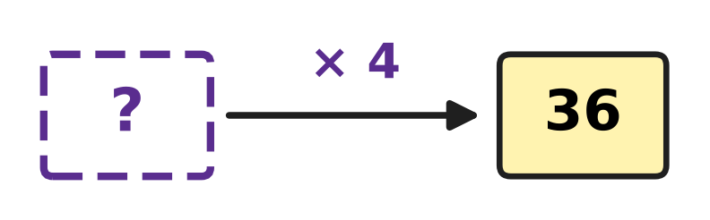
Q36. Look at the number machine. A number goes in at the "?". It is multiplied by 4 and 36 comes out. Which number went in?
(A) 32 | (B) 144 | (C) 9 | (D) 40

Q37. In this pattern, each number is the sum of the two numbers just before it. Which number comes next?
1, 3, 4, 7, 11, ___
(A) 15 | (B) 16 | (C) 22 | (D) 18

Q38. The pattern 4, 9, 14, 19, … goes on in the same way. Which number is the 8th number of the pattern?
(A) 40 | (B) 39 | (C) 34 | (D) 44

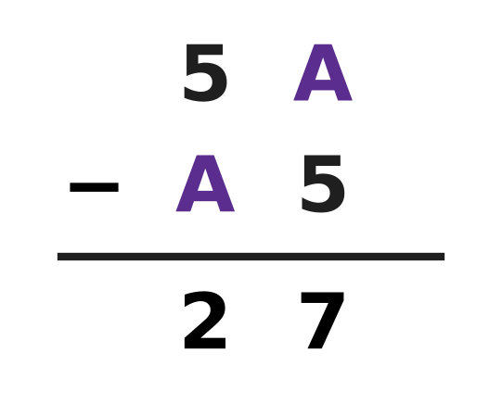
Q39. The picture shows one 2-digit number taken away from another. Each A stands for one and the same digit. Find A.
(A) 1 | (B) 2 | (C) 3 | (D) 7

Q40. A school bus starts with some children. At the first stop, 6 more get on. Then half of all the children get off, and 17 stay on. How many children were on the bus at the start?
(A) 28 | (B) 40 | (C) 34 | (D) 23

SECTION II — Star Questions 5 questions × 4 marks each
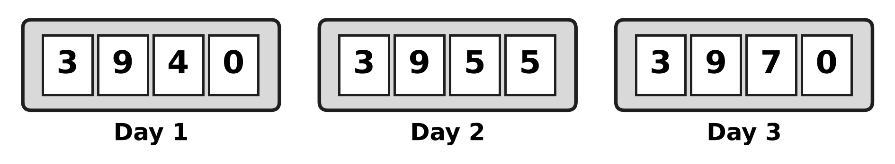
Q41. The pictures show the counter at a stadium gate at the end of Day 1, Day 2 and Day 3. It goes up by the same number every day. Which digit will be in the hundreds place at the end of Day 6? [4 marks]
(A) 4 | (B) 1 | (C) 0 | (D) 9

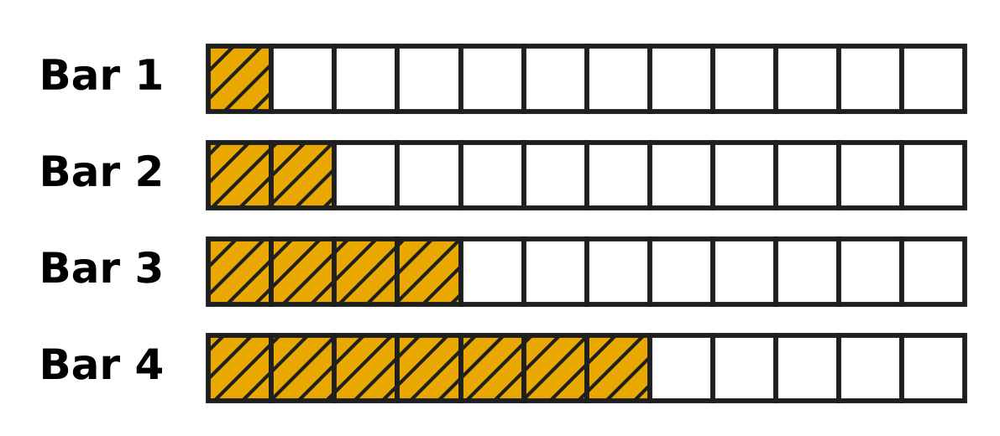
Q42. Look at the four bars. Each bar is cut into 12 equal parts. The shaded parts grow in a pattern, and the jump gets bigger by one each time. Bar 5 is made in the same way. What fraction of Bar 5 is NOT shaded? [4 marks]
(A) $\frac{11}{12}$ | (B) $\frac{1}{12}$ | (C) $\frac{2}{12}$ | (D) $\frac{5}{12}$

Q43. Ronak buys 6 pencils that cost ₹A each. The bill is ₹4A, a 2-digit amount with 4 tens and A ones. A is the same digit both times. He pays with a ₹100 note. How much change does he get? [4 marks]
(A) ₹52 | (B) ₹58 | (C) ₹48 | (D) ₹92

Q44. A library writes dates with the month as a Roman numeral, so 5-III means 5 March. Kartik borrows a book on 25-X. He must return it exactly 14 days later. How will the library write the return date? [4 marks]
(A) 8-IX | (B) 9-XI | (C) 39-X | (D) 8-XI

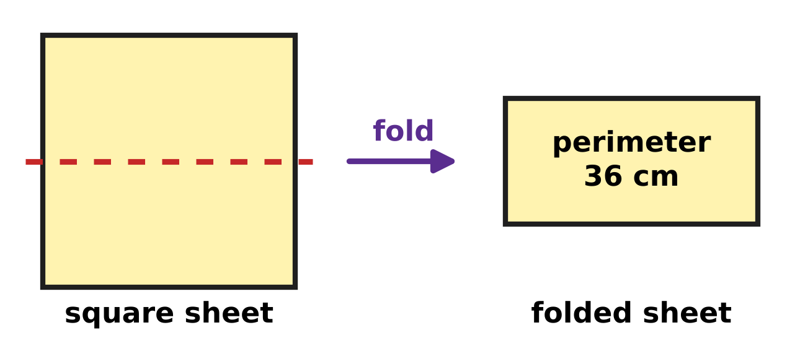
Q45. Jack folds a square sheet of paper in half along the dotted line, as in the picture. The folded rectangle has a perimeter of 36 cm. What is the perimeter of the square sheet? [4 marks]
(A) 72 cm | (B) 24 cm | (C) 48 cm | (D) 36 cm

Answer Sheet AMO Level 1 · Class 3 · Practice Paper 1
Name: | School: | Roll No.:
Shade or tick one circle for each question.
1. Ⓐ Ⓑ Ⓒ Ⓓ | 16. Ⓐ Ⓑ Ⓒ Ⓓ | 31. Ⓐ Ⓑ Ⓒ Ⓓ
2. Ⓐ Ⓑ Ⓒ Ⓓ | 17. Ⓐ Ⓑ Ⓒ Ⓓ | 32. Ⓐ Ⓑ Ⓒ Ⓓ
3. Ⓐ Ⓑ Ⓒ Ⓓ | 18. Ⓐ Ⓑ Ⓒ Ⓓ | 33. Ⓐ Ⓑ Ⓒ Ⓓ
4. Ⓐ Ⓑ Ⓒ Ⓓ | 19. Ⓐ Ⓑ Ⓒ Ⓓ | 34. Ⓐ Ⓑ Ⓒ Ⓓ
5. Ⓐ Ⓑ Ⓒ Ⓓ | 20. Ⓐ Ⓑ Ⓒ Ⓓ | 35. Ⓐ Ⓑ Ⓒ Ⓓ
6. Ⓐ Ⓑ Ⓒ Ⓓ | 21. Ⓐ Ⓑ Ⓒ Ⓓ | 36. Ⓐ Ⓑ Ⓒ Ⓓ
7. Ⓐ Ⓑ Ⓒ Ⓓ | 22. Ⓐ Ⓑ Ⓒ Ⓓ | 37. Ⓐ Ⓑ Ⓒ Ⓓ
8. Ⓐ Ⓑ Ⓒ Ⓓ | 23. Ⓐ Ⓑ Ⓒ Ⓓ | 38. Ⓐ Ⓑ Ⓒ Ⓓ
9. Ⓐ Ⓑ Ⓒ Ⓓ | 24. Ⓐ Ⓑ Ⓒ Ⓓ | 39. Ⓐ Ⓑ Ⓒ Ⓓ
10. Ⓐ Ⓑ Ⓒ Ⓓ | 25. Ⓐ Ⓑ Ⓒ Ⓓ | 40. Ⓐ Ⓑ Ⓒ Ⓓ
11. Ⓐ Ⓑ Ⓒ Ⓓ | 26. Ⓐ Ⓑ Ⓒ Ⓓ | 41. Ⓐ Ⓑ Ⓒ Ⓓ
12. Ⓐ Ⓑ Ⓒ Ⓓ | 27. Ⓐ Ⓑ Ⓒ Ⓓ | 42. Ⓐ Ⓑ Ⓒ Ⓓ
13. Ⓐ Ⓑ Ⓒ Ⓓ | 28. Ⓐ Ⓑ Ⓒ Ⓓ | 43. Ⓐ Ⓑ Ⓒ Ⓓ
14. Ⓐ Ⓑ Ⓒ Ⓓ | 29. Ⓐ Ⓑ Ⓒ Ⓓ | 44. Ⓐ Ⓑ Ⓒ Ⓓ
15. Ⓐ Ⓑ Ⓒ Ⓓ | 30. Ⓐ Ⓑ Ⓒ Ⓓ | 45. Ⓐ Ⓑ Ⓒ Ⓓ
Q41–Q45 are Section II Star Questions (4 marks each).
For the parent or teacher
Section I correct: ______ / 40 × 2 = ______ marks Section II correct: ______ / 5 × 4 = ______ marks
Correct: ______ / 45 Score: ______ / 100
Answer Key and Solutions AMO Level 1 · Class 3 · Practice Paper 1
Quick answers
1 A | 6 C | 11 B | 16 A | 21 C | 26 D | 31 C | 36 C | 41 C
2 D | 7 B | 12 D | 17 A | 22 B | 27 D | 32 B | 37 D | 42 B
3 A | 8 D | 13 D | 18 D | 23 C | 28 B | 33 A | 38 B | 43 A
4 D | 9 A | 14 B | 19 B | 24 C | 29 C | 34 D | 39 B | 44 D
5 A | 10 C | 15 C | 20 B | 25 A | 30 A | 35 C | 40 A | 45 C
Solutions
Q | Part · level | Answer | Why?
1 | Part 1 · Ch1 · Easy | (A) 3,000 + 500 + 20 + 6 | There are 3 thousands, 5 hundreds, 2 tens and 6 ones: 3,000 + 500 + 20 + 6 = 3,526.
2 | Part 1 · Ch1 · Easy | (D) XXXIX | The box is just before XL, which is 40. So it is 39. 39 = 30 + 9, written XXX and IX: XXXIX.
3 | Part 1 · Ch1 · Easy | (A) 4,700 | The marks go up by 100: 4,600 comes just before the dot and 4,800 just after it. So the dot is at 4,700.
4 | Part 1 · Ch1 · Easy | (D) River Orchard | All four numbers have 3 thousands. 3,907 and 3,970 have the most hundreds. Then 7 tens is more than 0 tens, so 3,970 is the greatest.
5 | Part 1 · Ch1 · Medium | (A) 90 | One hundred is taken away and one ten is added: 3,526 becomes 3,436. 100 − 10 = 90.
6 | Part 1 · Ch1 · Medium | (C) 800 | The new number is 2,853. In it, 8 is in the hundreds place, so its place value is 800.
7 | Part 2 · Ch2 · Easy | (B) 4,463 | 3,000 + 1,465 = 4,465. Taking away 2 gives 4,463, which is 2,998 + 1,465.
8 | Part 2 · Ch2 · Easy | (D) 1,255 | 3,040 − 1,785 = 1,255. Check: 1,255 + 1,785 = 3,040.
9 | Part 2 · Ch2 · Easy | (A) 108 | 12 × 9 is one more group of 12 than 12 × 8. 96 + 12 = 108.
10 | Part 2 · Ch2 · Easy | (C) 13 | 9 × 13 = 117, so 117 ÷ 9 = 13.
11 | Part 2 · Ch2 · Medium | (B) 296 | 8 × 30 = 240 and 8 × 7 = 56. 240 + 56 = 296.
12 | Part 2 · Ch2 · Medium | (D) 6 | A remainder is always smaller than the number we divide by. If 6 were left over, one more group of 6 could be made.
13 | Part 2 · Ch2 · Medium | (D) 9 | 6 × 12 = 72 stamps. 72 ÷ 8 = 9 stamps on each page.
14 | Part 3 · Ch3 · Easy | (B) Picture B | $\frac{1}{4}$ means the whole is cut into 4 equal parts. So 4 such pieces make the whole bar, and Picture B has 4 pieces.
15 | Part 3 · Ch3 · Easy | (C) 3 | A fraction is improper when the top number is equal to or bigger than the bottom number: $\frac{7}{3}$, $\frac{5}{5}$ and $\frac{11}{10}$.
16 | Part 3 · Ch3 · Easy | (A) $\frac{4}{12}$ | The bottom number stays the same. 7 − 3 = 4, so $\frac{4}{12}$ of the tank is full.
17 | Part 3 · Ch3 · Medium | (A) Chirag | The bottom numbers are the same, so compare the top numbers: 9, 7, 5, 2. The second greatest is $\frac{7}{11}$, read by Chirag.
18 | Part 3 · Ch3 · Medium | (D) Mei, 1/8 of a bag | Mei uses $\frac{3}{8}$ + $\frac{4}{8}$ = $\frac{7}{8}$ of a bag. Kai uses $\frac{6}{8}$. Mei uses more: $\frac{7}{8}$ − $\frac{6}{8}$ = $\frac{1}{8}$ of a bag.
19 | Part 4 · Ch5 · Easy | (B) 3 | The pairs are top and bottom, front and back, left and right. That is 3 pairs.
20 | Part 4 · Ch5 · Easy | (B) Picture B | A cube has 6 square faces. Picture B is a cross of 6 squares and closes into a cube. Pictures A and C overlap when folded, and Picture D has only 5 squares.
21 | Part 4 · Ch5 · Easy | (C) 7 cm and 4 cm | Opposite sides of a rectangle are equal. So the other two sides are 7 cm and 4 cm.
22 | Part 4 · Ch5 · Medium | (B) 4 | It can be folded up-and-down, across, and along two slanting lines through opposite inner corners. That is 4 lines of symmetry.
23 | Part 4 · Ch5 · Medium | (C) 3 | Each edge goes across, back or up. To reach B, the ant must go across, back and up once each, so it walks along 3 edges.
24 | Part 5 · Ch6 · Easy | (C) 2,500 m | 1 km = 1,000 m, so 2 km = 2,000 m. 2,000 m + 500 m = 2,500 m.
25 | Part 5 · Ch6 · Easy | (A) 150 g | Light things are weighed in grams. An apple weighs about 150 g. 1 g is far too light, and 15 kg and 150 kg are far too heavy.
26 | Part 5 · Ch6 · Medium | (D) 30 m | Add all six sides: 8 + 3 + 5 + 4 + 3 + 7 = 30 m.
27 | Part 5 · Ch6 · Medium | (D) 800 m | 8 × 25 = 200 m. 1 km = 1,000 m, and 1,000 − 200 = 800 m.
28 | Part 6 · Ch9 · Easy | (B) 10 minutes to 4 | The clock shows 3:50. From 3:50 to 4:00 is 10 minutes, so the time is 10 minutes to 4.
29 | Part 6 · Ch9 · Easy | (C) 1 hour 35 minutes | 1 hour = 60 minutes. 95 − 60 = 35, so 95 minutes is 1 hour 35 minutes.
30 | Part 6 · Ch9 · Easy | (A) 28 July | The same weekday comes back every 7 days: 14, 21, 28. So 28 July is a Tuesday.
31 | Part 6 · Ch9 · Easy | (C) 5 | Use the biggest notes first: 3 notes of ₹100, 1 note of ₹50 and 1 note of ₹10. 3 + 1 + 1 = 5 notes.
32 | Part 6 · Ch9 · Medium | (B) 1 hour 30 minutes | The trip starts at 9:40 and ends at 11:10. From 9:40 to 10:40 is 1 hour, and from 10:40 to 11:10 is 30 minutes.
33 | Part 6 · Ch9 · Medium | (A) ₹10 | 10 single pencils cost 10 × ₹6 = ₹60. The box costs ₹50. ₹60 − ₹50 = ₹10 saved.
34 | Part 7 · Ch10 · Easy | (D) 162 | Each number is 3 times the number before it: 2 × 3 = 6, 6 × 3 = 18, 18 × 3 = 54. Next is 54 × 3 = 162.
35 | Part 7 · Ch10 · Easy | (C) 4 | AA is half of 88, so AA = 44 and A = 4. Check: 44 + 44 = 88.
36 | Part 7 · Ch10 · Easy | (C) 9 | Work backwards: 36 ÷ 4 = 9. Check: 9 × 4 = 36.
37 | Part 7 · Ch10 · Easy | (D) 18 | Add the last two numbers: 7 + 11 = 18.
38 | Part 7 · Ch10 · Medium | (B) 39 | Each number is 5 more. The pattern is 4, 9, 14, 19, 24, 29, 34, 39. The 8th number is 39.
39 | Part 7 · Ch10 · Medium | (B) 2 | Try the digits: 52 − 25 = 27. No other digit works, so A = 2.
40 | Part 7 · Ch10 · Medium | (A) 28 | Work backwards: 17 is half, so there were 34 children before they got off. 34 − 6 = 28 at the start.
41 | Section II · Ch1 + Ch10 · Hard | (C) 0 | The counter goes up by 15 each day: 3,985 on Day 4, 4,000 on Day 5 and 4,015 on Day 6. In 4,015 the hundreds digit is 0.
42 | Section II · Ch3 + Ch10 · Hard | (B) $\frac{1}{12}$ | The shaded parts are 1, 2, 4, 7: the jumps are 1, 2, 3. The next jump is 4, so Bar 5 has 11 of 12 parts shaded. $\frac{12}{12}$ − $\frac{11}{12}$ = $\frac{1}{12}$ is not shaded.
43 | Section II · Ch9 + Ch10 · Hard | (A) ₹52 | 6 × 8 = 48, which has 4 tens and 8 ones, so A = 8 and the bill is ₹48. No other digit works. ₹100 − ₹48 = ₹52.
44 | Section II · Ch1 + Ch9 · Hard | (D) 8-XI | X is 10, so the book is borrowed on 25 October. October has 31 days: 6 days take us to 31 October and 8 more days to 8 November. November is month 11, written XI.
45 | Section II · Ch5 + Ch6 · Hard | (C) 48 cm | The rectangle is one side long and half a side wide, so its perimeter is 3 sides: 36 ÷ 3 = 12 cm. The square has 4 sides: 4 × 12 = 48 cm.

ARYABHATTA MATHS OLYMPIAD
Level 1
PRACTICE PAPER-2
CLASS 3
Total Questions | 45 multiple-choice questions
Total Marks | 100
Time | 60 minutes
Section I | 40 questions × 2 marks = 80 marks
Section II | 5 Star Questions × 4 marks = 20 marks
Negative Marking | No negative marking
Calculator | Not allowed
Chapters | Number System · Operations · Fractions, Decimals & Percentages · Geometry · Mensuration · Applied Mathematics · Mathematical Reasoning

👋 Hello, friend! How to do this paper:
⭐ Every question has four answer choices: (A), (B), (C) and (D). Only one is correct.
⭐ Read each question and look at its picture carefully. Then mark your answer on the answer sheet at the end.
⭐ Section I has 40 questions of 2 marks each. Section II has 5 Star Questions of 4 marks each.
⭐ There is no negative marking, so try every question.
⭐ Do not use a calculator. You may do rough work on a separate sheet.
⭐ All figures are not necessarily drawn to scale unless stated.

For parents and teachers
• Print or view this paper in colour. Pictures are part of the questions.
• Parts follow the AMO syllabus chapters. Chapters 4, 7 and 8 are not part of the Class 3 syllabus, so the chapter numbers shown in the Part headings have gaps.
• The answer sheet and the answer key are at the end. Remove only the answer key before the child begins.

SECTION I 40 questions × 2 marks each
Part 1 — Number System (Syllabus Chapter 1)
Q1. In the number Bina writes, the digit 4 has the place value 400 and the digit 7 has the place value 7. Which of these can be her number?
(A) 2,147 | (B) 2,417 | (C) 2,471 | (D) 4,217

Q2. On sports day, each runner wears a Roman numeral. Which of these runner numbers is even?
(A) XLI | (B) XXXV | (C) XXIII | (D) XVIII

Q3. Which number is 10 more than 3,995?
(A) 3,905 | (B) 4,005 | (C) 4,095 | (D) 4,995

Q4. Which of these numbers is greater than 6,050 but less than 6,500?
(A) 5,650 | (B) 6,005 | (C) 6,045 | (D) 6,405

Q5. Which of these is equal to XL?
(A) XXV + XXV | (B) XXX + XV
(C) L − V | (D) XXIV + XVI

Q6. Which is the smallest 4-digit number that has four different digits?
(A) 1,023 | (B) 1,032 | (C) 1,203 | (D) 1,234

Part 2 — Operations & Number Properties (Syllabus Chapter 2)
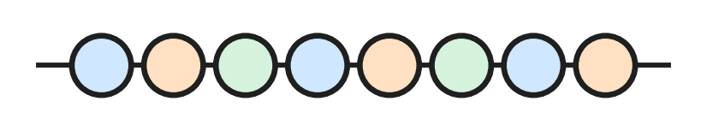
Q7. Look at the string of beads. Beads are sold only in full strings like this one. Which of these numbers of beads can Anya buy?
(A) 72 | (B) 76 | (C) 78 | (D) 82

Q8. A train carries 2,358 people on Saturday and 1,467 people on Sunday. How many people does it carry on the two days in all?
(A) 891 | (B) 3,715 | (C) 3,815 | (D) 3,825

Q9. Which of these is the same as 46 × 7?
(A) 40 × 7 + 6 × 7 | (B) 4 × 7 + 6 × 7
(C) 40 + 6 × 7 | (D) 40 × 7 + 6

Q10. Which of these divisions leaves a remainder?
(A) 50 ÷ 8 | (B) 48 ÷ 8 | (C) 54 ÷ 9 | (D) 56 ÷ 7

Q11. Which of these has the same answer as 4,000 − 1,865?
(A) 4,001 − 1,864 | (B) 4,000 − 1,864
(C) 3,999 − 1,864 | (D) 3,999 − 1,866

Q12. Jai has 47 small plants for the school garden. He puts 9 plants in each pot. How many more plants does he need to fill one more pot?
(A) 2 | (B) 5 | (C) 6 | (D) 7

Q13. A school hall has 12 rows of benches. Each row has 4 benches, and each bench seats 3 children. How many children can sit in the hall?
(A) 19 | (B) 36 | (C) 48 | (D) 144

Part 3 — Fractions, Decimals & Percentages (Syllabus Chapter 3)
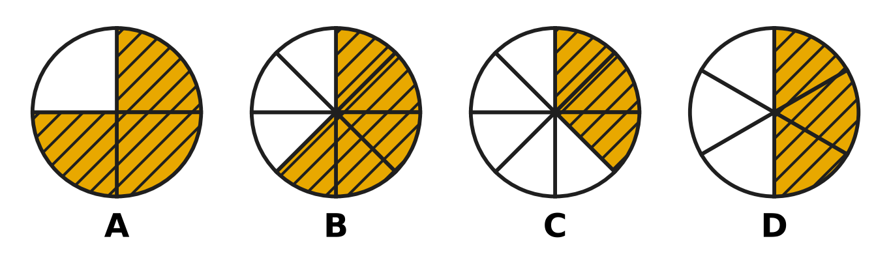
Q14. Look at the four circles. Each circle is cut into equal parts. Which picture has $\frac{3}{8}$ of the circle shaded?
(A) Picture A | (B) Picture B
(C) Picture C | (D) Picture D

Q15. Which of these fractions is greater than one whole?
(A) $\frac{1}{8}$ | (B) $\frac{8}{9}$ | (C) $\frac{8}{8}$ | (D) $\frac{9}{8}$

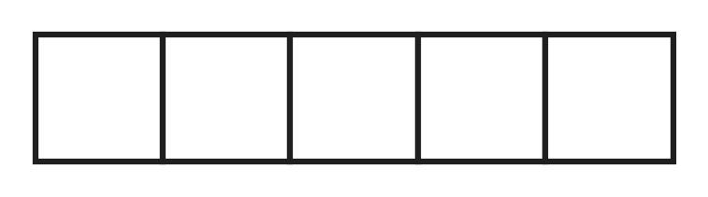
Q16. Look at the ribbon marked in 5 equal parts. Geeta uses $\frac{2}{5}$ of the ribbon for one gift and $\frac{1}{5}$ of it for another gift. What fraction of the ribbon does she use in all?
(A) $\frac{5}{3}$ | (B) $\frac{1}{5}$ | (C) $\frac{3}{10}$ | (D) $\frac{3}{5}$

Q17. Which of these has the greatest answer?
(A) $\frac{5}{12}$ + $\frac{3}{12}$ | (B) $\frac{10}{12}$ − $\frac{5}{12}$
(C) $\frac{2}{12}$ + $\frac{4}{12}$ | (D) $\frac{11}{12}$ − $\frac{4}{12}$

Q18. On sports day, Tejas runs $\frac{5}{8}$ of a round of the track. After a rest he runs $\frac{7}{8}$ of a round more. How much more than one full round does he run in all?
(A) $\frac{2}{8}$ | (B) $\frac{3}{8}$ | (C) $\frac{4}{8}$ | (D) $\frac{12}{8}$

Part 4 — Geometry (Syllabus Chapter 5)
Q19. The shoe box in the picture is a cuboid. Three of these numbers tell how many faces, edges and corners it has. Which number is NOT one of them? | 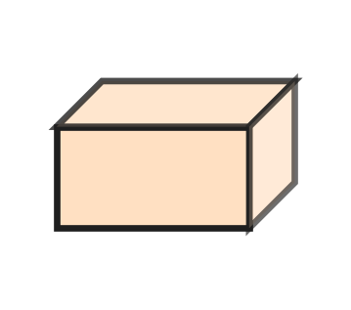
  (A) 5 | (B) 6 | (C) 8 | (D) 12

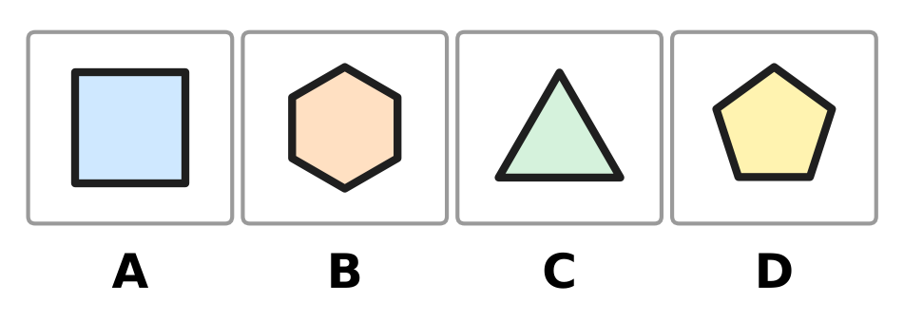
Q20. Look at the four shapes. Which shape has more sides than a pentagon?
(A) Picture A | (B) Picture B
(C) Picture C | (D) Picture D

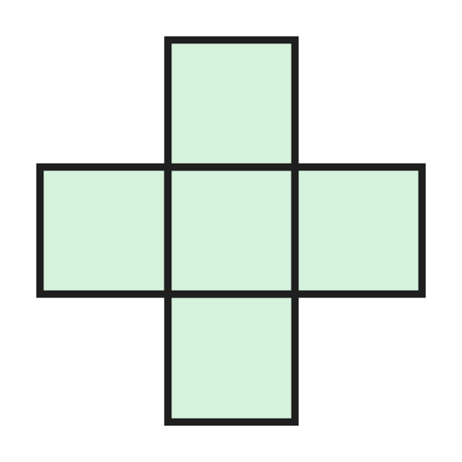
Q21. Luke folds the flat shape in the picture along its lines to make a box shaped like a cube. How many faces of the cube are missing?
(A) 1 | (B) 2 | (C) 3 | (D) 5

Q22. A toy is made by gluing the flat face of a cone onto a flat face of a cylinder, as in the picture. The two glued faces are the same size. How many flat faces does the toy have on the outside? | 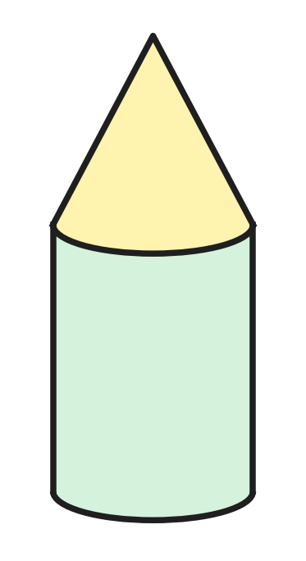
  (A) 0 | (B) 1 | (C) 2 | (D) 3

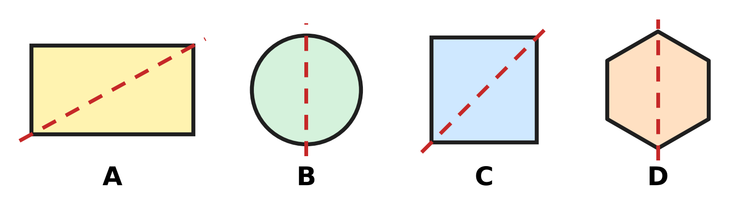
Q23. Look at the four shapes. Picture C is a square. Each shape is folded along its dotted line. In which picture do the two halves NOT lie exactly on each other?
(A) Picture A | (B) Picture B
(C) Picture C | (D) Picture D

Part 5 — Mensuration (Syllabus Chapter 6)
Q24. A jug holds 2 L 75 mL of juice. Which of these is the same amount?
(A) 275 mL | (B) 2,075 mL
(C) 2,705 mL | (D) 2,750 mL

Q25. A square picnic mat has sides of 3 m, as in the picture. Mahi sews a ribbon all round its edge. How long is the ribbon? | 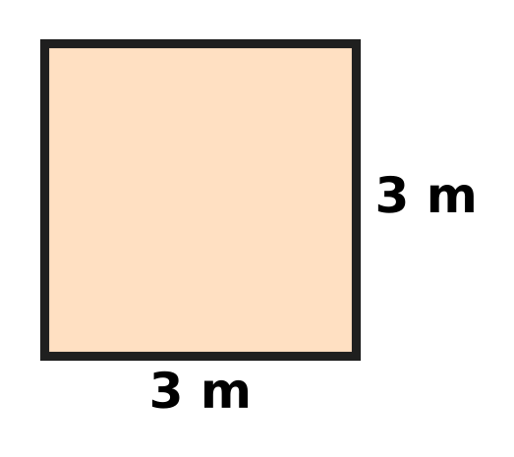
  (A) 3 m | (B) 6 m | (C) 9 m | (D) 12 m

Q26. A shoe rack has 3 shelves. Each shelf is 85 cm long. What is the total length of the shelves?
(A) 88 cm | (B) 2 m 55 cm
(C) 25 m 5 cm | (D) 2 m 5 cm

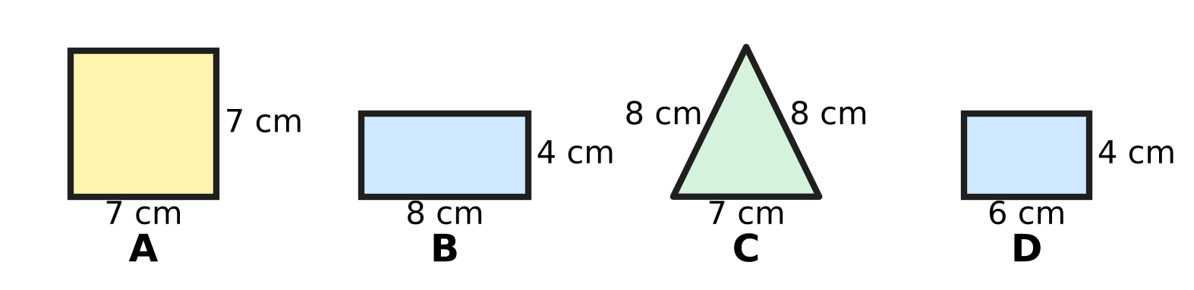
Q27. Look at the four shapes. Shape A is a square. Shape B and Shape D are rectangles. Which shape has a perimeter of exactly 24 cm?
(A) Shape A | (B) Shape B | (C) Shape C | (D) Shape D

Part 6 — Applied Mathematics (Syllabus Chapter 9)
Q28. Look at the clock. The school bell rang 10 minutes before the time on the clock. At what time did the bell ring? | 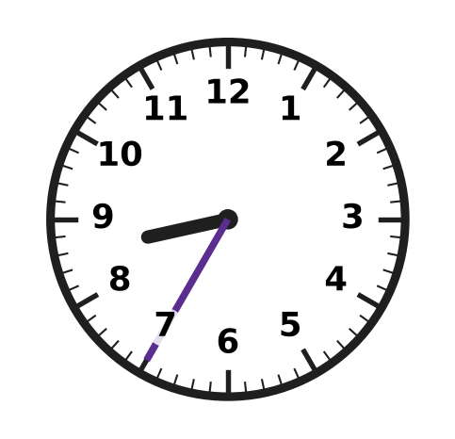
  (A) 7:25 | (B) 8:45 | (C) 8:25 | (D) 8:30

Q29. Look at the calendar. The circled date is Jaya's birthday. Her class picnic is 10 days after her birthday. On which day of the week is the picnic? | 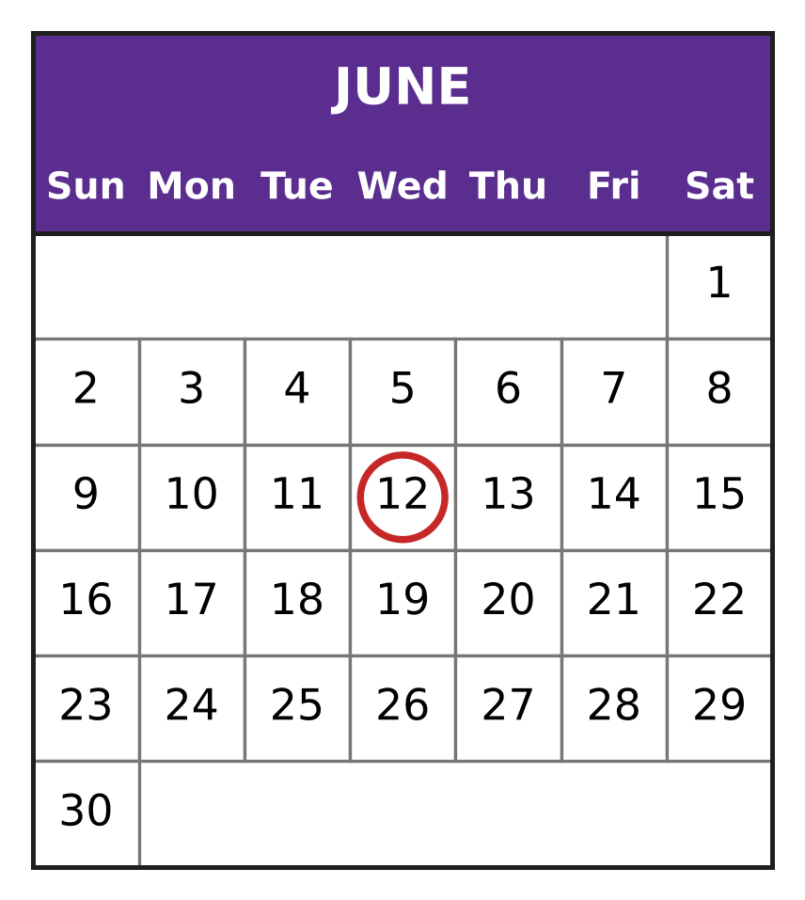
  (A) Thursday | (B) Friday
  (C) Saturday | (D) Sunday

Q30. A class reaches a picnic park at 9:25 AM. The children stay there for 2 hours 20 minutes. At what time do they leave?
(A) 11:45 AM | (B) 9:45 AM
(C) 11:05 AM | (D) 11:25 AM

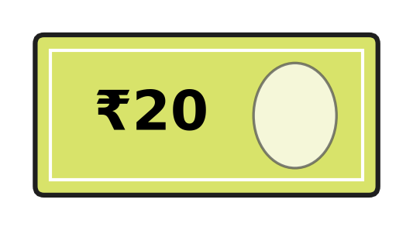
Q31. Zoe has only ₹20 notes like the one in the picture. She wants to pay with no change to be given back. Which of these amounts can she pay?
(A) ₹90 | (B) ₹110 | (C) ₹140 | (D) ₹150

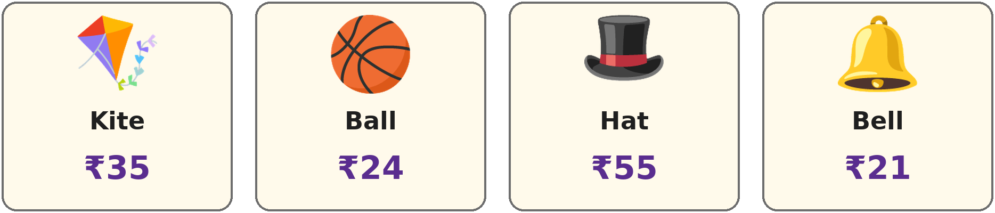
Q32. Look at the prices in a toy shop. Akash has ₹100. Which of these can he buy?
(A) 2 hats | (B) 3 kites | (C) 5 bells | (D) 4 balls

Q33. A month has 31 days. Its first day is a Friday. On which day of the week does the month end?
(A) Friday | (B) Saturday
(C) Sunday | (D) Monday

Part 7 — Mathematical Reasoning & Problem-Solving (Syllabus Chapter 10)
Q34. A number pattern starts with 400. Each number is half of the number before it. Which is the fourth number of the pattern?
(A) 25 | (B) 50 | (C) 100 | (D) 200

Q35. The letter A hides one digit. A × A = 49. What is A + A?
(A) 7 | (B) 14 | (C) 28 | (D) 98

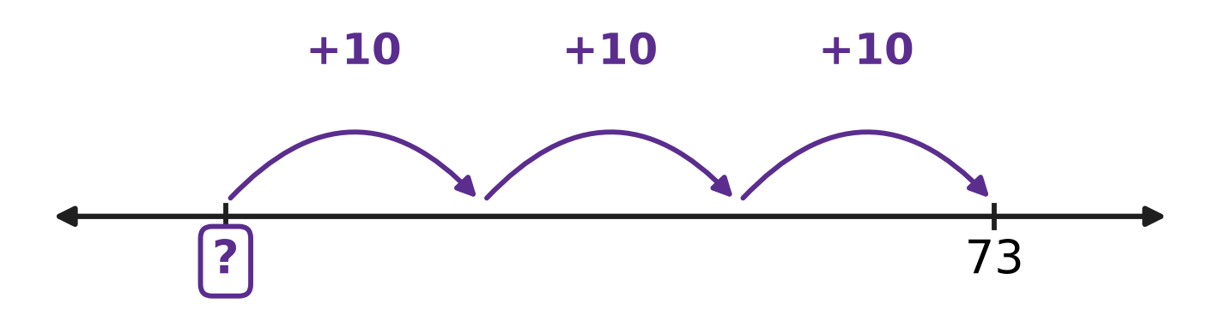
Q36. Look at the number line. Kush starts at a number and makes 3 hops of 10 forward. He lands on 73. At which number did he start?
(A) 43 | (B) 63 | (C) 70 | (D) 103

Q37. The pattern 7, 14, 21, 28 goes on in the same way. Which of these numbers will come in the pattern?
(A) 74 | (B) 81 | (C) 84 | (D) 90

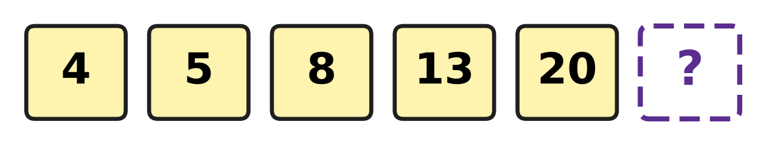
Q38. Look at the number cards. The jump from one card to the next grows by the same amount each time. Which number is on the last card?
(A) 27 | (B) 28 | (C) 29 | (D) 33

Q39. Each letter hides one digit. A + A = B and B + B = 16. Which digit does A hide?
(A) 2 | (B) 4 | (C) 6 | (D) 8

Q40. Some birds sit on a tree. Then 7 birds fly away. Next, more birds arrive, and the number of birds doubles to 26. How many birds were on the tree at first?
(A) 6 | (B) 13 | (C) 20 | (D) 33

SECTION II — Star Questions 5 questions × 4 marks each
Q41. Pavan takes a 4-digit number. First he adds 2 hundreds to it. Then he swaps the thousands digit and the ones digit of the answer, and he gets 7,461. Which number did he take? [4 marks]
(A) 1,267 | (B) 1,467 | (C) 1,667 | (D) 7,261

Q42. Look at the sum on the card. A hides the same digit both times. B is 1 more than A. The answer is $\frac{4}{9}$ more than one whole. Which digit is B? [4 marks] | 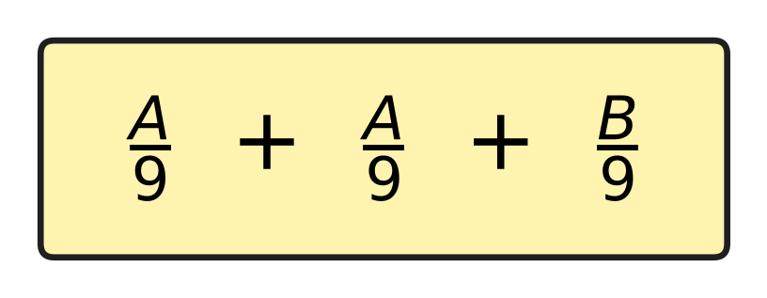
  (A) 2 | (B) 4 | (C) 5 | (D) 7

Q43. Trains leave a station every 40 minutes. The first train of the day leaves at 6:20 AM. Which of these is a time when a train leaves? [4 marks]
(A) 10:00 AM | (B) 10:40 AM
(C) 9:20 AM | (D) 9:40 AM

Q44. Veena saves money every Sunday, from Sunday 2 March to Sunday 4 May. She starts with an empty box. Each Sunday she puts one ₹100 note, one ₹10 note and one ₹1 coin into it. How much money is in the box after 4 May? [4 marks]
(A) ₹999 | (B) ₹1,000 | (C) ₹1,100 | (D) ₹1,110

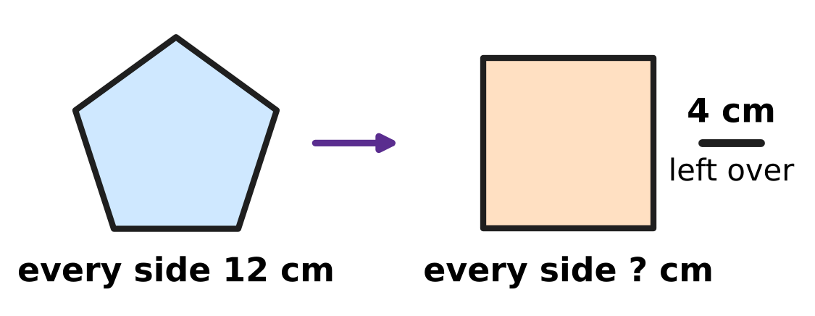
Q45. Look at the picture. A piece of wire is bent into a pentagon with every side 12 cm long. The same wire is then bent into a square, and 4 cm of wire is left over. How long is each side of the square? [4 marks]
(A) 12 cm | (B) 14 cm | (C) 15 cm | (D) 16 cm

Answer Sheet AMO Level 1 · Class 3 · Practice Paper 2
Name: | School: | Roll No.:
Shade or tick one circle for each question.
1. Ⓐ Ⓑ Ⓒ Ⓓ | 16. Ⓐ Ⓑ Ⓒ Ⓓ | 31. Ⓐ Ⓑ Ⓒ Ⓓ
2. Ⓐ Ⓑ Ⓒ Ⓓ | 17. Ⓐ Ⓑ Ⓒ Ⓓ | 32. Ⓐ Ⓑ Ⓒ Ⓓ
3. Ⓐ Ⓑ Ⓒ Ⓓ | 18. Ⓐ Ⓑ Ⓒ Ⓓ | 33. Ⓐ Ⓑ Ⓒ Ⓓ
4. Ⓐ Ⓑ Ⓒ Ⓓ | 19. Ⓐ Ⓑ Ⓒ Ⓓ | 34. Ⓐ Ⓑ Ⓒ Ⓓ
5. Ⓐ Ⓑ Ⓒ Ⓓ | 20. Ⓐ Ⓑ Ⓒ Ⓓ | 35. Ⓐ Ⓑ Ⓒ Ⓓ
6. Ⓐ Ⓑ Ⓒ Ⓓ | 21. Ⓐ Ⓑ Ⓒ Ⓓ | 36. Ⓐ Ⓑ Ⓒ Ⓓ
7. Ⓐ Ⓑ Ⓒ Ⓓ | 22. Ⓐ Ⓑ Ⓒ Ⓓ | 37. Ⓐ Ⓑ Ⓒ Ⓓ
8. Ⓐ Ⓑ Ⓒ Ⓓ | 23. Ⓐ Ⓑ Ⓒ Ⓓ | 38. Ⓐ Ⓑ Ⓒ Ⓓ
9. Ⓐ Ⓑ Ⓒ Ⓓ | 24. Ⓐ Ⓑ Ⓒ Ⓓ | 39. Ⓐ Ⓑ Ⓒ Ⓓ
10. Ⓐ Ⓑ Ⓒ Ⓓ | 25. Ⓐ Ⓑ Ⓒ Ⓓ | 40. Ⓐ Ⓑ Ⓒ Ⓓ
11. Ⓐ Ⓑ Ⓒ Ⓓ | 26. Ⓐ Ⓑ Ⓒ Ⓓ | 41. Ⓐ Ⓑ Ⓒ Ⓓ
12. Ⓐ Ⓑ Ⓒ Ⓓ | 27. Ⓐ Ⓑ Ⓒ Ⓓ | 42. Ⓐ Ⓑ Ⓒ Ⓓ
13. Ⓐ Ⓑ Ⓒ Ⓓ | 28. Ⓐ Ⓑ Ⓒ Ⓓ | 43. Ⓐ Ⓑ Ⓒ Ⓓ
14. Ⓐ Ⓑ Ⓒ Ⓓ | 29. Ⓐ Ⓑ Ⓒ Ⓓ | 44. Ⓐ Ⓑ Ⓒ Ⓓ
15. Ⓐ Ⓑ Ⓒ Ⓓ | 30. Ⓐ Ⓑ Ⓒ Ⓓ | 45. Ⓐ Ⓑ Ⓒ Ⓓ
Q41–Q45 are Section II Star Questions (4 marks each).
For the parent or teacher
Section I correct: ______ / 40 × 2 = ______ marks Section II correct: ______ / 5 × 4 = ______ marks
Correct: ______ / 45 Score: ______ / 100
Answer Key and Solutions AMO Level 1 · Class 3 · Practice Paper 2
Quick answers
1 B | 6 A | 11 C | 16 D | 21 A | 26 B | 31 C | 36 A | 41 A
2 D | 7 A | 12 D | 17 A | 22 B | 27 B | 32 D | 37 C | 42 C
3 B | 8 D | 13 D | 18 C | 23 A | 28 C | 33 C | 38 C | 43 D
4 D | 9 A | 14 C | 19 A | 24 B | 29 C | 34 B | 39 B | 44 D
5 D | 10 A | 15 D | 20 B | 25 D | 30 A | 35 B | 40 C | 45 B
Solutions
Q | Part · level | Answer | Why?
1 | Part 1 · Ch1 · Easy | (B) 2,417 | In 2,417 the digit 4 is in the hundreds place, so its place value is 400. The digit 7 is in the ones place, so its place value is 7.
2 | Part 1 · Ch1 · Easy | (D) XVIII | XVIII is 10 + 5 + 3 = 18, which is even. The others are 23, 35 and 41, which are odd.
3 | Part 1 · Ch1 · Easy | (B) 4,005 | The number 3,995 has 9 tens. One more ten makes 10 tens, which is 1 more hundred, and that makes 10 hundreds, which is 1 more thousand. The answer is 4,005.
4 | Part 1 · Ch1 · Easy | (D) 6,405 | The number 6,405 has 6 thousands and 4 hundreds. It is more than 6,050 and less than 6,500.
5 | Part 1 · Ch1 · Medium | (D) XXIV + XVI | XL means 10 less than 50, which is 40. XXIV is 24 and XVI is 16, and 24 + 16 = 40.
6 | Part 1 · Ch1 · Medium | (A) 1,023 | The thousands digit must be 1, the smallest digit that can come first. Then use the smallest digits left: 0, then 2, then 3. The number is 1,023.
7 | Part 2 · Ch2 · Easy | (A) 72 | One string has 8 beads. So 9 strings have 9 × 8 = 72 beads. The numbers 76, 78 and 82 are not in the table of 8.
8 | Part 2 · Ch2 · Easy | (D) 3,825 | Ones: 8 + 7 = 15, carry 1. Tens: 5 + 6 + 1 = 12, carry 1. Hundreds: 3 + 4 + 1 = 8. Thousands: 2 + 1 = 3. The total is 3,825.
9 | Part 2 · Ch2 · Easy | (A) 40 × 7 + 6 × 7 | The number 46 is 40 + 6. Multiply each part by 7 and add: 40 × 7 + 6 × 7 = 280 + 42 = 322.
10 | Part 2 · Ch2 · Easy | (A) 50 ÷ 8 | In the table of 8, 8 × 6 = 48 and 8 × 7 = 56, so 50 is not in it. So 50 ÷ 8 = 6 remainder 2.
11 | Part 2 · Ch2 · Medium | (C) 3,999 − 1,864 | If both numbers become 1 less, the difference stays the same. So 4,000 − 1,865 and 3,999 − 1,864 are both 2,135.
12 | Part 2 · Ch2 · Medium | (D) 7 | Here 47 ÷ 9 = 5 remainder 2. So 2 plants are left over, and a pot needs 9. He needs 9 − 2 = 7 more plants.
13 | Part 2 · Ch2 · Medium | (D) 144 | There are 12 × 4 = 48 benches. They seat 48 × 3 = 144 children.
14 | Part 3 · Ch3 · Easy | (C) Picture C | Picture C has 8 equal parts and 3 of them are shaded, which is $\frac{3}{8}$. Picture A shows $\frac{3}{4}$, Picture B shows $\frac{5}{8}$ and Picture D shows $\frac{3}{6}$.
15 | Part 3 · Ch3 · Easy | (D) $\frac{9}{8}$ | $\frac{8}{8}$ is one whole. $\frac{9}{8}$ has one more eighth, so it is greater than one whole.
16 | Part 3 · Ch3 · Easy | (D) $\frac{3}{5}$ | The bottom numbers are the same, so add the tops: 2 + 1 = 3. She uses $\frac{3}{5}$ of the ribbon.
17 | Part 3 · Ch3 · Medium | (A) 5/12 + 3/12 | The answers are $\frac{7}{12}$, $\frac{8}{12}$, $\frac{6}{12}$ and $\frac{5}{12}$. The greatest is $\frac{8}{12}$, from $\frac{5}{12}$ + $\frac{3}{12}$.
18 | Part 3 · Ch3 · Medium | (C) $\frac{4}{8}$ | He runs $\frac{5}{8}$ + $\frac{7}{8}$ = $\frac{12}{8}$ of a round. One full round is $\frac{8}{8}$. $\frac{12}{8}$ − $\frac{8}{8}$ = $\frac{4}{8}$ of a round more.
19 | Part 4 · Ch5 · Easy | (A) 5 | A cuboid has 6 faces, 12 edges and 8 corners. The number 5 is not one of these.
20 | Part 4 · Ch5 · Easy | (B) Picture B | A pentagon has 5 sides. Picture B is a hexagon with 6 sides, which is more than 5.
21 | Part 4 · Ch5 · Easy | (A) 1 | A cube has 6 faces. The flat shape has only 5 squares, so 6 − 5 = 1 face is missing. The box has no lid.
22 | Part 4 · Ch5 · Medium | (B) 1 | A cylinder has 2 flat faces and a cone has 1. One flat face of each is hidden where they are glued. So 2 + 1 − 2 = 1 flat face is left: the bottom.
23 | Part 4 · Ch5 · Medium | (A) Picture A | A rectangle that is not a square does not fold exactly along a corner-to-corner line: the corners do not meet. The square, the circle and the hexagon fold exactly along their dotted lines.
24 | Part 5 · Ch6 · Easy | (B) 2,075 mL | We know 1 L = 1,000 mL, so 2 L = 2,000 mL. Then 2,000 mL + 75 mL = 2,075 mL.
25 | Part 5 · Ch6 · Easy | (D) 12 m | The ribbon goes round all 4 equal sides. So it is 4 × 3 m = 12 m long.
26 | Part 5 · Ch6 · Medium | (B) 2 m 55 cm | The total is 3 × 85 cm = 255 cm. As 100 cm make 1 m, 255 cm = 2 m 55 cm.
27 | Part 5 · Ch6 · Medium | (B) Shape B | Rectangle B has sides 8 cm, 4 cm, 8 cm and 4 cm, so its perimeter is 8 + 4 + 8 + 4 = 24 cm. The other perimeters are 28 cm, 23 cm and 20 cm.
28 | Part 6 · Ch9 · Easy | (C) 8:25 | The clock shows 8:35. Ten minutes earlier the long hand was two numbers back, at 5. So the bell rang at 8:25.
29 | Part 6 · Ch9 · Easy | (C) Saturday | The birthday is on 12 June. Ten days later is 22 June, and the calendar shows that 22 June is a Saturday.
30 | Part 6 · Ch9 · Easy | (A) 11:45 AM | Two hours after 9:25 AM is 11:25 AM. Then 20 minutes more is 11:45 AM.
31 | Part 6 · Ch9 · Easy | (C) ₹140 | Seven notes of ₹20 make 7 × 20 = ₹140. The amounts ₹90, ₹110 and ₹150 need a ₹10 as well.
32 | Part 6 · Ch9 · Medium | (D) 4 balls | Four balls cost 4 × ₹24 = ₹96, which is less than ₹100. Three kites cost ₹105, 2 hats ₹110 and 5 bells ₹105, which are all more than ₹100.
33 | Part 6 · Ch9 · Medium | (C) Sunday | The 1st, 8th, 15th, 22nd and 29th are Fridays. Then the 30th is a Saturday and the 31st is a Sunday.
34 | Part 7 · Ch10 · Easy | (B) 50 | The pattern is 400, 200, 100, 50. The fourth number is 50.
35 | Part 7 · Ch10 · Easy | (B) 14 | Since 7 × 7 = 49, A = 7. Then A + A = 7 + 7 = 14.
36 | Part 7 · Ch10 · Easy | (A) 43 | Go back the 3 hops of 10: 73, 63, 53, 43. He started at 43.
37 | Part 7 · Ch10 · Easy | (C) 84 | Every number in the pattern is in the table of 7. As 12 × 7 = 84, the number 84 will come. The numbers 74, 81 and 90 are not in the table of 7.
38 | Part 7 · Ch10 · Medium | (C) 29 | The jumps are 1, 3, 5, 7. Each jump is 2 more than the one before, so the next jump is 9. The last card is 20 + 9 = 29.
39 | Part 7 · Ch10 · Medium | (B) 4 | B + B = 16, so B = 8. Then A + A = 8, so A = 4.
40 | Part 7 · Ch10 · Medium | (C) 20 | Work backwards. Before doubling there were 26 ÷ 2 = 13 birds. Before the 7 birds flew away there were 13 + 7 = 20 birds.
41 | Section II · Ch1 + Ch10 · Hard | (A) 1,267 | Work backwards. Swap the thousands digit and the ones digit of 7,461 to get 1,467. Then take away the 2 hundreds: 1,467 − 200 = 1,267.
42 | Section II · Ch3 + Ch10 · Hard | (C) 5 | One whole is $\frac{9}{9}$, so the sum is $\frac{13}{9}$ and A + A + B = 13. B is A + 1, so three A's and 1 make 13: A = 4 and B = 5.
43 | Section II · Ch9 + Ch10 · Hard | (D) 9:40 AM | The trains leave at 6:20, 7:00, 7:40, 8:20, 9:00, 9:40, 10:20 and so on. Of the four times, only 9:40 AM is in this list.
44 | Section II · Ch1 + Ch9 · Hard | (D) ₹1,110 | March has 31 days, so the Sundays are 2, 9, 16, 23, 30 March, 6, 13, 20, 27 April and 4 May: 10 Sundays. She puts in 10 × ₹100 + 10 × ₹10 + 10 × ₹1 = ₹1,000 + ₹100 + ₹10 = ₹1,110.
45 | Section II · Ch5 + Ch6 · Hard | (B) 14 cm | A pentagon has 5 sides, so the wire is 5 × 12 = 60 cm. Take away the 4 cm left over: 56 cm. A square has 4 equal sides, so each is 56 ÷ 4 = 14 cm.

ARYABHATTA MATHS OLYMPIAD
Level 1
PRACTICE PAPER-3
CLASS 3
Total Questions | 45 multiple-choice questions
Total Marks | 100
Time | 60 minutes
Section I | 40 questions × 2 marks = 80 marks
Section II | 5 Star Questions × 4 marks = 20 marks
Negative Marking | No negative marking
Calculator | Not allowed
Chapters | Number System · Operations · Fractions, Decimals & Percentages · Geometry · Mensuration · Applied Mathematics · Mathematical Reasoning

👋 Hello, friend! How to do this paper:
⭐ Every question has four answer choices: (A), (B), (C) and (D). Only one is correct.
⭐ Read each question and look at its picture carefully. Then mark your answer on the answer sheet at the end.
⭐ Section I has 40 questions of 2 marks each. Section II has 5 Star Questions of 4 marks each.
⭐ There is no negative marking, so try every question.
⭐ Do not use a calculator. You may do rough work on a separate sheet.
⭐ All figures are not necessarily drawn to scale unless stated.

For parents and teachers
• Print or view this paper in colour. Pictures are part of the questions.
• Parts follow the AMO syllabus chapters. Chapters 4, 7 and 8 are not part of the Class 3 syllabus, so the chapter numbers shown in the Part headings have gaps.
• The answer sheet and the answer key are at the end. Remove only the answer key before the child begins.

SECTION I 40 questions × 2 marks each
Part 1 — Number System (Syllabus Chapter 1)
Q1. Charu writes the number "four thousand six" in figures. How many zeros does she write?
(A) 0 | (B) 1 | (C) 2 | (D) 3

Q2. In 5,273, which digit has the place value 200?
(A) 5 | (B) 7 | (C) 3 | (D) 2

Q3. A card in a board game shows the Roman numeral XLVI. Which number is this?
(A) 64 | (B) 44 | (C) 66 | (D) 46

Q4. These numbers are in order, smallest first. Which number can fill the blank?
7,480, 7,495, ___, 7,520
(A) 7,508 | (B) 7,525 | (C) 7,058 | (D) 7,490

Q5. How many different 4-digit numbers have 9 thousands, 9 hundreds and 9 tens?
(A) 1 | (B) 9 | (C) 10 | (D) 27

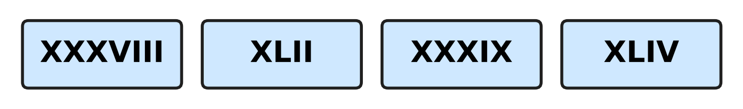
Q6. Look at the four cards. Which Roman numeral stands for the greatest number?
(A) XXXVIII | (B) XLIV | (C) XXXIX | (D) XLII

Part 2 — Operations & Number Properties (Syllabus Chapter 2)
Q7. Workers pick 3,468 mangoes on Monday and 2,754 mangoes on Tuesday. How many mangoes do they pick in all?
(A) 5,112 | (B) 6,122 | (C) 6,212 | (D) 6,222

Q8. A museum prints 8,000 tickets. It sells 5,364 of them. How many tickets are left?
(A) 2,636 | (B) 2,746 | (C) 3,364 | (D) 3,636

Q9. Which number fills the blank?
7 × ___ = 84
(A) 13 | (B) 77 | (C) 11 | (D) 12

Q10. Which number fills the blank?
47 ÷ 6 = 7 remainder ___
(A) 5 | (B) 6 | (C) 42 | (D) 1

Q11. A two-digit number has 4 as its tens digit. When it is multiplied by 6, the answer is 258. What is its ones digit?
(A) 2 | (B) 3 | (C) 8 | (D) 4

Q12. A postman has 8 bundles of 26 letters each. He delivers 120 letters. How many letters does he still have?
(A) 88 | (B) 98 | (C) 208 | (D) 328

Q13. Ken packs paper planes in boxes of 6. He fills some boxes and has 4 planes left over. He folds 2 more planes and packs again. How many planes are left over now?
(A) 0 | (B) 2 | (C) 4 | (D) 6

Part 3 — Fractions, Decimals & Percentages (Syllabus Chapter 3)
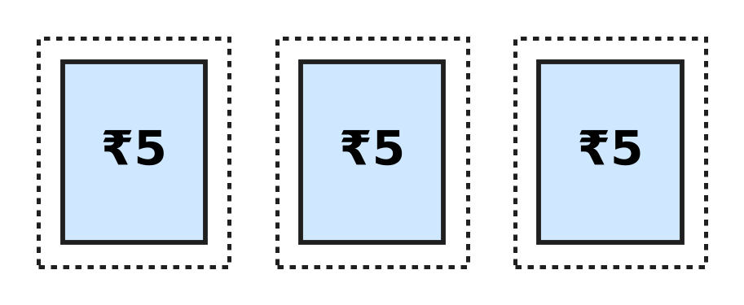
Q14. Vidya tears the 3 stamps in the picture off a full sheet. All the stamps on the sheet are the same size. These 3 stamps are $\frac{3}{10}$ of the full sheet. How many stamps were on the full sheet?
(A) 7 | (B) 10 | (C) 13 | (D) 30

Q15. A fraction is improper when its top number is equal to or bigger than its bottom number. Which is the smallest improper fraction with 9 as its bottom number?
(A) $\frac{1}{9}$ | (B) $\frac{9}{9}$ | (C) $\frac{8}{9}$ | (D) $\frac{10}{9}$

Q16. Which fraction fills the blank?
$\frac{11}{12}$ − ___ = $\frac{4}{12}$
(A) $\frac{15}{12}$ | (B) $\frac{8}{12}$ | (C) $\frac{4}{12}$ | (D) $\frac{7}{12}$

Q17. Which fraction fills the blank?
1 whole − ___ = $\frac{5}{11}$
(A) $\frac{6}{11}$ | (B) $\frac{5}{11}$ | (C) $\frac{11}{11}$ | (D) $\frac{4}{11}$

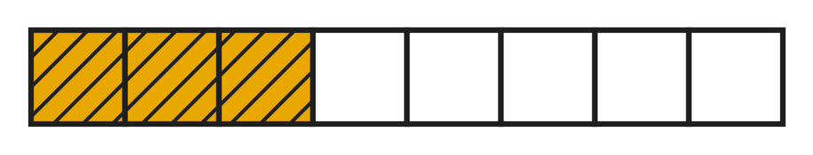
Q18. The shaded part of the bar in the picture shows how much of a honey jar the bees fill on Monday. On Tuesday they fill $\frac{2}{8}$ of the jar more than on Monday. How much of the jar do they fill in the two days together?
(A) $\frac{8}{8}$ | (B) $\frac{6}{8}$ | (C) $\frac{7}{8}$ | (D) $\frac{5}{8}$

Part 4 — Geometry (Syllabus Chapter 5)
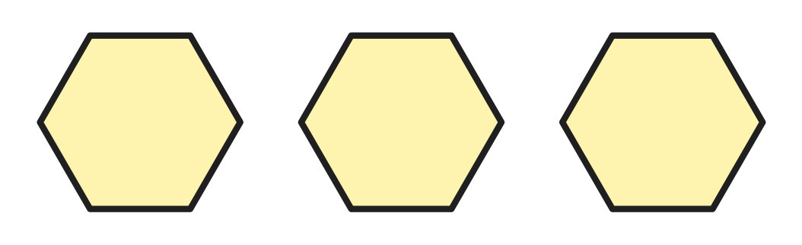
Q19. Rhea cuts the 3 separate hexagons in the picture out of card. How many corners do they have in all?
(A) 6 | (B) 15 | (C) 18 | (D) 24

Q20. Which number fills the blank?
A cube has 6 faces, 8 corners and ___ edges.
(A) 14 | (B) 12 | (C) 10 | (D) 16

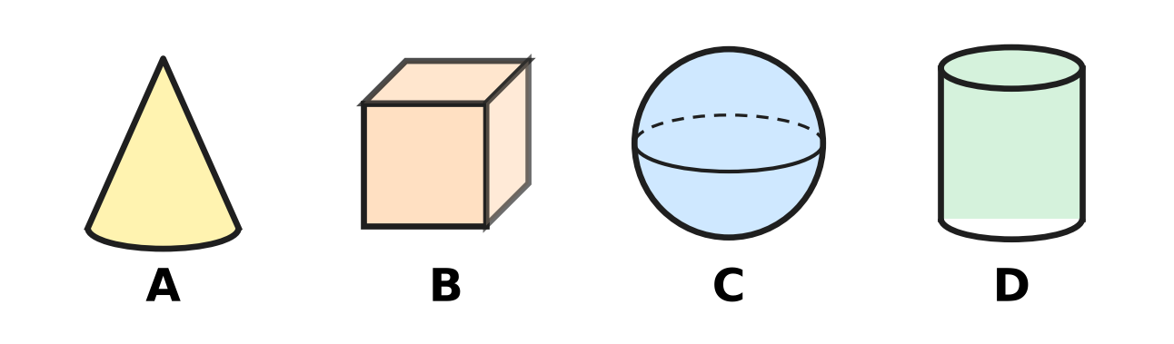
Q21. Which picture shows a solid with 2 flat faces and 1 curved face?
(A) Picture A | (B) Picture B
(C) Picture C | (D) Picture D

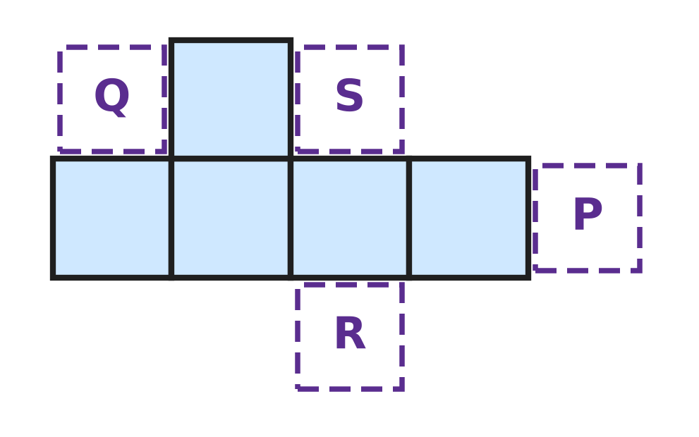
Q22. The 5 shaded squares in the figure are part of the net of a cube. One more square is added at P, Q, R or S. Which place gives a net that folds into a cube?
(A) P | (B) Q | (C) R | (D) S

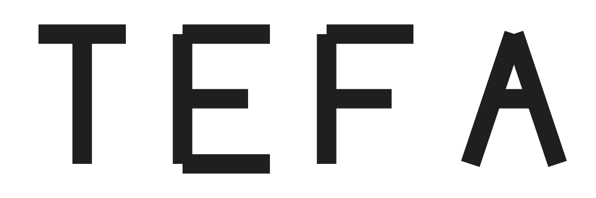
Q23. Kavin cuts the four capital letters in the picture out of card. Which letter has NO line of symmetry?
(A) T | (B) E | (C) F | (D) A

Part 5 — Mensuration (Syllabus Chapter 6)
Q24. Which number fills the blank?
407 cm = 4 m ___ cm
(A) 70 | (B) 47 | (C) 3 | (D) 7

Q25. A sack holds 2 kg 300 g of grain. How many more grams of grain are needed to make 3 kg?
(A) 70 g | (B) 300 g | (C) 700 g | (D) 1,700 g

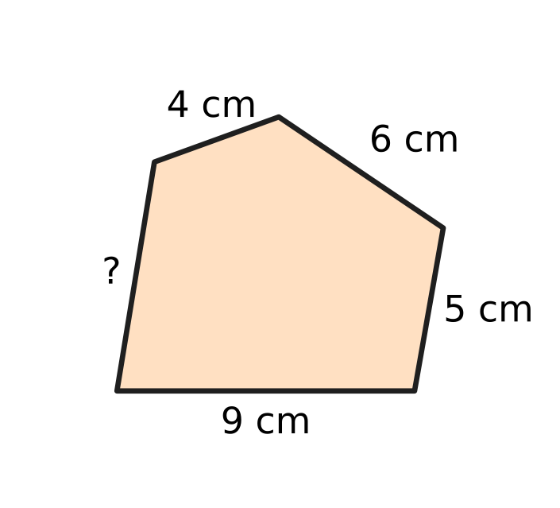
Q26. The perimeter of the five-sided shape in the figure is 31 cm. How long is the side marked "?"
(A) 5 cm | (B) 7 cm | (C) 24 cm | (D) 55 cm

Q27. A clay pot holds 3 L of water. Juhi pours out 750 mL, two times. How much water is left in the pot?
(A) 1 L 500 mL | (B) 2 L 250 mL
(C) 750 mL | (D) 1 L 750 mL

Part 6 — Applied Mathematics (Syllabus Chapter 9)
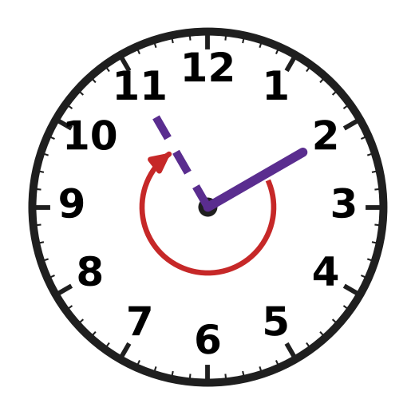
Q28. Only the minute hand is shown on the clock. It moves from the 2 to the 11, as the arrow shows. How many minutes go by?
(A) 9 minutes | (B) 40 minutes
(C) 45 minutes | (D) 55 minutes

Q29. Running practice on the school track starts at 4:45 PM and ends at 6:10 PM. How long does the practice last?
(A) 1 hour 15 minutes | (B) 1 hour 25 minutes
(C) 1 hour 35 minutes | (D) 2 hours 35 minutes

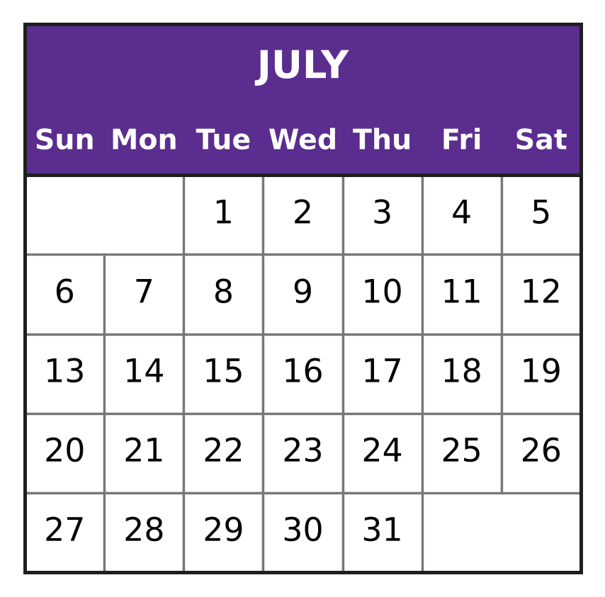
Q30. Look at the calendar. A boat fair at the harbour starts on 9 July. It ends 11 days later. On which date does it end?
(A) 18 July | (B) 19 July | (C) 20 July | (D) 21 July

Q31. One bus ticket costs ₹12. Lalit has ₹99. What is the greatest number of tickets he can buy?
(A) 10 | (B) 7 | (C) 8 | (D) 9

Q32. Vishal plants a mango seed on 22 August. The seed sprouts on 6 September. How many days after planting does it sprout?
(A) 16 days | (B) 28 days | (C) 14 days | (D) 15 days

Q33. On a museum visit, Avni buys 3 guidebooks of the same price. She pays ₹500 and gets ₹140 back. What is the price of one guidebook?
(A) ₹120 | (B) ₹140 | (C) ₹180 | (D) ₹360

Part 7 — Mathematical Reasoning & Problem-Solving (Syllabus Chapter 10)
Q34. In the sum 1A + A = 24, the letter A stands for the same digit both times. Here 1A is a two-digit number. Which digit is A?
(A) 7 | (B) 6 | (C) 4 | (D) 2

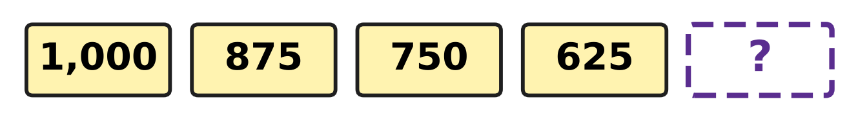
Q35. Look at the number pattern in the picture. Which number goes in the box?
(A) 475 | (B) 500 | (C) 525 | (D) 600

Q36. A wall clock shop sells half of its clocks in a sale. There are 18 clocks left. How many clocks did the shop have before the sale?
(A) 9 | (B) 20 | (C) 27 | (D) 36

Q37. The same rule takes each number in the picture to the next one. Which number is hidden? | 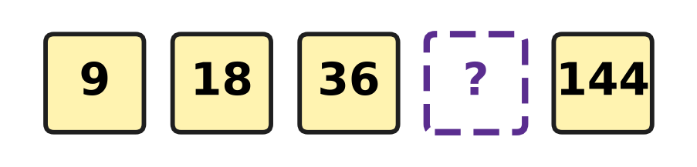
  (A) 54 | (B) 45 | (C) 72 | (D) 90

Q38. The letters A and B hide two digits. A + B = 11 and A − B = 5. Which digit does A hide?
(A) 3 | (B) 5 | (C) 6 | (D) 8

Q39. Nirav has some coins in his piggy bank. He doubles them, then spends 6 coins and then gets 10 more. Now he has 40 coins. How many coins did he have at first?
(A) 18 | (B) 22 | (C) 36 | (D) 72

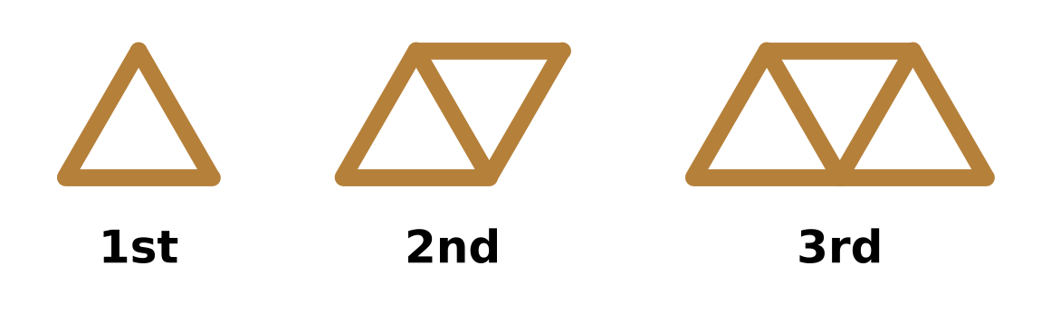
Q40. Look at the shapes made of sticks. Each new shape has one more triangle. Which shape in this pattern uses exactly 25 sticks?
(A) the 8th shape | (B) the 12th shape
(C) the 13th shape | (D) the 24th shape

SECTION II — Star Questions 5 questions × 4 marks each
Q41. In the 4-digit number A,6A3 the letter A stands for the same digit both times. The place value of the first A is 4,950 more than the place value of the second A. What is the number? [4 marks]
(A) 4,643 | (B) 5,653 | (C) 6,663 | (D) 9,693

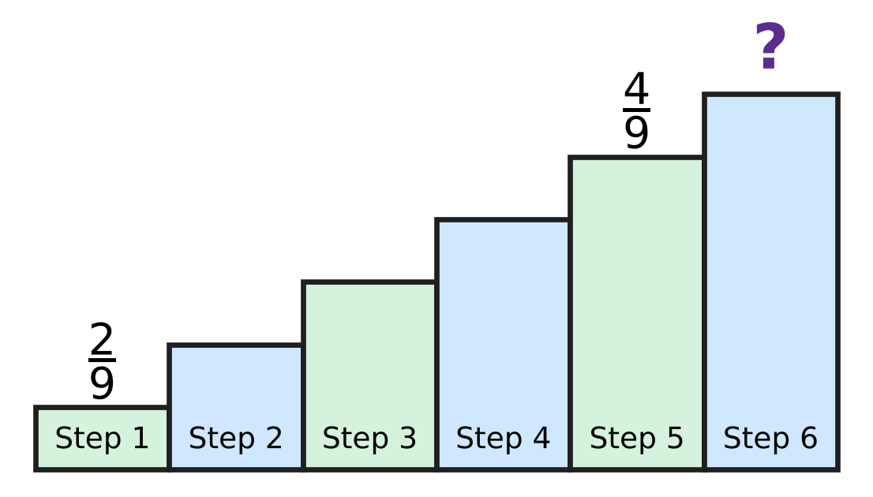
Q42. Look at the staircase in the picture. A fraction is written on each of its 6 steps. Step 1 has $\frac{2}{9}$ and Step 5 has $\frac{4}{9}$. The fractions on any three steps next to each other add up to 1 whole. Which fraction is on Step 6? [4 marks]
(A) $\frac{2}{9}$ | (B) $\frac{3}{9}$ | (C) $\frac{5}{9}$ | (D) $\frac{6}{9}$

Q43. A letter reaches Hemant on Friday, 4 July. It was posted 8 days before that day. It was written 6 days before it was posted. On which day and date was it written? [4 marks]
(A) Thursday, 26 June | (B) Saturday, 28 June
(C) Friday, 21 June | (D) Friday, 20 June

Q44. The rounds of a board game contest are numbered in Roman numerals. Each round lasts 25 minutes, and the next round starts at once. At 2:40 PM round XIV starts. At what time does round XVII start? [4 marks]
(A) 3:55 PM | (B) 3:30 PM | (C) 3:15 PM | (D) 4:20 PM

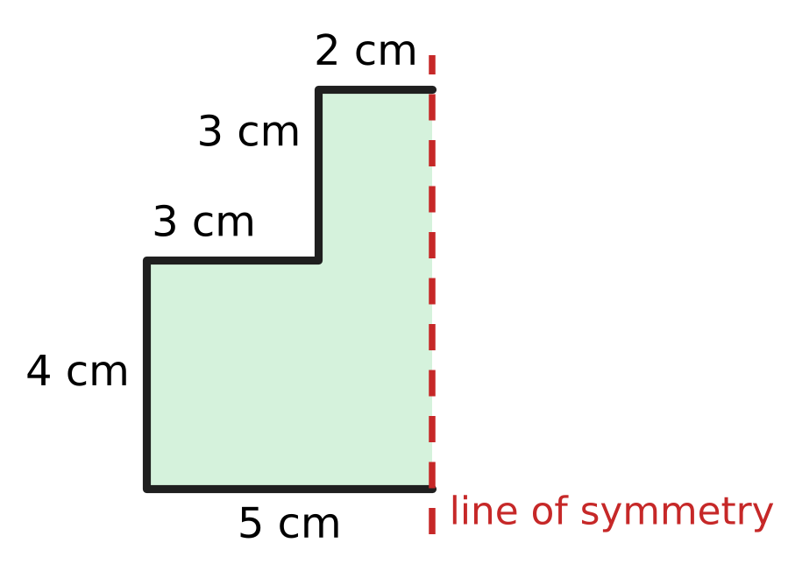
Q45. The figure shows one half of a paper shape. The dotted line is the line of symmetry of the whole shape. What is the perimeter of the whole shape? [4 marks]
(A) 17 cm | (B) 24 cm | (C) 34 cm | (D) 41 cm

Answer Sheet AMO Level 1 · Class 3 · Practice Paper 3
Name: | School: | Roll No.:
Shade or tick one circle for each question.
1. Ⓐ Ⓑ Ⓒ Ⓓ | 16. Ⓐ Ⓑ Ⓒ Ⓓ | 31. Ⓐ Ⓑ Ⓒ Ⓓ
2. Ⓐ Ⓑ Ⓒ Ⓓ | 17. Ⓐ Ⓑ Ⓒ Ⓓ | 32. Ⓐ Ⓑ Ⓒ Ⓓ
3. Ⓐ Ⓑ Ⓒ Ⓓ | 18. Ⓐ Ⓑ Ⓒ Ⓓ | 33. Ⓐ Ⓑ Ⓒ Ⓓ
4. Ⓐ Ⓑ Ⓒ Ⓓ | 19. Ⓐ Ⓑ Ⓒ Ⓓ | 34. Ⓐ Ⓑ Ⓒ Ⓓ
5. Ⓐ Ⓑ Ⓒ Ⓓ | 20. Ⓐ Ⓑ Ⓒ Ⓓ | 35. Ⓐ Ⓑ Ⓒ Ⓓ
6. Ⓐ Ⓑ Ⓒ Ⓓ | 21. Ⓐ Ⓑ Ⓒ Ⓓ | 36. Ⓐ Ⓑ Ⓒ Ⓓ
7. Ⓐ Ⓑ Ⓒ Ⓓ | 22. Ⓐ Ⓑ Ⓒ Ⓓ | 37. Ⓐ Ⓑ Ⓒ Ⓓ
8. Ⓐ Ⓑ Ⓒ Ⓓ | 23. Ⓐ Ⓑ Ⓒ Ⓓ | 38. Ⓐ Ⓑ Ⓒ Ⓓ
9. Ⓐ Ⓑ Ⓒ Ⓓ | 24. Ⓐ Ⓑ Ⓒ Ⓓ | 39. Ⓐ Ⓑ Ⓒ Ⓓ
10. Ⓐ Ⓑ Ⓒ Ⓓ | 25. Ⓐ Ⓑ Ⓒ Ⓓ | 40. Ⓐ Ⓑ Ⓒ Ⓓ
11. Ⓐ Ⓑ Ⓒ Ⓓ | 26. Ⓐ Ⓑ Ⓒ Ⓓ | 41. Ⓐ Ⓑ Ⓒ Ⓓ
12. Ⓐ Ⓑ Ⓒ Ⓓ | 27. Ⓐ Ⓑ Ⓒ Ⓓ | 42. Ⓐ Ⓑ Ⓒ Ⓓ
13. Ⓐ Ⓑ Ⓒ Ⓓ | 28. Ⓐ Ⓑ Ⓒ Ⓓ | 43. Ⓐ Ⓑ Ⓒ Ⓓ
14. Ⓐ Ⓑ Ⓒ Ⓓ | 29. Ⓐ Ⓑ Ⓒ Ⓓ | 44. Ⓐ Ⓑ Ⓒ Ⓓ
15. Ⓐ Ⓑ Ⓒ Ⓓ | 30. Ⓐ Ⓑ Ⓒ Ⓓ | 45. Ⓐ Ⓑ Ⓒ Ⓓ
Q41–Q45 are Section II Star Questions (4 marks each).
For the parent or teacher
Section I correct: ______ / 40 × 2 = ______ marks Section II correct: ______ / 5 × 4 = ______ marks
Correct: ______ / 45 Score: ______ / 100
Answer Key and Solutions AMO Level 1 · Class 3 · Practice Paper 3
Quick answers
1 C | 6 B | 11 B | 16 D | 21 D | 26 B | 31 C | 36 D | 41 B
2 D | 7 D | 12 A | 17 A | 22 C | 27 A | 32 D | 37 C | 42 B
3 D | 8 A | 13 A | 18 A | 23 C | 28 C | 33 A | 38 D | 43 D
4 A | 9 D | 14 B | 19 C | 24 D | 29 B | 34 A | 39 A | 44 A
5 C | 10 A | 15 B | 20 B | 25 C | 30 C | 35 B | 40 B | 45 C
Solutions
Q | Part · level | Answer | Why?
1 | Part 1 · Ch1 · Easy | (C) 2 | Four thousand six is 4,006: 4 thousands, 0 hundreds, 0 tens and 6 ones. It has 2 zeros.
2 | Part 1 · Ch1 · Easy | (D) 2 | In 5,273 the digit 2 is in the hundreds place, so its place value is 2 × 100 = 200.
3 | Part 1 · Ch1 · Easy | (D) 46 | X before L means 50 − 10 = 40. Then VI is 6. So XLVI = 40 + 6 = 46.
4 | Part 1 · Ch1 · Easy | (A) 7,508 | The blank must be greater than 7,495 and smaller than 7,520. Only 7,508 fits.
5 | Part 1 · Ch1 · Medium | (C) 10 | The first three digits are fixed: 9,99_. The ones digit can be any of 0, 1, 2, …, 9. That gives 10 numbers, from 9,990 to 9,999.
6 | Part 1 · Ch1 · Medium | (B) XLIV | XXXVIII = 38, XLII = 42, XXXIX = 39 and XLIV = 44. The greatest number is 44, which is XLIV.
7 | Part 2 · Ch2 · Easy | (D) 6,222 | Ones: 8 + 4 = 12. Tens: 6 + 5 + 1 = 12. Hundreds: 4 + 7 + 1 = 12. Thousands: 3 + 2 + 1 = 6. The total is 6,222.
8 | Part 2 · Ch2 · Easy | (A) 2,636 | Count up from 5,364: 36 more makes 5,400, 600 more makes 6,000, and 2,000 more makes 8,000. 36 + 600 + 2,000 = 2,636.
9 | Part 2 · Ch2 · Easy | (D) 12 | 7 × 10 = 70, 7 × 11 = 77 and 7 × 12 = 84. So the blank is 12.
10 | Part 2 · Ch2 · Easy | (A) 5 | 7 × 6 = 42. From 42 to 47 is 5, so the remainder is 5.
11 | Part 2 · Ch2 · Medium | (B) 3 | 40 × 6 = 240, and 258 − 240 = 18. Since 3 × 6 = 18, the ones digit is 3: 43 × 6 = 258.
12 | Part 2 · Ch2 · Medium | (A) 88 | He has 8 × 26 = 208 letters in all. Then 208 − 120 = 88 letters are left.
13 | Part 2 · Ch2 · Medium | (A) 0 | The 4 planes left over and the 2 new planes make 6 planes. These fill one more box of 6, so no plane is left over.
14 | Part 3 · Ch3 · Easy | (B) 10 | Three-tenths means 3 of 10 equal parts. Each stamp is one-tenth of the sheet, so the full sheet had 10 stamps.
15 | Part 3 · Ch3 · Easy | (B) $\frac{9}{9}$ | A fraction is improper when its top number is equal to or bigger than its bottom number. The smallest such top number is 9, so the answer is nine-ninths, which is one whole.
16 | Part 3 · Ch3 · Easy | (D) $\frac{7}{12}$ | The bottom numbers are the same, so look at the tops: 11 − 7 = 4. The blank is seven-twelfths.
17 | Part 3 · Ch3 · Medium | (A) $\frac{6}{11}$ | One whole is eleven-elevenths. 11 − 6 = 5, so six-elevenths must be taken away to leave five-elevenths.
18 | Part 3 · Ch3 · Medium | (A) $\frac{8}{8}$ | On Monday the bees fill three-eighths. On Tuesday they fill 3 + 2 = 5 eighths. Together that is 3 + 5 = 8 eighths, which is the whole jar.
19 | Part 4 · Ch5 · Easy | (C) 18 | A hexagon has 6 corners. So 3 hexagons have 3 × 6 = 18 corners.
20 | Part 4 · Ch5 · Easy | (B) 12 | A cube has 4 edges round the top, 4 edges round the bottom and 4 upright edges. 4 + 4 + 4 = 12.
21 | Part 4 · Ch5 · Easy | (D) Picture D | Picture D is a cylinder. It has a flat circle at each end and one curved face between them.
22 | Part 4 · Ch5 · Medium | (C) R | The row of 4 squares wraps round the cube. One square above the row makes the top, so the last square must be below the row to make the bottom. That place is R.
23 | Part 4 · Ch5 · Medium | (C) F | T and A match when folded along an upright middle line. E matches when folded along a line across its middle. F has no fold line, so F has no line of symmetry.
24 | Part 5 · Ch6 · Easy | (D) 7 | There are 100 cm in 1 m, so 400 cm make 4 m. That leaves 7 cm: 407 cm = 4 m 7 cm.
25 | Part 5 · Ch6 · Easy | (C) 700 g | In grams, 3 kg is 3,000 g and 2 kg 300 g is 2,300 g. Then 3,000 − 2,300 = 700, so 700 g more are needed.
26 | Part 5 · Ch6 · Medium | (B) 7 cm | The four sides that are given add up to 9 + 5 + 6 + 4 = 24 cm. The last side is 31 − 24 = 7 cm.
27 | Part 5 · Ch6 · Medium | (A) 1 L 500 mL | Two pours are 750 mL + 750 mL = 1,500 mL. The pot holds 3 L = 3,000 mL, and 3,000 mL − 1,500 mL = 1,500 mL, which is 1 L 500 mL.
28 | Part 6 · Ch9 · Easy | (C) 45 minutes | From 2 to 11 the hand makes 9 jumps, and each jump is 5 minutes. 9 × 5 = 45 minutes.
29 | Part 6 · Ch9 · Easy | (B) 1 hour 25 minutes | From 4:45 PM to 5:45 PM is 1 hour. From 5:45 PM to 6:10 PM is 15 + 10 = 25 minutes. The practice lasts 1 hour 25 minutes.
30 | Part 6 · Ch9 · Easy | (C) 20 July | Count on 11 days from 9 July: 9 + 11 = 20. The fair ends on 20 July.
31 | Part 6 · Ch9 · Easy | (C) 8 | Since 8 × ₹12 = ₹96 and 9 × ₹12 = ₹108, he can buy 8 tickets and has ₹3 left.
32 | Part 6 · Ch9 · Medium | (D) 15 days | August has 31 days, so from 22 August to 31 August is 9 days. Then 6 more days in September: 9 + 6 = 15 days.
33 | Part 6 · Ch9 · Medium | (A) ₹120 | The 3 guidebooks cost ₹500 − ₹140 = ₹360. One guidebook costs ₹360 ÷ 3 = ₹120.
34 | Part 7 · Ch10 · Easy | (A) 7 | Try digits: 16 + 6 = 22 is too small and 17 + 7 = 24 fits. So the hidden digit is 7.
35 | Part 7 · Ch10 · Easy | (B) 500 | Each number is 125 less than the one before: 1,000, 875, 750, 625. Then 625 − 125 = 500.
36 | Part 7 · Ch10 · Easy | (D) 36 | The 18 clocks left are the other half. So before the sale the shop had 18 + 18 = 36 clocks.
37 | Part 7 · Ch10 · Easy | (C) 72 | Each number is double the one before. Double 36 is 72, and double 72 is 144, which fits.
38 | Part 7 · Ch10 · Medium | (D) 8 | The two digits add up to 11 and differ by 5: they are 8 and 3, since 8 + 3 = 11 and 8 − 3 = 5. So the letter A hides 8 and B hides 3.
39 | Part 7 · Ch10 · Medium | (A) 18 | Work backwards from 40: take away the 10 to get 30, give back the 6 to get 36, then halve to get 18. Check: 18 → 36 → 30 → 40.
40 | Part 7 · Ch10 · Medium | (B) the 12th shape | The sticks go 3, 5, 7: one stick plus 2 sticks for each triangle. Then 25 − 1 = 24 and 24 ÷ 2 = 12, so it is the 12th shape.
41 | Section II · Ch1 + Ch10 · Hard | (B) 5,653 | The first A is worth A thousands and the second A is worth A tens. A = 5 gives 5,000 − 50 = 4,950, while A = 4 gives 3,960 and A = 6 gives 5,940. So the number is 5,653.
42 | Section II · Ch3 + Ch10 · Hard | (B) $\frac{3}{9}$ | Steps 1, 2, 3 and Steps 2, 3, 4 both make 1 whole, so Step 4 is the same as Step 1: $\frac{2}{9}$. Steps 4, 5, 6 make 1 whole, so Step 6 is 1 whole − $\frac{2}{9}$ − $\frac{4}{9}$ = $\frac{3}{9}$.
43 | Section II · Ch9 + Ch10 · Hard | (D) Friday, 20 June | The letter was written 8 + 6 = 14 days before 4 July. These 14 days are exactly 2 weeks, so the day is again a Friday. June has 30 days, so 4 days back is 30 June and 10 more days back is 20 June.
44 | Section II · Ch1 + Ch9 · Hard | (A) 3:55 PM | XIV is 14 and XVII is 17. Rounds 14, 15 and 16 must finish first: 3 × 25 = 75 minutes, which is 1 hour 15 minutes. 2:40 PM + 1 hour 15 minutes = 3:55 PM.
45 | Section II · Ch5 + Ch6 · Hard | (C) 34 cm | The five sides shown are 5 + 4 + 3 + 3 + 2 = 17 cm. The other half has the same sides, and the dotted line is inside the shape. So the perimeter is 17 + 17 = 34 cm.

ARYABHATTA MATHS OLYMPIAD
Level 1
PRACTICE PAPER-4
CLASS 3
Total Questions | 45 multiple-choice questions
Total Marks | 100
Time | 60 minutes
Section I | 40 questions × 2 marks = 80 marks
Section II | 5 Star Questions × 4 marks = 20 marks
Negative Marking | No negative marking
Calculator | Not allowed
Chapters | Number System · Operations · Fractions, Decimals & Percentages · Geometry · Mensuration · Applied Mathematics · Mathematical Reasoning

👋 Hello, friend! How to do this paper:
⭐ Every question has four answer choices: (A), (B), (C) and (D). Only one is correct.
⭐ Read each question and look at its picture carefully. Then mark your answer on the answer sheet at the end.
⭐ Section I has 40 questions of 2 marks each. Section II has 5 Star Questions of 4 marks each.
⭐ There is no negative marking, so try every question.
⭐ Do not use a calculator. You may do rough work on a separate sheet.
⭐ All figures are not necessarily drawn to scale unless stated.

For parents and teachers
• Print or view this paper in colour. Pictures are part of the questions.
• Parts follow the AMO syllabus chapters. Chapters 4, 7 and 8 are not part of the Class 3 syllabus, so the chapter numbers shown in the Part headings have gaps.
• The answer sheet and the answer key are at the end. Remove only the answer key before the child begins.

SECTION I 40 questions × 2 marks each
Part 1 — Number System (Syllabus Chapter 1)
Q1. A plant nursery has 3 thousand saplings in its field, 4 hundred in trays and 6 on a table. How many saplings does it have in all?
(A) 3,046 | (B) 346 | (C) 3,406 | (D) 3,460

Q2. A zoo sold 2,940 tickets in a week. In this number, what is the face value of the digit 9?
(A) 900 | (B) 100 | (C) 90 | (D) 9

Q3. Kriti reads page 34 of an old storybook. Its page numbers are printed in Roman numerals. Which numeral is printed on this page?
(A) XXIV | (B) XXXIV | (C) XXXIIII | (D) XXXVI

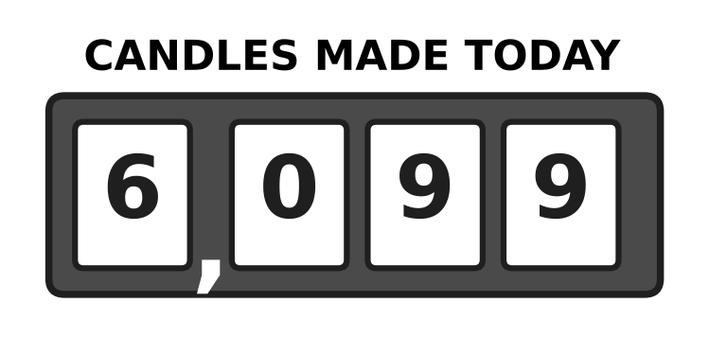
Q4. Look at the counter of a candle-making machine. It makes one more candle. Which number does the counter show now?
(A) 6,100 | (B) 6,109 | (C) 7,000 | (D) 6,010

Q5. Neel has three letter cards that show XVI. He puts the same three cards in a different order to make a smaller number. Which number does he make?
(A) 16 | (B) 6 | (C) 4 | (D) 14

Q6. At a school fair, every ticket with a number greater than 2,996 and less than 3,003 wins a prize. How many tickets win a prize?
(A) 7 | (B) 6 | (C) 8 | (D) 5

Part 2 — Operations & Number Properties (Syllabus Chapter 2)
Q7. A milk dairy fills 1,250 bottles on Friday. On Saturday it fills 1,375 more bottles than on Friday. How many bottles does it fill on Saturday?
(A) 3,875 | (B) 2,525 | (C) 2,625 | (D) 125

Q8. A school collected 4,020 bottle caps in March and 2,685 bottle caps in April. How many fewer caps did it collect in April than in March?
(A) 1,335 | (B) 1,435 | (C) 2,665 | (D) 6,705

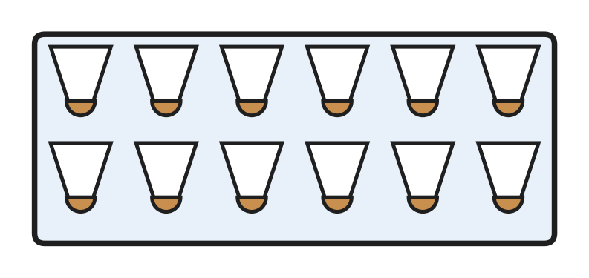
Q9. Look at the full box of shuttlecocks. A badminton club has 7 boxes like this, all full. How many shuttlecocks does the club have?
(A) 72 | (B) 96 | (C) 19 | (D) 84

Q10. A shop has 59 umbrellas. It puts 8 umbrellas in each stand and fills as many stands as it can. How many umbrellas are left over?
(A) 7 | (B) 51 | (C) 3 | (D) 8

Q11. A cook gets 7 crates of apples with 36 apples in each crate. Then 8 bad apples are thrown away. How many good apples are left?
(A) 224 | (B) 244 | (C) 260 | (D) 252

Q12. A nursery plants 156 saplings in 6 equal rows. Later, 4 saplings in each row dry up. How many saplings are left in each row?
(A) 26 | (B) 22 | (C) 132 | (D) 30

Q13. There are 52 children at a school assembly. Each bench seats 6 children. What is the smallest number of benches needed so that every child has a seat?
(A) 6 | (B) 8 | (C) 9 | (D) 4

Part 3 — Fractions, Decimals & Percentages (Syllabus Chapter 3)
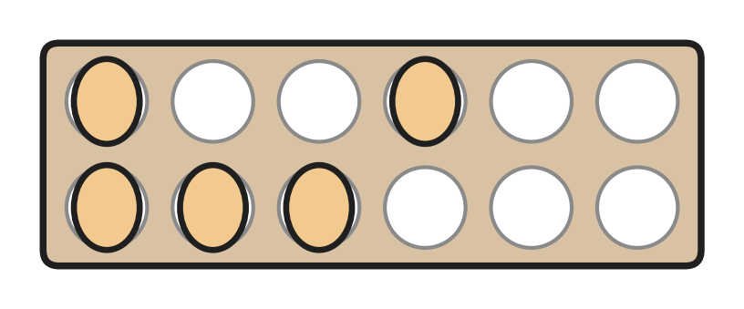
Q14. Look at the egg tray. All its cups are the same size. What fraction of the cups have an egg in them?
(A) $\frac{7}{12}$ | (B) $\frac{12}{5}$ | (C) $\frac{5}{7}$ | (D) $\frac{5}{12}$

Q15. A wooden plank is $\frac{5}{4}$ m long. Which of these is true about its length?
(A) It is more than 1 m. | (B) It is exactly 1 m.
(C) It is exactly 5 m. | (D) It is less than 1 m.

Q16. Vivek adds $\frac{2}{9}$ + $\frac{5}{9}$ and writes $\frac{7}{18}$. His answer is wrong. What is the correct answer?
(A) $\frac{3}{9}$ | (B) $\frac{8}{9}$ | (C) $\frac{7}{9}$ | (D) $\frac{10}{9}$

Q17. A cook has $\frac{5}{8}$ cup of sugar. Biscuits need $\frac{6}{8}$ cup, pudding needs $\frac{3}{8}$ cup, jam needs $\frac{7}{8}$ cup and a cake needs $\frac{9}{8}$ cups. Which one can she make with the sugar she has?
(A) cake | (B) jam
(C) biscuits | (D) pudding

Q18. Four bottles of the same size are full of water. From bottle P, $\frac{5}{8}$ of the water is drunk. From bottle Q, $\frac{3}{8}$ is drunk, from R $\frac{7}{8}$ and from S $\frac{6}{8}$. Which bottle now has the second most water left?
(A) bottle P | (B) bottle Q
(C) bottle R | (D) bottle S

Part 4 — Geometry (Syllabus Chapter 5)
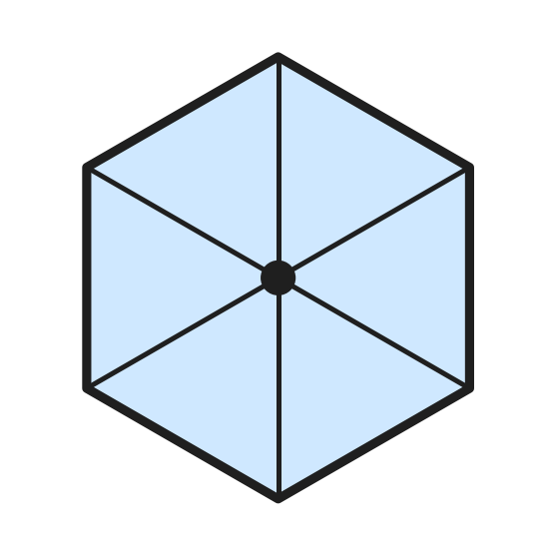
Q19. Look at the open umbrella seen from above. Its edge is made of straight sides. What is the name of this flat shape?
(A) hexagon | (B) triangle
(C) rectangle | (D) pentagon

Q20. Leah cuts open an empty tin can, which is a cylinder, and lays the pieces flat to make its net. Which flat shapes make the net?
(A) 1 circle and 1 rectangle | (B) 2 circles and 1 rectangle
(C) 2 circles and 2 rectangles | (D) 6 rectangles

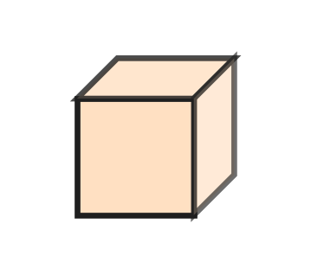
Q21. Look at the wooden cube. Sanjay paints every face in a different colour. How many colours does he need?
(A) 6 | (B) 4 | (C) 8 | (D) 12

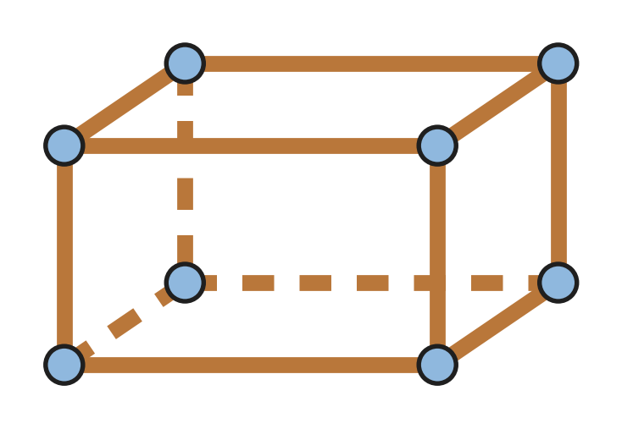
Q22. Look at the frame of a cuboid. Manu uses one stick for each edge and one clay ball for each corner. How many more sticks than clay balls does he use?
(A) 20 | (B) 12 | (C) 8 | (D) 4

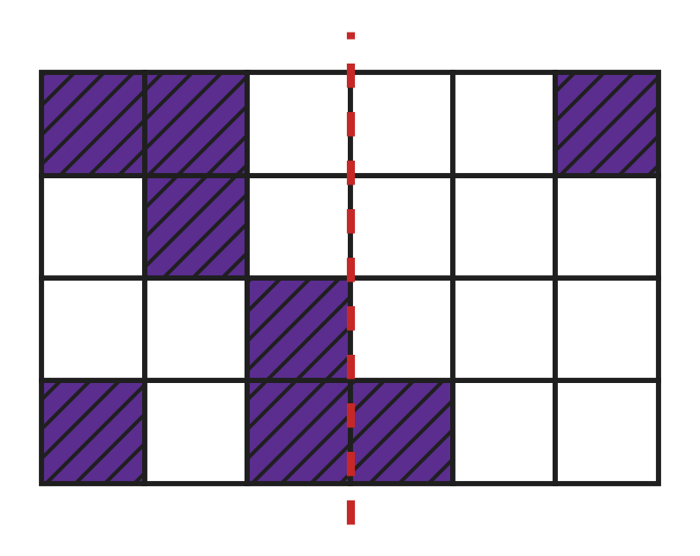
Q23. Look at the grid. The dotted line must become a line of symmetry of the shaded pattern. How many more small squares must be shaded on the right side?
(A) 5 | (B) 2 | (C) 4 | (D) 6

Part 5 — Mensuration (Syllabus Chapter 6)
Q24. Which of these is best measured in millilitres (mL)?
(A) the water in a swimming pool | (B) a teaspoon of honey
(C) the water in a full bucket | (D) the milk in a dairy tank

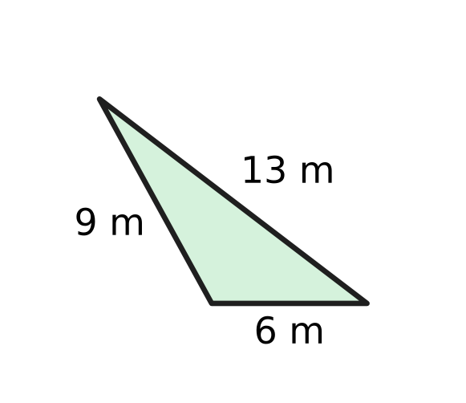
Q25. Look at the three-sided flower bed. A fence goes once all the way round it. How long is the fence?
(A) 19 m | (B) 22 m | (C) 28 m | (D) 15 m

Q26. A recipe needs 1 kg 250 g of flour. The jar in the kitchen has only 800 g of flour. How many more grams of flour are needed?
(A) 450 g | (B) 200 g | (C) 550 g | (D) 2,050 g

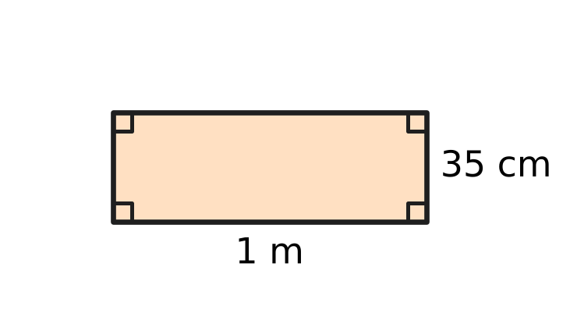
Q27. A carpenter makes the rectangular wooden frame in the picture. He fixes a strip all the way round its edge. How long is the strip?
(A) 135 cm | (B) 72 cm | (C) 170 cm | (D) 270 cm

Part 6 — Applied Mathematics (Syllabus Chapter 9)
Q28. A ferry trip across the river takes 1 hour 20 minutes. How many minutes is that?
(A) 120 minutes | (B) 80 minutes
(C) 70 minutes | (D) 21 minutes

Q29. An art class starts a big wall painting in October. The painting is finished 5 months later. In which month is it finished?
(A) December | (B) April
(C) March | (D) February

Q30. Three friends buy a badminton net together for ₹270. They share the cost equally. How much does each friend pay?
(A) ₹810 | (B) ₹90 | (C) ₹135 | (D) ₹70

Q31. Class 3 visits the zoo on 6 June. The next class visits exactly 2 weeks later. On which date does the next class visit?
(A) 20 June | (B) 13 June | (C) 8 June | (D) 26 June

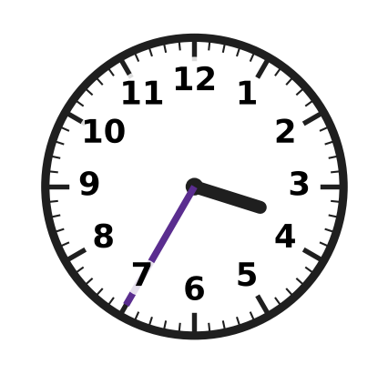
Q32. The clock shows the time when Ojas reaches the river jetty in the afternoon. The ferry leaves at 4:10. How many minutes does he wait?
(A) 25 minutes | (B) 45 minutes
(C) 75 minutes | (D) 35 minutes

Q33. At a bookshop sale, every book costs ₹60. For every 2 books you pay for, you get 1 more book free. Nidhi takes home 6 books. How much does she pay?
(A) ₹180 | (B) ₹300 | (C) ₹360 | (D) ₹240

Part 7 — Mathematical Reasoning & Problem-Solving (Syllabus Chapter 10)
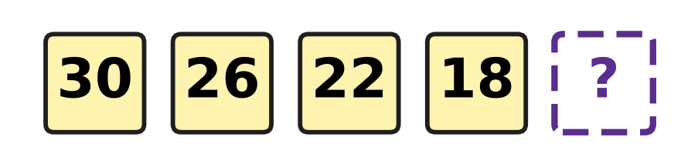
Q34. A candle burns down in a pattern. The picture shows its height in centimetres at the end of each hour. Which number comes next?
(A) 4 | (B) 16 | (C) 14 | (D) 12

Q35. Find the digit A that makes A0 − A = 63 true. In A0, A is the tens digit and 0 is the ones digit.
(A) 7 | (B) 3 | (C) 8 | (D) 6

Q36. At a school fair, 12 children leave a puppet show and nobody new comes in. Now 35 children are watching. How many were watching before?
(A) 37 | (B) 47 | (C) 23 | (D) 57

Q37. Hugo paints numbers on the steps of a hill path: 4, 7, 2, 4, 7, 2, and so on in the same order. Which number is on the 11th step?
(A) 4 | (B) 3 | (C) 7 | (D) 2

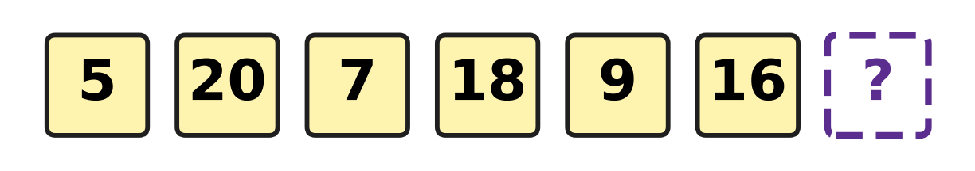
Q38. The numbers on the lockers of a badminton hall follow the pattern in the picture. Which number is on the next locker?
(A) 18 | (B) 23 | (C) 14 | (D) 11

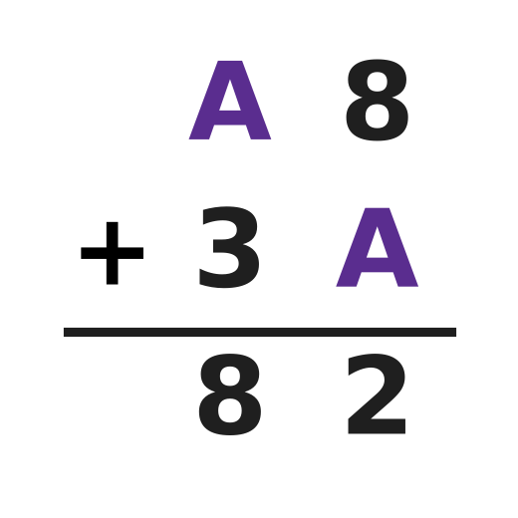
Q39. Look at the column addition in the picture. A hides one digit, and it is the same digit in both numbers. Find A.
(A) 2 | (B) 4 | (C) 6 | (D) 5

Q40. An art teacher puts all her crayons equally into 4 boxes. Then she takes 6 crayons out of one box. That box now has 9 crayons. How many crayons did she put into the boxes?
(A) 60 | (B) 42 | (C) 15 | (D) 36

SECTION II — Star Questions 5 questions × 4 marks each
Q41. Chetan thinks of a number. He doubles it and then adds X. He gets XLVIII. He writes every number in Roman numerals. Which number did he think of? [4 marks]
(A) XIX | (B) XIV | (C) XXXVIII | (D) XXIX

Q42. A jug is full of milk. Some milk is used in the morning. At noon, half of the milk left in the jug is used. In the evening, $\frac{3}{12}$ of the jug is used. Now $\frac{2}{12}$ of the jug is left. What fraction of the jug was used in the morning? [4 marks]
(A) $\frac{5}{12}$ | (B) $\frac{7}{12}$ | (C) $\frac{10}{12}$ | (D) $\frac{2}{12}$

Q43. On a mountain hike, Garima walks up for 1 hour 35 minutes and rests at the top for 25 minutes. Walking down takes her 50 minutes less than walking up. She is back at the start at 1:10 PM. At what time did she start? [4 marks]
(A) 9:35 AM | (B) 3:55 PM
(C) 10:25 AM | (D) 10:50 AM

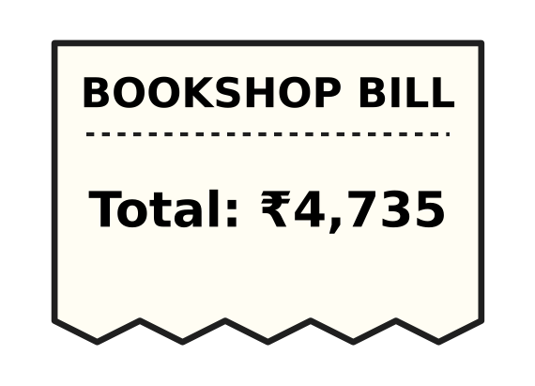
Q44. Look at the bill. By mistake, the shopkeeper swaps the hundreds digit and the tens digit when he asks for the money. How much less does the customer pay? [4 marks]
(A) ₹400 | (B) ₹360 | (C) ₹40 | (D) ₹440

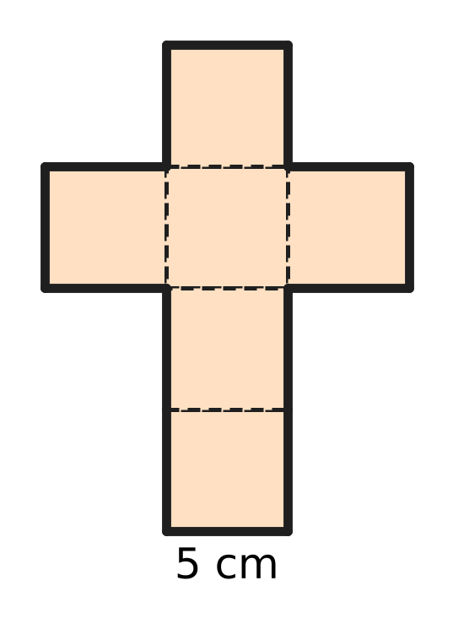
Q45. The picture shows the net of a cube. Every edge of the cube is 5 cm long. What is the perimeter of the whole net? [4 marks]
(A) 120 cm | (B) 70 cm | (C) 60 cm | (D) 30 cm

Answer Sheet AMO Level 1 · Class 3 · Practice Paper 4
Name: | School: | Roll No.:
Shade or tick one circle for each question.
1. Ⓐ Ⓑ Ⓒ Ⓓ | 16. Ⓐ Ⓑ Ⓒ Ⓓ | 31. Ⓐ Ⓑ Ⓒ Ⓓ
2. Ⓐ Ⓑ Ⓒ Ⓓ | 17. Ⓐ Ⓑ Ⓒ Ⓓ | 32. Ⓐ Ⓑ Ⓒ Ⓓ
3. Ⓐ Ⓑ Ⓒ Ⓓ | 18. Ⓐ Ⓑ Ⓒ Ⓓ | 33. Ⓐ Ⓑ Ⓒ Ⓓ
4. Ⓐ Ⓑ Ⓒ Ⓓ | 19. Ⓐ Ⓑ Ⓒ Ⓓ | 34. Ⓐ Ⓑ Ⓒ Ⓓ
5. Ⓐ Ⓑ Ⓒ Ⓓ | 20. Ⓐ Ⓑ Ⓒ Ⓓ | 35. Ⓐ Ⓑ Ⓒ Ⓓ
6. Ⓐ Ⓑ Ⓒ Ⓓ | 21. Ⓐ Ⓑ Ⓒ Ⓓ | 36. Ⓐ Ⓑ Ⓒ Ⓓ
7. Ⓐ Ⓑ Ⓒ Ⓓ | 22. Ⓐ Ⓑ Ⓒ Ⓓ | 37. Ⓐ Ⓑ Ⓒ Ⓓ
8. Ⓐ Ⓑ Ⓒ Ⓓ | 23. Ⓐ Ⓑ Ⓒ Ⓓ | 38. Ⓐ Ⓑ Ⓒ Ⓓ
9. Ⓐ Ⓑ Ⓒ Ⓓ | 24. Ⓐ Ⓑ Ⓒ Ⓓ | 39. Ⓐ Ⓑ Ⓒ Ⓓ
10. Ⓐ Ⓑ Ⓒ Ⓓ | 25. Ⓐ Ⓑ Ⓒ Ⓓ | 40. Ⓐ Ⓑ Ⓒ Ⓓ
11. Ⓐ Ⓑ Ⓒ Ⓓ | 26. Ⓐ Ⓑ Ⓒ Ⓓ | 41. Ⓐ Ⓑ Ⓒ Ⓓ
12. Ⓐ Ⓑ Ⓒ Ⓓ | 27. Ⓐ Ⓑ Ⓒ Ⓓ | 42. Ⓐ Ⓑ Ⓒ Ⓓ
13. Ⓐ Ⓑ Ⓒ Ⓓ | 28. Ⓐ Ⓑ Ⓒ Ⓓ | 43. Ⓐ Ⓑ Ⓒ Ⓓ
14. Ⓐ Ⓑ Ⓒ Ⓓ | 29. Ⓐ Ⓑ Ⓒ Ⓓ | 44. Ⓐ Ⓑ Ⓒ Ⓓ
15. Ⓐ Ⓑ Ⓒ Ⓓ | 30. Ⓐ Ⓑ Ⓒ Ⓓ | 45. Ⓐ Ⓑ Ⓒ Ⓓ
Q41–Q45 are Section II Star Questions (4 marks each).
For the parent or teacher
Section I correct: ______ / 40 × 2 = ______ marks Section II correct: ______ / 5 × 4 = ______ marks
Correct: ______ / 45 Score: ______ / 100
Answer Key and Solutions AMO Level 1 · Class 3 · Practice Paper 4
Quick answers
1 C | 6 B | 11 B | 16 C | 21 A | 26 A | 31 A | 36 B | 41 A
2 D | 7 C | 12 B | 17 D | 22 D | 27 D | 32 D | 37 C | 42 D
3 B | 8 A | 13 C | 18 A | 23 C | 28 B | 33 D | 38 D | 43 C
4 A | 9 D | 14 D | 19 A | 24 B | 29 C | 34 C | 39 B | 44 B
5 D | 10 C | 15 A | 20 B | 25 C | 30 B | 35 A | 40 A | 45 B
Solutions
Q | Part · level | Answer | Why?
1 | Part 1 · Ch1 · Easy | (C) 3,406 | 3 thousands, 4 hundreds, 0 tens and 6 ones make 3,000 + 400 + 6 = 3,406.
2 | Part 1 · Ch1 · Easy | (D) 9 | The face value of a digit is the digit itself, so it is 9. Its place value is 900.
3 | Part 1 · Ch1 · Easy | (B) XXXIV | 34 = 30 + 4. 30 is XXX and 4 is IV (1 before 5), so 34 is XXXIV.
4 | Part 1 · Ch1 · Easy | (A) 6,100 | One more than 6,099 is 6,100, because 99 + 1 = 100.
5 | Part 1 · Ch1 · Medium | (D) 14 | XVI is 16. The only other correct numeral with X, V and I is XIV, which is 10 + 4 = 14.
6 | Part 1 · Ch1 · Medium | (B) 6 | The winning numbers are 2,997, 2,998, 2,999, 3,000, 3,001 and 3,002. That is 6 tickets.
7 | Part 2 · Ch2 · Easy | (C) 2,625 | Saturday has 1,375 more than Friday: 1,250 + 1,375 = 2,625.
8 | Part 2 · Ch2 · Easy | (A) 1,335 | 4,020 − 2,685 = 1,335. Check by adding back: 1,335 + 2,685 = 4,020.
9 | Part 2 · Ch2 · Easy | (D) 84 | One box holds 12 shuttlecocks. 7 boxes hold 7 × 12 = 84 shuttlecocks.
10 | Part 2 · Ch2 · Easy | (C) 3 | 59 ÷ 8 = 7 remainder 3, because 7 × 8 = 56. So 3 umbrellas are left over.
11 | Part 2 · Ch2 · Medium | (B) 244 | 7 × 36 = 252 apples. 8 are thrown away, so 252 − 8 = 244 good apples are left.
12 | Part 2 · Ch2 · Medium | (B) 22 | 156 ÷ 6 = 26 saplings in each row. 26 − 4 = 22 are left in each row.
13 | Part 2 · Ch2 · Medium | (C) 9 | 52 ÷ 6 = 8 remainder 4. 8 benches are full and 4 children still need a seat, so 8 + 1 = 9 benches are needed.
14 | Part 3 · Ch3 · Easy | (D) $\frac{5}{12}$ | The tray has 12 equal cups and 5 of them have eggs. So $\frac{5}{12}$ of the cups have an egg.
15 | Part 3 · Ch3 · Easy | (A) It is more than 1 m. | $\frac{4}{4}$ m is one whole metre. $\frac{5}{4}$ m is one quarter more than that, so it is more than 1 m. It is an improper fraction.
16 | Part 3 · Ch3 · Easy | (C) $\frac{7}{9}$ | For like fractions, add the top numbers and keep the bottom number: 2 + 5 = 7, so the answer is $\frac{7}{9}$. Vivek wrongly added the bottom numbers too.
17 | Part 3 · Ch3 · Medium | (D) pudding | She has 5 eighths of a cup. Only pudding needs less: $\frac{3}{8}$ is less than $\frac{5}{8}$. The other three need 6, 7 and 9 eighths.
18 | Part 3 · Ch3 · Medium | (A) bottle P | Water left: P $\frac{3}{8}$, Q $\frac{5}{8}$, R $\frac{1}{8}$, S $\frac{2}{8}$. In order, Q has the most and P has the second most.
19 | Part 4 · Ch5 · Easy | (A) hexagon | The edge of the umbrella has 6 straight sides and 6 corners. A flat shape with 6 sides is a hexagon.
20 | Part 4 · Ch5 · Easy | (B) 2 circles and 1 rectangle | A cylinder has 2 flat round faces and 1 curved face. The curved face opens out into a rectangle. So the net has 2 circles and 1 rectangle.
21 | Part 4 · Ch5 · Easy | (A) 6 | A cube has 6 faces. One colour for each face makes 6 colours.
22 | Part 4 · Ch5 · Medium | (D) 4 | A cuboid has 12 edges and 8 corners. He uses 12 sticks and 8 clay balls. 12 − 8 = 4.
23 | Part 4 · Ch5 · Medium | (C) 4 | The left side has 6 shaded squares, so the right side needs 6 matching squares. 2 are already shaded. 6 − 2 = 4 more are needed.
24 | Part 5 · Ch6 · Easy | (B) a teaspoon of honey | Millilitres are used for very small amounts. A teaspoon holds only about 5 mL. The other three hold many litres.
25 | Part 5 · Ch6 · Easy | (C) 28 m | The perimeter is the sum of all the sides: 13 + 9 + 6 = 28 m.
26 | Part 5 · Ch6 · Medium | (A) 450 g | 1 kg 250 g = 1,250 g. Then 1,250 g − 800 g = 450 g more are needed.
27 | Part 5 · Ch6 · Medium | (D) 270 cm | 1 m = 100 cm. The perimeter is 100 + 35 + 100 + 35 = 270 cm.
28 | Part 6 · Ch9 · Easy | (B) 80 minutes | 1 hour = 60 minutes. 60 + 20 = 80 minutes.
29 | Part 6 · Ch9 · Easy | (C) March | Count on 5 months from October: November, December, January, February, March.
30 | Part 6 · Ch9 · Easy | (B) ₹90 | ₹270 ÷ 3 = ₹90, because 3 × 90 = 270.
31 | Part 6 · Ch9 · Easy | (A) 20 June | 2 weeks are 14 days. 6 + 14 = 20, so the next visit is on 20 June.
32 | Part 6 · Ch9 · Medium | (D) 35 minutes | The clock shows 3:35. From 3:35 to 4:00 is 25 minutes, and from 4:00 to 4:10 is 10 minutes. 25 + 10 = 35 minutes.
33 | Part 6 · Ch9 · Medium | (D) ₹240 | Every group of 3 books has 2 paid books and 1 free book. 6 books are 2 such groups, so she pays for 4 books. 4 × ₹60 = ₹240.
34 | Part 7 · Ch10 · Easy | (C) 14 | Each number is 4 less than the one before: 30, 26, 22, 18. Then 18 − 4 = 14.
35 | Part 7 · Ch10 · Easy | (A) 7 | A0 − A is 9 groups of A, so 9 × A = 63 and A = 7. Check: 70 − 7 = 63.
36 | Part 7 · Ch10 · Easy | (B) 47 | Undo the step: 35 + 12 = 47. Check: 47 − 12 = 35.
37 | Part 7 · Ch10 · Easy | (C) 7 | The numbers 4, 7, 2 repeat in groups of 3. Steps 10, 11 and 12 make the fourth group: 4, 7, 2. So the 11th step has 7.
38 | Part 7 · Ch10 · Medium | (D) 11 | Look at every second number. 5, 7, 9 go up by 2, and 20, 18, 16 go down by 2. The next number belongs to 5, 7, 9, so it is 11.
39 | Part 7 · Ch10 · Medium | (B) 4 | In the ones, 8 + A must end in 2, so 8 + A = 12 and A = 4. Check: 48 + 34 = 82.
40 | Part 7 · Ch10 · Medium | (A) 60 | Work backwards: the box had 9 + 6 = 15 crayons before. All 4 boxes had the same, so she put 15 × 4 = 60 crayons into the boxes.
41 | Section II · Ch1 + Ch10 · Hard | (A) XIX | XLVIII is 48 and X is 10. Work backwards: 48 − 10 = 38, and half of 38 is 19. In Roman numerals 19 is XIX.
42 | Section II · Ch3 + Ch10 · Hard | (D) $\frac{2}{12}$ | Work backwards. Before the evening there was $\frac{2}{12}$ + $\frac{3}{12}$ = $\frac{5}{12}$. Before noon there was twice that, $\frac{10}{12}$. So the morning used $\frac{12}{12}$ − $\frac{10}{12}$ = $\frac{2}{12}$.
43 | Section II · Ch9 + Ch10 · Hard | (C) 10:25 AM | Walking down takes 1 hour 35 minutes − 50 minutes = 45 minutes. In all: 1 hour 35 minutes + 25 minutes + 45 minutes = 2 hours 45 minutes. Going back 2 hours 45 minutes from 1:10 PM gives 10:25 AM.
44 | Section II · Ch1 + Ch9 · Hard | (B) ₹360 | The shopkeeper asks for ₹4,375. The hundreds go down by 400 and the tens go up by 40, so the customer pays ₹4,735 − ₹4,375 = ₹360 less.
45 | Section II · Ch5 + Ch6 · Hard | (B) 70 cm | Walk round the outside of the net and count the sides of the small squares: there are 14. Each is 5 cm long, so the perimeter is 14 × 5 = 70 cm.

ARYABHATTA MATHS OLYMPIAD
Level 1
PRACTICE PAPER-5
CLASS 3
Total Questions | 45 multiple-choice questions
Total Marks | 100
Time | 60 minutes
Section I | 40 questions × 2 marks = 80 marks
Section II | 5 Star Questions × 4 marks = 20 marks
Negative Marking | No negative marking
Calculator | Not allowed
Chapters | Number System · Operations · Fractions, Decimals & Percentages · Geometry · Mensuration · Applied Mathematics · Mathematical Reasoning

👋 Hello, friend! How to do this paper:
⭐ Every question has four answer choices: (A), (B), (C) and (D). Only one is correct.
⭐ Read each question and look at its picture carefully. Then mark your answer on the answer sheet at the end.
⭐ Section I has 40 questions of 2 marks each. Section II has 5 Star Questions of 4 marks each.
⭐ There is no negative marking, so try every question.
⭐ Do not use a calculator. You may do rough work on a separate sheet.
⭐ All figures are not necessarily drawn to scale unless stated.

For parents and teachers
• Print or view this paper in colour. Pictures are part of the questions.
• Parts follow the AMO syllabus chapters. Chapters 4, 7 and 8 are not part of the Class 3 syllabus, so the chapter numbers shown in the Part headings have gaps.
• The answer sheet and the answer key are at the end. Remove only the answer key before the child begins.

SECTION I 40 questions × 2 marks each
Part 1 — Number System (Syllabus Chapter 1)
Q1. Which of these numbers has the same digit in the thousands place and in the tens place?
(A) 4,145 | (B) 3,383 | (C) 2,272 | (D) 5,515

Q2. Zubin tries to list the number of visitors to a science exhibition on four days, from fewest to most: 2,009, 2,090, 2,909, 2,900. Which two numbers must change places?
(A) 2,909 and 2,900 | (B) 2,009 and 2,090
(C) 2,009 and 2,900 | (D) 2,090 and 2,909

Q3. The buttons in a lift are marked with Roman numerals. Isha gets in at floor XVIII and wants to go up 4 floors. Which button should she press?
(A) XXI | (B) XIV | (C) XXIV | (D) XXII

Q4. How do we read the number 6,040?
(A) six thousand forty | (B) six thousand four
(C) six hundred forty | (D) six thousand four hundred

Q5. Which number is the same as 23 hundreds, 14 tens and 6 ones?
(A) 376 | (B) 2,320 | (C) 2,346 | (D) 2,446

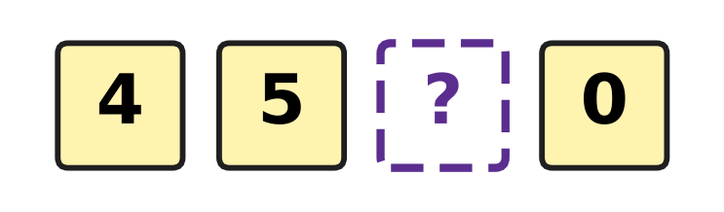
Q6. Look at the four digit cards. They make a 4-digit number, and one digit is hidden. The number is greater than 4,571. What is the smallest digit that can be hidden?
(A) 6 | (B) 7 | (C) 8 | (D) 9

Part 2 — Operations & Number Properties (Syllabus Chapter 2)
Q7. Two numbers add up to 6,000. One of them is 2,450. What is the other number?
(A) 3,550 | (B) 8,450 | (C) 3,650 | (D) 4,550

Q8. How much greater is 7 × 12 than 7 × 11?
(A) 1 | (B) 19 | (C) 12 | (D) 7

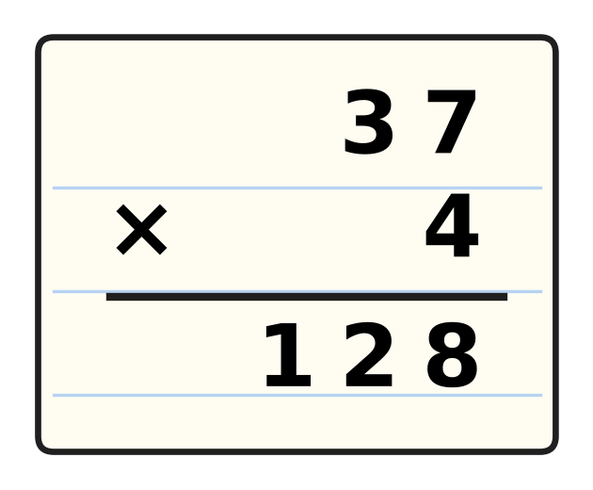
Q9. Look at the multiplication. Suresh forgot to add the number he carried. What is the correct answer?
(A) 148 | (B) 158 | (C) 138 | (D) 1,228

Q10. Deepak works out 46 ÷ 7 = 6 remainder 4. Which of these should he work out to check his answer?
(A) 7 × 4 + 6 | (B) 6 × 4 + 7
(C) 7 × 6 + 4 | (D) 7 + 6 + 4

Q11. Lata shares her stickers equally among 6 friends. Each friend gets 8 stickers and 3 stickers are left over. How many stickers did she have?
(A) 48 | (B) 17 | (C) 45 | (D) 51

Q12. One morning, 1,680 passengers leave an airport and 925 passengers arrive. Then there are 2,745 passengers at the airport. How many were there at the start?
(A) 5,350 | (B) 4,425 | (C) 3,500 | (D) 1,990

Q13. Two numbers are multiplied and the answer is 72. The same two numbers are added and the answer is 17. Which two numbers are they?
(A) 8 and 9 | (B) 7 and 10
(C) 4 and 18 | (D) 6 and 12

Part 3 — Fractions, Decimals & Percentages (Syllabus Chapter 3)
Q14. Each slice is $\frac{1}{4}$ of a pizza. Tanmay eats 5 slices. What fraction of a pizza does he eat?
(A) $\frac{1}{5}$ | (B) $\frac{4}{5}$ | (C) $\frac{5}{8}$ | (D) $\frac{5}{4}$

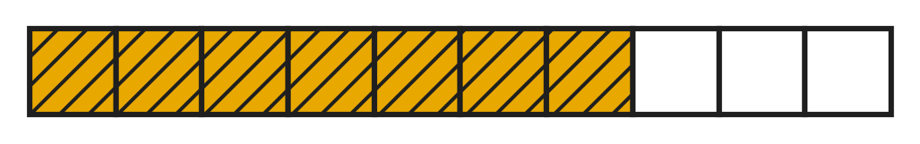
Q15. Look at the bar. Ana rubs out the shading on 4 of the shaded parts. What fraction of the bar is shaded then?
(A) $\frac{3}{10}$ | (B) $\frac{11}{10}$ | (C) $\frac{6}{10}$ | (D) $\frac{4}{10}$

Q16. Which of these fractions lies between $\frac{4}{11}$ and $\frac{8}{11}$?
(A) $\frac{3}{11}$ | (B) $\frac{9}{11}$ | (C) $\frac{6}{11}$ | (D) $\frac{4}{11}$

Q17. Which list shows the fractions in order from the smallest to the greatest?
(A) $\frac{7}{7}$, $\frac{2}{7}$, $\frac{5}{7}$, $\frac{9}{7}$
(B) $\frac{2}{7}$, $\frac{5}{7}$, $\frac{9}{7}$, $\frac{7}{7}$
(C) $\frac{9}{7}$, $\frac{7}{7}$, $\frac{5}{7}$, $\frac{2}{7}$
(D) $\frac{2}{7}$, $\frac{5}{7}$, $\frac{7}{7}$, $\frac{9}{7}$

Q18. Three different fractions are in order from the smallest to the greatest: $\frac{2}{9}$, $\frac{?}{9}$, $\frac{7}{9}$. How many different top numbers can be hidden by the question mark?
(A) 3 | (B) 4 | (C) 5 | (D) 6

Part 4 — Geometry (Syllabus Chapter 5)
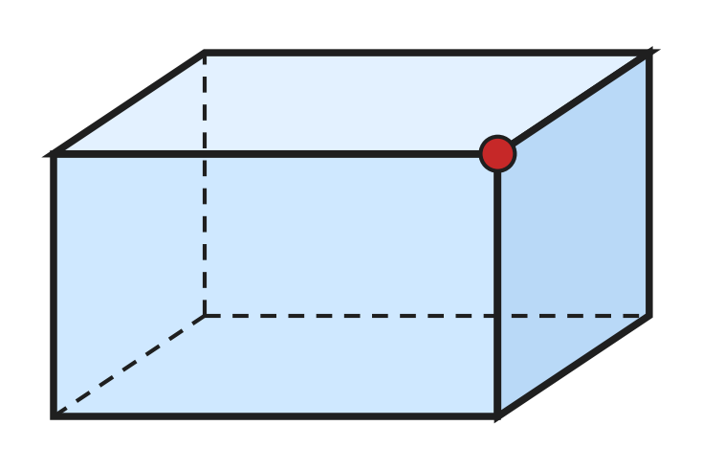
Q19. Look at the cuboid. How many edges meet at the corner marked with a dot?
(A) 2 | (B) 3 | (C) 4 | (D) 12

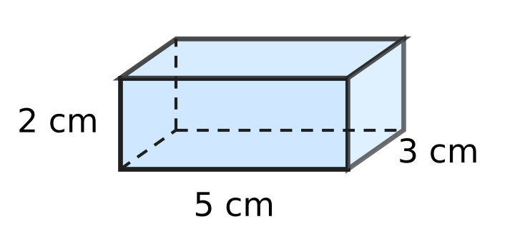
Q20. Look at the box. Lavina cuts it open to make a net of 6 rectangles. How many of the rectangles are 5 cm long and 3 cm wide?
(A) 1 | (B) 2 | (C) 4 | (D) 6

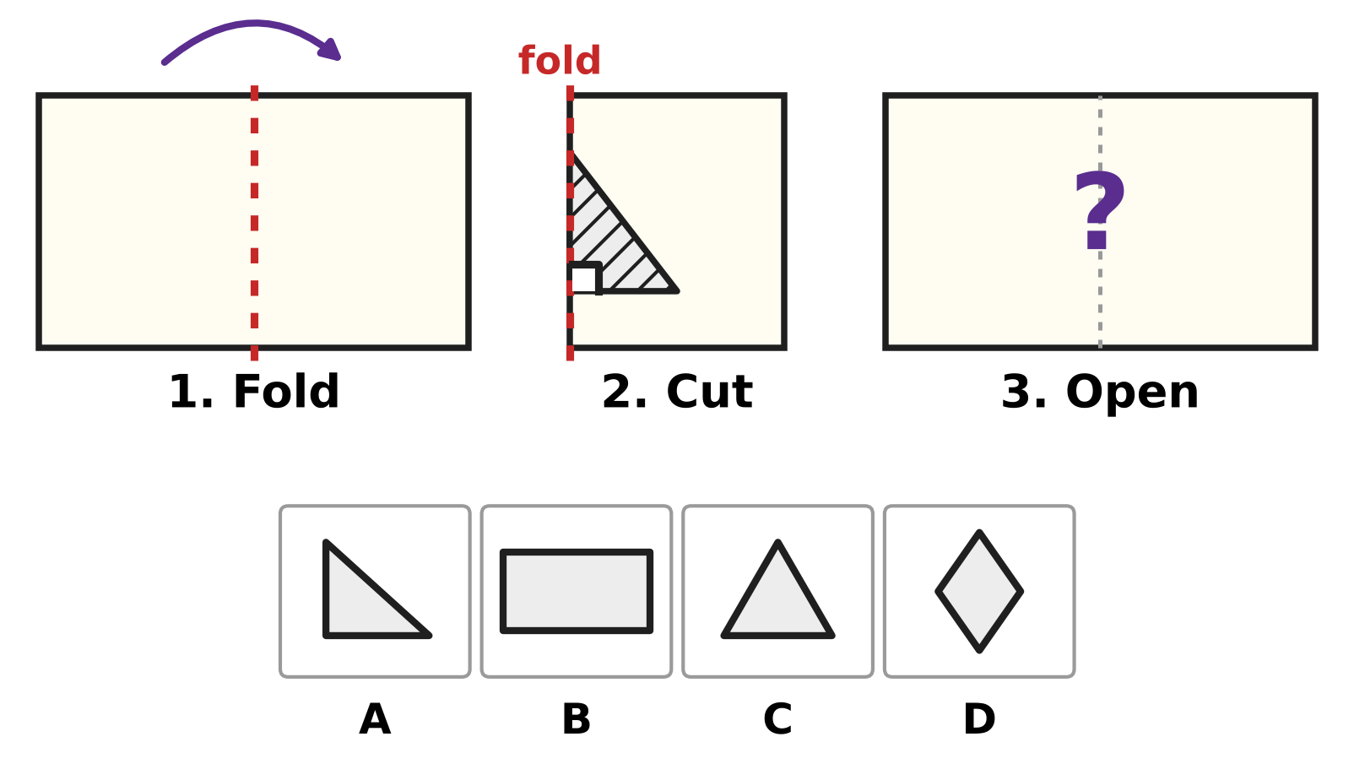
Q21. Look at the steps. Rani folds a paper along the dotted line. She cuts out the shaded triangle. One side of the cut is on the fold. The bottom side makes a square corner with the fold. Then she opens the paper. Which picture shows the hole she sees?
(A) Picture A | (B) Picture B
(C) Picture C | (D) Picture D

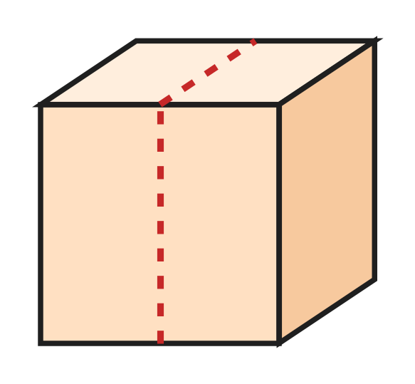
Q22. Look at the picture. Sohan cuts the cube into two equal cuboids along the dotted line. How many faces do the two cuboids have in all?
(A) 6 | (B) 7 | (C) 8 | (D) 12

Q23. Heena draws three flat shapes. Together they have 13 sides. One is a triangle and one is a square. What is the third shape?
(A) circle | (B) pentagon
(C) hexagon | (D) rectangle

Part 5 — Mensuration (Syllabus Chapter 6)
Q24. A tub on the roof collects 1 L 250 mL of rain on Monday and 750 mL on Tuesday. How much rain does it collect in all?
(A) 1,000 mL | (B) 1,900 mL
(C) 2,000 mL | (D) 2,750 mL

Q25. A slide in the playground is for children who are at least 125 cm tall. Yash is 1 m 32 cm tall. By how many centimetres is he taller than 125 cm?
(A) 7 cm | (B) 17 cm | (C) 93 cm | (D) 257 cm

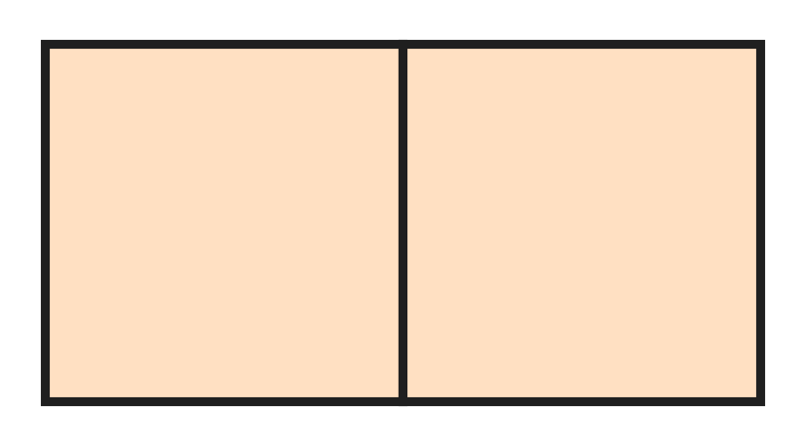
Q26. A square floor tile has a perimeter of 80 cm. Hana puts two such tiles side by side, as in the picture. What is the perimeter of the rectangle they make?
(A) 100 cm | (B) 120 cm | (C) 140 cm | (D) 160 cm

Q27. A rope is 3 m long. It is cut into 6 equal pieces. How long is each piece?
(A) 2 cm | (B) 5 cm | (C) 18 cm | (D) 50 cm

Part 6 — Applied Mathematics (Syllabus Chapter 9)
Q28. On a clock at the airport, the short hand is between 4 and 5. The long hand is on 9. What time does the clock show?
(A) 4:09 | (B) 4:45 | (C) 5:45 | (D) 9:20

Q29. A music class is 45 minutes long. It ends at 5:15 PM. At what time does it start?
(A) 4:15 PM | (B) 4:30 PM | (C) 4:45 PM | (D) 6:00 PM

Q30. The school play is on a Friday. Tickets go on sale 9 days before the play. On which day of the week do tickets go on sale?
(A) Sunday | (B) Thursday
(C) Tuesday | (D) Wednesday

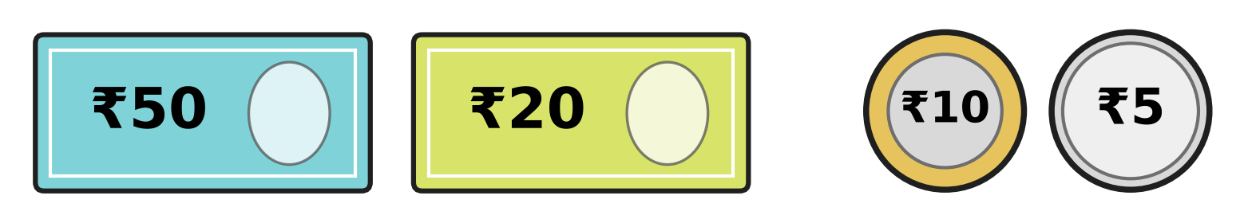
Q31. Look at the money Parth has. A bouquet at the flower shop costs ₹100. How much more money does Parth need to buy it?
(A) ₹15 | (B) ₹25 | (C) ₹85 | (D) ₹185

Q32. A plane takes off at 10:45 AM. It lands at 1:20 PM on the same day. How long is the flight?
(A) 1 hour 35 minutes | (B) 2 hours 35 minutes
(C) 3 hours 35 minutes | (D) 9 hours 25 minutes

Q33. Ivan has ₹200. He buys 3 tickets for the school play at ₹35 each. With the money left, he buys balloons at ₹9 each. How many balloons can he buy at most?
(A) 10 | (B) 11 | (C) 22 | (D) 95

Part 7 — Mathematical Reasoning & Problem-Solving (Syllabus Chapter 10)
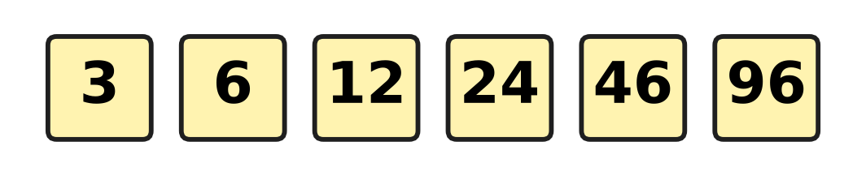
Q34. Look at the number pattern. Each number should be double the number before it, but one number is wrong. Which number is wrong?
(A) 12 | (B) 24 | (C) 46 | (D) 96

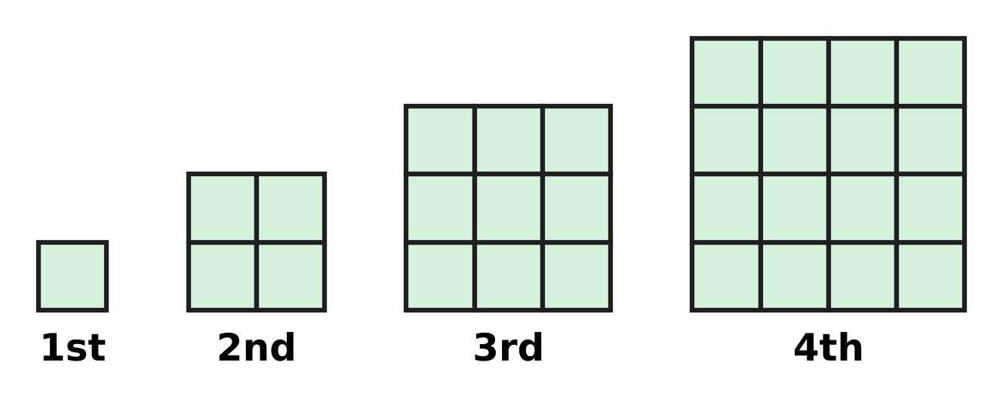
Q35. Look at the squares made of floor tiles. They grow in the same way each time. How many tiles will the 6th square have?
(A) 24 | (B) 25 | (C) 36 | (D) 49

Q36. The letter C hides a digit greater than zero. C × C gives the same answer as C + C. Which digit is C?
(A) 1 | (B) 2 | (C) 3 | (D) 4

Q37. Usha counts back in sevens: 100, 93, 86, 79, and so on. What is the first number she says that is less than 50?
(A) 37 | (B) 44 | (C) 49 | (D) 51

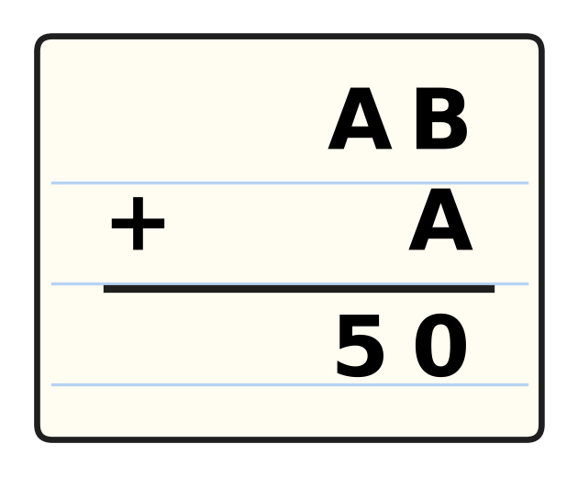
Q38. Look at the sum. The letters A and B hide two different digits. The same letter always hides the same digit. Which digit is B?
(A) 0 | (B) 4 | (C) 5 | (D) 6

Q39. What comes next in this number pattern?
5, 10, 8, 16, 14, 28, ___
(A) 26 | (B) 30 | (C) 42 | (D) 56

Q40. A hot-air balloon rises 250 m, comes down 120 m and then rises 75 m. Now it is 630 m above the ground. How high was it at the start?
(A) 185 m | (B) 205 m | (C) 425 m | (D) 835 m

SECTION II — Star Questions 5 questions × 4 marks each
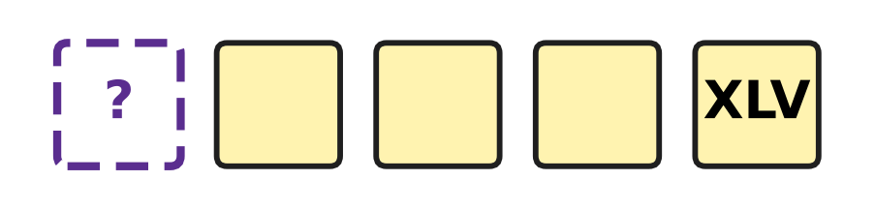
Q41. Look at the five tiles. The numbers on them go up by VII each time. The 5th tile shows XLV. Which Roman numeral is on the 1st tile? [4 marks]
(A) X | (B) XXXVIII | (C) XXIV | (D) XVII

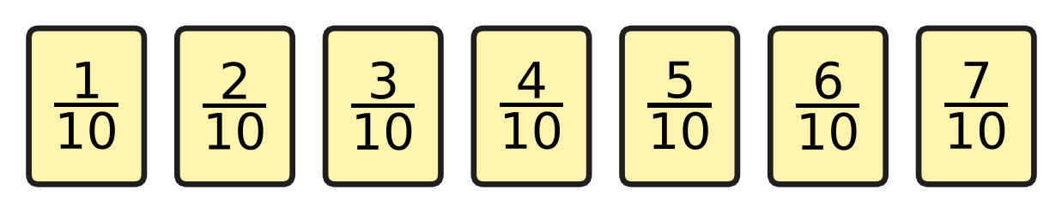
Q42. Look at the seven fraction cards. Sarika picks two different cards and adds their fractions. The same two cards in any order count as one pair. How many different pairs give a sum greater than one whole? [4 marks]
(A) 3 | (B) 4 | (C) 5 | (D) 8

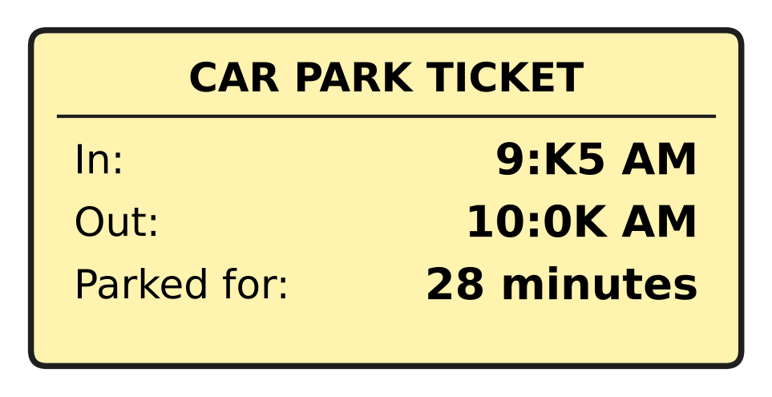
Q43. Look at the car park ticket. The letter K hides the same digit in both times. The car was parked for 28 minutes. At what time did it come in? [4 marks]
(A) 9:15 AM | (B) 9:25 AM | (C) 9:35 AM | (D) 9:45 AM

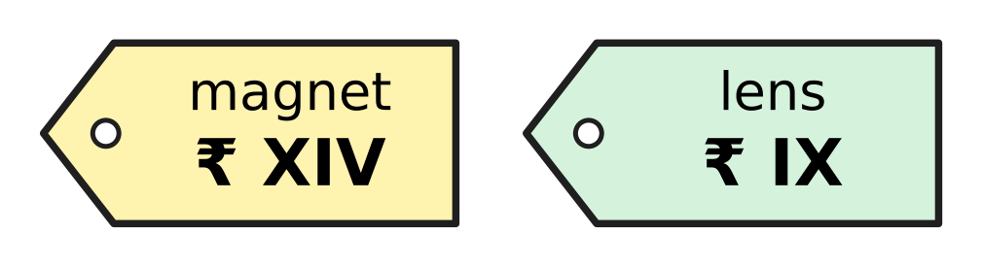
Q44. A stall at a science exhibition writes its prices in Roman numerals. Look at the price tags. Zoya buys 2 magnets and 1 lens and pays ₹50. How much change does she get? [4 marks]
(A) ₹11 | (B) ₹13 | (C) ₹27 | (D) ₹37

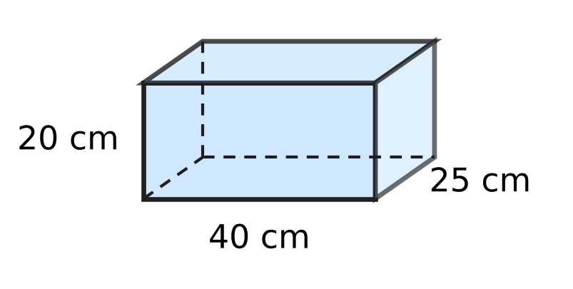
Q45. Look at the box. It is a cuboid. Tarun sticks tape along every edge of the box, with no overlaps. How much tape does he use in all? [4 marks]
(A) 1 m 70 cm | (B) 2 m 55 cm
(C) 2 m 60 cm | (D) 3 m 40 cm

Answer Sheet AMO Level 1 · Class 3 · Practice Paper 5
Name: | School: | Roll No.:
Shade or tick one circle for each question.
1. Ⓐ Ⓑ Ⓒ Ⓓ | 16. Ⓐ Ⓑ Ⓒ Ⓓ | 31. Ⓐ Ⓑ Ⓒ Ⓓ
2. Ⓐ Ⓑ Ⓒ Ⓓ | 17. Ⓐ Ⓑ Ⓒ Ⓓ | 32. Ⓐ Ⓑ Ⓒ Ⓓ
3. Ⓐ Ⓑ Ⓒ Ⓓ | 18. Ⓐ Ⓑ Ⓒ Ⓓ | 33. Ⓐ Ⓑ Ⓒ Ⓓ
4. Ⓐ Ⓑ Ⓒ Ⓓ | 19. Ⓐ Ⓑ Ⓒ Ⓓ | 34. Ⓐ Ⓑ Ⓒ Ⓓ
5. Ⓐ Ⓑ Ⓒ Ⓓ | 20. Ⓐ Ⓑ Ⓒ Ⓓ | 35. Ⓐ Ⓑ Ⓒ Ⓓ
6. Ⓐ Ⓑ Ⓒ Ⓓ | 21. Ⓐ Ⓑ Ⓒ Ⓓ | 36. Ⓐ Ⓑ Ⓒ Ⓓ
7. Ⓐ Ⓑ Ⓒ Ⓓ | 22. Ⓐ Ⓑ Ⓒ Ⓓ | 37. Ⓐ Ⓑ Ⓒ Ⓓ
8. Ⓐ Ⓑ Ⓒ Ⓓ | 23. Ⓐ Ⓑ Ⓒ Ⓓ | 38. Ⓐ Ⓑ Ⓒ Ⓓ
9. Ⓐ Ⓑ Ⓒ Ⓓ | 24. Ⓐ Ⓑ Ⓒ Ⓓ | 39. Ⓐ Ⓑ Ⓒ Ⓓ
10. Ⓐ Ⓑ Ⓒ Ⓓ | 25. Ⓐ Ⓑ Ⓒ Ⓓ | 40. Ⓐ Ⓑ Ⓒ Ⓓ
11. Ⓐ Ⓑ Ⓒ Ⓓ | 26. Ⓐ Ⓑ Ⓒ Ⓓ | 41. Ⓐ Ⓑ Ⓒ Ⓓ
12. Ⓐ Ⓑ Ⓒ Ⓓ | 27. Ⓐ Ⓑ Ⓒ Ⓓ | 42. Ⓐ Ⓑ Ⓒ Ⓓ
13. Ⓐ Ⓑ Ⓒ Ⓓ | 28. Ⓐ Ⓑ Ⓒ Ⓓ | 43. Ⓐ Ⓑ Ⓒ Ⓓ
14. Ⓐ Ⓑ Ⓒ Ⓓ | 29. Ⓐ Ⓑ Ⓒ Ⓓ | 44. Ⓐ Ⓑ Ⓒ Ⓓ
15. Ⓐ Ⓑ Ⓒ Ⓓ | 30. Ⓐ Ⓑ Ⓒ Ⓓ | 45. Ⓐ Ⓑ Ⓒ Ⓓ
Q41–Q45 are Section II Star Questions (4 marks each).
For the parent or teacher
Section I correct: ______ / 40 × 2 = ______ marks Section II correct: ______ / 5 × 4 = ______ marks
Correct: ______ / 45 Score: ______ / 100
Answer Key and Solutions AMO Level 1 · Class 3 · Practice Paper 5
Quick answers
1 A | 6 C | 11 D | 16 C | 21 C | 26 B | 31 A | 36 B | 41 D
2 A | 7 A | 12 C | 17 D | 22 D | 27 D | 32 B | 37 B | 42 B
3 D | 8 D | 13 A | 18 B | 23 C | 28 B | 33 A | 38 D | 43 C
4 A | 9 A | 14 D | 19 B | 24 C | 29 B | 34 C | 39 A | 44 B
5 D | 10 C | 15 A | 20 B | 25 A | 30 D | 35 C | 40 C | 45 D
Solutions
Q | Part · level | Answer | Why?
1 | Part 1 · Ch1 · Easy | (A) 4,145 | In 4,145 the thousands digit is 4 and the tens digit is 4. In the other numbers these two digits are different.
2 | Part 1 · Ch1 · Easy | (A) 2,909 and 2,900 | The numbers 2,900 and 2,909 have the same thousands, hundreds and tens. In the ones place 0 is less than 9, so 2,900 must come before 2,909.
3 | Part 1 · Ch1 · Easy | (D) XXII | XVIII is 18. Then 18 + 4 = 22, and 22 is written XXII.
4 | Part 1 · Ch1 · Easy | (A) six thousand forty | The number 6,040 has 6 thousands, 0 hundreds, 4 tens and 0 ones. It is read as six thousand forty.
5 | Part 1 · Ch1 · Medium | (D) 2,446 | Here, 23 hundreds = 2,300 and 14 tens = 140. So 2,300 + 140 + 6 = 2,446.
6 | Part 1 · Ch1 · Medium | (C) 8 | The thousands and hundreds are the same, so compare the tens. With 7 the number is 4,570, which is less than 4,571. With 8 it is 4,580, which is greater.
7 | Part 2 · Ch2 · Easy | (A) 3,550 | The other number is 6,000 − 2,450 = 3,550. Check: 3,550 + 2,450 = 6,000.
8 | Part 2 · Ch2 · Easy | (D) 7 | There is one more 7 in 7 × 12 than in 7 × 11. So it is 7 greater: 84 − 77 = 7.
9 | Part 2 · Ch2 · Easy | (A) 148 | First, 7 × 4 = 28: write 8 and carry 2. Next, 3 × 4 = 12, and 12 + 2 = 14. The answer is 148.
10 | Part 2 · Ch2 · Easy | (C) 7 × 6 + 4 | Here, 6 groups of 7 make 42, and the 4 left over make 46. So 7 × 6 + 4 = 46 checks the answer.
11 | Part 2 · Ch2 · Medium | (D) 51 | Lata shared 6 × 8 = 48 stickers, and 3 were left over. She had 48 + 3 = 51.
12 | Part 2 · Ch2 · Medium | (C) 3,500 | Undo the steps: 2,745 − 925 = 1,820, and 1,820 + 1,680 = 3,500.
13 | Part 2 · Ch2 · Medium | (A) 8 and 9 | Here, 8 × 9 = 72 and 8 + 9 = 17. No other pair does both.
14 | Part 3 · Ch3 · Easy | (D) $\frac{5}{4}$ | Tanmay eats 5 slices of one quarter each, which is 5/4. This is an improper fraction: one whole pizza and one more quarter.
15 | Part 3 · Ch3 · Easy | (A) $\frac{3}{10}$ | There are 7 of the 10 parts shaded. Then 7/10 − 4/10 = 3/10.
16 | Part 3 · Ch3 · Easy | (C) $\frac{6}{11}$ | The bottom numbers are the same, so compare the top numbers. The top number 6 is more than 4 and less than 8, so the fraction is 6/11.
17 | Part 3 · Ch3 · Medium | (D) 2/7, 5/7, 7/7, 9/7 | The bottom numbers are the same, so order the top numbers: 2, 5, 7, 9. The fraction 9/7 is more than one whole, so it comes last.
18 | Part 3 · Ch3 · Medium | (B) 4 | The top number must be more than 2 and less than 7. It can be 3, 4, 5 or 6. That is 4 numbers.
19 | Part 4 · Ch5 · Easy | (B) 3 | At every corner of a cuboid, 3 edges meet: across, down and back.
20 | Part 4 · Ch5 · Easy | (B) 2 | The top and the bottom faces are both 5 cm by 3 cm, so there are 2.
21 | Part 4 · Ch5 · Easy | (C) Picture C | The cut triangle is mirrored across the fold. Its bottom side makes a square corner with the fold, so the bottom side and its mirror image make one straight line. The hole is one big triangle, as in Picture C. It would be a diamond only if the corner away from the fold were halfway up.
22 | Part 4 · Ch5 · Medium | (D) 12 | Each piece is a cuboid, and every cuboid has 6 faces. So 6 + 6 = 12.
23 | Part 4 · Ch5 · Medium | (C) hexagon | The third shape has 13 − 3 − 4 = 6 sides, and a shape with 6 sides is a hexagon.
24 | Part 5 · Ch6 · Easy | (C) 2,000 mL | First, 1 L 250 mL = 1,250 mL. Then 1,250 mL + 750 mL = 2,000 mL, which is 2 L.
25 | Part 5 · Ch6 · Easy | (A) 7 cm | Yash is 1 m 32 cm = 132 cm tall. Then 132 cm − 125 cm = 7 cm.
26 | Part 5 · Ch6 · Medium | (B) 120 cm | Each side is 80 ÷ 4 = 20 cm. The rectangle is 40 cm by 20 cm, so its perimeter is 40 + 20 + 40 + 20 = 120 cm.
27 | Part 5 · Ch6 · Medium | (D) 50 cm | The rope is 3 m = 300 cm long. Then 300 ÷ 6 = 50, so each piece is 50 cm long.
28 | Part 6 · Ch9 · Easy | (B) 4:45 | The short hand has passed 4, so the hour is 4. The long hand on 9 means 9 × 5 = 45 minutes. The time is 4:45.
29 | Part 6 · Ch9 · Easy | (B) 4:30 PM | Back 15 minutes to 5:00 PM, then 30 minutes more to 4:30 PM.
30 | Part 6 · Ch9 · Easy | (D) Wednesday | Going back 7 days from a Friday gives a Friday again. Going back 2 more days gives a Wednesday.
31 | Part 6 · Ch9 · Easy | (A) ₹15 | ₹50 + ₹20 + ₹10 + ₹5 = ₹85. He needs ₹100 − ₹85 = ₹15 more.
32 | Part 6 · Ch9 · Medium | (B) 2 hours 35 minutes | From 10:45 AM to 12:45 PM is 2 hours. From 12:45 PM to 1:20 PM is 35 minutes. The flight is 2 hours 35 minutes.
33 | Part 6 · Ch9 · Medium | (A) 10 | He has ₹200 − 3 × ₹35 = ₹95 left. Then 10 balloons cost ₹90 and 11 balloons cost ₹99, so he can buy 10.
34 | Part 7 · Ch10 · Easy | (C) 46 | Double 24 is 48, not 46. With 48 the pattern is 3, 6, 12, 24, 48, 96.
35 | Part 7 · Ch10 · Easy | (C) 36 | The squares have 1 × 1, 2 × 2, 3 × 3 and 4 × 4 tiles, so the 6th has 6 × 6 = 36 tiles.
36 | Part 7 · Ch10 · Easy | (B) 2 | Try the digits: 2 × 2 = 4 and 2 + 2 = 4. No other digit from 1 to 9 works.
37 | Part 7 · Ch10 · Easy | (B) 44 | She says 100, 93, 86, 79, 72, 65, 58, 51, 44. The number 51 is still more than 50, so the first number less than 50 is 44.
38 | Part 7 · Ch10 · Medium | (D) 6 | In the ones place, B + A ends in 0, so B + A = 10 and 1 is carried. In the tens place, A + 1 = 5, so A is 4 and B is 6.
39 | Part 7 · Ch10 · Medium | (A) 26 | The rule is double, then take away 2, in turn. Next: 28 − 2 = 26.
40 | Part 7 · Ch10 · Medium | (C) 425 m | Undo: 630 − 75 = 555, 555 + 120 = 675, 675 − 250 = 425 m.
41 | Section II · Ch1 + Ch10 · Hard | (D) XVII | XLV is 45 and VII is 7. The 1st tile is 4 jumps back: 45 − 4 × 7 = 45 − 28 = 17, which is XVII.
42 | Section II · Ch3 + Ch10 · Hard | (B) 4 | The top numbers must add to more than 10: 4 + 7, 5 + 6, 5 + 7, 6 + 7. That is 4 pairs. (3 + 7 = 10 is not more.)
43 | Section II · Ch9 + Ch10 · Hard | (C) 9:35 AM | The car leaves after 10:00, so 9:K5 + 28 minutes passes 10:00. Try K = 3: 9:35 AM + 25 minutes = 10:00 AM, and 3 minutes more is 10:03 AM. So K is 3, and it came in at 9:35 AM.
44 | Section II · Ch1 + Ch9 · Hard | (B) ₹13 | XIV is 14 and IX is 9. Cost: 2 × ₹14 + ₹9 = ₹37. Change: ₹50 − ₹37 = ₹13.
45 | Section II · Ch5 + Ch6 · Hard | (D) 3 m 40 cm | A cuboid has 12 edges, 4 of each length. He uses 4 × (40 + 25 + 20) cm = 340 cm = 3 m 40 cm.

