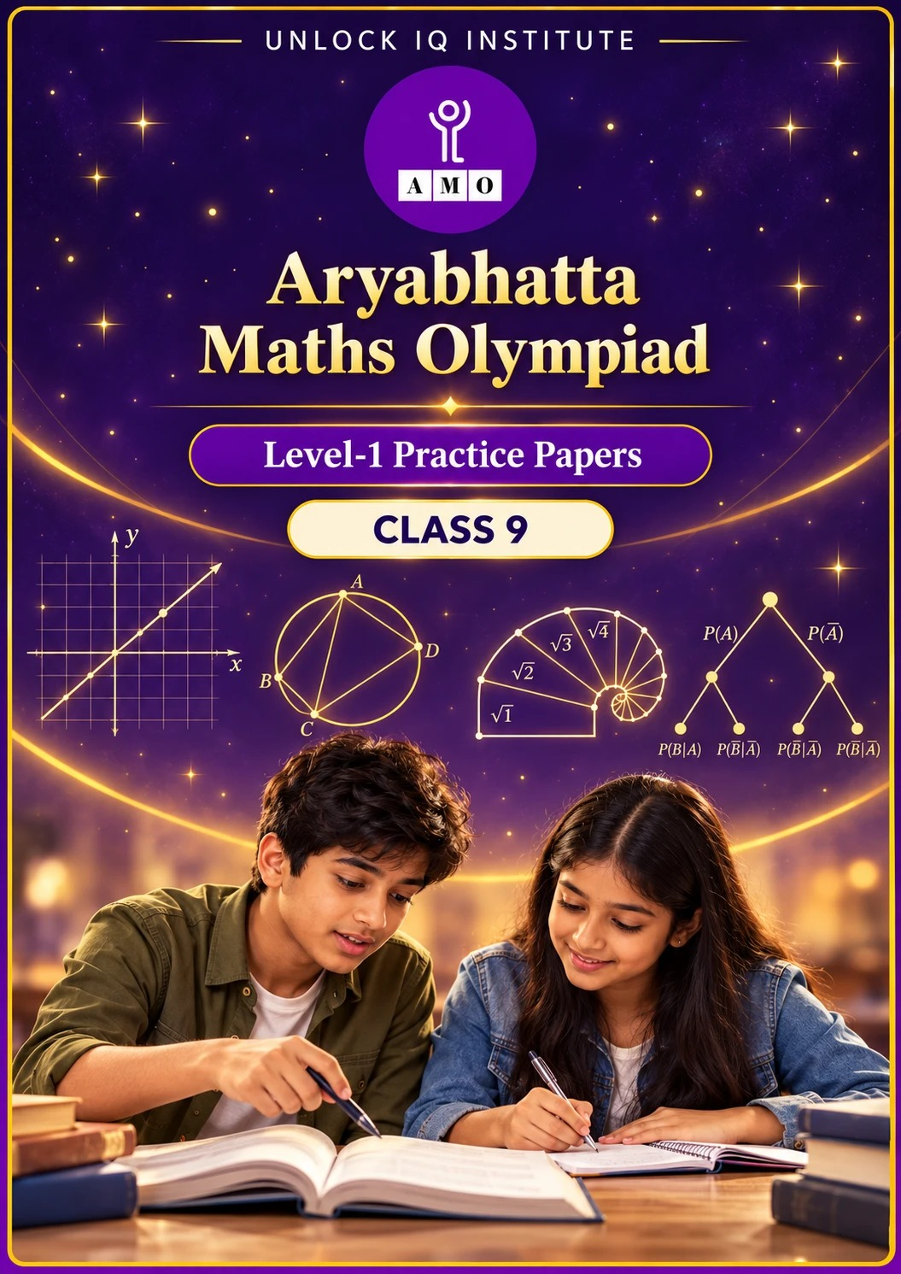
Five full practice papers · with answer keys & detailed solutions
Name: ____________________ | Class & Section: ________________
Roll No.: ________________ | School: ____________________
City: ____________________ | Date: ____________________

Published by Unlock IQ Institute Pvt. Ltd.
Register for Olympiads: www.aryabhattamathsolympiad.com/student-registration

ARYABHATTA MATHS OLYMPIAD
Level 1
PRACTICE PAPER-1
CLASS 9
Total Questions | 45 multiple-choice questions
Total Marks | 100
Time | 60 minutes
Section I | 40 questions × 2 marks = 80 marks
Section II | 5 Star Questions × 4 marks = 20 marks
Negative Marking | No negative marking
Calculator | Not allowed
Chapters | Number System · Fractions, Decimals & Percentages · Algebra · Geometry · Mensuration · Data Handling · Applied Mathematics · Mathematical Reasoning

Instructions to candidates
• This paper has 45 multiple-choice questions. Each question has four answer choices, of which exactly one is correct.
• Section I (Q1–Q40) carries 2 marks per question. Section II (Q41–Q45) carries 4 marks per question.
• There is no negative marking. Unanswered questions score zero.
• Calculators are not permitted. Rough work may be done on a separate sheet.
• Mark your answers on the answer sheet at the end of the paper.
• All figures are not necessarily drawn to scale unless stated.

For parents and teachers
• Print or view this paper in colour. Pictures are part of the questions.
• Parts follow the AMO syllabus chapters. Chapters 2 and 7 are not part of the Class 9 syllabus, so the chapter numbers shown in the Part headings have gaps.
• The answer sheet and the answer key are at the end. Remove only the answer key before the student begins.

SECTION I 40 questions × 2 marks each
Part 1 — Number System (Syllabus Chapter 1)
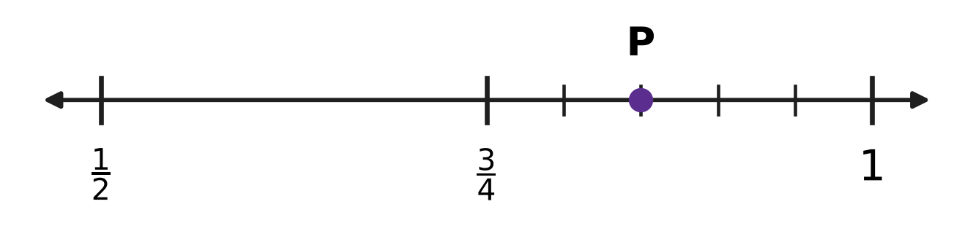
Q1. On the number line, the part from $\frac{3}{4}$ to 1 is divided into 5 equal parts. Which rational number is at the point P?
(A) $\frac{17}{20}$ | (B) $\frac{4}{5}$ | (C) $\frac{19}{20}$ | (D) $\frac{23}{20}$

Q2. Which of these fractions has a non-terminating recurring decimal expansion?
(A) $\frac{27}{150}$ | (B) $\frac{14}{45}$ | (C) $\frac{13}{64}$ | (D) $\frac{21}{56}$

Q3. The square-root spiral in the picture starts with OA = 1 unit. Each outer side AB, BC, CD, … is 1 unit long, with AB at right angles to OA, BC at right angles to OB, and so on. How many of the nine lengths OB, OC, OD, …, OJ are rational numbers? | 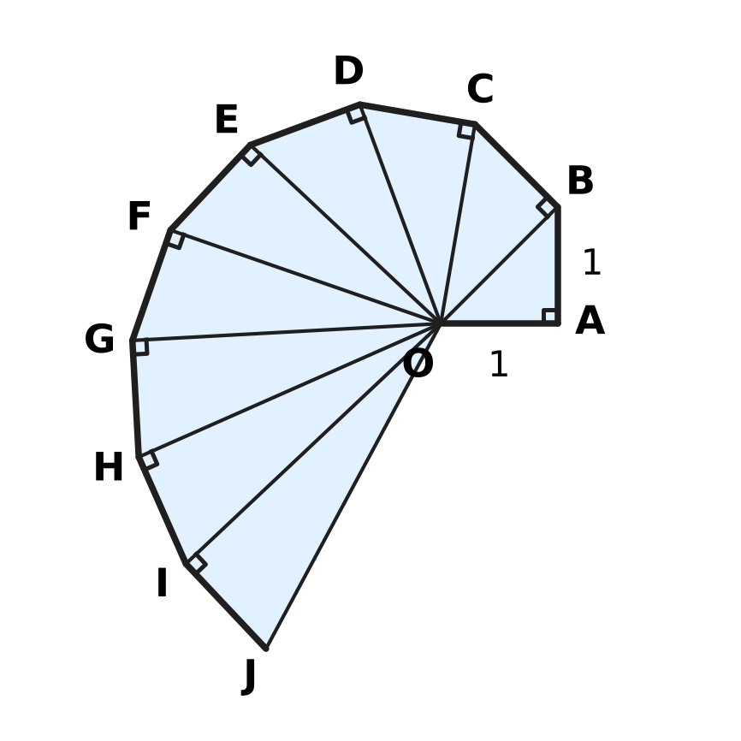
  (A) 2 | (B) 0 | (C) 3 | (D) 1

Part 2 — Fractions, Decimals & Percentages (Syllabus Chapter 3)
Stamp collection
Year | Year 1 | Year 2 | Year 3 | Year 4
Stamps in the collection | 1,000 | 1,200 | 1,440 | ?

Q4. A stamp collection grows by the same percentage every year. The table shows the number of stamps at the end of each year. How many stamps will there be at the end of Year 4?
(A) 1,640 | (B) 1,680 | (C) 1,720 | (D) 1,728

Q5. In a swimming test, 64% of the 25 boys and 80% of the 15 girls of a class passed. What percentage of the whole class passed?
(A) 28% | (B) 70% | (C) 72% | (D) 74%

Q6. A stationery shop buys a delivery van for ₹250,000. After 2 years the van is worth ₹90,000. It lost the same percentage of its value in each of the 2 years. What was the van worth after 1 year?
(A) ₹150,000 | (B) ₹170,000 | (C) ₹100,000 | (D) ₹160,000

Part 3 — Algebra (Syllabus Chapter 4)
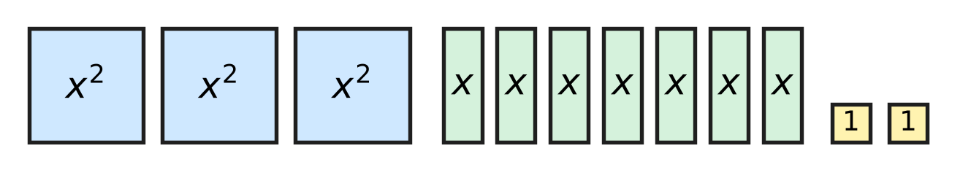
Q7. The picture shows 3 large square tiles (each of area $x^{2}$), 7 strip tiles (each of area $x$) and 2 small square tiles (each of area 1). All 12 tiles are put together, without gaps or overlaps, to make one rectangle. What are the length and breadth of the rectangle?
(A) (3x + 4) and (x + 1) | (B) (x + 1) and (x + 2)
(C) (3x + 2) and (x + 1) | (D) (3x + 1) and (x + 2)

Q8. The straight line drawn on the grid passes through the two marked points. Which equation does the line have? | 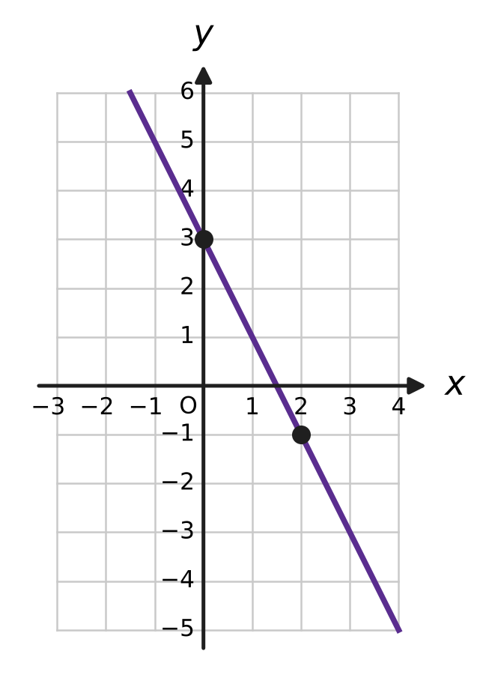
  (A) $y=3x−2$ | (B) $y=−2x+3$
  (C) $y=2x+3$ | (D) $y=−\frac{1}{2}x+3$

Q9. Ishan lays marbles in rows to make a triangle, as in the picture: 1 marble in Row 1, 2 in Row 2, 3 in Row 3, and so on. How many marbles does he need for a triangle with 24 rows? | 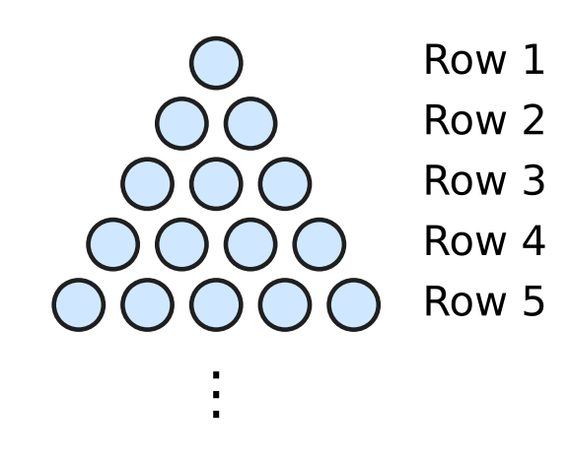
  (A) 276 | (B) 600 | (C) 300 | (D) 576

Q10. Which equation, taken together with 3x − 5y = 4, gives a pair of linear equations with infinitely many solutions?
(A) 9x − 15y = 4 | (B) 3x + 5y = 4
(C) 5x − 3y = 4 | (D) 9x − 15y = 12

Q11. Swati has a wooden cube of edge 13 cm. She makes three flat cuts, as shown by the dashed lines, each 10 cm from the same corner along an edge, so the cube splits into 8 blocks. Two of the blocks are cubes. What is the total volume of the other six blocks? | 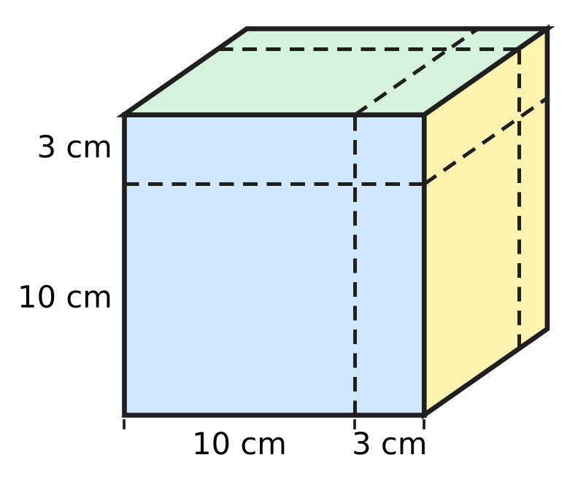
  (A) 1,197 cm³ | (B) 1,170 cm³
  (C) 1,027 cm³ | (D) 900 cm³

Q12. What is the value of $\frac{x^{2}−16}{x^{2}−2x−8}$ when x = 98?
(A) $\frac{51}{50}$ | (B) $\frac{47}{50}$ | (C) $\frac{47}{48}$ | (D) 2

Q13. In a geometric progression, the 2nd term is 12 and the 5th term is 324. What is the 1st term?
(A) −92 | (B) 3 | (C) 4 | (D) 6

Part 4 — Geometry (Syllabus Chapter 5)
Q14. M is the midpoint of the segment PQ drawn on the grid. What are the coordinates of M? | 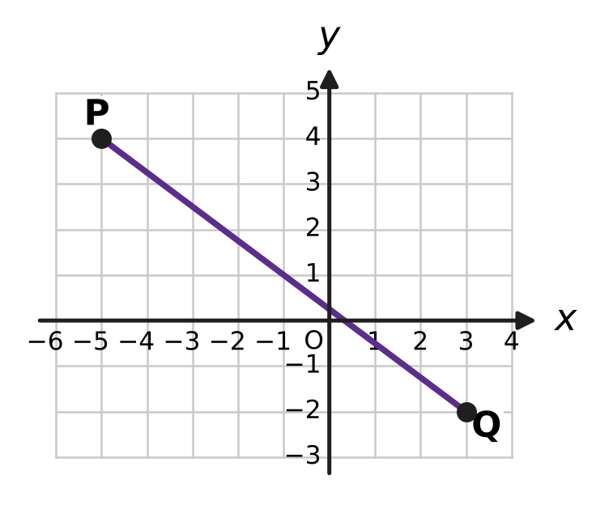
  (A) (−1, 1) | (B) (−2, 2) | (C) (1, −1) | (D) (4, −3)

Q15. ABCD is a cyclic quadrilateral. Side BC is extended to E, and ∠DCE = 84°, as shown. What is ∠BAD, marked x? | 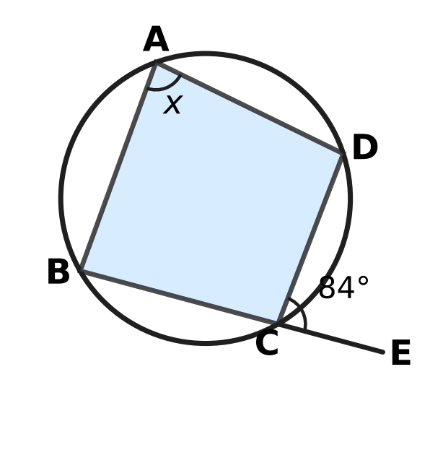
  (A) 168° | (B) 42° | (C) 96° | (D) 84°

Q16. In the figure, the circle has centre O and radius OA = 29 cm. OM is perpendicular to the chord AB and OM = 20 cm. How long is the chord AB? | 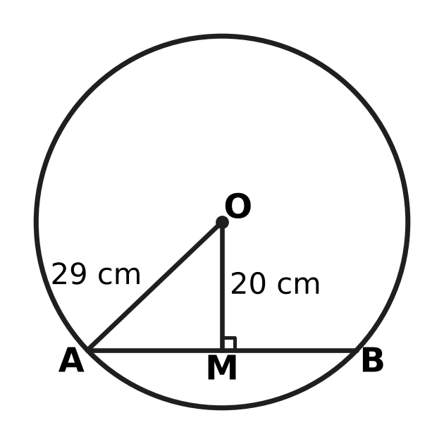
  (A) 21 cm | (B) 49 cm | (C) 42 cm | (D) 18 cm

Q17. In the figure, AB = AD and CB = CD, as shown by the marks. The diagonal AC is drawn. Which rule shows that △ABC ≅ △ADC? | 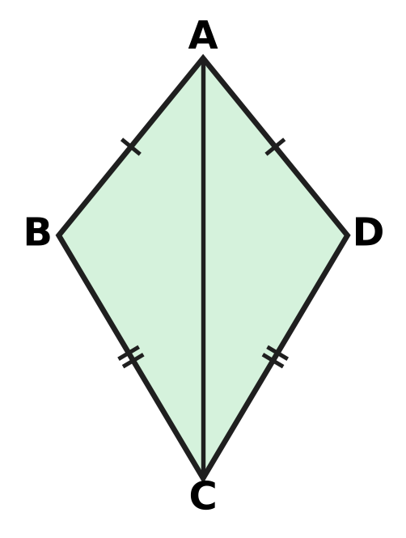
  (A) RHS | (B) SSS | (C) ASA | (D) SAS

Q18. The points A(−1, 5), B(2, 3) and C(k, −3) lie on one straight line. What is the value of k?
(A) −7 | (B) 5 | (C) 6 | (D) 11

Q19. In the figure, P, Q, R and S are the midpoints of the sides AB, BC, CD and DA of the quadrilateral ABCD. The diagonals are AC = 10 cm and BD = 14 cm. What is the perimeter of PQRS? | 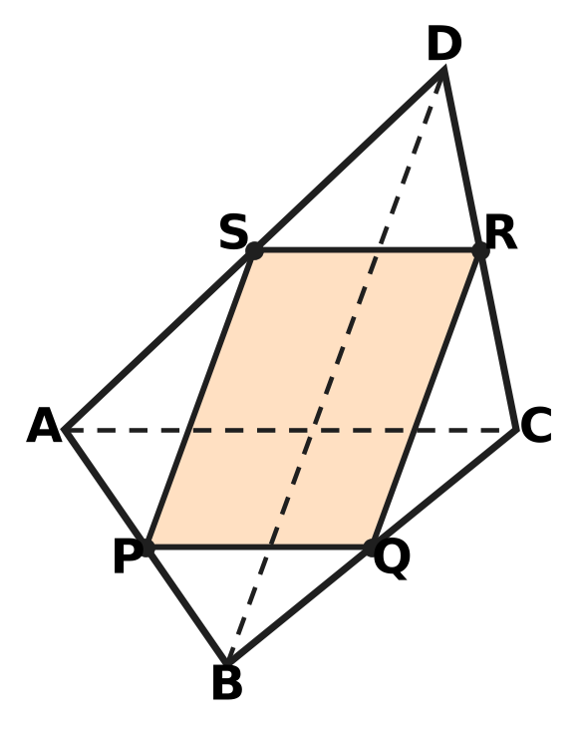
  (A) 12 cm | (B) 48 cm | (C) 20 cm | (D) 24 cm

Q20. AB is a diameter of the circle with centre O. C and D are points on the circle, and ∠CAB = 28°, as shown. What is ∠ADC, marked x? | 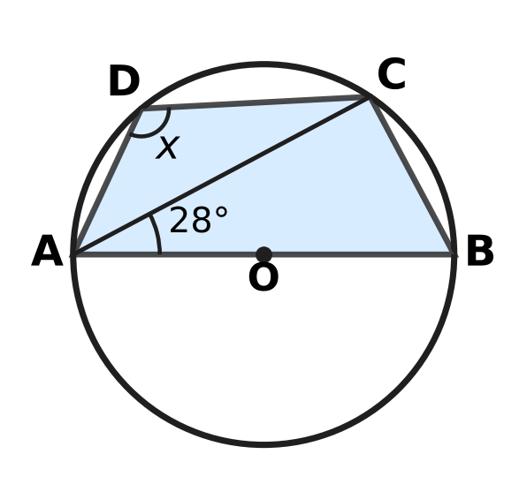
  (A) 90° | (B) 62° | (C) 118° | (D) 152°

Part 5 — Mensuration (Syllabus Chapter 6)
Q21. The wheel of Mei's bicycle has a diameter of 70 cm. How many complete turns does the wheel make in going 1.1 km? (Use π = $\frac{22}{7}$.)
(A) 250 | (B) 500 | (C) 50 | (D) 1,000

Q22. Farhan's vegetable plot is a triangle with sides 11 m, 13 m and 20 m, as shown. What is the area of the plot? | 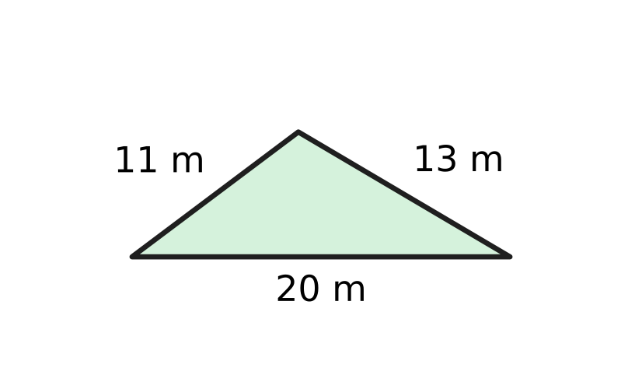
  (A) 66 m² | (B) 71.5 m² | (C) 130 m² | (D) 110 m²

Q23. A glass paperweight is a pyramid with a square base of side 12 cm and a height of 8 cm, as shown. What is its volume? | 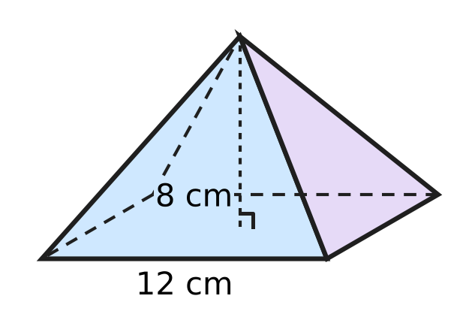
  (A) 576 cm³ | (B) 384 cm³
  (C) 32 cm³ | (D) 1,152 cm³

Q24. The figure shows a sector of a circle of radius 21 cm cut from paper. Its perimeter (two radii and the arc) is 75 cm. What is the angle θ of the sector? (Use π = $\frac{22}{7}$.) | 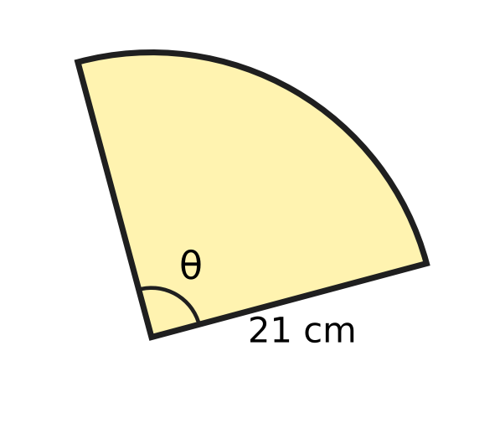
  (A) 120° | (B) 180° | (C) 90° | (D) 45°

Q25. A ball fits exactly inside a closed cylindrical tin: it touches the base, the lid and the curved side, as shown. What fraction of the tin's volume does the ball fill? | 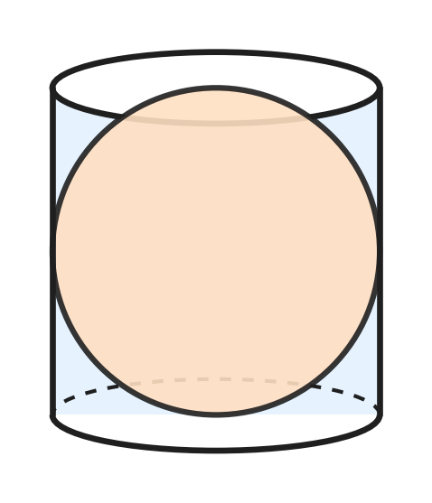
  (A) $\frac{2}{3}$ | (B) $\frac{3}{4}$ | (C) $\frac{1}{3}$ | (D) $\frac{1}{2}$

Part 6 — Data Handling, Statistics & Probability (Syllabus Chapter 8)
Picture for Q26 and Q29
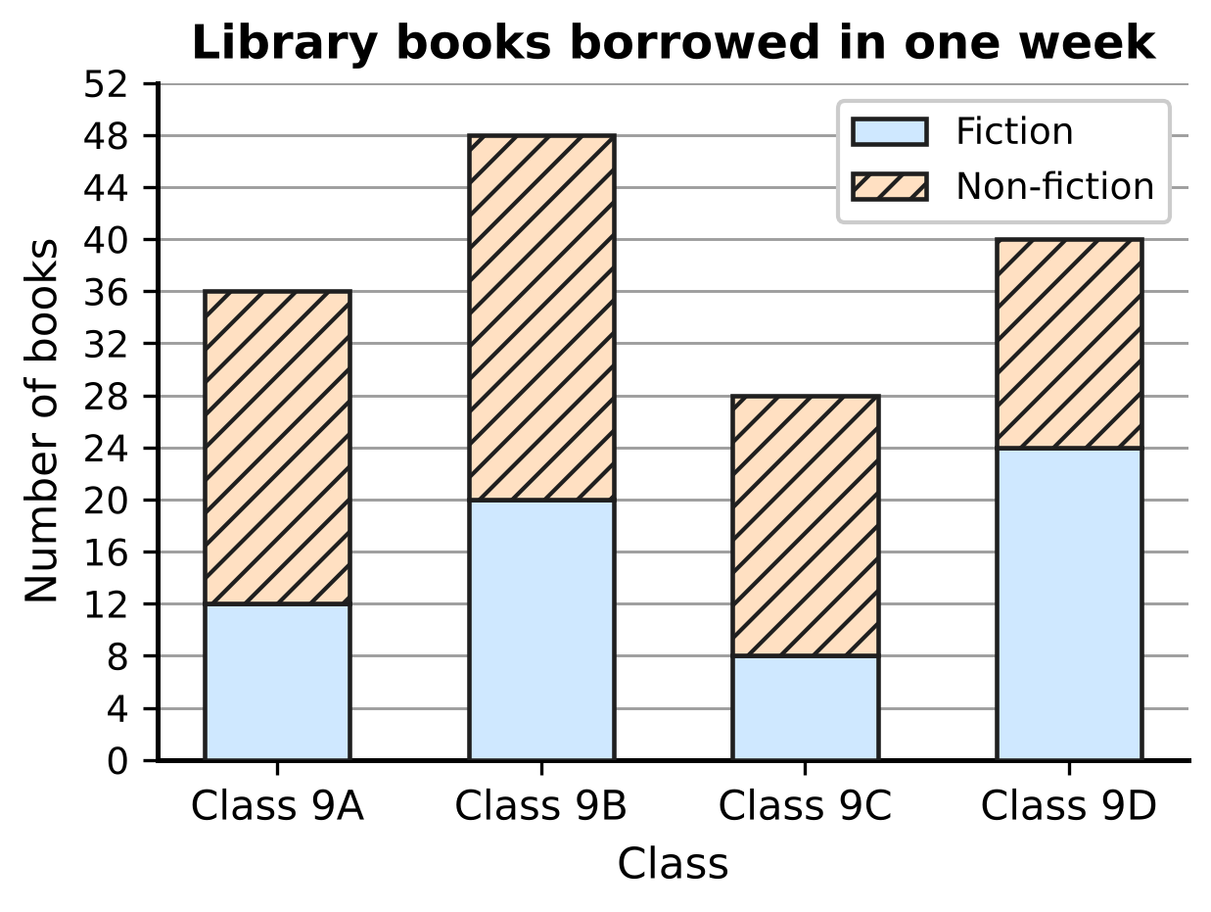
Q26. The stacked bar graph shows the fiction and non-fiction books borrowed from the school library by four classes in one week. How many non-fiction books did the four classes borrow altogether?
(A) 152 | (B) 80 | (C) 64 | (D) 88

Q27. The school bus was late on 18 of the last 60 school days. Use this record to estimate the probability that the bus is late. On about how many of the next 40 school days can the bus be expected to be late?
(A) 20 | (B) 12 | (C) 28 | (D) 18

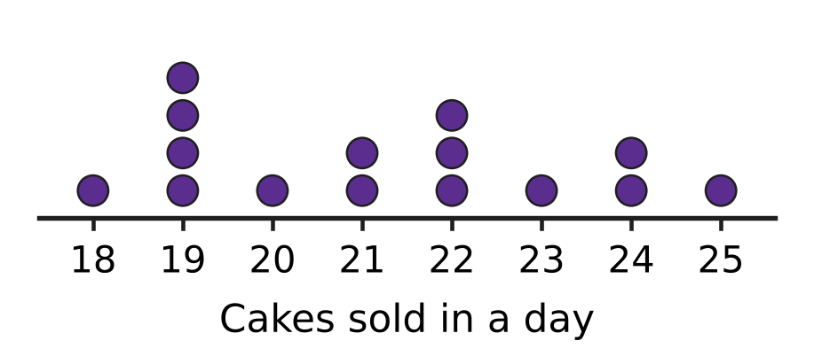
Q28. A bakery recorded the number of cakes it sold on each of 15 days. Each dot in the dot plot in the picture stands for one day. What is the median number of cakes sold in a day?
(A) 21 | (B) 21.5 | (C) 19 | (D) 22

Picture for Q26 and Q29
Q29. Use the same stacked bar graph of library books. In which class was the FRACTION of non-fiction books (out of all books borrowed by that class) the greatest?
(A) Class 9A | (B) Class 9B | (C) Class 9C | (D) Class 9D

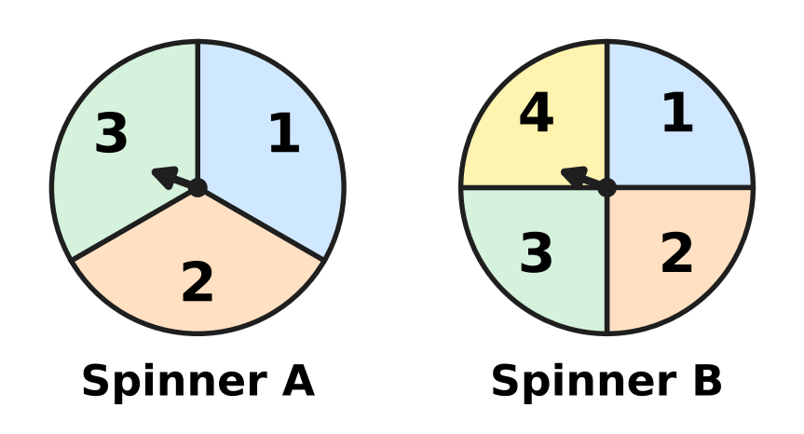
Q30. Spinner A has 3 equal parts and Spinner B has 4 equal parts, numbered as shown. Both are spun once and the two numbers are multiplied. What is the probability that the product is greater than 6?
(A) $\frac{3}{4}$ | (B) $\frac{5}{12}$ | (C) $\frac{3}{7}$ | (D) $\frac{1}{4}$

Part 7 — Applied Mathematics (Syllabus Chapter 9)
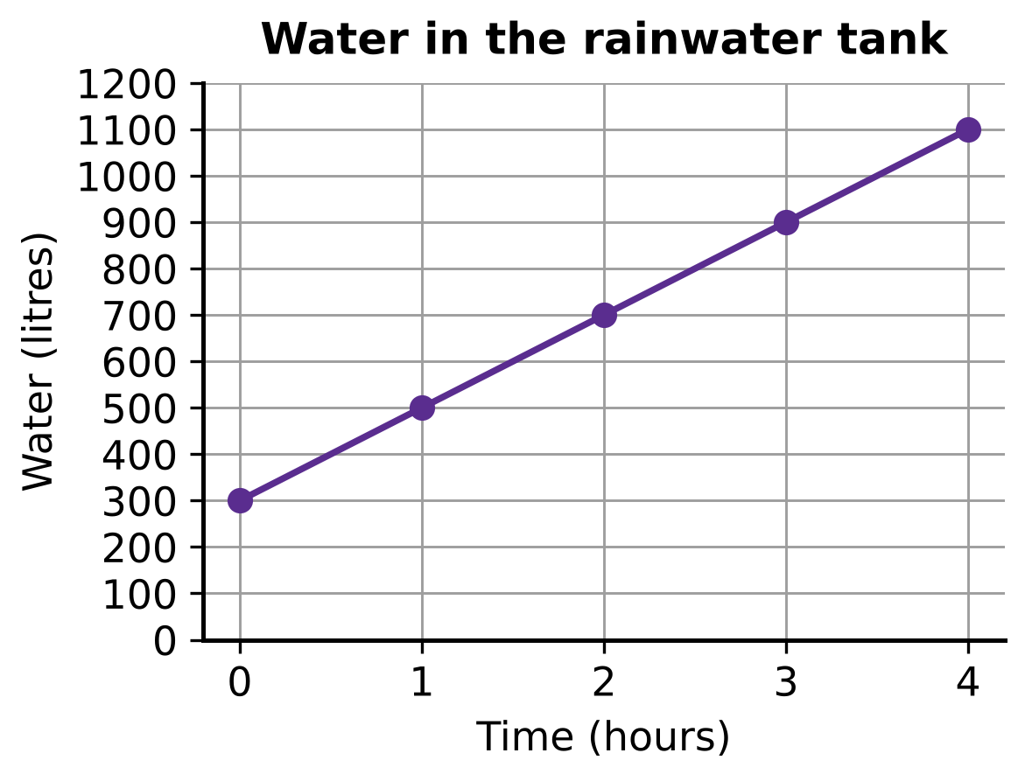
Q31. During steady rain, the water in a rainwater tank rises as shown in the graph. If it keeps rising at the same rate, how many litres of water will be in the tank after 10 hours? (The tank does not overflow.)
(A) 3,000 L | (B) 2,500 L | (C) 2,300 L | (D) 2,000 L

Q32. On the map of an apple orchard, F and G are two trees, and each unit on the grid stands for 40 m. What is the straight-line distance between the two trees? | 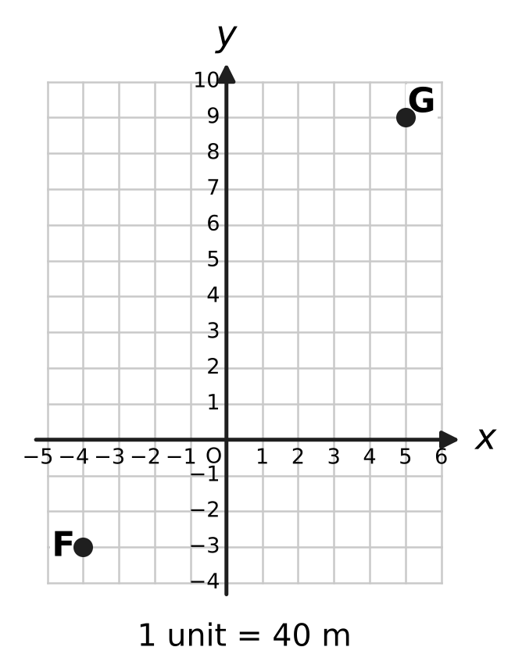
  (A) 360 m | (B) 480 m | (C) 600 m | (D) 840 m

Q33. The ages of Uday and his mother add up to 48 years. Six years ago, his mother was 5 times as old as Uday was then. How old is Uday now?
(A) 12 years | (B) 13 years | (C) 36 years | (D) 8 years

Q34. Vanya saves ₹50 in the first week. Each week after that she saves ₹15 more than in the week before. In which week does she first save more than ₹400 in that single week?
(A) Week 24 | (B) Week 23 | (C) Week 27 | (D) Week 25

Part 8 — Mathematical Reasoning & Problem-Solving (Syllabus Chapter 10)
Q35. What is the converse of the statement "If two angles form a linear pair, then they add up to 180°"?
(A) If two angles do not form a linear pair, then they do not add up to 180°.
(B) If two angles add up to 180°, then they form a linear pair.
(C) If two angles do not add up to 180°, then they do not form a linear pair.
(D) If two angles form a linear pair, then they are equal.

Q36. Which number is a counterexample to the statement "If a number is a multiple of 4, then it is a multiple of 8"?
(A) 28 | (B) 56 | (C) 14 | (D) 48

Q37. Follow the flowchart. What number does it print? | 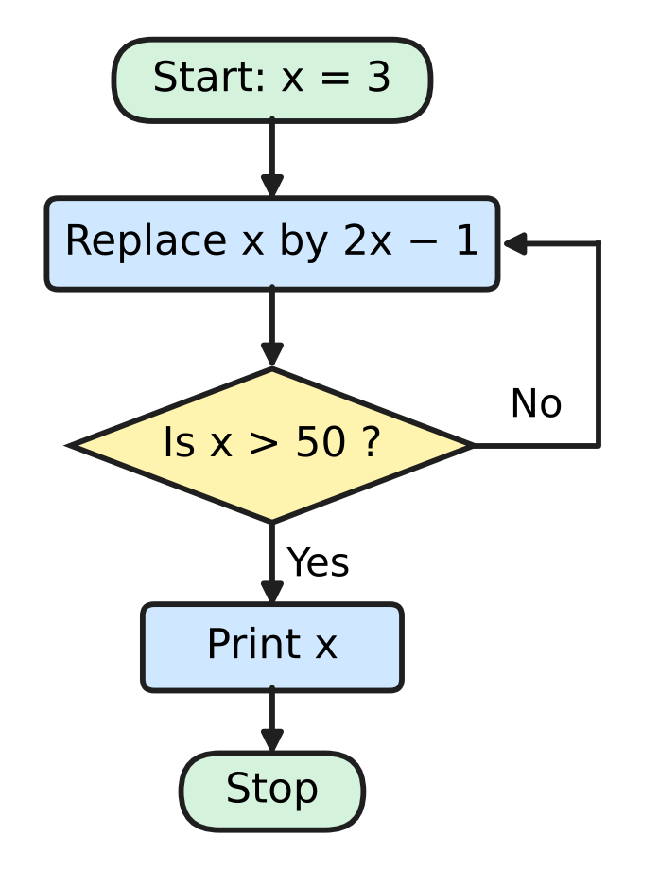
  (A) 33 | (B) 64 | (C) 65 | (D) 129

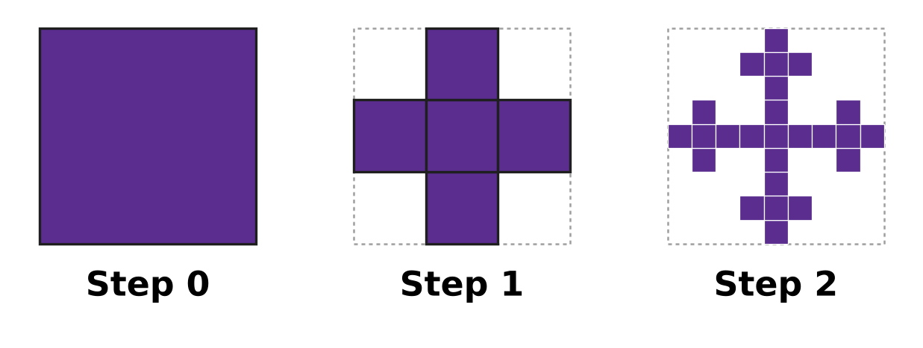
Q38. A fractal is built from a square. At each step, every shaded square is cut into 9 equal squares, and only the middle one and the four that share a side with it are kept shaded. The picture shows Steps 0, 1 and 2. How many small shaded squares are there at Step 4?
(A) 3,125 | (B) 20 | (C) 625 | (D) 125

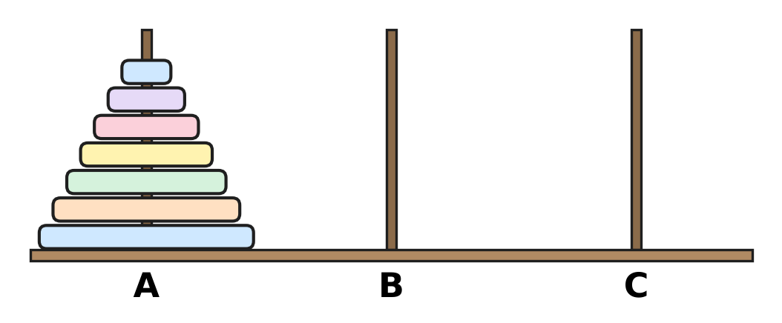
Q39. Seven discs of different sizes are on peg A, as shown. They are moved to peg C in the least possible number of moves: one disc at a time, never a larger disc on a smaller one. How many times does the third-smallest disc move?
(A) 32 | (B) 16 | (C) 4 | (D) 8

Q40. Leela wants to prove by contradiction: "If n² is a multiple of 3, then n is a multiple of 3", where n is a whole number. What should she assume at the start?
(A) n is a multiple of 3, so n² is a multiple of 3.
(B) n is a multiple of 3 but n² is not a multiple of 3.
(C) n² is not a multiple of 3 and n is not a multiple of 3.
(D) n² is a multiple of 3 but n is not a multiple of 3.

SECTION II — Star Questions 5 questions × 4 marks each
Q41. Kartik runs this algorithm.
Step 1: Put a = 7 and k = 1.
Step 2: Replace a by a × (k + 1) ÷ k.
Step 3: Replace k by k + 1.
Step 4: If k = 40, print a and stop. Otherwise go back to Step 2.
What number does the algorithm print? [4 marks]
(A) 280 | (B) 287 | (C) 273 | (D) 40

Q42. A, B, C and D lie on a circle with centre O and radius 5 cm. AC is a diameter, AB = 6 cm, and D is on the other side of AC with AD = DC, as shown. What is the area of the shaded part of the circle outside ABCD? (Use π = 3.14.) [4 marks] | 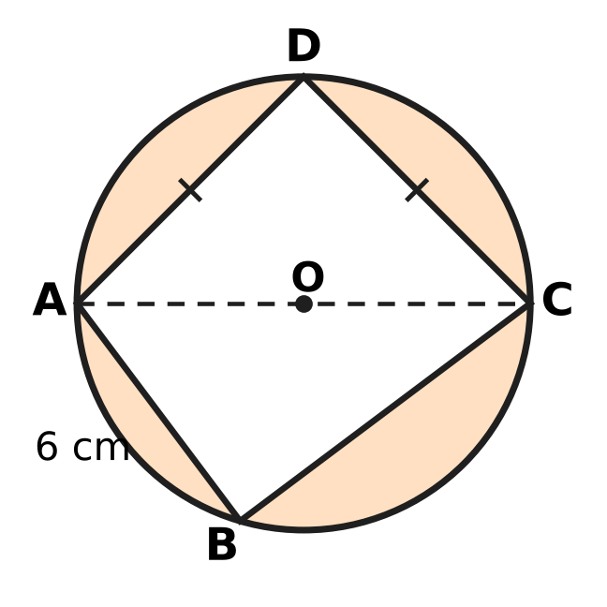
  (A) 54.5 cm² | (B) 265 cm² | (C) 29.5 cm² | (D) 53.5 cm²

Q43. ABCD is a parallelogram with vertices A(6, 1), B(−1, 6) and C(−3, 1), taken in that order. At which point does the diagonal BD cross the y-axis? [4 marks]
(A) (0, 8) | (B) (0, 1) | (C) (0, 6) | (D) (0, 4)

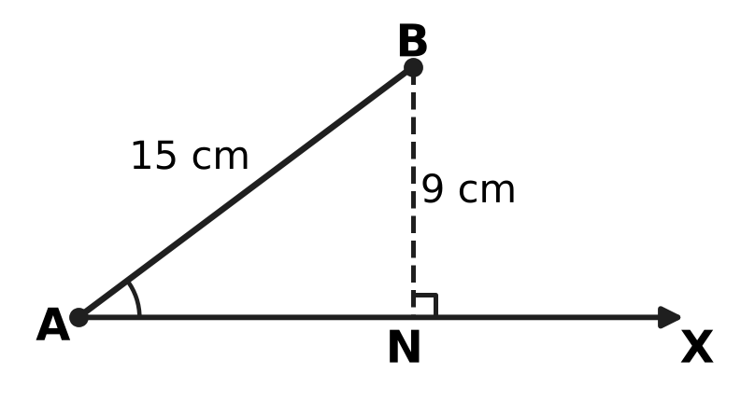
Q44. In the picture, AB = 15 cm and BN = 9 cm, where BN is perpendicular to the ray AX. A point C is placed on the ray AX, not at A, so that BC = r cm. AB and ∠A stay the same; only r changes. A whole number r is chosen at random from 1 to 20. What is the probability that C can be placed at exactly two different points on the ray, giving two different triangles ABC? [4 marks]
(A) $\frac{3}{10}$ | (B) $\frac{1}{4}$ | (C) $\frac{11}{20}$ | (D) $\frac{7}{20}$

Q45. Arnav puts ₹30,000 into two accounts. Account P pays 10% per year simple interest. Account Q pays 10% per year compounded annually. After 2 years the two accounts have earned ₹6,120 interest in total. How much did he put into Account Q? [4 marks]
(A) ₹1,200 | (B) ₹18,000 | (C) ₹15,000 | (D) ₹12,000

Answer Sheet AMO Level 1 · Class 9 · Practice Paper 1
Name: | School: | Roll No.:
Shade or tick one circle for each question.
1. Ⓐ Ⓑ Ⓒ Ⓓ | 16. Ⓐ Ⓑ Ⓒ Ⓓ | 31. Ⓐ Ⓑ Ⓒ Ⓓ
2. Ⓐ Ⓑ Ⓒ Ⓓ | 17. Ⓐ Ⓑ Ⓒ Ⓓ | 32. Ⓐ Ⓑ Ⓒ Ⓓ
3. Ⓐ Ⓑ Ⓒ Ⓓ | 18. Ⓐ Ⓑ Ⓒ Ⓓ | 33. Ⓐ Ⓑ Ⓒ Ⓓ
4. Ⓐ Ⓑ Ⓒ Ⓓ | 19. Ⓐ Ⓑ Ⓒ Ⓓ | 34. Ⓐ Ⓑ Ⓒ Ⓓ
5. Ⓐ Ⓑ Ⓒ Ⓓ | 20. Ⓐ Ⓑ Ⓒ Ⓓ | 35. Ⓐ Ⓑ Ⓒ Ⓓ
6. Ⓐ Ⓑ Ⓒ Ⓓ | 21. Ⓐ Ⓑ Ⓒ Ⓓ | 36. Ⓐ Ⓑ Ⓒ Ⓓ
7. Ⓐ Ⓑ Ⓒ Ⓓ | 22. Ⓐ Ⓑ Ⓒ Ⓓ | 37. Ⓐ Ⓑ Ⓒ Ⓓ
8. Ⓐ Ⓑ Ⓒ Ⓓ | 23. Ⓐ Ⓑ Ⓒ Ⓓ | 38. Ⓐ Ⓑ Ⓒ Ⓓ
9. Ⓐ Ⓑ Ⓒ Ⓓ | 24. Ⓐ Ⓑ Ⓒ Ⓓ | 39. Ⓐ Ⓑ Ⓒ Ⓓ
10. Ⓐ Ⓑ Ⓒ Ⓓ | 25. Ⓐ Ⓑ Ⓒ Ⓓ | 40. Ⓐ Ⓑ Ⓒ Ⓓ
11. Ⓐ Ⓑ Ⓒ Ⓓ | 26. Ⓐ Ⓑ Ⓒ Ⓓ | 41. Ⓐ Ⓑ Ⓒ Ⓓ
12. Ⓐ Ⓑ Ⓒ Ⓓ | 27. Ⓐ Ⓑ Ⓒ Ⓓ | 42. Ⓐ Ⓑ Ⓒ Ⓓ
13. Ⓐ Ⓑ Ⓒ Ⓓ | 28. Ⓐ Ⓑ Ⓒ Ⓓ | 43. Ⓐ Ⓑ Ⓒ Ⓓ
14. Ⓐ Ⓑ Ⓒ Ⓓ | 29. Ⓐ Ⓑ Ⓒ Ⓓ | 44. Ⓐ Ⓑ Ⓒ Ⓓ
15. Ⓐ Ⓑ Ⓒ Ⓓ | 30. Ⓐ Ⓑ Ⓒ Ⓓ | 45. Ⓐ Ⓑ Ⓒ Ⓓ
Q41–Q45 are Section II Star Questions (4 marks each).
For the parent or teacher
Section I correct: ______ / 40 × 2 = ______ marks Section II correct: ______ / 5 × 4 = ______ marks
Correct: ______ / 45 Score: ______ / 100
Answer Key and Solutions AMO Level 1 · Class 9 · Practice Paper 1
Quick answers
1 A | 6 A | 11 B | 16 C | 21 B | 26 D | 31 C | 36 A | 41 A
2 B | 7 D | 12 A | 17 B | 22 A | 27 B | 32 C | 37 C | 42 C
3 A | 8 B | 13 C | 18 D | 23 B | 28 A | 33 A | 38 C | 43 D
4 D | 9 C | 14 A | 19 D | 24 C | 29 C | 34 D | 39 B | 44 B
5 B | 10 D | 15 D | 20 C | 25 A | 30 D | 35 B | 40 D | 45 D
Solutions
Q | Part · level | Answer | Why?
1 | Part 1 · Ch1 · Easy | (A) $\frac{17}{20}$ | The gap from 3/4 to 1 is 1/4, so each part is 1/4 ÷ 5 = 1/20. P is 2 parts after 3/4: 15/20 + 2/20 = 17/20.
2 | Part 1 · Ch1 · Easy | (B) $\frac{14}{45}$ | 27/150 = 9/50 = 0.18, 13/64 = 0.203125 and 21/56 = 3/8 = 0.375 all terminate: each can be written over a power of 10. Dividing, 14/45 = 0.3111…, which recurs.
3 | Part 1 · Ch1 · Medium | (A) 2 | By Pythagoras OB = √2, OC = √3, OD = √4, …, OJ = √10. Only √4 = 2 and √9 = 3 are rational, so 2 of the lengths are rational.
4 | Part 2 · Ch3 · Easy | (D) 1,728 | Each year the number is multiplied by 1,200 ÷ 1,000 = 1.2 (a 20% rise). Year 4: 1,440 × 1.2 = 1,728.
5 | Part 2 · Ch3 · Easy | (B) 70% | Boys passed: 64% of 25 = 16. Girls passed: 80% of 15 = 12. So 28 of the 40 children passed, which is 70%.
6 | Part 2 · Ch3 · Medium | (A) ₹150,000 | In 2 years the value is multiplied by 90,000 ÷ 250,000 = 0.36 = 0.6 × 0.6, so it keeps 0.6 of its value each year (a 40% loss). After 1 year: ₹250,000 × 0.6 = ₹150,000.
7 | Part 3 · Ch4 · Easy | (D) (3x + 1) and (x + 2) | The area is 3x² + 7x + 2 = 3x² + 6x + x + 2 = 3x(x + 2) + 1(x + 2) = (3x + 1)(x + 2).
8 | Part 3 · Ch4 · Easy | (B) $y=−2x+3$ | The line cuts the y-axis at 3. From (0, 3) to (2, −1) it goes 4 down for 2 across, so the slope is −4 ÷ 2 = −2: y = −2x + 3.
9 | Part 3 · Ch4 · Easy | (C) 300 | Total = 1 + 2 + … + 24 = 24 × 25 ÷ 2 = 300.
10 | Part 3 · Ch4 · Easy | (D) 9x − 15y = 12 | Infinitely many solutions need the same line: every term multiplied by the same number. 3 × (3x − 5y) = 3 × 4 gives 9x − 15y = 12.
11 | Part 3 · Ch4 · Medium | (B) 1,170 cm³ | By (a + b)³ = a³ + b³ + 3ab(a + b), the six blocks have volume 3 × 10 × 3 × (10 + 3) = 1,170 cm³ (also 2,197 − 1,000 − 27).
12 | Part 3 · Ch4 · Medium | (A) $\frac{51}{50}$ | x² − 16 = (x − 4)(x + 4) and x² − 2x − 8 = (x − 4)(x + 2), so the expression is (x + 4)/(x + 2) = 102/100 = 51/50.
13 | Part 3 · Ch4 · Medium | (C) 4 | From the 2nd to the 5th term we multiply by r three times: r³ = 324 ÷ 12 = 27, so r = 3. The 1st term is 12 ÷ 3 = 4.
14 | Part 4 · Ch5 · Easy | (A) (−1, 1) | P is (−5, 4) and Q is (3, −2). M = ((−5 + 3) ÷ 2, (4 − 2) ÷ 2) = (−1, 1).
15 | Part 4 · Ch5 · Easy | (D) 84° | ∠BCD = 180° − 84° = 96°. Opposite angles of a cyclic quadrilateral add to 180°, so ∠BAD = 180° − 96° = 84°.
16 | Part 4 · Ch5 · Easy | (C) 42 cm | The perpendicular from the centre bisects the chord. AM = √(29² − 20²) = √441 = 21 cm, so AB = 2 × 21 = 42 cm.
17 | Part 4 · Ch5 · Easy | (B) SSS | AB = AD, CB = CD and AC is common to both triangles: three pairs of equal sides, so the triangles are congruent by SSS.
18 | Part 4 · Ch5 · Medium | (D) 11 | From A to B the line falls 2 for every 3 across. From B (y = 3) to C (y = −3) it falls 6, so it goes 9 across: k = 2 + 9 = 11.
19 | Part 4 · Ch5 · Medium | (D) 24 cm | By the midpoint theorem PQ = SR = ½AC = 5 cm and QR = PS = ½BD = 7 cm. Perimeter = 5 + 7 + 5 + 7 = 24 cm.
20 | Part 4 · Ch5 · Medium | (C) 118° | ∠ACB = 90° (angle in a semicircle), so ∠ABC = 90° − 28° = 62°. ABCD is cyclic, so ∠ADC = 180° − 62° = 118°.
21 | Part 5 · Ch6 · Easy | (B) 500 | One turn covers the circumference πd = 22/7 × 70 = 220 cm. Then 1.1 km = 110,000 cm, and 110,000 ÷ 220 = 500 turns.
22 | Part 5 · Ch6 · Easy | (A) 66 m² | s = (11 + 13 + 20) ÷ 2 = 22. Area = √(22 × 11 × 9 × 2) = √4,356 = 66 m².
23 | Part 5 · Ch6 · Easy | (B) 384 cm³ | Volume = ⅓ × base area × height = ⅓ × 12 × 12 × 8 = 384 cm³.
24 | Part 5 · Ch6 · Medium | (C) 90° | Arc = 75 − 2 × 21 = 33 cm. The full circumference is 2 × 22/7 × 21 = 132 cm, so θ = 33/132 × 360° = 90°.
25 | Part 5 · Ch6 · Medium | (A) $\frac{2}{3}$ | The tin has radius r and height 2r, so its volume is πr² × 2r = 2πr³. The ball's volume is (4/3)πr³, and (4/3) ÷ 2 = 2/3.
26 | Part 6 · Ch8 · Easy | (D) 88 | Non-fiction = top of the bar − top of the fiction part: 9A 36 − 12 = 24, 9B 48 − 20 = 28, 9C 28 − 8 = 20, 9D 40 − 24 = 16. Total = 88.
27 | Part 6 · Ch8 · Easy | (B) 12 | Empirical probability of being late = 18/60 = 0.3. Expected late days = 0.3 × 40 = 12.
28 | Part 6 · Ch8 · Easy | (A) 21 | There are 15 values, so the median is the 8th in order. Counting dots from the left: 1 + 4 + 1 = 6 up to 20, then the 7th and 8th are 21. Median = 21.
29 | Part 6 · Ch8 · Medium | (C) Class 9C | Non-fiction shares: 9A 24/36 = 2/3, 9B 28/48 = 7/12, 9C 20/28 = 5/7, 9D 16/40 = 2/5. The greatest is 5/7, for Class 9C.
30 | Part 6 · Ch8 · Medium | (D) $\frac{1}{4}$ | There are 3 × 4 = 12 equally likely pairs. Products greater than 6: 2 × 4 = 8, 3 × 3 = 9, 3 × 4 = 12, so 3 pairs. Probability = 3/12 = 1/4.
31 | Part 7 · Ch9 · Easy | (C) 2,300 L | The tank starts with 300 L and gains 200 L each hour: water = 300 + 200 × hours. After 10 hours: 300 + 2,000 = 2,300 L.
32 | Part 7 · Ch9 · Easy | (C) 600 m | F is (−4, −3) and G is (5, 9). The gaps are 9 and 12 units, so FG = √(9² + 12²) = 15 units = 15 × 40 = 600 m.
33 | Part 7 · Ch9 · Medium | (A) 12 years | Let Uday be u and his mother m years old: u + m = 48 and m − 6 = 5(u − 6). Then 48 − u − 6 = 5u − 30, so 6u = 72 and u = 12.
34 | Part 7 · Ch9 · Medium | (D) Week 25 | Saving in week n = 50 + 15(n − 1). Week 24: 50 + 345 = ₹395; week 25: 50 + 360 = ₹410. So week 25 is the first.
35 | Part 8 · Ch10 · Easy | (B) If two angles add up to 180°, then they form a linear pair. | The converse of "If P, then Q" is "If Q, then P". Here P is "the angles form a linear pair" and Q is "they add up to 180°".
36 | Part 8 · Ch10 · Easy | (A) 28 | A counterexample must make the "if" part true and the "then" part false: 28 is a multiple of 4 (4 × 7) but not of 8.
37 | Part 8 · Ch10 · Easy | (C) 65 | x goes 3 → 5 → 9 → 17 → 33 → 65. The first value more than 50 is 65, so 65 is printed.
38 | Part 8 · Ch10 · Easy | (C) 625 | Each step multiplies the number of shaded squares by 5: 1, 5, 25, 125, 625. At Step 4 there are 5⁴ = 625.
39 | Part 8 · Ch10 · Medium | (B) 16 | The least number of moves is 127. The smallest disc moves on every other move: 64 times. Each larger disc moves half as often: 64, 32, 16, … So the third-smallest moves 16 times.
40 | Part 8 · Ch10 · Medium | (D) n² is a multiple of 3 but n is not a multiple of 3. | To prove "If P, then Q" by contradiction, assume P is true and Q is false: n² is a multiple of 3 but n is not, and show this is impossible.
41 | Section II · Ch4 + Ch10 · Hard | (A) 280 | a goes 7 → 7 × 2/1 = 14 → 14 × 3/2 = 21 → 21 × 4/3 = 28, so after each round a = 7 × k. The fractions cancel, so when k = 40, a = 7 × 40 = 280.
42 | Section II · Ch5 + Ch6 · Hard | (C) 29.5 cm² | ∠ABC = 90° (angle in a semicircle), so BC = √(10² − 6²) = 8 cm and △ABC = 24 cm². D is the midpoint of arc AC, so its height above AC is the radius: △ADC = ½ × 10 × 5 = 25 cm². Shaded area = 3.14 × 25 − 49 = 78.5 − 49 = 29.5 cm².
43 | Section II · Ch4 + Ch5 · Hard | (D) (0, 4) | The diagonals bisect each other, so D = A + C − B = (6 − 3 + 1, 1 + 1 − 6) = (4, −4). Line BD: slope (−4 − 6) ÷ (4 + 1) = −2, so y = −2x + 4. It crosses the y-axis at (0, 4).
44 | Section II · Ch8 + Ch10 · Hard | (B) $\frac{1}{4}$ | The circle of radius r about B meets the ray at two points only when 9 < r < 15. At r = 9 it touches at N, and for r ≥ 15 the second point is at A or behind it. So r = 10, 11, 12, 13, 14: probability 5/20 = 1/4.
45 | Section II · Ch3 + Ch9 · Hard | (D) ₹12,000 | In 2 years ₹100 earns ₹20 simple interest but ₹21 compound interest. If all ₹30,000 earned simple interest the total would be ₹6,000; the extra ₹120 is 1% of Account Q, so Q = ₹12,000 (and P = ₹18,000).

ARYABHATTA MATHS OLYMPIAD
Level 1
PRACTICE PAPER-2
CLASS 9
Total Questions | 45 multiple-choice questions
Total Marks | 100
Time | 60 minutes
Section I | 40 questions × 2 marks = 80 marks
Section II | 5 Star Questions × 4 marks = 20 marks
Negative Marking | No negative marking
Calculator | Not allowed
Chapters | Number System · Fractions, Decimals & Percentages · Algebra · Geometry · Mensuration · Data Handling · Applied Mathematics · Mathematical Reasoning

Instructions to candidates
• This paper has 45 multiple-choice questions. Each question has four answer choices, of which exactly one is correct.
• Section I (Q1–Q40) carries 2 marks per question. Section II (Q41–Q45) carries 4 marks per question.
• There is no negative marking. Unanswered questions score zero.
• Calculators are not permitted. Rough work may be done on a separate sheet.
• Mark your answers on the answer sheet at the end of the paper.
• All figures are not necessarily drawn to scale unless stated.

For parents and teachers
• Print or view this paper in colour. Pictures are part of the questions.
• Parts follow the AMO syllabus chapters. Chapters 2 and 7 are not part of the Class 9 syllabus, so the chapter numbers shown in the Part headings have gaps.
• The answer sheet and the answer key are at the end. Remove only the answer key before the student begins.

SECTION I 40 questions × 2 marks each
Part 1 — Number System (Syllabus Chapter 1)
Q1. Which of these numbers is irrational?
(A) 0.1011111… (the digit 1 repeats for ever)
(B) 0.1011011101111 (the decimal ends after the last 1 shown)
(C) 0.101101101… (the block 101 repeats for ever)
(D) 0.1011011101111… (each group of 1s has one more 1 than the group before it)

Q2. The fraction $\frac{13}{160}$ is written as a decimal. How many digits does it have after the decimal point?
(A) 1 | (B) 4 | (C) 5 | (D) 6

Q3. $\frac{3}{7}$ = 0.428571428571…, where the block 428571 repeats for ever. What is the 50th digit after the decimal point?
(A) 1 | (B) 2 | (C) 4 | (D) 8

Part 2 — Fractions, Decimals & Percentages (Syllabus Chapter 3)
Q4. The number of birds nesting on an island falls by 10% every year. By what percentage does the number fall over 2 years altogether?
(A) 1% | (B) 19% | (C) 20% | (D) 81%

Q5. On a train journey, the train runs for 2 hours at 60 km/h and then for 3 hours at 80 km/h. What is its average speed for the whole journey?
(A) 68 km/h | (B) 70 km/h | (C) 72 km/h | (D) 75 km/h

Q6. Vijay wants to put ₹10,000 into a savings scheme for 2 years. Which of these schemes gives him the most money at the end of the 2 years?
(A) 15% per year, simple interest | (B) 14% per year, compounded annually
(C) 16% per year, simple interest | (D) 15% per year, compounded annually

Part 3 — Algebra (Syllabus Chapter 4)
Q7. Which of these is a polynomial of degree 3?
(A) $(2x−1)(x^{2}+4)$ | (B) $x^{2}(x^{2}+x)$
(C) $x(x^{2}−3)−x^{3}+5$ | (D) $x^{3}+\frac{2}{x}$

Q8. Using an identity, find the value of 1,001² − 999².
(A) 4 | (B) 2,000 | (C) 4,000 | (D) 8,000

Q9. The linear polynomial p(x) = ax + b has p(0) = 5 and p(2) = −1. What is p(4)?
(A) −13 | (B) −7 | (C) −3 | (D) 11

Q10. Which of these numbers is NOT a term of the geometric progression 3, −6, 12, −24, …?
(A) −96 | (B) 48 | (C) 192 | (D) 96

Q11. Which of these is a factor of $6x^{2}+x−15$?
(A) $x+3$ | (B) $3x−5$ | (C) $2x+3$ | (D) $2x−3$

Q12. At a toy shop, a kite costs ₹30 and a ball costs ₹50. Jai spends exactly ₹600 on kites and balls, and he buys at least one of each. In how many different ways can he do this?
(A) 2 | (B) 3 | (C) 4 | (D) 5

Q13. Which term of the arithmetic progression 100, 93, 86, 79, … is its first negative term?
(A) the 14th term | (B) the 15th term
(C) the 16th term | (D) the 17th term

Part 4 — Geometry (Syllabus Chapter 5)
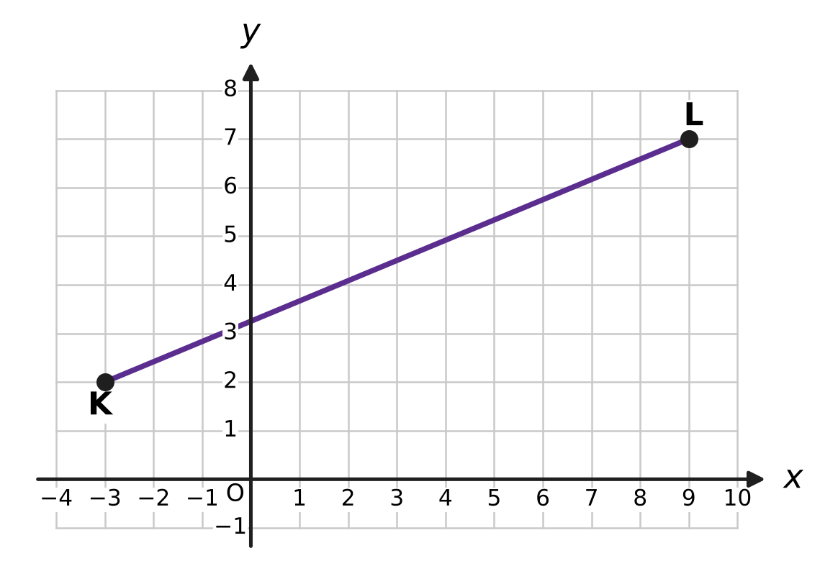
Q14. The points K and L are marked on the grid. What is the length of the segment KL? (Each square of the grid is 1 unit by 1 unit.)
(A) 7 units | (B) 13 units
(C) 17 units | (D) 169 units

Q15. In the figure of △ABC, D is the midpoint of AB and E is the midpoint of AC, as the marks show. ∠ADE = 64° and ∠AED = 50°. What is ∠ABC, marked x? | 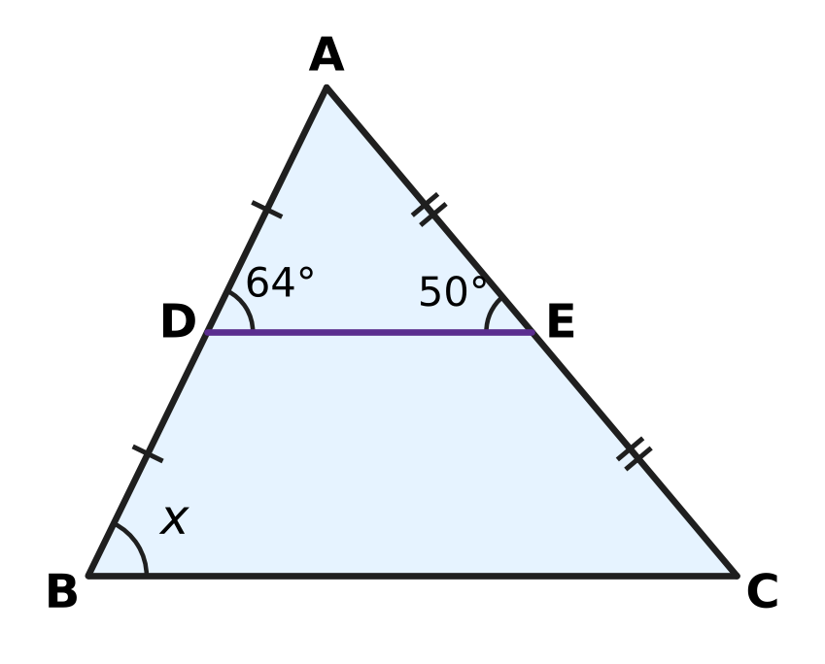
  (A) 64° | (B) 66° | (C) 50° | (D) 116°

Q16. Which of these quadrilaterals must be a parallelogram?
(A) a quadrilateral in which both pairs of opposite angles are equal
(B) a quadrilateral whose diagonals are perpendicular
(C) a quadrilateral whose diagonals are equal
(D) a quadrilateral in which one pair of opposite sides is parallel and the other pair is equal

Q17. The angles ∠A, ∠B, ∠C, ∠D of a quadrilateral ABCD are listed in that order. For which of these can A, B, C and D all lie on one circle?
(A) 85°, 95°, 85°, 95° | (B) 100°, 80°, 70°, 110°
(C) 60°, 120°, 110°, 70° | (D) 75°, 115°, 105°, 65°

Q18. A, B and C lie on a circle with centre O. C is on the minor arc AB and ∠ACB = 118°, as shown. What is ∠AOB, marked x? | 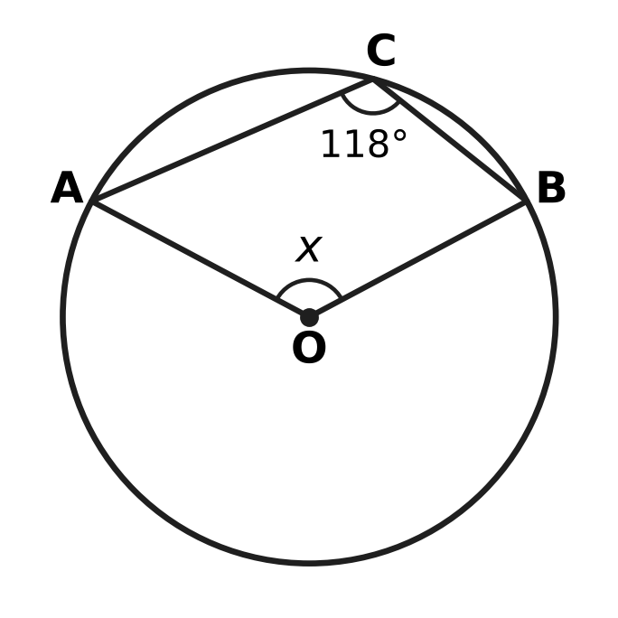
  (A) 124° | (B) 236° | (C) 59° | (D) 118°

Q19. The side lengths of four triangles are given. For which of these triangles does the circumcentre lie OUTSIDE the triangle?
(A) 7 cm, 8 cm, 10 cm | (B) 10 cm, 10 cm, 14 cm
(C) 8 cm, 15 cm, 17 cm | (D) 9 cm, 12 cm, 16 cm

Q20. ABCD is a parallelogram with ∠DAB = 76°. The bisector of ∠DAB meets the side DC at P, as shown. What is ∠APC, marked x? | 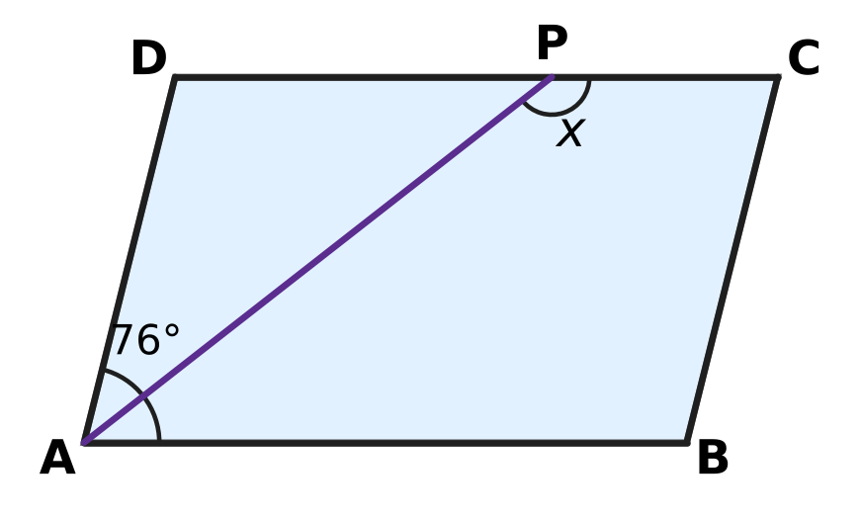
  (A) 142° | (B) 114° | (C) 104° | (D) 38°

Part 5 — Mensuration (Syllabus Chapter 6)
Q21. Which of these shapes has the same area as a circle of radius 14 cm? (Use π = $\frac{22}{7}$.)
(A) a square of side 25 cm
(B) a rectangle 88 cm long and 14 cm wide
(C) a triangle with base 44 cm and height 14 cm
(D) a rectangle 44 cm long and 14 cm wide

Q22. Simran's juice can is a closed cylinder with radius 3.5 cm and height 10 cm, as shown. How much juice can it hold when full? (Use π = $\frac{22}{7}$.) | 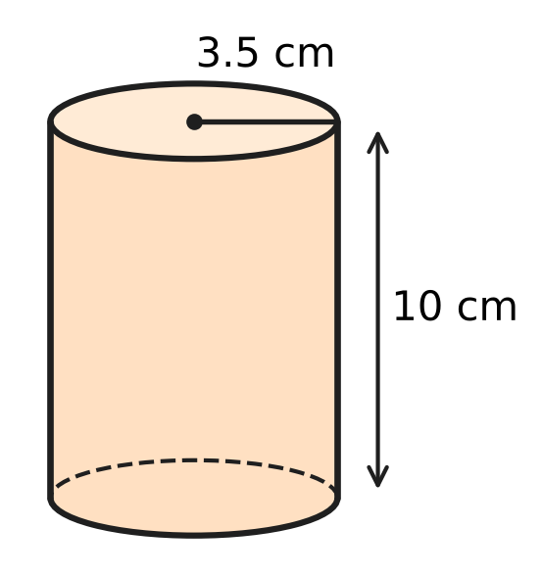
  (A) 110 cm³ | (B) 220 cm³
  (C) 385 cm³ | (D) 1,540 cm³

Q23. A curved stretch of road is an arc of a circle of radius 630 m. The arc makes an angle of 40° at the centre of the circle. How long is the curved stretch? (Use π = $\frac{22}{7}$.)
(A) 220 m | (B) 440 m | (C) 880 m | (D) 3,960 m

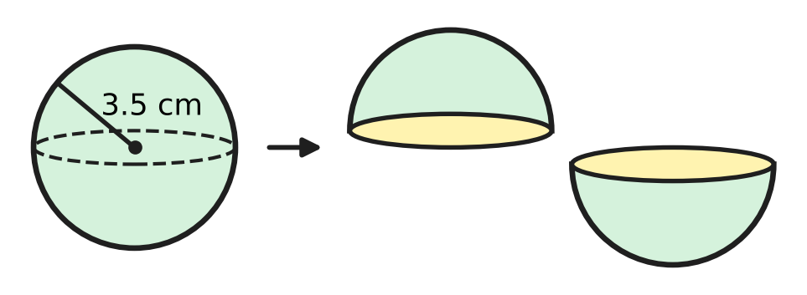
Q24. Kush has a solid wooden ball of radius 3.5 cm. He cuts it into two equal halves, as shown. By how much is the total surface area of the two halves more than the surface area of the ball? (Use π = $\frac{22}{7}$.)
(A) 38.5 cm² | (B) 77 cm²
(C) 115.5 cm² | (D) 154 cm²

Q25. A triangular plot ABC has sides 13 m, 20 m and 21 m, as shown. A straight fence runs from A to M, the midpoint of BC. What is the area of each of the two parts? | 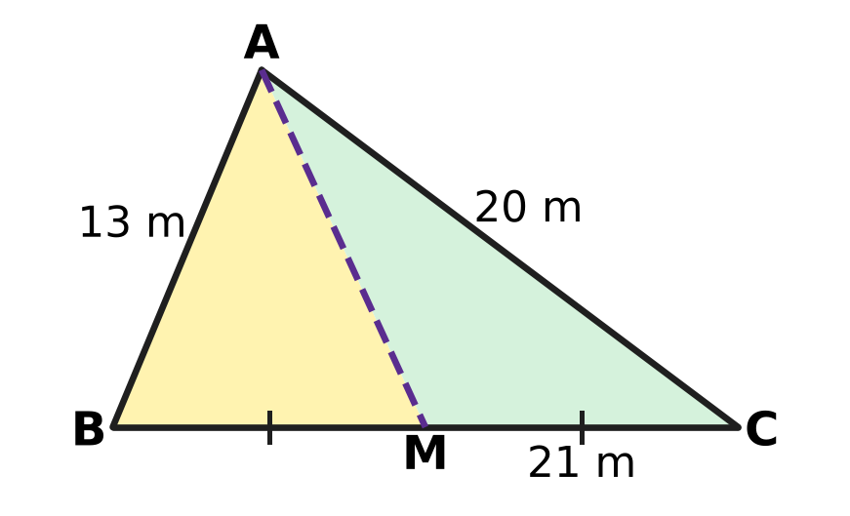
  (A) 42 m² | (B) 63 m² | (C) 65 m² | (D) 126 m²

Part 6 — Data Handling, Statistics & Probability (Syllabus Chapter 8)
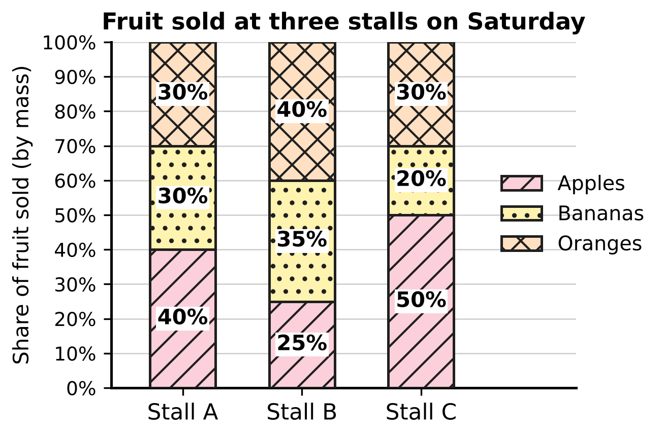
Q26. The 100% stacked bar graph shows how the fruit sold at three stalls of a fruit market on Saturday was shared among apples, bananas and oranges. Stall B sold 400 kg of fruit in all. How many kilograms of bananas did Stall B sell?
(A) 35 kg | (B) 100 kg | (C) 140 kg | (D) 160 kg

Pihu's 200 throws
Number on the die | 1 | 2 | 3 | 4 | 5 | 6
Number of times | 30 | 36 | 28 | 40 | 32 | 34

Q27. Pihu throws a die 200 times and records the results in the table. Based on her results, what is the empirical probability of getting a number greater than 4?
(A) 0.17 | (B) 0.33 | (C) 0.53 | (D) 0.66

Q28. Which of these events has a probability of exactly one half?
(A) a fair die shows a number greater than 2
(B) two fair coins tossed together show at least one tail
(C) a card drawn at random from cards numbered 1 to 12 shows a factor of 12
(D) a card drawn at random from cards numbered 1 to 20 shows a prime number

Q29. Mahi has a bag with 1 red bead and 3 green beads for a necklace. She takes a bead at random, notes its colour and puts it back. Then she takes a bead at random again. What is the probability that both beads are the same colour?
(A) $\frac{5}{8}$ | (B) $\frac{1}{2}$ | (C) $\frac{9}{16}$ | (D) $\frac{3}{8}$

Q30. A teacher worked out the mean of 10 test scores as 24. Later she found that a score of 47 had been copied as 74. What is the correct mean of the 10 scores?
(A) 21 | (B) 21.3 | (C) 23.7 | (D) 26.7

Part 7 — Applied Mathematics (Syllabus Chapter 9)
Q31. On a floor plan of a classroom, 1 unit stands for 50 cm. The teacher's table is at the origin (0, 0). Which of these desks is exactly 2.5 m (in a straight line) from the teacher's table?
(A) Desk L at (2, 3) | (B) Desk M at (2.5, 0)
(C) Desk K at (3, 4) | (D) Desk N at (5, 5)

Q32. Before sports day, four children practise penalty kicks. Their records are given below. Using these records, which child is the most likely to score with the next kick?
(A) Jaya: 20 goals from 30 kicks | (B) Mihir: 26 goals from 40 kicks
(C) Geeta: 33 goals from 50 kicks | (D) Pavan: 17 goals from 25 kicks

Q33. At a picnic in the park, every sandwich has the same price and every juice has the same price. Veena says, "3 sandwiches and 2 juices cost ₹130, and 6 sandwiches and 4 juices cost ₹250." Which of these is true?
(A) A sandwich costs ₹30 and a juice costs ₹20.
(B) Any prices that fit the first statement also fit the second.
(C) A sandwich costs ₹20 and a juice costs ₹35.
(D) Veena's two statements cannot both be correct.

Q34. Gaurav paints a fence 65 m long. He paints 2 m on the first day, 3 m on the second day, and each day after that 1 m more than on the day before. On which day does he finish the fence?
(A) Day 9 | (B) Day 10 | (C) Day 11 | (D) Day 33

Part 8 — Mathematical Reasoning & Problem-Solving (Syllabus Chapter 10)
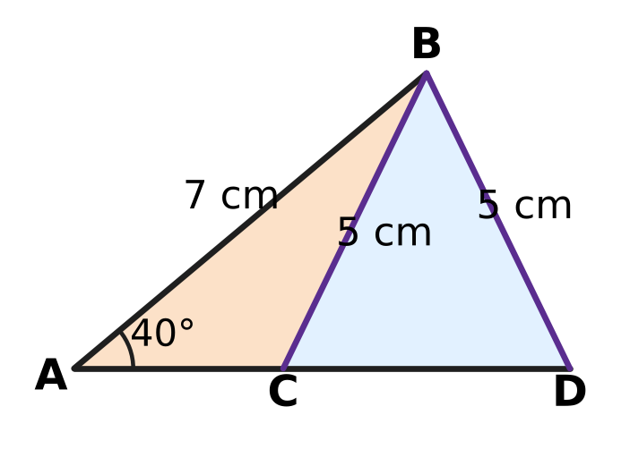
Q35. Yuvan drew the figure. In △ABC and △ABD, AB = 7 cm is common, the angle at A is 40° in both, and BC = BD = 5 cm. The two triangles are clearly different. Which of these does the figure show?
(A) Two sides and the included angle do not always fix a triangle.
(B) Three sides do not always fix a triangle.
(C) Two sides and a non-included angle do not always fix a triangle.
(D) Two triangles with one equal side and one equal angle are always congruent.

Q36. Which of these is a special case of the result "The diagonals of a parallelogram bisect each other"?
(A) The diagonals of a rectangle bisect each other.
(B) If the diagonals of a quadrilateral bisect each other, it is a parallelogram.
(C) The diagonals of any quadrilateral bisect each other.
(D) The diagonals of a rectangle are equal.

Q37. Atharv follows this algorithm. Step 1: Write down 79,868. Step 2: Replace the number by the sum of its digits. Step 3: If the number has more than one digit, go back to Step 2; otherwise print it and stop. What number is printed?
(A) 2 | (B) 9 | (C) 11 | (D) 38

Q38. A sequence has the recursive rule $a_{1}=2$ and $a_{n}=2a_{n−1}+1$. Which of these explicit rules gives the same sequence?
(A) $a_{n}=3n−1$ | (B) $a_{n}=n^{2}+1$
(C) $a_{n}=3×2^{n−1}−1$ | (D) $a_{n}=\frac{n(n+3)}{2}$

Q39. An algorithm starts with a whole number. In each step, if the number is even it is halved, and if it is odd 1 is subtracted from it. The algorithm stops when the number becomes 1. Which of these starting numbers needs the most steps?
(A) 63 | (B) 64 | (C) 96 | (D) 100

Q40. Which of these statements is TRUE but has a FALSE converse?
(A) If a triangle has two equal sides, then it has two equal angles.
(B) If x² = 49, then x = 7.
(C) If a whole number ends in 0 or 5, then it is divisible by 5.
(D) If a quadrilateral is a rhombus, then its diagonals are perpendicular to each other.

SECTION II — Star Questions 5 questions × 4 marks each
Q41. Tanya's algorithm builds a list of whole numbers.
(1) Write 7 as the first number of the list.
(2) Add 6 to the last number in the list. If the result is less than 1,000, write it in the list and repeat instruction (2); if not, stop.
How many numbers in the finished list are perfect squares? [4 marks]
(A) 10 | (B) 5 | (C) 15 | (D) 11

Q42. A, B, C and D lie in that order on a circle with centre O and radius 42 cm. In the cyclic quadrilateral ABCD, ∠ABC = 5 × ∠ADC. The chord AC cuts off the shaded minor segment, as shown. Take π = $\frac{22}{7}$. What is the perimeter of the shaded segment? [4 marks] | 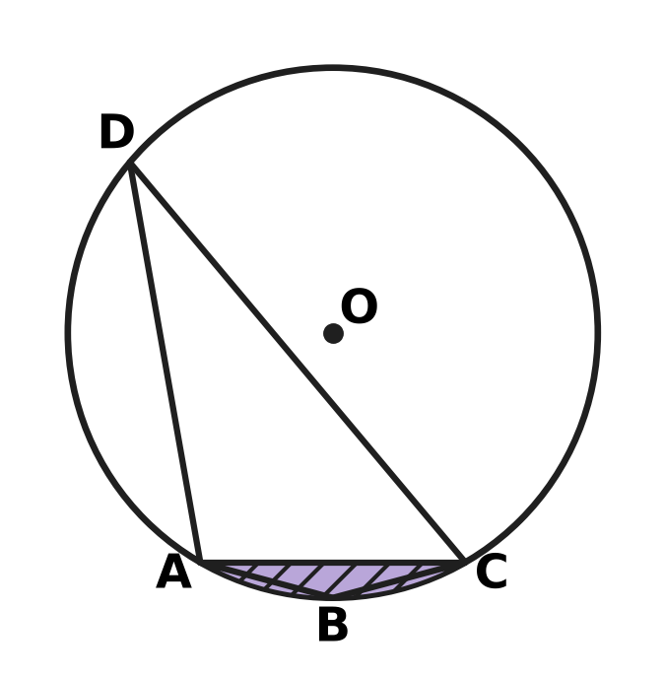
  (A) 44 cm | (B) 86 cm | (C) 128 cm | (D) 262 cm

Q43. The lines y = 2x + 1 and x + 2y = 12 meet at the point P. The first line cuts the y-axis at A and the second line cuts the y-axis at B. Which of these is the centre of the circle that passes through P, A and B? [4 marks]
(A) $(\frac{2}{3},4)$ | (B) (1, 5.5) | (C) (0, 3.5) | (D) (1, 3)

Q44. Lena starts with the number 1 and tosses a fair coin three times. After each toss she changes her number: for heads (H) she multiplies it by 3, and for tails (T) she adds 5 to it. The tree diagram shows the 8 equally likely ways the three tosses can fall. What is the probability that her final number is greater than 25? [4 marks] | 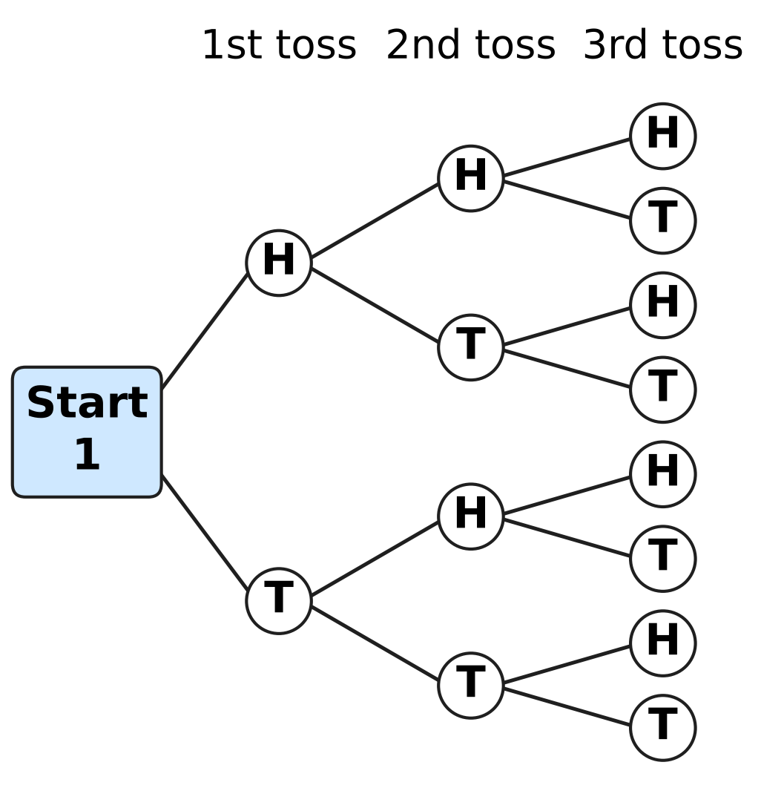
  (A) $\frac{3}{8}$ | (B) $\frac{5}{8}$ | (C) $\frac{1}{8}$ | (D) $\frac{1}{2}$

Q45. A fish farm has 2,000 fish at the start. During each year the number of fish grows by 50%. At the end of each of the 2 years, Umesh sells the same number of fish. Just after the second sale there are 3,000 fish. How many fish does he sell each year? [4 marks]
(A) 500 | (B) 600 | (C) 750 | (D) 1,500

Answer Sheet AMO Level 1 · Class 9 · Practice Paper 2
Name: | School: | Roll No.:
Shade or tick one circle for each question.
1. Ⓐ Ⓑ Ⓒ Ⓓ | 16. Ⓐ Ⓑ Ⓒ Ⓓ | 31. Ⓐ Ⓑ Ⓒ Ⓓ
2. Ⓐ Ⓑ Ⓒ Ⓓ | 17. Ⓐ Ⓑ Ⓒ Ⓓ | 32. Ⓐ Ⓑ Ⓒ Ⓓ
3. Ⓐ Ⓑ Ⓒ Ⓓ | 18. Ⓐ Ⓑ Ⓒ Ⓓ | 33. Ⓐ Ⓑ Ⓒ Ⓓ
4. Ⓐ Ⓑ Ⓒ Ⓓ | 19. Ⓐ Ⓑ Ⓒ Ⓓ | 34. Ⓐ Ⓑ Ⓒ Ⓓ
5. Ⓐ Ⓑ Ⓒ Ⓓ | 20. Ⓐ Ⓑ Ⓒ Ⓓ | 35. Ⓐ Ⓑ Ⓒ Ⓓ
6. Ⓐ Ⓑ Ⓒ Ⓓ | 21. Ⓐ Ⓑ Ⓒ Ⓓ | 36. Ⓐ Ⓑ Ⓒ Ⓓ
7. Ⓐ Ⓑ Ⓒ Ⓓ | 22. Ⓐ Ⓑ Ⓒ Ⓓ | 37. Ⓐ Ⓑ Ⓒ Ⓓ
8. Ⓐ Ⓑ Ⓒ Ⓓ | 23. Ⓐ Ⓑ Ⓒ Ⓓ | 38. Ⓐ Ⓑ Ⓒ Ⓓ
9. Ⓐ Ⓑ Ⓒ Ⓓ | 24. Ⓐ Ⓑ Ⓒ Ⓓ | 39. Ⓐ Ⓑ Ⓒ Ⓓ
10. Ⓐ Ⓑ Ⓒ Ⓓ | 25. Ⓐ Ⓑ Ⓒ Ⓓ | 40. Ⓐ Ⓑ Ⓒ Ⓓ
11. Ⓐ Ⓑ Ⓒ Ⓓ | 26. Ⓐ Ⓑ Ⓒ Ⓓ | 41. Ⓐ Ⓑ Ⓒ Ⓓ
12. Ⓐ Ⓑ Ⓒ Ⓓ | 27. Ⓐ Ⓑ Ⓒ Ⓓ | 42. Ⓐ Ⓑ Ⓒ Ⓓ
13. Ⓐ Ⓑ Ⓒ Ⓓ | 28. Ⓐ Ⓑ Ⓒ Ⓓ | 43. Ⓐ Ⓑ Ⓒ Ⓓ
14. Ⓐ Ⓑ Ⓒ Ⓓ | 29. Ⓐ Ⓑ Ⓒ Ⓓ | 44. Ⓐ Ⓑ Ⓒ Ⓓ
15. Ⓐ Ⓑ Ⓒ Ⓓ | 30. Ⓐ Ⓑ Ⓒ Ⓓ | 45. Ⓐ Ⓑ Ⓒ Ⓓ
Q41–Q45 are Section II Star Questions (4 marks each).
For the parent or teacher
Section I correct: ______ / 40 × 2 = ______ marks Section II correct: ______ / 5 × 4 = ______ marks
Correct: ______ / 45 Score: ______ / 100
Answer Key and Solutions AMO Level 1 · Class 9 · Practice Paper 2
Quick answers
1 D | 6 D | 11 D | 16 A | 21 D | 26 C | 31 C | 36 A | 41 A
2 C | 7 A | 12 B | 17 D | 22 C | 27 B | 32 D | 37 A | 42 B
3 B | 8 C | 13 C | 18 A | 23 B | 28 C | 33 D | 38 C | 43 C
4 B | 9 B | 14 B | 19 D | 24 B | 29 A | 34 B | 39 A | 44 A
5 C | 10 D | 15 A | 20 A | 25 B | 30 B | 35 C | 40 D | 45 B
Solutions
Q | Part · level | Answer | Why?
1 | Part 1 · Ch1 · Easy | (D) 0.1011011101111… | A rational number has a decimal that ends or repeats a fixed block. 0.1011011101111… never ends and, because the groups of 1s keep getting longer, no block repeats, so it is irrational.
2 | Part 1 · Ch1 · Easy | (C) 5 | Since 160 = 2⁵ × 5, multiply top and bottom by 5⁴: 13/160 = 8,125/100,000 = 0.08125, which has 5 digits after the point.
3 | Part 1 · Ch1 · Medium | (B) 2 | The block has 6 digits. Since 50 = 6 × 8 + 2, after 8 full blocks the 50th digit is the 2nd digit of 428571, which is 2.
4 | Part 2 · Ch3 · Easy | (B) 19% | Each year the number is multiplied by 0.9, so after 2 years it is 0.9 × 0.9 = 0.81 of the start. It has fallen by 19%.
5 | Part 2 · Ch3 · Easy | (C) 72 km/h | Distance = 2 × 60 + 3 × 80 = 360 km in 5 hours, so the average speed is 360 ÷ 5 = 72 km/h.
6 | Part 2 · Ch3 · Medium | (D) 15% per year, compounded annually | After 2 years: 15% compound gives 10,000 × 1.15 × 1.15 = ₹13,225; 16% simple gives ₹13,200; 15% simple gives ₹13,000; 14% compound gives ₹12,996. So 15% compound is the most.
7 | Part 3 · Ch4 · Easy | (A) $(2x−1)(x^{2}+4)$ | (2x − 1)(x² + 4) = 2x³ − x² + 8x − 4, of degree 3. The others are −3x + 5 (degree 1), x⁴ + x³ (degree 4) and x³ + 2/x (not a polynomial).
8 | Part 3 · Ch4 · Easy | (C) 4,000 | a² − b² = (a + b)(a − b) = (1,001 + 999) × (1,001 − 999) = 2,000 × 2 = 4,000.
9 | Part 3 · Ch4 · Easy | (B) −7 | b = p(0) = 5 and 2a + 5 = −1, so a = −3. Then p(4) = −3 × 4 + 5 = −7.
10 | Part 3 · Ch4 · Easy | (D) 96 | The terms are 3 × (−2)^{n−1}: 3, −6, 12, −24, 48, −96, 192, … The term with 2⁵ is 3 × (−32) = −96, so 96 never appears.
11 | Part 3 · Ch4 · Medium | (D) $2x−3$ | Split x as 10x − 9x (10 × (−9) = 6 × (−15)): 6x² + 10x − 9x − 15 = 2x(3x + 5) − 3(3x + 5) = (2x − 3)(3x + 5).
12 | Part 3 · Ch4 · Medium | (B) 3 | For k kites and b balls, 30k + 50b = 600, so 3k + 5b = 60 and k must be a multiple of 5. With k, b ≥ 1: (5, 9), (10, 6), (15, 3) — 3 ways.
13 | Part 3 · Ch4 · Medium | (C) the 16th term | The nth term is 100 − 7(n − 1). The 15th term is 100 − 98 = 2 and the 16th term is 100 − 105 = −5, so the 16th term is the first negative one.
14 | Part 4 · Ch5 · Easy | (B) 13 units | Across: 9 − (−3) = 12. Up: 7 − 2 = 5. KL = √(12² + 5²) = √169 = 13 units.
15 | Part 4 · Ch5 · Easy | (A) 64° | By the midpoint theorem DE ∥ BC, so ∠ABC and ∠ADE are corresponding angles. ∠ABC = 64°.
16 | Part 4 · Ch5 · Easy | (A) both pairs of opposite angles equal | If both pairs of opposite angles are equal, each pair of adjacent angles adds up to 180°, so both pairs of opposite sides are parallel. A kite fits (B) and an isosceles trapezium fits (C) and (D), but neither is a parallelogram.
17 | Part 4 · Ch5 · Easy | (D) 75°, 115°, 105°, 65° | A quadrilateral is cyclic exactly when its opposite angles add up to 180°. Only 75° + 105° = 180° and 115° + 65° = 180° works.
18 | Part 4 · Ch5 · Medium | (A) 124° | ∠ACB stands on the major arc AB, so the reflex angle AOB = 2 × 118° = 236°. The marked angle is 360° − 236° = 124°.
19 | Part 4 · Ch5 · Medium | (D) 9 cm, 12 cm, 16 cm | The circumcentre is outside only for an obtuse triangle, where the square of the longest side is more than the sum of the other two squares. 9² + 12² = 225 < 16² = 256, so that triangle is obtuse.
20 | Part 4 · Ch5 · Medium | (A) 142° | ∠PAB = 76° ÷ 2 = 38°. DC ∥ AB, so ∠DPA = ∠PAB = 38° (alternate angles). ∠APC = 180° − 38° = 142°.
21 | Part 5 · Ch6 · Easy | (D) a rectangle 44 cm long and 14 cm wide | Area of the circle = $\frac{22}{7}$ × 14 × 14 = 616 cm². A rectangle 44 cm × 14 cm (half the circumference × the radius) also has area 616 cm².
22 | Part 5 · Ch6 · Easy | (C) 385 cm³ | Volume = πr²h = $\frac{22}{7}$ × 3.5 × 3.5 × 10 = 385 cm³.
23 | Part 5 · Ch6 · Easy | (B) 440 m | Circumference = 2 × $\frac{22}{7}$ × 630 = 3,960 m. The arc is $\frac{40}{360}$ = $\frac{1}{9}$ of it: 3,960 ÷ 9 = 440 m.
24 | Part 5 · Ch6 · Medium | (B) 77 cm² | Cutting makes two new flat circles, each of area πr² = $\frac{22}{7}$ × 3.5 × 3.5 = 38.5 cm². The increase is 2 × 38.5 = 77 cm².
25 | Part 5 · Ch6 · Medium | (B) 63 m² | Heron: s = 27, area = √(27 × 14 × 7 × 6) = √(3⁴ × 2² × 7²) = 9 × 2 × 7 = 126 m². The median AM splits the triangle into two parts of equal area, 126 ÷ 2 = 63 m².
26 | Part 6 · Ch8 · Easy | (C) 140 kg | Bananas are 35% of Stall B's 400 kg: 35% of 400 = 140 kg.
27 | Part 6 · Ch8 · Easy | (B) 0.33 | Numbers greater than 4 are 5 and 6: 32 + 34 = 66 of the 200 throws. Empirical probability = 66 ÷ 200 = 0.33.
28 | Part 6 · Ch8 · Easy | (C) a factor of 12 (cards 1 to 12) | The factors of 12 are 1, 2, 3, 4, 6 and 12: 6 of the 12 cards, so the probability is 6/12 = 1/2. The others are 2/3, 3/4 and 2/5.
29 | Part 6 · Ch8 · Medium | (A) $\frac{5}{8}$ | Red–red: 1/4 × 1/4 = 1/16. Green–green: 3/4 × 3/4 = 9/16. Both the same colour: 1/16 + 9/16 = 10/16 = 5/8.
30 | Part 6 · Ch8 · Medium | (B) 21.3 | The wrong total is 10 × 24 = 240. The correct total is 240 − 74 + 47 = 213, so the correct mean is 213 ÷ 10 = 21.3.
31 | Part 7 · Ch9 · Easy | (C) Desk K at (3, 4) | The distance 2.5 m = 250 cm = 5 units. Desk K is √(3² + 4²) = 5 units = 2.5 m from the origin. The others are √13, 2.5 and √50 units away.
32 | Part 7 · Ch9 · Easy | (D) Pavan: 17 goals from 25 kicks | Compare the fractions of kicks scored: 17/25 = 68%, 33/50 = 66%, 26/40 = 65% and 20/30 ≈ 66.7%. Pavan's 68% is the highest.
33 | Part 7 · Ch9 · Medium | (D) Veena's two statements cannot both be correct. | If 3s + 2j = 130, then 6s + 4j = 2 × 130 = 260, not 250. The two equations give parallel lines, so no prices fit both statements.
34 | Part 7 · Ch9 · Medium | (B) Day 10 | After n days he has painted 2 + 3 + … + (n + 1) = (1 + 2 + … + (n + 1)) − 1. For n = 10 this is 66 − 1 = 65 m, so he finishes on Day 10.
35 | Part 8 · Ch10 · Easy | (C) Two sides and a non-included angle do not always fix a triangle. | The data AB, BC (or BD) and ∠A are two sides and an angle that is not between them (SSA). Both △ABC and △ABD fit the data, so SSA does not fix a triangle.
36 | Part 8 · Ch10 · Easy | (A) The diagonals of a rectangle bisect each other. | A rectangle is a particular kind of parallelogram, so "the diagonals of a rectangle bisect each other" is the same result applied to a special case.
37 | Part 8 · Ch10 · Easy | (A) 2 | The number changes as 79,868 → 7 + 9 + 8 + 6 + 8 = 38 → 3 + 8 = 11 → 1 + 1 = 2. The number 2 has one digit, so 2 is printed.
38 | Part 8 · Ch10 · Easy | (C) aₙ = 3 × 2^{n−1} − 1 | The recursive rule gives 2, 5, 11, 23, 47, … The rule 3 × 2^{n−1} − 1 gives 2, 5, 11, 23, 47, …; the other rules give 8, 10 and 9 for the third term.
39 | Part 8 · Ch10 · Medium | (A) 63 | Starting from 63: 63 → 62 → 31 → 30 → 15 → 14 → 7 → 6 → 3 → 2 → 1 takes 10 steps. The number 64 takes 6, 96 takes 7 and 100 takes 8 steps.
40 | Part 8 · Ch10 · Medium | (D) If a quadrilateral is a rhombus, then its diagonals are perpendicular. | Every rhombus has perpendicular diagonals, so the statement is true. Its converse is false: a kite that is not a rhombus also has perpendicular diagonals.
41 | Section II · Ch4 + Ch10 · Hard | (A) 10 | The list is the AP 7, 13, 19, …, 997, whose terms are 6k + 1, so a square m² appears when m² − 1 = (m − 1)(m + 1) is a multiple of 6, that is, when m is odd and not a multiple of 3. Since 1 is not in the list, these are m = 5, 7, 11, 13, 17, 19, 23, 25, 29 and 31 (31² = 961), so the list has 10 squares.
42 | Section II · Ch5 + Ch6 · Hard | (B) 86 cm | ∠ABC + ∠ADC = 180°, so 6∠ADC = 180° and ∠ADC = 30°. Then ∠AOC = 60°, so △AOC is equilateral and AC = 42 cm. Arc AC = $\frac{60}{360}$ × 2 × $\frac{22}{7}$ × 42 = 44 cm. Perimeter = 44 + 42 = 86 cm.
43 | Section II · Ch4 + Ch5 · Hard | (C) (0, 3.5) | Solving gives P(2, 5); A = (0, 1) and B = (0, 6). PA² + PB² = 20 + 5 = 25 = AB², so ∠APB = 90°. The circumcentre of a right triangle is the midpoint of its hypotenuse AB: (0, 3.5).
44 | Section II · Ch8 + Ch10 · Hard | (A) $\frac{3}{8}$ | Tracing the 8 paths gives HHH 27, HHT 14, HTH 24, HTT 13, THH 54, THT 23, TTH 33, TTT 16. The order of the tosses matters; only 27, 54 and 33 are greater than 25, so the probability is 3/8.
45 | Section II · Ch3 + Ch9 · Hard | (B) 600 | After year 1: 2,000 × 1.5 − x = 3,000 − x. After year 2: (3,000 − x) × 1.5 − x = 4,500 − 2.5x = 3,000, so 2.5x = 1,500 and x = 600.

ARYABHATTA MATHS OLYMPIAD
Level 1
PRACTICE PAPER-3
CLASS 9
Total Questions | 45 multiple-choice questions
Total Marks | 100
Time | 60 minutes
Section I | 40 questions × 2 marks = 80 marks
Section II | 5 Star Questions × 4 marks = 20 marks
Negative Marking | No negative marking
Calculator | Not allowed
Chapters | Number System · Fractions, Decimals & Percentages · Algebra · Geometry · Mensuration · Data Handling · Applied Mathematics · Mathematical Reasoning

Instructions to candidates
• This paper has 45 multiple-choice questions. Each question has four answer choices, of which exactly one is correct.
• Section I (Q1–Q40) carries 2 marks per question. Section II (Q41–Q45) carries 4 marks per question.
• There is no negative marking. Unanswered questions score zero.
• Calculators are not permitted. Rough work may be done on a separate sheet.
• Mark your answers on the answer sheet at the end of the paper.
• All figures are not necessarily drawn to scale unless stated.

For parents and teachers
• Print or view this paper in colour. Pictures are part of the questions.
• Parts follow the AMO syllabus chapters. Chapters 2 and 7 are not part of the Class 9 syllabus, so the chapter numbers shown in the Part headings have gaps.
• The answer sheet and the answer key are at the end. Remove only the answer key before the student begins.

SECTION I 40 questions × 2 marks each
Part 1 — Number System (Syllabus Chapter 1)
Q1. On the number line, the point exactly halfway between $−\frac{1}{2}$ and $\frac{2}{3}$ stands for the rational number ___. Which number fills the blank?
(A) $\frac{1}{5}$ | (B) $\frac{1}{12}$ | (C) $\frac{7}{12}$ | (D) $\frac{1}{6}$

Q2. How many fractions of the form $\frac{n}{15}$, where n is a whole number, are greater than $\frac{1}{3}$ and less than $\frac{4}{5}$?
(A) 8 | (B) 7
(C) infinitely many | (D) 6

Q3. The fraction $\frac{k}{84}$ can be written as a decimal with exactly 2 decimal places, and k is a positive whole number. What is the smallest possible value of k?
(A) 3 | (B) 7 | (C) 21 | (D) 42

Part 2 — Fractions, Decimals & Percentages (Syllabus Chapter 3)
Q4. A fishing boat in a harbour loses 20% of its value every year. At the end of one year it is worth ₹360,000. What was it worth at the start of that year?
(A) ₹432,000 | (B) ₹1,800,000
(C) ₹288,000 | (D) ₹450,000

Q5. A trader empties a 3 kg sack of grain costing ₹40 per kg and a 2 kg sack of another grain into one bin. The mixture is worth ₹46 per kg. What is the price per kg of the grain in the 2 kg sack?
(A) ₹110 | (B) ₹55 | (C) ₹50 | (D) ₹52

Q6. The number of visitors to a museum rose by 25% from April to May. From May to June it fell by ___, and June had exactly the same number of visitors as April. Which number fills the blank?
(A) 20% | (B) 80% | (C) 12.5% | (D) 25%

Part 3 — Algebra (Syllabus Chapter 4)
Q7. Which expression goes in the box to make this true for every value of x?
$x^{2}−x−42=(x+6)$ × $□$
(A) $x−6$ | (B) $x−7$ | (C) $x−1$ | (D) $x+7$

Q8. When $(x+2)(x^{2}−3x+5)$ is multiplied out and simplified, what is the coefficient of x?
(A) 11 | (B) −6 | (C) −1 | (D) 5

Q9. The pair x = 4, y = $□$ is a solution of the equation 3x − 4y = 20. Which number goes in the box?
(A) 2 | (B) −8 | (C) 8 | (D) −2

Q10. The four numbers 7, $□$, $□$, 25 are consecutive terms of an arithmetic progression. What is the number in the first box?
(A) 13 | (B) 19 | (C) 16 | (D) 11.5

Q11. The large square in the figure has side 9 cm. It is cut into two shaded squares and two equal rectangles marked R. The two shaded squares have a total area of 45 cm². What is the area of ONE rectangle R? | 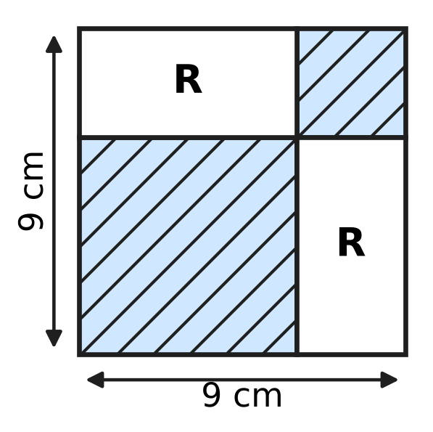
  (A) 22.5 cm² | (B) 36 cm² | (C) 27 cm² | (D) 18 cm²

Q12. The line $y=(k−2)x+5$ is parallel to the line through the points (1, 3) and (4, 12). What is the value of k?
(A) 11 | (B) 1 | (C) 5 | (D) 3

Q13. The numbers k, k + 6 and 4k, in that order, are three consecutive terms of a geometric progression whose terms are all positive. What is the next term of the progression?
(A) 22 | (B) 48 | (C) 24 | (D) 96

Part 4 — Geometry (Syllabus Chapter 5)
Q14. A circle has its centre at C(1, −2) and passes through the point A(4, 2). Which of these points also lies on the circle?
(A) (−2, 2) | (B) (−1, 1) | (C) (5, −1) | (D) (3, 1)

Q15. The vertices of △ABC lie on a circle, and its side AB passes through the centre O, as in the figure. AC = 9 cm and BC = 12 cm. What is the radius of the circle? | 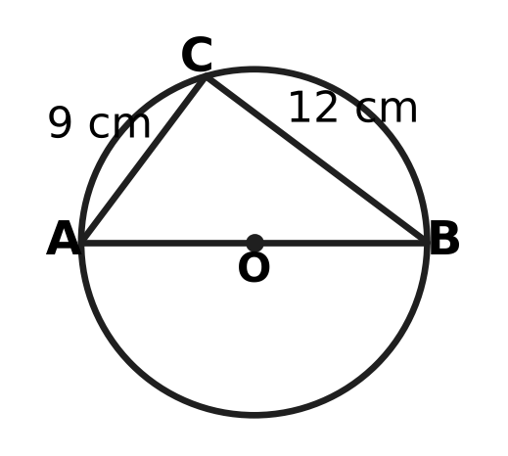
  (A) 10.5 cm | (B) 6 cm | (C) 15 cm | (D) 7.5 cm

Q16. In how many different ways can a circle be drawn so that A(−1, 2), B(1, 3) and C(5, 5) all lie on it?
(A) in no way at all | (B) in exactly one way
(C) in exactly two ways | (D) in infinitely many ways

Q17. Which of these quadrilaterals has rotational symmetry of order 2 but NO line of symmetry?
(A) a kite whose four sides are not all equal
(B) a parallelogram with unequal adjacent sides and no right angle
(C) a rectangle whose length and breadth are unequal
(D) a rhombus none of whose angles is a right angle

Q18. The points are A(2, 3), B(6, 5) and C(4, k). For which value of k is ∠ABC = 90°?
(A) 9 | (B) 7 | (C) −1 | (D) 1

Q19. In the figure, the chord AB and the radii OA and OB are drawn, and C is a point on the major arc AB. ∠OAB = 25°. What is ∠ACB, marked x? | 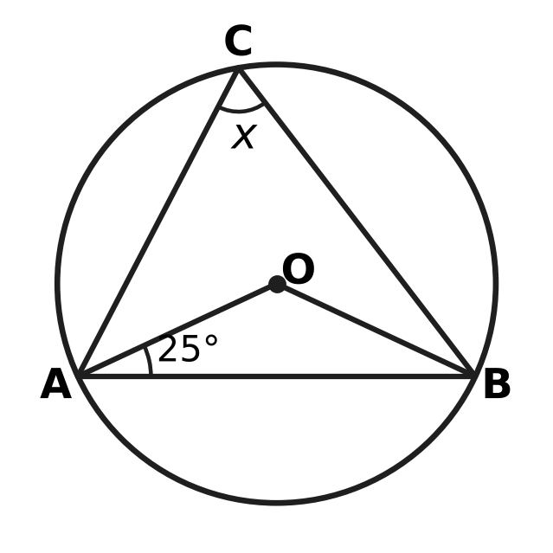
  (A) 50° | (B) 25° | (C) 65° | (D) 130°

Q20. In △ABC in the figure, AB = AC and ∠BAC = 40°. D is a point on AC such that BD = BC, as the marks show. What is ∠ABD, marked x? | 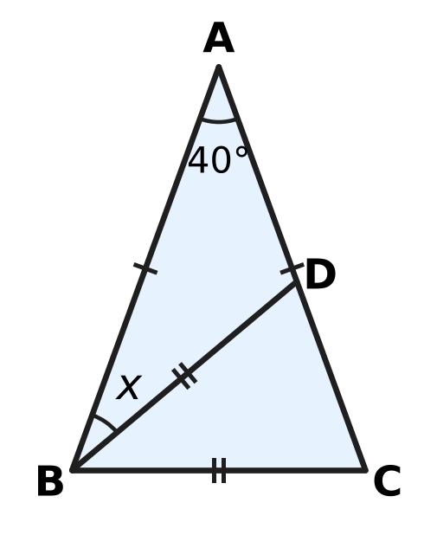
  (A) 30° | (B) 70° | (C) 40° | (D) 35°

Part 5 — Mensuration (Syllabus Chapter 6)
Q21. ABCD is a cyclic quadrilateral with AB = 8 cm, BC = 10 cm, CD = 15 cm and DA = 3 cm, as shown. Use Brahmagupta's formula to find its area. | 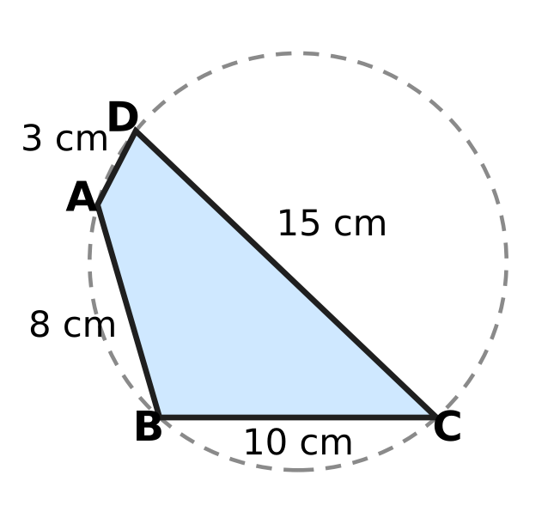
  (A) 30 cm² | (B) 60 cm²
  (C) 36 cm² | (D) 3,600 cm²

Q22. The minute hand of Hema's wall clock is 21 cm long. How far does its tip travel from 3:00 to 3:20? (Use π = $\frac{22}{7}$.)
(A) 66 cm | (B) 22 cm | (C) 132 cm | (D) 44 cm

Q23. Kavin, a potter, makes a solid clay cone and a solid clay cylinder with the same base radius. Both use exactly the same amount of clay. The cylinder is 8 cm tall. How tall is the cone?
(A) 16 cm | (B) $\frac{8}{3}$ cm | (C) 24 cm | (D) 8 cm

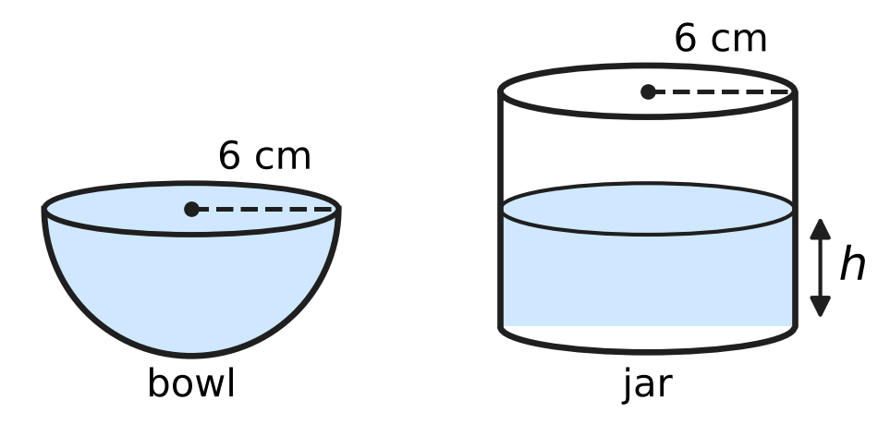
Q24. Charu's hemispherical bowl has an inner radius of 6 cm and is full of water. She pours all the water into an empty cylindrical jar whose inner radius is also 6 cm, as shown. How deep, h, is the water in the jar?
(A) 8 cm | (B) 6 cm | (C) 12 cm | (D) 4 cm

Q25. Manav makes a cuboid box with NO lid from card. Its base is 12 cm by 6 cm, and he uses exactly 360 cm² of card. What is the height h of the box? | 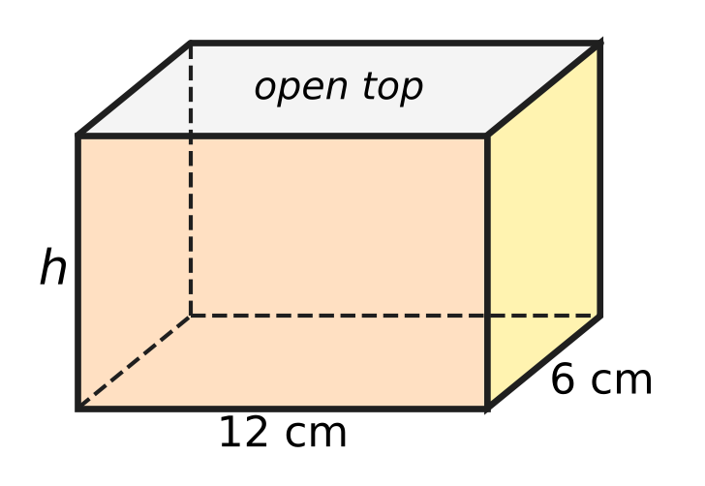
  (A) 16 cm | (B) 6 cm | (C) 8 cm | (D) 10 cm

Part 6 — Data Handling, Statistics & Probability (Syllabus Chapter 8)
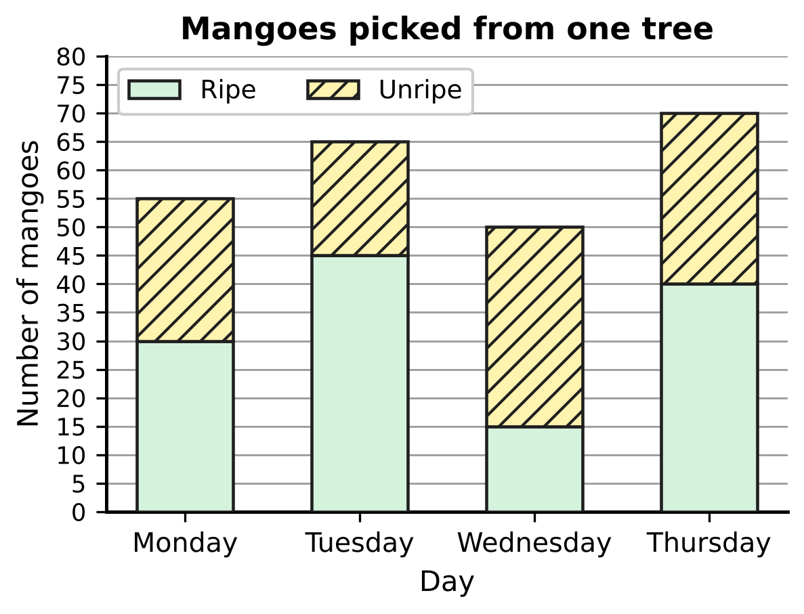
Q26. The stacked bar graph shows the ripe and unripe mangoes picked from one mango tree on four days. On which day were the MOST unripe mangoes picked?
(A) Monday | (B) Tuesday
(C) Wednesday | (D) Thursday

Q27. In a board game, Rhea rolls an ordinary fair die once. Which of these events is more likely to happen than not to happen, but is NOT certain?
(A) the die shows an odd number | (B) the die shows a number less than 5
(C) the die shows a number greater than 4 | (D) the die shows a number less than 7

Drinks chosen at the school canteen
Students | Tea | Juice | Milk | Total
Juniors | 10 | 20 | 10 | 40
Seniors | 14 | 16 | 10 | 40
All students | 24 | 36 | 20 | 80

Q28. The table shows the drinks chosen by 80 students at the school canteen. Each student chose exactly one drink. One of the 80 students is chosen at random. What is the probability that this student is a senior who chose juice?
(A) $\frac{1}{5}$ | (B) $\frac{9}{20}$ | (C) $\frac{1}{4}$ | (D) $\frac{2}{5}$

Q29. Six friends count the money in their piggy banks. The median amount is ₹40. Which of these MUST be true?
(A) The mean amount is ₹40.
(B) At least three of the friends have ₹40 or less.
(C) Exactly three of the friends have more than ₹40.
(D) One of the friends has exactly ₹40.

Q30. Two ordinary fair dice are rolled together. What is the probability that the larger number shown is exactly twice the smaller number?
(A) $\frac{1}{6}$ | (B) $\frac{1}{3}$ | (C) $\frac{1}{9}$ | (D) $\frac{1}{12}$

Part 7 — Applied Mathematics (Syllabus Chapter 9)
Mass of parcel (kg) | 2 | 5 | 8 | 12
Charge (₹) | 70 | 130 | 190 | ?

Q31. At a post office, the charge for sending a parcel follows a linear rule: a fixed amount plus the same amount for every kilogram. The table shows some charges. How much does Vikram pay to send a 12 kg parcel?
(A) ₹420 | (B) ₹240 | (C) ₹270 | (D) ₹250

Q32. On a plan of the school running track, Sneha marks the start at S(−4, 5) and a water stall at W(2, 1). The water stall is exactly halfway between the start and the finish F. What are the coordinates of F?
(A) (6, −4) | (B) (−10, 9) | (C) (−1, 3) | (D) (8, −3)

Q33. On a bus, 3 adult tickets and 2 child tickets cost ₹190, and 2 adult tickets and 5 child tickets cost ₹200. Lalit buys 1 adult ticket and 1 child ticket. How much does he pay?
(A) ₹50 | (B) ₹78 | (C) ₹70 | (D) ₹20

Q34. The number of honey bees in a hive grows by the same percentage every month. There were 1,600 bees on 1 June and 3,600 bees on 1 August. How many bees were there on 1 July?
(A) 5,400 | (B) 2,000 | (C) 2,600 | (D) 2,400

Part 8 — Mathematical Reasoning & Problem-Solving (Syllabus Chapter 10)
Q35. Consider the statement: "If a fraction in lowest terms has an odd denominator, then its decimal expansion does NOT terminate." Which fraction is a counterexample to this statement?
(A) $\frac{4}{9}$ | (B) $\frac{7}{25}$ | (C) $\frac{3}{8}$ | (D) $\frac{5}{21}$

Q36. The theorem "The opposite angles of a cyclic quadrilateral add up to 180°" has this special case: "If all four vertices of a parallelogram lie on a circle, then the parallelogram must be a ___." Which word fills the blank?
(A) rectangle | (B) kite
(C) square | (D) rhombus

Q37. The sequence 4, 7, 12, 19, 28, … has the recursive rule $a_{1}=4$ and $a_{n}=a_{n−1}+□$ for n ≥ 2. What goes in the box?
(A) $n+1$ | (B) 3 | (C) $2n−1$ | (D) $2n+1$

Q38. Naina is proving that √3 is irrational. She assumes √3 = $\frac{p}{q}$, where p and q are positive whole numbers with no common factor other than 1. Squaring gives $p^{2}=3q^{2}$, so p is a multiple of 3. She writes p = 3m. Then $q^{2}$ = ___. What fills the blank?
(A) $3m$ | (B) $9m^{2}$ | (C) $m^{2}$ | (D) $3m^{2}$

Q39. The statement "If a quadrilateral is a square, then its diagonals are equal and perpendicular" is true. Tushar wants a quadrilateral that shows its CONVERSE is false. Which quadrilateral should he draw?
(A) diagonals 8 cm and 8 cm, crossing at right angles, one cut into 2 cm and 6 cm
(B) diagonals 8 cm and 8 cm, crossing at 60° at their midpoints
(C) diagonals 8 cm and 6 cm, crossing at right angles at their midpoints
(D) diagonals 8 cm and 8 cm, crossing at right angles at their midpoints

Q40. Juhi thinks of a whole number from 1 to 100. Ankit finds it by asking questions of the form "Is your number greater than k?", and Juhi answers each one truthfully with yes or no. Each time, Ankit chooses k so that the numbers still possible are split into two groups as equal as possible. What is the least number of questions that is always enough for Ankit to be sure of the number?
(A) 6 | (B) 7 | (C) 50 | (D) 10

SECTION II — Star Questions 5 questions × 4 marks each
Q41. Daksh writes a list of numbers by following these instructions.
Step 1: Start with a = $□$ and d = 4.
Step 2: Write a in the list.
Step 3: Replace a by a + d, then replace d by d + 2.
Step 4: If the list has 10 numbers, stop. Otherwise go back to Step 2.
The last number in the list is 150. What number was in the box? [4 marks]
(A) 114 | (B) 62 | (C) 42 | (D) 20

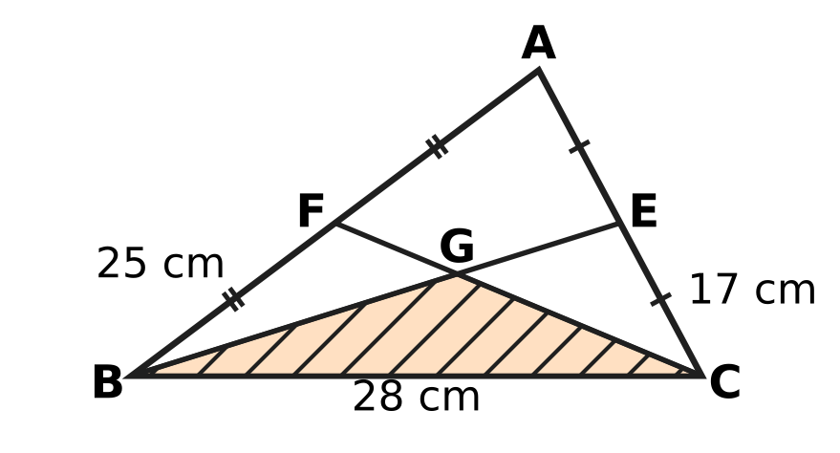
Q42. In △ABC, AB = 25 cm, BC = 28 cm and CA = 17 cm. E and F are the midpoints of CA and AB, and the medians BE and CF meet at G, as shown. What is the area of the shaded triangle GBC? [4 marks]
(A) 140 cm² | (B) 105 cm² | (C) 35 cm² | (D) 70 cm²

Q43. P(−3, 4) and Q(7, 0) are two points. The line L passes through the midpoint of PQ and is parallel to the line through R(−1, 1) and S(2, 7). L cuts the x-axis at one point and the y-axis at another. What is the length of the part of L between these two points? [4 marks]
(A) √5 units | (B) √3 units | (C) 5 units | (D) 3 units

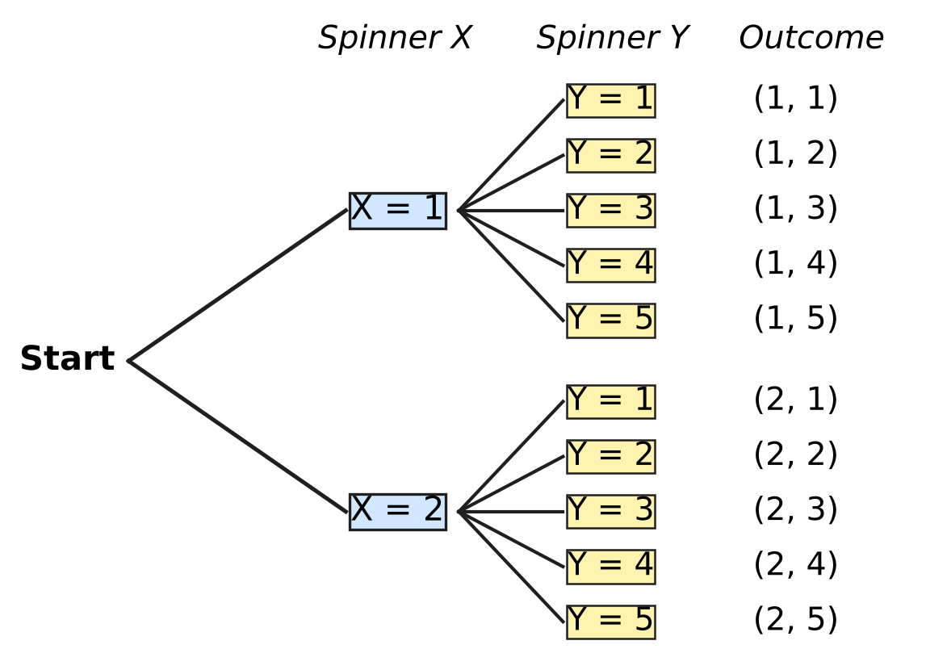
Q44. Spinner X has 2 equal parts numbered 1, 2. Spinner Y has 5 equal parts numbered 1 to 5. Avni spins both once; the tree diagram shows all 10 equally likely outcomes (X, Y). Statement S says: "If X shows 2, then X + Y is greater than 5." An outcome is a counterexample to an if-then statement when its "if" part is true but its "then" part is false. What is the probability that Avni's outcome is a counterexample to NEITHER S nor the converse of S? [4 marks]
(A) $\frac{2}{5}$ | (B) $\frac{3}{5}$ | (C) $\frac{1}{5}$ | (D) $\frac{7}{10}$

Q45. Park X and Park Y start with the same number of rabbits. In Park X the number grows by 25% every year, each year on the number at the start of that year. In Park Y the number grows by 450 every year. At the end of Year 2, Park X has 540 more rabbits than Park Y. How many rabbits did each park start with? [4 marks]
(A) 3,960 | (B) 2,560 | (C) 2,880 | (D) 1,600

Answer Sheet AMO Level 1 · Class 9 · Practice Paper 3
Name: | School: | Roll No.:
Shade or tick one circle for each question.
1. Ⓐ Ⓑ Ⓒ Ⓓ | 16. Ⓐ Ⓑ Ⓒ Ⓓ | 31. Ⓐ Ⓑ Ⓒ Ⓓ
2. Ⓐ Ⓑ Ⓒ Ⓓ | 17. Ⓐ Ⓑ Ⓒ Ⓓ | 32. Ⓐ Ⓑ Ⓒ Ⓓ
3. Ⓐ Ⓑ Ⓒ Ⓓ | 18. Ⓐ Ⓑ Ⓒ Ⓓ | 33. Ⓐ Ⓑ Ⓒ Ⓓ
4. Ⓐ Ⓑ Ⓒ Ⓓ | 19. Ⓐ Ⓑ Ⓒ Ⓓ | 34. Ⓐ Ⓑ Ⓒ Ⓓ
5. Ⓐ Ⓑ Ⓒ Ⓓ | 20. Ⓐ Ⓑ Ⓒ Ⓓ | 35. Ⓐ Ⓑ Ⓒ Ⓓ
6. Ⓐ Ⓑ Ⓒ Ⓓ | 21. Ⓐ Ⓑ Ⓒ Ⓓ | 36. Ⓐ Ⓑ Ⓒ Ⓓ
7. Ⓐ Ⓑ Ⓒ Ⓓ | 22. Ⓐ Ⓑ Ⓒ Ⓓ | 37. Ⓐ Ⓑ Ⓒ Ⓓ
8. Ⓐ Ⓑ Ⓒ Ⓓ | 23. Ⓐ Ⓑ Ⓒ Ⓓ | 38. Ⓐ Ⓑ Ⓒ Ⓓ
9. Ⓐ Ⓑ Ⓒ Ⓓ | 24. Ⓐ Ⓑ Ⓒ Ⓓ | 39. Ⓐ Ⓑ Ⓒ Ⓓ
10. Ⓐ Ⓑ Ⓒ Ⓓ | 25. Ⓐ Ⓑ Ⓒ Ⓓ | 40. Ⓐ Ⓑ Ⓒ Ⓓ
11. Ⓐ Ⓑ Ⓒ Ⓓ | 26. Ⓐ Ⓑ Ⓒ Ⓓ | 41. Ⓐ Ⓑ Ⓒ Ⓓ
12. Ⓐ Ⓑ Ⓒ Ⓓ | 27. Ⓐ Ⓑ Ⓒ Ⓓ | 42. Ⓐ Ⓑ Ⓒ Ⓓ
13. Ⓐ Ⓑ Ⓒ Ⓓ | 28. Ⓐ Ⓑ Ⓒ Ⓓ | 43. Ⓐ Ⓑ Ⓒ Ⓓ
14. Ⓐ Ⓑ Ⓒ Ⓓ | 29. Ⓐ Ⓑ Ⓒ Ⓓ | 44. Ⓐ Ⓑ Ⓒ Ⓓ
15. Ⓐ Ⓑ Ⓒ Ⓓ | 30. Ⓐ Ⓑ Ⓒ Ⓓ | 45. Ⓐ Ⓑ Ⓒ Ⓓ
Q41–Q45 are Section II Star Questions (4 marks each).
For the parent or teacher
Section I correct: ______ / 40 × 2 = ______ marks Section II correct: ______ / 5 × 4 = ______ marks
Correct: ______ / 45 Score: ______ / 100
Answer Key and Solutions AMO Level 1 · Class 9 · Practice Paper 3
Quick answers
1 B | 6 A | 11 D | 16 A | 21 B | 26 C | 31 C | 36 A | 41 C
2 D | 7 B | 12 C | 17 B | 22 D | 27 B | 32 D | 37 C | 42 D
3 C | 8 C | 13 B | 18 A | 23 C | 28 A | 33 C | 38 D | 43 A
4 D | 9 D | 14 A | 19 C | 24 D | 29 B | 34 D | 39 A | 44 B
5 B | 10 A | 15 D | 20 A | 25 C | 30 A | 35 B | 40 B | 45 B
Solutions
Q | Part · level | Answer | Why?
1 | Part 1 · Ch1 · Easy | (B) $\frac{1}{12}$ | The halfway point is the average: (−1/2 + 2/3) ÷ 2 = (1/6) ÷ 2 = 1/12.
2 | Part 1 · Ch1 · Easy | (D) 6 | Write 1/3 = 5/15 and 4/5 = 12/15. The fractions strictly between are 6/15, 7/15, …, 11/15, which is 6 fractions.
3 | Part 1 · Ch1 · Medium | (C) 21 | If k/84 = m/100, then k = 84m/100 = 21m/25, so k must be a multiple of 21. The smallest is k = 21, and 21/84 = 1/4 = 0.25.
4 | Part 2 · Ch3 · Easy | (D) ₹450,000 | After a 20% fall, 80% of the value is left, so 0.8 × (value) = ₹360,000. The value was ₹360,000 ÷ 0.8 = ₹450,000.
5 | Part 2 · Ch3 · Easy | (B) ₹55 | The mixture is worth 5 × ₹46 = ₹230. The 3 kg sack is worth 3 × ₹40 = ₹120, so the 2 kg sack is worth ₹110, which is ₹55 per kg.
6 | Part 2 · Ch3 · Medium | (A) 20% | May = 1.25 × April. To get back, June = May ÷ 1.25 = 0.8 × May, which is a fall of 20%.
7 | Part 3 · Ch4 · Easy | (B) $x−7$ | The second factor is x + c with 6c = −42, so c = −7. Check: (x + 6)(x − 7) = x² − 7x + 6x − 42 = x² − x − 42.
8 | Part 3 · Ch4 · Easy | (C) −1 | The x terms come from x × 5 = 5x and 2 × (−3x) = −6x. Together 5x − 6x = −x, so the coefficient is −1.
9 | Part 3 · Ch4 · Easy | (D) −2 | With x = 4: 12 − 4y = 20, so −4y = 8 and y = −2.
10 | Part 3 · Ch4 · Easy | (A) 13 | From 7 to 25 there are 3 equal steps, so the common difference is 18 ÷ 3 = 6. The first box is 7 + 6 = 13.
11 | Part 3 · Ch4 · Medium | (D) 18 cm² | The large square has area 9² = 81 cm². The two rectangles together are 81 − 45 = 36 cm², so one rectangle is 18 cm². (This is (a + b)² = a² + b² + 2ab with a + b = 9.)
12 | Part 3 · Ch4 · Medium | (C) 5 | Slope of the line through (1, 3) and (4, 12) = (12 − 3) ÷ (4 − 1) = 3. Parallel lines have equal slopes, so k − 2 = 3 and k = 5.
13 | Part 3 · Ch4 · Medium | (B) 48 | In a GP the middle term squared equals the product of its neighbours: (k + 6)² = 4k². All terms are positive, so k + 6 = 2k and k = 6. The terms are 6, 12, 24 (ratio 2), so the next term is 48.
14 | Part 4 · Ch5 · Easy | (A) (−2, 2) | The radius is CA = √(3² + 4²) = 5. From C to (−2, 2) the steps are 3 and 4, so the distance is also 5. Points (B), (C) and (D) are √13, √17 and √13 from C.
15 | Part 4 · Ch5 · Easy | (D) 7.5 cm | The angle in a semicircle is 90°, so ∠ACB = 90° and AB = √(9² + 12²) = 15 cm. The radius is half of AB, 7.5 cm.
16 | Part 4 · Ch5 · Easy | (A) in no way at all | The slope of AB is (3 − 2) ÷ (1 + 1) = 1/2 and the slope of BC is (5 − 3) ÷ (5 − 1) = 1/2, so A, B, C lie on one straight line. A circle cannot pass through three points of a line, so there is no such circle.
17 | Part 4 · Ch5 · Easy | (B) a parallelogram with unequal adjacent sides and no right angle | Every parallelogram looks the same after a half turn about the point where its diagonals meet (order 2). Unless it is a rectangle or a rhombus, no fold line maps it onto itself.
18 | Part 4 · Ch5 · Medium | (A) 9 | ∠B = 90° when AB² + BC² = AC²: 20 + [4 + (k − 5)²] = 4 + (k − 3)². This gives 20 + 25 − 10k = 9 − 6k, so 4k = 36 and k = 9.
19 | Part 4 · Ch5 · Medium | (C) 65° | OA = OB (radii), so ∠OBA = 25° and ∠AOB = 180° − 50° = 130°. The angle at C on the remaining arc is half of that: 65°.
20 | Part 4 · Ch5 · Medium | (A) 30° | ∠ABC = ∠ACB = (180° − 40°) ÷ 2 = 70°. In △BCD, BD = BC, so ∠BDC = ∠BCD = 70° and ∠DBC = 40°. Then ∠ABD = 70° − 40° = 30°.
21 | Part 5 · Ch6 · Easy | (B) 60 cm² | s = (8 + 10 + 15 + 3) ÷ 2 = 18. Area = √[(18 − 8)(18 − 10)(18 − 15)(18 − 3)] = √(10 × 8 × 3 × 15) = √3,600 = 60 cm².
22 | Part 5 · Ch6 · Easy | (D) 44 cm | In 20 minutes the minute hand turns 20/60 = 1/3 of a full turn (120°). The tip travels 1/3 × 2 × 22/7 × 21 = 44 cm.
23 | Part 5 · Ch6 · Easy | (C) 24 cm | Cone: (1/3)πr²h; cylinder: πr² × 8. Equal volumes give (1/3)h = 8, so h = 24 cm.
24 | Part 5 · Ch6 · Medium | (D) 4 cm | Water = (2/3)π × 6³ = 144π cm³. In the jar π × 6² × h = 144π, so 36h = 144 and h = 4 cm.
25 | Part 5 · Ch6 · Medium | (C) 8 cm | Card = base + four sides = 12 × 6 + 2 × (12 + 6) × h = 72 + 36h. So 72 + 36h = 360, 36h = 288 and h = 8 cm.
26 | Part 6 · Ch8 · Easy | (C) Wednesday | Unripe = top of the bar − top of the ripe part: Monday 55 − 30 = 25, Tuesday 65 − 45 = 20, Wednesday 50 − 15 = 35, Thursday 70 − 40 = 30. Wednesday has the most.
27 | Part 6 · Ch8 · Easy | (B) the die shows a number less than 5 | "Less than 5" means 1, 2, 3 or 4: probability 4/6 = 2/3, which is more than 1/2 and less than 1. The others have probabilities 1/2, 1 and 1/3.
28 | Part 6 · Ch8 · Easy | (A) $\frac{1}{5}$ | There are 16 seniors who chose juice among the 80 students, so the probability is 16/80 = 1/5.
29 | Part 6 · Ch8 · Medium | (B) At least three of the friends have ₹40 or less. | With six amounts in order, the median is the average of the 3rd and 4th, so the 3rd amount is at most ₹40 and the three smallest amounts are ₹40 or less. The amounts ₹10, ₹20, ₹30, ₹50, ₹60, ₹70 have median ₹40, yet nobody has exactly ₹40 and the mean is not ₹40.
30 | Part 6 · Ch8 · Medium | (A) $\frac{1}{6}$ | There are 36 equally likely outcomes. The good ones are (1, 2), (2, 1), (2, 4), (4, 2), (3, 6), (6, 3): 6 outcomes, so the probability is 6/36 = 1/6.
31 | Part 7 · Ch9 · Easy | (C) ₹270 | Each 3 kg adds ₹60, so the rate is ₹20 per kg and the fixed amount is 70 − 40 = ₹30. For 12 kg: 30 + 20 × 12 = ₹270.
32 | Part 7 · Ch9 · Easy | (D) (8, −3) | The step from S to W is 6 across and 4 down. F is the same step on from W: (2 + 6, 1 − 4) = (8, −3).
33 | Part 7 · Ch9 · Medium | (C) ₹70 | Doubling the first and tripling the second: 6a + 4c = 380 and 6a + 15c = 600, so 11c = 220, c = ₹20 and a = ₹50. Together ₹70.
34 | Part 7 · Ch9 · Medium | (D) 2,400 | Two months multiply 1,600 by 3,600 ÷ 1,600 = 2.25 = 1.5 × 1.5, so each month multiplies by 1.5 (50% growth). On 1 July: 1,600 × 1.5 = 2,400.
35 | Part 8 · Ch10 · Easy | (B) $\frac{7}{25}$ | A counterexample must have an odd denominator AND a terminating decimal. 7/25 = 28/100 = 0.28 terminates, and 25 is odd.
36 | Part 8 · Ch10 · Easy | (A) rectangle | In a parallelogram opposite angles are equal; on a circle they also add up to 180°, so each is 90°. A parallelogram with right angles is a rectangle.
37 | Part 8 · Ch10 · Easy | (C) $2n−1$ | The differences are 3, 5, 7, 9 for n = 2, 3, 4, 5, and 2n − 1 gives exactly 3, 5, 7, 9. So aₙ = aₙ₋₁ + (2n − 1).
38 | Part 8 · Ch10 · Easy | (D) $3m^{2}$ | p² = (3m)² = 9m², and 9m² = 3q² gives q² = 3m². So q is also a multiple of 3, which contradicts "no common factor".
39 | Part 8 · Ch10 · Medium | (A) diagonals 8 cm and 8 cm, crossing at right angles, one cut into 2 cm and 6 cm | The converse is "If the diagonals are equal and perpendicular, then it is a square." A counterexample needs equal, perpendicular diagonals but must not be a square. Diagonals of 8 cm crossing at 90° but not bisecting each other give such a quadrilateral (not even a parallelogram).
40 | Part 8 · Ch10 · Medium | (B) 7 | Each answer at most halves the numbers left: 100 → 50 → 25 → 13 → 7 → 4 → 2 → 1, which takes 7 questions. Six questions can separate at most 2⁶ = 64 numbers, so 7 is the least.
41 | Section II · Ch4 + Ch10 · Hard | (C) 42 | Between the 1st and 10th numbers in the list there are 9 additions: 4 + 6 + 8 + … + 20 = 2 × (2 + 3 + … + 10) = 2 × 54 = 108. So the start was 150 − 108 = 42.
42 | Section II · Ch5 + Ch6 · Hard | (D) 70 cm² | Heron: s = 35 and area = √(35 × 7 × 18 × 10) = 210 cm². G divides each median 2 : 1 from the vertex, so G's height above BC is 1/3 of A's height. Area of GBC = 210 ÷ 3 = 70 cm².
43 | Section II · Ch4 + Ch5 · Hard | (A) √5 units | Midpoint of PQ = (2, 2). Slope of RS = (7 − 1) ÷ (2 + 1) = 2, so L is y − 2 = 2(x − 2), that is y = 2x − 2. L cuts the axes at (1, 0) and (0, −2); the length between them is √(1² + 2²) = √5 units.
44 | Section II · Ch8 + Ch10 · Hard | (B) $\frac{3}{5}$ | Counterexamples to S need X = 2 and X + Y not greater than 5: (2, 1), (2, 2), (2, 3). The converse is "If X + Y is greater than 5, then X shows 2"; its only counterexample is (1, 5). That leaves 10 − 4 = 6 outcomes, so the probability is 6/10 = 3/5.
45 | Section II · Ch3 + Ch9 · Hard | (B) 2,560 | Let each park start with N rabbits. After 2 years Park X has N × 5/4 × 5/4 = 25N/16 and Park Y has N + 900. So 25N/16 − N − 900 = 540, 9N/16 = 1,440 and N = 2,560 (check: 2,560 → 3,200 → 4,000 against 3,460).

ARYABHATTA MATHS OLYMPIAD
Level 1
PRACTICE PAPER-4
CLASS 9
Total Questions | 45 multiple-choice questions
Total Marks | 100
Time | 60 minutes
Section I | 40 questions × 2 marks = 80 marks
Section II | 5 Star Questions × 4 marks = 20 marks
Negative Marking | No negative marking
Calculator | Not allowed
Chapters | Number System · Fractions, Decimals & Percentages · Algebra · Geometry · Mensuration · Data Handling · Applied Mathematics · Mathematical Reasoning

Instructions to candidates
• This paper has 45 multiple-choice questions. Each question has four answer choices, of which exactly one is correct.
• Section I (Q1–Q40) carries 2 marks per question. Section II (Q41–Q45) carries 4 marks per question.
• There is no negative marking. Unanswered questions score zero.
• Calculators are not permitted. Rough work may be done on a separate sheet.
• Mark your answers on the answer sheet at the end of the paper.
• All figures are not necessarily drawn to scale unless stated.

For parents and teachers
• Print or view this paper in colour. Pictures are part of the questions.
• Parts follow the AMO syllabus chapters. Chapters 2 and 7 are not part of the Class 9 syllabus, so the chapter numbers shown in the Part headings have gaps.
• The answer sheet and the answer key are at the end. Remove only the answer key before the student begins.

SECTION I 40 questions × 2 marks each
Part 1 — Number System (Syllabus Chapter 1)
Q1. The decimal expansion of $\frac{1}{37}$ is 0.027027…, with the three digits 027 repeating. Without dividing, which of these is the decimal expansion of $\frac{7}{37}$?
(A) 0.189 | (B) 0.0189189…
(C) 0.189027027… | (D) 0.189189…

Q2. Which of these numbers is NOT equal to 0.5?
(A) $\frac{9}{18}$ | (B) 0.4555… (the digit 5 repeats for ever)
(C) $\frac{4.5}{9}$ | (D) 0.4999… (the digit 9 repeats for ever)

Q3. The number a is rational and the number b is irrational. Which of these MUST be irrational, whatever the values of a and b?
(A) $a×b+b$ | (B) $a×b$
(C) $a+b$ | (D) $b×b$

Part 2 — Fractions, Decimals & Percentages (Syllabus Chapter 3)
Q4. At a zoo, there are 250 flamingos on the lake. The number of flamingos grows by 8% every year. Which expression gives the number of flamingos after n years?
(A) $250×{(1.08)}^{n}$ | (B) $250+20n$
(C) $250×{(0.08)}^{n}$ | (D) $250×{(1.8)}^{n}$

Q5. Rehan deposits ₹12,000 at 6% per year simple interest. The amounts in his account at the end of Year 1, Year 2, Year 3, … form an arithmetic progression. What is the amount at the end of Year 5?
(A) ₹14,880 | (B) ₹16,320 | (C) ₹15,600 | (D) ₹3,600

Q6. Sonal kept some money in a bank for 2 years at 20% per year compound interest, compounded annually, and it grew to ₹36,000. How much would the same money have grown to in the same 2 years at 20% per year simple interest?
(A) ₹10,000 | (B) ₹35,000 | (C) ₹30,000 | (D) ₹25,000

Part 3 — Algebra (Syllabus Chapter 4)
Q7. The numbers x and y satisfy $3x+2y=17$ and $2x+3y=13$. What is the value of $x−y$?
(A) 4 | (B) 5 | (C) 6 | (D) 30

Q8. If $x+y=7$ and $xy=10$, what is the value of $x^{2}+y^{2}$?
(A) 69 | (B) 49 | (C) 39 | (D) 29

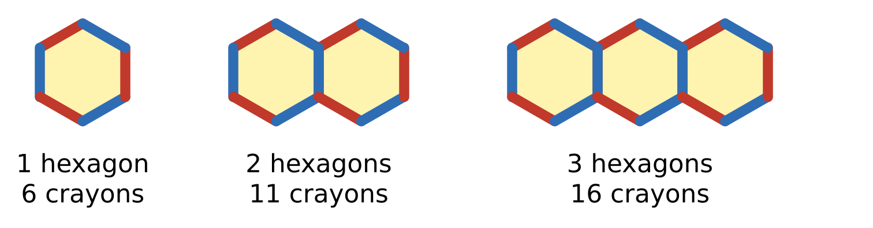
Q9. In art class, Kiara lays crayons end to end to make a row of hexagons, as shown. Neighbouring hexagons share one crayon. One hexagon needs 6 crayons, two need 11 and three need 16. How many hexagons are in a row made with exactly 151 crayons?
(A) 30 | (B) 25 | (C) 29 | (D) 31

Q10. What are the slope and the y-intercept of the line $6x−3y=9$?
(A) slope 6, y-intercept 9 | (B) slope 2, y-intercept −3
(C) slope 2, y-intercept 3 | (D) slope −2, y-intercept 3

Q11. Which of these is a factor of $x^{2}−y^{2}+6y−9$?
(A) $x+y+3$ | (B) $x+y−9$
(C) $x−y+3$ | (D) $x−y−3$

Q12. A rectangle has area $(3x^{2}+10x+8)$ cm² and length $(3x+4)$ cm. What is its perimeter?
(A) $(4x+6)$ cm | (B) $(x+2)$ cm
(C) $(6x+8)$ cm | (D) $(8x+12)$ cm

Q13. How many two-digit numbers leave a remainder of 5 when divided by 8?
(A) 12 | (B) 10 | (C) 11 | (D) 13

Part 4 — Geometry (Syllabus Chapter 5)
Q14. A circle has radius 6.5 cm. Which of these CANNOT be the length of a chord of this circle?
(A) 13 cm | (B) 14 cm | (C) 5 cm | (D) 12 cm

Q15. In △ABC in the figure, D is the midpoint of AB, and DE is parallel to BC with E on AC. AC = 13 cm and BC = 11 cm. How long is AE? | 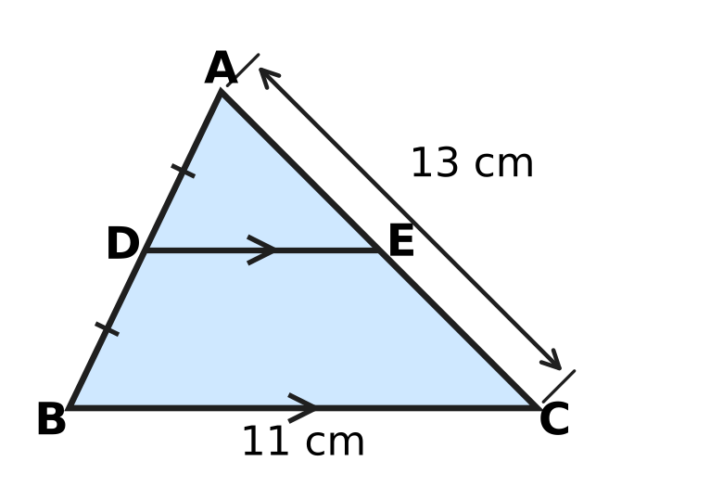
  (A) 6.5 cm | (B) 5.5 cm | (C) 3.25 cm | (D) 13 cm

Q16. Which of these quadrilaterals can ALWAYS be drawn with all four of its vertices on one circle? (An isosceles trapezium is a trapezium whose two non-parallel sides are equal.)
(A) a rhombus | (B) a kite
(C) a parallelogram | (D) an isosceles trapezium

Q17. Chetan wants to find the centre of a round wooden tabletop. He draws two chords AB and CD that are not parallel. Then he draws the perpendicular bisector of each chord. Where do the two perpendicular bisectors meet?
(A) at the centre of the tabletop
(B) halfway between the midpoints of AB and CD
(C) on the edge of the tabletop
(D) at the midpoint of chord AB

Q18. In the figure, A, B, C and D lie on a circle, and the chords AC and BD meet at E. ∠BAC = 35° and ∠ACD = 40°. What is ∠BEC, marked x? | 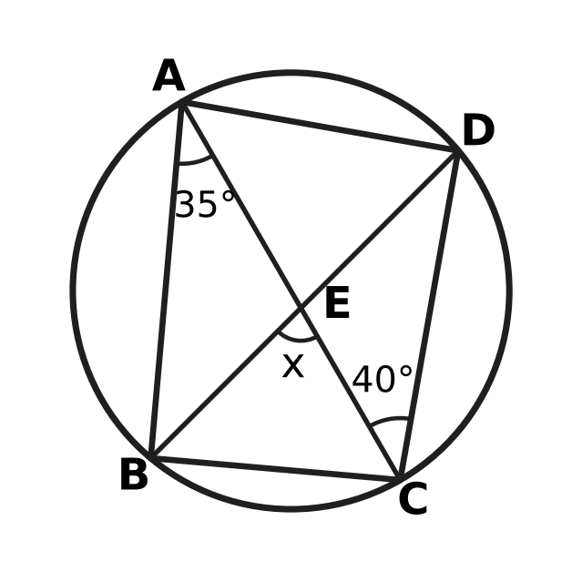
  (A) 105° | (B) 75° | (C) 80° | (D) 70°

Q19. In the figure, O is the centre of the circle, and the chords AB and CD are equal, as the marks show. ∠AOB = 70°. What is ∠OCD, marked x? | 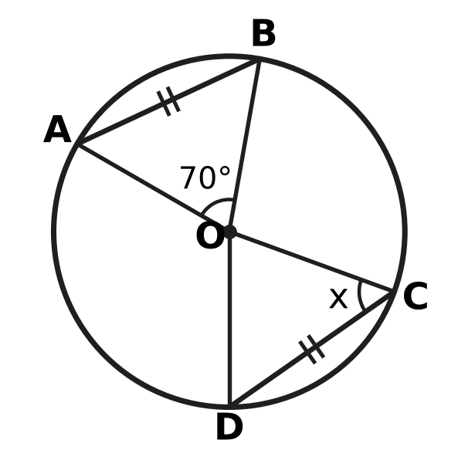
  (A) 110° | (B) 35° | (C) 70° | (D) 55°

Q20. The points A(1, 1), B(5, 2), C(6, 6) and D(2, 5) are joined in order to make the quadrilateral ABCD. Which of these best describes ABCD?
(A) a rectangle that is not a square | (B) a square
(C) a rhombus that is not a square | (D) a parallelogram that is not a rhombus

Part 5 — Mensuration (Syllabus Chapter 6)
Q21. Komal's round cake has radius 14 cm. She cuts it from the centre into 8 equal slices, as shown. What is the area of the top of one slice? (Use π = $\frac{22}{7}$.) | 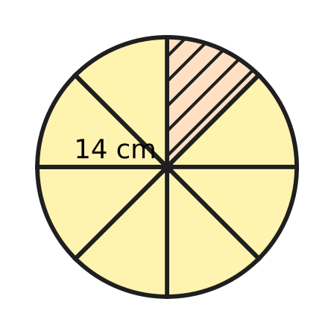
  (A) 19.25 cm² | (B) 154 cm²
  (C) 77 cm² | (D) 616 cm²

Q22. Imran's tent is a right circular cone with base radius 2.1 m and height 2.8 m, as shown. How much canvas covers its curved surface? (Use π = $\frac{22}{7}$.) | 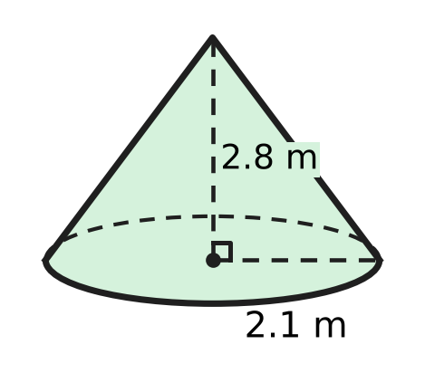
  (A) 23.1 m² | (B) 36.96 m² | (C) 46.2 m² | (D) 18.48 m²

Q23. The roof of a garden kiosk is a square pyramid. Its base is 6 m by 6 m and its vertical height is 4 m, as shown. What is the total area of its four sloping faces? | 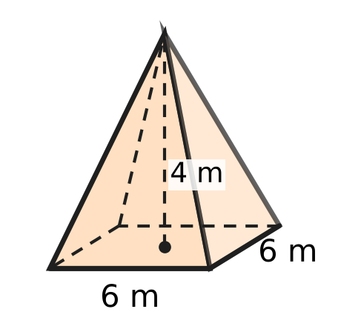
  (A) 48 m² | (B) 60 m² | (C) 96 m² | (D) 120 m²

Q24. A triangular field has sides 10 m, 17 m and 21 m, as shown. What is the shortest distance h from the corner opposite the 21 m side to that side? | 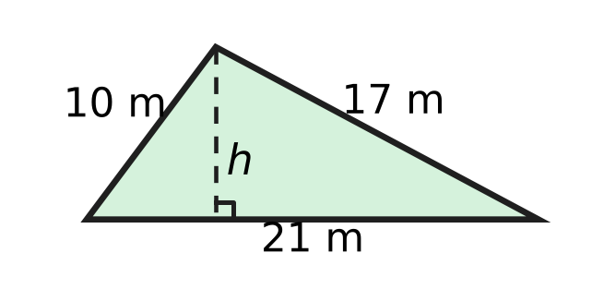
  (A) 3.5 m | (B) 16.8 m | (C) 4 m | (D) 8 m

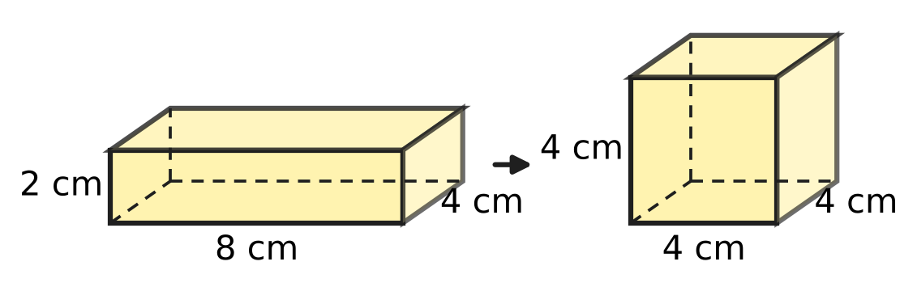
Q25. Nidhi has a cuboid slab of candle wax 8 cm × 4 cm × 2 cm. She melts it and uses all the wax to make one cube, as shown. By how much is the surface area of the cube less than the surface area of the slab?
(A) 0 cm² | (B) 48 cm² | (C) 112 cm² | (D) 16 cm²

Part 6 — Data Handling, Statistics & Probability (Syllabus Chapter 8)
Eggs in one tray
Mass of one egg (g) | Number of eggs
50 | 6
55 | 9
60 | 15

Q26. Use the table. A tray holds 30 eggs of three sizes. What is the mean mass of an egg in the tray?
(A) 55 g | (B) 60 g | (C) 56.5 g | (D) 57.5 g

Q27. The umbrella stand at a school gate holds 24 umbrellas: 9 black, 5 blue and the rest red. Leah picks one umbrella at random. What is the probability that it is NOT red?
(A) $\frac{5}{24}$ | (B) $\frac{7}{12}$ | (C) $\frac{5}{12}$ | (D) $\frac{3}{8}$

Q28. Which of these is a statistical question, that is, one that is answered by collecting data that vary?
(A) How many hours do Class 9 students sleep on a school night?
(B) How tall is the school flagpole?
(C) How many days are there in June?
(D) What is the sum of the angles of a triangle?

Q29. A whole number from 1 to 50 is chosen at random. What is the probability that it is a perfect square or a perfect cube (or both)?
(A) $\frac{9}{50}$ | (B) $\frac{7}{50}$ | (C) $\frac{1}{5}$ | (D) $\frac{4}{25}$

Q30. At the school assembly, the front row has 5 girls and 1 boy. On Monday one of these six students is chosen at random to lead the assembly. On Tuesday one is again chosen at random from all six, so the same student may be chosen twice. What is the probability that the boy leads on exactly one of the two days?
(A) $\frac{11}{36}$ | (B) $\frac{5}{36}$ | (C) $\frac{1}{3}$ | (D) $\frac{5}{18}$

Part 7 — Applied Mathematics (Syllabus Chapter 9)
Q31. At a milk dairy, the volume V litres of milk left in a tank t minutes after bottling starts is given by V = 1,200 − 75t. What does the number 75 stand for?
(A) the litres of milk left in the tank after 1 minute
(B) the litres of milk in the tank at the start
(C) the litres of milk taken out of the tank each minute
(D) the number of minutes the tank takes to empty

Q32. On the floor plan of a school hall, each unit of the grid stands for 3 m. The hall is the rectangle KLMN drawn on the grid. What is the real floor area of the hall? | 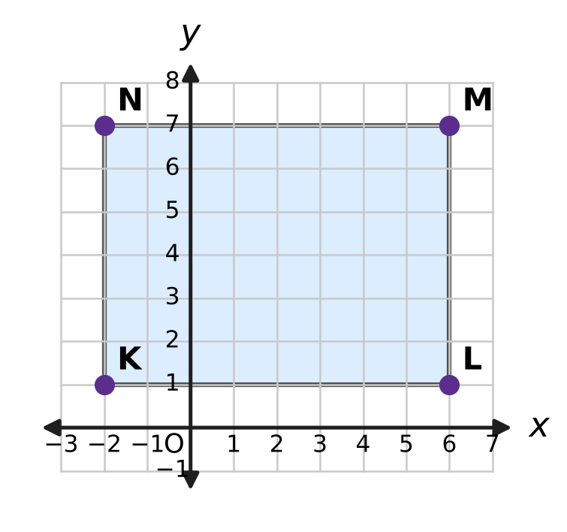
  (A) 144 m² | (B) 432 m² | (C) 1,296 m² | (D) 48 m²

Q33. A river ferry travels 36 km downstream in 2 hours. It comes back the same 36 km upstream in 3 hours. Its speed in still water and the speed of the current do not change. What is the speed of the current?
(A) 6 km/h | (B) 15 km/h | (C) 3 km/h | (D) 12 km/h

Q34. On a mountain hike, Trisha finds that the temperature falls steadily as she climbs. It is 22 °C at a height of 600 m and 17.2 °C at a height of 1,400 m. At the same rate, at what height will the temperature be 10 °C?
(A) 3,400 m | (B) 1,200 m | (C) 2,000 m | (D) 2,600 m

Part 8 — Mathematical Reasoning & Problem-Solving (Syllabus Chapter 10)
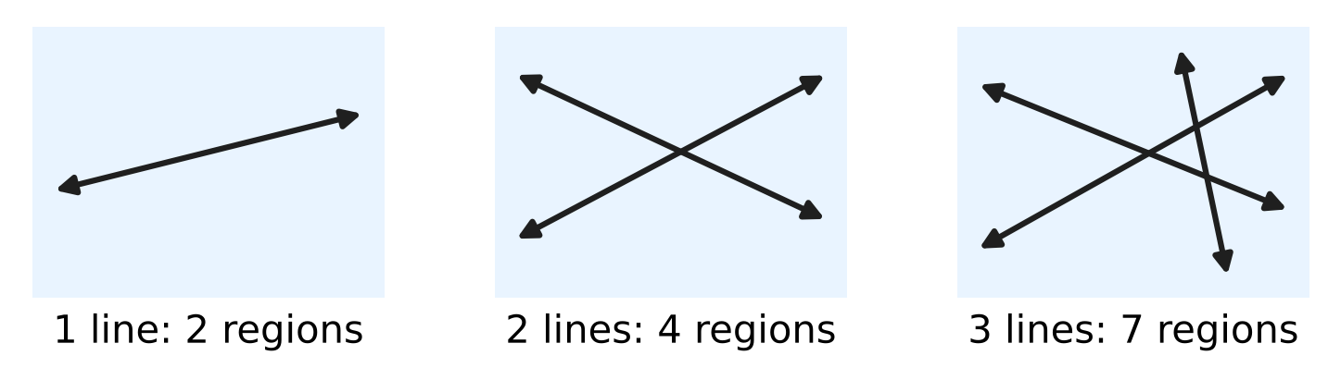
Q35. Straight lines are drawn so that no two are parallel and no three pass through one point. The picture shows that 1 line makes 2 regions, 2 lines make 4 and 3 lines make 7. The number of regions follows the rule $R(n)=R(n−1)+n$. How many regions do 6 such lines make?
(A) 64 | (B) 22 | (C) 29 | (D) 16

Q36. Prateek's algorithm tests whether a whole number n greater than 1 is prime. It divides n by 2, then by 3, then by 4, and so on. It stops as soon as a division leaves no remainder, or when the next divisor multiplied by itself is greater than n. How many divisions does it carry out for n = 91?
(A) 6 | (B) 7 | (C) 9 | (D) 5

Q37. A proposition is a sentence that is either true or false. Which of these is a proposition?
(A) Write 51 as a product of primes. | (B) What a big number 51 is!
(C) The number 51 is prime. | (D) Is 51 a prime number?

Q38. The statement "If a and b are both even whole numbers, then a + b is even" is true. Which pair of whole numbers is a counterexample to its CONVERSE?
(A) a = 6 and b = 9 | (B) a = 4 and b = 5
(C) a = 4 and b = 6 | (D) a = 3 and b = 5

Q39. Yamini climbs a staircase of 8 steps. Each time she moves, she climbs either 1 step or 2 steps. In how many different ways can she reach the top? (The same moves in a different order count as a different way.)
(A) 32 | (B) 34 | (C) 21 | (D) 55

Q40. Ojas has a Tower of Hanoi puzzle with 9 discs of different sizes on peg A, the largest at the bottom. He moves all of them to peg C in the least possible number of moves. He moves one disc at a time and never puts a larger disc on a smaller one. On which move does the largest disc move?
(A) 256 | (B) 511 | (C) 255 | (D) 128

SECTION II — Star Questions 5 questions × 4 marks each
Q41. Vivek's algorithm writes a list of numbers. Step 1: Write 3, then 7. Step 2: Write the last number minus the number before it. Step 3: Repeat Step 2 until 100 numbers have been written. (So $a_{1}=3$, $a_{2}=7$ and $a_{n}=a_{n−1}−a_{n−2}$.) What is the sum of all 100 numbers? [4 marks]
(A) 0 | (B) 11 | (C) −3 | (D) 14

Q42. In the quadrilateral ABCD, AB = AD = 15 cm and CB = CD = 20 cm. All four vertices lie on one circle, as shown. What is the circumference of the circle? (Use π = 3.14.) [4 marks] | 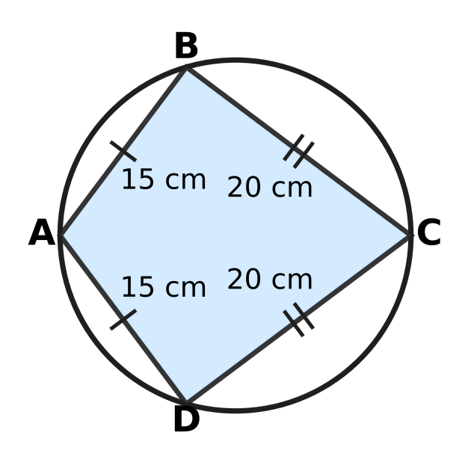
  (A) 78.5 cm | (B) 109.9 cm | (C) 62.8 cm | (D) 157 cm

Q43. A is the point (0, 3) and B is the point (4, 1). The point P lies on the line $y=3x−5$, and P is at the same distance from A as from B. What are the coordinates of P? [4 marks]
(A) (2, 1) | (B) (4, 7) | (C) (2, 2) | (D) (3, 4)

Q44. Eva rolls two fair dice and calls the numbers shown a and b. She then runs this algorithm. Step 1: If a = b, print a and stop. Step 2: Replace the larger of a and b by (larger − smaller), keep the other one, and go back to Step 1. What is the probability that the number printed is 1? [4 marks]
(A) $\frac{13}{36}$ | (B) $\frac{11}{36}$ | (C) $\frac{23}{36}$ | (D) $\frac{11}{18}$

Q45. A plant nursery had 3,000 saplings at the end of Year 1 and 4,320 at the end of Year 3. The count for the end of Year 2 was lost. Rupa assumes the number grew by the same AMOUNT every year. Neel assumes it grew by the same PERCENTAGE every year. By how many saplings do their two estimates for the end of Year 2 differ? [4 marks]
(A) 660 | (B) 600 | (C) 60 | (D) 720

Answer Sheet AMO Level 1 · Class 9 · Practice Paper 4
Name: | School: | Roll No.:
Shade or tick one circle for each question.
1. Ⓐ Ⓑ Ⓒ Ⓓ | 16. Ⓐ Ⓑ Ⓒ Ⓓ | 31. Ⓐ Ⓑ Ⓒ Ⓓ
2. Ⓐ Ⓑ Ⓒ Ⓓ | 17. Ⓐ Ⓑ Ⓒ Ⓓ | 32. Ⓐ Ⓑ Ⓒ Ⓓ
3. Ⓐ Ⓑ Ⓒ Ⓓ | 18. Ⓐ Ⓑ Ⓒ Ⓓ | 33. Ⓐ Ⓑ Ⓒ Ⓓ
4. Ⓐ Ⓑ Ⓒ Ⓓ | 19. Ⓐ Ⓑ Ⓒ Ⓓ | 34. Ⓐ Ⓑ Ⓒ Ⓓ
5. Ⓐ Ⓑ Ⓒ Ⓓ | 20. Ⓐ Ⓑ Ⓒ Ⓓ | 35. Ⓐ Ⓑ Ⓒ Ⓓ
6. Ⓐ Ⓑ Ⓒ Ⓓ | 21. Ⓐ Ⓑ Ⓒ Ⓓ | 36. Ⓐ Ⓑ Ⓒ Ⓓ
7. Ⓐ Ⓑ Ⓒ Ⓓ | 22. Ⓐ Ⓑ Ⓒ Ⓓ | 37. Ⓐ Ⓑ Ⓒ Ⓓ
8. Ⓐ Ⓑ Ⓒ Ⓓ | 23. Ⓐ Ⓑ Ⓒ Ⓓ | 38. Ⓐ Ⓑ Ⓒ Ⓓ
9. Ⓐ Ⓑ Ⓒ Ⓓ | 24. Ⓐ Ⓑ Ⓒ Ⓓ | 39. Ⓐ Ⓑ Ⓒ Ⓓ
10. Ⓐ Ⓑ Ⓒ Ⓓ | 25. Ⓐ Ⓑ Ⓒ Ⓓ | 40. Ⓐ Ⓑ Ⓒ Ⓓ
11. Ⓐ Ⓑ Ⓒ Ⓓ | 26. Ⓐ Ⓑ Ⓒ Ⓓ | 41. Ⓐ Ⓑ Ⓒ Ⓓ
12. Ⓐ Ⓑ Ⓒ Ⓓ | 27. Ⓐ Ⓑ Ⓒ Ⓓ | 42. Ⓐ Ⓑ Ⓒ Ⓓ
13. Ⓐ Ⓑ Ⓒ Ⓓ | 28. Ⓐ Ⓑ Ⓒ Ⓓ | 43. Ⓐ Ⓑ Ⓒ Ⓓ
14. Ⓐ Ⓑ Ⓒ Ⓓ | 29. Ⓐ Ⓑ Ⓒ Ⓓ | 44. Ⓐ Ⓑ Ⓒ Ⓓ
15. Ⓐ Ⓑ Ⓒ Ⓓ | 30. Ⓐ Ⓑ Ⓒ Ⓓ | 45. Ⓐ Ⓑ Ⓒ Ⓓ
Q41–Q45 are Section II Star Questions (4 marks each).
For the parent or teacher
Section I correct: ______ / 40 × 2 = ______ marks Section II correct: ______ / 5 × 4 = ______ marks
Correct: ______ / 45 Score: ______ / 100
Answer Key and Solutions AMO Level 1 · Class 9 · Practice Paper 4
Quick answers
1 D | 6 B | 11 C | 16 D | 21 C | 26 C | 31 C | 36 A | 41 B
2 B | 7 A | 12 D | 17 A | 22 A | 27 B | 32 B | 37 C | 42 A
3 C | 8 D | 13 C | 18 B | 23 B | 28 A | 33 C | 38 D | 43 D
4 A | 9 A | 14 B | 19 D | 24 D | 29 A | 34 D | 39 B | 44 C
5 C | 10 B | 15 A | 20 C | 25 D | 30 D | 35 B | 40 A | 45 C
Solutions
Q | Part · level | Answer | Why?
1 | Part 1 · Ch1 · Easy | (D) 0.189189… | Here 7/37 = 7 × 0.027027… and 7 × 027 = 189, so every block of three digits becomes 189: 7/37 = 0.189189…
2 | Part 1 · Ch1 · Easy | (B) 0.4555… (the digit 5 repeats for ever) | If x = 0.4555…, then 100x − 10x = 45.555… − 4.555… = 41, so x = 41/90, which is not 1/2. The same method gives 0.4999… = 45/90 = 1/2.
3 | Part 1 · Ch1 · Medium | (C) $a+b$ | If a + b were rational, then b = (a + b) − a would be rational, which it is not. The others can be rational: a = 0 makes a × b = 0, b = √2 makes b × b = 2, and a = −1 makes a × b + b = 0.
4 | Part 2 · Ch3 · Easy | (A) $250×{(1.08)}^{n}$ | Each year the number is multiplied by 1 + 8/100 = 1.08, so after n years it is 250 × (1.08)^{n}, a geometric progression.
5 | Part 2 · Ch3 · Easy | (C) ₹15,600 | Each year adds the same interest, 6% of ₹12,000 = ₹720 (the common difference). After 5 years the amount is ₹12,000 + 5 × ₹720 = ₹15,600.
6 | Part 2 · Ch3 · Medium | (B) ₹35,000 | The money was multiplied by 1.2 × 1.2 = 1.44, so it was ₹36,000 ÷ 1.44 = ₹25,000. Simple interest for 2 years is 2 × ₹5,000 = ₹10,000, so the amount would be ₹35,000.
7 | Part 3 · Ch4 · Easy | (A) 4 | Subtracting the second equation from the first gives x − y = 17 − 13 = 4.
8 | Part 3 · Ch4 · Easy | (D) 29 | (x + y)² = x² + 2xy + y², so x² + y² = 7² − 2 × 10 = 49 − 20 = 29.
9 | Part 3 · Ch4 · Easy | (A) 30 | The numbers 6, 11, 16, … form an AP: n hexagons need 5n + 1 crayons. Then 5n + 1 = 151 gives n = 30.
10 | Part 3 · Ch4 · Easy | (B) slope 2, y-intercept −3 | Here 3y = 6x − 9, so y = 2x − 3. The slope is 2 and the y-intercept is −3.
11 | Part 3 · Ch4 · Medium | (C) $x−y+3$ | x² − y² + 6y − 9 = x² − (y² − 6y + 9) = x² − (y − 3)² = (x − y + 3)(x + y − 3).
12 | Part 3 · Ch4 · Medium | (D) $(8x+12)$ cm | Here 3x² + 10x + 8 = (3x + 4)(x + 2), so the breadth is (x + 2) cm. Perimeter = 2(3x + 4 + x + 2) = (8x + 12) cm.
13 | Part 3 · Ch4 · Medium | (C) 11 | The numbers are 13, 21, 29, …, 93, an AP with d = 8. Then 93 = 13 + (n − 1) × 8 gives n = 11.
14 | Part 4 · Ch5 · Easy | (B) 14 cm | The longest chord is a diameter, 2 × 6.5 = 13 cm. A chord of 14 cm would be longer than the diameter, so it is impossible.
15 | Part 4 · Ch5 · Easy | (A) 6.5 cm | A line through the midpoint of one side parallel to another side bisects the third side (converse of the midpoint theorem). So E is the midpoint of AC and AE = 13 ÷ 2 = 6.5 cm.
16 | Part 4 · Ch5 · Easy | (D) an isosceles trapezium | In an isosceles trapezium the two base angles at each parallel side are equal, so each pair of opposite angles adds up to 180°. By the converse of the cyclic-quadrilateral theorem its vertices lie on a circle.
17 | Part 4 · Ch5 · Easy | (A) at the centre of the tabletop | The perpendicular bisector of any chord passes through the centre. Two such lines that are not parallel meet at exactly one point, the centre.
18 | Part 4 · Ch5 · Medium | (B) 75° | ∠BDC = ∠BAC = 35° (angles in the same segment). ∠BEC is an exterior angle of △DEC, so x = 35° + 40° = 75°.
19 | Part 4 · Ch5 · Medium | (D) 55° | Equal chords subtend equal angles at the centre, so ∠COD = 70°. OC = OD (radii), so x = (180° − 70°) ÷ 2 = 55°.
20 | Part 4 · Ch5 · Medium | (C) a rhombus that is not a square | AB² = BC² = CD² = DA² = 17, so all four sides are equal. The diagonals are unequal (AC² = 50, BD² = 18), so it is a rhombus but not a square.
21 | Part 5 · Ch6 · Easy | (C) 77 cm² | Each slice is a sector of 360° ÷ 8 = 45°. Area = (1/8) × (22/7) × 14 × 14 = 616 ÷ 8 = 77 cm².
22 | Part 5 · Ch6 · Easy | (A) 23.1 m² | Slant height l = √(2.1² + 2.8²) = 3.5 m. Curved surface = πrl = (22/7) × 2.1 × 3.5 = 23.1 m².
23 | Part 5 · Ch6 · Easy | (B) 60 m² | Each sloping face has height √(3² + 4²) = 5 m (from the middle of a base edge to the top). Area = 4 × ½ × 6 × 5 = 60 m².
24 | Part 5 · Ch6 · Medium | (D) 8 m | s = (10 + 17 + 21) ÷ 2 = 24. Area = √(24 × 14 × 7 × 3) = √7,056 = 84 m². Then ½ × 21 × h = 84, so h = 8 m.
25 | Part 5 · Ch6 · Medium | (D) 16 cm² | Volume = 8 × 4 × 2 = 64 cm³, so the cube has edge 4 cm. Slab: 2(32 + 8 + 16) = 112 cm². Cube: 6 × 16 = 96 cm². Difference = 16 cm².
26 | Part 6 · Ch8 · Easy | (C) 56.5 g | Total mass = 6 × 50 + 9 × 55 + 15 × 60 = 300 + 495 + 900 = 1,695 g. Mean = 1,695 ÷ 30 = 56.5 g.
27 | Part 6 · Ch8 · Easy | (B) $\frac{7}{12}$ | There are 24 − 9 − 5 = 10 red umbrellas, so 14 are not red. P(not red) = 14/24 = 7/12.
28 | Part 6 · Ch8 · Easy | (A) How many hours do Class 9 students sleep on a school night? | Only the sleep question has answers that differ from student to student, so data must be collected and summarised.
29 | Part 6 · Ch8 · Medium | (A) $\frac{9}{50}$ | Squares: 1, 4, 9, 16, 25, 36, 49 (7). Cubes: 1, 8, 27; 1 is already counted, so 2 more. That gives 9 numbers, and the probability is 9/50.
30 | Part 6 · Ch8 · Medium | (D) $\frac{5}{18}$ | There are 6 × 6 = 36 equally likely (Monday, Tuesday) choices. The boy leads on exactly one day in 5 + 5 = 10 of them (girl then boy, or boy then girl), so the probability is 10/36 = 5/18.
31 | Part 7 · Ch9 · Easy | (C) the litres of milk taken out of the tank each minute | For every extra minute, V goes down by 75. So 75 is the number of litres of milk taken out each minute (the slope); 1,200 is the starting volume.
32 | Part 7 · Ch9 · Easy | (B) 432 m² | On the plan KL = 8 units and LM = 6 units. Really these are 24 m and 18 m, so the floor area is 24 × 18 = 432 m².
33 | Part 7 · Ch9 · Medium | (C) 3 km/h | Downstream speed = 36 ÷ 2 = 18 km/h and upstream speed = 36 ÷ 3 = 12 km/h. If the ferry goes at u and the current at v, then u + v = 18 and u − v = 12, so v = 3 km/h.
34 | Part 7 · Ch9 · Medium | (D) 2,600 m | The temperature falls 4.8 °C in 800 m, that is 0.6 °C every 100 m. From 22 °C to 10 °C is a fall of 12 °C, which needs 2,000 m more than 600 m: 2,600 m.
35 | Part 8 · Ch10 · Easy | (B) 22 | R(4) = 7 + 4 = 11, R(5) = 11 + 5 = 16, R(6) = 16 + 6 = 22.
36 | Part 8 · Ch10 · Easy | (A) 6 | It divides by 2, 3, 4, 5, 6 (each leaves a remainder) and then by 7, and 91 ÷ 7 = 13 with no remainder, so it stops after 6 divisions.
37 | Part 8 · Ch10 · Easy | (C) The number 51 is prime. | The sentence "The number 51 is prime" is a proposition; it happens to be false, since 51 = 3 × 17. A question, an instruction and an exclamation are not true or false.
38 | Part 8 · Ch10 · Easy | (D) a = 3 and b = 5 | The converse is "If a + b is even, then a and b are both even". For a = 3 and b = 5 the sum 8 is even, but neither number is even, so the converse is false.
39 | Part 8 · Ch10 · Medium | (B) 34 | Let W(n) be the number of ways for n steps. The last move is 1 or 2 steps, so W(n) = W(n − 1) + W(n − 2), with W(1) = 1, W(2) = 2. Then 3, 5, 8, 13, 21, 34, so W(8) = 34.
40 | Part 8 · Ch10 · Medium | (A) 256 | The largest disc can move only when the 8 smaller discs are all on peg B, which takes at least 2⁸ − 1 = 255 moves. So it moves on move 256 (and only once).
41 | Section II · Ch4 + Ch10 · Hard | (B) 11 | The list is 3, 7, 4, −3, −7, −4, 3, 7, … and repeats every 6 numbers; each block of 6 adds to 0. Since 100 = 16 × 6 + 4, the sum is 3 + 7 + 4 − 3 = 11.
42 | Section II · Ch5 + Ch6 · Hard | (A) 78.5 cm | △ABC ≅ △ADC (SSS), so ∠B = ∠D. In a cyclic quadrilateral ∠B + ∠D = 180°, so ∠B = 90°. Then AC is a diameter (angle in a semicircle) and AC = √(15² + 20²) = 25 cm. Circumference = 3.14 × 25 = 78.5 cm.
43 | Section II · Ch4 + Ch5 · Hard | (D) (3, 4) | PA² = PB² gives x² + (y − 3)² = (x − 4)² + (y − 1)², which simplifies to 2x − y = 2. With y = 3x − 5: 2x − 3x + 5 = 2, so x = 3 and y = 4. P is (3, 4).
44 | Section II · Ch8 + Ch10 · Hard | (C) $\frac{23}{36}$ | Subtracting the smaller number from the larger keeps the HCF, so the algorithm prints the HCF of a and b. Of the 36 outcomes, 13 have HCF more than 1 (equal pairs from 2 to 6, and (2, 4), (2, 6), (4, 6), (3, 6) both ways), so 23 print 1: 23/36.
45 | Section II · Ch3 + Ch9 · Hard | (C) 60 | Rupa: the increase of 1,320 over 2 years is 660 a year, so her estimate is 3,660. Neel: 4,320 ÷ 3,000 = 1.44 = 1.2 × 1.2, so the growth is 20% a year and his estimate is 3,600. They differ by 60 saplings.

ARYABHATTA MATHS OLYMPIAD
Level 1
PRACTICE PAPER-5
CLASS 9
Total Questions | 45 multiple-choice questions
Total Marks | 100
Time | 60 minutes
Section I | 40 questions × 2 marks = 80 marks
Section II | 5 Star Questions × 4 marks = 20 marks
Negative Marking | No negative marking
Calculator | Not allowed
Chapters | Number System · Fractions, Decimals & Percentages · Algebra · Geometry · Mensuration · Data Handling · Applied Mathematics · Mathematical Reasoning

Instructions to candidates
• This paper has 45 multiple-choice questions. Each question has four answer choices, of which exactly one is correct.
• Section I (Q1–Q40) carries 2 marks per question. Section II (Q41–Q45) carries 4 marks per question.
• There is no negative marking. Unanswered questions score zero.
• Calculators are not permitted. Rough work may be done on a separate sheet.
• Mark your answers on the answer sheet at the end of the paper.
• All figures are not necessarily drawn to scale unless stated.

For parents and teachers
• Print or view this paper in colour. Pictures are part of the questions.
• Parts follow the AMO syllabus chapters. Chapters 2 and 7 are not part of the Class 9 syllabus, so the chapter numbers shown in the Part headings have gaps.
• The answer sheet and the answer key are at the end. Remove only the answer key before the student begins.

SECTION I 40 questions × 2 marks each
Part 1 — Number System (Syllabus Chapter 1)
Q1. Which of these numbers is the greatest?
(A) 0.67
(B) 0.666… (the digit 6 repeats for ever)
(C) 0.67777… (the digit 7 repeats for ever)
(D) 0.676767… (the block 67 repeats for ever)

Q2. Exactly one of these square roots is an irrational number. Which one is it?
(A) $\sqrt{0.04}$
(B) $\sqrt{0.4}$
(C) $\sqrt{0.444…}$ (the digit 4 repeats for ever)
(D) $\sqrt{1.21}$

Q3. Isha divides 7 by a whole number q and gets 0.31818…, where the block 18 repeats for ever after the digit 3. What is q?
(A) 22 | (B) 44 | (C) 220 | (D) 21

Part 2 — Fractions, Decimals & Percentages (Syllabus Chapter 3)
Q4. Usha invests a sum of money at simple interest. Two years later it has grown to ₹7,200, and one year after that it has grown to ₹7,800. What sum did she invest?
(A) ₹6,600 | (B) ₹5,400 | (C) ₹1,200 | (D) ₹6,000

Q5. The population of a town is 50,000. It grows by 4% every year. By how many people does it grow during the SECOND year?
(A) 2,080 | (B) 2,000 | (C) 54,080 | (D) 4,080

Q6. Anjali keeps part of her savings in Deposit A, which pays 6% per year simple interest. The rest is in Deposit B, which pays 10% per year simple interest. In one year her savings earn the same interest as they would if all of the money earned 7.5% per year. What percentage of her savings is in Deposit B?
(A) 62.5% | (B) 75% | (C) 25% | (D) 37.5%

Part 3 — Algebra (Syllabus Chapter 4)
Q7. What number must be added to $9x^{2}+24x$ to make it a perfect square, that is, the square of a linear polynomial?
(A) 144 | (B) 16 | (C) 64 | (D) 8

Q8. The 1st term of an arithmetic progression is 3 and its 15th term is 59. What is its 8th term?
(A) 27 | (B) 28 | (C) 31 | (D) 35

Q9. The numbers x and y satisfy $x^{2}−y^{2}=72$ and $x−y=4$. What is the value of x?
(A) 9 | (B) 7 | (C) 11 | (D) 18

Q10. For the polynomial $p(x)=x^{2}+kx−6$, the value $p(2)$ is 4. What is the value of k?
(A) 7 | (B) 3 | (C) −3 | (D) 1

Q11. The expression $\frac{x^{2}+3x−10}{x^{2}−4}$ simplifies to $\frac{x+5}{x+2}$. For which value of x does the simplified form have a value but the original expression does NOT?
(A) $x=2$ | (B) $x=5$ | (C) $x=−2$ | (D) $x=−5$

Q12. The expression $x^{2}+kx+24$ can be written as $(x+a)(x+b)$, where a and b are positive whole numbers. How many different values can k take?
(A) 5 | (B) 3 | (C) 8 | (D) 4

Q13. A sequence starts 2, 6, … . If it is an arithmetic progression, its 5th term is A. If it is a geometric progression, its 5th term is G. What is $G−A$?
(A) 148 | (B) 464 | (C) 144 | (D) 40

Part 4 — Geometry (Syllabus Chapter 5)
Q14. Four chords are drawn in the same circle of radius 10 cm. Their lengths are 10 cm, 12 cm, 16 cm and 18 cm. Which chord is at the shortest distance from the centre?
(A) the 12 cm chord | (B) the 18 cm chord
(C) the 16 cm chord | (D) the 10 cm chord

Q15. The point P(a, 3) is 5 units from the point Q(1, −1), and a is positive. What is the value of a?
(A) 4 | (B) 10 | (C) 3 | (D) 6

Q16. ABCD is a parallelogram, and its diagonals meet at O, as shown. AO = (3x − 2) cm and OC = (x + 8) cm. What is the length of the diagonal AC? | 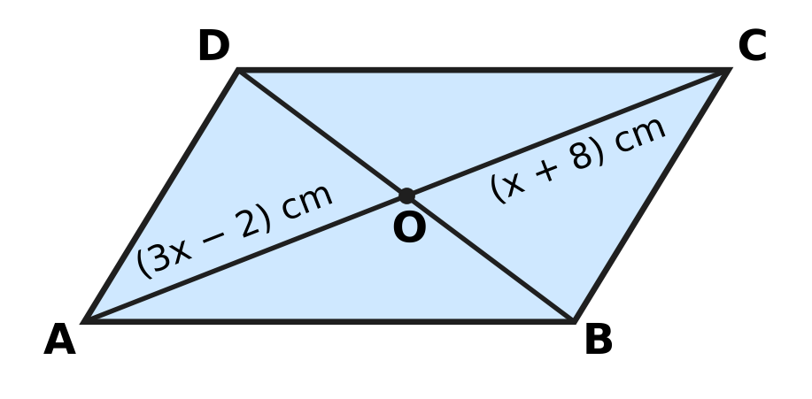
  (A) 52 cm | (B) 13 cm | (C) 5 cm | (D) 26 cm

Q17. In △ABC, AB = AC. The bisector of ∠BAC meets BC at D, as shown. BC = 16 cm and AD = 15 cm. What is the length of AB? | 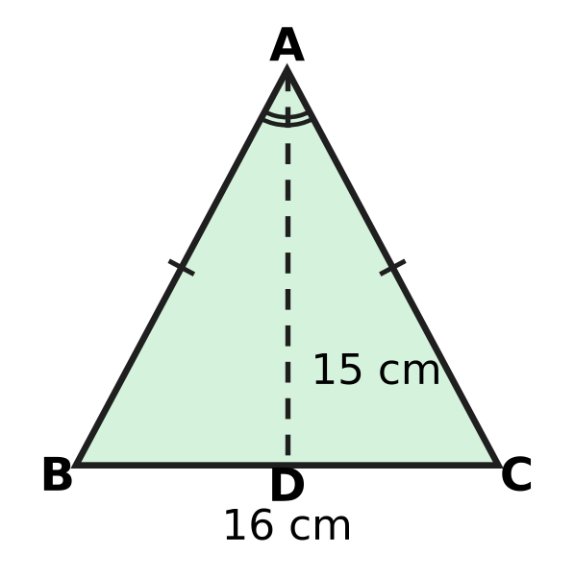
  (A) 23 cm | (B) 17 cm | (C) 31 cm | (D) 15 cm

Q18. ABCD is a cyclic quadrilateral with AB = AD, as the marks show. The diagonal BD is drawn, and ∠BCD = 104°. What is ∠ABD, marked x? | 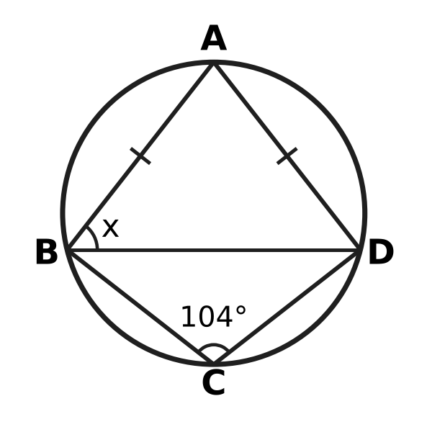
  (A) 104° | (B) 38° | (C) 76° | (D) 52°

Q19. A, B and C lie on a circle with centre O, as shown, and A is on the major arc BC. ∠BAC = 30° and the chord BC = 7 cm. What is the radius of the circle? | 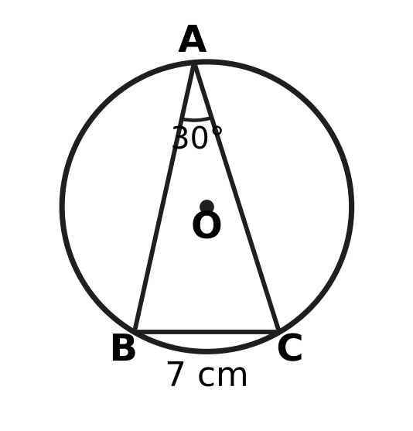
  (A) 14 cm | (B) 10.5 cm | (C) 7 cm | (D) 3.5 cm

Q20. In △ABC, the midpoint of AB is D(1, 5) and the midpoint of AC is E(5, 2). What is the length of BC?
(A) 10 units | (B) 5 units
(C) 2.5 units | (D) 14 units

Part 5 — Mensuration (Syllabus Chapter 6)
Q21. Kian's fishing net is a circle with a rim 8.8 m long. When it is spread out flat, what area of water does it cover? (Use π = $\frac{22}{7}$.)
(A) 24.64 m² | (B) 12.32 m² | (C) 3.08 m² | (D) 6.16 m²

Q22. For a science exhibition, Parth makes a model globe, a sphere of radius 7 cm. He then decides to make it bigger, with radius 14 cm. By how much does the surface area of the globe increase? (Use π = $\frac{22}{7}$.)
(A) 4,312 cm² | (B) 616 cm²
(C) 1,848 cm² | (D) 924 cm²

Q23. A window is a semicircle with a straight bottom edge 1.4 m long, as shown. A metal strip is fixed all the way round its edge (the curved part and the straight part). How long is the strip? (Use π = $\frac{22}{7}$.) | 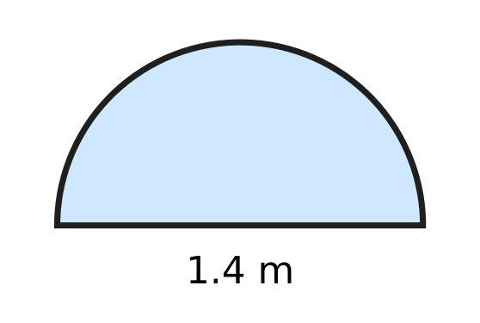
  (A) 3.6 m | (B) 5.8 m | (C) 2.2 m | (D) 2.9 m

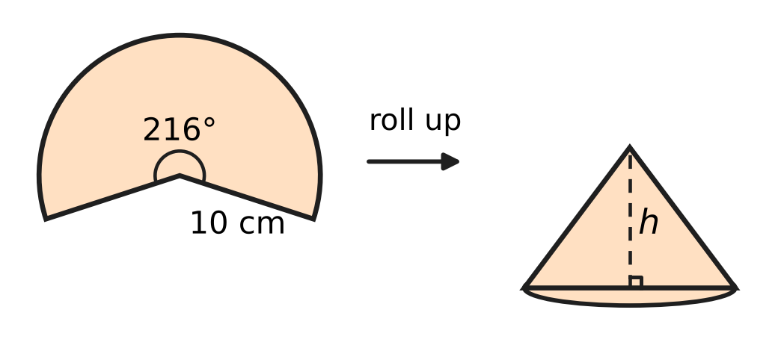
Q24. A paper sector has radius 10 cm and angle 216°. It is rolled up so that its two straight edges just meet, making the curved surface of a cone with no overlap, as shown. What is the height h of the cone?
(A) 4 cm | (B) 8 cm | (C) 6 cm | (D) 10 cm

Q25. Varsha cuts out a paper triangle with sides 25 cm, 25 cm and 14 cm, as shown. She wants a DIFFERENT triangle that also has two 25 cm sides and exactly the same area. How long must its third side be? | 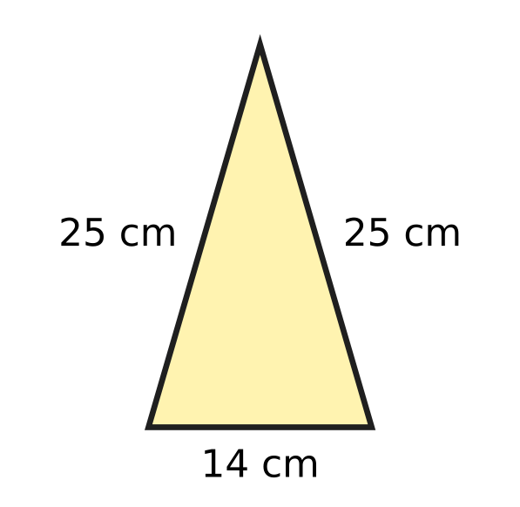
  (A) 24 cm | (B) 48 cm | (C) 7 cm | (D) 28 cm

Part 6 — Data Handling, Statistics & Probability (Syllabus Chapter 8)
Q26. In a course, the final mark is 30% of the Test A mark plus 70% of the Test B mark. Myra scored 60 in Test A. What must she score in Test B so that her final mark is 74?
(A) 56 | (B) 88 | (C) 80 | (D) 74

Q27. In a music class test, seven students scored 12, 15, 15, 18, 20, 22 and 26. Later the student who scored 26 was given 14 extra marks for a solo performance. Which of these is correct?
(A) The mean goes up by 14 and the median does NOT change.
(B) The median goes up by 2 and the mean does NOT change.
(C) The mean and the median both go up by 2.
(D) The mean goes up by 2 and the median does NOT change.

Q28. A fair eight-sided die has faces numbered 1 to 8. It is rolled once. What is the probability that the number shown is a factor of 24?
(A) $\frac{3}{4}$ | (B) $\frac{1}{4}$ | (C) $\frac{1}{2}$ | (D) $\frac{5}{8}$

Q29. At Heena's ice-cream stall, the freezer holds only mango cups and vanilla cups. A cup taken at random is mango with probability $\frac{2}{5}$. Heena then adds 6 more vanilla cups, and the probability of a mango cup becomes $\frac{1}{4}$. How many mango cups are in the freezer?
(A) 2 | (B) 6 | (C) 4 | (D) 10

Cups of tea sold at a tea stall
Day | Mon | Tue | Wed | Thu | Fri | Sat
Cups of tea sold | 40 | 90 | 60 | x | 70 | 90

Q30. Use the table. The data have exactly one mode, and the mean number of cups sold per day is equal to the mode. What is the value of x?
(A) 100 | (B) 70 | (C) 90 | (D) 190

Part 7 — Applied Mathematics (Syllabus Chapter 9)
Q31. The ladder of a playground slide has equally spaced rungs. The lowest rung is 30 cm above the ground, and each rung is 25 cm above the one below it. Which rung is 230 cm above the ground?
(A) the 9th rung | (B) the 8th rung
(C) the 10th rung | (D) the 7th rung

Battery readings
Time on the charger, t (minutes) | 10 | 20 | 40 | 50
Battery charge, c (%) | 27 | 42 | 72 | 87

Q32. A phone battery charges at a steady rate. The table shows its charge at some times after it was put on the charger. Which equation fits all the readings?
(A) c = 12t + 1.5 | (B) c = 1.5t + 12
(C) c = 1.5t + 27 | (D) c = 15t + 12

Q33. A hot-air balloon rises at a steady rate from the moment it leaves the ground. A timer was started before take-off. The timer shows the balloon 240 m above the ground at 10 minutes and 690 m above the ground at 25 minutes. At what timer reading did the balloon leave the ground?
(A) 0 minutes | (B) 2 minutes
(C) 8 minutes | (D) 5 minutes

Q34. In a building, Lift P starts at floor 20 and goes down steadily, 2 floors every 5 seconds. At the same moment, Lift Q starts at the ground floor (floor 0) and goes up steadily, 3 floors every 5 seconds. At which floor do the two lifts pass each other?
(A) floor 12 | (B) floor 4 | (C) floor 8 | (D) floor 10

Part 8 — Mathematical Reasoning & Problem-Solving (Syllabus Chapter 10)
Q35. Consider the statement: "If a whole number greater than 0 ends in 00, then it is a multiple of k." For which value of k is this statement true AND its converse also true?
(A) 25 | (B) 50 | (C) 200 | (D) 100

Q36. Lata multiplies 37 by 24 with this algorithm.
Step 1: Write 37 and 24 side by side as the first row.
Step 2: In the next row, write half of the left number (ignore any remainder) and double the right number. Repeat until the left number is 1.
Step 3: Cross out every row whose left number is even.
Step 4: Add the right-hand numbers that are left.
Which right-hand numbers does she add in Step 4?
(A) 96, 192 and 768 | (B) 24, 48 and 96
(C) 24, 96 and 768 | (D) 48, 192 and 384

Q37. Zoya wants to prove this statement by contradiction: "Among all the rational numbers that are less than 2, there is NO greatest one." She assumes that there is a greatest one and calls it r. Which number shows at once that her assumption is false?
(A) $r^{2}$ | (B) $2r$ | (C) $r−1$ | (D) $\frac{r+2}{2}$

Q38. Brahmagupta's formula, area = √((s − a)(s − b)(s − c)(s − d)), where a, b, c, d are the sides and s is half the perimeter, is true for every cyclic quadrilateral. Sarika uses it for the rhombus in the picture, whose sides are 13 cm and whose diagonals are 10 cm and 24 cm. What is the difference between her answer and the true area? | 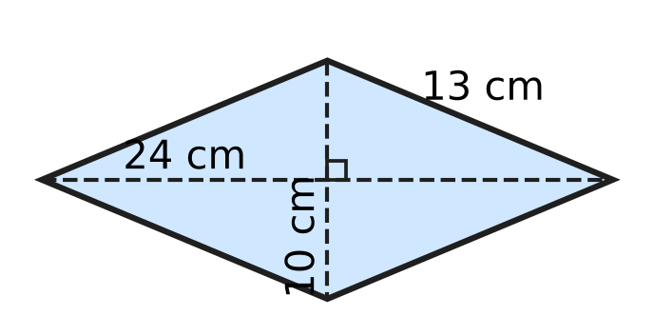
  (A) 49 cm² | (B) 109 cm² | (C) 0 cm² | (D) 71 cm²

Q39. Lata sorts the list 5, 1, 4, 2, 3 into increasing order. She goes along the list from left to right, swapping any two neighbours in the wrong order, and repeats this until no swap is needed. How many swaps does she make?
(A) 4 | (B) 6 | (C) 5 | (D) 10

Q40. The numbers 2 to 50 are written in a list.
Step 1: Circle 2, then cross out all the other multiples of 2 (that is, 4, 6, 8, …).
Step 2: Circle 3, then cross out every multiple of 3, other than 3 itself, that has NOT already been crossed out.
How many numbers are crossed out in Step 2?
(A) 15 | (B) 16 | (C) 7 | (D) 8

SECTION II — Star Questions 5 questions × 4 marks each
Q41. Jatin runs this algorithm.
Step 1: Put n = 1.
Step 2: If n leaves remainder 3 when divided by 7 AND remainder 1 when divided by 4, print n.
Step 3: Increase n by 1. If n is at most 500, go back to Step 2; otherwise stop.
How many numbers are printed? [4 marks]
(A) 18 | (B) 125 | (C) 72 | (D) 17

Q42. A ball rests in a circular hole of diameter 16 cm cut in a flat board. The lowest point of the ball is 4 cm below the top of the board, as the cross-section through the centre O shows. What is the surface area of the ball? (Use π = 3.14.) [4 marks] | 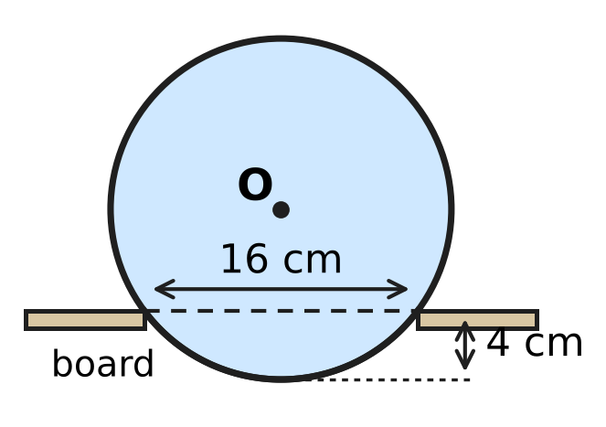
  (A) 628 cm² | (B) 1,004.8 cm²
  (C) 1,256 cm² | (D) 803.84 cm²

Q43. ABCD is a parallelogram in which A(1, 2) and C(7, 6) are opposite vertices. The vertex B lies on the x-axis, and the vertex D lies on the line $y=x+3$. What are the coordinates of D? [4 marks]
(A) (3, 0) | (B) (1, 4) | (C) (4, 7) | (D) (5, 8)

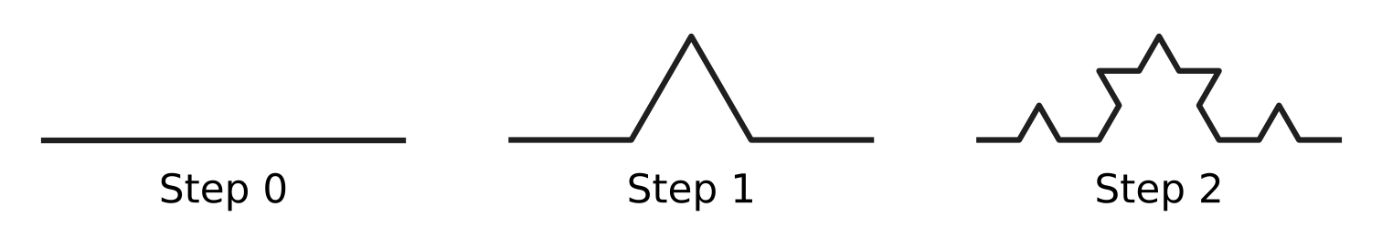
Q44. The picture shows Steps 0, 1 and 2 of the Koch curve. Step 0 is one horizontal segment. At each step, every segment is cut into 3 equal parts, and the middle part is replaced by the other two sides of an equilateral triangle, as shown. One segment of Step 3 is chosen at random, each segment being equally likely. What is the probability that it is horizontal on the page, like the Step 0 segment? [4 marks]
(A) $\frac{1}{8}$ | (B) $\frac{11}{32}$ | (C) $\frac{3}{8}$ | (D) $\frac{1}{3}$

Q45. Every year a school buys 100 roses and 25 lilies from a flower shop to decorate its hall. Each year the price of a rose goes up by 10% of the previous year's price, and the price of a lily goes up by 20% of the previous year's price. The flowers cost ₹1,625 in Year 1 and ₹2,110 in Year 3. What was the price of one lily in Year 1? [4 marks]
(A) ₹36 | (B) ₹10 | (C) ₹30 | (D) ₹25

Answer Sheet AMO Level 1 · Class 9 · Practice Paper 5
Name: | School: | Roll No.:
Shade or tick one circle for each question.
1. Ⓐ Ⓑ Ⓒ Ⓓ | 16. Ⓐ Ⓑ Ⓒ Ⓓ | 31. Ⓐ Ⓑ Ⓒ Ⓓ
2. Ⓐ Ⓑ Ⓒ Ⓓ | 17. Ⓐ Ⓑ Ⓒ Ⓓ | 32. Ⓐ Ⓑ Ⓒ Ⓓ
3. Ⓐ Ⓑ Ⓒ Ⓓ | 18. Ⓐ Ⓑ Ⓒ Ⓓ | 33. Ⓐ Ⓑ Ⓒ Ⓓ
4. Ⓐ Ⓑ Ⓒ Ⓓ | 19. Ⓐ Ⓑ Ⓒ Ⓓ | 34. Ⓐ Ⓑ Ⓒ Ⓓ
5. Ⓐ Ⓑ Ⓒ Ⓓ | 20. Ⓐ Ⓑ Ⓒ Ⓓ | 35. Ⓐ Ⓑ Ⓒ Ⓓ
6. Ⓐ Ⓑ Ⓒ Ⓓ | 21. Ⓐ Ⓑ Ⓒ Ⓓ | 36. Ⓐ Ⓑ Ⓒ Ⓓ
7. Ⓐ Ⓑ Ⓒ Ⓓ | 22. Ⓐ Ⓑ Ⓒ Ⓓ | 37. Ⓐ Ⓑ Ⓒ Ⓓ
8. Ⓐ Ⓑ Ⓒ Ⓓ | 23. Ⓐ Ⓑ Ⓒ Ⓓ | 38. Ⓐ Ⓑ Ⓒ Ⓓ
9. Ⓐ Ⓑ Ⓒ Ⓓ | 24. Ⓐ Ⓑ Ⓒ Ⓓ | 39. Ⓐ Ⓑ Ⓒ Ⓓ
10. Ⓐ Ⓑ Ⓒ Ⓓ | 25. Ⓐ Ⓑ Ⓒ Ⓓ | 40. Ⓐ Ⓑ Ⓒ Ⓓ
11. Ⓐ Ⓑ Ⓒ Ⓓ | 26. Ⓐ Ⓑ Ⓒ Ⓓ | 41. Ⓐ Ⓑ Ⓒ Ⓓ
12. Ⓐ Ⓑ Ⓒ Ⓓ | 27. Ⓐ Ⓑ Ⓒ Ⓓ | 42. Ⓐ Ⓑ Ⓒ Ⓓ
13. Ⓐ Ⓑ Ⓒ Ⓓ | 28. Ⓐ Ⓑ Ⓒ Ⓓ | 43. Ⓐ Ⓑ Ⓒ Ⓓ
14. Ⓐ Ⓑ Ⓒ Ⓓ | 29. Ⓐ Ⓑ Ⓒ Ⓓ | 44. Ⓐ Ⓑ Ⓒ Ⓓ
15. Ⓐ Ⓑ Ⓒ Ⓓ | 30. Ⓐ Ⓑ Ⓒ Ⓓ | 45. Ⓐ Ⓑ Ⓒ Ⓓ
Q41–Q45 are Section II Star Questions (4 marks each).
For the parent or teacher
Section I correct: ______ / 40 × 2 = ______ marks Section II correct: ______ / 5 × 4 = ______ marks
Correct: ______ / 45 Score: ______ / 100
Answer Key and Solutions AMO Level 1 · Class 9 · Practice Paper 5
Quick answers
1 C | 6 D | 11 A | 16 D | 21 D | 26 C | 31 A | 36 C | 41 A
2 B | 7 B | 12 D | 17 B | 22 C | 27 D | 32 B | 37 D | 42 C
3 A | 8 C | 13 C | 18 D | 23 A | 28 A | 33 B | 38 A | 43 D
4 D | 9 C | 14 B | 19 C | 24 B | 29 C | 34 A | 39 B | 44 B
5 A | 10 B | 15 A | 20 A | 25 B | 30 D | 35 D | 40 C | 45 D
Solutions
Q | Part · level | Answer | Why?
1 | Part 1 · Ch1 · Easy | (C) 0.67777… | Compare digit by digit: all start 0.6; the second digits are 7, 7, 7 and 6; the third digits are 7 for 0.6777…, 6 for 0.6767… and 0 for 0.67. So 0.67777… is the greatest.
2 | Part 1 · Ch1 · Easy | (B) $\sqrt{0.4}$ | √0.04 = 0.2, √1.21 = 1.1 and 0.444… = 4/9, so √0.444… = 2/3; all three are rational. But 0.4 = 2/5 is not the square of any rational, so √0.4 is irrational.
3 | Part 1 · Ch1 · Medium | (A) 22 | Let x = 0.31818…. Then 1,000x = 318.1818… and 10x = 3.1818…, so 990x = 315 and x = 315/990 = 7/22. So q = 22.
4 | Part 2 · Ch3 · Easy | (D) ₹6,000 | Simple interest adds the same amount each year: ₹7,800 − ₹7,200 = ₹600. Going back two years from Year 2: ₹7,200 − 2 × ₹600 = ₹6,000.
5 | Part 2 · Ch3 · Easy | (A) 2,080 | After Year 1 the population is 50,000 × 1.04 = 52,000. During Year 2 it grows by 4% of 52,000 = 2,080.
6 | Part 2 · Ch3 · Medium | (D) 37.5% | The 7.5% rate is the weighted average of 6% and 10%. It lies 1.5 above 6 out of the gap of 4 between 6 and 10, so the share in Deposit B is 1.5 ÷ 4 = 37.5%. Check: 0.625 × 6 + 0.375 × 10 = 7.5.
7 | Part 3 · Ch4 · Easy | (B) 16 | 9x² + 24x + 16 = (3x)² + 2 × 3x × 4 + 4² = (3x + 4)², so 16 must be added.
8 | Part 3 · Ch4 · Easy | (C) 31 | The common difference d satisfies 14d = 59 − 3 = 56, so d = 4. The 8th term is 3 + 7 × 4 = 31 (it is also the average of the 1st and 15th terms, since 8 is halfway between 1 and 15).
9 | Part 3 · Ch4 · Easy | (C) 11 | x² − y² = (x + y)(x − y), so 4(x + y) = 72 and x + y = 18. With x − y = 4, adding gives 2x = 22, so x = 11.
10 | Part 3 · Ch4 · Easy | (B) 3 | p(2) = 4 + 2k − 6 = 2k − 2. Setting 2k − 2 = 4 gives k = 3.
11 | Part 3 · Ch4 · Medium | (A) $x=2$ | x² + 3x − 10 = (x + 5)(x − 2) and x² − 4 = (x − 2)(x + 2). The common factor x − 2 was cancelled, so at x = 2 the original is 0/0 (undefined) while (x + 5)/(x + 2) = 7/4.
12 | Part 3 · Ch4 · Medium | (D) 4 | ab = 24 and k = a + b. The pairs are 1 × 24, 2 × 12, 3 × 8 and 4 × 6, giving k = 25, 14, 11 and 10: four values.
13 | Part 3 · Ch4 · Medium | (C) 144 | AP: d = 4, so A = 2 + 4 × 4 = 18. GP: r = 3, so G = 2 × 3⁴ = 162. G − A = 162 − 18 = 144.
14 | Part 4 · Ch5 · Easy | (B) the 18 cm chord | The distance from the centre is √(10² − (half-chord)²): 8.66 cm, 8 cm, 6 cm and about 4.4 cm. The longest chord, 18 cm, is the nearest.
15 | Part 4 · Ch5 · Easy | (A) 4 | (a − 1)² + (3 − (−1))² = 25, so (a − 1)² = 9 and a − 1 = 3 or −3. Since a is positive, a = 4.
16 | Part 4 · Ch5 · Easy | (D) 26 cm | The diagonals of a parallelogram bisect each other, so 3x − 2 = x + 8 and x = 5. Then AO = OC = 13 cm, and AC = 26 cm.
17 | Part 4 · Ch5 · Easy | (B) 17 cm | △ABD ≅ △ACD (SAS: AB = AC, equal angles at A, AD common), so BD = DC = 8 cm and ∠ADB = ∠ADC = 90°. Then AB = √(15² + 8²) = 17 cm.
18 | Part 4 · Ch5 · Medium | (D) 52° | Opposite angles of a cyclic quadrilateral add to 180°, so ∠BAD = 180° − 104° = 76°. In △ABD, AB = AD, so ∠ABD = ∠ADB = (180° − 76°) ÷ 2 = 52°.
19 | Part 4 · Ch5 · Medium | (C) 7 cm | ∠BOC = 2 × ∠BAC = 60°. Since OB = OC, △OBC is isosceles with a 60° angle between the equal sides, so it is equilateral. The radius OB = BC = 7 cm.
20 | Part 4 · Ch5 · Medium | (A) 10 units | DE = √((5 − 1)² + (2 − 5)²) = √(16 + 9) = 5 units. By the midpoint theorem, DE is half of BC, so BC = 10 units.
21 | Part 5 · Ch6 · Easy | (D) 6.16 m² | The rim is the circumference, so 2πr = 8.8 and r = 8.8 × 7 ÷ 44 = 1.4 m. Area = 22/7 × 1.4 × 1.4 = 6.16 m².
22 | Part 5 · Ch6 · Easy | (C) 1,848 cm² | The surface area 4πr² is 616 cm² for r = 7 and 2,464 cm² for r = 14 (four times as much). The increase is 2,464 − 616 = 1,848 cm².
23 | Part 5 · Ch6 · Easy | (A) 3.6 m | Curved part = half of π × 1.4 = ½ × 22/7 × 1.4 = 2.2 m. Strip = 2.2 + 1.4 = 3.6 m.
24 | Part 5 · Ch6 · Medium | (B) 8 cm | The arc, 216/360 × 2π × 10 = 12π cm, becomes the base circumference 2πr, so r = 6 cm. The slant height is 10 cm, so h = √(10² − 6²) = 8 cm.
25 | Part 5 · Ch6 · Medium | (B) 48 cm | Heron: s = 32, area = √(32 × 7 × 7 × 18) = 168 cm². The height on the 14 cm side is 24 cm, so the triangle is two 7-24-25 right triangles. Swapping their legs (half-base 24 cm, height 7 cm) gives the same area, so the third side is 48 cm. Check: s = 49, area = √(49 × 24 × 24 × 1) = 168 cm².
26 | Part 6 · Ch8 · Easy | (C) 80 | Test A gives 0.3 × 60 = 18, so 0.7 × B = 74 − 18 = 56 and B = 56 ÷ 0.7 = 80.
27 | Part 6 · Ch8 · Easy | (D) The mean goes up by 2 and the median does NOT change. | The total rises by 14, so the mean rises by 14 ÷ 7 = 2. The middle (4th) score is still 18, so the median does not change.
28 | Part 6 · Ch8 · Easy | (A) $\frac{3}{4}$ | The factors of 24 from 1 to 8 are 1, 2, 3, 4, 6 and 8: six of the eight equally likely outcomes. P = 6/8 = 3/4.
29 | Part 6 · Ch8 · Medium | (C) 4 | Let there be m mango cups and n cups in all. m/n = 2/5 and m/(n + 6) = 1/4. So 5m = 2n and 4m = n + 6, giving m = 4 and n = 10.
30 | Part 6 · Ch8 · Medium | (D) 190 | The mode must be 90 (x = 40, 60 or 70 would give two modes, and x = 90 gives a mean below 90). Mean = 90 means the total is 6 × 90 = 540, so x = 540 − 350 = 190.
31 | Part 7 · Ch9 · Easy | (A) the 9th rung | Rung n is 30 + 25(n − 1) cm high. Solving 30 + 25(n − 1) = 230 gives n − 1 = 8, so n = 9.
32 | Part 7 · Ch9 · Easy | (B) c = 1.5t + 12 | The charge rises by 15% every 10 minutes, that is 1.5% per minute. Going back 10 minutes from 27% gives 27 − 15 = 12% at t = 0, so c = 1.5t + 12.
33 | Part 7 · Ch9 · Medium | (B) 2 minutes | Rate = (690 − 240) ÷ (25 − 10) = 30 m per minute. Climbing 240 m takes 240 ÷ 30 = 8 minutes, so it left the ground at 10 − 8 = 2 minutes.
34 | Part 7 · Ch9 · Medium | (A) floor 12 | After k intervals of 5 seconds, P is at 20 − 2k and Q is at 3k. Solving 20 − 2k = 3k gives k = 4, so they pass at floor 3 × 4 = 12 (after 20 seconds).
35 | Part 8 · Ch10 · Easy | (D) 100 | The converse is "If a whole number greater than 0 is a multiple of k, then it ends in 00." A number greater than 0 ends in 00 exactly when it is a multiple of 100, so both are true only for k = 100 (25 and 50 fail the converse, 200 fails the statement).
36 | Part 8 · Ch10 · Easy | (C) 24, 96 and 768 | Rows: 37|24, 18|48, 9|96, 4|192, 2|384, 1|768. The left numbers 37, 9 and 1 are odd, so she adds 24 + 96 + 768 = 888, which is 37 × 24.
37 | Part 8 · Ch10 · Easy | (D) $\frac{r+2}{2}$ | (r + 2)/2 is the average of r and 2. It is rational, and since r < 2 it lies between r and 2. So it is a rational number less than 2 that is greater than r, which contradicts the assumption.
38 | Part 8 · Ch10 · Easy | (A) 49 cm² | Here s = 26, so the formula gives √(13 × 13 × 13 × 13) = 169 cm². The true area is (10 × 24) ÷ 2 = 120 cm². The difference is 49 cm², because a rhombus that is not a square is not cyclic.
39 | Part 8 · Ch10 · Medium | (B) 6 | First pass: 5 moves past 1, 4, 2 and 3, giving 1, 4, 2, 3, 5 (4 swaps). Second pass: 4 moves past 2 and 3, giving 1, 2, 3, 4, 5 (2 swaps). Third pass: no swaps. Total = 4 + 2 = 6.
40 | Part 8 · Ch10 · Medium | (C) 7 | After Step 1 only odd numbers are left, so Step 2 crosses out the odd multiples of 3 other than 3: 9, 15, 21, 27, 33, 39 and 45, which is 7 numbers.
41 | Section II · Ch4 + Ch10 · Hard | (A) 18 | The first number printed is 17. The next is 28 more (28 is the smallest number divisible by both 7 and 4), so the printed numbers form the AP 17, 45, 73, … with d = 28. Then 17 + 28(k − 1) ≤ 500 gives k ≤ 18.25, so 18 numbers.
42 | Section II · Ch5 + Ch6 · Hard | (C) 1,256 cm² | The edge of the hole is a chord of length 16 cm, and the perpendicular from O bisects it. If the radius is r cm, the centre is (r − 4) cm above the hole, so r² = 8² + (r − 4)², giving 8r = 80 and r = 10. Surface area = 4 × 3.14 × 10² = 1,256 cm².
43 | Section II · Ch4 + Ch5 · Hard | (D) (5, 8) | The diagonals bisect each other, so BD has the same midpoint as AC, namely (4, 4). If B = (b, 0), then D = (8 − b, 8). D is on y = x + 3, so 8 = 8 − b + 3, giving b = 3 and D = (5, 8).
44 | Section II · Ch8 + Ch10 · Hard | (B) $\frac{11}{32}$ | Each horizontal segment gives 2 horizontal pieces, and each slanted segment gives 1 horizontal piece. Step 2 has 6 horizontal and 10 slanted segments, so Step 3 has 2 × 6 + 10 = 22 horizontal segments out of 64, and P = 22/64 = 11/32.
45 | Section II · Ch3 + Ch9 · Hard | (D) ₹25 | Let a rose cost ₹r and a lily ₹l in Year 1. Then 100r + 25l = 1,625. In Year 3 the prices are 1.21r and 1.44l, so 121r + 36l = 2,110. From the first, l = 65 − 4r, so 121r + 2,340 − 144r = 2,110, giving r = 10 and l = 25.

