UNLOCK IQ INSTITUTE
Realize Your True Potential
Aryabhatta Maths Olympiad (AMO)
Level 1 — Practice Paper 1
CLASS 3

Questions | 45 multiple-choice questions
Marks | 100
Time | 60 minutes
Section I | 40 questions × 2 marks = 80 marks
Section II | 5 Star Questions × 4 marks = 20 marks
Negative marking | No negative marking
Calculator | Not allowed
Chapters | Number System · Operations · Fractions, Decimals & Percentages · Geometry · Mensuration · Applied Mathematics · Mathematical Reasoning

Hello, friend!
• Every question has four answer choices: (A), (B), (C) and (D). Only one is correct.
• Read each question and look at its picture carefully. Then mark your answer on the answer sheet at the end.
• Section I has 40 questions of 2 marks each. Section II has 5 Star Questions of 4 marks each.
• There is no negative marking, so try every question.
• Do not use a calculator. You may do rough work on a separate sheet.
• All figures are not necessarily drawn to scale unless stated.

For parents and teachers
Print or view this paper in colour. Pictures are part of the questions.
Parts follow the AMO syllabus chapters. Chapters 4, 7 and 8 are not part of the Class 3 syllabus, so the chapter numbers shown in the Part headings have gaps.
The answer sheet and the answer key are at the end. Remove only the answer key before the child begins.

Name: | School: | Roll No.:

SECTION I 40 questions × 2 marks each
Part 1 — Number System (Syllabus Chapter 1)
Picture for Q1 and Q5
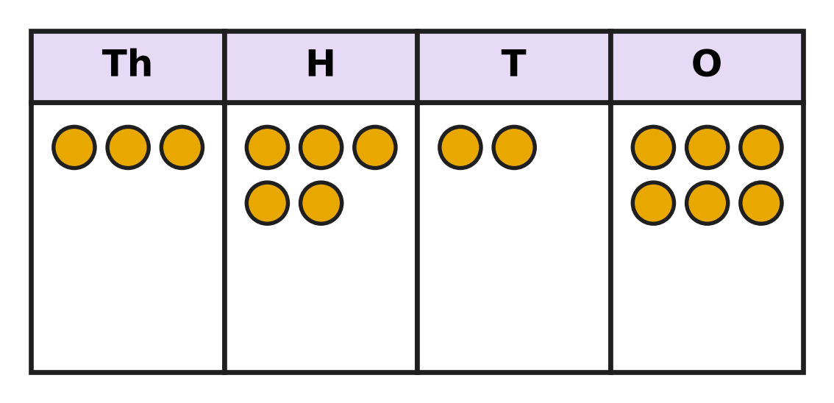
Q1. Look at the place-value chart. Each counter stands for one thousand, one hundred, one ten or one. Which sum is the same as the number on the chart?
(A) 3,000 + 500 + 20 + 6 | (B) 300 + 50 + 20 + 6
(C) 3 + 5 + 2 + 6 | (D) 3,000 + 50 + 20 + 6

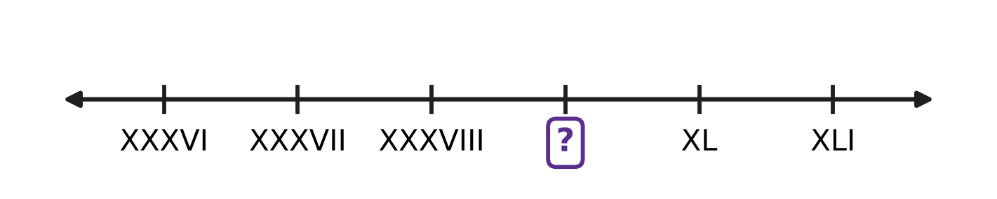
Q2. Look at the number line. The marks are labelled with Roman numerals, and each mark is one more than the mark before it. Which Roman numeral goes in the box?
(A) XXXX | (B) XXIX | (C) IXL | (D) XXXIX

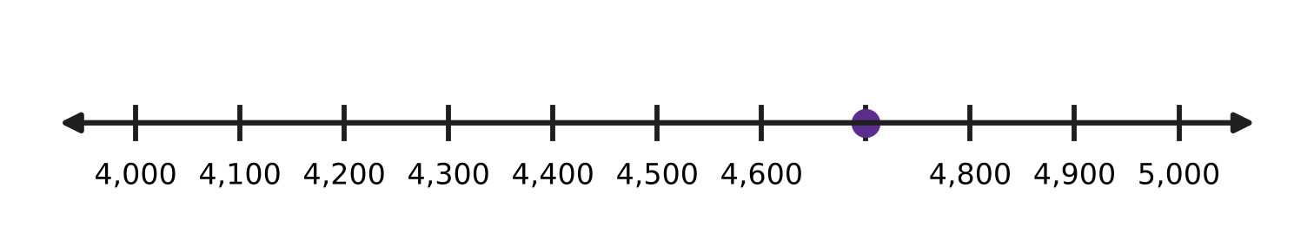
Q3. Look at the number line. The marks are equally spaced. Which number is at the dot?
(A) 4,700 | (B) 4,070 | (C) 4,600 | (D) 4,800

Apples picked in one week
Orchard | Apples picked
Hill Orchard | 3,907
River Orchard | 3,970
Lake Orchard | 3,790
Valley Orchard | 3,097

Q4. Use the table. Which orchard picked the most apples?
(A) Lake Orchard | (B) Hill Orchard
(C) Valley Orchard | (D) River Orchard

Picture for Q1 and Q5
Q5. Look at the place-value chart. Shreya moves one counter from the H column to the T column. By how much does the number become smaller?
(A) 90 | (B) 100 | (C) 10 | (D) 110

Q6. Reena writes the digits of 3,582 in the opposite order. What is the place value of the digit 8 in her new number?
(A) 8,000 | (B) 8 | (C) 800 | (D) 80

Part 2 — Operations & Number Properties (Syllabus Chapter 2)
Q7. To add 2,998 and 1,465, Ira first adds 3,000 and 1,465. Then she takes away 2. What is her answer?
(A) 4,467 | (B) 4,463 | (C) 3,463 | (D) 4,465

Q8. A farm has 3,040 hens and 1,785 ducks. How many more hens than ducks does it have?
(A) 1,355 | (B) 2,745 | (C) 4,825 | (D) 1,255

Q9. Madhu knows that 12 × 8 = 96. What is 12 × 9?
(A) 108 | (B) 105 | (C) 97 | (D) 104

Q10. There are 117 marbles. They are put equally into 9 glass jars. How many marbles are in each jar?
(A) 108 | (B) 14 | (C) 13 | (D) 12

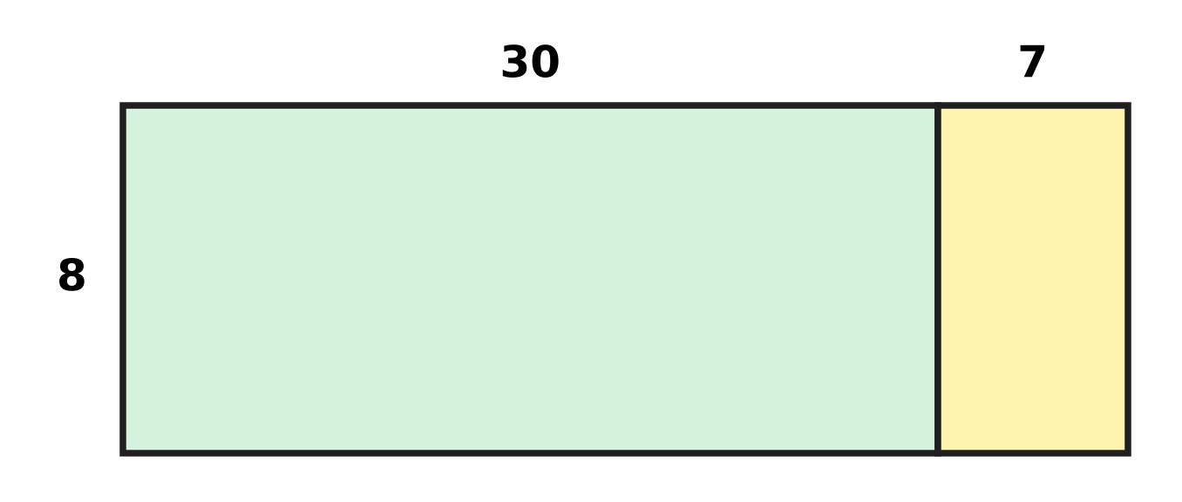
Q11. A garden bed has 8 rows with 37 plants in each row. The picture splits the bed into two parts. How many plants are there in all?
(A) 56 | (B) 296 | (C) 247 | (D) 286

Q12. A number is divided by 6. Which of these can NOT be the remainder?
(A) 1 | (B) 3 | (C) 5 | (D) 6

Q13. Farah has 6 sheets with 12 stamps on each sheet. She shares all the stamps equally among 8 pages of her album. How many stamps go on each page?
(A) 64 | (B) 26 | (C) 72 | (D) 9

Part 3 — Fractions, Decimals & Percentages (Syllabus Chapter 3)
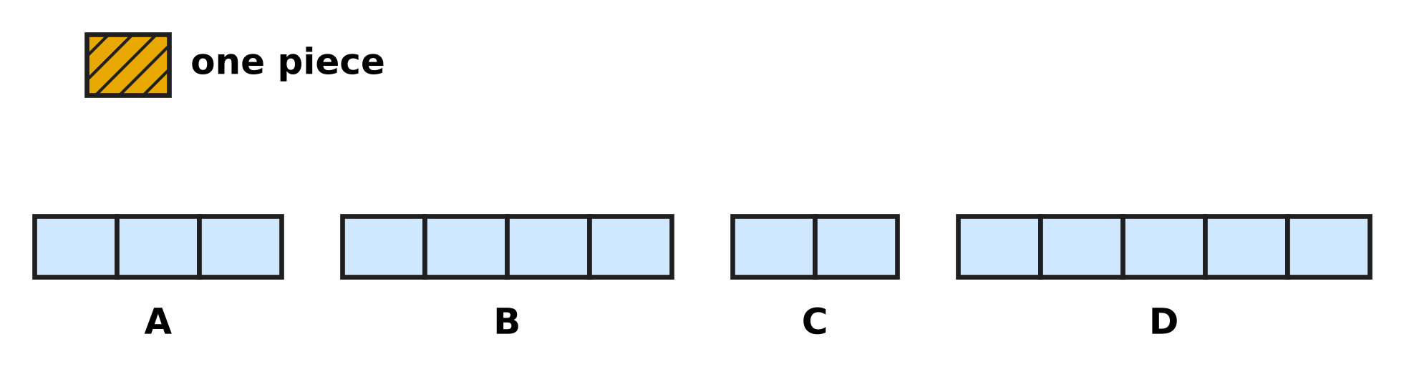
Q14. Look at the picture. The shaded piece at the top is $\frac{1}{4}$ of a whole bar. Each bar below is made of pieces of the same size. Which picture shows the whole bar?
(A) Picture A | (B) Picture B
(C) Picture C | (D) Picture D

Q15. An improper fraction has a top number equal to or bigger than its bottom number. How many of these five fractions are improper fractions?
$\frac{3}{7}$, $\frac{7}{3}$, $\frac{5}{5}$, $\frac{2}{9}$, $\frac{11}{10}$
(A) 1 | (B) 2 | (C) 3 | (D) 4

Q16. A rainwater tank is $\frac{7}{12}$ full. Water equal to $\frac{3}{12}$ of the tank is used for the garden. What fraction of the tank is full now?
(A) $\frac{4}{12}$ | (B) $\frac{10}{12}$ | (C) $\frac{3}{12}$ | (D) $\frac{4}{24}$

Q17. Four children read the same story book. Navya has read $\frac{5}{11}$ of it, Leo $\frac{9}{11}$, Bela $\frac{2}{11}$ and Chirag $\frac{7}{11}$. Who has read the second most?
(A) Chirag | (B) Bela | (C) Navya | (D) Leo

Q18. Mei and Kai bake with bags of flour of the same size. Mei uses $\frac{3}{8}$ of a bag for bread and $\frac{4}{8}$ of a bag for buns. Kai uses $\frac{6}{8}$ of a bag for cakes. Who uses more flour, and how much more?
(A) Mei, $\frac{7}{8}$ of a bag | (B) Kai, $\frac{3}{8}$ of a bag
(C) Kai, $\frac{2}{8}$ of a bag | (D) Mei, $\frac{1}{8}$ of a bag

Part 4 — Geometry (Syllabus Chapter 5)
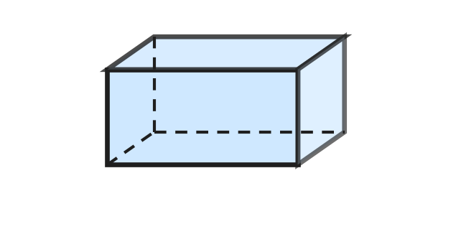
Q19. A cuboid box has 6 faces. Each face has one face opposite to it. How many pairs of opposite faces does the box have?
(A) 2 | (B) 3 | (C) 12 | (D) 6

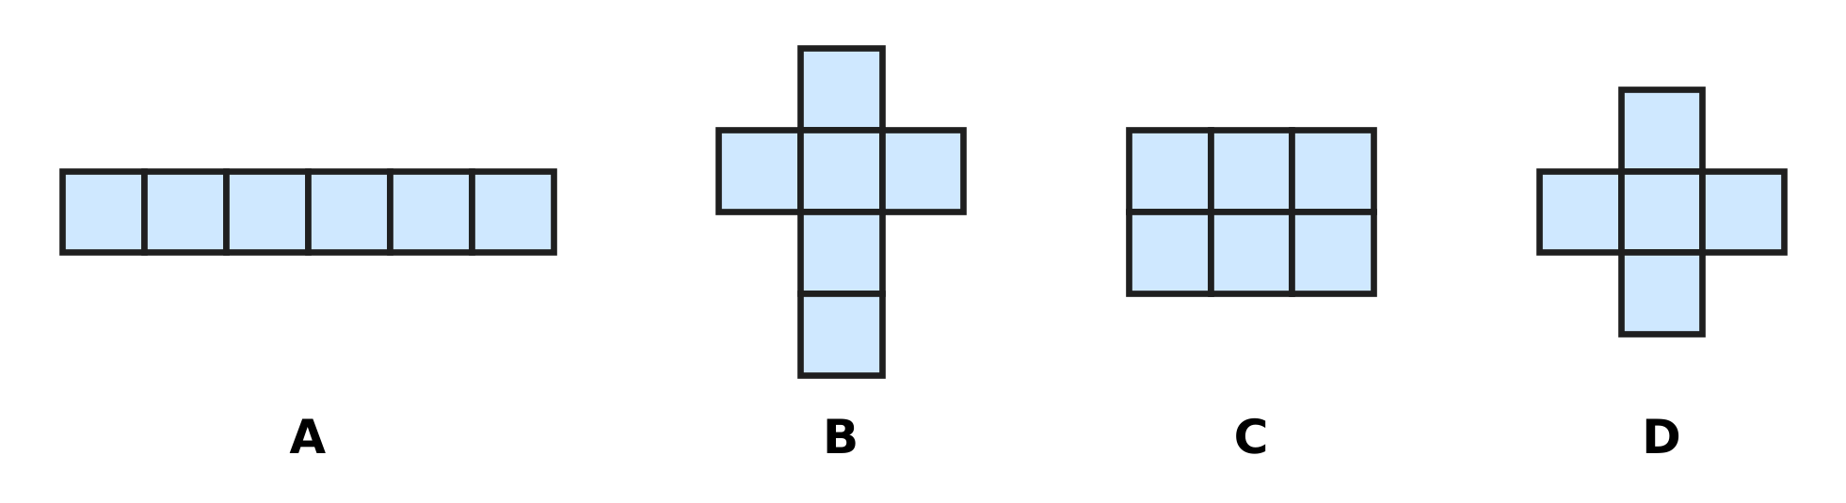
Q20. Look at the four drawings made of equal squares. Which one can be folded along its lines to make a closed cube?
(A) Picture A | (B) Picture B
(C) Picture C | (D) Picture D

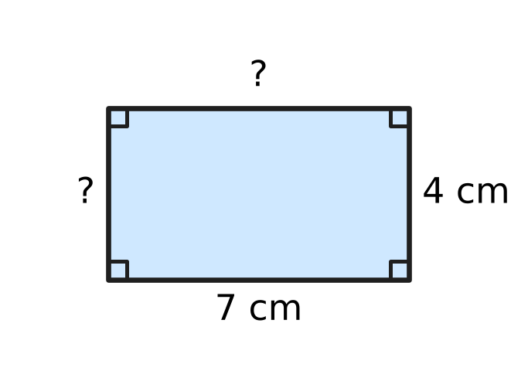
Q21. Look at the rectangle. Two of its sides are marked. How long are the other two sides?
(A) 11 cm and 3 cm | (B) 7 cm and 7 cm
(C) 7 cm and 4 cm | (D) 4 cm and 4 cm

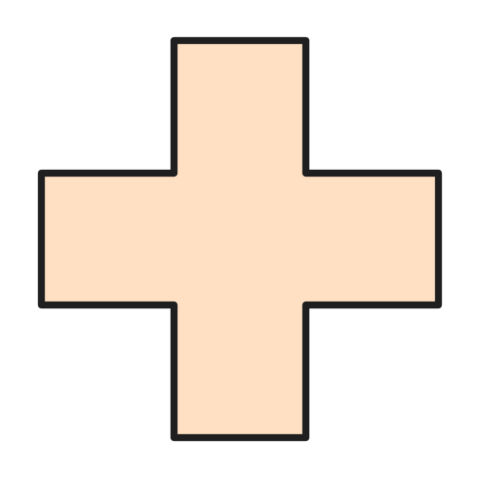
Q22. Look at the plus-shaped piece of paper. All its arms are the same size. How many lines of symmetry does it have?
(A) 2 | (B) 4 | (C) 1 | (D) 8

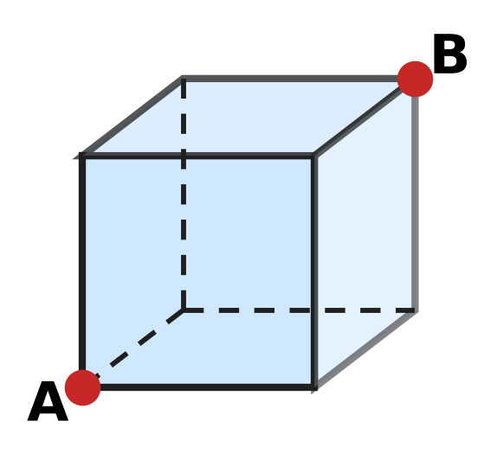
Q23. Look at the cube. An ant walks only along the edges of the cube, from corner A to corner B. What is the smallest number of edges it must walk along?
(A) 1 | (B) 2 | (C) 3 | (D) 4

Part 5 — Mensuration (Syllabus Chapter 6)
Q24. Viraj rides 2 km to school. Then he rides 500 m more to the park. How many metres does he ride in all?
(A) 2,050 m | (B) 502 m | (C) 2,500 m | (D) 700 m

Q25. Which of these is most likely to be the weight of one apple?
(A) 150 g | (B) 15 kg | (C) 1 g | (D) 150 kg

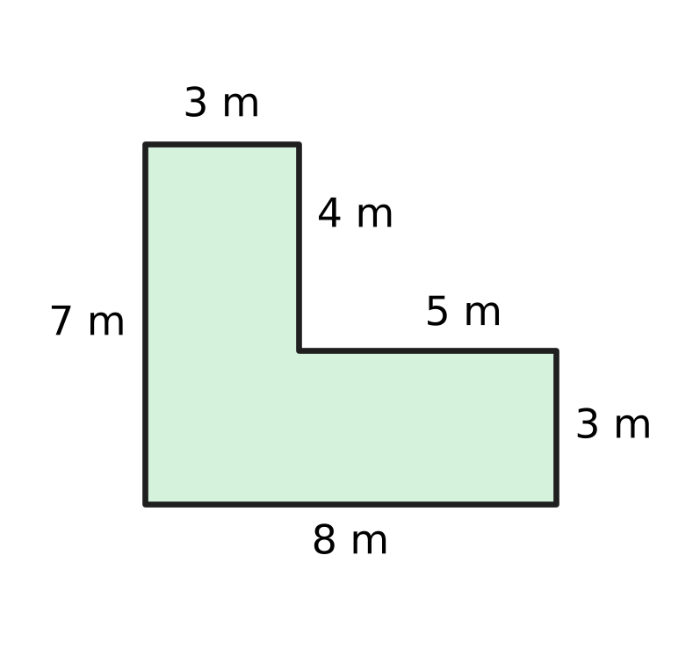
Q26. Look at the plan of a vegetable garden. A fence goes all the way round it. How long is the fence?
(A) 27 m | (B) 56 m | (C) 22 m | (D) 30 m

Q27. A swimming pool is 25 m long. Ishan has swum 8 lengths of the pool. How many more metres must he swim to complete 1 km?
(A) 975 m | (B) 992 m | (C) 200 m | (D) 800 m

Part 6 — Applied Mathematics (Syllabus Chapter 9)
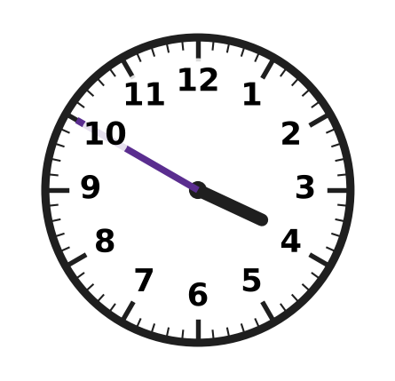
Q28. Look at the clock. Which is another way to say this time?
(A) 10 minutes to 3 | (B) 10 minutes to 4
(C) 50 minutes to 4 | (D) 10 minutes past 4

Q29. A film shown at school lasts 95 minutes. How long is that in hours and minutes?
(A) 9 hours 5 minutes | (B) 1 hour 5 minutes
(C) 1 hour 35 minutes | (D) 1 hour 45 minutes

Q30. The date 14 July is a Tuesday. Which of these dates in the same month is also a Tuesday?
(A) 28 July | (B) 22 July | (C) 20 July | (D) 30 July

Q31. Yuki pays exactly ₹360 using only ₹100, ₹50 and ₹10 notes. What is the smallest number of notes she can use?
(A) 9 | (B) 3 | (C) 5 | (D) 36

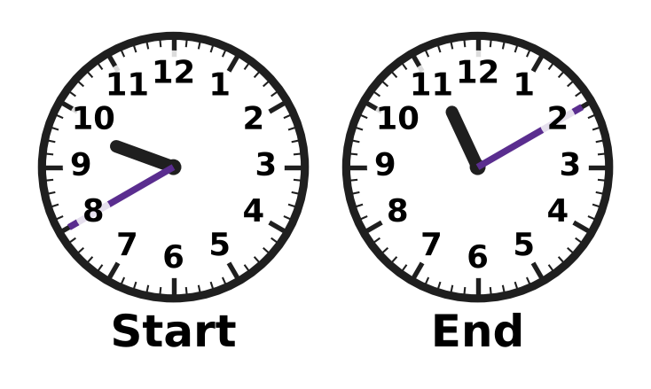
Q32. Look at the two clocks. They show when a bicycle trip starts and ends on the same morning. How long is the trip?
(A) 2 hours 10 minutes | (B) 1 hour 30 minutes
(C) 2 hours 30 minutes | (D) 1 hour 50 minutes

Q33. In a stationery shop, one pencil costs ₹6. A box of 10 pencils costs ₹50. Mona needs 10 pencils. How much money does she save by buying the box?
(A) ₹10 | (B) ₹5 | (C) ₹60 | (D) ₹44

Part 7 — Mathematical Reasoning & Problem-Solving (Syllabus Chapter 10)
Q34. Which number comes next in this pattern?
2, 6, 18, 54, ___
(A) 108 | (B) 90 | (C) 72 | (D) 162

Q35. AA is a 2-digit number with the same digit A in both places. AA + AA = 88. Which digit is A?
(A) 1 | (B) 2 | (C) 4 | (D) 8

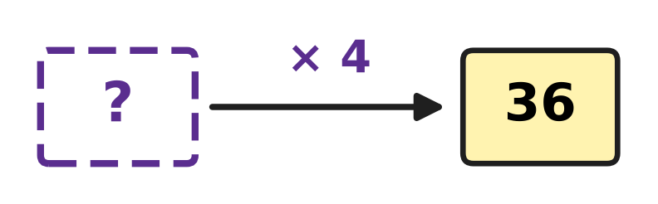
Q36. Look at the number machine. A number goes in at the "?". It is multiplied by 4 and 36 comes out. Which number went in?
(A) 32 | (B) 144 | (C) 9 | (D) 40

Q37. In this pattern, each number is the sum of the two numbers just before it. Which number comes next?
1, 3, 4, 7, 11, ___
(A) 15 | (B) 16 | (C) 22 | (D) 18

Q38. The pattern 4, 9, 14, 19, … goes on in the same way. Which number is the 8th number of the pattern?
(A) 40 | (B) 39 | (C) 34 | (D) 44

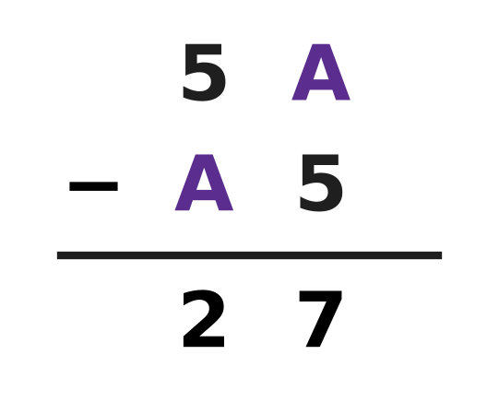
Q39. The picture shows one 2-digit number taken away from another. Each A stands for one and the same digit. Find A.
(A) 1 | (B) 2 | (C) 3 | (D) 7

Q40. A school bus starts with some children. At the first stop, 6 more get on. Then half of all the children get off, and 17 stay on. How many children were on the bus at the start?
(A) 28 | (B) 40 | (C) 34 | (D) 23

SECTION II — Star Questions 5 questions × 4 marks each
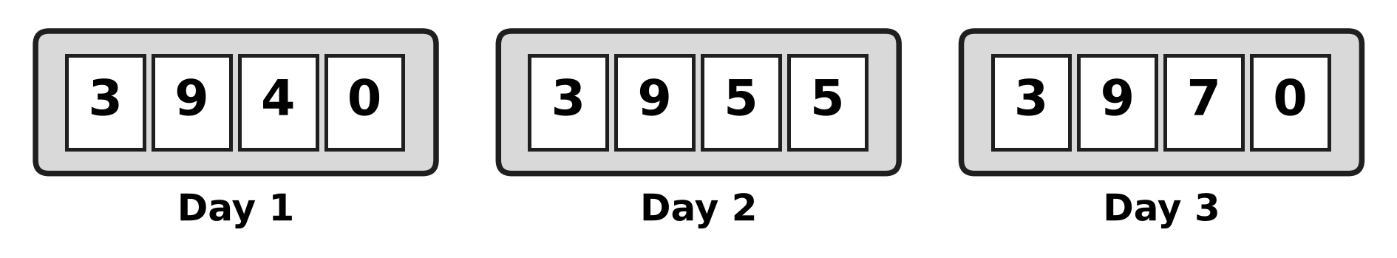
Q41. The pictures show the counter at a stadium gate at the end of Day 1, Day 2 and Day 3. It goes up by the same number every day. Which digit will be in the hundreds place at the end of Day 6? [4 marks]
(A) 4 | (B) 1 | (C) 0 | (D) 9

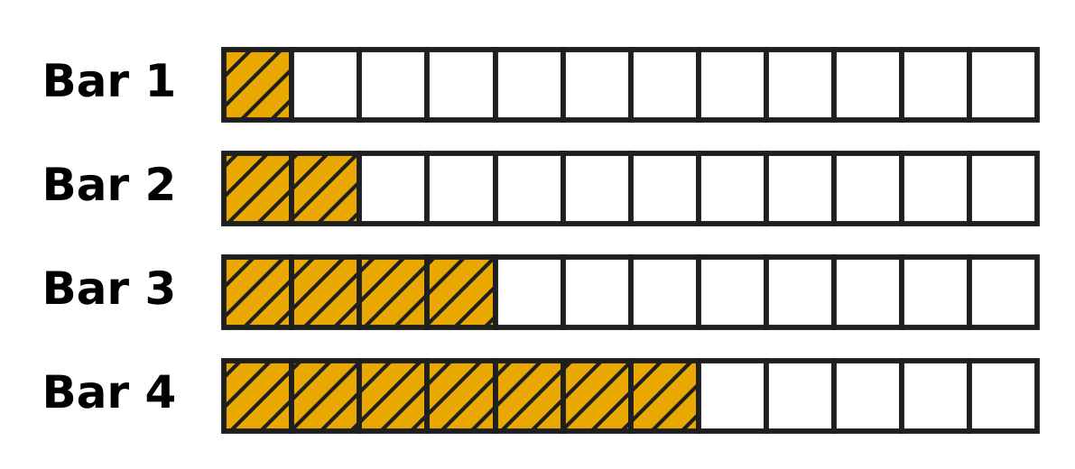
Q42. Look at the four bars. Each bar is cut into 12 equal parts. The shaded parts grow in a pattern, and the jump gets bigger by one each time. Bar 5 is made in the same way. What fraction of Bar 5 is NOT shaded? [4 marks]
(A) $\frac{11}{12}$ | (B) $\frac{1}{12}$ | (C) $\frac{2}{12}$ | (D) $\frac{5}{12}$

Q43. Ronak buys 6 pencils that cost ₹A each. The bill is ₹4A, a 2-digit amount with 4 tens and A ones. A is the same digit both times. He pays with a ₹100 note. How much change does he get? [4 marks]
(A) ₹52 | (B) ₹58 | (C) ₹48 | (D) ₹92

Q44. A library writes dates with the month as a Roman numeral, so 5-III means 5 March. Kartik borrows a book on 25-X. He must return it exactly 14 days later. How will the library write the return date? [4 marks]
(A) 8-IX | (B) 9-XI | (C) 39-X | (D) 8-XI

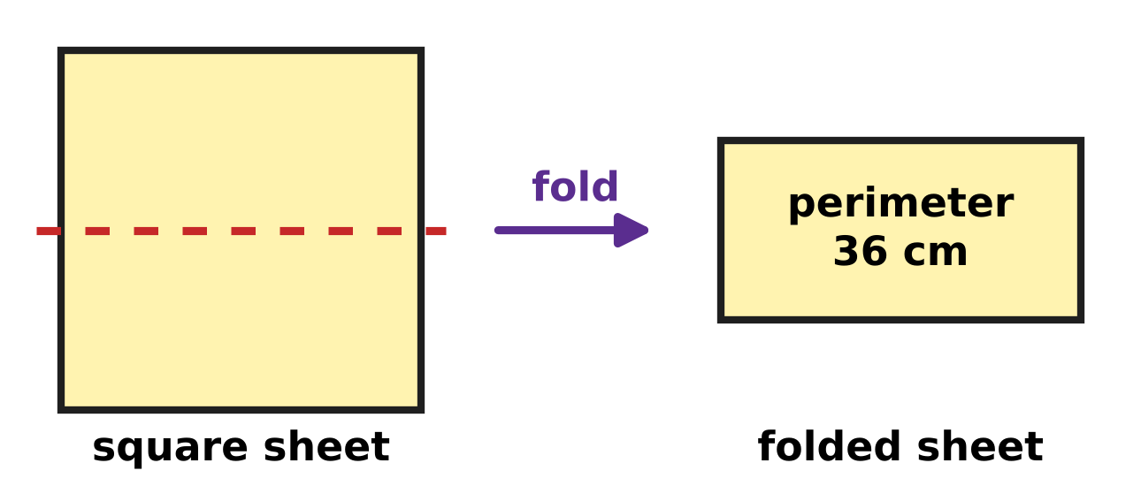
Q45. Jack folds a square sheet of paper in half along the dotted line, as in the picture. The folded rectangle has a perimeter of 36 cm. What is the perimeter of the square sheet? [4 marks]
(A) 72 cm | (B) 24 cm | (C) 48 cm | (D) 36 cm

Answer Sheet AMO Level 1 · Class 3 · Practice Paper 1
Name: | School: | Roll No.:
Shade or tick one circle for each question.
1. Ⓐ Ⓑ Ⓒ Ⓓ | 16. Ⓐ Ⓑ Ⓒ Ⓓ | 31. Ⓐ Ⓑ Ⓒ Ⓓ
2. Ⓐ Ⓑ Ⓒ Ⓓ | 17. Ⓐ Ⓑ Ⓒ Ⓓ | 32. Ⓐ Ⓑ Ⓒ Ⓓ
3. Ⓐ Ⓑ Ⓒ Ⓓ | 18. Ⓐ Ⓑ Ⓒ Ⓓ | 33. Ⓐ Ⓑ Ⓒ Ⓓ
4. Ⓐ Ⓑ Ⓒ Ⓓ | 19. Ⓐ Ⓑ Ⓒ Ⓓ | 34. Ⓐ Ⓑ Ⓒ Ⓓ
5. Ⓐ Ⓑ Ⓒ Ⓓ | 20. Ⓐ Ⓑ Ⓒ Ⓓ | 35. Ⓐ Ⓑ Ⓒ Ⓓ
6. Ⓐ Ⓑ Ⓒ Ⓓ | 21. Ⓐ Ⓑ Ⓒ Ⓓ | 36. Ⓐ Ⓑ Ⓒ Ⓓ
7. Ⓐ Ⓑ Ⓒ Ⓓ | 22. Ⓐ Ⓑ Ⓒ Ⓓ | 37. Ⓐ Ⓑ Ⓒ Ⓓ
8. Ⓐ Ⓑ Ⓒ Ⓓ | 23. Ⓐ Ⓑ Ⓒ Ⓓ | 38. Ⓐ Ⓑ Ⓒ Ⓓ
9. Ⓐ Ⓑ Ⓒ Ⓓ | 24. Ⓐ Ⓑ Ⓒ Ⓓ | 39. Ⓐ Ⓑ Ⓒ Ⓓ
10. Ⓐ Ⓑ Ⓒ Ⓓ | 25. Ⓐ Ⓑ Ⓒ Ⓓ | 40. Ⓐ Ⓑ Ⓒ Ⓓ
11. Ⓐ Ⓑ Ⓒ Ⓓ | 26. Ⓐ Ⓑ Ⓒ Ⓓ | 41. Ⓐ Ⓑ Ⓒ Ⓓ
12. Ⓐ Ⓑ Ⓒ Ⓓ | 27. Ⓐ Ⓑ Ⓒ Ⓓ | 42. Ⓐ Ⓑ Ⓒ Ⓓ
13. Ⓐ Ⓑ Ⓒ Ⓓ | 28. Ⓐ Ⓑ Ⓒ Ⓓ | 43. Ⓐ Ⓑ Ⓒ Ⓓ
14. Ⓐ Ⓑ Ⓒ Ⓓ | 29. Ⓐ Ⓑ Ⓒ Ⓓ | 44. Ⓐ Ⓑ Ⓒ Ⓓ
15. Ⓐ Ⓑ Ⓒ Ⓓ | 30. Ⓐ Ⓑ Ⓒ Ⓓ | 45. Ⓐ Ⓑ Ⓒ Ⓓ
Q41–Q45 are Section II Star Questions (4 marks each).
For the parent or teacher
Section I correct: ______ / 40 × 2 = ______ marks Section II correct: ______ / 5 × 4 = ______ marks
Correct: ______ / 45 Score: ______ / 100
Answer Key and Solutions AMO Level 1 · Class 3 · Practice Paper 1
Quick answers
1 A | 6 C | 11 B | 16 A | 21 C | 26 D | 31 C | 36 C | 41 C
2 D | 7 B | 12 D | 17 A | 22 B | 27 D | 32 B | 37 D | 42 B
3 A | 8 D | 13 D | 18 D | 23 C | 28 B | 33 A | 38 B | 43 A
4 D | 9 A | 14 B | 19 B | 24 C | 29 C | 34 D | 39 B | 44 D
5 A | 10 C | 15 C | 20 B | 25 A | 30 A | 35 C | 40 A | 45 C
Solutions
Q | Part · level | Answer | Why?
1 | Part 1 · Ch1 · Easy | (A) 3,000 + 500 + 20 + 6 | There are 3 thousands, 5 hundreds, 2 tens and 6 ones: 3,000 + 500 + 20 + 6 = 3,526.
2 | Part 1 · Ch1 · Easy | (D) XXXIX | The box is just before XL, which is 40. So it is 39. 39 = 30 + 9, written XXX and IX: XXXIX.
3 | Part 1 · Ch1 · Easy | (A) 4,700 | The marks go up by 100: 4,600 comes just before the dot and 4,800 just after it. So the dot is at 4,700.
4 | Part 1 · Ch1 · Easy | (D) River Orchard | All four numbers have 3 thousands. 3,907 and 3,970 have the most hundreds. Then 7 tens is more than 0 tens, so 3,970 is the greatest.
5 | Part 1 · Ch1 · Medium | (A) 90 | One hundred is taken away and one ten is added: 3,526 becomes 3,436. 100 − 10 = 90.
6 | Part 1 · Ch1 · Medium | (C) 800 | The new number is 2,853. In it, 8 is in the hundreds place, so its place value is 800.
7 | Part 2 · Ch2 · Easy | (B) 4,463 | 3,000 + 1,465 = 4,465. Taking away 2 gives 4,463, which is 2,998 + 1,465.
8 | Part 2 · Ch2 · Easy | (D) 1,255 | 3,040 − 1,785 = 1,255. Check: 1,255 + 1,785 = 3,040.
9 | Part 2 · Ch2 · Easy | (A) 108 | 12 × 9 is one more group of 12 than 12 × 8. 96 + 12 = 108.
10 | Part 2 · Ch2 · Easy | (C) 13 | 9 × 13 = 117, so 117 ÷ 9 = 13.
11 | Part 2 · Ch2 · Medium | (B) 296 | 8 × 30 = 240 and 8 × 7 = 56. 240 + 56 = 296.
12 | Part 2 · Ch2 · Medium | (D) 6 | A remainder is always smaller than the number we divide by. If 6 were left over, one more group of 6 could be made.
13 | Part 2 · Ch2 · Medium | (D) 9 | 6 × 12 = 72 stamps. 72 ÷ 8 = 9 stamps on each page.
14 | Part 3 · Ch3 · Easy | (B) Picture B | $\frac{1}{4}$ means the whole is cut into 4 equal parts. So 4 such pieces make the whole bar, and Picture B has 4 pieces.
15 | Part 3 · Ch3 · Easy | (C) 3 | A fraction is improper when the top number is equal to or bigger than the bottom number: $\frac{7}{3}$, $\frac{5}{5}$ and $\frac{11}{10}$.
16 | Part 3 · Ch3 · Easy | (A) $\frac{4}{12}$ | The bottom number stays the same. 7 − 3 = 4, so $\frac{4}{12}$ of the tank is full.
17 | Part 3 · Ch3 · Medium | (A) Chirag | The bottom numbers are the same, so compare the top numbers: 9, 7, 5, 2. The second greatest is $\frac{7}{11}$, read by Chirag.
18 | Part 3 · Ch3 · Medium | (D) Mei, 1/8 of a bag | Mei uses $\frac{3}{8}$ + $\frac{4}{8}$ = $\frac{7}{8}$ of a bag. Kai uses $\frac{6}{8}$. Mei uses more: $\frac{7}{8}$ − $\frac{6}{8}$ = $\frac{1}{8}$ of a bag.
19 | Part 4 · Ch5 · Easy | (B) 3 | The pairs are top and bottom, front and back, left and right. That is 3 pairs.
20 | Part 4 · Ch5 · Easy | (B) Picture B | A cube has 6 square faces. Picture B is a cross of 6 squares and closes into a cube. Pictures A and C overlap when folded, and Picture D has only 5 squares.
21 | Part 4 · Ch5 · Easy | (C) 7 cm and 4 cm | Opposite sides of a rectangle are equal. So the other two sides are 7 cm and 4 cm.
22 | Part 4 · Ch5 · Medium | (B) 4 | It can be folded up-and-down, across, and along two slanting lines through opposite inner corners. That is 4 lines of symmetry.
23 | Part 4 · Ch5 · Medium | (C) 3 | Each edge goes across, back or up. To reach B, the ant must go across, back and up once each, so it walks along 3 edges.
24 | Part 5 · Ch6 · Easy | (C) 2,500 m | 1 km = 1,000 m, so 2 km = 2,000 m. 2,000 m + 500 m = 2,500 m.
25 | Part 5 · Ch6 · Easy | (A) 150 g | Light things are weighed in grams. An apple weighs about 150 g. 1 g is far too light, and 15 kg and 150 kg are far too heavy.
26 | Part 5 · Ch6 · Medium | (D) 30 m | Add all six sides: 8 + 3 + 5 + 4 + 3 + 7 = 30 m.
27 | Part 5 · Ch6 · Medium | (D) 800 m | 8 × 25 = 200 m. 1 km = 1,000 m, and 1,000 − 200 = 800 m.
28 | Part 6 · Ch9 · Easy | (B) 10 minutes to 4 | The clock shows 3:50. From 3:50 to 4:00 is 10 minutes, so the time is 10 minutes to 4.
29 | Part 6 · Ch9 · Easy | (C) 1 hour 35 minutes | 1 hour = 60 minutes. 95 − 60 = 35, so 95 minutes is 1 hour 35 minutes.
30 | Part 6 · Ch9 · Easy | (A) 28 July | The same weekday comes back every 7 days: 14, 21, 28. So 28 July is a Tuesday.
31 | Part 6 · Ch9 · Easy | (C) 5 | Use the biggest notes first: 3 notes of ₹100, 1 note of ₹50 and 1 note of ₹10. 3 + 1 + 1 = 5 notes.
32 | Part 6 · Ch9 · Medium | (B) 1 hour 30 minutes | The trip starts at 9:40 and ends at 11:10. From 9:40 to 10:40 is 1 hour, and from 10:40 to 11:10 is 30 minutes.
33 | Part 6 · Ch9 · Medium | (A) ₹10 | 10 single pencils cost 10 × ₹6 = ₹60. The box costs ₹50. ₹60 − ₹50 = ₹10 saved.
34 | Part 7 · Ch10 · Easy | (D) 162 | Each number is 3 times the number before it: 2 × 3 = 6, 6 × 3 = 18, 18 × 3 = 54. Next is 54 × 3 = 162.
35 | Part 7 · Ch10 · Easy | (C) 4 | AA is half of 88, so AA = 44 and A = 4. Check: 44 + 44 = 88.
36 | Part 7 · Ch10 · Easy | (C) 9 | Work backwards: 36 ÷ 4 = 9. Check: 9 × 4 = 36.
37 | Part 7 · Ch10 · Easy | (D) 18 | Add the last two numbers: 7 + 11 = 18.
38 | Part 7 · Ch10 · Medium | (B) 39 | Each number is 5 more. The pattern is 4, 9, 14, 19, 24, 29, 34, 39. The 8th number is 39.
39 | Part 7 · Ch10 · Medium | (B) 2 | Try the digits: 52 − 25 = 27. No other digit works, so A = 2.
40 | Part 7 · Ch10 · Medium | (A) 28 | Work backwards: 17 is half, so there were 34 children before they got off. 34 − 6 = 28 at the start.
41 | Section II · Ch1 + Ch10 · Hard | (C) 0 | The counter goes up by 15 each day: 3,985 on Day 4, 4,000 on Day 5 and 4,015 on Day 6. In 4,015 the hundreds digit is 0.
42 | Section II · Ch3 + Ch10 · Hard | (B) $\frac{1}{12}$ | The shaded parts are 1, 2, 4, 7: the jumps are 1, 2, 3. The next jump is 4, so Bar 5 has 11 of 12 parts shaded. $\frac{12}{12}$ − $\frac{11}{12}$ = $\frac{1}{12}$ is not shaded.
43 | Section II · Ch9 + Ch10 · Hard | (A) ₹52 | 6 × 8 = 48, which has 4 tens and 8 ones, so A = 8 and the bill is ₹48. No other digit works. ₹100 − ₹48 = ₹52.
44 | Section II · Ch1 + Ch9 · Hard | (D) 8-XI | X is 10, so the book is borrowed on 25 October. October has 31 days: 6 days take us to 31 October and 8 more days to 8 November. November is month 11, written XI.
45 | Section II · Ch5 + Ch6 · Hard | (C) 48 cm | The rectangle is one side long and half a side wide, so its perimeter is 3 sides: 36 ÷ 3 = 12 cm. The square has 4 sides: 4 × 12 = 48 cm.

