UNLOCK IQ INSTITUTE
Realize Your True Potential
Aryabhatta Maths Olympiad (AMO)
Level 1 — Practice Paper 2
CLASS 3

Questions | 45 multiple-choice questions
Marks | 100
Time | 60 minutes
Section I | 40 questions × 2 marks = 80 marks
Section II | 5 Star Questions × 4 marks = 20 marks
Negative marking | No negative marking
Calculator | Not allowed
Chapters | Number System · Operations · Fractions, Decimals & Percentages · Geometry · Mensuration · Applied Mathematics · Mathematical Reasoning

Hello, friend!
• Every question has four answer choices: (A), (B), (C) and (D). Only one is correct.
• Read each question and look at its picture carefully. Then mark your answer on the answer sheet at the end.
• Section I has 40 questions of 2 marks each. Section II has 5 Star Questions of 4 marks each.
• There is no negative marking, so try every question.
• Do not use a calculator. You may do rough work on a separate sheet.
• All figures are not necessarily drawn to scale unless stated.

For parents and teachers
Print or view this paper in colour. Pictures are part of the questions.
Parts follow the AMO syllabus chapters. Chapters 4, 7 and 8 are not part of the Class 3 syllabus, so the chapter numbers shown in the Part headings have gaps.
The answer sheet and the answer key are at the end. Remove only the answer key before the child begins.

Name: | School: | Roll No.:

SECTION I 40 questions × 2 marks each
Part 1 — Number System (Syllabus Chapter 1)
Q1. In the number Bina writes, the digit 4 has the place value 400 and the digit 7 has the place value 7. Which of these can be her number?
(A) 2,147 | (B) 2,417 | (C) 2,471 | (D) 4,217

Q2. On sports day, each runner wears a Roman numeral. Which of these runner numbers is even?
(A) XLI | (B) XXXV | (C) XXIII | (D) XVIII

Q3. Which number is 10 more than 3,995?
(A) 3,905 | (B) 4,005 | (C) 4,095 | (D) 4,995

Q4. Which of these numbers is greater than 6,050 but less than 6,500?
(A) 5,650 | (B) 6,005 | (C) 6,045 | (D) 6,405

Q5. Which of these is equal to XL?
(A) XXV + XXV | (B) XXX + XV
(C) L − V | (D) XXIV + XVI

Q6. Which is the smallest 4-digit number that has four different digits?
(A) 1,023 | (B) 1,032 | (C) 1,203 | (D) 1,234

Part 2 — Operations & Number Properties (Syllabus Chapter 2)
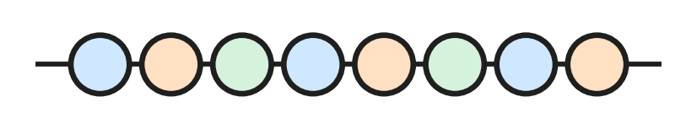
Q7. Look at the string of beads. Beads are sold only in full strings like this one. Which of these numbers of beads can Anya buy?
(A) 72 | (B) 76 | (C) 78 | (D) 82

Q8. A train carries 2,358 people on Saturday and 1,467 people on Sunday. How many people does it carry on the two days in all?
(A) 891 | (B) 3,715 | (C) 3,815 | (D) 3,825

Q9. Which of these is the same as 46 × 7?
(A) 40 × 7 + 6 × 7 | (B) 4 × 7 + 6 × 7
(C) 40 + 6 × 7 | (D) 40 × 7 + 6

Q10. Which of these divisions leaves a remainder?
(A) 50 ÷ 8 | (B) 48 ÷ 8 | (C) 54 ÷ 9 | (D) 56 ÷ 7

Q11. Which of these has the same answer as 4,000 − 1,865?
(A) 4,001 − 1,864 | (B) 4,000 − 1,864
(C) 3,999 − 1,864 | (D) 3,999 − 1,866

Q12. Jai has 47 small plants for the school garden. He puts 9 plants in each pot. How many more plants does he need to fill one more pot?
(A) 2 | (B) 5 | (C) 6 | (D) 7

Q13. A school hall has 12 rows of benches. Each row has 4 benches, and each bench seats 3 children. How many children can sit in the hall?
(A) 19 | (B) 36 | (C) 48 | (D) 144

Part 3 — Fractions, Decimals & Percentages (Syllabus Chapter 3)
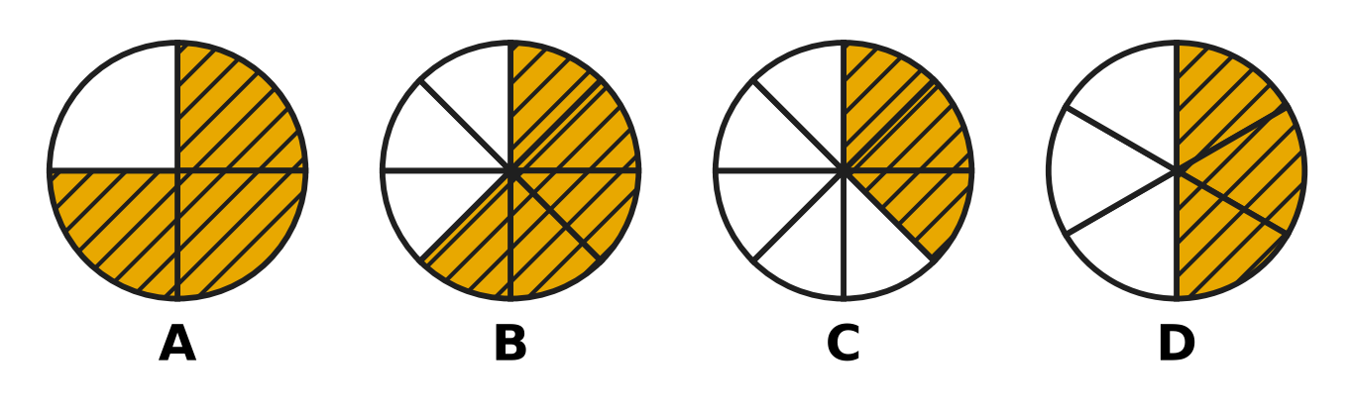
Q14. Look at the four circles. Each circle is cut into equal parts. Which picture has $\frac{3}{8}$ of the circle shaded?
(A) Picture A | (B) Picture B
(C) Picture C | (D) Picture D

Q15. Which of these fractions is greater than one whole?
(A) $\frac{1}{8}$ | (B) $\frac{8}{9}$ | (C) $\frac{8}{8}$ | (D) $\frac{9}{8}$

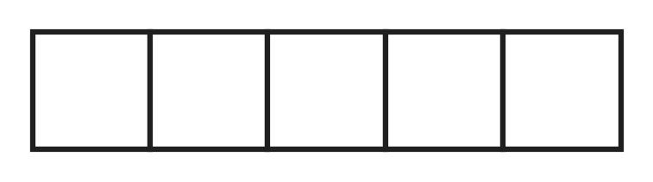
Q16. Look at the ribbon marked in 5 equal parts. Geeta uses $\frac{2}{5}$ of the ribbon for one gift and $\frac{1}{5}$ of it for another gift. What fraction of the ribbon does she use in all?
(A) $\frac{5}{3}$ | (B) $\frac{1}{5}$ | (C) $\frac{3}{10}$ | (D) $\frac{3}{5}$

Q17. Which of these has the greatest answer?
(A) $\frac{5}{12}$ + $\frac{3}{12}$ | (B) $\frac{10}{12}$ − $\frac{5}{12}$
(C) $\frac{2}{12}$ + $\frac{4}{12}$ | (D) $\frac{11}{12}$ − $\frac{4}{12}$

Q18. On sports day, Tejas runs $\frac{5}{8}$ of a round of the track. After a rest he runs $\frac{7}{8}$ of a round more. How much more than one full round does he run in all?
(A) $\frac{2}{8}$ | (B) $\frac{3}{8}$ | (C) $\frac{4}{8}$ | (D) $\frac{12}{8}$

Part 4 — Geometry (Syllabus Chapter 5)
Q19. The shoe box in the picture is a cuboid. Three of these numbers tell how many faces, edges and corners it has. Which number is NOT one of them? | 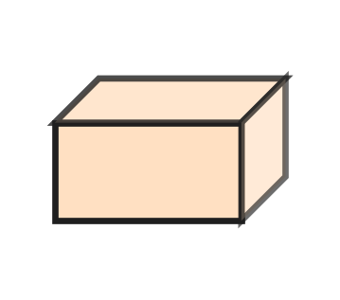
  (A) 5 | (B) 6 | (C) 8 | (D) 12

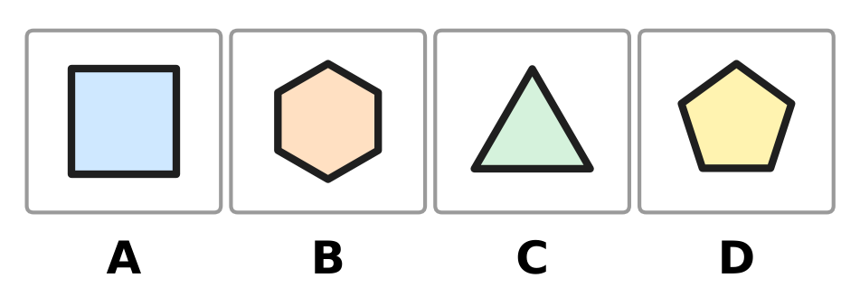
Q20. Look at the four shapes. Which shape has more sides than a pentagon?
(A) Picture A | (B) Picture B
(C) Picture C | (D) Picture D

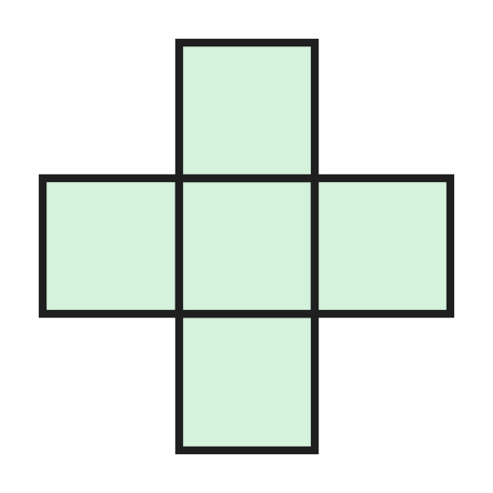
Q21. Luke folds the flat shape in the picture along its lines to make a box shaped like a cube. How many faces of the cube are missing?
(A) 1 | (B) 2 | (C) 3 | (D) 5

Q22. A toy is made by gluing the flat face of a cone onto a flat face of a cylinder, as in the picture. The two glued faces are the same size. How many flat faces does the toy have on the outside? | 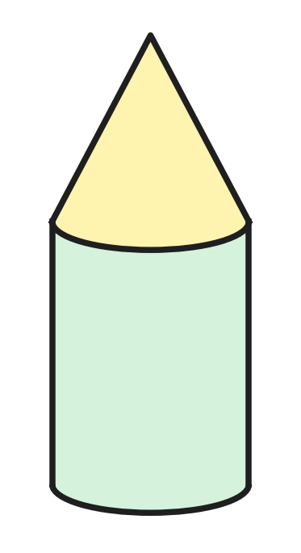
  (A) 0 | (B) 1 | (C) 2 | (D) 3

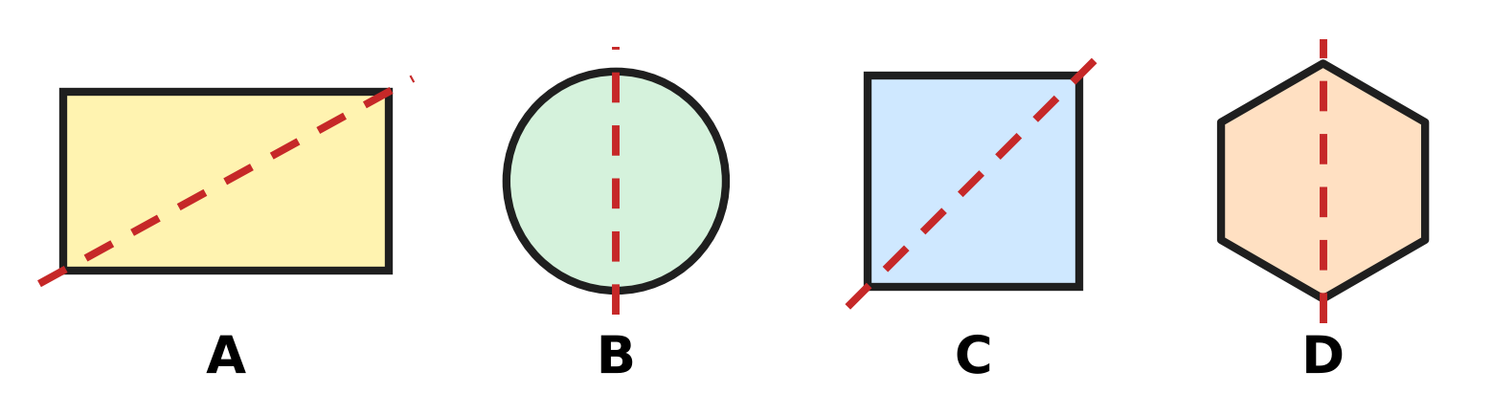
Q23. Look at the four shapes. Picture C is a square. Each shape is folded along its dotted line. In which picture do the two halves NOT lie exactly on each other?
(A) Picture A | (B) Picture B
(C) Picture C | (D) Picture D

Part 5 — Mensuration (Syllabus Chapter 6)
Q24. A jug holds 2 L 75 mL of juice. Which of these is the same amount?
(A) 275 mL | (B) 2,075 mL
(C) 2,705 mL | (D) 2,750 mL

Q25. A square picnic mat has sides of 3 m, as in the picture. Mahi sews a ribbon all round its edge. How long is the ribbon? | 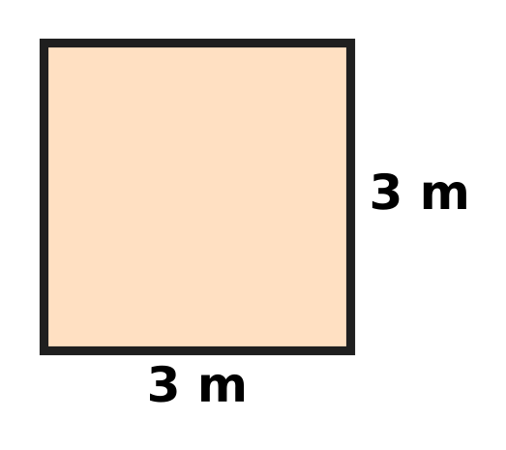
  (A) 3 m | (B) 6 m | (C) 9 m | (D) 12 m

Q26. A shoe rack has 3 shelves. Each shelf is 85 cm long. What is the total length of the shelves?
(A) 88 cm | (B) 2 m 55 cm
(C) 25 m 5 cm | (D) 2 m 5 cm

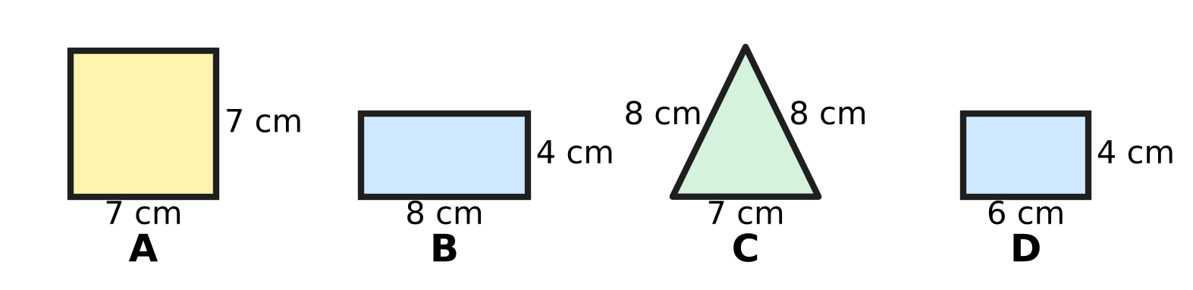
Q27. Look at the four shapes. Shape A is a square. Shape B and Shape D are rectangles. Which shape has a perimeter of exactly 24 cm?
(A) Shape A | (B) Shape B | (C) Shape C | (D) Shape D

Part 6 — Applied Mathematics (Syllabus Chapter 9)
Q28. Look at the clock. The school bell rang 10 minutes before the time on the clock. At what time did the bell ring? | 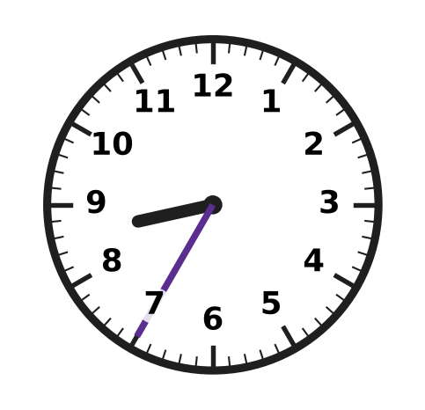
  (A) 7:25 | (B) 8:45 | (C) 8:25 | (D) 8:30

Q29. Look at the calendar. The circled date is Jaya's birthday. Her class picnic is 10 days after her birthday. On which day of the week is the picnic? | 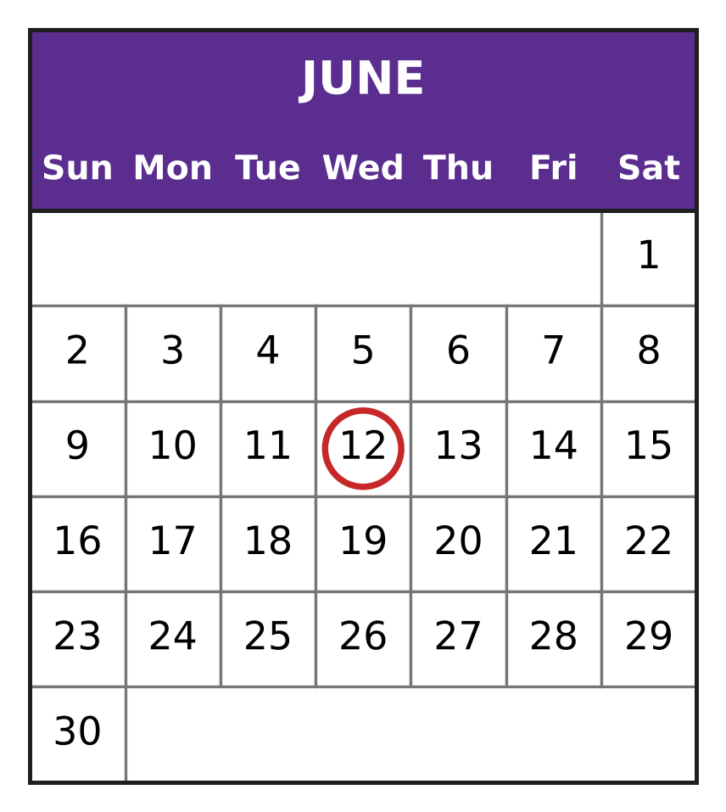
  (A) Thursday | (B) Friday
  (C) Saturday | (D) Sunday

Q30. A class reaches a picnic park at 9:25 AM. The children stay there for 2 hours 20 minutes. At what time do they leave?
(A) 11:45 AM | (B) 9:45 AM
(C) 11:05 AM | (D) 11:25 AM

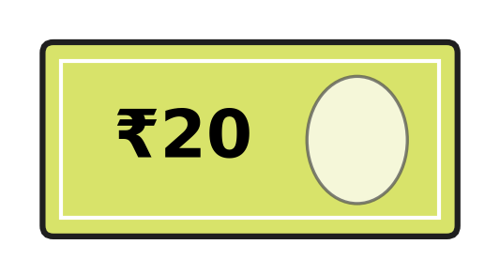
Q31. Zoe has only ₹20 notes like the one in the picture. She wants to pay with no change to be given back. Which of these amounts can she pay?
(A) ₹90 | (B) ₹110 | (C) ₹140 | (D) ₹150

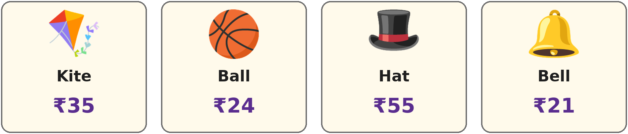
Q32. Look at the prices in a toy shop. Akash has ₹100. Which of these can he buy?
(A) 2 hats | (B) 3 kites | (C) 5 bells | (D) 4 balls

Q33. A month has 31 days. Its first day is a Friday. On which day of the week does the month end?
(A) Friday | (B) Saturday
(C) Sunday | (D) Monday

Part 7 — Mathematical Reasoning & Problem-Solving (Syllabus Chapter 10)
Q34. A number pattern starts with 400. Each number is half of the number before it. Which is the fourth number of the pattern?
(A) 25 | (B) 50 | (C) 100 | (D) 200

Q35. The letter A hides one digit. A × A = 49. What is A + A?
(A) 7 | (B) 14 | (C) 28 | (D) 98

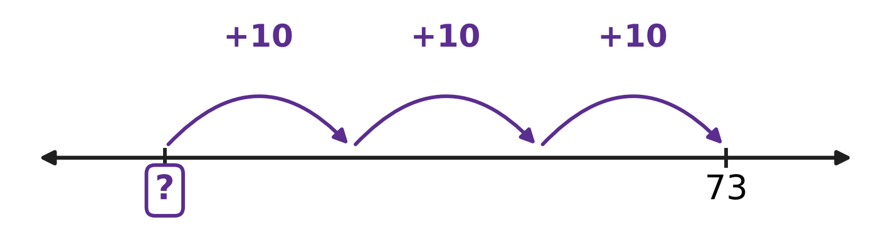
Q36. Look at the number line. Kush starts at a number and makes 3 hops of 10 forward. He lands on 73. At which number did he start?
(A) 43 | (B) 63 | (C) 70 | (D) 103

Q37. The pattern 7, 14, 21, 28 goes on in the same way. Which of these numbers will come in the pattern?
(A) 74 | (B) 81 | (C) 84 | (D) 90

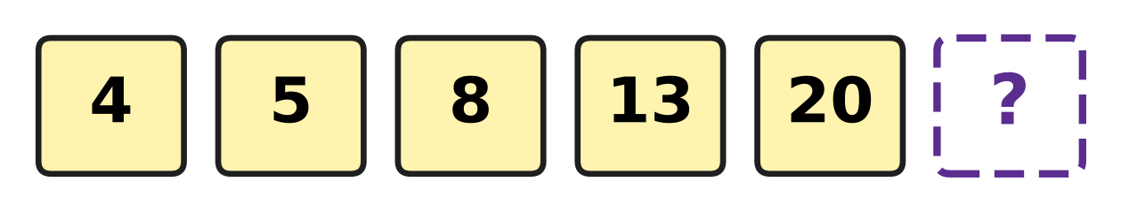
Q38. Look at the number cards. The jump from one card to the next grows by the same amount each time. Which number is on the last card?
(A) 27 | (B) 28 | (C) 29 | (D) 33

Q39. Each letter hides one digit. A + A = B and B + B = 16. Which digit does A hide?
(A) 2 | (B) 4 | (C) 6 | (D) 8

Q40. Some birds sit on a tree. Then 7 birds fly away. Next, more birds arrive, and the number of birds doubles to 26. How many birds were on the tree at first?
(A) 6 | (B) 13 | (C) 20 | (D) 33

SECTION II — Star Questions 5 questions × 4 marks each
Q41. Pavan takes a 4-digit number. First he adds 2 hundreds to it. Then he swaps the thousands digit and the ones digit of the answer, and he gets 7,461. Which number did he take? [4 marks]
(A) 1,267 | (B) 1,467 | (C) 1,667 | (D) 7,261

Q42. Look at the sum on the card. A hides the same digit both times. B is 1 more than A. The answer is $\frac{4}{9}$ more than one whole. Which digit is B? [4 marks] | 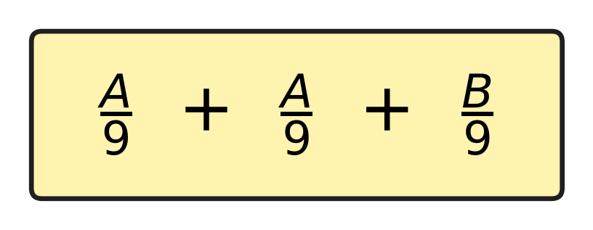
  (A) 2 | (B) 4 | (C) 5 | (D) 7

Q43. Trains leave a station every 40 minutes. The first train of the day leaves at 6:20 AM. Which of these is a time when a train leaves? [4 marks]
(A) 10:00 AM | (B) 10:40 AM
(C) 9:20 AM | (D) 9:40 AM

Q44. Veena saves money every Sunday, from Sunday 2 March to Sunday 4 May. She starts with an empty box. Each Sunday she puts one ₹100 note, one ₹10 note and one ₹1 coin into it. How much money is in the box after 4 May? [4 marks]
(A) ₹999 | (B) ₹1,000 | (C) ₹1,100 | (D) ₹1,110

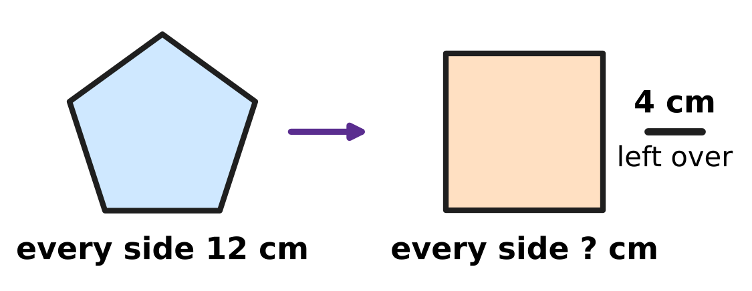
Q45. Look at the picture. A piece of wire is bent into a pentagon with every side 12 cm long. The same wire is then bent into a square, and 4 cm of wire is left over. How long is each side of the square? [4 marks]
(A) 12 cm | (B) 14 cm | (C) 15 cm | (D) 16 cm

Answer Sheet AMO Level 1 · Class 3 · Practice Paper 2
Name: | School: | Roll No.:
Shade or tick one circle for each question.
1. Ⓐ Ⓑ Ⓒ Ⓓ | 16. Ⓐ Ⓑ Ⓒ Ⓓ | 31. Ⓐ Ⓑ Ⓒ Ⓓ
2. Ⓐ Ⓑ Ⓒ Ⓓ | 17. Ⓐ Ⓑ Ⓒ Ⓓ | 32. Ⓐ Ⓑ Ⓒ Ⓓ
3. Ⓐ Ⓑ Ⓒ Ⓓ | 18. Ⓐ Ⓑ Ⓒ Ⓓ | 33. Ⓐ Ⓑ Ⓒ Ⓓ
4. Ⓐ Ⓑ Ⓒ Ⓓ | 19. Ⓐ Ⓑ Ⓒ Ⓓ | 34. Ⓐ Ⓑ Ⓒ Ⓓ
5. Ⓐ Ⓑ Ⓒ Ⓓ | 20. Ⓐ Ⓑ Ⓒ Ⓓ | 35. Ⓐ Ⓑ Ⓒ Ⓓ
6. Ⓐ Ⓑ Ⓒ Ⓓ | 21. Ⓐ Ⓑ Ⓒ Ⓓ | 36. Ⓐ Ⓑ Ⓒ Ⓓ
7. Ⓐ Ⓑ Ⓒ Ⓓ | 22. Ⓐ Ⓑ Ⓒ Ⓓ | 37. Ⓐ Ⓑ Ⓒ Ⓓ
8. Ⓐ Ⓑ Ⓒ Ⓓ | 23. Ⓐ Ⓑ Ⓒ Ⓓ | 38. Ⓐ Ⓑ Ⓒ Ⓓ
9. Ⓐ Ⓑ Ⓒ Ⓓ | 24. Ⓐ Ⓑ Ⓒ Ⓓ | 39. Ⓐ Ⓑ Ⓒ Ⓓ
10. Ⓐ Ⓑ Ⓒ Ⓓ | 25. Ⓐ Ⓑ Ⓒ Ⓓ | 40. Ⓐ Ⓑ Ⓒ Ⓓ
11. Ⓐ Ⓑ Ⓒ Ⓓ | 26. Ⓐ Ⓑ Ⓒ Ⓓ | 41. Ⓐ Ⓑ Ⓒ Ⓓ
12. Ⓐ Ⓑ Ⓒ Ⓓ | 27. Ⓐ Ⓑ Ⓒ Ⓓ | 42. Ⓐ Ⓑ Ⓒ Ⓓ
13. Ⓐ Ⓑ Ⓒ Ⓓ | 28. Ⓐ Ⓑ Ⓒ Ⓓ | 43. Ⓐ Ⓑ Ⓒ Ⓓ
14. Ⓐ Ⓑ Ⓒ Ⓓ | 29. Ⓐ Ⓑ Ⓒ Ⓓ | 44. Ⓐ Ⓑ Ⓒ Ⓓ
15. Ⓐ Ⓑ Ⓒ Ⓓ | 30. Ⓐ Ⓑ Ⓒ Ⓓ | 45. Ⓐ Ⓑ Ⓒ Ⓓ
Q41–Q45 are Section II Star Questions (4 marks each).
For the parent or teacher
Section I correct: ______ / 40 × 2 = ______ marks Section II correct: ______ / 5 × 4 = ______ marks
Correct: ______ / 45 Score: ______ / 100
Answer Key and Solutions AMO Level 1 · Class 3 · Practice Paper 2
Quick answers
1 B | 6 A | 11 C | 16 D | 21 A | 26 B | 31 C | 36 A | 41 A
2 D | 7 A | 12 D | 17 A | 22 B | 27 B | 32 D | 37 C | 42 C
3 B | 8 D | 13 D | 18 C | 23 A | 28 C | 33 C | 38 C | 43 D
4 D | 9 A | 14 C | 19 A | 24 B | 29 C | 34 B | 39 B | 44 D
5 D | 10 A | 15 D | 20 B | 25 D | 30 A | 35 B | 40 C | 45 B
Solutions
Q | Part · level | Answer | Why?
1 | Part 1 · Ch1 · Easy | (B) 2,417 | In 2,417 the digit 4 is in the hundreds place, so its place value is 400. The digit 7 is in the ones place, so its place value is 7.
2 | Part 1 · Ch1 · Easy | (D) XVIII | XVIII is 10 + 5 + 3 = 18, which is even. The others are 23, 35 and 41, which are odd.
3 | Part 1 · Ch1 · Easy | (B) 4,005 | The number 3,995 has 9 tens. One more ten makes 10 tens, which is 1 more hundred, and that makes 10 hundreds, which is 1 more thousand. The answer is 4,005.
4 | Part 1 · Ch1 · Easy | (D) 6,405 | The number 6,405 has 6 thousands and 4 hundreds. It is more than 6,050 and less than 6,500.
5 | Part 1 · Ch1 · Medium | (D) XXIV + XVI | XL means 10 less than 50, which is 40. XXIV is 24 and XVI is 16, and 24 + 16 = 40.
6 | Part 1 · Ch1 · Medium | (A) 1,023 | The thousands digit must be 1, the smallest digit that can come first. Then use the smallest digits left: 0, then 2, then 3. The number is 1,023.
7 | Part 2 · Ch2 · Easy | (A) 72 | One string has 8 beads. So 9 strings have 9 × 8 = 72 beads. The numbers 76, 78 and 82 are not in the table of 8.
8 | Part 2 · Ch2 · Easy | (D) 3,825 | Ones: 8 + 7 = 15, carry 1. Tens: 5 + 6 + 1 = 12, carry 1. Hundreds: 3 + 4 + 1 = 8. Thousands: 2 + 1 = 3. The total is 3,825.
9 | Part 2 · Ch2 · Easy | (A) 40 × 7 + 6 × 7 | The number 46 is 40 + 6. Multiply each part by 7 and add: 40 × 7 + 6 × 7 = 280 + 42 = 322.
10 | Part 2 · Ch2 · Easy | (A) 50 ÷ 8 | In the table of 8, 8 × 6 = 48 and 8 × 7 = 56, so 50 is not in it. So 50 ÷ 8 = 6 remainder 2.
11 | Part 2 · Ch2 · Medium | (C) 3,999 − 1,864 | If both numbers become 1 less, the difference stays the same. So 4,000 − 1,865 and 3,999 − 1,864 are both 2,135.
12 | Part 2 · Ch2 · Medium | (D) 7 | Here 47 ÷ 9 = 5 remainder 2. So 2 plants are left over, and a pot needs 9. He needs 9 − 2 = 7 more plants.
13 | Part 2 · Ch2 · Medium | (D) 144 | There are 12 × 4 = 48 benches. They seat 48 × 3 = 144 children.
14 | Part 3 · Ch3 · Easy | (C) Picture C | Picture C has 8 equal parts and 3 of them are shaded, which is $\frac{3}{8}$. Picture A shows $\frac{3}{4}$, Picture B shows $\frac{5}{8}$ and Picture D shows $\frac{3}{6}$.
15 | Part 3 · Ch3 · Easy | (D) $\frac{9}{8}$ | $\frac{8}{8}$ is one whole. $\frac{9}{8}$ has one more eighth, so it is greater than one whole.
16 | Part 3 · Ch3 · Easy | (D) $\frac{3}{5}$ | The bottom numbers are the same, so add the tops: 2 + 1 = 3. She uses $\frac{3}{5}$ of the ribbon.
17 | Part 3 · Ch3 · Medium | (A) 5/12 + 3/12 | The answers are $\frac{7}{12}$, $\frac{8}{12}$, $\frac{6}{12}$ and $\frac{5}{12}$. The greatest is $\frac{8}{12}$, from $\frac{5}{12}$ + $\frac{3}{12}$.
18 | Part 3 · Ch3 · Medium | (C) $\frac{4}{8}$ | He runs $\frac{5}{8}$ + $\frac{7}{8}$ = $\frac{12}{8}$ of a round. One full round is $\frac{8}{8}$. $\frac{12}{8}$ − $\frac{8}{8}$ = $\frac{4}{8}$ of a round more.
19 | Part 4 · Ch5 · Easy | (A) 5 | A cuboid has 6 faces, 12 edges and 8 corners. The number 5 is not one of these.
20 | Part 4 · Ch5 · Easy | (B) Picture B | A pentagon has 5 sides. Picture B is a hexagon with 6 sides, which is more than 5.
21 | Part 4 · Ch5 · Easy | (A) 1 | A cube has 6 faces. The flat shape has only 5 squares, so 6 − 5 = 1 face is missing. The box has no lid.
22 | Part 4 · Ch5 · Medium | (B) 1 | A cylinder has 2 flat faces and a cone has 1. One flat face of each is hidden where they are glued. So 2 + 1 − 2 = 1 flat face is left: the bottom.
23 | Part 4 · Ch5 · Medium | (A) Picture A | A rectangle that is not a square does not fold exactly along a corner-to-corner line: the corners do not meet. The square, the circle and the hexagon fold exactly along their dotted lines.
24 | Part 5 · Ch6 · Easy | (B) 2,075 mL | We know 1 L = 1,000 mL, so 2 L = 2,000 mL. Then 2,000 mL + 75 mL = 2,075 mL.
25 | Part 5 · Ch6 · Easy | (D) 12 m | The ribbon goes round all 4 equal sides. So it is 4 × 3 m = 12 m long.
26 | Part 5 · Ch6 · Medium | (B) 2 m 55 cm | The total is 3 × 85 cm = 255 cm. As 100 cm make 1 m, 255 cm = 2 m 55 cm.
27 | Part 5 · Ch6 · Medium | (B) Shape B | Rectangle B has sides 8 cm, 4 cm, 8 cm and 4 cm, so its perimeter is 8 + 4 + 8 + 4 = 24 cm. The other perimeters are 28 cm, 23 cm and 20 cm.
28 | Part 6 · Ch9 · Easy | (C) 8:25 | The clock shows 8:35. Ten minutes earlier the long hand was two numbers back, at 5. So the bell rang at 8:25.
29 | Part 6 · Ch9 · Easy | (C) Saturday | The birthday is on 12 June. Ten days later is 22 June, and the calendar shows that 22 June is a Saturday.
30 | Part 6 · Ch9 · Easy | (A) 11:45 AM | Two hours after 9:25 AM is 11:25 AM. Then 20 minutes more is 11:45 AM.
31 | Part 6 · Ch9 · Easy | (C) ₹140 | Seven notes of ₹20 make 7 × 20 = ₹140. The amounts ₹90, ₹110 and ₹150 need a ₹10 as well.
32 | Part 6 · Ch9 · Medium | (D) 4 balls | Four balls cost 4 × ₹24 = ₹96, which is less than ₹100. Three kites cost ₹105, 2 hats ₹110 and 5 bells ₹105, which are all more than ₹100.
33 | Part 6 · Ch9 · Medium | (C) Sunday | The 1st, 8th, 15th, 22nd and 29th are Fridays. Then the 30th is a Saturday and the 31st is a Sunday.
34 | Part 7 · Ch10 · Easy | (B) 50 | The pattern is 400, 200, 100, 50. The fourth number is 50.
35 | Part 7 · Ch10 · Easy | (B) 14 | Since 7 × 7 = 49, A = 7. Then A + A = 7 + 7 = 14.
36 | Part 7 · Ch10 · Easy | (A) 43 | Go back the 3 hops of 10: 73, 63, 53, 43. He started at 43.
37 | Part 7 · Ch10 · Easy | (C) 84 | Every number in the pattern is in the table of 7. As 12 × 7 = 84, the number 84 will come. The numbers 74, 81 and 90 are not in the table of 7.
38 | Part 7 · Ch10 · Medium | (C) 29 | The jumps are 1, 3, 5, 7. Each jump is 2 more than the one before, so the next jump is 9. The last card is 20 + 9 = 29.
39 | Part 7 · Ch10 · Medium | (B) 4 | B + B = 16, so B = 8. Then A + A = 8, so A = 4.
40 | Part 7 · Ch10 · Medium | (C) 20 | Work backwards. Before doubling there were 26 ÷ 2 = 13 birds. Before the 7 birds flew away there were 13 + 7 = 20 birds.
41 | Section II · Ch1 + Ch10 · Hard | (A) 1,267 | Work backwards. Swap the thousands digit and the ones digit of 7,461 to get 1,467. Then take away the 2 hundreds: 1,467 − 200 = 1,267.
42 | Section II · Ch3 + Ch10 · Hard | (C) 5 | One whole is $\frac{9}{9}$, so the sum is $\frac{13}{9}$ and A + A + B = 13. B is A + 1, so three A's and 1 make 13: A = 4 and B = 5.
43 | Section II · Ch9 + Ch10 · Hard | (D) 9:40 AM | The trains leave at 6:20, 7:00, 7:40, 8:20, 9:00, 9:40, 10:20 and so on. Of the four times, only 9:40 AM is in this list.
44 | Section II · Ch1 + Ch9 · Hard | (D) ₹1,110 | March has 31 days, so the Sundays are 2, 9, 16, 23, 30 March, 6, 13, 20, 27 April and 4 May: 10 Sundays. She puts in 10 × ₹100 + 10 × ₹10 + 10 × ₹1 = ₹1,000 + ₹100 + ₹10 = ₹1,110.
45 | Section II · Ch5 + Ch6 · Hard | (B) 14 cm | A pentagon has 5 sides, so the wire is 5 × 12 = 60 cm. Take away the 4 cm left over: 56 cm. A square has 4 equal sides, so each is 56 ÷ 4 = 14 cm.

